Virginia

http://www.pen.k12.va.us

Districts and schools

Number of districts (CCD) | 1993-94 | 2003-04
 | 141 | 135

Number of public schools (CCD) | 1993-94 | 2003-04
Elementary | 1,093 | 1,172
Middle | 308 | 340
High | 286 | 312
Combined | 13 | 26
Other | 44 | 6
Total | 1,744 | 1,856

Number of charter schools (CCD) | 2003-04
 | 6

Finances

Total current expenditures  (CCD, in thousands of dollars, adjusted for inflation to 2002-03) | 1993-94 | 2002-03
Instructional | $4,173,044 | $5,661,332
Noninstructional | 360,291 | 362,643
Support | 2,400,076 | 3,184,354
Total | 6,933,411 | 9,208,329

Per-pupil expenditures  (CCD, adjusted for inflation to 2002-03) | 1993-94 | 2002-03
 | $6,632 | $7,822

Sources of Funding
(CCD, 2002-03)

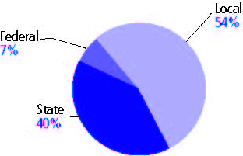

Title I allocation 2002-03 (ED; Includes Title I, Part A) | $182,110,558

Students

Public school enrollment (CCD) | 1993-94 | 2003-04
Pre-K | 3,186 | 16,524
K-8 | 734,673 | 819,972
9-12 | 278,009 | 354,836
Total (K-12) | 1,012,682 | 1,174,808

Race/ethnicity (CCD) | 1993-94 | 2003-04
American Indian/Alaskan Native | * | *
Asian/Pacific Islander | 3% | 5%
Black, non-Hispanic | 26 | 27
Hispanic | 3 | 7
White, non-Hispanic | 68 | 61

Students with disabilities (OSEP) | 1993-94 | 2003-04
 | 11% | 12%

Students with limited  English proficiency (NCELA) | 1993-94 | 2003-04
 | - | 5%

Migrant students (OME) | 1993-94 | 2003-04
 | * | *

Eighth-grade students enrolled in Algebra I for high school credit (NAEP) | 1996 | 2003
 | 29% | 28%

Students eligible to participate in the Free or Reduced-Price Lunch Program, 2003-04 (CCD) | 360,342

All schools by percent of students eligible to participate in the Free or Reduced-Price Lunch Program, 2003-04† (CCD)
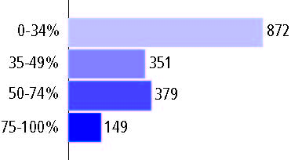
† 85 schools did not report

Staff

Number of FTE teachers (CCD) | 1993-94 | 2003-04
Elementary | 28,540 | 42,203
Middle | 12,141 | 19,019
High | 27,727 | 24,633
Combined | 576 | 820
Other | 642 | 284
Total | 69,626 | 86,959

Number of FTE non-teacher staff (CCD) | 1993-94 | 2003-04
Instructional aides | 11,209 | 15,287
Instructional coordinators | 1,077 | 1,525
Administrators | 5,183 | 5,480
Other | 41,705 | 53,713
Total | 59,174 | 76,005

Percentage of teachers with a major in the main subject taught, grades 7-12 (SASS) | 1994 | 2000
English | 93% | 63%
Mathematics | 69 | 59
Science | 67 | 74
Social Studies | 84 | 77

Percentage of core courses taught by highly qualified teachers, 2003-04 (As defined and reported by states, collected by ED)
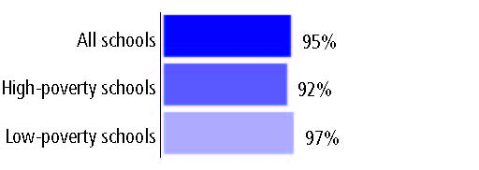

Outcomes

 | 1993-94 | 2000-01
High school dropout rate (NCES) | 5% | 4%
Avg. freshman graduation rate (NCES) | 76 | 78
College-going rate (IPEDS/NCES) | 53 | 53

NAEP state results
Reading, Grade 4 | 1994 | 2005
Proficient level or above | 26% | 37%
Basic level or above | 57 | 72
Math, Grade 8 | 1996 | 2005
Proficient level or above | 21% | 33%
Basic level or above | 58 | 74

Statewide Accountability Information:

State Accountability Website: http://www.pen.k12.va.us/VDOE/src/vasrc-reportcard-intropage.shtml

State assessment for NCLB accountability: Standards of Learning Assessments

State student achievement levels: Fails/Does not meet the standard, Pass/Proficient, Pass/Advanced

 |  | 2001-02  Annual measurable  objective starting point | Target  2003-04
Grade 3 | English | 60.7% | 61%
 | Mathematics | 58.4 | 59
Grade 8 | English | 60.7 | 61
 | Mathematics | 58.4 | 59
High school | English | 60.7 | 61
 | Mathematics | 58.4 | 59

2003-04 NCLB accountability results, applied to 2004-05 school year
AYP outcomes and consequences | Title I schools |  | All schools |  | All districts
Made AYP | 586 | 76% | 1,345 | 74% | 30 | 23%
Identified for improvement:
Year 1 | 82 | 11% | 82 | 5% | 0 | 0
Year 2 | 21 | 3% | 21 | 1% | 0 | 0
Corrective action | 8 | 1% | 8 | * | 0 | 0
Restructuring | 0 | 0 | 0 | 0 | 0 | 0
Exited improvement status (made AYP twice after missing twice or more, includes total “made” above) | 9 | 1% | 9 | * | 0 | 0

Other indicator, 2003-04 | State target | State outcome
Elementary Indicator: Attendance rate | 94% | Met
Middle Indicator: Attendance rate | 94% | Met
High School Indicator: Graduation rate | 51.7% | Met

NCLB choice participation | Number of Title I students | Percent of eligible students
Title I school choice: | 432 | 2%
Supplemental educational services: | 1,301 | 11%

Student Achievement 2003-04

Standards of Learning Assessments, used for NCLB accountability
Grade 3

English
Proficient Level or above for:
All students | 71%
Economically disadvantaged students | 57
Migrant students | 70
Students with disabilities | 47
Students with limited English proficiency | 60
Black, non-Hispanic students | 56
Hispanic students | 62
White, non-Hispanic students | 79

Student achievement trend: English percent proficient level or above

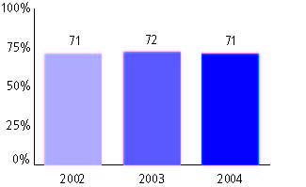

Standards of Learning Assessments, used for NCLB accountability
Grade 3

Mathematics
Proficient Level or above for:
All students | 87%
Economically disadvantaged students | 79
Migrant students | 78
Students with disabilities | 74
Students with limited English proficiency | 84
Black, non-Hispanic students | 77
Hispanic students | 84
White, non-Hispanic students | 92

Student achievement trend: Mathematics percent proficient level or above

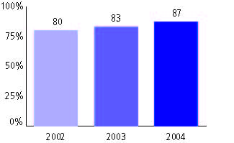

Standards of Learning Assessments, used for NCLB accountability
Grade 4

English
Proficient Level or above for:
All students | n/a
Economically disadvantaged students | n/a
Migrant students | n/a
Students with disabilities | n/a
Students with limited English proficiency | n/a
Black, non-Hispanic students | n/a
Hispanic students | n/a
White, non-Hispanic students | n/a

Trend Data Not Available

Standards of Learning Assessments, used for NCLB accountability
Grade 4

Mathematics
Proficient Level or above for:
All students | n/a
Economically disadvantaged students | n/a
Migrant students | n/a
Students with disabilities | n/a
Students with limited English proficiency | n/a
Black, non-Hispanic students | n/a
Hispanic students | n/a
White, non-Hispanic students | n/a

Trend Data Not Available

Standards of Learning Assessments, used for NCLB accountability
Grade 5

English
Proficient Level or above for:
All students | 85%
Economically disadvantaged students | 74
Migrant students | 78
Students with disabilities | 62
Students with limited English proficiency | 78
Black, non-Hispanic students | 74
Hispanic students | 79
White, non-Hispanic students | 89

Student achievement trend: English percent proficient level or above

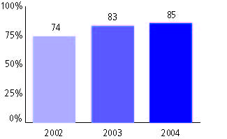

Standards of Learning Assessments, used for NCLB accountability
Grade 5

Mathematics
Proficient Level or above for:
All students | 78%
Economically disadvantaged students | 66
Migrant students | 67
Students with disabilities | 52
Students with limited English proficiency | 67
Black, non-Hispanic students | 66
Hispanic students | 69
White, non-Hispanic students | 84

Student achievement trend: Mathematics percent proficient level or above

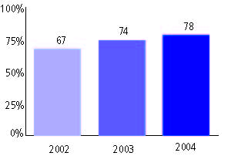

Standards of Learning Assessments, used for NCLB accountability
Grade 6

English
Proficient Level or above for:
All students | n/a
Economically disadvantaged students | n/a
Migrant students | n/a
Students with disabilities | n/a
Students with limited English proficiency | n/a
Black, non-Hispanic students | n/a
Hispanic students | n/a
White, non-Hispanic students | n/a

Trend Data Not Available

Standards of Learning Assessments, used for NCLB accountability
Grade 6

Mathematics
Proficient Level or above for:
All students | n/a
Economically disadvantaged students | n/a
Migrant students | n/a
Students with disabilities | n/a
Students with limited English proficiency | n/a
Black, non-Hispanic students | n/a
Hispanic students | n/a
White, non-Hispanic students | n/a

Trend Data Not Available

Standards of Learning Assessments, used for NCLB accountability
Grade 7

English
Proficient Level or above for:
All students | n/a
Economically disadvantaged students | n/a
Migrant students | n/a
Students with disabilities | n/a
Students with limited English proficiency | n/a
Black, non-Hispanic students | n/a
Hispanic students | n/a
White, non-Hispanic students | n/a

Trend Data Not Available

Standards of Learning Assessments, used for NCLB accountability
Grade 7

Mathematics
Proficient Level or above for:
All students | n/a
Economically disadvantaged students | n/a
Migrant students | n/a
Students with disabilities | n/a
Students with limited English proficiency | n/a
Black, non-Hispanic students | n/a
Hispanic students | n/a
White, non-Hispanic students | n/a

Trend Data Not Available

Standards of Learning Assessments, used for NCLB accountability
Grade 8

English
Proficient Level or above for:
All students | 72%
Economically disadvantaged students | 54
Migrant students | 48
Students with disabilities | 36
Students with limited English proficiency | 50
Black, non-Hispanic students | 56
Hispanic students | 59
White, non-Hispanic students | 79

Student achievement trend: English percent proficient level or above

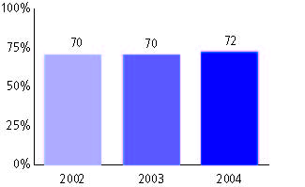

Standards of Learning Assessments, used for NCLB accountability
Grade 8

Mathematics
Proficient Level or above for:
All students | 80%
Economically disadvantaged students | 67
Migrant students | 59
Students with disabilities | 45
Students with limited English proficiency | 70
Black, non-Hispanic students | 67
Hispanic students | 73
White, non-Hispanic students | 85

Student achievement trend: Mathematics percent proficient level or above

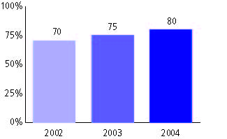

Standards of Learning Assessments, used for NCLB accountability
High school

English
Proficient Level or above for:
All students | 89%
Economically disadvantaged students | 80
Migrant students | 59
Students with disabilities | 68
Students with limited English proficiency | 75
Black, non-Hispanic students | 80
Hispanic students | 83
White, non-Hispanic students | 93

Student achievement trend: English percent proficient level or above

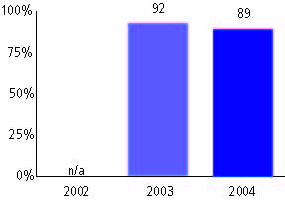

Standards of Learning Assessments, used for NCLB accountability
High school

Mathematics
Proficient Level or above for:
All students | 84%
Economically disadvantaged students | 75
Migrant students | 65
Students with disabilities | 59
Students with limited English proficiency | 78
Black, non-Hispanic students | 71
Hispanic students | 76
White, non-Hispanic students | 88

Student achievement trend: Mathematics percent proficient level or above

