West Virginia

http://wvde.state.wv.us

Districts and schools

Number of districts (CCD) | 1993-94 | 2003-04
 | 55 | 55

Number of public schools (CCD) | 1993-94 | 2003-04
Elementary | 557 | 479
Middle | 137 | 127
High | 133 | 124
Combined | 23 | 22
Other | 20 | 3
Total | 870 | 755

Number of charter schools (CCD) | 2003-04
 | 0

Finances

Total current expenditures  (CCD, in thousands of dollars, adjusted for inflation to 2002-03) | 1993-94 | 2002-03
Instructional | $1,318,742 | $1,444,689
Noninstructional | 120,121 | 130,675
Support | 681,238 | 774,469
Total | 2,120,101 | 2,349,833

Per-pupil expenditures  (CCD, adjusted for inflation to 2002-03) | 1993-94 | 2002-03
 | $6,743 | $8,319

Sources of Funding
(CCD, 2002-03)

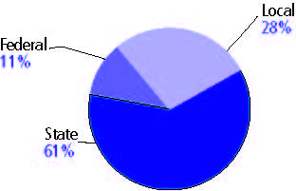

Title I allocation 2002-03 (ED; Includes Title I, Part A) | $94,167,837

Students

Public school enrollment (CCD) | 1993-94 | 2003-04
Pre-K | 2,327 | 7,911
K-8 | 210,733 | 190,920
9-12 | 96,256 | 82,375
Total (K-12) | 306,989 | 273,295

Race/ethnicity (CCD) | 1993-94 | 2003-04
American Indian/Alaskan Native | * | *
Asian/Pacific Islander | * | 1%
Black, non-Hispanic | 4% | 5
Hispanic | * | 1
White, non-Hispanic | 95 | 94

Students with disabilities (OSEP) | 1993-94 | 2003-04
 | 9% | 16%

Students with limited  English proficiency (NCELA) | 1993-94 | 2003-04
 | 2% | 1%

Migrant students (OME) | 1993-94 | 2003-04
 | * | *

Eighth-grade students enrolled in Algebra I for high school credit (NAEP) | 1996 | 2003
 | 26% | 25%

Students eligible to participate in the Free or Reduced-Price Lunch Program, 2003-04 (CCD) | 138,537

All schools by percent of students eligible to participate in the Free or Reduced-Price Lunch Program, 2003-04† (CCD)
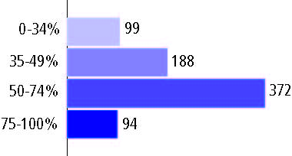
† 2 schools did not report

Staff

Number of FTE teachers (CCD) | 1993-94 | 2003-04
Elementary | 9,637 | 9,440
Middle | 4,119 | 4,041
High | 5,290 | 5,334
Combined | 751 | 284
Other | 167 | 13
Total | 19,964 | 19,112

Number of FTE non-teacher staff (CCD) | 1993-94 | 2003-04
Instructional aides | 2,858 | 3,113
Instructional coordinators | 334 | 335
Administrators | 1,388 | 1,465
Other | 12,877 | 13,024
Total | 17,457 | 17,937

Percentage of teachers with a major in the main subject taught, grades 7-12 (SASS) | 1994 | 2000
English | 74% | 72%
Mathematics | 80 | 79
Science | 76 | 69
Social Studies | 83 | 80

Percentage of core courses taught by highly qualified teachers, 2003-04 (As defined and reported by states, collected by ED)
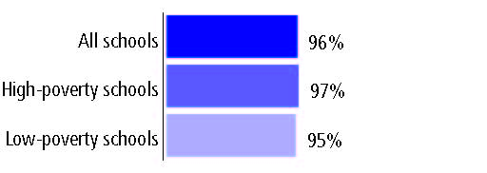

Outcomes

 | 1993-94 | 2000-01
High school dropout rate (NCES) | 4% | 4%
Avg. freshman graduation rate (NCES) | 78 | 76
College-going rate (IPEDS/NCES) | 50 | 52

NAEP state results
Reading, Grade 4 | 1994 | 2005
Proficient level or above | 26% | 26%
Basic level or above | 58 | 61
Math, Grade 8 | 1996 | 2005
Proficient level or above | 14% | 17%
Basic level or above | 54 | 59

Statewide Accountability Information:

State Accountability Website: http://wveis.k12.wv.us/nclb/public04/nclbmenu.cfm

State assessment for NCLB accountability: West Virginia Educational Standards Tests

State student achievement levels: Novice, Partial Mastery, Mastery, Distinguished, Above mastery

 |  | 2001-02  Annual measurable  objective starting point | Target  2003-04
Grade 3 | Reading or language arts | 69% | 69%
 | Mathematics | 63 | 63
Grade 8 | Reading or language arts | 74 | 74
 | Mathematics | 61 | 61
High school | Reading or language arts | 72 | 72
 | Mathematics | 57 | 57

2003-04 NCLB accountability results, applied to 2004-05 school year
AYP outcomes and consequences | Title I schools |  | All schools |  | All districts
Made AYP | 299 | 75% | 519 | 73% | 2 | 4%
Identified for improvement:
Year 1 | 31 | 8% | 200 | 28% | 0 | 0
Year 2 | 5 | 1% | 54 | 8% | 0 | 0
Corrective action | 1 | * | 4 | 1% | 2 | 4%
Restructuring | 0 | 0 | 0 | 0 | 0 | 0
Exited improvement status (made AYP twice after missing twice or more, includes total “made” above) | 4 | 1% | 4 | 1% | 0 | 0

Other indicator, 2003-04 | State target | State outcome
Elementary Indicator: Attendance | Meet or progress toward 90% | Met
Middle Indicator: Attendance | Meet or progress toward 90% | Met
High School Indicator: Graduation rate | Meet or progress toward 80%. | Met

NCLB choice participation | Number of Title I students | Percent of eligible students
Title I school choice: | 90 | 6%
Supplemental educational services: | 33 | 7%

Student Achievement 2003-04

West Virginia Educational Standards Tests, used for NCLB accountability
Grade 3

Reading or language arts
Proficient Level or above for:
All students | 77%
Economically disadvantaged students | 69
Migrant students | 69
Students with disabilities | 45
Students with limited English proficiency | 75
Black, non-Hispanic students | 68
Hispanic students | 75
White, non-Hispanic students | 78

Student achievement trend: Reading or language arts percent proficient level or above

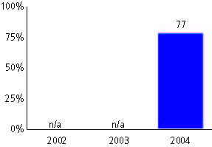

West Virginia Educational Standards Tests, used for NCLB accountability
Grade 3

Mathematics
Proficient Level or above for:
All students | 72%
Economically disadvantaged students | 64
Migrant students | 77
Students with disabilities | 50
Students with limited English proficiency | 71
Black, non-Hispanic students | 61
Hispanic students | 73
White, non-Hispanic students | 73

Student achievement trend: Mathematics percent proficient level or above

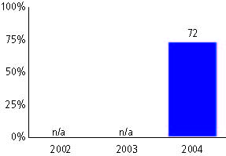

West Virginia Educational Standards Tests, used for NCLB accountability
Grade 4

Reading or language arts
Proficient Level or above for:
All students | 73%
Economically disadvantaged students | 64
Migrant students | 89
Students with disabilities | 33
Students with limited English proficiency | 68
Black, non-Hispanic students | 57
Hispanic students | 63
White, non-Hispanic students | 74

Student achievement trend: Reading or language arts percent proficient level or above

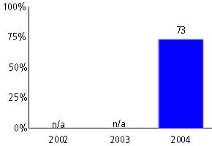

West Virginia Educational Standards Tests, used for NCLB accountability
Grade 4

Mathematics
Proficient Level or above for:
All students | 69%
Economically disadvantaged students | 64
Migrant students | 89
Students with disabilities | 33
Students with limited English proficiency | 68
Black, non-Hispanic students | 53
Hispanic students | 68
White, non-Hispanic students | 70

Student achievement trend: Mathematics percent proficient level or above

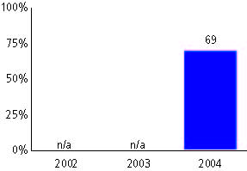

West Virginia Educational Standards Tests, used for NCLB accountability
Grade 5

Reading or language arts
Proficient Level or above for:
All students | 76%
Economically disadvantaged students | 67
Migrant students | 63
Students with disabilities | 33
Students with limited English proficiency | 74
Black, non-Hispanic students | 63
Hispanic students | 68
White, non-Hispanic students | 76

Student achievement trend: Reading or language arts percent proficient level or above

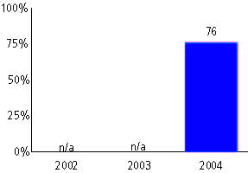

West Virginia Educational Standards Tests, used for NCLB accountability
Grade 5

Mathematics
Proficient Level or above for:
All students | 71%
Economically disadvantaged students | 67
Migrant students | 63
Students with disabilities | 33
Students with limited English proficiency | 74
Black, non-Hispanic students | 59
Hispanic students | 60
White, non-Hispanic students | 72

Student achievement trend: Mathematics percent proficient level or above

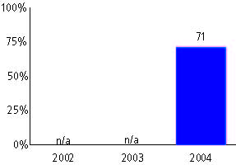

West Virginia Educational Standards Tests, used for NCLB accountability
Grade 6

Reading or language arts
Proficient Level or above for:
All students | 78%
Economically disadvantaged students | 69
Migrant students | 75
Students with disabilities | 32
Students with limited English proficiency | 71
Black, non-Hispanic students | 67
Hispanic students | 74
White, non-Hispanic students | 78

Student achievement trend: Reading or language arts percent proficient level or above

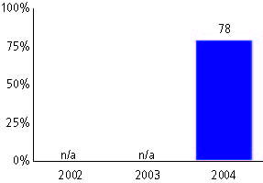

West Virginia Educational Standards Tests, used for NCLB accountability
Grade 6

Mathematics
Proficient Level or above for:
All students | 63%
Economically disadvantaged students | 69
Migrant students | 75
Students with disabilities | 32
Students with limited English proficiency | 71
Black, non-Hispanic students | 47
Hispanic students | 51
White, non-Hispanic students | 64

Student achievement trend: Mathematics percent proficient level or above

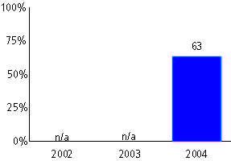

West Virginia Educational Standards Tests, used for NCLB accountability
Grade 7

Reading or language arts
Proficient Level or above for:
All students | 79%
Economically disadvantaged students | 70
Migrant students | 74
Students with disabilities | 32
Students with limited English proficiency | 87
Black, non-Hispanic students | 67
Hispanic students | 78
White, non-Hispanic students | 79

Student achievement trend: Reading or language arts percent proficient level or above

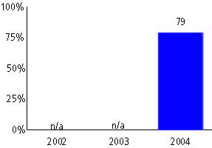

West Virginia Educational Standards Tests, used for NCLB accountability
Grade 7

Mathematics
Proficient Level or above for:
All students | 65%
Economically disadvantaged students | 70
Migrant students | 74
Students with disabilities | 32
Students with limited English proficiency | 87
Black, non-Hispanic students | 47
Hispanic students | 60
White, non-Hispanic students | 66

Student achievement trend: Mathematics percent proficient level or above

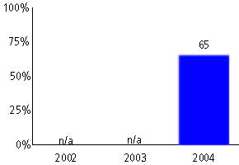

West Virginia Educational Standards Tests, used for NCLB accountability
Grade 8

Reading or language arts
Proficient Level or above for:
All students | 80%
Economically disadvantaged students | 71
Migrant students | 75
Students with disabilities | 32
Students with limited English proficiency | 81
Black, non-Hispanic students | 72
Hispanic students | 77
White, non-Hispanic students | 81

Student achievement trend: Reading or language arts percent proficient level or above

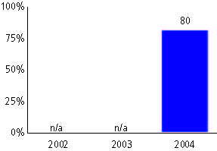

West Virginia Educational Standards Tests, used for NCLB accountability
Grade 8

Mathematics
Proficient Level or above for:
All students | 69%
Economically disadvantaged students | 58
Migrant students | 31
Students with disabilities | 22
Students with limited English proficiency | 77
Black, non-Hispanic students | 51
Hispanic students | 63
White, non-Hispanic students | 70

Student achievement trend: Mathematics percent proficient level or above

West Virginia Educational Standards Tests, used for NCLB accountability
High school

Reading or language arts
Proficient Level or above for:
All students | 77%
Economically disadvantaged students | 65
Migrant students | 83
Students with disabilities | 24
Students with limited English proficiency | 84
Black, non-Hispanic students | 61
Hispanic students | 81
White, non-Hispanic students | 77

Student achievement trend: Reading or language arts percent proficient level or above

West Virginia Educational Standards Tests, used for NCLB accountability
High school

Mathematics
Proficient Level or above for:
All students | 64%
Economically disadvantaged students | 50
Migrant students | 33
Students with disabilities | 15
Students with limited English proficiency | 79
Black, non-Hispanic students | 45
Hispanic students | 66
White, non-Hispanic students | 65

Student achievement trend: Mathematics percent proficient level or above

