 |  |  | Advisory Circular
U.S. Department
of Transportation
Federal Aviation
Administration
Subject: CONSTRUCTION PROGRESS AND INSPECTION REPORT—AIRPORT IMPROVEMENT PROGRAM (AIP) |  | Date: 9/29/07  Initiated by: AAS-100 |  | AC No.: 150/5370-6C  Change:
- PURPOSE. This advisory circular (AC) provides guidance for reporting construction progress of projects under the Airport Improvement Program (AIP).
- APPLICATION. The Federal Aviation Administration recommends the guidelines and standards in this AC for airport construction projects. This AC does not constitute a regulation and in general is not mandatory. However, use of these guidelines is mandatory for construction projects funded under the Airport Improvement Program (AIP). Mandatory terms such as “must” apply only to those who undertake construction projects using AIP funds.
- RESPONSIBILITY FOR SUPERVISION AND INSPECTION. The airport sponsor (owner) has primary responsibility for supervision and inspection of construction work under the AIP. The FAA Airports Division/District/Field Offices are responsible for monitoring the project to ensure the terms and conditions of the grant agreement are met, to maintain a broad overview of the construction to be reasonably certain the work is accomplished in accordance with the plans and specifications, and to evaluate the adequacy of the sponsor’s construction inspection.
4. FAA NEED FOR INFORMATION. In order to meet the above responsibility, the FAA needs information as to what work is in progress, completed, or planned; recent testing; and problem areas. This information is discussed at the preconstruction conference and can be obtained in a convenient manner in an appropriate timeframe through use of FAA Form 5370-1, Construction Progress and Inspection Report. Use of this form is not mandatory. The sponsor may prepare and use customized forms.
5. USE OF FAA FORM 5370-1. FAA Form 5370-1, Construction Progress and Inspection Report (see Appendix 1), or a form that provides equivalent information, must be maintained by the sponsor’s engineer and submitted to the appropriate Airports Division/District/Field Office upon request. If any problems, delays, or adverse conditions occur that will affect the project, the engineer should submit an interim report to the FAA.
6. CANCELLATION. This AC cancels AC 150/5370-6B, Construction Progress and Inspection Report—Airport Development Aid Program, dated August 7, 1989.
7. COPIES OF THIS AC. This AC can be found on the Federal Aviation Administration (FAA) website at http://www.faa.gov/airports_airtraffic/airports/resources/advisory_circulars/.
8. COPIES OF FAA FORM 5370-1. This form can be found on the Federal Aviation Administration (FAA) website at http://forms.faa.gov.
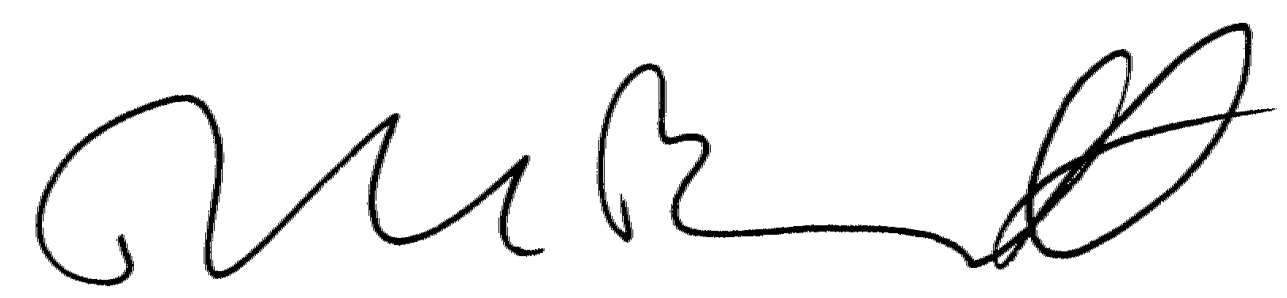

David L. Bennett
Director of Airport Safety and Standards

This page intentionally left blank.
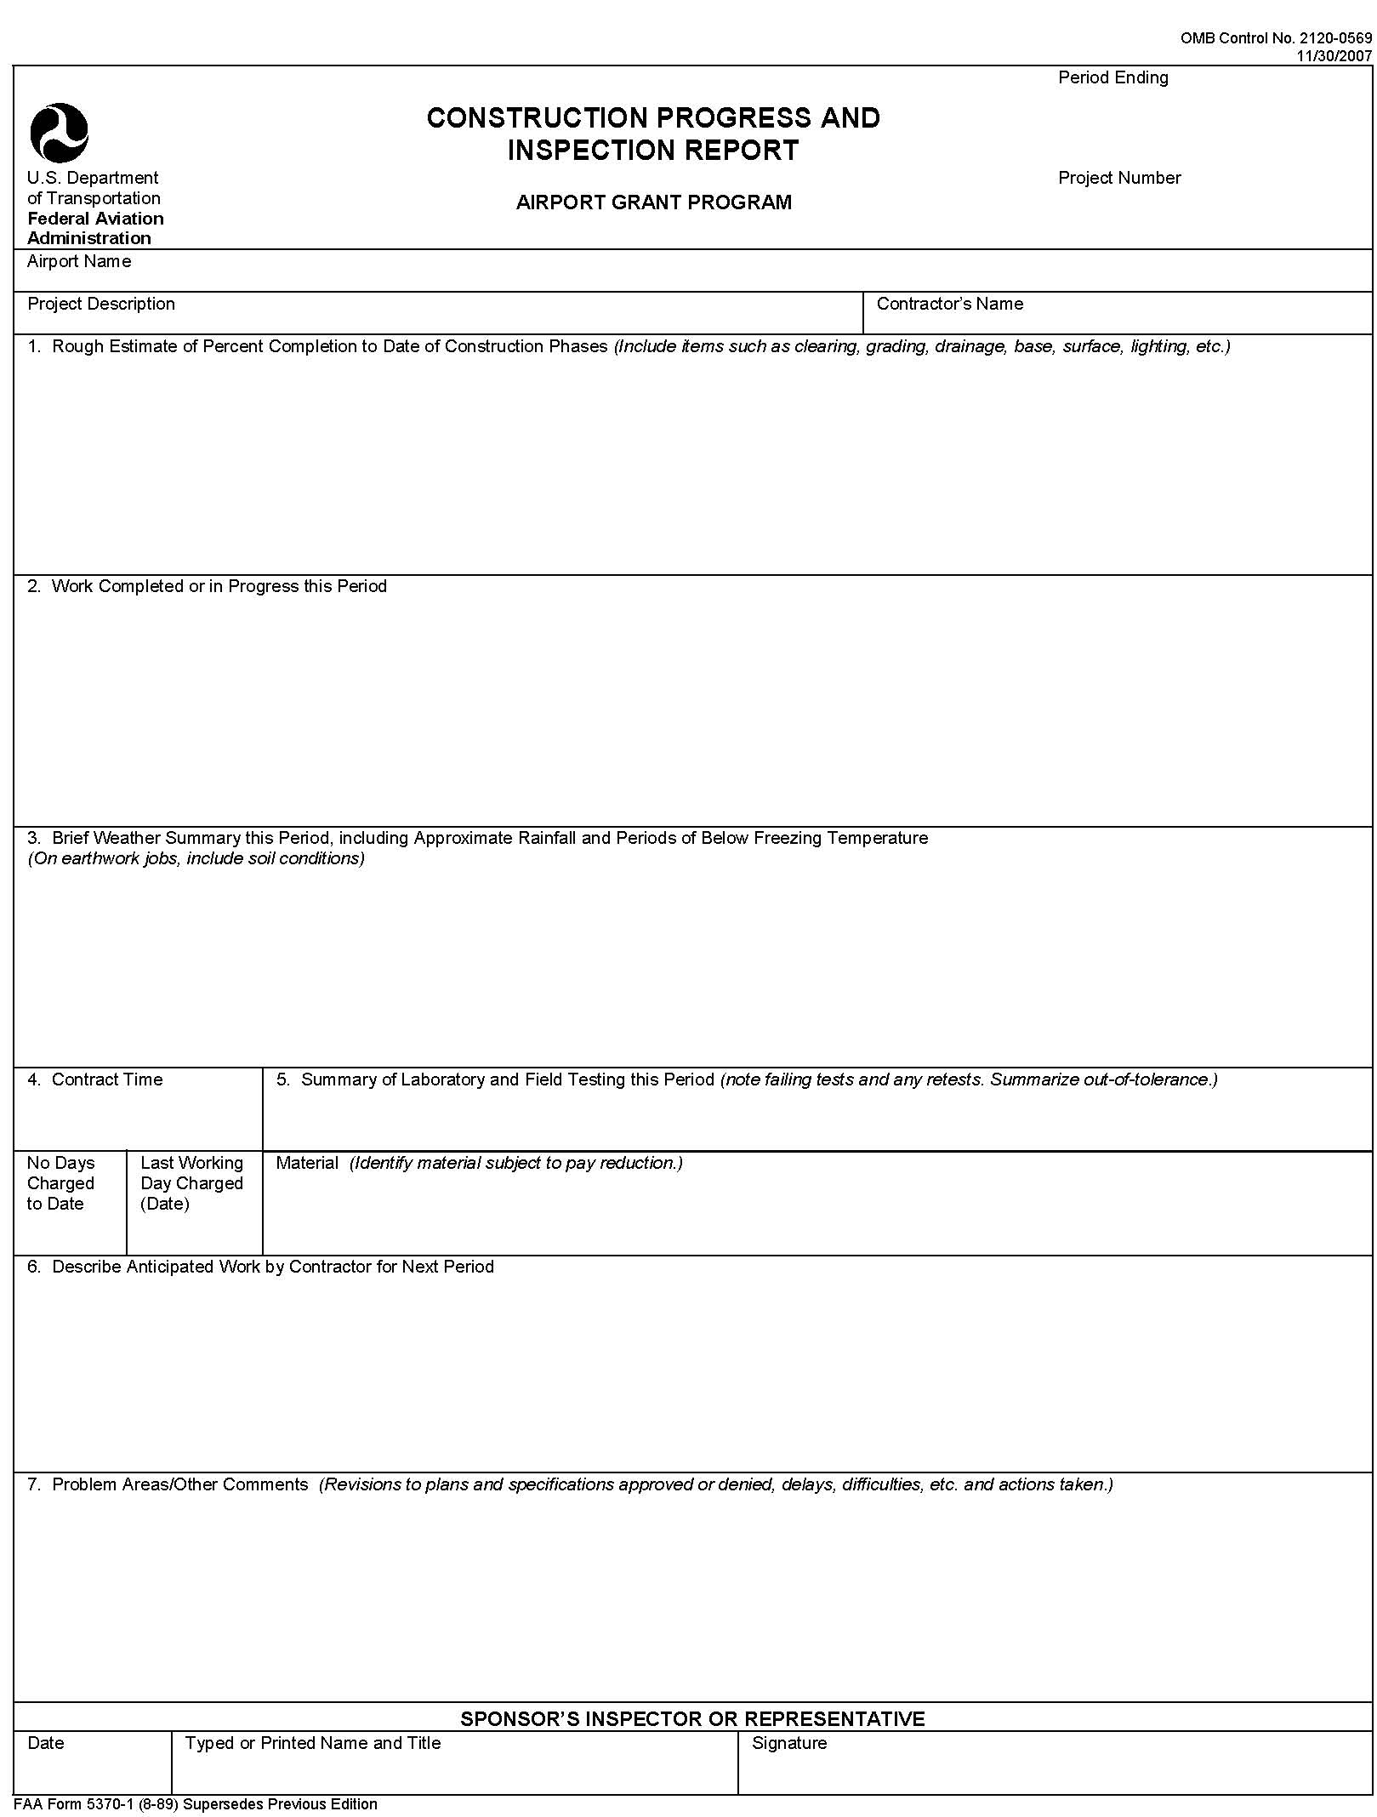

Form 5370-1, Construction Progress and Inspection Report

