Wisconsin

http://www.dpi.state.wi.us

Districts and schools

Number of districts (CCD) | 1993-94 | 2002-03
 | 427 | 437

Number of public schools (CCD) | 1993-94 | 2002-03
Elementary | 1,235 | 1,251
Middle | 347 | 390
High | 424 | 511
Combined | 23 | 67
Other | 3 | 13
Total | 2,032 | 2,232

Number of charter schools (CCD) | 2002-03
 | 128

Finances

Total current expenditures  (CCD, in thousands of dollars, adjusted for inflation to 2001-02) | 1993-94 | 2001-02
Instructional | $4,205,737 | $4,705,538
Noninstructional | 198,240 | 243,733
Support | 2,215,036 | 2,642,906
Total | 6,619,013 | 7,592,177

Per-pupil expenditures  (CCD, adjusted for inflation to 2001-02) | 1993-94 | 2001-02
 | $7,842 | $8,634

Sources of funding
(CCD, 2001-02)

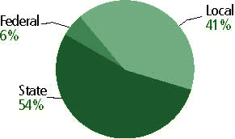

Title I allocation 2001-02 (ED; Includes Title I, Part A) | $149,746,614

Students

Public school enrollment (CCD) | 1993-94 | 2002-03
Pre-K | 17,270 | 26,092
K-8 | 578,447 | 565,592
9-12 | 248,284 | 289,333
Total (K-12) | 826,731 | 854,925

Race/ethnicity (CCD) | 1993-94 | 2002-03
American Indian/Alaskan Native | 3% | 1%
Asian/Pacific Islander | 1 | 3
Black, non-Hispanic | 1 | 10
Hispanic | 6 | 5
White, non-Hispanic | 89 | 79

Students with disabilities (OSEP) | 1993-94 | 2002-03
 | 10% | 11%

Students with limited  English proficiency (NCELA) | 1993-94 | 2002-03
 | 2% | 4%

Migrant students (OME) | 1993-94 | 2002-03
 | * | *

Eighth-grade students enrolled in Algebra I for high school credit (NAEP) | 1996 | 2003
 | 25% | 22%

Students eligible to participate in the Free or Reduced-Price Lunch Program, 2002-03 (CCD) | 242,158

All schools by percent of students eligible to participate in the Free or Reduced-Price Lunch Program, 2002-03† (CCD)

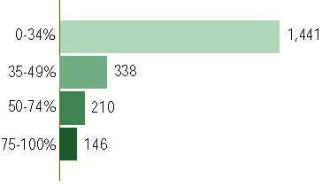
†97 schools did not report
Staff

Number of FTE teachers (CCD) | 1993-94 | 2002-03
Elementary | 24,508 | 28,447
Middle | 10,278 | 12,052
High | 15,742 | 18,092
Combined | 523 | 1,334
Other | 1,771 | 461
Total | 52,822 | 60,385

Number of FTE non-teacher staff (CCD) | 1993-94 | 2002-03
Instructional aides | 7,565 | 12,851
Instructional coordinators | 314 | 1,663
Administrators | 3,973 | 3,461
Other | 23,966 | 34,902
Total | 35,818 | 52,877

Percentage of teachers with a major in the main subject taught, grades 7-12 (SASS) | 1994 | 2000
English | 75% | 81%
Mathematics | 76 | 75
Science | 68 | 82
Social Studies | 85 | 85

Percentage of core courses taught by highly qualified teachers, 2002-03
(As defined and reported by states, collected by ED)

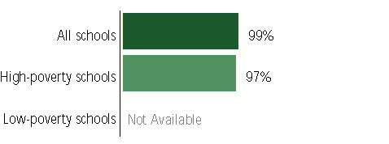

Outcomes

 | 1993-94 | 2000-01
High school dropout rate (NCES) | 3% | 2%
Averaged freshman graduation rate (NCES) | 85 | 83
College-going rate (IPEDS/NCES) | 60 | 57

NAEP state results
Reading, Grade 4 | 1994 | 2003
Proficient level or above | 35% | 33%
Basic level or above | 71 | 68
Math, Grade 8 | 1996 | 2003
Proficient level or above | 32% | 35%
Basic level or above | 75 | 75

Statewide Accountability Information:

State Accountability Website:
http://www.dpi.state.wi.us/oea/accounty.html

State assessment for NCLB accountability: Wisconsin Knowledge & Concepts Examinations (WKCE) plus the Wisconsin Alternate Assessments for students with disabilities (WAA-SwD) and for English language learners (WAA-LEP)

State student achievement levels: Minimum, Basic, Proficient, Advanced

 |  | 2001-02  Annual measurable  objective starting point | Target  2002-03
Grade 4 | Reading | 61% | 61%
 | Mathematics | 37 | 37
Grade 8 | Reading | 61 | 61
 | Mathematics | 37 | 37
Grade 10 | Reading | 61 | 61
 | Mathematics | 37 | 37

AYP outcomes and consequences | Title I schools |  | All schools |  | All districts
Made AYP | 950 | 94% | 1,915 | 95% | 404 | 95%
Identified for improvement:
Year 1 | 16 | 2% | 25 | 1% | 0 | 0
Year 2 | 30 | 3% | 36 | 2% | 0 | 0
Corrective action | 6 | 1% | 7 | * | 0 | 0
Restructuring | 0 | 0 | 0 | 0 | 0 | 0
Exited improvement status (made AYP twice after missing twice or more, includes total “made” above) | 21 | 2% | 23 | 1% | 0 | 0

Other indicator, 2002-03 | State target | State outcome
Elementary indicator: Attendance | Meet or progress toward 90% of statewide average attendance | Met
Middle indicator: Attendance | Meet or progress toward 90% of statewide average attendance | Met
High school indicator: Graduation rate | Meet or progress toward 90% of statewide average graduation rate | Met

NCLB choice participation | Number of Title I students | Percent of Eligible Students
Title I school choice | 111 | *
Supplemental educational services | 750 | 3%

Student Achievement 2002-03

Wisconsin Knowledge and Concepts Examinations, WAA-SwD and WAA-LEP, used for NCLB accountability
Grade 3

Reading
Proficient Level or above for:
All students | 81%
Economically disadvantaged students | 67
Migrant students | 46
Students with disabilities | 42
Students with limited English proficiency | 48
Black, non-Hispanic students | 62
Hispanic students | 58
White, non-Hispanic students | 86

Student achievement trend: Reading percent proficient level or above

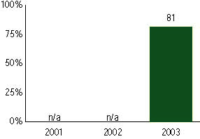

Wisconsin Knowledge and Concepts Examinations, WAA-SwD and WAA-LEP, used for NCLB accountability
Grade 3

Mathematics
Proficient Level or above for:
All students | n/a
Economically disadvantaged students | n/a
Migrant students | n/a
Students with disabilities | n/a
Students with limited English proficiency | n/a
Black, non-Hispanic students | n/a
Hispanic students | n/a
White, non-Hispanic students | n/a

Trend Data Not Available

Wisconsin Knowledge and Concepts Examinations, WAA-SwD and WAA-LEP, used for NCLB accountability
Grade 4

Reading
Proficient Level or above for:
All students | 81%
Economically disadvantaged students | 68
Migrant students | #
Students with disabilities | 50
Students with limited English proficiency | 52
Black, non-Hispanic students | 62
Hispanic students | 63
White, non-Hispanic students | 87

Student achievement trend: Reading percent proficient level or above

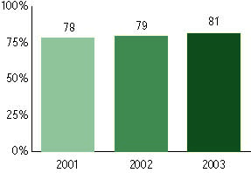

Wisconsin Knowledge and Concepts Examinations, WAA-SwD and WAA-LEP, used for NCLB accountability
Grade 4

Mathematics
Proficient Level or above for:
All students | 71%
Economically disadvantaged students | 53
Migrant students | #
Students with disabilities | 46
Students with limited English proficiency | 51
Black, non-Hispanic students | 42
Hispanic students | 54
White, non-Hispanic students | 76

Student achievement trend: Mathematics percent proficient level or above

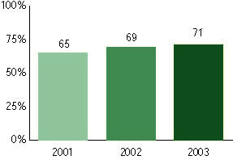

Wisconsin Knowledge and Concepts Examinations, WAA-SwD and WAA-LEP, used for NCLB accountability
Grade 5

Reading
Proficient Level or above for:
All students | n/a
Economically disadvantaged students | n/a
Migrant students | n/a
Students with disabilities | n/a
Students with limited English proficiency | n/a
Black, non-Hispanic students | n/a
Hispanic students | n/a
White, non-Hispanic students | n/a

Trend Data Not Available

Wisconsin Knowledge and Concepts Examinations, WAA-SwD and WAA-LEP, used for NCLB accountability
Grade 5

Mathematics
Proficient Level or above for:
All students | n/a
Economically disadvantaged students | n/a
Migrant students | n/a
Students with disabilities | n/a
Students with limited English proficiency | n/a
Black, non-Hispanic students | n/a
Hispanic students | n/a
White, non-Hispanic students | n/a

Trend Data Not Available

Wisconsin Knowledge and Concepts Examinations, WAA-SwD and WAA-LEP, used for NCLB accountability
Grade 6

Reading
Proficient Level or above for:
All students | n/a
Economically disadvantaged students | n/a
Migrant students | n/a
Students with disabilities | n/a
Students with limited English proficiency | n/a
Black, non-Hispanic students | n/a
Hispanic students | n/a
White, non-Hispanic students | n/a

Trend Data Not Available

Wisconsin Knowledge and Concepts Examinations, WAA-SwD and WAA-LEP, used for NCLB accountability
Grade 6

Mathematics
Proficient Level or above for:
All students | n/a
Economically disadvantaged students | n/a
Migrant students | n/a
Students with disabilities | n/a
Students with limited English proficiency | n/a
Black, non-Hispanic students | n/a
Hispanic students | n/a
White, non-Hispanic students | n/a

Trend Data Not Available

Wisconsin Knowledge and Concepts Examinations, WAA-SwD and WAA-LEP, used for NCLB accountability
Grade 7

Reading
Proficient Level or above for:
All students | n/a
Economically disadvantaged students | n/a
Migrant students | n/a
Students with disabilities | n/a
Students with limited English proficiency | n/a
Black, non-Hispanic students | n/a
Hispanic students | n/a
White, non-Hispanic students | n/a

Trend Data Not Available

Wisconsin Knowledge and Concepts Examinations, WAA-SwD and WAA-LEP, used for NCLB accountability
Grade 7

Mathematics
Proficient Level or above for:
All students | n/a
Economically disadvantaged students | n/a
Migrant students | n/a
Students with disabilities | n/a
Students with limited English proficiency | n/a
Black, non-Hispanic students | n/a
Hispanic students | n/a
White, non-Hispanic students | n/a

Trend Data Not Available

Wisconsin Knowledge and Concepts Examinations, WAA-SwD and WAA-LEP, used for NCLB accountability
Grade 8

Reading
Proficient Level or above for:
All students | 83%
Economically disadvantaged students | 65
Migrant students | #
Students with disabilities | 46
Students with limited English proficiency | 39
Black, non-Hispanic students | 54
Hispanic students | 60
White, non-Hispanic students | 89

Student achievement trend: Reading percent proficient level or above

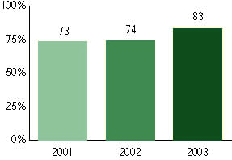

Wisconsin Knowledge and Concepts Examinations, WAA-SwD and WAA-LEP, used for NCLB accountability
Grade 8

Mathematics
Proficient Level or above for:
All students | 73%
Economically disadvantaged students | 50
Migrant students | #
Students with disabilities | 34
Students with limited English proficiency | 40
Black, non-Hispanic students | 31
Hispanic students | 47
White, non-Hispanic students | 81

Student achievement trend: Mathematics percent proficient level or above

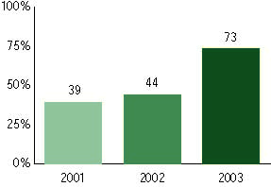

Wisconsin Knowledge and Concepts Examinations, WAA-SwD and WAA-LEP, used for NCLB accountability
Grade 10

Reading
Proficient Level or above for:
All students | 71%
Economically disadvantaged students | 50
Migrant students | #
Students with disabilities | 29
Students with limited English proficiency | 20
Black, non-Hispanic students | 36
Hispanic students | 45
White, non-Hispanic students | 78

Student achievement trend: Reading percent proficient level or above

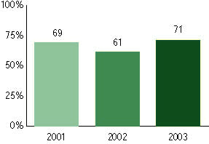

Wisconsin Knowledge and Concepts Examinations, WAA-SwD and WAA-LEP, used for NCLB accountability
Grade 10

Mathematics
Proficient Level or above for:
All students | 69%
Economically disadvantaged students | 43
Migrant students | #
Students with disabilities | 24
Students with limited English proficiency | 25
Black, non-Hispanic students | 23
Hispanic students | 40
White, non-Hispanic students | 76

Student achievement trend: Mathematics percent proficient level or above

