West Virginia

http://wvde.state.wv.us

Districts and schools

Number of districts (CCD) | 1993-94 | 2002-03
 | 55 | 55

Number of public schools (CCD) | 1993-94 | 2002-03
Elementary | 557 | 484
Middle | 137 | 131
High | 133 | 131
Combined | 23 | 14
Other | 20 | 8
Total | 870 | 768

Number of charter schools (CCD) | 2002-03
 | -

Finances

Total current expenditures  (CCD, in thousands of dollars, adjusted for inflation to 2001-02) | 1993-94 | 2001-02
Instructional | $1,324,939 | $1,368,692
Noninstructional | 120,686 | 129,203
Support | 684,440 | 721,118
Total | 2,130,064 | 2,219,013

Per-pupil expenditures  (CCD, adjusted for inflation to 2001-02) | 1993-94 | 2001-02
 | $6,775 | $7,844

Sources of funding
(CCD, 2001-02)

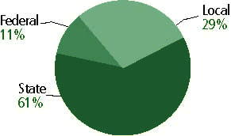

Title I allocation 2001-02 (ED; Includes Title I, Part A) | $81,033,051

Students

Public school enrollment (CCD) | 1993-94 | 2002-03
Pre-K | 3,981 | 7,734
K-8 | 209,090 | 192,050
9-12 | 96,264 | 82,281
Total (K-12) | 305,354 | 274,331

Race/ethnicity (CCD) | 1993-94 | 2002-03
American Indian/Alaskan Native | * | *
Asian/Pacific Islander | * | 1%
Black, non-Hispanic | 4% | 5
Hispanic | * | *
White, non-Hispanic | 95 | 94

Students with disabilities (OSEP) | 1993-94 | 2002-03
 | 12% | 16%

Students with limited  English proficiency (NCELA) | 1993-94 | 2002-03
 | n/a | 1%

Migrant students (OME) | 1993-94 | 2002-03
 | * | *

Eighth-grade students enrolled in Algebra I for high school credit (NAEP) | 1996 | 2003
 | 26% | 25%

Students eligible to participate in the Free or Reduced-Price Lunch Program, 2002-03 (CCD) | 136,469

All schools by percent of students eligible to participate in the Free or Reduced-Price Lunch Program, 2002-03† (CCD)

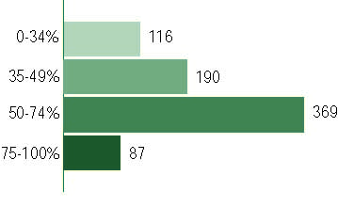
† 6 schools did not report
Staff

Number of FTE teachers (CCD) | 1993-94 | 2002-03
Elementary | 9,628 | 9,522
Middle | 4,110 | 4,066
High | 5,277 | 5,377
Combined | 684 | 214
Other | 1,331 | 878
Total | 21,029 | 20,119

Number of FTE non-teacher staff (CCD) | 1993-94 | 2002-03
Instructional aides | 2,858 | 3,087
Instructional coordinators | 334 | 336
Administrators | 1,388 | 1,478
Other | 12,877 | 13,112
Total | 17,457 | 18,013

Percentage of teachers with a major in the main subject taught, grades 7-12 (SASS) | 1994 | 2000
English | 74% | 72%
Mathematics | 80 | 79
Science | 76 | 69
Social Studies | 83 | 80

Percentage of core courses taught by highly qualified teachers, 2002-03
(As defined and reported by states, collected by ED)

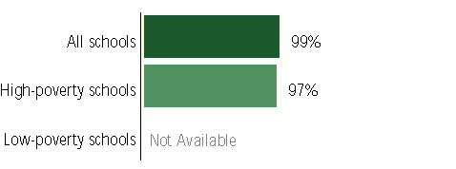

Outcomes

 | 1993-94 | 2000-01
High school dropout rate (NCES) | 4% | 4%
Averaged freshman graduation rate (NCES) | 78 | 76
College-going rate (IPEDS/NCES) | 50 | 52

NAEP state results
Reading, Grade 4 | 1994 | 2003
Proficient level or above | 26% | 29%
Basic level or above | 58 | 65
Math, Grade 8 | 1996 | 2003
Proficient level or above | 14% | 20%
Basic level or above | 54 | 63

Statewide Accountability Information:

State Accountability Website:
http://wveis.k12.wv.us/nclb/public04/nclbmenu.cfm

State assessment for NCLB accountability: WESTEST

State student achievement levels: Novice, Partial Mastery, Mastery, Distinguished, Above mastery

 |  | 2001-02  Annual measurable  objective starting point | Target  2002-03
Grade - |  | n/a | n/a
 |  | n/a | n/a
Grade - |  | n/a | n/a
 |  | n/a | n/a
Grade - |  | n/a | n/a
 |  | n/a | n/a

AYP outcomes and consequences* | Title I schools |  | All schools |  | All districts
Made AYP | n/a | n/a | n/a | n/a | n/a | n/a
Identified for improvement:
Year 1 | 7 | 2% | 58 | 8% | n/a | n/a
Year 2 | 4 | 1% | 4 | * | n/a | n/a
Corrective action | 1 | * | 4 | * | 2 | 4%
Restructuring | 0 | 0 | 0 | 0 | 0 | 0
Exited improvement status (made AYP twice after missing twice or more, includes total “made” above) | 0 | 0 | 0 | 0 | 0 | 0
*AYP outcomes for this state are not available due to issues with data collection, measurement, or other reasons. For more information, please visit the state’s Web site, above.

Other indicator, 2002-03 | State target | State outcome
Elementary indicator: Attendance | Meet or progress toward 95% | Met
Middle indicator: Attendance | Meet or progress toward 95% | Met
High school indicator: Graduation rate | Meet or progress toward 80% | Met

NCLB choice participation | Number of Title I students | Percent of Eligible Students
Title I school choice | 90 | *
Supplemental educational services | 33 | *

Student Achievement 2002-03

WESTEST, used for NCLB accountability as a proxy for AYP
Grade 3-11

Reading
Proficient Level or above for:
All students | 61%
Economically disadvantaged students | 51
Migrant students | -
Students with disabilities | 39
Students with limited English proficiency | 58
Black, non-Hispanic students | 28
Hispanic students | 52
White, non-Hispanic students | 62

Student achievement trend: Reading percent proficient level or above

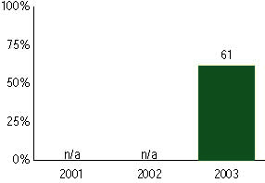

WESTEST, used for NCLB accountability as a proxy for AYP
Grade 3-11

Mathematics
Proficient Level or above for:
All students | 69%
Economically disadvantaged students | 61
Migrant students | -
Students with disabilities | 44
Students with limited English proficiency | 72
Black, non-Hispanic students | 55
Hispanic students | 59
White, non-Hispanic students | 70

Student achievement trend: Math percent proficient level or above

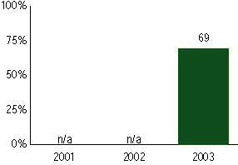

WESTEST, used for NCLB accountability as a proxy for AYP
Grade 4

Reading
Proficient Level or above for:
All students | n/a
Economically disadvantaged students | n/a
Migrant students | n/a
Students with disabilities | n/a
Students with limited English proficiency | n/a
Black, non-Hispanic students | n/a
Hispanic students | n/a
White, non-Hispanic students | n/a

Trend Data Not Available

WESTEST, used for NCLB accountability as a proxy for AYP
Grade 4

Mathematics
Proficient Level or above for:
All students | n/a
Economically disadvantaged students | n/a
Migrant students | n/a
Students with disabilities | n/a
Students with limited English proficiency | n/a
Black, non-Hispanic students | n/a
Hispanic students | n/a
White, non-Hispanic students | n/a

Trend Data Not Available

WESTEST, used for NCLB accountability as a proxy for AYP
Grade 5

Reading
Proficient Level or above for:
All students | n/a
Economically disadvantaged students | n/a
Migrant students | n/a
Students with disabilities | n/a
Students with limited English proficiency | n/a
Black, non-Hispanic students | n/a
Hispanic students | n/a
White, non-Hispanic students | n/a

Trend Data Not Available

WESTEST, used for NCLB accountability as a proxy for AYP
Grade 5

Mathematics
Proficient Level or above for:
All students | n/a
Economically disadvantaged students | n/a
Migrant students | n/a
Students with disabilities | n/a
Students with limited English proficiency | n/a
Black, non-Hispanic students | n/a
Hispanic students | n/a
White, non-Hispanic students | n/a

Trend Data Not Available

WESTEST, used for NCLB accountability as a proxy for AYP
Grade 6

Reading
Proficient Level or above for:
All students | n/a
Economically disadvantaged students | n/a
Migrant students | n/a
Students with disabilities | n/a
Students with limited English proficiency | n/a
Black, non-Hispanic students | n/a
Hispanic students | n/a
White, non-Hispanic students | n/a

Trend Data Not Available

WESTEST, used for NCLB accountability as a proxy for AYP
Grade 6

Mathematics
Proficient Level or above for:
All students | n/a
Economically disadvantaged students | n/a
Migrant students | n/a
Students with disabilities | n/a
Students with limited English proficiency | n/a
Black, non-Hispanic students | n/a
Hispanic students | n/a
White, non-Hispanic students | n/a

Trend Data Not Available

WESTEST, used for NCLB accountability as a proxy for AYP
Grade 7

Reading
Proficient Level or above for:
All students | n/a
Economically disadvantaged students | n/a
Migrant students | n/a
Students with disabilities | n/a
Students with limited English proficiency | n/a
Black, non-Hispanic students | n/a
Hispanic students | n/a
White, non-Hispanic students | n/a

Trend Data Not Available

WESTEST, used for NCLB accountability as a proxy for AYP
Grade 7

Mathematics
Proficient Level or above for:
All students | n/a
Economically disadvantaged students | n/a
Migrant students | n/a
Students with disabilities | n/a
Students with limited English proficiency | n/a
Black, non-Hispanic students | n/a
Hispanic students | n/a
White, non-Hispanic students | n/a

Trend Data Not Available

WESTEST, used for NCLB accountability as a proxy for AYP
Grade 8

Reading
Proficient Level or above for:
All students | n/a
Economically disadvantaged students | n/a
Migrant students | n/a
Students with disabilities | n/a
Students with limited English proficiency | n/a
Black, non-Hispanic students | n/a
Hispanic students | n/a
White, non-Hispanic students | n/a

Trend Data Not Available

WESTEST, used for NCLB accountability as a proxy for AYP
Grade 8

Mathematics
Proficient Level or above for:
All students | n/a
Economically disadvantaged students | n/a
Migrant students | n/a
Students with disabilities | n/a
Students with limited English proficiency | n/a
Black, non-Hispanic students | n/a
Hispanic students | n/a
White, non-Hispanic students | n/a

Trend Data Not Available

WESTEST, used for NCLB accountability as a proxy for AYP
High School

Reading
Proficient Level or above for:
All students | n/a
Economically disadvantaged students | n/a
Migrant students | n/a
Students with disabilities | n/a
Students with limited English proficiency | n/a
Black, non-Hispanic students | n/a
Hispanic students | n/a
White, non-Hispanic students | n/a

Trend Data Not Available

WESTEST, used for NCLB accountability as a proxy for AYP
High School

Mathematics
Proficient Level or above for:
All students | n/a
Economically disadvantaged students | n/a
Migrant students | n/a
Students with disabilities | n/a
Students with limited English proficiency | n/a
Black, non-Hispanic students | n/a
Hispanic students | n/a
White, non-Hispanic students | n/a

Trend Data Not Available

