Virginia

http://www.pen.k12.va.us

Districts and schools

Number of districts (CCD) | 1993-94 | 2002-03
 | 141 | 135

Number of public schools (CCD) | 1993-94 | 2002-03
Elementary | 1,093 | 1,160
Middle | 308 | 341
High | 286 | 315
Combined | 13 | 22
Other | 44 | 8
Total | 1,744 | 1,846

Number of charter schools (CCD) | 2002-03
 | 7

Finances

Total current expenditures  (CCD, in thousands of dollars, adjusted for inflation to 2001-02) | 1993-94 | 2001-02
Instructional | $4,192,655 | $5,373,764
Noninstructional | 361,991 | 340,875
Support | 2,411,355 | 3,003,915
Total | 6,966,001 | 8,718,554

Per-pupil expenditures  (CCD, adjusted for inflation to 2001-02) | 1993-94 | 2001-02
 | $6,663 | $7,496

Sources of funding
(CCD, 2001-02)

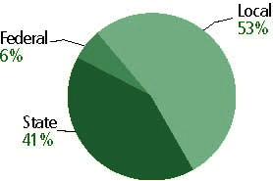

Title I allocation 2001-02 (ED; Includes Title I, Part A) | $174,346,805

Students

Public school enrollment (CCD) | 1993-94 | 2002-03
Pre-K | 3,186 | 14,507
K-8 | 734,673 | 815,946
9-12 | 278,009 | 345,720
Total (K-12) | 1,012,682 | 1,161,666

Race/ethnicity (CCD) | 1993-94 | 2002-03
American Indian/Alaskan Native | * | *
Asian/Pacific Islander | 3% | 5%
Black, non-Hispanic | 26 | 27
Hispanic | 3 | 6
White, non-Hispanic | 68 | 62

Students with disabilities (OSEP) | 1993-94 | 2002-03
 | 11% | 12%

Students with limited  English proficiency (NCELA) | 1993-94 | 2002-03
 | n/a | 4%

Migrant students (OME) | 1993-94 | 2002-03
 | * | *

Eighth-grade students enrolled in Algebra I for high school credit (NAEP) | 1996 | 2003
 | 29% | 28%

Students eligible to participate in the Free or Reduced-Price Lunch Program, 2002-03 (CCD) | 355,212

All schools by percent of students eligible to participate in the Free or Reduced-Price Lunch Program, 2002-03† (CCD)

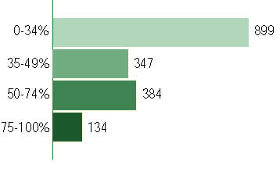
† 82 schools did not report
Staff

Number of FTE teachers (CCD) | 1993-94 | 2002-03
Elementary | 28,540 | 44,038
Middle | 12,131 | 20,273
High | 27,535 | 26,895
Combined | 575 | 561
Other | 1,440 | 8,153
Total | 70,221 | 99,920

Number of FTE non-teacher staff (CCD) | 1993-94 | 2002-03
Instructional aides | 11,209 | 2,632
Instructional coordinators | 1077 | 1,465
Administrators | 5183 | 5963
Other | 41,705 | 53,015
Total | 59,174 | 63,075

Percentage of teachers with a major in the main subject taught, grades 7-12 (SASS) | 1994 | 2000
English | 93% | 63%
Mathematics | 69 | 59
Science | 67 | 74
Social Studies | 84 | 77

Percentage of core courses taught by highly qualified teachers, 2002-03
(As defined and reported by states, collected by ED)

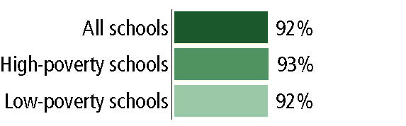

Outcomes

 | 1993-94 | 2000-01
High school dropout rate (NCES) | 5% | 4%
Averaged freshman graduation rate (NCES) | 76 | 78
College going rate (IPEDS/NCES) | 53 | 53

NAEP State Results
Reading, Grade 4 | 1994 | 2003
Proficient level or above | 26% | 35%
Basic level or above | 57 | 69
Math, Grade 8 | 1996 | 2003
Proficient level or above | 21% | 31%
Basic level or above | 58 | 72

Statewide Accountability Information:

State Accountability Website: http://www.pen.k12.va.us/VDOE/src/vasrc-reportcard-intropage.shtml

State assessment for NCLB accountability: Standards of Learning Assessments

State student achievement levels: Fails/Does not meet the standard, Pass/Proficient, Pass/Advanced

 |  | 2001-02  Annual measurable  objective starting point | Target  2002-03
Grade 3 | English | 60.7% | 61%
 | Mathematics | 58.4 | 59
Grade 8 | English | 60.7 | 61
 | Mathematics | 58.4 | 59
Grade 11 | English | 60.7 | 61
 | Mathematics | 58.4 | 59

AYP outcomes and consequences* | Title I schools |  | All schools |  | All districts
Made AYP | 457 | 58% | 1,064 | 59% | 109 | 83%
Identified for improvement:
Year 1 | 22 | 3% | 22 | 1% | 0 | 0
Year 2 | 22 | 3% | 22 | 1% | 0 | 0
Corrective action | 0 | 0 | 0 | 0 | 0 | 0
Restructuring | 0 | 0 | 0 | 0 | 0 | 0
Exited improvement status (made AYP twice after missing twice or more, includes total “made” above) | n/a | n/a | n/a | n/a | n/a | n/a
*AYP outcomes for this state are not available due to issues with data collection, measurement, or other reasons. For more information, please visit the state’s Web site, above.

Other indicator, 2002-03 | State target | State outcome
Elementary indicator: Attendance | 94% | Met
Middle indicator: Attendance | 94% | Met
High school indicator: Graduation rate | 51.70% | Met

NCLB choice participation | Number of Title I students | Percent of Eligible Students
Title I school choice | 432 | *
Supplemental educational services | 1,301 | 1%

Student Achievement 2002-03

Standards of Learning Assessments
Grade 3

English
Proficient Level or above for:
All students | 72%
Economically disadvantaged students | 57
Migrant students | 47
Students with disabilities | 54
Students with limited English proficiency | 56
Black, non-Hispanic students | 58
Hispanic students | 62
White, non-Hispanic students | 79

Student achievement trend: English percent proficient level or above

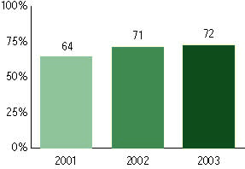

Standards of Learning Assessments, used for NCLB accountability
Grade 3

Mathematics
Proficient Level or above for:
All students | 83%
Economically disadvantaged students | 72
Migrant students | 63
Students with disabilities | 64
Students with limited English proficiency | 75
Black, non-Hispanic students | 72
Hispanic students | 78
White, non-Hispanic students | 88

Student achievement trend: Mathematics percent proficient level or above

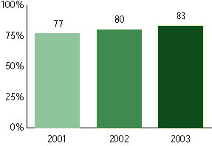

Standards of Learning Assessments, used for NCLB accountability
Grade 4

English
Proficient Level or above for:
All students | n/a
Economically disadvantaged students | n/a
Migrant students | n/a
Students with disabilities | n/a
Students with limited English proficiency | n/a
Black, non-Hispanic students | n/a
Hispanic students | n/a
White, non-Hispanic students | n/a

Trend Data Not Available

Standards of Learning Assessments, used for NCLB accountability
Grade 4

Mathematics
Proficient Level or above for:
All students | n/a
Economically disadvantaged students | n/a
Migrant students | n/a
Students with disabilities | n/a
Students with limited English proficiency | n/a
Black, non-Hispanic students | n/a
Hispanic students | n/a
White, non-Hispanic students | n/a

Trend Data Not Available

Standards of Learning Assessments, used for NCLB accountability
Grade 5

English
Proficient Level or above for:
All students | 83%
Economically disadvantaged students | 70
Migrant students | 61
Students with disabilities | 63
Students with limited English proficiency | 66
Black, non-Hispanic students | 71
Hispanic students | 74
White, non-Hispanic students | 88

Student achievement trend: English percent proficient level or above

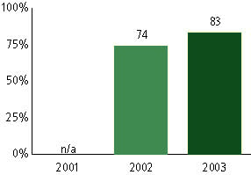

Standards of Learning Assessments, used for NCLB accountability
Grade 5

Mathematics
Proficient Level or above for:
All students | 74%
Economically disadvantaged students | 59
Migrant students | 53
Students with disabilities | 50
Students with limited English proficiency | 60
Black, non-Hispanic students | 60
Hispanic students | 65
White, non-Hispanic students | 81

Student achievement trend: Mathematics percent proficient level or above

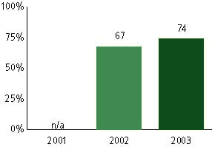

Standards of Learning Assessments, used for NCLB accountability
Grade 6

English
Proficient Level or above for:
All students | n/a
Economically disadvantaged students | n/a
Migrant students | n/a
Students with disabilities | n/a
Students with limited English proficiency | n/a
Black, non-Hispanic students | n/a
Hispanic students | n/a
White, non-Hispanic students | n/a

Trend Data Not Available

Standards of Learning Assessments, used for NCLB accountability
Grade 6

Mathematics
Proficient Level or above for:
All students | n/a
Economically disadvantaged students | n/a
Migrant students | n/a
Students with disabilities | n/a
Students with limited English proficiency | n/a
Black, non-Hispanic students | n/a
Hispanic students | n/a
White, non-Hispanic students | n/a

Trend Data Not Available

Standards of Learning Assessments, used for NCLB accountability
Grade 7

English
Proficient Level or above for:
All students | n/a
Economically disadvantaged students | n/a
Migrant students | n/a
Students with disabilities | n/a
Students with limited English proficiency | n/a
Black, non-Hispanic students | n/a
Hispanic students | n/a
White, non-Hispanic students | n/a

Trend Data Not Available

Standards of Learning Assessments, used for NCLB accountability
Grade 7

Mathematics
Proficient Level or above for:
All students | n/a
Economically disadvantaged students | n/a
Migrant students | n/a
Students with disabilities | n/a
Students with limited English proficiency | n/a
Black, non-Hispanic students | n/a
Hispanic students | n/a
White, non-Hispanic students | n/a

Trend Data Not Available

Standards of Learning Assessments, used for NCLB accountability
Grade 8

English
Proficient Level or above for:
All students | 70%
Economically disadvantaged students | 50
Migrant students | 46
Students with disabilities | 37
Students with limited English proficiency | 35
Black, non-Hispanic students | 52
Hispanic students | 53
White, non-Hispanic students | 78

Student achievement trend: English percent proficient level or above

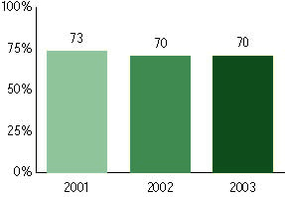

Standards of Learning Assessments, used for NCLB accountability
Grade 8

Mathematics
Proficient Level or above for:
All students | 75%
Economically disadvantaged students | 59
Migrant students | 59
Students with disabilities | 39
Students with limited English proficiency | 65
Black, non-Hispanic students | 59
Hispanic students | 68
White, non-Hispanic students | 81

Student achievement trend: Mathematics percent proficient level or above

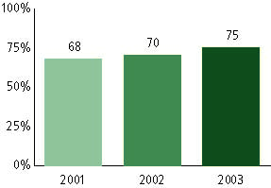

Standards of Learning Assessments, used for NCLB accountability
Grade 11

English
Proficient Level or above for:
All students | 92%
Economically disadvantaged students | 86
Migrant students | 76
Students with disabilities | 73
Students with limited English proficiency | 79
Black, non-Hispanic students | 86
Hispanic students | 88
White, non-Hispanic students | 95

Student achievement trend: English percent proficient level or above

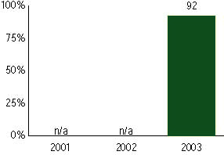

Standards of Learning Assessments, used for NCLB accountability
Grade 11

Mathematics
Proficient Level or above for:
All students | 80%
Economically disadvantaged students | 69
Migrant students | 73
Students with disabilities | 54
Students with limited English proficiency | 74
Black, non-Hispanic students | 65
Hispanic students | 73
White, non-Hispanic students | 84

Student achievement trend: Mathematics percent proficient level or above

