Texas

http://www.tea.state.tx.us

Districts and schools

Number of districts (CCD) | 1993-94 | 2002-03
 | 1,046 | 1,039

Number of public schools (CCD) | 1993-94 | 2002-03
Elementary | 3,385 | 3,934
Middle | 1,308 | 1,570
High | 1,148 | 1,403
Combined | 392 | 800
Other | 19 | 50
Total | 6,252 | 7,757

Number of charter schools (CCD) | 2002-03
 | 260

Finances

Total current expenditures  (CCD, in thousands of dollars, adjusted for inflation to 2001-02) | 1993-94 | 2001-02
Instructional | $12,292,564 | $17,026,101
Noninstructional | 1,242,635 | 1,409,676
Support | 7,195,813 | 9,755,351
Total | 20,731,012 | 28,191,128

Per-pupil expenditures  (CCD, adjusted for inflation to 2001-02) | 1993-94 | 2001-02
 | $5,745 | $6,771

Sources of funding
(CCD, 2001-02)

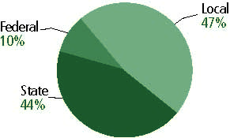

Title I allocation 2001-02 (ED; Includes Title I, Part A) | $862,758,289

Students

Public school enrollment (CCD) | 1993-94 | 2002-03
Pre-K | 120,446 | 182,176
K-8 | 2,560,607 | 2,895,725
9-12 | 927,209 | 1,180,108
Total (K-12) | 3,487,816 | 4,075,833

Race/ethnicity (CCD) | 1993-94 | 2002-03
American Indian/Alaskan Native | * | *
Asian/Pacific Islander | 2% | 3%
Black, non-Hispanic | 14 | 14
Hispanic | 36 | 43
White, non-Hispanic | 48 | 40

Students with disabilities (OSEP) | 1993-94 | 2002-03
 | 11% | 11%

Students with limited  English proficiency (NCELA) | 1993-94 | 2002-03
 | 12% | 15%

Migrant students (OME) | 1993-94 | 2002-03
 | 3% | 5%

Eighth-grade students enrolled in Algebra I for high school credit (NAEP) | 1996 | 2003
 | 25% | 25%

Students eligible to participate in the Free or Reduced-Price Lunch Program, 2002-03 (CCD) | 1,968,976

All schools by percent of students eligible to participate in the Free or Reduced-Price Lunch Program, 2002-03† (CCD)

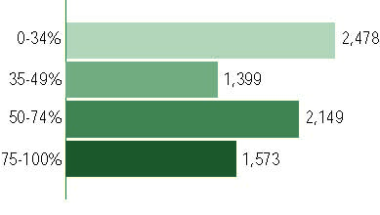
† 158 schools did not report
Staff

Number of FTE teachers (CCD) | 1993-94 | 2002-03
Elementary | 107,516 | 134,768
Middle | 50,750 | 6,579
High | 55,381 | 74,823
Combined | 5,958 | 8,238
Other | 5,224 | 64,247
Total | 224,830 | 288,655

Number of FTE non-teacher staff (CCD) | 1993-94 | 2002-03
Instructional aides | 38,816 | 58,933
Instructional coordinators | 1,257 | 1,335
Administrators | 13,286 | 37,341
Other | 154,913 | 207,738
Total | 208,272 | 305,347

Percentage of teachers with a major in the main subject taught, grades 7-12 (SASS) | 1994 | 2000
English | 71% | 64%
Mathematics | 65 | 57
Science | 70 | 57
Social Studies | 67 | 60

Percentage of core courses taught by highly qualified teachers, 2002-03
(As defined and reported by states, collected by ED)

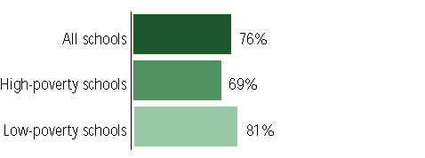

Outcomes

 | 1993-94 | 2000-01
High school dropout rate (NCES) | n/a | 4%
Averaged freshman graduation rate (NCES) | 66% | 71
College-going rate (IPEDS/NCES) | 50 | 53

NAEP state results
Reading, Grade 4 | 1994 | 2003
Proficient level or above | 26% | 27%
Basic level or above | 58 | 60
Math, Grade 8 | 1996 | 2003
Proficient level or above | 21% | 25%
Basic level or above | 59 | 69

Statewide Accountability Information:

State Accountability Website:
http://www.tea.state.tx.us/perfreport

State assessment for NCLB accountability: Texas Assessment of Knowledge and Skills (TAKS)

State student achievement levels: Did Not Meet the Standard, Met the Standard, Commended Performance

 |  | 2001-02  Annual measurable  objective starting point | Target  2002-03
Grade 4 | Reading | 46.8% | 46.8%
 | Mathematics | 33.4 | 33.4
Grade 8 | Reading | 46.8 | 46.8
 | Mathematics | 33.4 | 33.4
Grade 10 | Reading | 46.8 | 46.8
 | Mathematics | 33.4 | 33.4

AYP outcomes and consequences* | Title I schools |  | All schools |  | All districts
Made AYP | 4,241 | 88% | 6,262 | 81% | 1,001 | 82%
Identified for improvement:
Year 1 | 6 | * | 6 | * | 0 | 0
Year 2 | 3 | * | 3 | * | 0 | 0
Corrective action | 0 | 0 | 0 | 0 | 0 | 0
Restructuring | 0 | 0 | 0 | 0 | 0 | 0
Exited improvement status (made AYP twice after missing twice or more, includes total “made” above) | n/a | n/a | n/a | n/a | n/a | n/a
*AYP outcomes for this state are not available due to issues with data collection, measurement, or other reasons. For more information, please visit the state’s Web site, above.

Other indicator, 2002-03 | State target | State outcome
Elementary indicator: Attendance | Meet or exceed 90% | Met
Middle indicator: Attendance | Meet or exceed 90% | Met
High school indicator: Graduation rate | Meet or exceed 70% | Met

NCLB choice participation | Number of Title I students | Percent of Eligible Students
Title I school choice | 0 | 0
Supplemental educational services | 45 | *

Student Achievement 2002-03

Texas Assessment of Knowledge and Skills, used for NCLB accountability
Grade 3

Reading
Proficient Level or above for:
All students | 89%
Economically disadvantaged students | 83
Migrant students | 78
Students with disabilities | 83
Students with limited English proficiency | 78
Black, non-Hispanic students | 83
Hispanic students | 84
White, non-Hispanic students | 96

Student achievement trend: Reading percent proficient level or above

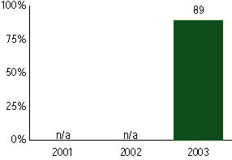

Texas Assessment of Knowledge and Skills, used for NCLB accountability
Grade 3

Mathematics
Proficient Level or above for:
All students | 89%
Economically disadvantaged students | 85
Migrant students | 84
Students with disabilities | 85
Students with limited English proficiency | 84
Black, non-Hispanic students | 82
Hispanic students | 87
White, non-Hispanic students | 96

Student achievement trend: Mathematics percent proficient level or above

Texas Assessment of Knowledge and Skills, used for NCLB accountability
Grade 4

Reading
Proficient Level or above for:
All students | 86%
Economically disadvantaged students | 78
Migrant students | 72
Students with disabilities | 79
Students with limited English proficiency | 70
Black, non-Hispanic students | 76
Hispanic students | 80
White, non-Hispanic students | 93

Student achievement trend: Reading percent proficient level or above

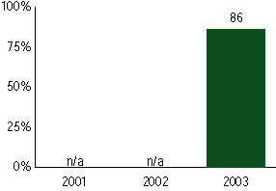

Texas Assessment of Knowledge and Skills, used for NCLB accountability
Grade 4

Mathematics
Proficient Level or above for:
All students | 87%
Economically disadvantaged students | 81
Migrant students | 77
Students with disabilities | 80
Students with limited English proficiency | 74
Black, non-Hispanic students | 78
Hispanic students | 83
White, non-Hispanic students | 94

Student achievement trend: Mathematics percent proficient level or above

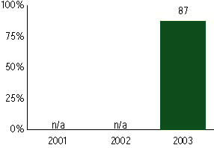

Texas Assessment of Knowledge and Skills, used for NCLB accountability
Grade 5

Reading
Proficient Level or above for:
All students | 79%
Economically disadvantaged students | 71
Migrant students | 65
Students with disabilities | 65
Students with limited English proficiency | 54
Black, non-Hispanic students | 69
Hispanic students | 73
White, non-Hispanic students | 89

Student achievement trend: Reading percent proficient level or above

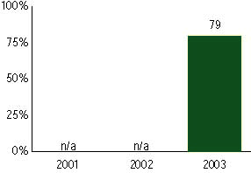

Texas Assessment of Knowledge and Skills, used for NCLB accountability
Grade 5

Mathematics
Proficient Level or above for:
All students | 86%
Economically disadvantaged students | 80
Migrant students | 76
Students with disabilities | 74
Students with limited English proficiency | 67
Black, non-Hispanic students | 74
Hispanic students | 82
White, non-Hispanic students | 93

Student achievement trend: Mathematics percent proficient level or above

Texas Assessment of Knowledge and Skills, used for NCLB accountability
Grade 6

Reading
Proficient Level or above for:
All students | 86%
Economically disadvantaged students | 78
Migrant students | 71
Students with disabilities | 73
Students with limited English proficiency | 52
Black, non-Hispanic students | 78
Hispanic students | 80
White, non-Hispanic students | 93

Student achievement trend: Reading percent proficient level or above

Texas Assessment of Knowledge and Skills, used for NCLB accountability
Grade 6

Mathematics
Proficient Level or above for:
All students | 78%
Economically disadvantaged students | 69
Migrant students | 64
Students with disabilities | 58
Students with limited English proficiency | 49
Black, non-Hispanic students | 66
Hispanic students | 72
White, non-Hispanic students | 88

Student achievement trend: Mathematics percent proficient level or above

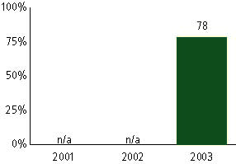

Texas Assessment of Knowledge and Skills, used for NCLB accountability
Grade 7

Reading
Proficient Level or above for:
All students | 87%
Economically disadvantaged students | 81
Migrant students | 75
Students with disabilities | 72
Students with limited English proficiency | 47
Black, non-Hispanic students | 82
Hispanic students | 82
White, non-Hispanic students | 94

Student achievement trend: Reading percent proficient level or above

Texas Assessment of Knowledge and Skills, used for NCLB accountability
Grade 7

Mathematics
Proficient Level or above for:
All students | 73%
Economically disadvantaged students | 61
Migrant students | 55
Students with disabilities | 48
Students with limited English proficiency | 35
Black, non-Hispanic students | 59
Hispanic students | 64
White, non-Hispanic students | 84

Student achievement trend: Mathematics percent proficient level or above

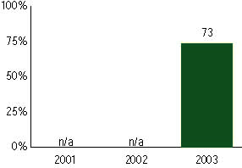

Texas Assessment of Knowledge and Skills, used for NCLB accountability
Grade 8

Reading
Proficient Level or above for:
All students | 88%
Economically disadvantaged students | 82
Migrant students | 75
Students with disabilities | 71
Students with limited English proficiency | 45
Black, non-Hispanic students | 82
Hispanic students | 83
White, non-Hispanic students | 94

Student achievement trend: Reading percent proficient level or above

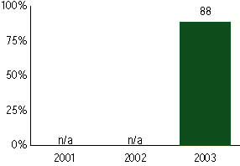

Texas Assessment of Knowledge and Skills, used for NCLB accountability
Grade 8

Mathematics
Proficient Level or above for:
All students | 73%
Economically disadvantaged students | 60
Migrant students | 54
Students with disabilities | 46
Students with limited English proficiency | 32
Black, non-Hispanic students | 57
Hispanic students | 63
White, non-Hispanic students | 84

Student achievement trend: Mathematics percent proficient level or above

Texas Assessment of Knowledge and Skills, used for NCLB accountability
High School

Reading
Proficient Level or above for:
All students | 81%
Economically disadvantaged students | 73
Migrant students | 63
Students with disabilities | 52
Students with limited English proficiency | 31
Black, non-Hispanic students | 76
Hispanic students | 73
White, non-Hispanic students | 91

Student achievement trend: Reading percent proficient level or above

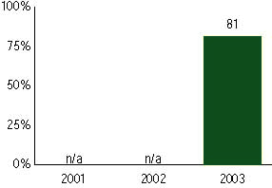

Texas Assessment of Knowledge and Skills, used for NCLB accountability
High School

Mathematics
Proficient Level or above for:
All students | 73%
Economically disadvantaged students | 61
Migrant students | 56
Students with disabilities | 39
Students with limited English proficiency | 43
Black, non-Hispanic students | 59
Hispanic students | 64
White, non-Hispanic students | 83

Student achievement trend: Mathematics percent proficient level or above

