North Carolina

http://www.ncpublicschools.org

Districts and schools

Number of districts (CCD) | 1993-94 | 2002-03
 | 121 | 117

Number of public schools (CCD) | 1993-94 | 2002-03
Elementary | 1,167 | 1,323
Middle | 407 | 464
High | 321 | 359
Combined | 29 | 95
Other | 28 | 4
Total | 1,952 | 2,245

Number of charter schools (CCD) | 2002-03
 | 93

Finances

Total current expenditures  (CCD, in thousands of dollars, adjusted for inflation to 2001-02) | 1993-94 | 2001-02
Instructional | $4,046,687 | $5,412,927
Noninstructional | 501,891 | 494,358
Support | 2,038,528 | 2,643,261
Total | 6,587,106 | 8,550,546

Per-pupil expenditures  (CCD, adjusted for inflation to 2001-02) | 1993-94 | 2001-02
 | $5,812 | $6,501

Sources of funding
(CCD, 2001-02)

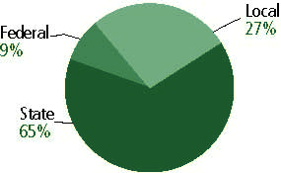

Title I allocation 2001-02 (ED; Includes Title I, Part A) | $214,422,710

Students

Public school enrollment (CCD) | 1993-94 | 2002-03
Pre-K | 8,469 | 10,310
K-8 | 798,816 | 953,657
9-12 | 305,060 | 371,987
Total (K-12) | 1,103,876 | 1,325,644

Race/ethnicity (CCD) | 1993-94 | 2002-03
American Indian/Alaskan Native | 2% | 1%
Asian/Pacific Islander | 1 | 2
Black, non-Hispanic | 30 | 31
Hispanic | 1 | 6
White, non-Hispanic | 66 | 59

Students with disabilities (OSEP) | 1993-94 | 2002-03
 | 11% | 12%

Students with limited  English proficiency (NCELA) | 1993-94 | 2002-03
 | 1% | 5%

Migrant students (OME) | 1993-94 | 2002-03
 | 1% | 2%

Eighth-grade students enrolled in Algebra I for high school credit (NAEP) | 1996 | 2003
 | 29% | 29%

Students eligible to participate in the Free or Reduced-Price Lunch Program, 2002-03 (CCD) | 452,486

All schools by percent of students eligible to participate in the Free or Reduced-Price Lunch Program, 2002-03 (CCD)

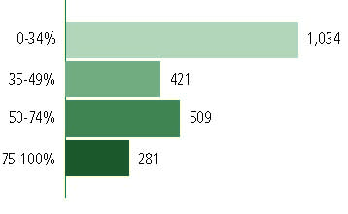
† 2 schools did not report

Staff

Number of FTE teachers (CCD) | 1993-94 | 2002-03
Elementary | 33,841 | 44,233
Middle | 15,990 | 17,507
High | 18,559 | 23,926
Combined | 778 | 1,877
Other | 253 | 134
Total | 69,421 | 87,677

Number of FTE non-teacher staff (CCD) | 1993-94 | 2002-03
Instructional aides | 20,721 | 27,476
Instructional coordinators | 767 | 889
Administrators | 5,228 | 6,288
Other | 36,922 | 46,998
Total | 63,638 | 81,651

Percentage of teachers with a major in the main subject taught, grades 7-12 (SASS) | 1994 | 2000
English | 87% | 81%
Mathematics | 79 | 64
Science | 73 | 75
Social Studies | 88 | 93

Percentage of core courses taught by highly qualified teachers, 2002-03
(As defined and reported by states, collected by ED)

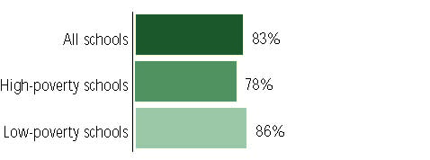

Outcomes

 | 1993-94 | 2000-01
High school dropout rate (NCES) | n/a | 6%
Averaged freshman graduation rate (NCES) | 70% | 67
College-going rate (IPEDS/NCES) | 51 | 65

NAEP state results
Reading, Grade 4 | 1994 | 2003
Proficient level or above | 30% | 32%
Basic level or above | 59 | 65
Math, Grade 8 | 1996 | 2003
Proficient level or above | 20% | 32%
Basic level or above | 56 | 71

Statewide Accountability Information:

State Accountability Website: http://www.ncreportcards.org/src/stateDetails.jsp?Page=1&pYear=2003-2004

State assessment for NCLB accountability: End-of-Grade Mathematics/Reading

State student achievement levels: Level I, Level II, Level III, Level IV

 |  | 2001-02  Annual measurable  objective starting point | Target  2002-03
Grade 4 | Reading | 68.9% | 68.9%
 | Mathematics | 74.6 | 74.6
Grade 8 | Reading | 68.9 | 68.9
 | Mathematics | 74.6 | 74.6
High school | Reading | 52 | 52
 | Mathematics | 54.9 | 54.9

AYP outcomes and consequences* | Title I schools |  | All schools |  | All districts
Made AYP | 617 | 55% | 1,031 | 47% | 2 | 2%
Identified for improvement:
Year 1 | 36 | 3% | 1,195 | 53% | 115 | 54%
Year 2 | 0 | 0 | 0 | 0 | 0 | 0
Corrective action | 0 | 0 | 0 | 0 | 0 | 0
Restructuring | 0 | 0 | 0 | 0 | 0 | 0
Exited improvement status (made AYP twice after missing twice or more, includes total “made” above) | n/a | n/a | n/a | n/a | n/a | n/a
*AYP outcomes for this state are not available due to issues with data collection, measurement, or other reasons. For more information, please visit the state’s Web site, above.

Other indicator, 2002-03 | State target | State outcome
Elementary Indicator: Attendance | Meet or at least .1% progress toward 90% | Met
Middle Indicator: Attendance | Meet or at least .1% progress toward 90% | Met
High School Indicator: Graduation rate | Meet or at least .1% progress toward 90%. | Met

NCLB choice participation | Number of Title I students | Percent of Eligible Students
Title I school choice | 337 | *
Supplemental educational services | 362 | *

Student Achievement 2002-03

End-of-Grade/Course Tests, used for NCLB accountability
Grade 3

Reading
Proficient Level or above for:
All students | 80%
Economically disadvantaged students | 69
Migrant students | 59
Students with disabilities | 48
Students with limited English proficiency | 53
Black, non-Hispanic students | 69
Hispanic students | 64
White, non-Hispanic students | 88

Student achievement trend: Reading percent proficient level or above

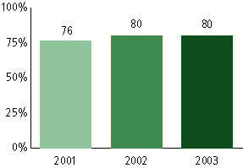

End-of-Grade/Course Tests, used for NCLB accountability
Grade 3

Mathematics
Proficient Level or above for:
All students | 87%
Economically disadvantaged students | 79
Migrant students | 75
Students with disabilities | 63
Students with limited English proficiency | 71
Black, non-Hispanic students | 77
Hispanic students | 78
White, non-Hispanic students | 93

Student achievement trend: Mathematics percent proficient level or above

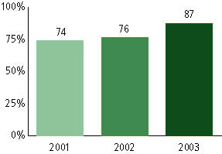

End-of-Grade/Course Tests, used for NCLB accountability
Grade 4

Reading
Proficient Level or above for:
All students | 81%
Economically disadvantaged students | 70
Migrant students | 60
Students with disabilities | 48
Students with limited English proficiency | 48
Black, non-Hispanic students | 71
Hispanic students | 64
White, non-Hispanic students | 89

Student achievement trend: Reading percent proficient level or above

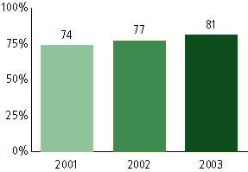

End-of-Grade/Course Tests, used for NCLB accountability
Grade 4

Mathematics
Proficient Level or above for:
All students | 92%
Economically disadvantaged students | 87
Migrant students | 80
Students with disabilities | 71
Students with limited English proficiency | 72
Black, non-Hispanic students | 87
Hispanic students | 82
White, non-Hispanic students | 95

Student achievement trend: Mathematics percent proficient level or above

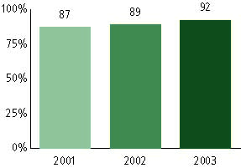

End-of-Grade/Course Tests, used for NCLB accountability
Grade 5

Reading
Proficient Level or above for:
All students | 86%
Economically disadvantaged students | 77
Migrant students | 67
Students with disabilities | 54
Students with limited English proficiency | 52
Black, non-Hispanic students | 77
Hispanic students | 71
White, non-Hispanic students | 92

Student achievement trend: Reading percent proficient level or above

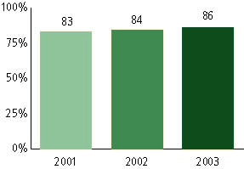

End-of-Grade/Course Tests, used for NCLB accountability
Grade 5

Mathematics
Proficient Level or above for:
All students | 90%
Economically disadvantaged students | 84
Migrant students | 77
Students with disabilities | 66
Students with limited English proficiency | 67
Black, non-Hispanic students | 83
Hispanic students | 80
White, non-Hispanic students | 95

Student achievement trend: Mathematics percent proficient level or above

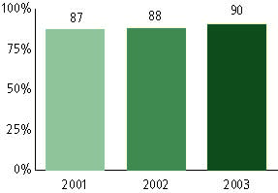

End-of-Grade/Course Tests, used for NCLB accountability
Grade 6

Reading
Proficient Level or above for:
All students | 79%
Economically disadvantaged students | 67
Migrant students | 56
Students with disabilities | 41
Students with limited English proficiency | 38
Black, non-Hispanic students | 66
Hispanic students | 61
White, non-Hispanic students | 88

Student achievement trend: Reading percent proficient level or above

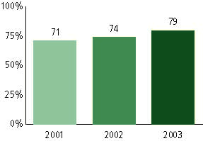

End-of-Grade/Course Tests, used for NCLB accountability
Grade 6

Mathematics
Proficient Level or above for:
All students | 88%
Economically disadvantaged students | 80
Migrant students | 76
Students with disabilities | 58
Students with limited English proficiency | 60
Black, non-Hispanic students | 79
Hispanic students | 76
White, non-Hispanic students | 94

Student achievement trend: Mathematics percent proficient level or above

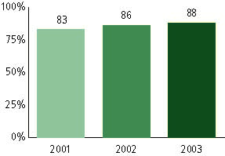

End-of-Grade/Course Tests, used for NCLB accountability
Grade 7

Reading
Proficient Level or above for:
All students | 83%
Economically disadvantaged students | 72
Migrant students | 57
Students with disabilities | 46
Students with limited English proficiency | 41
Black, non-Hispanic students | 73
Hispanic students | 63
White, non-Hispanic students | 90

Student achievement trend: Reading percent proficient level or above

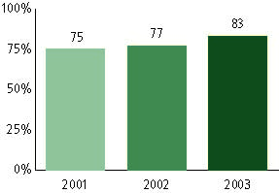

End-of-Grade/Course Tests, used for NCLB accountability
Grade 7

Mathematics
Proficient Level or above for:
All students | 82%
Economically disadvantaged students | 70
Migrant students | 58
Students with disabilities | 46
Students with limited English proficiency | 48
Black, non-Hispanic students | 69
Hispanic students | 66
White, non-Hispanic students | 90

Student achievement trend: Mathematics percent proficient level or above

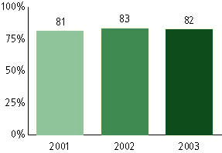

End-of-Grade/Course Tests, used for NCLB accountability
Grade 8

Reading
Proficient Level or above for:
All students | 86%
Economically disadvantaged students | 74
Migrant students | 57
Students with disabilities | 50
Students with limited English proficiency | 41
Black, non-Hispanic students | 76
Hispanic students | 65
White, non-Hispanic students | 92

Student achievement trend: Reading percent proficient level or above

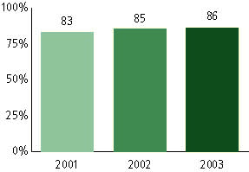

End-of-Grade/Course Tests, used for NCLB accountability
Grade 8

Mathematics
Proficient Level or above for:
All students | 82%
Economically disadvantaged students | 70
Migrant students | 64
Students with disabilities | 46
Students with limited English proficiency | 52
Black, non-Hispanic students | 69
Hispanic students | 68
White, non-Hispanic students | 90

Student achievement trend: Mathematics percent proficient level or above

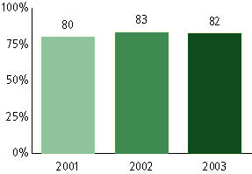

End-of-Grade/Course Tests, used for NCLB accountability
High School

Reading
Proficient Level or above for:
All students | 64%
Economically disadvantaged students | 43
Migrant students | 27
Students with disabilities | 21
Students with limited English proficiency | 25
Black, non-Hispanic students | 43
Hispanic students | 44
White, non-Hispanic students | 75

Student achievement trend: Reading percent proficient level or above

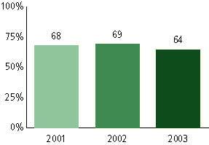

End-of-Grade/Course Tests, used for NCLB accountability
High School

Mathematics
Proficient Level or above for:
All students | 69%
Economically disadvantaged students | 50
Migrant students | 44
Students with disabilities | 26
Students with limited English proficiency | 41
Black, non-Hispanic students | 48
Hispanic students | 53
White, non-Hispanic students | 79

Student achievement trend: Mathematics percent proficient level or above

