Missouri

http://services.dese.state.mo.us

Districts and schools

Number of districts (CCD) | 1993-94 | 2002-03
 | 541 | 524

Number of public schools (CCD) | 1993-94 | 2002-03
Elementary | 1,176 | 1,253
Middle | 314 | 375
High | 482 | 495
Combined | 26 | 115
Other | 23 | 48
Total | 2,021 | 2,286

Number of charter schools (CCD) | 2002-03
 | 25

Finances

Total current expenditures  (CCD, in thousands of dollars, adjusted for inflation to 2001-02) | 1993-94 | 2001-02
Instructional | $3,092,460 | $3,954,002
Noninstructional | 225,296 | 288,301
Support | 1,779,459 | 2,249,300
Total | 5,097,216 | 6,491,603

Per-pupil expenditures  (CCD, adjusted for inflation to 2001-02) | 1993-94 | 2001-02
 | $5,821 | $7,135

Sources of funding
(CCD, 2001-02)

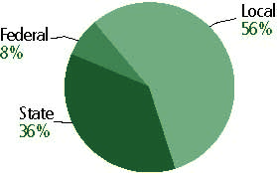

Title I allocation 2001-02 (ED; Includes Title I, Part A) | $163,743,528

Students

Public school enrollment (CCD) | 1993-94 | 2002-03
Pre-K | 23,597 | 28,614
K-8 | 601,691 | 622,524
9-12 | 241,874 | 269,997
Total (K-12) | 843,565 | 892,521

Race/ethnicity (CCD) | 1993-94 | 2002-03
American Indian/Alaskan Native | *% | *%
Asian/Pacific Islander | 1 | 1
Black, non-Hispanic | 16 | 18
Hispanic | 1 | 2
White, non-Hispanic | 82 | 78

Students with disabilities (OSEP) | 1993-94 | 2002-03
 | 11% | 13%

Students with limited  English proficiency (NCELA) | 1993-94 | 2002-03
 | 1% | 1%

Migrant students (OME) | 1993-94 | 2002-03
 | * | 1%

Eighth-grade students enrolled in Algebra I for high school credit (NAEP) | 1996 | 2003
 | 27% | 26%

Students eligible to participate in the Free or Reduced-Price Lunch Program, 2002-03 (CCD) | 333,964

All schools by percent of students eligible to participate in the Free or Reduced-Price Lunch Program, 2002-03 (CCD)

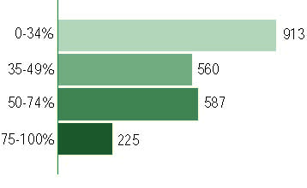
† 1 school did not report

Staff

Number of FTE teachers (CCD) | 1993-94 | 2002-03
Elementary | 26,009 | 31,266
Middle | 9,764 | 12,614
High | 14,939 | 17,666
Combined | 375 | 2,617
Other | n/a | n/a
Total | 51,087 | 64,163

Number of FTE non-teacher staff (CCD) | 1993-94 | 2002-03
Instructional aides | 6,430 | 11,884
Instructional coordinators | 1,256 | 1,057
Administrators | 3,048 | 4,411
Other | 46,481 | 44,055
Total | 57,215 | 61,407

Percentage of teachers with a major in the main subject taught, grades 7-12 (SASS) | 1994 | 2000
English | 81% | 64%
Mathematics | 89 | 52
Science | 70 | 70
Social Studies | 84 | 80

Percentage of core courses taught by highly qualified teachers, 2002-03
(As defined and reported by states, collected by ED)

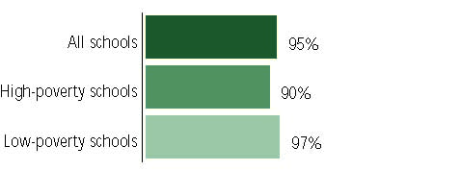

Outcomes

 | 1993-94 | 2000-01
High school dropout rate (NCES) | 7% | 4%
Averaged freshman graduation rate (NCES) | 77 | 75
College-going rate (IPEDS/NCES) | 51 | 53

NAEP state results
Reading, Grade 4 | 1994 | 2003
Proficient level or above | 31% | 34%
Basic level or above | 62 | 68
Math, Grade 8 | 1996 | 2003
Proficient level or above | 22% | 28%
Basic level or above | 64 | 71

Statewide Accountability Information:

State Accountability Website:
http://dese.mo.gov/commissioner/statereportcard/

State assessment for NCLB accountability: Missouri Assessment Program (MAP)

State student achievement levels: Step One, Progressing, Nearing Proficient, Proficient, Advanced

 |  | 2001-02  Annual measurable  objective starting point | Target  2002-03
Grade 4 | Communication arts | 18.4% | 19.4%
 | Mathematics | 8.3 | 9.3
Grade 7 | Communication arts | 18.4 | 19.4
 | Mathematics | 8.3 | 9.3
High School | Communication arts | 18.4 | 19.4
 | Mathematics | 8.3 | 9.3

AYP outcomes and consequences* | Title I schools |  | All schools |  | All districts
Made AYP | 735 | 63% | 1,056 | 51% | 220 | 42%
Identified for improvement:
Year 1 | 32 | 3% | 32 | 1% | 0 | 0
Year 2 | 0 | 0 | 0 | 0 | 0 | 0
Corrective action | 0 | 0 | 0 | 0 | 0 | 0
Restructuring | 0 | 0 | 0 | 0 | 0 | 0
Exited improvement status (made AYP twice after missing twice or more, includes total “made” above) | n/a | n/a | n/a | n/a | n/a | n/a
*AYP outcomes for this state are not available due to issues with data collection, measurement, or other reasons. For more information, please visit the state’s Web site, above.

Other indicator, 2002-03 | State target | State outcome
Elementary Indicator: Attendance | Meet or progress toward 95% | Met
Middle Indicator: Attendance | Meet or progress toward 95% | Met
High School Indicator: Graduation rate | n/a | n/a
Note: Other indicator was not applied to AYP decisions in 2002-03, except in the case of safe harbor.

NCLB choice participation | Number of Title I students | Percent of Eligible Students
Title I school choice | n/a | -
Supplemental educational services | 992 | 1%

Student Achievement 2002-03

Missouri Assessment Program, used for NCLB accountability
Grade 3

Communication Arts
Proficient Level or above for:
All students | 34%
Economically disadvantaged students | 22
Migrant students | 23
Students with disabilities | 18
Students with limited English proficiency | 14
Black, non-Hispanic students | 16
Hispanic students | 22
White, non-Hispanic students | 39

Student achievement trend: Communication Arts percent proficient level or above

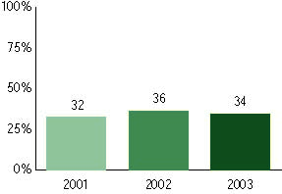

Missouri Assessment Program, used for NCLB accountability
Grade 3

Mathematics
Proficient Level or above for:
All students | n/a
Economically disadvantaged students | n/a
Migrant students | n/a
Students with disabilities | n/a
Students with limited English proficiency | n/a
Black, non-Hispanic students | n/a
Hispanic students | n/a
White, non-Hispanic students | n/a

Trend Data Not Available

Missouri Assessment Program, used for NCLB accountability
Grade 4

Communication Arts
Proficient Level or above for:
All students | n/a
Economically disadvantaged students | n/a
Migrant students | n/a
Students with disabilities | n/a
Students with limited English proficiency | n/a
Black, non-Hispanic students | n/a
Hispanic students | n/a
White, non-Hispanic students | n/a

Trend Data Not Available

Missouri Assessment Program, used for NCLB accountability
Grade 4

Mathematics
Proficient Level or above for:
All students | 37%
Economically disadvantaged students | 24
Migrant students | 21
Students with disabilities | 20
Students with limited English proficiency | 21
Black, non-Hispanic students | 18
Hispanic students | 27
White, non-Hispanic students | 42

Student achievement trend: Mathematics percent proficient level or above

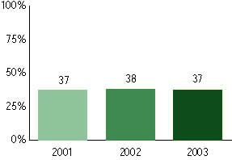

Missouri Assessment Program, used for NCLB accountability
Grade 5

Communication Arts
Proficient Level or above for:
All students | n/a
Economically disadvantaged students | n/a
Migrant students | n/a
Students with disabilities | n/a
Students with limited English proficiency | n/a
Black, non-Hispanic students | n/a
Hispanic students | n/a
White, non-Hispanic students | n/a

Trend Data Not Available

Missouri Assessment Program, used for NCLB accountability
Grade 5

Mathematics
Proficient Level or above for:
All students | n/a
Economically disadvantaged students | n/a
Migrant students | n/a
Students with disabilities | n/a
Students with limited English proficiency | n/a
Black, non-Hispanic students | n/a
Hispanic students | n/a
White, non-Hispanic students | n/a

Trend Data Not Available

Missouri Assessment Program, used for NCLB accountability
Grade 6

Communication Arts
Proficient Level or above for:
All students | n/a
Economically disadvantaged students | n/a
Migrant students | n/a
Students with disabilities | n/a
Students with limited English proficiency | n/a
Black, non-Hispanic students | n/a
Hispanic students | n/a
White, non-Hispanic students | n/a

Trend Data Not Available

Missouri Assessment Program, used for NCLB accountability
Grade 6

Mathematics
Proficient Level or above for:
All students | n/a
Economically disadvantaged students | n/a
Migrant students | n/a
Students with disabilities | n/a
Students with limited English proficiency | n/a
Black, non-Hispanic students | n/a
Hispanic students | n/a
White, non-Hispanic students | n/a

Trend Data Not Available

Missouri Assessment Program, used for NCLB accountability
Grade 7

Communication Arts
Proficient Level or above for:
All students | 32%
Economically disadvantaged students | 18
Migrant students | 7
Students with disabilities | 6
Students with limited English proficiency | 9
Black, non-Hispanic students | 11
Hispanic students | 25
White, non-Hispanic students | 37

Student achievement trend: Communication Arts percent proficient level or above

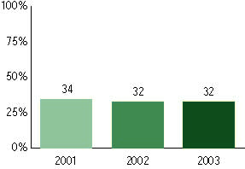

Missouri Assessment Program, used for NCLB accountability
Grade 7

Mathematics
Proficient Level or above for:
All students | n/a
Economically disadvantaged students | n/a
Migrant students | n/a
Students with disabilities | n/a
Students with limited English proficiency | n/a
Black, non-Hispanic students | n/a
Hispanic students | n/a
White, non-Hispanic students | n/a

Trend Data Not Available

Missouri Assessment Program, used for NCLB accountability
Grade 8

Communication Arts
Proficient Level or above for:
All students | n/a
Economically disadvantaged students | n/a
Migrant students | n/a
Students with disabilities | n/a
Students with limited English proficiency | n/a
Black, non-Hispanic students | n/a
Hispanic students | n/a
White, non-Hispanic students | n/a

Trend Data Not Available

Missouri Assessment Program, used for NCLB accountability
Grade 8

Mathematics
Proficient Level or above for:
All students | 14%
Economically disadvantaged students | 6
Migrant students | 6
Students with disabilities | <5
Students with limited English proficiency | 13
Black, non-Hispanic students | <5
Hispanic students | 8
White, non-Hispanic students | 16

Student achievement trend: Mathematics percent proficient level or above

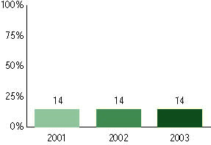

Missouri Assessment Program, used for NCLB accountability
High School

Communication Arts
Proficient Level or above for:
All students | 22%
Economically disadvantaged students | 10
Migrant students | 5
Students with disabilities | <5
Students with limited English proficiency | <5
Black, non-Hispanic students | 6
Hispanic students | 14
White, non-Hispanic students | 24

Student achievement trend: Communication Arts percent proficient level or above

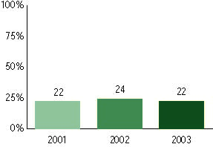

Missouri Assessment Program, used for NCLB accountability
High School

Mathematics
Proficient Level or above for:
All students | 12%
Economically disadvantaged students | <5
Migrant students | 7
Students with disabilities | <5
Students with limited English proficiency | <5
Black, non-Hispanic students | <5
Hispanic students | 8
White, non-Hispanic students | 14

Student achievement trend: Mathematics percent proficient level or above

