Maine

http://www.state.me.us/education

Districts and schools

Number of districts (CCD) | 1993-94 | 2002-03
 | 226 | 282

Number of public schools (CCD) | 1993-94 | 2002-03
Elementary | 455 | 418
Middle | 125 | 126
High | 106 | 111
Combined | 14 | 16
Other | 2 | 1
Total | 702 | 672

Number of charter schools (CCD) | 2002-03
 | n/a

Finances

Total current expenditures  (CCD, in thousands of dollars, adjusted for inflation to 2001-02) | 1993-94 | 2001-02
Instructional | $1,035,170 | $1,208,176
Noninstructional | 56,523 | 60,634
Support | 455,300 | 543,988
Total | 1,546,933 | 1,812,798

Per-pupil expenditures  (CCD, adjusted for inflation to 2001-02) | 1993-94 | 2001-02
 | $7,129 | $8,818

Sources of funding
(CCD, 2001-02)

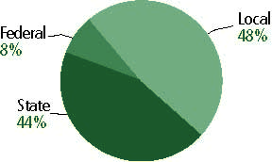

Title I allocation 2001-02 (ED; Includes Title I, Part A) | $37,942,178

Students

Public school enrollment (CCD) | 1993-94 | 2002-03
Pre-K | 1,036 | 1,503
K-8 | 152,981 | 138,124
9-12 | 59,632 | 61,873
Total (K-12) | 212,613 | 199,997

Race/ethnicity (CCD) | 1993-94 | 2002-03
American Indian/Alaskan Native | n/a | 1%
Asian/Pacific Islander | n/a | 1
Black, non-Hispanic | n/a | 2
Hispanic | n/a | 1
White, non-Hispanic | n/a | 96

Students with disabilities (OSEP) | 1993-94 | 2002-03
 | 12% | 16%

Students with limited  English proficiency (NCELA) | 1993-94 | 2002-03
 | 1% | 1%

Migrant students (OME) | 1993-94 | 2002-03
 | 4% | 5%

Eighth-grade students enrolled in Algebra I for high school credit (NAEP) | 1996 | 2003
 | 25% | 21%

Students eligible to participate in the Free or Reduced-Price Lunch Program, 2002-03 (CCD) | 62,047

All schools by percent of students eligible to participate in the Free or Reduced-Price Lunch Program, 2002-03† (CCD)

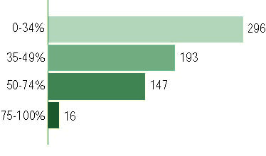
† 20 schools did not report
Staff

Number of FTE teachers (CCD) | 1993-94 | 2002-03
Elementary | 6,658 | 6,964
Middle | 2,835 | 3,462
High | 3,822 | 4,475
Combined | 329 | 364
Other | 1,700 | 1,572
Total | 15,344 | 16,837

Number of FTE non-teacher staff (CCD) | 1993-94 | 2002-03
Instructional aides | 3,452 | 5,903
Instructional coordinators | 118 | 218
Administrators | 1,287 | 1,493
Other | 8,664 | 10,127
Total | 13,521 | 17,741

Percentage of teachers with a major in the main subject taught, grades 7-12 (SASS) | 1994 | 2000
English | 81% | 71%
Mathematics | 68 | 64
Science | 67 | 63
Social Studies | 72 | 56

Percentage of core courses taught by highly qualified teachers, 2002-03
(As defined and reported by states, collected by ED)

Not available

Outcomes

 | 1993-94 | 2000-01
High school dropout rate (NCES) | 3% | 3%
Avg. freshman graduation rate (NCES) | 75 | 76
College-going rate (IPEDS/NCES) | 50 | 54

NAEP state results
Reading, Grade 4 | 1994 | 2003
Proficient level or above | 41% | 36%
Basic level or above | 75 | 71
Math, Grade 8 | 1996 | 2003
Proficient level or above | 31% | 29%
Basic level or above | 77 | 74

Statewide Accountability Information:

State Accountability Website:
http://www.state.me.us/education/profiles/getprofiles.htm

State assessment for NCLB accountability: Maine Educational Assessment (MEA)

State student achievement levels: Does Not Meet the Standard, Partially Meets the Standard, Meets the Standard, Exceeds the Standard

 |  | 2001-02  Annual measurable  objective starting point | Target  2002-03
Grade 4 | Reading | 34% | 34%
 | Mathematics | 12 | 12
Grade 8 | Reading | 35 | 35
 | Mathematics | 13 | 13
High School | Reading | 44 | 44
 | Mathematics | 11 | 11

AYP outcomes and consequences * | Title I schools |  | All schools |  | All districts
Made AYP | n/a | n/a | n/a | n/a | n/a | n/a
Identified for improvement:
Year 1 | 6 | * | 10 | 1% | 0 | 0
Year 2 | 0 | 0 | 0 | 0 | 0 | 0
Corrective action | 0 | 0 | 0 | 0 | 0 | 0
Restructuring | 0 | 0 | 0 | 0 | 0 | 0
Exited improvement status (made AYP twice after missing twice or more, includes total “made” above) | 0 | 0 | 0 | 0 | 0 | 0
*AYP outcomes for this state are not available due to issues with data collection, measurement, or other reasons. For more information, please visit the state’s Web site, above.

Other indicator, 2002-03 | State target | State outcome
Elementary indicator: Attendance | Meet or progress toward 96%. | Met
Middle indicator: Attendance | Meet or progress toward 96%. | Met
High school indicator: Graduation rate | n/a | n/a

NCLB choice participation | Number of Title I students | Percent of Eligible Students
Title I school choice: | 0 | -
Supplemental educational services: | 0 | -

Student Achievement 2002-03

Maine Educational Assessment, used for NCLB accountability
Grade 3

Reading
Proficient Level or above for:
All students | n/a
Economically disadvantaged students | n/a
Migrant students | n/a
Students with disabilities | n/a
Students with limited English proficiency | n/a
Black, non-Hispanic students | n/a
Hispanic students | n/a
White, non-Hispanic students | n/a

Trend Data Not Available

Maine Educational Assessment, used for NCLB accountability
Grade 3

Mathematics
Proficient Level or above for:
All students | n/a
Economically disadvantaged students | n/a
Migrant students | n/a
Students with disabilities | n/a
Students with limited English proficiency | n/a
Black, non-Hispanic students | n/a
Hispanic students | n/a
White, non-Hispanic students | n/a

Trend Data Not Available

Maine Educational Assessment, used for NCLB accountability
Grade 4

Reading
Proficient Level or above for:
All students | 49%
Economically disadvantaged students | 39
Migrant students | n/a
Students with disabilities | 10
Students with limited English proficiency | 29
Black, non-Hispanic students | 30
Hispanic students | 40
White, non-Hispanic students | 50

Student achievement trend: Reading percent proficient level or above

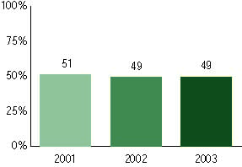

Maine Educational Assessment, used for NCLB accountability
Grade 4

Mathematics
Proficient Level or above for:
All students | 28%
Economically disadvantaged students | 20
Migrant students | 20
Students with disabilities | 8
Students with limited English proficiency | 18
Black, non-Hispanic students | 7
Hispanic students | 22
White, non-Hispanic students | 29

Student achievement trend: Mathematics percent proficient level or above

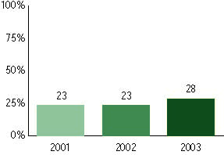

Maine Educational Assessment, used for NCLB accountability
Grade 5

Reading
Proficient Level or above for:
All students | n/a
Economically disadvantaged students | n/a
Migrant students | n/a
Students with disabilities | n/a
Students with limited English proficiency | n/a
Black, non-Hispanic students | n/a
Hispanic students | n/a
White, non-Hispanic students | n/a

Trend Data Not Available

Maine Educational Assessment, used for NCLB accountability
Grade 5

Mathematics
Proficient Level or above for:
All students | n/a
Economically disadvantaged students | n/a
Migrant students | n/a
Students with disabilities | n/a
Students with limited English proficiency | n/a
Black, non-Hispanic students | n/a
Hispanic students | n/a
White, non-Hispanic students | n/a

Trend Data Not Available

Maine Educational Assessment, used for NCLB accountability
Grade 6

Reading
Proficient Level or above for:
All students | n/a
Economically disadvantaged students | n/a
Migrant students | n/a
Students with disabilities | n/a
Students with limited English proficiency | n/a
Black, non-Hispanic students | n/a
Hispanic students | n/a
White, non-Hispanic students | n/a

Trend Data Not Available

Maine Educational Assessment, used for NCLB accountability
Grade 6

Mathematics
Proficient Level or above for:
All students | n/a
Economically disadvantaged students | n/a
Migrant students | n/a
Students with disabilities | n/a
Students with limited English proficiency | n/a
Black, non-Hispanic students | n/a
Hispanic students | n/a
White, non-Hispanic students | n/a

Trend Data Not Available

Maine Educational Assessment, used for NCLB accountability
Grade 7

Reading
Proficient Level or above for:
All students | n/a
Economically disadvantaged students | n/a
Migrant students | n/a
Students with disabilities | n/a
Students with limited English proficiency | n/a
Black, non-Hispanic students | n/a
Hispanic students | n/a
White, non-Hispanic students | n/a

Trend Data Not Available

Maine Educational Assessment, used for NCLB accountability
Grade 7

Mathematics
Proficient Level or above for:
All students | n/a
Economically disadvantaged students | n/a
Migrant students | n/a
Students with disabilities | n/a
Students with limited English proficiency | n/a
Black, non-Hispanic students | n/a
Hispanic students | n/a
White, non-Hispanic students | n/a

Trend Data Not Available

Maine Educational Assessment, used for NCLB accountability
Grade 8

Reading
Proficient Level or above for:
All students | 45%
Economically disadvantaged students | 27
Migrant students | 25
Students with disabilities | 7
Students with limited English proficiency | 18
Black, non-Hispanic students | 26
Hispanic students | 41
White, non-Hispanic students | 45

Student achievement trend: Reading percent proficient level or above

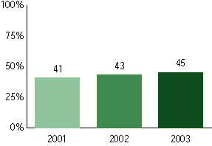

Maine Educational Assessment, used for NCLB accountability
Grade 8

Mathematics
Proficient Level or above for:
All students | 18%
Economically disadvantaged students | 9
Migrant students | 7
Students with disabilities | <5
Students with limited English proficiency | 12
Black, non-Hispanic students | 6
Hispanic students | 10
White, non-Hispanic students | 18

Student achievement trend: Mathematics percent proficient level or above

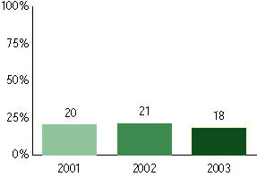

Maine Educational Assessment, used for NCLB accountability
High school

Reading
Proficient Level or above for:
All students | 46%
Economically disadvantaged students | 25
Migrant students | 16
Students with disabilities | 5
Students with limited English proficiency | 12
Black, non-Hispanic students | 22
Hispanic students | 29
White, non-Hispanic students | 47

Student achievement trend: Reading percent proficient level or above

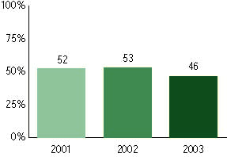

Maine Educational Assessment, used for NCLB accountability
High school

Mathematics
Proficient Level or above for:
All students | 20%
Economically disadvantaged students | 8
Migrant students | <5
Students with disabilities | <5
Students with limited English proficiency | <5
Black, non-Hispanic students | 65
Hispanic students | 10
White, non-Hispanic students | 20

Student achievement trend: Mathematics percent proficient level or above

