Alabama

http://www.alsde.edu

Districts and schools

Number of districts (CCD) | 1993-94 | 2002-03
 | 127 | 129

Number of public schools (CCD) | 1993-94 | 2002-03
Elementary | 664 | 710
Middle | 218 | 231
High | 246 | 274
Combined | 155 | 167
Other | 11 | 9
Total | 1,294 | 1,391

Number of charter schools (CCD) | 2002-03
 | n/a

Finances

Total current expenditures  (CCD, in thousands of dollars, adjusted for inflation to 2001-02) | 1993-94 | 2001-02
Instructional | $2,249,389 | $2,721,721
Noninstructional | 284,407 | 307,556
Support | 935,139 | 1,415,114
Total | 3,468,935 | 4,444,391

Per-pupil expenditures  (CCD, adjusted for inflation to 2001-02) | 1993-94 | 2001-02
 | $4,898 | $6,029

Sources of funding
(CCD, 2001-02)

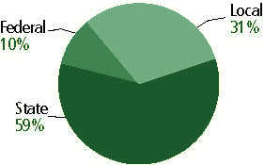

Title I allocation 2001-02 (ED; Includes Title I, Part A) | $154,938,816

Students

Public school enrollment (CCD) | 1993-94 | 2002-03
Pre-K | 8,445 | n/a
K-8 | 527,373 | 523,594
9-12 | 198,651 | 203,117
Total (K-12) | 726,024 | 726,711

Race/ethnicity (CCD) | 1993-94 | 2002-03
American Indian/Alaskan Native | 1% | 1%
Asian/Pacific Islander | 1 | 1
Black, non-Hispanic | 36 | 36
Hispanic | * | 2
White, non-Hispanic | 62 | 60

Students with disabilities (OSEP) | 1993-94 | 2002-03
 | 12% | 11%

Students with limited  English proficiency (NCELA) | 1993-94 | 2002-03
 | * | 1%

Migrant students (OME) | 1993-94 | 2002-03
 | 1% | 1%

Eighth-grade students enrolled in Algebra I for high school credit (NAEP) | 1996 | 2003
 | 20% | 17%

Students eligible to participate in the Free or Reduced-Price Lunch Program, 2002-03 (CCD) | 364,226

All schools by percent of students eligible to participate in the Free or Reduced-Price Lunch Program, 2002-03† (CCD)

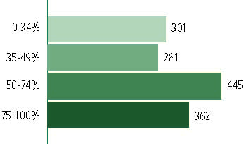

† 2 schools did not report
Staff

Number of FTE teachers (CCD) | 1993-94 | 2002-03
Elementary | 18,619 | 21,325
Middle | 6,474 | 7,436
High | 9,699 | 10,962
Combined | 5,898 | 5,455
Other | 2,312 | 1,927
Total | 43,002 | 47,104

Number of FTE non-teacher staff (CCD) | 1993-94 | 2002-03
Instructional aides | 3,897 | 6,169
Instructional coordinators | 393 | 667
Administrators | 2,384 | 4,697
Other | 31,246 | 30,245
Total | 37,920 | 41,778

Percentage of teachers with a major in the main subject taught, grades 7-12 (SASS) | 1994 | 2000
English | 75% | 63%
Mathematics | 89 | 83
Science | 73 | 78
Social Studies | 80 | 69

Percentage of core courses taught by highly qualified teachers, 2002-03 (As defined and reported by states, collected by ED)

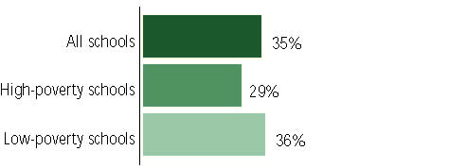

Outcomes

 | 1993-94 | 2000-01
High school dropout rate (NCES) | 6% | 4%
Averaged freshman graduation rate (NCES) | 64 | 64
College-going rate (IPEDS/NCES) | 64 | 58

NAEP state results
Reading, Grade 4 | 1994 | 2003
Proficient level or above | 23% | 23%
Basic level or above | 52 | 53
Math, Grade 8 | 1996 | 2003
Proficient level or above | 12% | 16%
Basic level or above | 45 | 53

Statewide Accountability Information:

State Accountability Website: http://www.alsde.edu/html/reports1.asp?systemcode=000&schoolcode=0000

State assessment for NCLB accountability: n/a

State student achievement levels: n/a

 |  | 2001-02  Annual measurable  objective starting point | Target  2002-03
Grade 4 | Reading/language arts | - | -
 | Mathematics | - | -
Grade 8 | Reading/language arts | - | -
 | Mathematics | - | -
Grade - | - | - | -
 | - | - | -

AYP outcomes and consequences* | Title I schools |  | All schools |  | All districts
Made AYP | n/a | n/a | n/a | n/a | n/a | n/a
Identified for improvement:
Year 1 | n/a | n/a | n/a | n/a | n/a | n/a
Year 2 | n/a | n/a | n/a | n/a | n/a | n/a
Corrective action | n/a | n/a | n/a | n/a | n/a | n/a
Restructuring | n/a | n/a | n/a | n/a | n/a | n/a
Exited improvement status (made AYP twice after missing twice or more, includes total “made” above) | n/a | n/a | n/a | n/a | n/a | n/a
*AYP outcomes for this state are not available due to issues with data collection, measurement, or other reasons. For more information, please visit the state’s Web site, above.

Other indicator, 2002-03 | State target | State outcome
Elementary indicator: Attendance | - | -
Middle indicator: Attendance | - | -
High school indicator: Graduation rate | - | -

NCLB choice participation | Number of Title I students | Percent of Eligible Students
Title I school choice | 836 | *
Supplemental educational services | 726 | 1%

Student Achievement 2002-03

Stanford 10, not used for NCLB accountability in 2002-03
Grade 3

Reading
Proficient Level or above for:
All students | 55%
Economically disadvantaged students | 40
Migrant students | 32
Students with disabilities | 22
Students with limited English proficiency | 21
Black, non-Hispanic students | 35
Hispanic students | 35
White, non-Hispanic students | 68

Student achievement trend: Reading percent proficient level or above

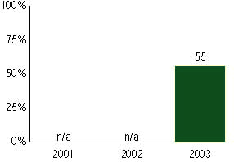

Stanford 10, not used for NCLB accountability in 2002-03
Grade 3

Mathematics
Proficient Level or above for:
All students | 58%
Economically disadvantaged students | 45
Migrant students | 61
Students with disabilities | 26
Students with limited English proficiency | 35
Black, non-Hispanic students | 41
Hispanic students | 42
White, non-Hispanic students | 69

Student achievement trend: Mathematics percent proficient level or above

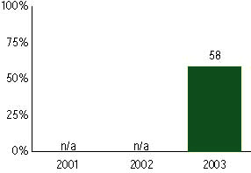

Stanford 10, not used for NCLB accountability in 2002-03
Grade 4

Reading
Proficient Level or above for:
All students | 63%
Economically disadvantaged students | 50
Migrant students | 43
Students with disabilities | 25
Students with limited English proficiency | 32
Black, non-Hispanic students | 45
Hispanic students | 49
White, non-Hispanic students | 76

Student achievement trend: Reading percent proficient level or above

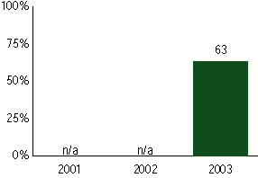

Stanford 10, not used for NCLB accountability in 2002-03
Grade 4

Mathematics
Proficient Level or above for:
All students | 64%
Economically disadvantaged students | 53
Migrant students | 50
Students with disabilities | 26
Students with limited English proficiency | 46
Black, non-Hispanic students | 49
Hispanic students | 52
White, non-Hispanic students | 74

Student achievement trend: Mathematics percent proficient level or above

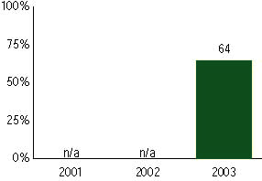

Stanford 10, not used for NCLB accountability in 2002-03
Grade 5

Reading
Proficient Level or above for:
All students | 62%
Economically disadvantaged students | 49
Migrant students | 41
Students with disabilities | 22
Students with limited English proficiency | 24
Black, non-Hispanic students | 44
Hispanic students | 43
White, non-Hispanic students | 74

Student achievement trend: Reading percent proficient level or above

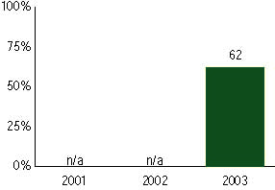

Stanford 10, not used for NCLB accountability in 2002-03
Grade 5

Mathematics
Proficient Level or above for:
All students | 54%
Economically disadvantaged students | 41
Migrant students | 47
Students with disabilities | 18
Students with limited English proficiency | 37
Black, non-Hispanic students | 37
Hispanic students | 47
White, non-Hispanic students | 65

Student achievement trend: Mathematics percent proficient level or above

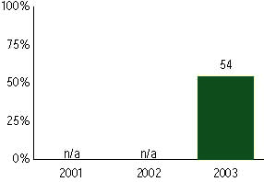

Stanford 10, not used for NCLB accountability in 2002-03
Grade 6

Reading
Proficient Level or above for:
All students | 58%
Economically disadvantaged students | 43
Migrant students | 32
Students with disabilities | 17
Students with limited English proficiency | 20
Black, non-Hispanic students | 38
Hispanic students | 40
White, non-Hispanic students | 71

Student achievement trend: Reading percent proficient level or above

Stanford 10, not used for NCLB accountability in 2002-03
Grade 6

Mathematics
Proficient Level or above for:
All students | 54%
Economically disadvantaged students | 36
Migrant students | 35
Students with disabilities | 15
Students with limited English proficiency | 36
Black, non-Hispanic students | 36
Hispanic students | 46
White, non-Hispanic students | 65

Student achievement trend: Mathematics percent proficient level or above

Stanford 10, not used for NCLB accountability in 2002-03
Grade 7

Reading
Proficient Level or above for:
All students | 63%
Economically disadvantaged students | 48
Migrant students | 41
Students with disabilities | 17
Students with limited English proficiency | 21
Black, non-Hispanic students | 45
Hispanic students | 41
White, non-Hispanic students | 74

Student achievement trend: Reading percent proficient level or above

Stanford 10, not used for NCLB accountability in 2002-03
Grade 7

Mathematics
Proficient Level or above for:
All students | 55%
Economically disadvantaged students | 40
Migrant students | 41
Students with disabilities | 14
Students with limited English proficiency | 30
Black, non-Hispanic students | 37
Hispanic students | 43
White, non-Hispanic students | 66

Student achievement trend: Mathematics percent proficient level or above

Stanford 10, not used for NCLB accountability in 2002-03
Grade 8

Reading
Proficient Level or above for:
All students | 59%
Economically disadvantaged students | 42
Migrant students | 38
Students with disabilities | 16
Students with limited English proficiency | 14
Black, non-Hispanic students | 38
Hispanic students | 38
White, non-Hispanic students | 71

Student achievement trend: Reading percent proficient level or above

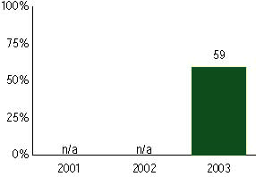

Stanford 10, not used for NCLB accountability in 2002-03
Grade 8

Mathematics
Proficient Level or above for:
All students | 56%
Economically disadvantaged students | 41
Migrant students | 45
Students with disabilities | 14
Students with limited English proficiency | 34
Black, non-Hispanic students | 38
Hispanic students | 42
White, non-Hispanic students | 67

Student achievement trend: Mathematics percent proficient level or above

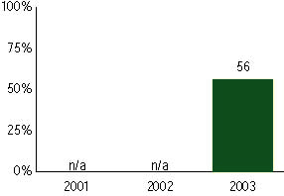

Stanford 10, not used for NCLB accountability in 2002-03
Grade 11

Reading
Proficient Level or above for:
All students | -
Economically disadvantaged students | -
Migrant students | -
Students with disabilities | -
Students with limited English proficiency | -
Black, non-Hispanic students | -
Hispanic students | -
White, non-Hispanic students | -

Trend Data Not Available

Stanford 10, not used for NCLB accountability in 2002-03
Grade 11

Mathematics
Proficient Level or above for:
All students | -
Economically disadvantaged students | -
Migrant students | -
Students with disabilities | -
Students with limited English proficiency | -
Black, non-Hispanic students | -
Hispanic students | -
White, non-Hispanic students | -

Trend Data Not Available

