Subject: ENVIRONMENTAL MANAGEMENT Date: 09/26/2007 AC No: 150/5050-8
SYSTEMS FOR AIRPORT SPONSORS Initiated by: APP-400 Change:

1. THE PURPOSE OF THIS ADVISORY CIRCULAR. This Advisory Circular (AC) provides guidance to airport sponsors that develop Environmental Management Systems (EMS). It provides guidance to airport sponsors on the needed parts of an EMS.
Several recognized methods exist for developing an acceptable EMS, including standards developed by the Environmental Protection Agency and the International Organization for Standardization (ISO) 14001. ISO 14001 requirements for an EMS can be used for certification, registration, and/or self declaration. An EMS must satisfy one of the recognized standards if an airport sponsor is seeking Federal financial support for its development. An airport sponsor that receives Federal aid to develop an EMS must keep the EMS current, without further Federal financial aid.
2. WHAT THIS AC CANCELS. There are no publications that this AC cancels.
3. WHO THIS AC AFFECTS. This AC affects sponsors of public use large and medium hub airports that choose to develop and complete an EMS at the airport.
4. RELATED READING MATERIAL.
- International Organization for Standardization, Standard 14000 series (most current version).
- International Organization for Standardization, Standard 9000 series (most current version), including 19011:03 guidelines for quality and/or environmental management system auditing.
- Fact sheets and guidance on preparing an EMS, Office of the Federal Environmental Executive
- Environmental Protection Agency’s EMS guidance, models, reports and training materials

5. COMMENTS OR SUGGESTIONS. Send comments or suggestions for improving this AC to:
Manager, Airport Planning and Environmental Division
Federal Aviation Administration
ATTN: APP-400
800 Independence Avenue, S.W.
Washington DC 20591

6. COPIES OF THIS AC. The Office of Airport Planning and Programming makes its AC’s available online at http://www.faa.gov/airports_airtraffic/airports/resources/advisory_circulars/.

Benito DeLeon
Director, Office of Airport Planning and Programming

This page intentionally blank

Table of Contents

Section 1.0 – BACKGROUND
A – Background on the origin of “Environmental Management Systems” 1
B – EMS Principles 1
C – What is an “EMS”? 1
D – What are the benefits of an EMS? 3

Section 2.0 – SETTING UP THE EMS
A – Environmental policy 3
B – What steps should the airport sponsor take to create an effective EMS? 3
C – Devise a system for implementation of the policy 5
D – Evaluate the effectiveness of the system and develop a process for
imposing corrective action 6
E – Management Review 6

Section 3.0 – VALIDATION OF COMPLETION OF EMP DEVELOPMENT 6

This page intentionally blank

1.0 BACKGROUND.

A. Background on the origin of “Environmental Management Systems”. The federal government began setting up EMS’s in the late 1990s. In response to requirements of Executive Order 13148, “Greening the Government Through Leadership in Environmental Management”, over 960 federal facilities completed an EMS by December 31, 2005. Several formally registered their EMSs at the American National Standard: International Organization for Standardization’s (ISO) 14001 standard (ANSI/ISO/ASQE14001, most current version). Executive Order 13423, “Strengthening Federal Environmental, Energy, and Transportation Management”, expands the scope of EMS to all proper organizational levels. It also makes the EMS the primary management approach for addressing environmental aspects of internal agency operations and activities.

Although several recognized EMS frameworks exist, most are based on the ISO 14001 EMS standard. Globally, over 130,000 organizations have certified their EMSs to the ISO 14001 standard. This AC also is based on the ISO-14001 EMS standard.

An EMS is a management framework based on the Plan-Do-Check-Act model. It helps organizations that adopt an EMS to balance environmental performance with business objectives through a process of continual improvement. It has resulted in significant savings and cost avoidance for many organizations, including airport sponsors.
B. EMS Principles. Effective environmental management is based on process control, lessening resource consumption, both human and natural, and complying with applicable environmental laws and other requirements. Process control results in a continually improving management system. Resource conservation supports our national commitment to stewardship and lessens impacts to an organization’s budget. Compliance with regulations and other requirements ensures organizations meet minimum environmental performance standards. Efficient management of environmental issues is a benefit to organizations, such as airport sponsors, and the customers and communities they serve.

C. What is an “EMS”? For purposes of this AC, an EMS is a business management practice that allows an organization to address strategically its environmental matters. EMS implementation reflects accepted management principles based on the “Plan, Do, Check, Act,” model. That model uses a systematic process to identify goals, complete them, determine progress, and make changes to ensure continual improvement.

In an EMS, this effort focuses on:

(1) Senior management’s commitment to an environmental policy (see Figure 1 Five Components of an Environmental Management System). The policy incorporates continual improvement, pollution prevention and compliance with applicable regulations and other requirements.

(2) (a) Identifying significant environmental aspects of the organization. Environmental aspects (that is activities, products or services that impact the environment) are evaluated based on the organization’s rating criteria. Example criteria include: how often they occur, what are the costs and benefits, and legal concerns. Organizations tailor the EMS to their needs.

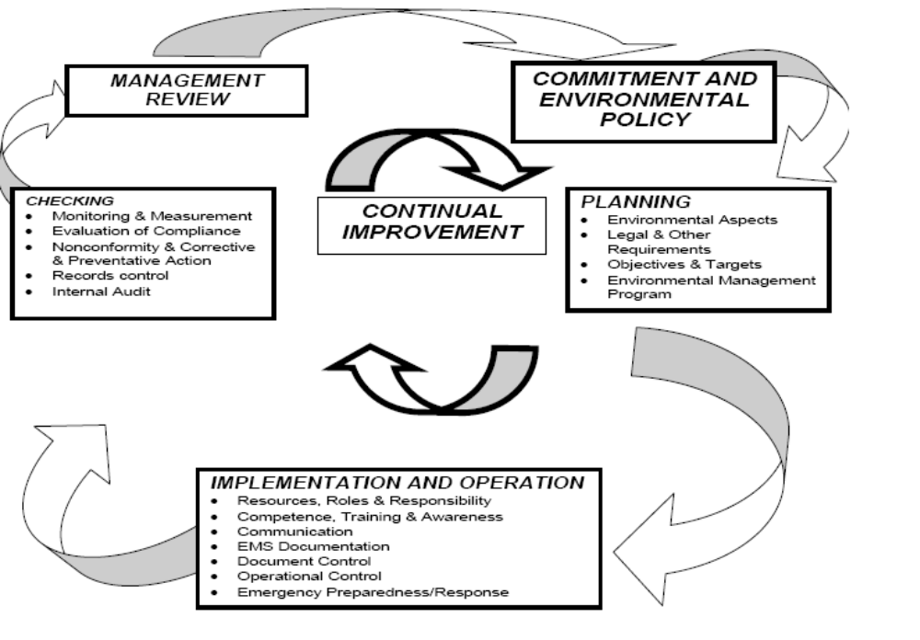
Figure 1 – The Five Components of an Environmental Management System

(b) Developing environmental performance goals, objectives and targets for the significant environmental aspects. The organization customizes environmental management programs to achieve its goals, objectives and targets.

(3) Setting up implementation plans (that is, Environmental Management Programs (EMP)) to identify the roles and responsibilities of individuals and resources. Also, schedule and manage the requirements to achieve the plan’s goals. Plan and manage variables that increase an organization’s likelihood of success. For example, operational controls (aka work instructions) ensure that environmental operations are carried out under specified conditions.

(4) Checking the status of environmental management programs and evaluate compliance with applicable regulations and other requirements. If the EMP manager notices nonconformity, procedures are in place to ensure the process is properly managed. Finally, the EMS is audited to assess conformance with the organization’s policies and procedures as well as the management system to which the organization subscribes (for example ISO 14001).

(5) Reviewing audit results and EMS performance with senior management. Senior management decides and takes actions to address changes to the environmental policy, objectives and targets and other elements of the environmental management system.
Airports may choose to set up an EMS for the airport. The sponsor may limit the scope of the airport EMS to a portion of an airport’s activities. The EMS may include only the activities for which the airport has responsibility or it may include all tenant and airline activities. It is important to identify clearly the scope of the EMS.

D. What are the benefits of an EMS? A properly developed and carried out EMS can improve regulatory compliance and environmental performance. It can increase overall efficiency and accountability, reduce costs and potential liability, increase employee awareness of environmental responsibilities, and improve community relations.

An EMS adds environmental activities to an organization’s current business structure. It employs an approach (planning, execution, and measurement) similar to that used in managing other parts of the business (for example, operations, finance).

While an EMS does not relieve the airport operator of its environmental responsibilities under Federal, state, and local law, it could reduce the costs and time for processing environmental analyses. It would provide baseline data and a framework for checking and reporting compliance with mitigation commitments.

2.O Setting up the EMS.

Some U.S. airports have developed their own EMSs and have posted them on their websites. Dallas-Ft Worth International; Denver International, and Westchester County are three airports that have carried out ISO-14001 compliant environmental management systems.

Environmental Policy. The environmental policy must be a written document signed by the Airport Director or Manager, or the Head of the airport’s governing Board. The Policy must at a minimum include commitments to continual improvement, compliance with legal and other requirements, and pollution prevention. The Policy (not the entire EMS) must be made available to the public and given to personnel working for or on behalf of the organization. The EMS framework identified in the policy statement provides the means for setting and reviewing objectives and targets for environmental performance improvement.

B. What steps should the airport sponsor take to create an effective EMS? Besides committing to the Environmental Policy, the airport sponsor should review and understand the EMS criteria to simplify developing the EMS. Identify all the EMS components and the minimum requirements for each component. To develop the EMS:

(1) Identify aspects and impacts from airport activities, products and services
(a) Aspects – This is any part of an activity, operation, product, process or service that can interact with the environment. The environmental aspect of an activity is that part of it that creates a possibility for an environmental impact. An impact could be positive or negative.
(b) Impacts – This is any change to the environment, whether adverse or favorable, resulting from the airport’s activities, operations, processes or services. Each of these activities can have tangible impacts on the environment either directly or through implementation by another party over which the airport has some control.
(2) Identify the airport’s significant environmental aspects. Evaluate each of the aspects against predetermined ranking criteria. These criteria may include relative risk, legal implications, costs and benefits of addressing the aspect, frequency of occurrence, and community concerns.
(3) Conduct a review of legal requirements. Include enforceable requirements issued by Federal, state, and local authorities (for example, statutes and ordinances) that are applicable to the airport’s environmental aspects identified above in subparagraph 1.
(4) Develop objectives and targets. The airport sponsor’s next step would be to set objectives and targets for any significant environmental aspects identified (for example, objectives for noise, air quality, water quality, and energy).
(a) Environmental objective – This is an overall environmental goal, consistent with the environmental policy the airport sponsor sets to achieve. Quantify this goal where practicable. An example of an environmental objective is to publish water quality management procedures by xx date.

(b) Environmental target – This is a detailed performance requirement set by the airport sponsor. It arises from the environmental objectives. Use it to measure whether the airport sponsor achieves its environmental objective. Quantify the environmental target where practicable, and identify to which parts of the airport sponsor’s operations it is applicable. The airport sponsor must set the target and meet it to achieve the identified objectives. An example of targets associated with the environmental objective would be to coordinate draft by xx date; incorporate review comments and issue the final procedures by [the objective] date.
(5) Set up a formal program – This is a reliable and consistent approach set up by the airport sponsor, to create and document its Environmental Management Programs (EMP). The results must relate to each significant environmental aspect. The EMP provides guidance, information, and references necessary for the efficient and effective accomplishment of the objectives and targets. It is a tool for the airport sponsor’s management to document tasks, responsibilities, and other operational details to achieve the environmental objectives and targets.

The EMP includes timelines, resources, and responsibilities and accountability for achieving the objectives and targets. The airport sponsor should amend the EMP as necessary with the changing environmental, organizational, and legal requirements. Amend it with new or changed activities and operations within the organization. An EMP incorporates several other EMS parts, including:

(a) Reference to each significant environmental aspect being addressed;
(b) The objectives and targets that were set for the significant aspect(s);
(c) The performance indicators (that is, metrics) the airport sponsor will use to measure progress in achieving the objectives and targets;
(d) The factors that caused the aspect to be significant;
(e) The programmatic and operational tasks needed to achieve the objectives and targets;
(f) The individuals responsible for each task;
(g) Declarations of employee competency or needed training;
(h) Listing of records that will be produced by completing the EMP;
(i) Reference to other documents used with the EMP; and
(j) Operational controls (OC) that are carried out to ensure the objectives and targets will be achieved as planned.

C. Devise a system for implementation of the policy. Implementation of the policy means you have completed your Environmental Management Programs (EMP), and set up your system for carrying them out. EMPs are the mechanisms that help an organization fulfill its commitment to pollution prevention, regulatory compliance, and continual improvement. This should include:

(1) Roles, responsibilities, and competency – list the people (organizational layout or positions) named to perform specific tasks in the EMP. The EMP also should include a declaration of their competence, based on their education, training, or experience. The declarations prove the individuals can carry out the tasks they’ve been assigned competently.
(2) Training and awareness– in instances where employee competency is lacking, identify training needs, develop training, and provide a system for ensuring EMS-responsible employees complete training. All employees also should receive EMS awareness training yearly.
(3) Internal and external communication procedures –
(a) Internal communication – This is communication between employees internal to the airport sponsor’s organization (that is, specific to the day-to-day operation of the airport. It does not include tenants and/or subcontractors or lessees).
(b) External communication – This is communication to or from parties or organizations external to the airport sponsor’s internal organizational structure. It also can be external to the physical site boundaries or airport sponsor roles or activities. This could also include communication between airport sponsor staff when an airport sponsor owns or manages more than one airport.
(4) Document control system – This step is necessary to ensure that EMS documents are readable, appropriate, and readily identifiable. Only the most current EMS documents should be in circulation at points of use. As part of document control, records should be managed. This includes a method for identifying, archiving, and disposing of the airport sponsor’s EMS records.

(5) Set operational controls – Apply operational controls to the airport sponsor’s activities and services that present significant environmental aspects. An OC is a mechanism used to achieve and preserve a needed level of environmental performance. An OC applies to the activities, products, and services of the airport sponsor. It is intended to prevent (or reduce) any negative environmental impact from occurring, and to ensure any positive environmental impact occurs or continues.

Examples of an OC include: Technological – motion sensors, sleep mode for electronics. Operator intervention – selecting duplex printing, electronic documents instead of paper. Standard operational procedures of an organization – setting up procedures for storage and disposal of hazardous waste.
(6) Emergency readiness and response - Set up procedures on how to carry on essential operations. It should plan for normal operations being interrupted by an event or threat that could have an associated environmental impact. An incident or emergency is more than a mere nonconformance in the EMS. It is more than a minor spill or release that can be corrected without invoking General Emergency Preparedness and Response Procedure.

D. Evaluate the effectiveness of the system and develop a process for imposing corrective action. To be effective each EMS needs a process for evaluation and corrective actions. The following activities should be used to carry this out.

(1) Conduct periodic checking of environmental performance
- Identify root causes of findings and conduct corrective and preventive actions
- Preserve EMS records
(4) Conduct periodic EMS audits

E. Management Review. An effective EMS requires the airport’s active senior management participation. Management conducts reviews to gauge whether the EMS continues to be effective, suitable and satisfactory for the organization. Management review will determine whether there is the need to make any decisions or to authorize necessary actions for continual improvement.

(1) Senior management should review the EMS at least yearly.
(2) Senior management should ensure policies and practices are revised as necessary because of the periodic review and because of the EMS audit process.

3.0 Validation of Completion OF EMS Development.

Developing an airport EMS is complete on submittal of the EMS document to the FAA Airports Regional Office or Airports District Office. The document shall include the airport sponsor’s self-certification that the EMS is compliant with ISO 14001-like requirements. (Variations to the ISO-14001 are available, as noted elsewhere in this circular.) A copy of the airport’s yearly management review of the EMS shall be forwarded to the same FAA office, for FAA records, to demonstrate continued currency of the EMS.

