U.S. Department  of Transportation  Federal Aviation  Administration | Advisory  Circular
Subject: Standards for Airport Markings | Date: 6/6/2008  Initiated by: AAS-100 | AC No: 150/5340-1J  Change: 2

1. PURPOSE. This advisory circular (AC) contains the Federal Aviation Administration (FAA) standards for markings used on airport runways, taxiways, and aprons.

2. CANCELLATION. AC 150/5340-1J cancels AC 150/5340-1H, Standards for Airport Markings, dated August 31, 1999. It also cancels AC 150/5340-1I, although version J is substantially the same document and only changes the AC version letter from I to J. In addition, this Change 2 cancels Change 1 of AC 150/5340-1J, dated March 31, 2008.

3. EXPLANATION OF CHANGES. Change 2 clarifies the intent of the previous change and modifies certain compliance dates for airports located in areas that receive snow or ice storms. Change 1 adopted three surface painted markings to reduce runway incursions. These surface painted markings either use a new marking scheme or expand an existing marking scheme. These surface painted markings, referred to as an enhancement, are the enhanced taxiway centerline marking, the extension of the runway holding position marking onto the paved taxiway shoulder, and the surface painted holding position sign. These adoptions became standard surface markings for airports certificated under Title 14 of the Code of Federal Regulations, Chapter I – FAA, Department of Transportation, Part 139, Certification of Airports (14 CFR Part 139) and, as indicated in paragraph 5, Application, for airport projects that receive Federal funds under the Airport Grant Assistance Program or public funds received from the Passenger Facility Charge Program. This AC uses the terms “commercial service airports” and “passenger enplanements” as defined in FAA Order 5100.38C, Airport Improvement Program Handbook, and “airplane design groups” as defined in AC 150/5300-13, Airport Design.
a. The enhanced taxiway centerline marking, as illustrated in Figure C-1 of Appendix 3, is mandatory for all 14 CFR Part 139 certificated airports. All runway holding positions for any runway are to have the enhanced taxiway centerline marking. Painting of the enhancement for all runway holding positions to a given runway should be completed in the shortest period of time. These actions eliminate erratic application of the enhancement, thereby avoiding pilot confusion and reducing the potential for runway incursions. Compliance dates vary as follows: June 30, 2008, for commercial service airports that have 1.5 million or more passenger enplanements in a calendar year; December 31, 2009, for commercial service airports with less than 1.5 million annual passenger enplanements but more than 370,000 annual passenger enplanements; and December 31, 2010, for all other commercial service airports certificated under 14 CFR Part 139. As indicated, this surface painted marking was adopted as part of the taxiway centerline marking standard under 14 CFR Part 139.311(a)(2). Paragraph 21(e) of this advisory circular provides other details and scenarios to handle various taxiway centerline geometries.
b. The extension of the runway holding position marking onto the paved shoulder, as illustrated in Figure C-3 of Appendix 3, is only mandatory for those 14 CFR Part 139 certificated airports that serve Airplane Design Group V and VI airplanes. Furthermore, the enhanced runway holding position marking applies only to those taxiways on that airport that serve these airplane design groups. The enhancement, which must extend on both sides of the taxiway centerline, has a compliance date of June 30, 2008. Paragraph 23(b)(2) of this advisory circular provides other details.
c. The surface painted holding position signs, as illustrated in Figure C-4 of Appendix 3, is mandatory for all 14 CFR Part 139 certificated airports that have two or more runways. Of the two surface painted holding position signs, the left-of-centerline surface painted sign is mandatory even if the vertical runway holding position sign exists. This requirement standardizes the use (pilot expectation/human factor) of the surface painted sign, thereby reducing confusion and runway incursions.
The right-of-centerline surface painted sign, which is highly recommended for taxiway entrances serving airplane operations that require two person crews, may be eliminated. The option to eliminate this enhancement occurs when a taxiway centerline is closer than 45 feet (13.7 m) from the edge of the taxiway and a mandatory vertical hold sign is in clear view. Paragraph 26(b) of this advisory circular describes other special situations in which one of the enhancements may be eliminated.
For airports with one or more runways, any taxiway entrance of insufficient lead-in length that causes this enhancement to be painted on or very close to a parallel taxiway must have both surface painted signs. At airports with one or more runways, any taxiway entrance with a width of more than 200 feet (61 m) at the runway holding position requires several surface painted holding position signs. This latter requirement is in direct response to reducing documented runway incursions at such locations. Paragraph 26(b) of this advisory circular determines the number of surface painted holding signs for such locations.
Taxiway entrances that serve multiple runways require that the surface painted signs contain all runway designators with directional arrows. The purpose for requiring the inclusion of the directional arrows is eliminating “wrong runway” takeoffs. In certain cases where the taxiway geometry is narrow and/or complex, special procedures to fit the enhancements should be followed. Paragraph 26(d) and Figure C-4 of this advisory circular provide such guidance on dealing with these situations.
In all cases. this surface painted marking is never painted over the taxiway centerline or onto the taxiway shoulders. The surface painted marking, which became part of the standard signage requirement under 14 CFR Part 139.311(b)(1)(ii), has a compliance date of December 31, 2010.
4. METRIC UNITS. To promote an orderly transition to metric units, the text and figures include both English and metric dimensions. The metric conversions are based on operational significance and may not be exact equivalents. Until there is an official changeover to the metric system, the English dimensions govern.
5. APPLICATION. The FAA recommends the guidelines and standards contained herein for the marking of airport runways, taxiways, and aprons. These standards are the only method of compliance with the marking of runways and taxiways for airports certificated under 14 CFR Part 139. These standards are to be used on all new projects that are under development and are to be implemented at all Part 139 certificated airports, as specified in paragraph 3, Explanation of Changes. These standards are also mandatory for airport projects receiving Federal funds under the Airport Grant Assistance Program or funds received from the Passenger Facility Charge Program.

6. CHANGED TEXT. Changed text is indicated by vertical bars in the margins.

PAGE CONTROL CHART
Remove Pages | Dated | Insert Pages | Dated
i–ii  iii–iv  9–10  11–12  13  14-15  16  49–52 | 3/31/2008  4/29/2005  3/31/2008  4/29/2005  3/31/2008  4/29/2005  4/29/2005  4/29/2005 | i–ii  iii  iv  9–10  11–12  13–15  16–16-2  49–52 | 6/6/2008  6/6/2008  4/29/2005  6/6/2008  6/6/2008  6/6/2008  6/6/2008  6/6/2008  6/6/2008
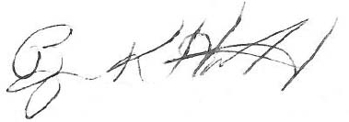

Byron K. Huffman
Acting Director, Airport Safety and Standards
CONTENTS

MARKINGS FOR PAVED RUNWAYS AND TAXIWAYS. 1
SECTION 1. GENERAL. 1
1. Purpose 1
2. Definitions 1
3. Marking Practices 1
4. Visibility of Markings. 1
SECTION 2. RUNWAY MARKINGS 2
5. Application. 2
6. Runway Marking Precedence 3
7. Runway Designation Marking. 3
8. Runway Centerline Marking 4
9. Runway Threshold Marking 4
10. Runway Aiming Point Marking. 5
11. Runway Touchdown Zone Marking 5
12. Runway Side Stripe Marking 6
13. Runway Threshold Bar 6
14. Demarcation Bar 6
15. Arrows and Arrowheads 7
16. Chevrons 7
17. Holding Position Markings on Runways. 7
18. Runway Shoulder Markings 8
19. Reserved 8
SECTION 3. TAXIWAY MARKINGS 8
20. Application 8
21. Taxiway Centerline Markings 8
22. Taxiway Edge Marking 10
23. Runway Holding Position Markings on Taxiways 11
24. Holding Position Markings for Instrument Landing System (ILS)/
Precision Obstacle Free Zone (POFZ) 12
25. Intermediate Holding Position Markings for Taxiway/Taxiway Intersections 12
26. Surface Painted Holding Position Signs 13
27. Surface Painted Taxiway Direction Signs 15
28. Surface Painted Taxiway Location Signs 15
29. Surface Painted Gate Identification Signs 15
30. Surface Painted Apron Entrance Point Signs 16
31. Taxiway Shoulder Markings 16
32. Geographic Position Markings 16-1
33. Reserved 16-1
34. Reserved 16-1
SECTION 4. OTHER MARKINGS 17
35. Application 17
36. Vehicle Roadway Markings 17
37. VOR Receiver Checkpoint Markings 17
38. Non-Movement Area Boundary Marking 18
39. Marking of Temporarily Relocated Thresholds 18
40. Marking and Lighting of Permanently Closed Runways and Taxiways 18
41. Temporarily Closed Runways and Taxiways 18
42. Converting a Runway to a Taxiway 19
43. Intermittent Use of a Taxiway as a Runway 19
44. Closed/Abandoned Airports 19
45. Heliport Marking 19
46. Vertiport Marking 19
47. Marking for Arresting Gear 19
48. Hazardous Areas 19

FIGURES

Figure 1. Precision Runway Markings 20
Figure 2. Nonprecision Runway and Visual Runway Markings 21
Figure 3. Example of Conflicting Markings on Crossing Runways 22
Figure 4. Runway Designation Numerals and Letters 23
Figure 5. Displaced Threshold Markings 24
Figure 6. Markings for Taxiway Aligned With Runway 25
Figure 7. Markings for Blast Pads and Stopways 26
Figure 8. Marking for Blast Pad or Taxiway Preceding a Displaced Threshold 27
Figure 9. Runway Shoulder Markings 28
Figure 10. Marking Details 29
Figure 11. Taxiway Markings 30
Figure 12. Taxiway Centerline Marking Methods 31
Figure 13. Surface Painted Signs 32
Figure 14. Surface Painted Gate Identification Signs 33
Figure 15. Surface Painted Apron Entrance Point Signs 34
Figure 16. Taxiway Shoulder Markings 35
Figure 17. Geographic Position Markings 36
Figure 18. Vehicle Roadway Markings 37
Figure 19. VOR Receiver Checkpoint Markings 38
Figure 20. Closed Runway and Taxiway Markings 39

APPENDIX 1. Inscriptions for Signs and Geographic Position Markings (5 Pages)
Figure A-1. Pavement Markings ABCDEFGH 40
Figure A-2. Pavement Markings IJKLMNOP 41

Figure A-3. Pavement Markings QRSTUVWX 42
Figure A-4. Pavement Markings YZ123456 43
Figure A-5. Pavement Markings 7890-,↑ 44

APPENDIX 2. EXAMPLES OF MARKINGS OUTLINED IN BLACK (2 pages)
Figure B-1. Runway Holding Position Marking 45
Figure B-2. ILS/MLS Holding Position Marking 45
Figure B-3. Continuous Taxiway Edge Line Marking 46
Figure B-4. Dashed Taxiway Edge Line Marking 46
Figure B-5. Alternate Outlining Method for Dashed Taxiway Edge Line Marking 46
Figure B-6. Taxiway Centerline Marking 46
Figure B-7. Intermediate Holding Position Markings 46
Figure B-8. Non-Movement Area Boundary Area Marking 46

APPENDIX 3. ENHANCED MARKINGS FOR RUNWAY HOLDING POSITION (12 pages)

Figure C-1. Enhanced Taxiway Centerline Markings 47
Figure C-2. Dashed Lines at Converging Taxiway Centerlines 48
Figure C-3. Enhanced Runway Holding Position Markings on Taxiways 49

Figure C-4. Surface Painted Holding Position Signs 50
Figure C-5. Surface Painted Holding Position Signs when Taxiway Centerline is not Perpendicular to Runway Holding Position Marking 51
Figure C-6. Surface Painted Holding Position Signs Co-Located with a Geographic Position Marking 52
Figure C-7. Two Taxiway Centerlines Converging at a Runway Holding Position Marking 53

Figure C-8. Intersection of Two Taxiways at Runway End 54
Figure C-9. Intersection of Three Converging Taxiway Centerlines 55

most demanding aircraft, the centerline markings follow the taxiway curve, as shown in Figure 12b, to permit cockpit-over-centerline steering.

(2) At taxiway intersections with runway ends, the taxiway centerline is terminated at the runway edge except that the following applies:

(i) Where there is a displaced threshold the centerline continues into the displaced area of the runway.

(ii) The taxiway centerline continues across the runway when it is a crossing route as designated by the local Air Traffic Facility.

(3) On all other taxiways, the taxiway centerline marking curves onto the runway and extends parallel to the runway centerline marking for a distance of 200 feet (60 m) beyond the point of tangency or terminating at the threshold bar, which ever is less, and three feet from the runway centerline measured near-edge to near-edge. See Figure 11, detail A. This lead-on or lead-off line (the taxiway centerline) is interrupted for all runway markings.

(4) For taxiways crossing a runway, either straight across or offset and normally used as a taxi route, the taxiway centerline marking may continue across the runway but is normally interrupted for any runway markings. For low visibility operations, when the runway visual range is below 1200 feet (360 m), taxiway centerline markings continue across all runway markings with the exception of the runway designation marking.

c. Color. Taxiway centerline markings are yellow.

d. Characteristics.

(1) Width. A width of 6 inches (15 cm) to 12 inches (30 cm) is acceptable for a taxiway centerline. However, the width selected must be uniform for the entire length of the taxiway unless:

(i) It involves a surface movement guidance and control system (SMGCS) route. When a taxiway or part of a taxiway is designated as a SMGCS route, the width of the taxiway centerline must be 12 inches (30 cm) wide and is outlined in black in light colored pavement. The centerline width of the remaining part of a taxiway that is not a part of a SMGCS route can change abruptly at the intersection with other taxiway centerline markings, e.g. from 12 inches (30 cm) to 6 inches (15 cm).

(ii) Confusing intersections require the designation of a preferred routing through such an intersection.

(2) Continuity. The centerline is continuous in length except where it intersects a holding position marking (see Figure 10) or a runway designation (see paragraph 21b(4)).

e. Enhanced Taxiway Centerline Marking. The guidelines and standards contained in this section for enhanced taxiway centerline markings will be considered the only acceptable means of compliance with 14 CFR Part 139 for airports with annual passenger enplanements of 1,500,000 or more, effective June 30, 2008. For airports with less than 1.5 million annual passenger enplanements but more than 370,000 annual passenger enplanements, the compliance date is December 31, 2009. At all remaining airports certificated under 14 CFR Part 139, these same enhanced taxiway centerline markings will be the standard effective December 31, 2010. All runway holding positions for any runway are to have the enhanced taxiway centerline marking. That is, the enhanced taxiway centerline is used throughout the airport. Painting of the enhancement for all runway holding positions to a given runway should be completed in the shortest period of time. These actions eliminate erratic application of this enhancement, thereby avoiding pilot confusion and reducing the potential for runway incursions. This surface painted marking is part of the taxiway centerline marking standard under 14 CFR Part 139.311(a)(2).

(1) Location. Taxiway centerlines are enhanced for 150 feet (45.7 m) prior to a runway holding position marking, except in the situations described in Paragraph 21(e)(3)(i) below. The taxiway centerline is not enhanced between the runway holding position marking and the runway. The following methods are commonly used to measure the 150-foot (45.7 m) length on a curved taxiway from the runway holding position:

(i) With a measuring wheel, measure from the intersection of the taxiway centerline at the runway holding position along the existing taxiway centerline out to 150 feet (45.7 m).

(ii) With a 150-foot (45.7 m) tape measure, swing an arc from the intersection of the taxiway centerline at the runway holding position until it intersects the taxiway centerline.

(2) Color. Enhanced taxiway centerline markings are yellow and must contain glass beads. In addition, the enhanced taxiway centerline marking must be outlined in black paint on light-colored pavements.

(3) Characteristics. An enhanced taxiway centerline marking consists of a parallel line of yellow dashes on either side of the existing taxiway centerline. The first dashes start 6 to 12 inches (15–30 cm) from the runway holding position marking, and the pattern is repeated for a distance of 150 feet (45.7 m). The yellow dashes are 9 feet (2.74 m) in length and 6 inches (15 cm) wide and have a gap of 3 feet (1 m) between them, as shown in Appendix 3, Figure C-1.

(i) If the taxiway centerline to be enhanced continues through a taxiway/taxiway intersection that is located within 150 feet (45.7 m) from a runway holding position marking, the taxiway centerline enhancement must be terminated 5 feet (1.5 m) prior to the point where the other taxiway centerline crosses the taxiway centerline that is being enhanced (see Appendix 3, Figure C-10).

(ii) If the enhanced taxiway centerline intersects another runway holding position marking that is located within 150 feet (45.7 m) of the runway holding position marking that is being enhanced, then the entire length of taxiway centerline between the two runway holding position markings must be enhanced. However, in no case should the taxiway centerline be enhanced between the runway holding position marking and the runway (see Appendix 3, Figure C-10).

(iii) Where two taxiway centerlines come together (converge) at or before the runway holding position marking, there must be no partial dashed lines less than 9-feet (2.74 m) at the point of convergence. The first inside dashed lines must be aligned with the outside dashed lines―starting and stopping with the dashed lines on the outside (Appendix 3, Figure C-2).

(iv) If an ILS holding position marking is within 150 feet of a runway holding position marking, the enhanced taxiway centerline is interrupted the same as it is for a regular centerline (i.e. 3 feet (0.9 m) on the runway side and 6 - 12 inches (15 to 30 cm) on the holding side).

22. TAXIWAY EDGE MARKING.

a. Purpose. Taxiway edge markings are used to delineate the edge of the taxiway. They are primarily used when the usable taxiway edge does not correspond with the edge of the pavement. Two types of markings are used depending upon whether the aircraft is supposed to cross the taxiway edge. The outer edge of the stripe defines the edge of the usable pavement.

(1) Continuous Markings. Continuous taxiway edge markings are used to delineate the taxiway edge from the shoulder or some other contiguous paved surface not intended for use by aircraft (see Figures 10 and B-3). When an operational need exists, the continuous taxiway edge marking may be used to delineate the edge of the taxiway from a contiguous non-paved surface. Continuous taxiway edge markings are not to be used in situations where aircraft would be required to cross them.

(2) Dashed Markings. Dashed taxiway edge markings are used when there is an operational need to define the edge of a taxiway or taxilane on a paved surface where the pavement contiguous to the taxiway edge is intended for use by aircraft, e.g., an apron (see Figures 10 and B-4). Where the taxiway is contiguous to an apron, the markings must be installed at a distance equal to one-half the taxiway width from taxiway centerline. Dashed edge stripes are not to be used to provide wing tip clearances for parked aircraft on an apron. See taxiway/taxiway hold lines Par. 25, or non-movement area boundary markings Par. 38, as appropriate.

b. Location. Taxiway edge markings are located on the taxiway at its defined edge, and are part of the usable taxiway pavement.

c. Color. Taxiway edge markings are yellow.

d. Characteristics. Continuous taxiway edge markings consist of a continuous double yellow line, with each line being at least 6 inches (15 cm) in width, spaced 6 inches (15 cm) apart (edge to edge). These markings can also be used to designate islands that have been painted green or striated with yellow markings. Dashed taxiway edge markings consist of a broken double yellow line, with each line being at least 6 inches (15 cm) in width, spaced 6 inches (15 cm) apart (edge to edge). The dashed lines are 15 feet (4.5 m) in length with 25-foot (7.5 m) gaps (see Figure 10). These markings are not to be used to designate islands.

23. RUNWAY HOLDING POSITION MARKINGS ON TAXIWAYS.

a. Purpose. At airports with operating airport traffic control towers, runway holding position markings identify the location on a taxiway where a pilot is to stop until clearance is received to proceed onto the runway. Holding position markings may be supplemented with Geographic Position Markings (see paragraph 32) as part of the airport’s SMGCS Plan. At airports without operating airport traffic control towers these runway holding position markings identify the location where a pilot should assure there is adequate separation with other aircraft before proceeding onto the runway.

- Location.

(1) The runway holding position marking should be located in accordance with Table 4 on all taxiways that intersect runways based upon the most critical aircraft using the runway and extend across the entire width of the taxiway. These surface painted markings are also located on taxiways crossing through the runway approach area. This action protects the following surfaces and ensures that an aircraft on the taxiway will not penetrate the surface used to locate the runway threshold, runway inner approach obstacle free zone, and runway inner transitional obstacle free zone. If located closer, such that aircraft penetrate the Terminal Instrument Procedures (TERPS) surfaces, higher minimums may result or the taxiway is restricted. A discussion of these surfaces is contained in AC 150/5300-13. Locating holding position markings other than in accordance with the preceding criteria must be approved by the FAA. Except as specified in paragraph 17, holding position markings should not be used for any situation other than those described in this paragraph.

(2) The runway holding position markings of entrance taxiways used by Airplane Design Group V or VI airplanes are enhanced by extending this surface marking onto both paved shoulders (see Appendix 3, Figure C-3). For both airplane design groups, the total length of the enhancement from one paved shoulder to the other paved shoulder measures 125 feet (38 m), i.e., 62.5 feet (19 m) from the taxiway centerline. This measurement takes into account the downward viewing angle that pilots have while seated in the normal position plus safety factors, such as aircraft wander from centerline. Only those taxiway entrances to a runway that serve these airplane design groups are to be enhanced. Typical Airplane Design Groups V and VI airplane models include the Airbus 330-200/-300, A-340-200/-300/-500/-600, A-380, Boeing-747-100/-200/-400, B-777-200/-300, and B-787-8/-9. The use of a single measurement of 125 feet (38 m) permits a consistent application of this surface marking relative to these aircraft categories rather than the taxiway widths they traverse. The compliance date for these taxiways is June 30, 2008, and is the only acceptable means of compliance by 14 CFR Part 139 certified airports.

(i) Taxiway edge markings must be removed for the width of the extended runway holding position marking.

(ii) If the runway holding position marking is outlined in black, taxiway edge markings should abut the black outline on both sides that contain the solid yellow lines and dashed yellow lines.

(iii) If the runway holding position marking is not outlined in black, taxiway edge markings should abut the holding position markings on both sides, i.e., the outer solid yellow line and the outer dashed yellow line.

(iv) If a light fixture or sign is located on the taxiway shoulder and aligned with the extended runway holding position marking, the extended runway holding position marking should be extended no closer than 5 feet (1.5 m) to the edge of the light fixture or sign.

(v) If a taxiway has taxiway shoulder markings (see paragraph 31, Taxiway Shoulder Markings) and the extended runway holding position marking will be located within 10 feet (3 m) of the taxiway shoulder marking, the extended runway holding position marking must supersede the taxiway shoulder marking, i.e., the taxiway shoulder marking must be omitted in this location.

c. Color. Runway holding position markings on taxiways are yellow, and will be outlined in black on light colored pavements.

d. Characteristics. Runway holding position markings consist of a set of 4 yellow lines and 3 spaces, each 12 inches (30 cm) in width, as shown in Figure 10 [see note] The solid lines of these markings are always on the side where the aircraft is to hold. The markings are installed perpendicular to the taxiway centerline but may be canted from the perpendicular in unique situations, such as illustrated in Figure 11. In these cases, it may be necessary to install additional holding position signs, runway guard lights, etc. Runway holding position markings on taxiways may be angled as needed where two or more taxiways intersect at the runway hold line. On angled taxiways the distances given in Table 4 is measured from the runway centerline to the taxiway centerline (Figure 11). On an angled taxiway, consideration should also be given to locating the markings such that no portion of an aircraft (i.e., wing tip) placed at the holding position line will penetrate the runway safety area.

Note: At airports that do not have an airport traffic control tower and are not certificated under 14 CFR Part 139, each of the four yellow lines and three spaces may be 6 inches (15 cm) in width.

24. HOLDING POSITION MARKINGS FOR INSTRUMENT LANDING SYSTEM (ILS)/ PRECISION OBSTACLE FREE ZONE (POFZ).

a. Purpose. The ILS critical area/POFZ holding position marking identifies the location on a taxiway or holding bay where an aircraft is to stop when it does not have clearance to enter the ILS critical area or the POFZ. This marking also can be used to identify the boundary of a microwave landing system (MLS) critical area and to identify the holding position for CAT II/III operations. Marking the boundary of these areas is necessary to protect the navigational aid signal.

b. Location. The ILS critical area/POFZ holding position marking is located on the taxiway at the perimeter of the ILS (or MLS) critical area or the POFZ and, as appropriate, at the holding position for CAT II/III operations.

(1) Where the distance between the runway holding position marking on a taxiway and the holding position marking for an ILS (or MLS) critical area is 50 feet (15 m) or less, one holding position may be established, provided it will not affect capacity. In this case, the runway holding position is moved back to the ILS/MLS holding position and only the runway holding position markings are installed.

(2) If a taxiway penetrates the POFZ, only one holding position marking should be installed to delineate the ILS critical area and the POFZ. This holding position marking should be located at the more conservative boundary of these two areas. In this instance, the ILS/POFZ holding position marking cannot be replaced with, or used in lieu of, a runway holding position marking.

(3) FAA will designate the ILS (or MLS) critical area and POFZ boundaries and, as appropriate, determine the holding position location for CAT II/III operations for the airport operator. The markings are installed perpendicular to the taxiway centerline but may be canted from the perpendicular in unique situations, such as illustrated in Figure 11.

- The runway holding position markings of taxiways used by Airplane Design Group V or VI airplanes are recommended to be extended onto both paved shoulders (see Appendix 3, Figure C-3). Typical Airplane Design Group V and VI airplane models include the Airbus 330-200/-300, A-340-200/-300/-500/-600, A-380, Boeing-747-100/-200/-400, B-777-200/-300, and B-787-8/-9. See paragraph 23(b)(2) for further design guidance. The extended holding position markings will be the only acceptable means of compliance with 14 CFR Part 139 effective June 30, 2008. At all other airports, this enhanced surface marking is optional.

c. Color. The ILS critical area/POFZ holding position markings on taxiways are yellow, and will be outlined in black on light colored pavements.

d. Characteristics. The ILS critical area/POFZ holding position marking consists of a set of two 2-foot (0.6 m) wide parallel yellow lines spaced 4 feet (1.2 m) apart, 6 inches (15 cm) from the taxiway centerline on the aircraft holding side as shown in Figure 10 [see note]. In between these two lines and perpendicular to them, there are sets of two 1-foot (0.3 m) wide parallel yellow lines 1-foot (0.3 m) apart. See Figure 10 for proper spacing dimensions.
Note: At airports that do not have airport traffic control towers and are not certificated under 14 CFR Part 139, the airport operator has the option to reduce the dimension for the width of the parallel yellow lines and spaces from 2 feet (.6 m) to 1 foot (0.3 m) and from 4 feet (1.2 m) to 2 feet (0.6 m).

25. INTERMEDIATE HOLDING POSITION MARKINGS FOR TAXIWAY/TAXIWAY INTERSECTIONS.

a. Purpose. These markings identify the location on a taxiway or apron where aircraft are supposed to stop when told to hold short of another taxiway or apron. They should be used at airports with an operating ATCT where there is an operational need to hold traffic at a taxiway/taxiway intersection, at a geographic position (see paragraph 32), or holding bay, as illustrated in Figure 11, to define the edge of the taxiway object free area to assure adequate clearance from taxiing aircraft.
b. Location. Holding position markings for taxiway/taxiway intersections are located for the most demanding aircraft using the airport in accordance with Table 5.

c. Color. Holding position markings on taxiways are yellow, and will be outlined in black on light colored pavements.
d. Characteristics. The holding position markings for taxiway/taxiway intersections consist of a 1 foot (0.3 m) wide yellow line with 3 foot (0.9 m) long dashes and spaces. The taxiway centerline is 6 – 12 inches (15 cm – 30 cm) on either side of the intermediate holding position marking, as shown in Figure 10.

Table 5. Perpendicular Distances for Taxiway
Intersection Markings from Centerline of Crossing Taxiway.

Airplane Design Group¹
I | II | III | IV | V | VI
44.5 feet | 65.5 feet | 93 feet | 129.5 feet | 160 feet | 193 feet
(13.5 m) | (20 m) | (28.5 m) | (39 m) | (48.5 m) | (59 m)

Note 1: See AC 150/5300-13, Airport Design.

26. SURFACE PAINTED HOLDING POSITION SIGNS.

a. Purpose. Surface painted holding position signs supplement the signs located at the runway holding position marking (including ILS/Precision Obstacle Free Zone holding position markings) in accordance with current AC 150/5340-18, Standards for Airport Sign Systems. These surface painted markings provide additional visual cues to alert pilots of an upcoming runway holding position, identify the location as a runway holding position, and confirm the runway designation(s). The surface painted holding position signs, as illustrated in Figure C-4 of Appendix 3, are mandatory for all 14 CFR Part 139 certificated airports that have two or more runways.

Of the two surface painted holding position signs, the left-of-centerline surface painted sign is mandatory even if the vertical runway holding position sign exists. This requirement standardizes the use (pilot expectation/human factor) of the surface painted sign, thereby reducing confusion and runway incursions. The right-of-centerline surface painted sign, which is highly recommended for taxiway entrances serving airplane operations that require two person crews, may be eliminated. The option to eliminate this enhancement occurs only when a taxiway centerline is closer than 45 feet (13.7 m) from the edge of the taxiway and a mandatory vertical hold sign is in clear view.
Paragraph 26(b) describes other special situations when one of the enhancements may be eliminated. For airports with one or more runways, any taxiway entrance of insufficient lead-in length, such as non-standard separation between a runway and parallel taxiway, that causes this enhancement to be painted on or very close to a parallel taxiway must have both surface painted signs. For airports with one or more runways, any taxiway entrance whose width measures more than 200 feet (61 m) at the runway holding position requires several surface painted holding position signs. This latter requirement is in direct response to reducing documented runway incursions at such locations. Paragraph 26(b) determines the number of surface painted holding signs for such locations.

Taxiway entrances that serve multiple runways require that the surface painted signs contain all runway designators with directional arrows. The purpose for requiring the inclusion of the directional arrows is eliminating “wrong runway” takeoffs. In certain cases where the taxiway geometry is narrow and/or complex, such as narrow entrance taxiways, special procedures to fit the enhancements should be followed. Paragraph 26(d) and Figure C-4 provide such guidance on dealing with these situations. In all cases, this surface painted marking is never painted over the taxiway centerline or onto the taxiway shoulders. The surface painted marking, which became part of the standard signage requirement under 14 CFR Part 139.311(b)(1)(ii), has a compliance date of December 31, 2010.

b. Location. The surface painted holding position signs are recommended on the left and to the right of the taxiway centerline (see paragraph 26(a) to determine when they are mandatory). It might not be possible to install surface painted holding position signs on both sides of the taxiway centerline, particularly where taxiway centerlines converge just prior to the runway holding position marking. In these cases, the surface painted holding position signs may be omitted on one side. Additionally, surface painted hold position signs are to be at least 2 feet from the edge of the inside taxiway edge marking or from the edge of the taxiway when there are no taxiway edge markings. Holding position signs must not be painted on runways. Airports with one or more runways having a taxiway entrance with a width of more than 200 feet (61 m) at the runway holding position require several surface painted holding position signs. At such locations, place one surface painted sign on the left-of-centerline taxiway entrance and place additional surface painted signs every 100 feet (left or right) from the taxiway centerline. Surface painted location signs may be located along with the surface painted holding position signs when adequate pavement width exists. In these cases, the surface painted signs will mimic the mandatory hold position signs. If the collocated surface painted location sign and mandatory sign serves two converging taxiways, then the surface painted location sign should be located on the left of the surface painted holding position sign. Surface painted taxiway direction signs are not to be co-located with a surface painted holding position sign.

(1) The surface painted holding position signs may be located parallel to the runway holding position marking:

(i) At a distance of 2 feet (.67m) to 4 feet (1.34m) prior to the holding position marking to allow clearance of in-pavement runway guard lights and/or stopbars (see Appendix 3, Figures C-4 and C-5), and

(ii) At a distance of 3 to 10 feet (1–3 m) from the center of the taxiway centerline. If the holding position marking and the taxiway centerline are not perpendicular to each other, then this distance should be measured from the center of the taxiway centerline to the nearest corner of the surface painted holding position sign (see Appendix 3, Figure C-5).

(2) Alternately, surface painted holding position signs may be located perpendicular to the taxiway centerline:
(i) At a distance of 3 – 10 feet (1 – 3 m) from the center of the taxiway centerline

(ii) The distance measured from the runway holding position marking to the nearest corner of one of the surface painted holding position sign should be 2 – 4 feet (0.6 – 1.2 m).

(3) Surface painted holding position signs located between two taxiway centerlines should be:

(i) Parallel to the runway holding position marking.

(ii) Approximately equidistant from both taxiway centerlines at a distance of no less then 3 feet (1 m) or more than 15 feet (4.57 m) from either taxiway centerline as measured from the center of the taxiway centerlines to the nearest corner of the surface painted holding position sign.

(4) If two or more taxiway centerlines intersect the runway holding position marking or intersect each other within 15 feet (4.57 m) of the runway holding position, there might not be enough space for two or more surface painted holding position signs. These locations will require individual assessment for applying surface painted holding position signs that take into account such factors as taxi route usage rate and space.

c. Color. The surface painted holding position sign has a red background with a white inscription, and will be outlined in black on light colored pavements. The black border around the white alphanumerics required on the actual mandatory holding position sign is not necessary on the surface painted holding position signs
d. Characteristics. The inscription is to have a height of 12 feet (3.67m), however it may be reduced, as necessary to the minimum height of 9 feet (3m). If it is necessary to reduce the height below 12 feet at one location on the airport, the airport operator may want to reduce all surface painted holding position signs on the airport to the same height in order to avoid the need for multiple stencils. However, the height of the surface painted holding position signs should be uniform for each holding position. The width of the letters, numbers, and other symbols used in the inscription must be proportional to the height in order to conform in appearance to the letters, numbers, and other symbols in Appendix 1. The background is rectangular and extends a minimum of 15 inches (38 cm) laterally and vertically beyond the extremities of the inscription. The surface painted holding position sign may be eliminated if it would extend onto another taxiway. In certain cases where the taxiway geometry is narrow and/or complex, such as narrow entrance taxiways, special procedures as described in Figure C-4 to fit the enhancement(s) allow the height to be lower than 9 feet (3 m) but not below 3 feet (1 m.) In this special application, only this surface enhancement(s) will differ in height as compared to all other runway holding positions. In all cases, this surface painted marking is never painted over the taxiway centerline or onto the taxiway shoulders.

27. SURFACE PAINTED TAXIWAY DIRECTION SIGNS .

a. Purpose. Surface painted taxiway direction signs will be provided when it is not possible to provide taxiway direction signs at intersections in accordance with AC 150/5340-18 or, when necessary, to supplement such signs.

b. Location. Surface painted taxiway direction signs are 3 feet (1 m) from the centerline with signs indicating turns to the left being on the left side of the taxiway centerline and signs indicating turns to the right being on the right side of the centerline, as shown in Figure 13. Taxiway direction signs are not painted on runways, or between a runway holding position and a runway. For taxiways intersecting at 90 degrees a surface painted taxiway direction sign is combined with arrows to indicate directions and is located on the left side of the taxiway centerline.

(1) When a direction sign is not installed along side of the taxiway, the surface painted taxiway direction sign is located at the same distance from the intersection as the distance specified in AC 150/5340-18.

(2) When a surface painted taxiway direction sign supplements a direction sign installed along side of the taxiway, the surface painted direction sign may be located at or anywhere between the distance specified in subparagraph (1) above and the point of divergence of the painted centerlines.

c. Color. Surface painted taxiway direction signs have a yellow background with a black inscription.

d. Characteristics. The inscription is to have a height of 12 feet (3.67m), however it may be reduced, as necessary to the minimum height of 9 feet (3m). The width of the letters, numbers, and other symbols used in the inscription must be proportional to the height in order to conform in appearance to the letters, numbers, and other symbols in Appendix 1. Each taxiway designation must be accompanied by an arrow showing the general direction of turn. The background is rectangular and extends a minimum of 15 inches (38 cm) laterally and vertically beyond the extremities of the inscription. A 6-inch (15 cm) wide vertical black stripe separates each taxiway designation when more than one designation is included on either side of the centerline.

28. SURFACE PAINTED TAXIWAY LOCATION SIGNS .

a. Purpose. Surface painted taxiway location signs are used, when necessary, to supplement the signs located along side the taxiway and assist the pilot in confirming the designation of the taxiway on which the aircraft is located.
b. Location. The surface painted taxiway location signs are normally located on the right side of the taxiway centerline as shown in Figure 13. The edge of the surface painted taxiway location sign should be 3 feet (1 m) from the edge of the taxiway centerline. However, a surface painted taxiway location sign can be located on the left side of the taxiway centerline if it is located with a surface painted taxiway holding position sign on a large expanse of pavement. Location signs are not painted on runways, or between a taxiway/runway holding position and a runway.

c. Color. Surface painted taxiway location signs have a black background with a yellow inscription and yellow border around its perimeter.

d. Characteristics. The inscription is to have a height of 12 feet (3.67m), however it may be reduced, as necessary to the minimum height of 9 feet (3m). The width of the letters, numbers, and other symbols used in the inscription must be proportional to the height in order to conform in appearance to the letters, numbers, and other symbols in Appendix 1. The background is rectangular and extends a minimum of 15 inches (38 cm), including the 6 inch (15 cm) yellow border, laterally and vertically beyond the extremities of the inscription.

29. SURFACE PAINTED GATE IDENTIFICATION SIGNS .

a. Purpose. Surface painted gate identification signs are used, when necessary, to assist pilots in locating their destination gate. They are especially useful for low visibility operations.

b. Location. Surface painted gate identification signs may be installed in non-movement areas or movement areas, which are in the proximity of terminal buildings, as shown in Figure 14. They are located adjacent to taxiway centerlines on the side to which a turn will be made to travel toward the gate(s).

c. Color. Surface painted gate identification signs have a yellow background with a black inscription.

d. Characteristics. For surface painted gate identification signs containing one row of gate designations, as shown in Figure 14, the inscriptions must have a maximum height of 4 feet (1.2 m). For gate identification signs containing more than one row of gate designations, also shown in Figure 14, the inscriptions must have a minimum height of 3 feet (1 m). The width of the letters, numbers, and other symbols used in the inscription must be proportional to the height in order to conform in appearance to the letters, numbers, and other symbols in Appendix 1. The background is rectangular and extends a minimum of 15 inches (38 cm) laterally and vertically beyond the extremities of the inscriptions. There is no maximum size for a surface painted identification sign of more than one row. A range of gates should be indicated with a “dash” (i.e. gate A1 through A4 is indicated by “A1 - A4”). Non-sequential individual gates contained within the same gate identification sign should be separated by a “comma” (i.e., “B1, B3, B5”).

30. SURFACE PAINTED APRON ENTRANCE POINT SIGNS .

a. Purpose. Surface painted apron entrance point signs are used, when needed, to assist pilots in locating their position on an apron, which has a large expanse of continuous pavement along the edge of the terminal apron. They are especially useful to identify entrances and exits from the terminal apron.

b. Location. Surface painted apron entrance point signs may be installed in non-movement areas or movement areas which are in the proximity of an apron leading to the terminal buildings, as shown in Figure 15. They are located 7 feet from the taxiway centerlines on the side to which a turn will be made to travel toward the apron.

c. Color. The surface painted apron entrance point sign has a yellow background with a black inscription and black border around its perimeter as shown in Figure 15.

d. Characteristics. The surface painted apron entrance point sign consists of two 9-foot (3 m) diameter circles located 7 feet from the associated taxiway/apron entrance centerline with a line leading to another 9-foot (3 m) diameter circle on the apron. Each one of three circles is comprised of a 6-inch (15 cm) outer back ring with an 8 foot (2.7 m) diameter yellow circle in the middle. The numeric identification of the three associated markings should be the same. The inscription inside the circle should be a number only, black in color and 4 feet (1.3 m) in height. The width of the numbers used in the inscription must be proportional to the height in order to conform in appearance to the numbers in Appendix 1. When installed on asphalt or other dark-colored pavements, the white ring is substituted for the black ring.
31. TAXIWAY SHOULDER MARKINGS .
a. Purpose. Holding bays, aprons, and taxiways are sometimes provided with shoulder stabilization to prevent blast and water erosion. This stabilization may have the appearance of a full strength pavement but is not intended for use by aircraft. Usually the taxiway edge marking will define this area, but conditions may exist such as stabilized islands or taxiway curves where confusion may exist as to which side of the edge stripe is intended for use by aircraft. Where such a condition exists, taxiway shoulder markings should be used to indicate the pavement is not to be used to taxi an aircraft.

b. Location. On straight sections, the marks are placed at a maximum spacing of 100 feet (30 m). On curves, the marks are placed a maximum of 50 feet (15 m) apart between the curve tangents.
c. Color. Taxiway shoulder markings are yellow. It is also acceptable to paint the stabilized island area green in lieu of shoulder markings, and to use green on both stabilized surfaces and structural pavement.

d. Characteristics. The stabilized area is marked with 3-foot (1 m) yellow stripes perpendicular to the edge stripes as shown in Figure 16. The stripes are extended to 5 feet (1.5 m) from the edge of the stabilized area or to 25 feet (7.5 m) in length, whichever is less.

32. GEOGRAPHIC POSITION MARKINGS .

a. Purpose. Geographic position markings are installed when points are necessary to identify the location of taxiing aircraft during low visibility operations. Low visibility operations are those that occur when the runway visual range (RVR) is below 1200 feet (350 m).

b. Location. These markings are located along low visibility taxi routes designated in the airport’s SMGCS plan. They are positioned to the left of the taxiway centerline in the direction of taxiing. When the geographic position marking will be used by Air Traffic Control to designate a holding position, it will always be located in conjunction with and prior to the holding position marking as shown in Figure 17. When the geographic position marking is not used as a holding position, the installation of a holding position and clearance bar is optional. The geographic position marking shall not be located at a runway holding position for the low visibility runway but may be located at the holding positions for other runways that the designated taxi route crosses. Unless the geographic position marking is located at a runway holding position (see paragraph 23), a taxiway/taxiway holding position marking should be used (see paragraph 25). If the geographic position marking is located at a holding position along a taxi route designated for use in visibilities below 600 RVR, then a clearance bar consisting of three yellow lights must also be installed in conjunction with the geographic position marking and holding position marking. On a particular airport, the airport operator in coordination with the regional Airports Division, will determine where these markings are needed.
c. Color. A geographic position marking is a 7 foot (2.3 m) diameter pink circle surrounded by a 6 inch wide white ring contiguous to a 6 inch wide black outer ring, when installed on concrete or other light colored pavements as shown in Figure 17. When installed on asphalt or other dark-colored pavements, the white ring and the black ring are reversed, i.e., the white ring becomes the outer ring and the black ring becomes the inner ring.

d. Characteristics. Geographic position markings are designated with either a number or a number and letter. The number corresponds to the consecutive position of the marking on the route. When used the letter indicates the letter designation of the taxiway on which the marking is located. If a geographic position marking is located on a taxiway with an alphanumeric designation only the alpha portion of the designation should be used for designating the geographic position markings. For example, the fourth spot on the route is located on Taxiway A7. The alphanumeric designation for this spot would be “4A.” The geographic position marking is never designated with a letter followed by a number. The designation of the geographic position marking should be centered in the circle. The designation is black, has a height of 4 feet (1.3 m) and conforms in appearance to the numbers and letters in Appendix 1.

33. RESERVED .

34. RESERVED .

This page intentionally left blank.

4. ENHANCED RUNWAY HOLDING POSITION MARKINGS. The enhanced runway holding position marking, applicable only to those taxiway entrances that serve Airplane Design Group (ADG) V or VI airplanes, measures 125 feet (38 m) from one paved shoulder to the other paved shoulder, i.e., 62.5 feet (19 m) from the main taxiway centerline. Figure C-3 illustrates the enhanced surface marking on a standard 75-foot (23 m) wide taxiway with standard 35-foot (10.5 m) wide taxiway shoulder for ADG V.

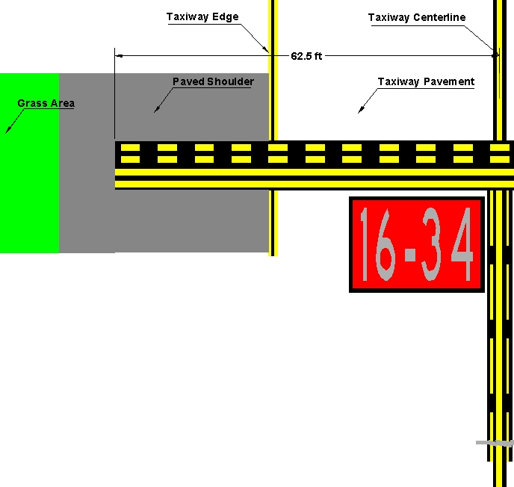

Figure C-3. Enhanced Runway Holding Position Markings on Taxiways

5. SURFACE PAINTED HOLDING POSITION SIGNS.

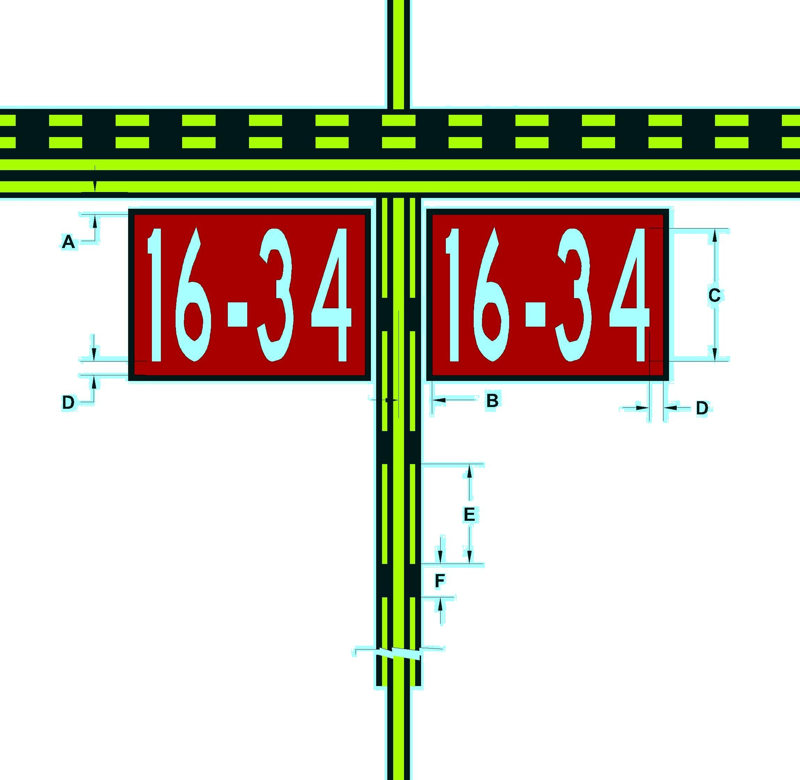

Dimension Letter | Dimension  feet (meters) | Notes
A | 2 – 4  (0.67 – 1.34)
B | 3 – 10  (0.91 – 2.75)
C | 9 – 12  (3.0 – 3.67) | The inscriptions must have a height of 12 feet (3.67 m); however, the height may be reduced, as necessary, to the minimum height of 9 feet (3 m). In special situations, the surface painted marking may be reduced below 9 feet (3 m) in order to fit the marking appropriately. Examples include taxiways with widths narrower than 75 feet (23 m) or taxiways that need to display multiple runway designations with arrows. In all cases, the inscriptions follow Appendix 1 inscription criteria. All other taxiway entrances to the same runway not needing the reduction are to maintain the 12 foot (3 m) height dimension. For practicality, the lowest height reduction is 3 feet (1 m).
D | 15 inches  (38 cm)
E | 9  (2.75)
F | 3  (0.91)

Figure C-4. Surface Painted Holding Position Signs

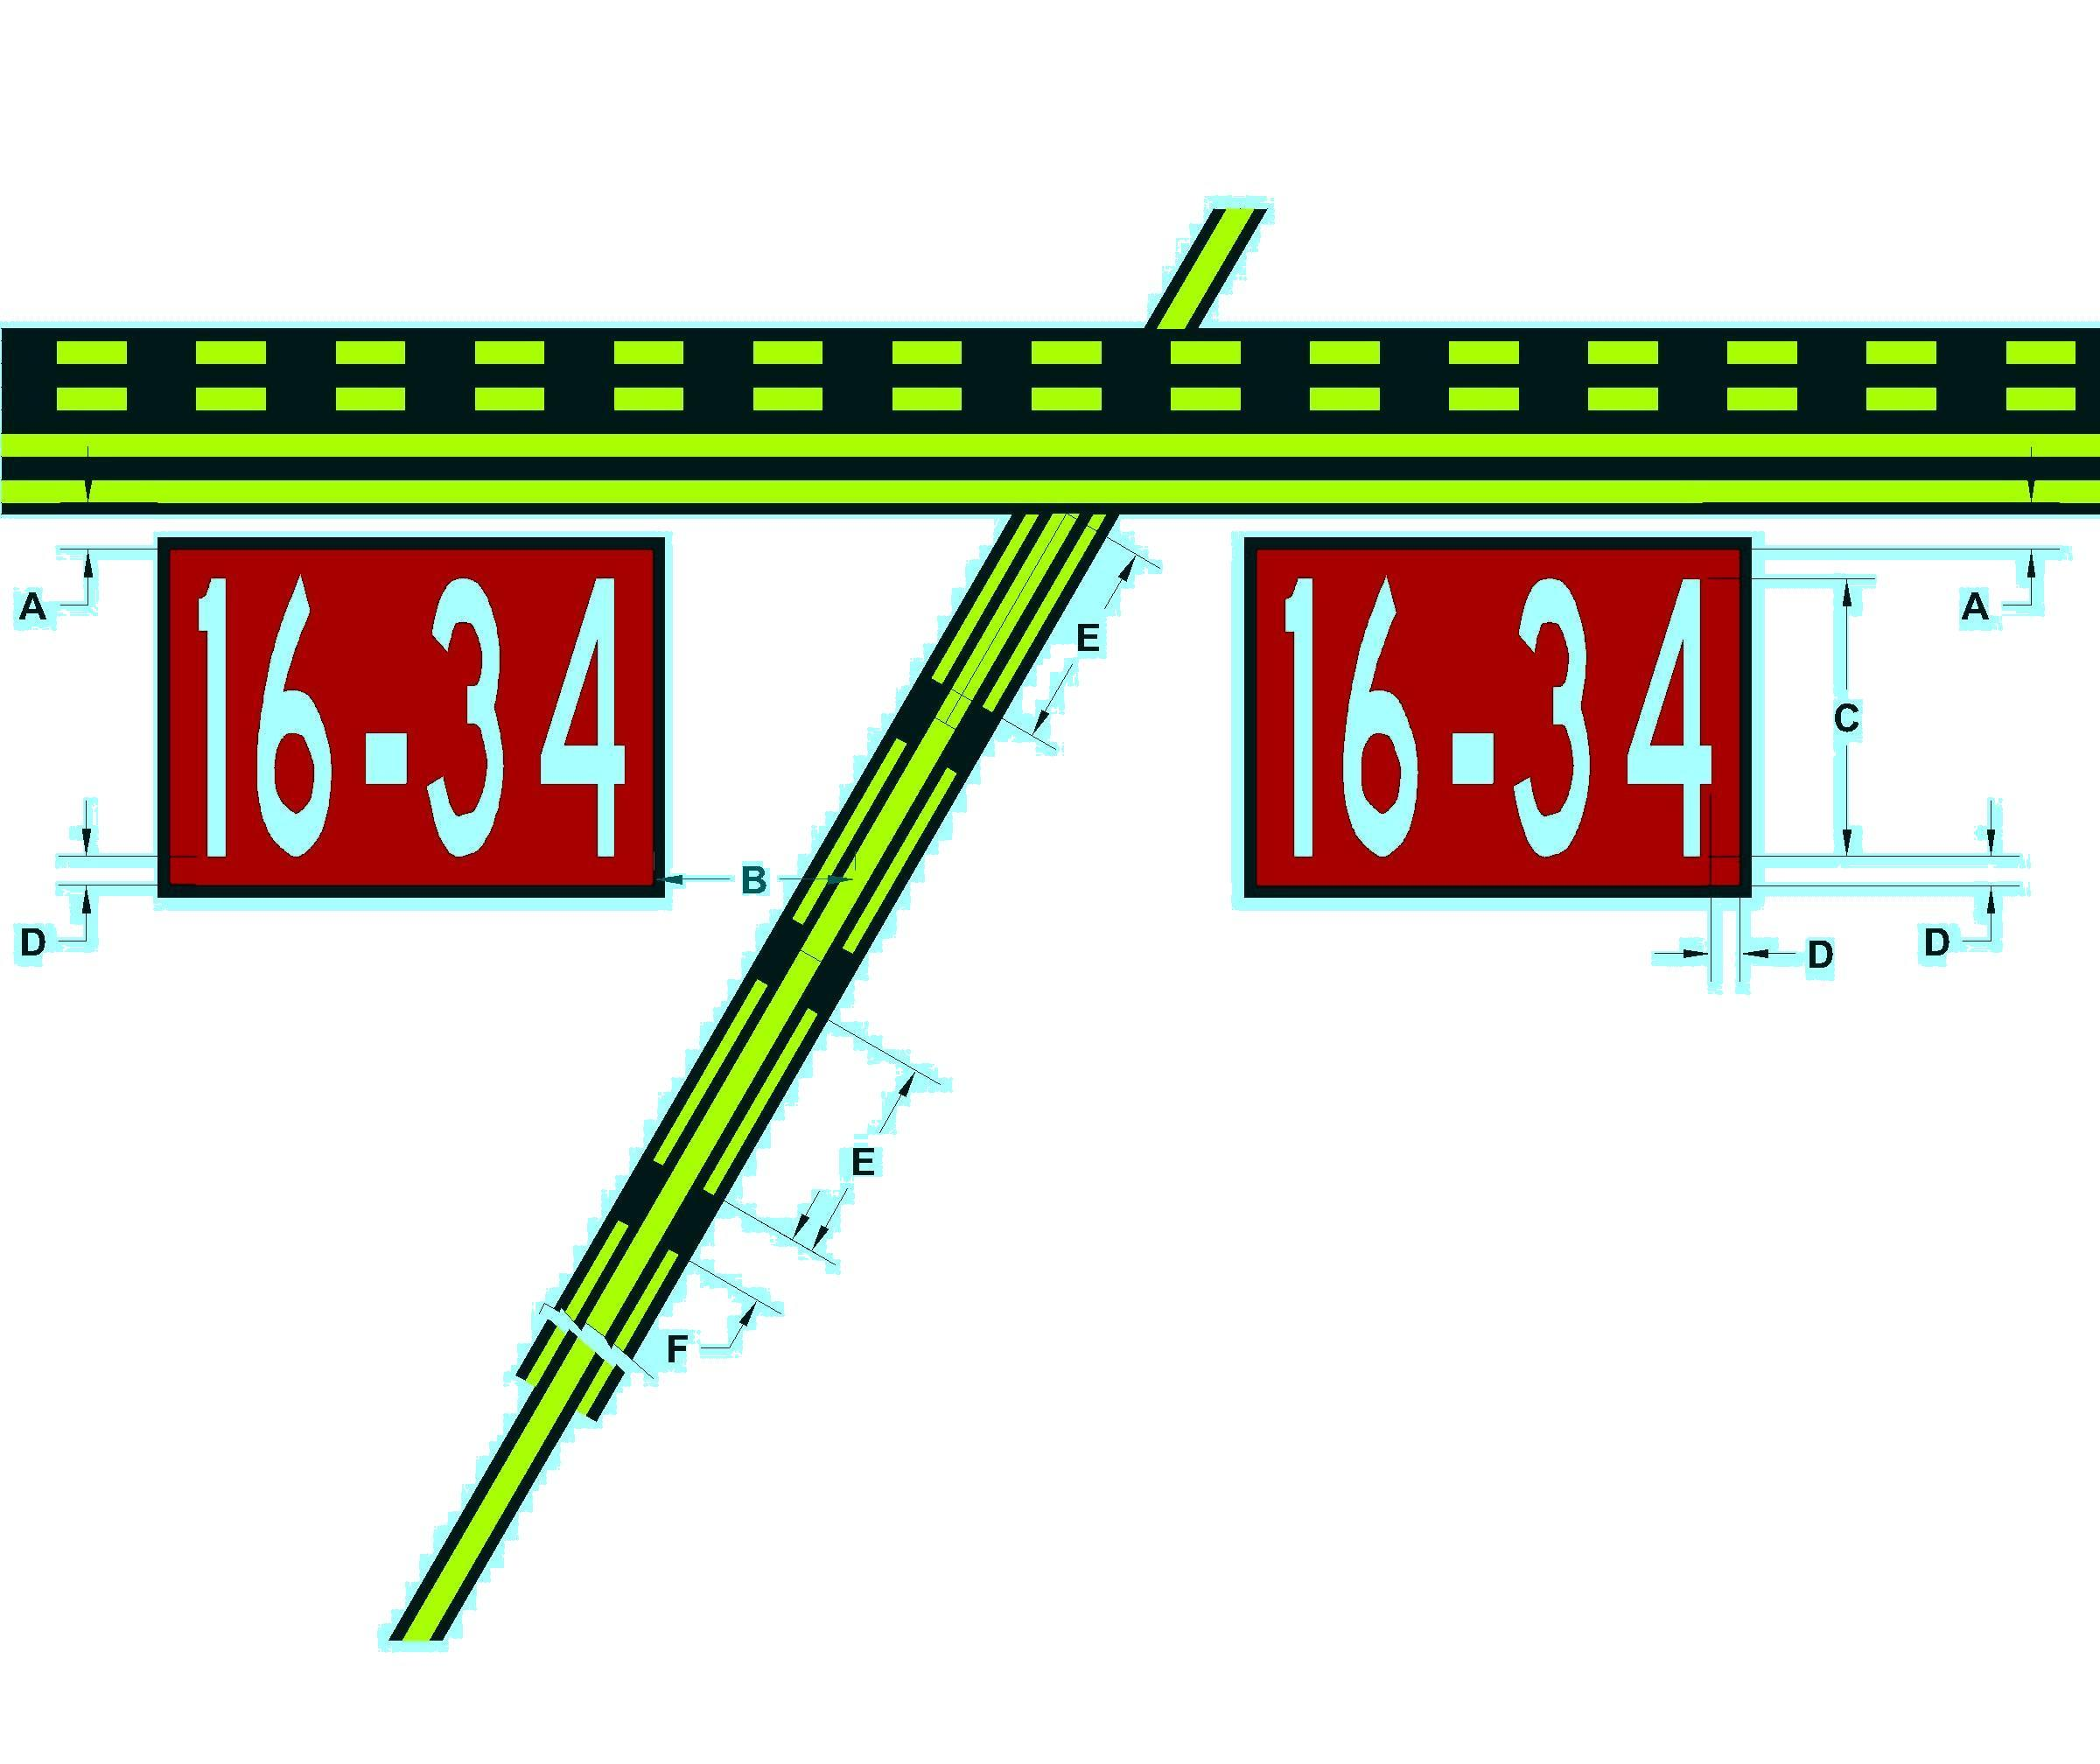

Dimension Letter | Dimension  feet (meters) | Notes
A | 2 – 4  (0.67 – 1.34)
B | 3 – 10  (0.91 – 2.75)
C | 9 – 12  (3.0 – 3.67) | The inscriptions must have a height of 12 feet (3.67 m); however, the height may be reduced, as necessary, to the minimum height of 9 feet (3 m). In special situations, the surface painted marking may be reduced below 9 feet (3 m) in order to fit the marking appropriately. Examples include taxiways with widths narrower than 75 feet (23 m) or taxiways that need to display multiple runway designations with arrows. In all cases, the inscriptions follow Appendix 1 inscription criteria. All other taxiway entrances to the same runway not needing the reduction are to maintain the 12 foot (3 m) height dimension. For practicality, the lowest height reduction is 3 feet (1 m).
D | 15 inches  (38 cm)
E | 9  (2.75)
F | 3  (0.91)

Figure C-5. Surface Painted Holding Position Signs when Taxiway Centerline is not Perpendicular to Runway Holding Position Marking

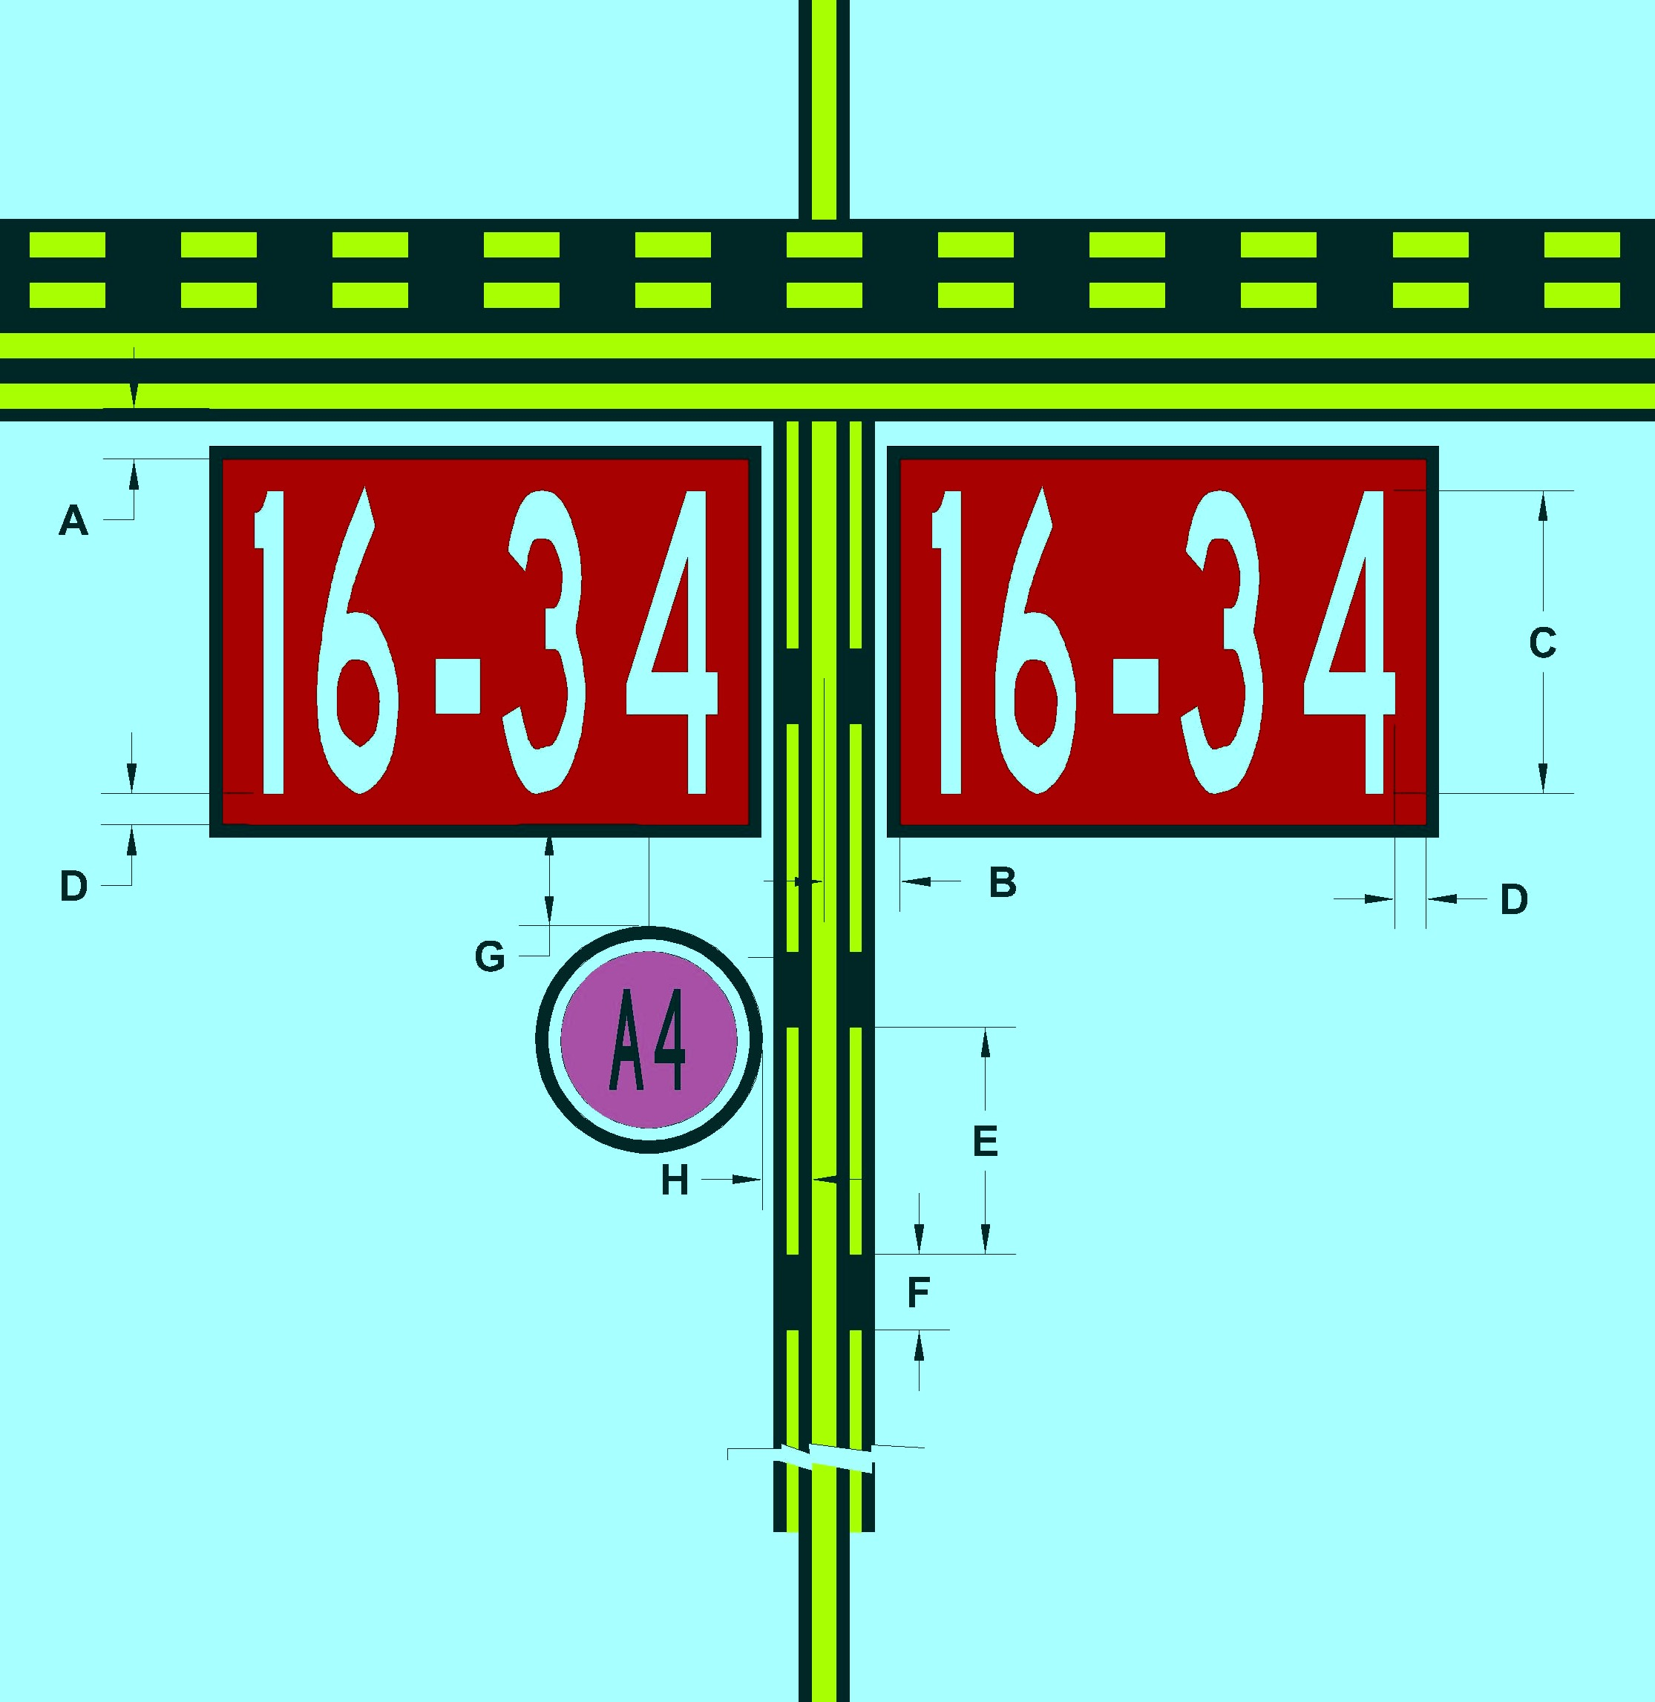

Dimension Letter | Dimension  feet (meters) | Notes
A | 2 – 4  (0.67 – 1.34)
B | 3 – 10  (0.91 – 2.75)
C | 9 – 12  (3.0 – 3.67) | The inscriptions must have a height of 12 feet (3.67 m); however, the height may be reduced, as necessary, to the minimum height of 9 feet (3 m). In special situations, the surface painted marking may be reduced below 9 feet (3 m) in order to fit the marking appropriately. Examples include taxiways with widths narrower than 75 feet (23 m) or taxiways that need to display multiple runway designations with arrows. In all cases, the inscriptions follow Appendix 1 inscription criteria. All other taxiway entrances to the same runway not needing the reduction are to maintain the 12 foot (3 m) height dimension. For practicality, the lowest height reduction is 3 feet (1 m).
D | 15 inches (38 cm)
E | 9 (2.75)
F | 3 (0.91)
G | 4  (1.3) | From edge of red border
H | 2  (0.65) | From outermost edge of main yellow taxiway centerline
Note: Because the geographic position marking cannot be located at a runway holding position for the low-visibility runway (see Paragraph 32(b)), this figure would apply only where the designated taxi route for low-visibility operations crosses a runway that is not itself the low-visibility runway.

Figure C-6. Surface Painted Holding Position Signs Co-Located with a Geographic Position Marking

