U.S. Department  of Transportation  Federal Aviation  Administration | Advisory  Circular

Subject: Change 7 to MEASUREMENT, CONSTRUCTION, AND MAINTENANCE OF SKID-RESISTANT AIRPORT PAVEMENT SURFACES | Date: 12/05/2005  Initiated by: AAS-100 | AC No: 150/5320-12C  Change: 7

- PURPOSE. This change updates information regarding FAA qualified Continuous Friction Measuring Equipment.

2. PRINCIPAL CHANGES. The following editorial changes have been made:

a. Appendix 4. Changes have been made to reflect updated information for manufacturers.

PAGE CONTROL CHART
Remove Pages | Dated | Insert Pages | Dated
Appendix 4  pg. 1 (and 2) | 05/25/05 | Appendix 4  pg. 1 (and 2) | 12/05/05

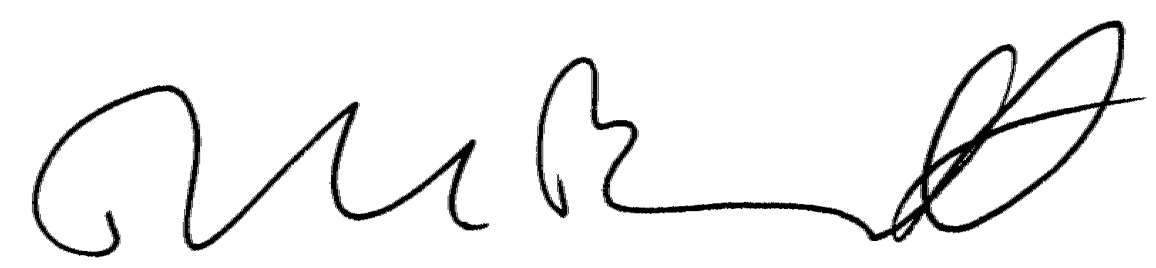

DAVID L. BENNETT
Director of Airport Safety
and Standards

APPENDIX 4. FAA APPROVED CFME

AIRPORT SURFACE FRICTION TESTER INDUSTRIES AB AIRPORT SURFACE FRICTION TESTER
Metallgatan 7 +46 0 411 651 00
271 39 Ystad, Sweden FAX +46 0 411 190 12
SWEDEN email: sales@asft.se

AIRPORT TECHNOLOGY USA SAFEGATE FRICTION TESTER
NO LONGER AVAILABLE

DOUGLAS EQUIPMENT LTD MU METER
Douglas House, Village Road +44 1242 531219
Arle, Cheltenham FAX +44 1242 571667
Gloucestershire email: spd@douglas-equipment.com
GL51 0AB UK
DYNATEST CONSULTING, INC., RUNWAY FRICTION TESTER (6810, 6850 and 6875)
(FORMERLY K.J. LAW ENGINEERS, INC.) +(904) 964-3777
13952 US Highway 301 South FAX +(904) 964-3749
Starke, FL 32091
FINDLAY, IRVINE, LTD. GRIPTESTER FRICTION TESTER
42-44 Bog Road, Penicuik +44 1968 672111
Midlothian EH 26 9 BU FAX +44 1968 671237
SCOTLAND www.findlayirvine.com
INTERTECH ENGINEERING TATRA FRICTION TESTER
NO LONGER AVAILABLE

NEUBERT AERO CORP. NAC DYNAMIC FRICTION TESTER
4105 West De Leon Street +(727) 538-8744
Tampa, FL 33609 FAX +(727) 538-8765
email: info@airportnac.com
www.airportnac.com
NORSEMETER RUNAR RUNWAY ANALYSER AND RECORDER
P. O. Box 125 +47 23 20 1270
Bogstadvien FAX +47 23 20 1271
0323 0310
NORWAY
PATRIA VAMMAS AEC BV-11 SKIDDOMETER
P.O. Box 18 Vammaksentie +358 20 4694041
FIN-38201 Vammala FAX +358 20 4694250
FINLAND www.patria.fi
SCANDINAVIAN AIRPORT AND ROAD SYSTEMS AB SARSYS FRICTION TESTER (SFT)
Box 31, Sjoviksvagen 4 SARSYS TRAILER FRICTION TESTER (STFT)
23121 Trelleborg +46 410 46 110
SWEDEN FAX +46 410 46 111
US/Canada Tradewind Scientific Ltd. www.tradewindscientific.com

CONCURRENCES
ROUTING SYMBOL
AAS-100
INITIALS/SIG
DATE
ROUTING SYMBOL
AAS-2
INITIALS/SIG
DATE
ROUTING SYMBOL
INITIALS/SIG
DATE
ROUTING SYMBOL
INITIALS/SIG
DATE
ROUTING SYMBOL
INITIALS/SIG
DATE
ROUTING SYMBOL
INITIALS/SIG
DATE
ROUTING SYMBOL
INITIALS/SIG
DATE
ROUTING SYMBOL
INITIALS/SIG
DATE

