Allotment Management Plan
Baker Creek Allotment

Ketchum Ranger District

Sawtooth National Forest

Prepared by: Date:
(Title)

Reviewed by: Date:
Permittee

Date:
Permittee

Date:
Permittee

This Allotment Management Plan implements direction established in the July 2003 Revision of the Sawtooth National Forest Land and Resource Management Plan and the September 30, 2004 Record of Decision for the Baker Creek Allotment Final Environmental Impact Statement. This Allotment Management Plan is made part of your Term Grazing Permit in accordance with Section 8(a) Part 2 of that permit.

Approved by: Date:
District Ranger

Table of Contents

I. PURPOSE 3
A. Area Map 4
II. GOALS & OBJECTIVES 5
A. Forest Plan 5
1. Forest-Wide Goals 5
2. Forest-Wide Objectives 5
3. Management Area Goals (Prescriptions) 5
4. Management Area Objectives 6
B. North Fork-Boulder and Baker Creek ROD 7
1. Goals 7
2. Objectives 7
C. Desired Conditions 7
1. Forest Plan Level 7
2. Allotment Specific 7
a) Riparian 7
(1) Riparian Associations common to the allotment 8
b) Sagebrush & Non-forested Uplands 9
c) Aspen 9
d) Noxious Weeds 9
III. Adaptive Management Actions 10
A. Adaptive Management Decision Tree 11
B. Potential Adaptive Management Actions 15
IV. MANAGEMENT REQUIREMENTS 20
A. Livestock kind, class, numbers permitted, and season: 20
V. General Grazing Prescription: 21
VI. IMPROVEMENTS 22
VII. MONITORING 22
A. Implementation Monitoring: 23
1. Riparian Implementation Monitoring: 24
B. Effectiveness Monitoring: 24
1. Riparian Effectiveness Monitoring: 24
2. Upland Effectiveness Monitoring: 25
3. Aspen Monitoring: 26
4. Alpine Community monitoring: 26
VIII. References 28

PURPOSE

The Federal Land Policy Management Act (FLPMA), as amended by the Public Rangelands Improvement Act (PRIA) allows for Allotment Management Plans (AMPs) to be included in grazing permits at the discretion of the Secretary of Agriculture (43 U.S.C. (1752(d), as amended by 92 Stat. 1803 (1978)). The Secretary has elected to exercise this discretion, and has delegated his authority to issue regulations in this area to the Chief of the Forest Service (36 CFR 222.1 et.seq.). An AMP is defined in FLPMA as a document prepared in consultation with permittees applying to livestock operations on the public lands (1) prescribing the manner in and extent to which livestock operations will be conducted in order to meet multiple use, sustained yield, economic and other needs and objectives,(2) describing range improvements to be installed and maintained, and (3) containing such other provisions relating to livestock grazing and other objectives found by the Secretary to be consistent with the provisions of the FLPMA (43 USC 1702(k), and 36 CFR 222.1(b)( 2), and FSM 1023)..

This AMP contains the pertinent livestock management direction specific to implementing the July 2003 revision of the Sawtooth National Forest Land and Resource Management Plan (Forest Plan) and the September 30, 2004 North Fork-Boulder and Baker Creek Allotment Management Plan Updates Record of Decision (ROD). This AMP is included as part of any term grazing permit that authorizes livestock grazing on the Baker Creek Allotment per Section 8(a) Part 2 of the term grazing permit.
This AMP implements an adaptive management approach to livestock management on the Baker Creek Allotment. Adaptive management provides for: 1) identification of site specific desired conditions; 2) definition of appropriate decision criteria (constraints) to guide management; 3) identification of pre-determined optional courses of action, as part of a proposed action, from which to adjust management decisions over time; and 4) establishment of carefully focused project monitoring to be used to make adaptive adjustments in management over time (R4 FSH 2209.13 chapter 90). This AMP is an essential part of implementing this direction. As such, the management requirements, improvement needs, and monitoring plan may be modified as needed to insure that management direction is consistent with achieving the direction established in the Forest Plan and ROD. Additional NEPA analysis and decision processes will not be needed as long as the direction identified in this plan is consistent with the analysis conducted in the September 2004 North Sheep Final Environmental Impact Statement (FEIS). Adaptive of vegetation improvement projects which were not specifically addressed in the FEIS. These will require additional analysis at the appropriate level and scale.

Adaptive management protocols will follow the direction established in the Rangeland Resources Forest Plan Implementation Guide of 11/3/2005 (attached as Appendix A).

Area Map
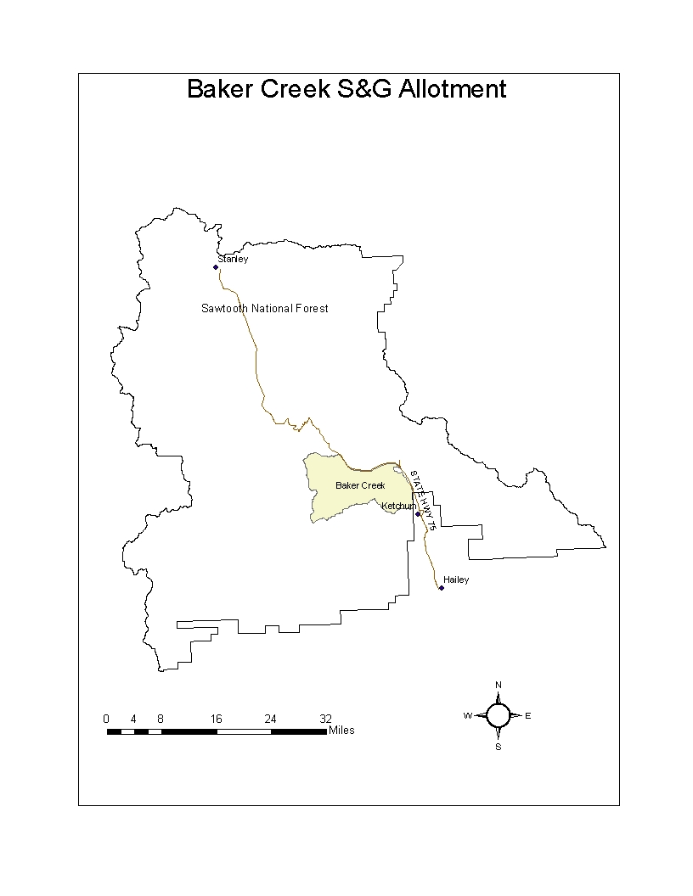

GOALS & OBJECTIVES

Forest Plan
Forest Plan goals and objectives are identified at two scales. The Forest Plan scale describes goals and objectives that are generally applied to all areas within the Forest. The management area scale describes management direction for specific management areas within the National Forest. This allotment falls within the Big Wood River Management Area (Management Area No. 4).

Forest-Wide Goals
RAGO01- Provide for livestock forage within existing open allotments, in a manner that is consistent with other resource management direction and uses.
RAGO02- Manage rangelands using controlled livestock grazing, range structural and non-structural improvements, vegetative and ground rehabilitation, fire, and timber management in various combinations to meet desired conditions.
RAGO03- Manage upland vegetation on suitable rangelands to maintain or restore hydrologic function and soil productivity of watersheds.
RAGO04- Manage herbaceous and shrub vegetation on suitable rangelands to meet resource objectives in an efficient manner.
RAGO05- Manage livestock grazing within riparian areas to accommodate the maintenance or restoration of aquatic and riparian processes and functions.
RAGO06- Coordinate livestock grazing to address conflicts with other resource uses in a manner that is consistent with Forest Plan management direction.
VEOB03- Utilize emerging technologies and science, and implement adaptive management process to provide for increasing the effectiveness of vegetation monitoring.
VEOB06- Determine high priority areas for vegetation management actions that restore or maintain desired vegetation attributes.

Forest-Wide Objectives
RAOB01 - Coordinate the design, update and/or revision of AMPs with adjacent landowners to maximize opportunities and minimize potential management conflicts.
RAOB02 - Coordinate livestock grazing with timber harvest and forest regeneration activities to capitalize on management opportunities, while minimizing activity conflicts to help meet Forest Plan Vegetation and Rangeland Resource goals.
RAOB03 - Identify rangeland facilities that are degrading resource conditions and prioritize opportunities to mitigate their effects or to initiate restoration of resource conditions.

Management Area Goals (Prescriptions)
Management prescriptions are defined as, “Management practices and intensity selected and scheduled for application on a specific area to attain multiple use and other goals and objectives” (36 CFR 219.3). Management prescription categories (MPC) are broad categories of management prescriptions that indicate the general management emphasis prescribed for a given area. They are based on Forest Service definitions developed at the national level, and represent management emphasis themes, ranging from Wilderness (1.0) to Concentrated Development (8.0). The national MPCs have been customized during Forest Plan revision to better fit the needs and issues of the Forest. The allotment includes two MPCs, MPC 4.1c and 4.2 (see map).

4.1c – Undeveloped Recreation: Maintain Unroaded Character with Allowance for Restoration Activities
This prescription applies to lands where dispersed recreation uses are the primary emphasis. Providing dispersed recreation opportunities in an unroaded landscape is the main objective. Both motorized and non-motorized recreation opportunities may be provided. Other resource uses are allowed to the extent that they do not compromise the area’s Recreation Opportunity Spectrum (ROS) settings.

4.2 – Roaded Recreation Emphasis
This prescription applies to lands where dispersed and developed recreation uses are the primary emphasis. A wide range of recreational activities and developments occurs. Facilities are maintained, and both motorized and non-motorized recreation opportunities may be provided. Multiple uses such as timber harvest and grazing are allowed to the extent that they do not compromise recreation resource objectives. Generally, a mix of mechanical and fire activities are used to treat vegetation to achieve desired conditions for recreation settings and developments, and to reduce the risk of uncharacteristic vegetative damage or loss from insects, diseases, and fire.

Management Area Objectives
- Minimize further surface soil loss due to late season livestock grazing impacts on upland vegetation in Baker Creek. (Objective 0437)
- Restore dry meadows by improving specie composition, reducing compaction and increasing plant vigor from Baker Creek north due to the effects of livestock grazing. (Objective 0447)
- Maintain and restore habitat for deer, elk, migratory land birds, and sage grouse in lower elevation sagebrush communities.( Objective 0456)
- Coordinate seasonal road closures with Idaho Department of Fish and Game to reduce elk mortality and disturbance in the East Fork of Baker Creek.(Objective 0457)
- Adjust management practices to minimize livestock/recreation conflicts within high density recreation areas from Fox Gulch north, to include Baker Creek., and Prairie Creek (Objective 04109)
- Discontinue sheep grazing in the Adams Gulch drainage to eliminate conflicts between grazing and concentrated recreation use. (Objective 04110)
- Prevent the spread of noxious weed seeds due to domestic sheep by adjusting or changing management practices, such as trailing route locations and driveway/grazing area seasons of use. (Objective 04111)
- Do not bed sheep within designated campgrounds or summer home tracts, or on trails, trailheads, or maintained roads.( objective 04112)

North Fork-Boulder and Baker Creek ROD

Goals
Achieve and maintain sustainable grazing system on the Baker Cr. Allotment
Implement adaptive management approach
Authorize grazing in a manner that will meet FLRMP standards
Achieve or make progress towards FLRMP desired conditions affected by grazing

Objectives
- Confine, reduce or eradicate, noxious weed infestations, particularly spotted knapweed in the Fox Cr., Oregon Gulch, Hulen Meadows and Phantom hill areas.
- Prevent the spread of noxious weeds seeds due to domestic sheep by adjusting or changing management practices, such as trailing routes, and grazing area seasons of use.
- Attempt to restore about 100 acres of seasonally wet meadows dominated by Wyethia through rest and possible seeding.
- Adjust management practices to minimize livestock/recreation conflicts within high density recreation areas from Fox Cr. to Prairie Creek.
- Provide for high –quality mountain goat forage by minimizing or eliminating summer and fall forage use by domestic sheep in the high basins.
- Restore the protective soil mantle and indigenous plants species that are characteristic of these extreme high altitude environments by adhering to closures.
- Increase vegetative cover, density, and structure to uplands sites in the East Fork of Baker, Upper Fox Cr. Baker Cr. and the deposition areas adjacent to the tributaries of the Big Wood River. Implementation monitoring and stocking adjustments will be emphasized.

Desired Conditions

Forest Plan Level
Rangeland Resource Desired Condition. A sustainable level of forage, consistent with other resource management direction, is available for use through the Forest Service grazing permit system. Rangeland forage quality is maintained or improved in areas where vegetation management projects and range management actions occur. Riparian areas continue to be a focal point for providing vegetative diversity, landscape capability, soil productivity, wildlife habitat, proper stream channel function, and water quality important to sustaining beneficial uses. Riparian areas are functioning properly and/or have improving trends in vegetative composition, age class structure and vigor. Upland range vegetation is contributing to proper hydrologic function. The composition and densities of shrubs, grasses and forbs are variable and dynamic across the landscape.

Allotment Specific

Riparian
Streambank vegetation in late seral condition per Winword 2000 Classification
Bank Stability at 90 % of potential in areas impacted by grazing. Manage for
Maximum of 45% use or retain a 4-inch stubble height of hydric greenline specie.

Riparian Associations common to the allotment
Salix exigua/mesic graminoid- Characterized by overstoru of Salix exigua with moderate to dense cover of graminoid species, including Carex nebrascensis, C. lanuginose, Juncus balticus, Eleocharis palustris, Agrostis stolonifera, Scirpus pungens, and Agropyron repens. The rhizomatous graminoid cover in this association results in high soil-holding and streambank stability. Care must be taken to prevent increased grazing levels from causing these stand stands to dry out and being replaced with bluegrass.

Salix geyeriana/mesic forb- Characterized by Salix Geyeriana with some S. drummndiana and S. boothii, and understory shrubs of Ribes inerme, Amelanchier alnifolia, and forb component of Veratrum, Senecio, Heracleum, Geum, and graminoids such as Agrostis stolonifera, Carex nebrascensis, and poa pratensis. This association has moderate value for grazing, and is characterized by corridors between willow clumps, providing livestock access. These types must be closely monitored to prevent lost vigor, decreased stand density, and eventual elimination of the willow component.

Salix geyeriana/mesic graminoid- Characterized by Salix geyeriana and a diverse mix of graminoids such as Carex lanuginose, Deschampsia cespitosa, C. microptera, C. aquatilis, C. ultriculata , and forbs including Taraxacum officinale, Achillea millefolium, Trifolium, and Potentella gracilis. This association has a high cover of grasses and sedges making this association highly productive for livestock forage. Overgrazing can lead to replacement of the carex sod mats with bluegrass which are much poorer at soil stabilization leading to bank sloughing, creek widening, and water table alterations. One time watering along a reach of creek, and moving nooning sheep away from the stream will minimize adverse impacts from watering.

Sagebrush & Non-forested Uplands
Sagebrush meets FLRMP standards of:
30-40% of area in 0-10% canopy cover class
30-40% of area in 11-20% canopy cover class
20-30% of area in 21-30% canopy cover class
<= 5% of area in > 30% canopy cover class

Note: Recovery to meet this condition will require disturbance treatment by fire or other means irrespective of sheep management practices. This will require planning treatment projects with additional NEPA analysis as funds and priorities warrant.
Soil Cover on grazed areas will be within the desired range based on information available for existing land type classifications.
Plant composition on grazed areas will include species diversity and presence as described in FLRMP App. B.
Perennial Grass Slopes (10-18 in. precipitation zone). Bluebunch wheatgrass is the dominant bunch grass. Perennial grasses compose 80-90% of production. Sandberg bluegrass is a minor component of the vegetation. Common forbs include Indian wheat, shining chickweed, salsify, yarrow, lupine, balsamroot, biscuit root, hawksbeard, fleabane, milkvetch and phlox. Noxious weeds are absent.
Perennial Grass Montane (14 – 30 inch precipitation zone). This type is interspersed with sagebrush, forested and mountain brush types. Idaho fescue is the dominant grass. Other species may include intermediate oatgrass, western needlegrass and Richardson needlegrass. Forbs compose 40-65% of production. Common forbs are yarrow, besssaya, geum, Indan paintbrush, lupines, phlox, and balsamroot.

Aspen
Desired Condition at the Stand Level
Aspen dominates the overstory canopy (aspen >8” DBH. Over 2/3rds of the
Over story is Aspen.
Aspen dominates the mid-level canopy (aspen 1-8” DBH). Over 2/3rds of this
Level of canopy is composed of aspen.
There is significant aspen regeneration occurring to support a healthy stand.
The stand has over 500 stems per acre<1in. DBH with less than 20% having Multiple leaders or are hedged from browsing.
Less than 20% of the stand contains sagebrush.

Noxious Weeds
Areas on the Allotment which do not currently have noxious weed infestations will be maintained noxious weed free. Current noxious weed infestations will be contained and weed density reduced.

Adaptive Management Actions
Adaptive management is a strategy based on three principles:
- Achievement of realistic, clearly defined objectives;
- Ongoing monitoring to assess progress toward those objectives; and
- Flexibility to alter management when adequate progress is not being achieved.

This management strategy is most appropriate in dynamic situations, where change is the norm. Change can be a characteristic of the management setting, or the result of management activities, or both. In such situations, adaptive management is the most efficient way to achieve desired objectives.

The Sawtooth Forest Plan recognizes that most physical, biological, social, and economic systems are dynamic and that management must be correspondingly flexible in order to be effective.

The adaptive management procedure is based on both annual grazing use and long-term monitoring to determine if management is achieving long-term management objectives. Establishing a relationship between annual grazing use and achievement of long-term objectives necessarily emphasizes use of end-of-season annual grazing use indicators, as well as long-term indicators of rangeland condition. Within-season annual grazing use indicators may also be established through the adaptive management process to determine when livestock should be moved from a grazing unit to achieve appropriate end-of-season grazing use levels and resource management objectives. Annual grazing use indicators (including Forest Plan Standards and Guidelines), both within-season and end-of-season, along with other required management practices, are a total package that, when implemented and adhered to, will result in a reasonable expectation that long-term desired condition objectives will be achieved.

Adaptive Management Decision Tree
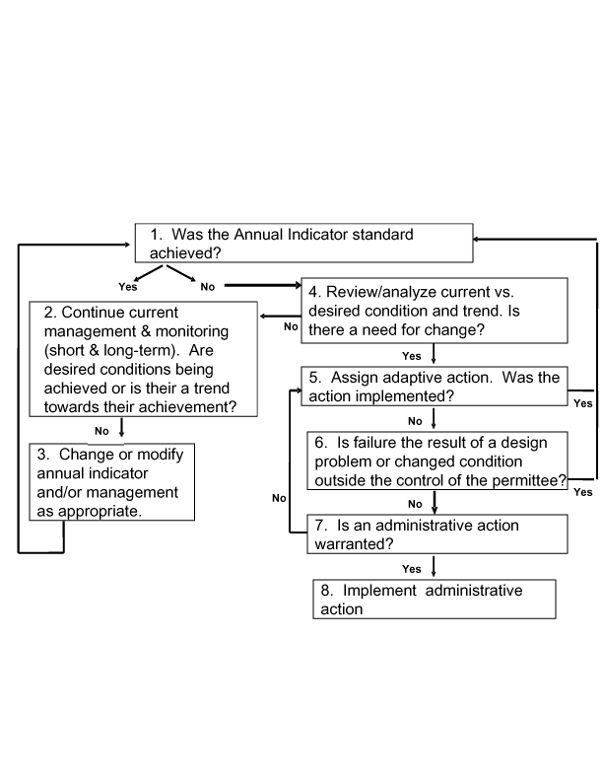

In Block 1, the grazing permittee(s) and/or land manager evaluates whether the annual grazing use indicator or standard was met. This assumes that the correct indicator and value was being used. These annual indicators are initially set in the Forest Plan and NSEIS ROD. The adaptive management process provides the opportunity to evaluate and adjust annual grazing indicators. As the adaptive management process is followed, indicators may be modified based on the results of annual and long-term monitoring.
This may be subject to re-evaluation later in the process.

- Annual Indicator or Standard is Met: If the annual grazing use indicator is met, current management will continue, including short- and long-term monitoring as indicated in Block 2.

A1. Continue Current Management and Monitoring (Block 2): Long-term monitoring indicators are used to assess whether management objectives for resource conditions and values are being achieved. This data will be used over time to determine the effectiveness of management direction and/or annual grazing use indicators in achieving the desired conditions. Note: The adaptive management process may begin with this block when long-term monitoring is completed and evaluated.

A2. Modify the Annual Indicator and/or Management as Appropriate (Block 3): If the desired condition objective is not being achieved, there is a need to change management and/or modify either the type or value of annual grazing use indicators being used.

If the desired condition objective is achieved, it may be possible to modify either the value or type of annual grazing use indicator and still maintain the desired condition. An example would be relaxing the numerical value (i.e., 4-inch versus 6-inch stubble height) or changing the type of annual grazing use indicator being used (i.e., change indicator from herbaceous utilization to woody utilization).

- Annual Grazing Use Indicator or Standard Is Not Met: If the grazing use exceeds the annual grazing use indicator or standard, proceed to the evaluation steps in Block 4.

B1. Analysis and Determination of the Need for an Adaptive Management Adjustment (Block 4): If the grazing use exceeds the established annual grazing use indicator or standard, the resource manager, in consultation with the permittee(s) and others as appropriate, determine: 1) the potential cause for exceeding the standard, and 2) the significance of the excessive grazing use relative to its impact on the achievement of the desired resource conditions.

The resource manager, in consultation with the permittee(s), should determine whether the failure to meet the annual grazing use indicator is an infrequent occurrence or whether there is routine difficulty in meeting annual grazing use standards. A one-time occurrence due to some unique variable may not be significant and may not require further evaluation or adaptive management adjustments. Routine difficulty in meeting the annual grazing use indicator may indicate further evaluation and the need for adaptive management adjustments.

If further evaluation is warranted, comparison of the current condition with the desired condition should be made. If there is a large departure between current conditions and desired resource conditions, it may be fairly obvious that the need to achieve the annual use indicator is significant and that adaptive management actions are needed to provide for the achievement of the annual use indicator and meet long-term objectives.

While the evaluation of current versus desired conditions should be made with the use of long-term monitoring data, this information may not be available. In that case, utilize the best available information or complete a simple and rapid qualitative analysis to compare current conditions with desired conditions. While long-term trend and condition information is preferred, the lack of such information should not delay the evaluation of the current rangeland condition and needed adaptive management adjustments. Adaptive management adjustments should be temporary modifications until quantitative long-term condition and trend information is available to support permanent changes. If the resource manager’s evaluation concludes that current conditions are close to desired resource conditions, then failure to achieve the annual grazing use indicator during that grazing season may not be significant in terms of achieving long-term objectives. In this case, adaptive management adjustments may not be necessary. Existing management and monitoring to achieve desired conditions would continue (Blocks 2 and 3). The exception to this situation may be where available information indicates that the long-term trend is negative, and adaptive management adjustments are needed.

If the resource manager’s evaluation concludes that there is a significant gap between current and desired conditions and there is no indication of a positive trend, then the need for adaptive management adjustments are indicated.

Note: Determination of “large departure” may be either qualitative or quantitative depending on available information. Interdisciplinary teams or resource specialists may rely on personal experience, observations, and/or quantitative assessments to make this determination. Where available, quantitative data such as is found in the Natural Conditions Database (Overton et.al. 1995), could be used. For example, a bank stability rating that is greater than the standard error in the Database could be used to define “large departure”. Where observational data is used for this determination, specialists should use photographs and/or descriptions of the observed conditions related to desired conditions to support the need for changing management and/or use indicators.

B2. Development and Implementation of Adaptive Management Adjustments (Block 5): If adaptive management adjustments are warranted, the resource manager develops these actions in collaboration with the permittee(s) and others, as appropriate. The adaptive actions are implemented through annual authorizations or operating instructions issued by the resource manager. These actions typically include, implementation of additional or more restrictive annual use criteria; change in season, timing, or duration of grazing; changes in numbers of livestock; changes in herding or routing practices; changes in grazing rotations; closures or resting areas from grazing; changes in salting and watering practices, and changes in other livestock management practices and requirements.
Once adaptive management adjustments are developed and assigned, the resource manager, in collaboration with permittee(s) and others, as appropriate, must assess whether the adaptive management adjustments were implemented as designed during the following grazing period.

If adaptive management adjustments were implemented by the permittee(s), then a determination as to whether these adjustments achieved the annual grazing use indicator would be made the following grazing period (Block 1). If the adaptive management adjustments were effective in achieving the annual grazing use indicator, then management and monitoring would continue as planned (Blocks 2 and 3). If they were not effective, then the resource manager, in collaboration with permittee(s) and others, as appropriate, must determine what additional adaptive management actions are needed (return to Block 5). Adaptive management actions considered in the proposed action are described below.
B3. Adaptive Management Adjustment Not Implemented (Block 6): If the adaptive management adjustments were not implemented, the resource manager must determine if the failure results from a design problem or changed condition, outside the control of the permittee(s). If there were problems with the design or ability to implement the adaptive management adjustments outside the control of the permittee(s), the resource manager and/or permittee(s) would revisit the design or selection of the adaptive management adjustment (return to Block 5).

B4. Determination of Non-compliance (Block 7): If failure to implement the adaptive management adjustment is not related to the design or inability to implement the adaptive action by the permittee(s), the resource manager would assess the need for an administrative action. If the resource manager determines that an administrative action is not warranted, additional changes or adaptive management direction should be considered (return to Block 5).

B5. Issue Notice of Non-compliance (Block 8): If failure to implement adaptive management adjustments is an issue of permittee(s) performance and compliance or is repetitive, then take appropriate action under the grazing regulations (36 CFR Part 222.4), Forest Service Manual direction (FSM 2231.6), and Forest Service Handbook direction (FSH 2209.13 sec. 16 & R4 FSH 2209.13 sec. 16).

This AMP is a component of the grazing permit that authorizes grazing use on National Forest System lands. The AMP implements management direction designed to achieve the goals and directives identified in the Forest Plan and allotment level NEPA decisions.

Annually, Agency personnel meet with the grazing permittees to evaluate management activities and accomplishment of the grazing objectives. During these annual meetings, the previous year’s grazing use and monitoring is reviewed, and annual operating instructions (AOI) are developed for the following grazing season. The AOI adapts management direction from the AMP, term grazing permit, and NEPA decisions to the current conditions and expectations for the grazing season. The AOI sets the stage for the on-the-ground application of management direction for livestock grazing on the allotment. The AOI are used to implement direction within the context of the existing NEPA decisions and the Agency’s administrative authority established by law and regulation. Actions implemented through the AOI must be consistent with the direction evaluated in the existing NEPA analyses and/or the existing administrative authority of the Agency.

Adaptive management actions may be implemented as long as they are consistent with existing NEPA analyses and decisions and/or the administrative authority of the Forest Service. The administrative authority of the Forest Service is described in Title 36 of the Code of Federal Regulations, part 222; and in Forest Service Manuals and Handbooks. Courses of action that would be considered if monitoring did not indicate progress toward desired future conditions, particularly in light of the constraints discussed above are described in the following section. Such changes would generally be determined in advance and documented in the AOI describing authorized management actions for the upcoming grazing season. Additional NEPA analysis would not be required.

Adaptive management actions should be applied where:
- Monitoring shows management objectives are not being achieved or that trend towards achieving desired conditions is not improving or improving at an adequate rate.
- Annual indicators of grazing use or grazing standards are not met.
- Climatic events, fire, flood or uses and activities detrimentally impact resource conditions and a modification of grazing use is needed to provide for recovery of the site.

Implementation of adaptive management actions will be consistent with the direction established in the December 19, 2005, Forest Plan Grazing Implementation Guide (1920/2200 Memo to District Rangers signed by SE Idaho Forest Supervisors on Dec. 19, 2005). Adaptive actions may be needed and applied in both the short-term and long-term. Adaptive management actions may be implemented singly or as a set of management actions. Short-term actions will be implemented through the AOI. Modifications to the AMP and/or term grazing permit should be considered where monitoring shows that these actions need to be continued in the long-term or are implemented repeatedly or consistently over time.
The following table lists and describes the probable actions that would be considered and implemented under adaptive management. However, it is not intended to exclude other actions which may be authorized by the grazing permit or under authority of 36 CFR 222, Forest Service Manuals and Handbooks, and other laws and regulations as they exist or may be enacted.

Potential Adaptive Management Actions
Table of Potential Adaptive Management Actions | Authority
1. Modify the terms and conditions of a permit to conform to current situations brought about by changes in law, regulation, executive order, development or revision of an allotment management plan, or other management needs. | 36 CFR 222.4
2. Modify the seasons of use, numbers, kind, and class of livestock allowed or the allotment to be used under the permit, because of resource condition, or permittee request. | 36 CFR 222.4 (Change in livestock kind will require additional NEPA evaluation.)
3. Adjustments to sheep numbers and seasons of use. | NSEIS, p. 2-11
4. Implement periods of rest for the allotment or areas within the allotment. | NSEIS, p. 2-11
5. Closure of grazing areas within the allotment. | NSEIS, p. 2-11
6. Implementation of additional grazing restrictions.  Includes: annual grazing use indicators (end of season and/or within season), salting practices, herding practices, and other management practices. | NSEIS, p. 2-11; FLRMP p. III-44 - 47
7. Alteration of trailing routes (timing and location). | NSEIS, p. 2-11; FLRMP p. III-44 - 47
8. Adjust grazing to address conflicts with other resource uses. | FLRMP, p. III-44 - 47
9. Adjust grazing to provide for maintenance or restoration of aquatic and riparian processes and functions and beneficial uses. | FLRMP, p. III-44 - 47
10. Coordinate grazing with timber harvest and forest regeneration activities. | FLRMP, p. III-44 - 47
11. Temporary corrals. | NSEIS p. 2-12 & associated RODs.
12. Structural range improvements and handling facilities (water developments, fences, permanent corrals, etc. | Will require additional NEPA evaluation.
13. Vegetation treatments (prescribed fire, brush control, seedings, etc.) implemented to achieve management objectives and desired conditions. | Will require additional NEPA evaluation.

1. Modification of Terms and Conditions of the Grazing Permit. Term grazing permits may be modified at the request of the permit holder to adjust the permit to his/her ranch operation. It may also be modified to achieve consistency with changes in law and regulation, Forest Plan direction, NEPA decisions, AMP direction, monitoring results, etc. Permit modifications are administrative actions and do not require additional NEPA unless they are inconsistent with existing NEPA analyses and decisions. Permit modifications may include the actions described below.

2. Modify the seasons of use, numbers, kind, and class of livestock allowed or the allotment to be used under the permit, because of resource condition, or permittee request. This action may include changing the timing, duration and intensity of grazing use, class of livestock grazed (ewes with lambs, dry ewes, and rams), changes in allotment boundaries, etc. without additional NEPA as long as these actions are consistent with current NEPA decisions. Changes in kind of livestock such as changing from sheep to cattle use will require additional NEPA analysis. These changes may be implemented at the request of the permittee to adapt grazing to his/her ranch operation or they may be the result monitoring and the need to adapt management to changing conditions using actions such as those described below to achieve resource desired conditions and or resolve conflicts in resource uses.

3a. Modify Season of Use. As appropriate, adjust the season of use for the allotment or areas within an allotment to reduce grazing impacts. These actions include shortening the period of use to reduce or eliminate grazing impacts during periods where plants or other resources are most susceptible to damage, or avoid conflicts with other uses such as during periods of high recreation use. They may include: changing the season of use to avoid grazing impacts or conflicts with critical resource needs of TES species and other wildlife, adjusting the season of use at the request of the permittee to provide a better fit to his/her ranch operation, adjusting the season of use to take advantage of the availability of additional forage through extending the grazing season, and adapting the grazing season in response to seasonal variations in climate and productivity such as during periods of drought. Adjustments to stocking and season of use may be considered jointly or separately as appropriate.

3.b Modify Stocking. As appropriate, adjust authorized or permitted livestock numbers during all or a portion of the grazing season to match grazing use to resource conditions and productivity. Adjustments to stocking and season of use may be considered jointly or separately as appropriate.

4. Rest (i.e. closure to grazing for a full year). Rest the allotment or areas within the allotment for a specific period of years or on a periodic rotation where monitoring shows that trend towards achieving desired conditions are not stable, improving, or improving at an adequate rate. May also be implemented where fire, flood, etc; detrimentally impact resource conditions or where treatment activities require a period of rest to provide for recovery of the site. Where this occurs, specific recovery criteria for when grazing will be allowed should be specified.

5. Closure of Areas. Close areas within allotments where monitoring shows that desired conditions cannot be met while sustaining grazing use. This may include alteration of allotment boundaries or identification of specific areas within an allotment where livestock grazing will not be allowed. Modify the AMP and term grazing permit to identify the change in the allotment boundary or the area closure.

6. Grazing Restrictions – Modification of Indicators of Annual Grazing Use. Annual grazing use indicators generally consist of measures of allowable grazing use including: forage utilization limits, woody species utilization limits, streambank disturbance limits, soil disturbance limits, once-over grazing, open herding, one-time use of bedding areas, one-time use of watering areas, location of nooning areas, location of watering areas, location of bedding areas, camp locations, length of stay at camp locations, corral locations, use limits around corrals, season and duration of use, etc. These indicators of livestock use may be modified or other indicators identified as needed to facilitate achievement of objectives and desired conditions. Levels of acceptable use such as forage utilization are set for some of these practices in the Forest Plan and/or the NSEIS. Where specific allowable use limits are set in the Forest Plan or in the NSEIS and ROD, they may be modified, if needed, to be more restrictive without additional NEPA analysis.

6a. Grazing Restrictions – Changes in Grazing Use Indicators. Changes in end-of-year and in-season grazing use indicators may be made based on results of short-term and/or long-term monitoring. Indicators evaluated during monitoring are described in the AMP Monitoring Plan. Modification and/or implementation of these annual use indicators will be consistent with the direction established in the December 19, 2005, Forest Plan Grazing Implementation Guide (1920/2200 Memo, dated 12/19/2005, signed by Boise, Payette, and Sawtooth Forest Supervisors).

6b. Grazing Restrictions – Modification of Management Practices. This includes a range of management and herding practices that vary according to conditions and use that are found on individual grazing allotments. These practices may include specification of areas where trailing or open herding techniques are used, location of bedding and nooning areas, use of salt and mineral supplement, location and duration of use of herder camps, etc.

7. Alteration of grazing routes. Alteration of designated trailing routes and route rotations to avoid resource damage, avoid use conflicts, reduce grazing pressure in specific areas, improve distribution, access unused grazing areas, facilitate shipping, or facilitate rest or deferred rotation grazing.

8. Adjust grazing to address conflicts with other resource uses. Modification of grazing use may be appropriate to prevent or manage conflicts with other uses such as dispersed recreation, coordinate with other management activities such as timber harvest and forest regeneration, or mitigate conflicts or impacts to other resources. Examples include management of impacts to roads and trails, herding and trailing practices around developed recreation sites, use of sheep grazing as a tool for noxious weed management and site preparation for reforestation, management of sheep camps, fire and noxious weed prevention, etc.

9. Adjust grazing to provide for maintenance or restoration of aquatic and riparian processes and functions and beneficial uses. This practice may involve use of the adaptive actions described in this section with the specific purpose of reducing grazing impacts or managing grazing use to achieve functioning riparian systems. The focus of these actions will be on ecological conditions or processes that may be impacted by grazing. They include managing for properly functioning riparian vegetation, bank stability, sedimentation, etc.

10. Coordinate grazing with timber harvest and forest regeneration activities. This covers three areas of coordination actions. First, the potential for physical conflict between grazing and timber activities (harvest, thinning, site preparation, etc.) as the timber activities are implemented; second, the potential for physical damage to tree seedlings on new plantations or regeneration sites; and third, the potential for using grazing for vegetation management and site preparation to facilitate timber stand regeneration and reduce competition from other vegetation, (noxious weeds, brush, etc.). Coordination may include changing use routes, closing or resting areas for periods needed for regeneration, adjusting grazing intensity to remove competing vegetation prior to planting, etc.

11. Temporary Corrals. The location and use of temporary corrals has been provided for in the North Sheep FEIS. These corrals are composed of panels that may be erected at the time of shipping and removed afterwards. They include some permanent structures required to support the corral panels and associated use. Use of fully portable corrals with no associated permanent structures may be considered in other locations as long as they are consistent with direction for management of heritage and archeological resources, Threatened, Endangered, and Sensitive (TES) species requirements, noxious weed management direction, recreation management direction, etc. identified in the Forest Plan and other appropriate NEPA decisions.

12. Range Improvements – Structural. Structural range improvements include construction of water developments, fences, corrals and other permanent livestock handling facilities, trails, bridges, etc. These actions may be proposed as adaptive management actions. Additional NEPA analysis will be required for these activities unless they are currently covered under existing NEPA analyses.

13. Vegetative Treatments – Nonstructural range improvements. Actions include implementing vegetation treatments to achieve desired rangeland conditions including prescribed fire, noxious weed treatment, seedings, aspen stand treatments, sagebrush manipulation, etc. These actions may be proposed as adaptive management actions. Additional NEPA analysis will be required for these activities unless they are currently covered under existing NEPA analyses such as is the case with noxious weed management activities.

MANAGEMENT REQUIREMENTS

MPC 4.1c Standards and Guideline
Standard |  | Management actions—including mechanical vegetation treatments, salvage harvest, wildland fire use, prescribed fire, special use authorizations, and road maintenance—must be designed and implemented in a manner that would be consistent with the unroaded landscape in the temporary, short term, and long term. Exceptions to this standard are actions in the 4.1c road standards, below.
MPC 4.2 Standard and Guideline
Standard | Vegetation management actions—including wildland fire use, prescribed fire, and mechanical treatments—may be used to maintain or restore desired vegetation and fuel conditions provided they do not prevent achievement of recreation resource objectives.
.

Livestock kind, class, numbers permitted, and season:

Grazing use will be authorized through a term grazing permit which specifies variable numbers of sheep and a variable season of use which allows for up to 4,181 sheep head months of use within the grazing season of June 12 through September 25. Band size is limited to a maximum size of 1000 head of ewes with lambs (not to exceed 2500 total animals) or 1400 head of dry ewes. In addition, a trailing band of up to 1000 ewe/lambs may spend 4 days on the allotment shipping at Newman creek. 900 dry ewes from this band will combine with 500 drys to form the 1400 head Baker Cr. dry band.

Livestock Management: These band management practices are aimed at reducing adverse resource impacts on soil, vegetation, water, and wildlife.
Reduce sheep activity around corrals at shipping time by bringing bands into the corral the night before trucks arrive, and only allowing them out for water after handling is completed and they are being removed from the area.
Avoid sheep bedding and nooning in areas of noxious weed infestation to the extent possible.
Utilize open herding where possible, and once over grazing (No repeated use of an area previously grazed) except on designated driveways, travel routes, or where specifically authorized in the AOI.
Only one night/one time use of bed grounds is allowed.
Livestock salting is prohibited in Riparian Conservation Areas(RCA’s) Salting will be confined to bed grounds and placed in some form of containers or tarps.
Sheep shall not be shaded or bedded within 200 yards of any stream or standing water unless topography is restrictive. Only one watering at each site is allowed, excluding troughs.
Sheep shall be routed to avoid steep slopes, loose soil, rehabilitation sites and areas of active gullies.
The trailing route of the Big Peak band to Newman creek should be 4days, roughly following Baker Creek down to the trailhead. No bedding of the trailing band will be allowed in the high basin.
Sheep will be bedded away from known calving or fawning sites, and outside of a 30 acre buffer from known goshawk nest sites. These locations to be determined by the District Biologist.
After shipping, sheep destined for the SNRA Smiley Creek Allotment will be hauled and not trailed.

General Grazing Prescription:
The Ewe/lamb band will enter the allotment at Adams Gulch on or about June 12. The band (#3) will trail across the lower Adams/Hulen and Fox Creek units to Oregon Gulch. (The main Adams drainage will be closed up-stream of the trailhead) The band will graze Oregon Gulch to the East Fork of Baker Creek. From the East Fork the band will ship at the Newman corrals approximately July 30. 500 head will be removed from the allotment with the remaining 400 head grazing in the Newman/ Baccal vicinity. The Big Peak band (#5) from Fairfield will trail down Baker Creek about August 4 to ship at Newman on/ or about August 8, and be sorted into other bands. This band will be allowed 4 days travel using the lower portions of Brodie, Apollo, and Norton creeks adjacent to the Baker Cr. road. A dry band will be formed on Baker Creek on/or about August 10 consisting of approximately 900 head from band #5 and the 400 head from band #3. They will use the Baker Creek unit below the East Fork and then the Prairie Creek unit, returning through unused portions of the East Fork and out the Fox/ Adams area by September 25

The 2007 Castle Rock fire impacted 20% of the Baker Creek allotment, primarily in the southern half including portions of the Adams and Fox Cr. drainages. Due to the impact of the 2007 Castle Rock Fire, management changes consistent with Forest Plan Guidelines VEGU05 and VEGU06 will be required. Guideline VEGU05, states: Where wildfire has burned within an allotment, burned areas should be evaluated to determine if rest from livestock grazing is necessary for recovery of desired vegetation conditions and related biophysical resources.
Guideline VEGU06, states: When sagebrush cover types are determined to need rest from livestock grazing following a wildfire, areas should be rested for a minimum of two growing seasons. Evaluate whether additional rest is needed after two growing seasons. Base this determination on the following factors: a) The ecological status of the sagebrush community prior to the wildfire, b) how long the sagebrush community had a density of canopy closure greater than 15 percent prior to the wildfire, c) The severity and intensity of the fire, d) the amount, diversity and recovery of forbs, grasses and palatable shrubs that are present after 2 years of rest in relation to desired conditions. In areas other than sagebrush cover types, an appropriate rest period should be determined. Base this determination on the following factors: Soil conditions, the amount, diversity and recovery of forbs, grasses and palatable shrubs that are present after 2 years of rest. Resting the burned portion of the Allotment will negate using the current route for entering and trailing out of the allotment as well as temporary loss of approximately 4 weeks of grazing use. Alternate trailing or trucking will need to be worked out for those grazing seasons that the burned area is rested.

Each year the permittee will meet with the District Range Staff to discuss the previous years grazing summary to include both positive results due to management as well as areas needing further attention. Included in this discussion will be management area direction, authorized use, maintenance needs, routing, shipping dates, special instructions, and possible influences that may affect the current seasons grazing. These discussions are designed to manage annual grazing practices and associated impacts within the ability of the range to support and achieve resource management objectives and values. From these meetings Annual Operating Instructions will be developed and distributed to the permittee and his agents.

Camp locations: Both pack strings and sheep wagons will be utilized to service the herders. Where wagon campsites become unavailable due to conflicts or loss of access, new locations will be approved by the District Ranger.

IMPROVEMENTS

Existing troughs:
Fox Peak Spr.: #033106 - Sec. 35, 5N. 15E. 60 Ft. fiber glass

Easley : #033107- SE Sec. 15, 5N. 16E. 60 Ft. fiber glass

These water troughs are currently in good condition. The permittee is responsible to maintain these facilities in functional condition including providing for and maintaining functional small animal escape ramps.

Corrals: Newman Creek Corral: #035001- NW SE Sec.17 5N. 16E. and water system (used primarily to water corral for dust abatement). This facility is in satisfactory condition and is adequate for shipping and sorting bands. No alternate sites have been identified for use as either permanent or temporary sites. The existing corral will be evaluated for reconstruction (it was built in 1969). The permittee is responsible for maintaining this improvement.

MONITORING
The use of the monitoring protocols identified in the following sections will be adaptive. Changes in protocols used may occur where new or more effective protocols are developed, identified protocols are found to not be effective in evaluating achievement of objectives, etc.
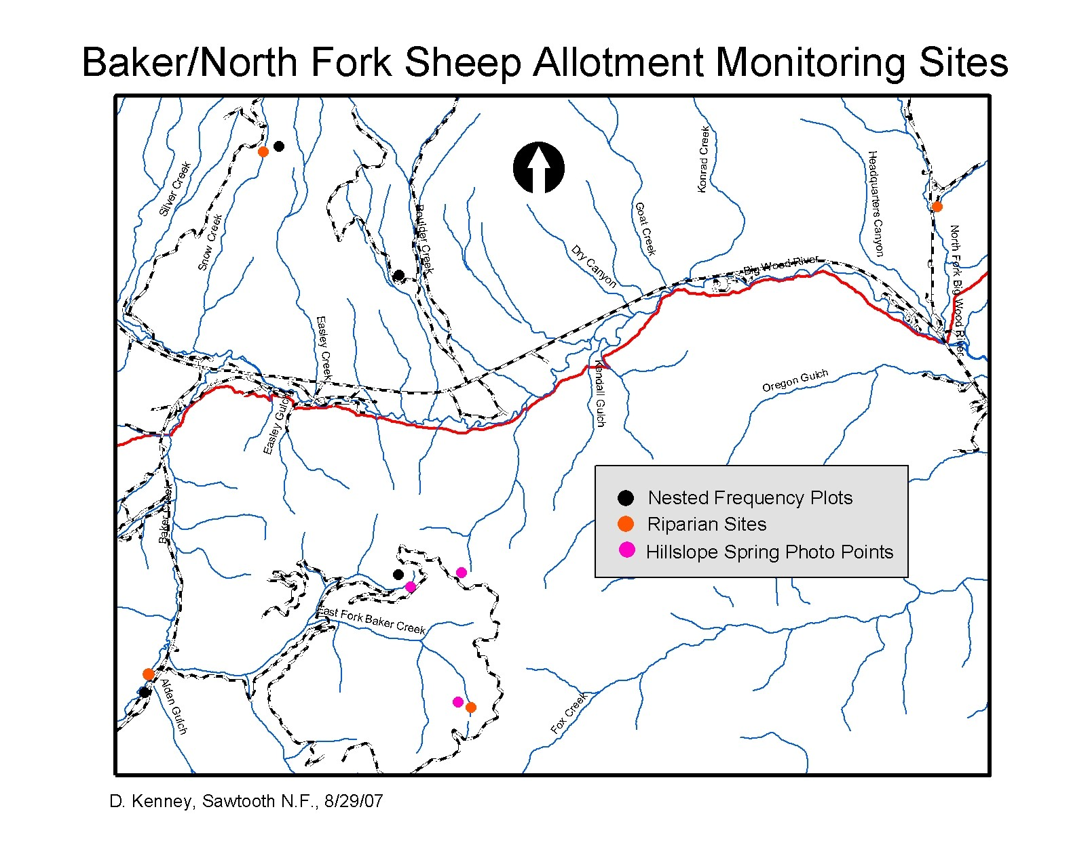

Implementation Monitoring:
Annual Grazing Standards listed under Management Requirements will be monitored for compliance within the allotment. Seasonal monitoring and allotment administration will include field reviews of grazing practices, to include inspections with permittee and their agents, review of annual grazing use information provided by the permittee, and pertinent information provided by Forest specialists working within the allotment. This information will be evaluated on a yearly basis to insure management deficiencies are corrected and that successful management practices continue moving the resource in the desired direction. The results of this monitoring will help determine the need for adaptive changes to livestock management.

Additional annual inspections will focus on:
Presence of livestock in closed or outside the permitted area or season.
Extent and location of impact areas (e.g. salting, nooning, bedding, and trailing).
General patterns of utilization and identification of areas of concentrated use or areas underutilized.
Areas showing recent impacts due to drought or other weather related influences such as drying up of springs and seeps, increased use on vegetation or areas not generally used, and obvious increase in bare ground through lack of production.

Riparian Implementation Monitoring:
The main purpose of this type of monitoring is to aid in within season grazing management. The monitoring protocol and location of the implementation monitoring sites are intended to measure whether the desired level of use has occurred on the allotment and whether Forest Plan standards and guidelines are met.
Protocols: Stubble height, woody vegetation regeneration, and stream bank alteration, per Burton et. al. 2007. Stubble height measurements will be used where appropriate and streambank alteration and /or woody vegetation regeneration measurements at the remainder of sites.
Location/Number of Sites: See following table.
Timing/Frequency: Monitoring would be performed annually within two weeks of date of band routing through/past monitoring site. Implementation monitoring would not be performed at a site if it were determined that sheep were not grazed or routed through that site in that year.
Participants: Range staff would perform stubble height monitoring; either range or aquatics staff would take stream bank alteration measurements.

DMA Description and Location (GPS ) | Site Type | Study Type/Protocol | Short Term Monitoring End-of-Season Indicator
DMA: E. Fk. Baker  Lat: 43.735750°  Long: 114.502250° | Streambank | MIM (Burton & Cowley 2006) | Stubble Ht. > 4 in.  Bank Alteration < 20%  Woody Utiliz. < 25%
DMA: Alden Gulch  Lat: 43.738500°  Long: 114.5599° | Streambank | MIM (Burton & Cowley 2006) | Stubble Ht. > 4 in  Bank Alteration < 20%  Woody Utiliz. < 25%

Effectiveness Monitoring:
The main purpose of this type of monitoring is to determine condition/trend and progress toward achievement of desired conditions as described in the Sawtooth National Forest Revised Resource Management Plan and the North Sheep Final Environmental Impact Statement. Data from this monitoring should allow the Forest to document successful adaptive management and compliance with Forest Plan goals and objectives.

Due to the impact of the 2007 Castle Rock Fire, additional monitoring associated with Forest Plan Guidelines VEGU05 and VEGU06 will be required.

Riparian Effectiveness Monitoring:
Protocols: Green line vegetation community composition, woody species regeneration, and stream bank stability multiple indicator monitoring (MIM); per Crowley et al. 2006 and /or PIBO monitoring protocols. Location /Number of sites: Each effectiveness monitoring site would be co-located with an implementation monitoring site. Sites selected are:
- East Fork of Baker- T.5N. R.16E, SE ¼ Sec. 26- GPS: 43° 44.145’ 114° 30.135’
- Mouth of Alden Gulch and Baker Cr.- T. 5N. R.16E, NE ¼ Sec.28- GPS: 43° 44.310’ 114° 33.594’
Timing/ Frequency: After establishment, data collection at each site would follow at three to five-year intervals. Because this effort is intended to be long term monitoring, the data collection would not occur at any particular time relative to sheep routing or location on the allotment.

Participants: Range staff would perform vegetation community and woody regeneration monitoring in cooperation with the permittee. The range and/or aquatics staff would take stream bank stability measurements.

Riparian DMA | Last Monitored | Location | Protocol | Desired Condition | Current Condition
#1 E. Fk. Baker Cr. | 2006 | Lat: 43.735750°  Long: 114.502250° | MIM (Burton &Cowley 2006) | Late Seral  ¹Bank Stability = 79% | Mid Seral  Bank Stability = 100%
#2 Alden Gulch-Baker Cr. | 2006 | Lat: 43.738500°  Long: 114.5599° | MIM (Burton &Cowley 2006) | Late Seral  ¹Bank Stability = 74% | Early Seral  Bank Stability = 90%
¹Based on natural conditions for volcanic B & C Channel types (Overton et. al. 1995).

In order to collect additional information on the long-term effectiveness of the adaptive management strategy, photo points have been established at sites that reflect impacts from grazing. Repeat photos will be taken at these sites at a three to five year interval (per Hall 2002 protocol). Note: Insert table showing location of photo point sites, responsibility and frequency for retaking the photos. Identify where the photo records will be stored, etc.

Upland Effectiveness Monitoring:
Nested Frequency Plots (USDA et. al. 1996): These are established to provide quantitative measurements of frequency and ground cover. Frequency is the presence or absence of a species on a quadrant by quadrant basis. It is a useful index for monitoring changes in vegetation over time and comparing different plant communities. Ground cover is the percentage of material, other than bare ground, covering the land surface. These measurements will be made along the frequency belts using the sharp pins of the frame.

Line Intercept measurements of sagebrush crown canopy cover will be conducted along each leg of the Nested Frequency Plot. These measurements provide an estimate of the relative cover of the shrub species measured on the study site.

Additional photo-points will be used to evaluate changes in conditions of key vegetative communities at locations impacted from grazing use.

Upland DMA | Year Last Monitored | Location | Protocol | Desired Condition | Current Condtition
E. Fk. Baker | 2006 | 43.756633º  114.520667º | Nested Frequency & Line Intercept | <30% sagebrush cover  >70% Soil cover | 3% sagebrush cover  73% soil cover
Baker Cr | 2006 | 43.740617º  114.56860º | Nested Frequency & Line Intercept | <30% sagebrush cover  >70% Soil cover | 0% sagebrush cover  70% soil cover
EFB 1 | 2006 | 43.756383º  114.518733º | Photo Pt. Hillside Seeps
EFB 2 | 2006 | 43.758400º  114.508211º | Photo Pt. Hillside Seeps

Aspen Monitoring:

Aspen monitoring will be conducted by the District resources staffs according to protocol established in USDA Forest Service 2003 DRAFT, An integrated approach to adaptive management of aspen on rangelands, Rangeland Analysis and Planning Guide, Pacific Southwest Region. Stands selected for monitoring have a history of sheep use.

Monitoring will focus on:
Aspen regeneration- stems per acre. (Belt transect)
Aspen browsing- utilization of terminal leader. (Belt transect)
Domestic vs. wild ungulate use-Fecal count/browsing height. (Ocular estimate)
Ground cover- Bare ground. (Ocular estimate)

Transects will be read every 3 years. (Locations to be chosen in 2008 due to area wildfires in 2007).

Aspen  DMA | Year Last  Monitored | Location  UTM | Desired Condition | Current Condition
 | 2008 |  | >500 Stems/Acre < 1” dbh  < 20% leader use

Alpine Community monitoring:
The desired condition of alpine communities as described in the FLRMP is an abundance of perennial vegetation communities (i.e. cushion plants, grasses and sedges forming sod-like mats). Soils have not been compacted by livestock trampling and species composition has not altered substantially to include dominance of non-native or annual plant species.

Monitoring objectives:
Assess conditions and monitor trends in alpine communities in the absence of grazing pressures.
Monitor changes in alpine community with continued grazing pressure.
Characterize vegetation in alpine communities that have not had grazing pressure in past 20 years.
Monitor known and newly discovered population of TES plant species within the allotments.

Monitoring Sites:
GPS: N. 43º 43.116’ W. 114º 40.516’ (Norton/Royal Gorge junction)
GPS: N. 43º 42.935’ W. 114º 40.740’ (Apollo/Norton divide)
GPS: N. 43º 40.626’ W. 114º 40.974 (Big Peak/Baker divide)

Monitoring Methods:
Locate macro plots 50x50m permanently marked, photographed with locations recorded. Within the macro plot are five micro plots lying perpendicular to the 50 m base line which runs along a ridge. Each micro plot transect is 50m long, with 5m2 microplots 5m apart.

Site characteristics are recorded regarding plant phenology, soil crust, insect infestation, human disturbance, wildlife impacts, grazing impacts, pollinators, weather data.( snow, drought) Frequency data will be recorded. All vascular plants in the microplots are tallied, as well as gravel, rock, litter, bare ground, and soil crust. Re-sampling will occur approximately every 5 years.

References

Bartos, Dale L. 2001. Landscape Dynamics of Aspen and Conifer Forests, in Sustaining Aspen in Western Landscapes: Symposium Proceedings. USDA Forest Service, Rocky Mountain Research Station. RMRS-P-18.

Burton, David; et al. 2002. Aspen Delineation Project – Protocol for Recording Aspen Location and Condition. USDA Forest Service, Pacific Southwest Region.

Burton, Timothy A., Cowley, Ervin R., and Smith Steven J. 2007. Monitoring Stream Channels and Riparian Vegetation-Multiple Indicators. Technical Bulletin 2007-01.USDI Bureau of Land Management, Idaho State Office.

Mueggler, Walter F. 1988. Aspen Community Types of the Intermountain Region. USDA Forest Service, Intermountain Research Station, GTR INT-250.

Overton, C. Kerry, McIntyre, John D., Armstrong, Robyn, Whitwell, Shari L., and Duncan, Kelly A. 1995. User’s Guide to Fish Habitat: Descriptions that Represent Natural Conditions in the Salmon River Basin, Idaho. USDA Forest Service. Intermountain Research Station, GTR INT-322.

USDA Forest Service, Pacific Southwest Region. 2004. Browsed Plant Method for Young Quaking Aspen - An Annual Monitoring Method for Determining the Incidence of Use on Sprouts and Young Plants During the Growing Season.

USDA Forest Service, USDA Natural Resource Conservation Service, USDI Bureau of Land Management. 1996. Sampling Vegetation Attributes - Interagency Technical Reference. BLM/RS/ST-96/002+1730.

USDA Forest Service, USDA Natural Resource Conservation Service, USDI Bureau of Land Management. 1996. Utilization Studies and Residual Measurements - Interagency Technical Reference. BLM/RS/ST-96/004+1730.

USDA Forest Service. 2003. DRAFT: An integrated approach to adaptive management of aspen on rangelands. Rangeland Analysis and Planning Guide. Pacific Southwest Region.

Winward, Alma H. 2000. Monitoring The Vegetation Resources In Riparian Areas. Gen. Tech. Rep. RMRS-GTR-47. Ogden, UT. USDA Forest Service, Rocky Mountain Research Station.

