 | File Code: |  | 1950-1
 | Date: |  | November 16, 2006

Dear Interested Party:
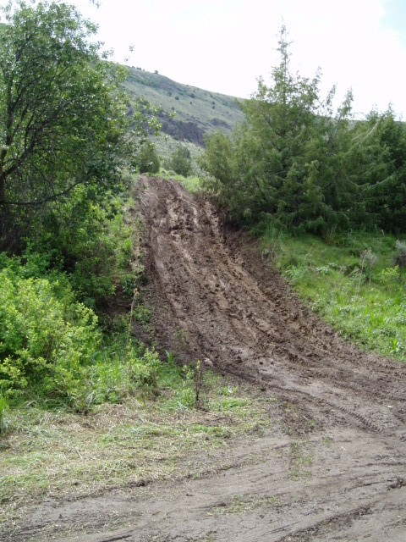
We are currently faced with a serious challenge with the way people are recreating in Lower Rock Creek. The area is literally being “loved to death”. Vegetation is disappearing due to overuse. The number of “user-created roads” is increasing. Water quality in the Rock Creek is declining due to sedimentation caused by the loss of vegetation and increased erosion

As the population in the Magic Valley continues to grow and the demand for outdoor recreation increases, we are concerned that the situation in Lower Rock Creek will continue to worsen unless changes are made. As the agency charged with the responsibility of caring for your National Forest, we can no longer accept the impacts that are occurring here and want to be proactive in finding solutions.
This steep, highly eroded road in the Magpie Basin area of Lower Rock Creek was “user-created”.

The following is a proposal we feel is a proper and responsible approach to improving the previously described, unsatisfactory situation. If you are not already familiar with this situation, please take the time to read our proposal. We are sincere in asking for your thoughts and ideas regarding our proposed solution. We are also interested in other solutions you feel would help remedy this situation.
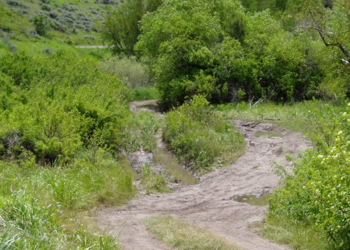

Sincerely,
Scott c. nannenga

SCOTT C. NANNENGA
Minidoka District Ranger
Roads created by motor vehicles have denuded part of this riparian area. Soil compaction and loss of native vegetation is significantly contributing to the degradation of water quality in Rock Creek.

