
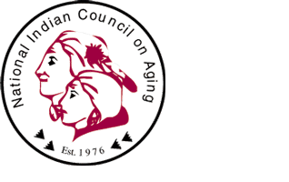


• Agency On Aging • Indian Health Service • National Indian Council On Aging •

American Indian and Alaska Native
Roundtable on Long Term Care:
Final Report 2002



American Indian and Alaska Native
Roundtable on Long Term Care:

Final Report 2002

Bruce Finke, MD
Indian Health Service Elder Care Initiative
P.O. Box 467
Zuni, NM 87327
bfinke@abq.ihs.gov

Yvonne Jackson
Director,
Office for American Indian, Alaska Native and Native Hawaiian Programs
Administration on Aging
Department of Health and Human Services
330 Independence Avenue SW
Washington, D.C. 20011

Lahoma Roebuck
Office of Clinical and Preventive Services
Indian Health Service
12300 Twinbrook Parkway - Suite 605
Rockville, MD 20857

Dave Baldridge
Executive Director, National Indian Council on Aging
10501 Montgomery Blvd NE, Suite 210
Albuquerque, NM 87111-3846

Roundtable Report Prepared by:
Jo Ann Kauffman
Kauffman and Associates, Incorporated
425 West First Avenue
Spokane, WA 99201
(509) 747-4994

This report was prepared by Kauffman and Associates, Inc. (KAI) under contract with the Indian Health Service (IHS). The views and opinions expressed in this report are those of the participants and authors and do not represent official policy or positions of the Indian Health Service or the Administration on Aging. In addition to the five papers presented herein, this report summarizes the proceedings, implications and recommendations which emerged from the American Indian and Alaska Native Roundtable on Long Term Care held April 11-12, 2002, in Albuquerque, New Mexico.
Roundtable Participants and Contributors

Bill Benson
7106 Maple Avenue, No. 2
Silver Spring, MD 20912
Phone: 202-255-2001
Fax: 301-270-4066
Email: tbcg@erols.com

Kay Branch
State of Alaska, Division of Senior Services
3601 C St, Suite 310
Anchorage, AK 99503
Phone: 907-269-3663
Fax: 907-269-3689
Email: Kay_Branch@admin.state.ak.us

Mim Dixon
1618 Spruce St.
Boulder, CO 80302
Phone: 303-674-9513
Fax: 303-443-4733
Email: mimdixon@hotmail.com

Ralph Forquera
P.O. Box 3364
Seattle, WA 98114
Phone: 206-834-4002
Fax: 206-834-4012
Email: ralphf@sihb.org

Ladonna Fowler
American Indian Disability
Technical Assistance Center
R.I.D., 52 Corbin
University of Montana
Missoula, MT 59812
Phone: 866-424-3822
Fax: 406-243-2349
Email: wareagle@centurytel.net

Neil Henderson
OU College of Public Health
Dept. of Health Promotion Sciences
801 NE 13th St.
P.O. Box 26901
Oklahoma City, OK 73190
Phone: 405-271-2017, ext. 46756
Fax: 405-271-2099
Email: neil-henderson@ouhsc.edu

Holly Kibble
Director, Elder Care Services
Sault Ste. Marie Tribe of Chippewa Indians
2864 Ashmun St.
Sault Ste. Marie, MI 49783
Phone: 906-632-5243
Fax: 906-632-5208
Email: nuk@30below.com

Andy Lorentine
Tohono O’Odham Nation
Community Health
P.O. Box 837
Sells, AZ 85634
Phone: 520-383-6200
Fax: 520-383-8806

Leander Russ McDonald
National Resource Center on Native American Aging
University of North Dakota Center for Rural Health
P.O. Box 9037
Grand Forks, ND 58202-9037
Phone: 800-896-7628
Fax: 701-777-6779
Email: rmcdonal@medicine.nodak.edu

Corrine Rago
Cornerstone Home Health
P.O. Box 210407
Auke Bay, AK 99821
Phone: 907-586-6838
Fax: 907-586-6884
Email: crago@gci.net

Linda Redford
8408 Hedges
Raytown, MO 64138
Phone: 913-588-1636
Cell: 816-213-7910
Fax: 913-588-3179
Email: lredford@kumc.edu

Theron Wauneka
Inter-Tribal Council of Arizona
2214 North Central Avenue
Suite 100
Phoenix, AZ 85004
Phone: 602-258-4822
Email: Theron.Wauneka@itcaonline.com

Frank Chee Willetto, Sr.
P.O. Box 1415
Crownpoint, NM 87313
Phone: 928-871-6380 (Window Rock)
Fax: 928-871-7259 (Window Rock)

Lahoma Roebuck
Long Term Care Coordinator
Indian Health Service
Office of Clinical and Preventive Services
Division of Behavioral Health
12300 Twinbrook Parkway
Suite 605
Rockville, MD 20857
Phone: 301-443-0226
Fax: 301-443-7623
Email: lroebuck@hqe.ihs.gov

Shelly Carter
Staff Assistant
Indian Health Service
Office of Clinical and Preventive Services
Division of Behavioral Health
12300 Twinbrook Parkway
Suite 605
Rockville, MD 20857
Phone: 301-443-0226
Fax: 301-443-7623
Email: scarter@hqe.ihs.gov

Gale Arden
Director, Private Health Insurance Group
Center for Medicare and Medicaid Services
7500 Security Boulevard, MS S3-16-16
Baltimore, MD 21244
Phone: 410-786-6810
Email: Garden@cms.hhs.gov

*Dorothy Dupree
Senior Policy Advisor
American Indian/Alaska Native Programs
7500 Security Boulevard
Mailstop S2-26-12
Baltimore, MD 21244
Phone: 410-786-1942
Email: DDupree@cms.hhs.gov

Bruce Finke, MD
Indian Health Service
Zuni Service Unit
P.O. Box 467
Zuni, NM 87327
Phone: 505-782-7357
Email: bfinke@abq.ihs.gov

Roberta Kinzhuma
Oneida Tribe of Indians of WI
2907 South Overland Drive
Oneida, WI 54155
Phone: 920-869-2448

Sydney Bird
Winnebago Tribe of NE
Main Street Highway 77
Winnebago, NB 68071
Phone: 402-878-2487

Oneida Winship
Choctaw Nation of OK
324 North Washington Street
Durrant, OK 74701
Phone: 580-924-8280

Cynthia La Counte
Chairwomen
HC58 Box 77
Bainville, Montana 59212
Phone: 701-572-8316

Stephen Wilson
601 N. Pine
Holdenville, Okla 74447
Phone: 918-637-6798

James Delacruz
Quinault Indian Nation
Taholah, WA 98587
Phone: 360-276-4191, 277

Shannon McDaniel
Tribal Administrator
133 Madison Street
Durant, OK 74701
Phone: 580-924-3473

Laverne Wyaco
Administration Building Complex #2
Navajo Boulevard
Window Rock, AZ 86515
Phone: 928-871-6783

Carolyn Rackard
3410 Bell Creek Road
Atmore, AL 36502
Phone: 251-368-9136

Regina LittleBeaver
Winnebago Tribe of Nebraska
St. Augustine Drive
Human Resource Building
Winnebago, NB 68071
Phone: 402-878-2447

Debbie West
Rt. 1, Box BN B5
Cherokee of NC 28719
Phone: 828-497-4471

Glenda MCConnell Chiltosky
Route 1, Box 888
Cherokee, North Carolina 28714
Phone: 828-497-4471
Kenneth Mallory
Winnebago Tribe of Nebraska
St Augustine Drive
Human Resources Building
Winnebago, NB 68701

Yvonne Jackson
330 Independence Avenue SW
Washington, D.C. 20011
Phone: 202-619-2713
Email: Yvonne.Jackson@aoa.gov

Meg Graves
330 Independence Avenue SW
Washington, D.C. 20011
Phone: 202-619-3108
Email: Margaret.Graves@aoa.gov

Connie Fox
CHR Program
Three Affiliated Tribes
404 Frontage Rd.
New Town, ND 58763
Phone: 701-627-4781, 8333
Fax: 701-627-3655
Email: chr@mhanation.com

Linda Carson Henderson, MPH
Vice President, Two Hawks Institute
5937 NW 81st
Oklahoma City, OK 73132
Phone: 405-271-2017, 46756
Email: TwoHawkInstitute@cox.net

Robert P. Shuckahosee
Tribal Disability Technical Assistance Director
American Indian Disability Technical Assistance Center
The University of Montana
52 Corbin
Missoula, MT 59812
Phone: 406-243-4815
Fax: 406-243-2349
Email: roberts@selway.umt.edu

*Muriel Peterson
North Dakota Department of Human Services
Phone: 701-328-8905
Email: sopetm@state.nd.us

*Shelly Zylstra
Northwest Washington Area Agency on Aging
Phone: 360-676-6749
Email: ZylstRA@dshs.wa.gov

*Not present at the meeting, but contributed significantly to the process.

TABLE OF CONTENTS

Introduction

Introduction………………………………………………………………….6

Highlights of Implications and Recommendations…………………………...8

Presentation of Five Papers

Long Term Care in Indian Country Today: A Snapshot…………………….12
William Benson
Implications and Recommendations………………………………25

Opportunities for Medicaid Financing of Long Term Care
in American Indian and Alaska Native Communities……………………….26
Mim Dixon, Ph.D.
Implications and Recommendations………………………………47

Long Term Care in Indian Country: Important Considerations
in Developing Long Term Care Services……………………………………50
Linda J. Redford, R.N., Ph.D.
Implications and Recommendations………………………………65

How Do We Understand and Integrate Elders’ Teaching and Tribal Values
in Planning a Long Term Care System?……………………………………..67
J. Neil Henderson, Ph.D.
Implications and Recommendations………………………………76

How Do We Address the Long term Care Needs
of Urban Indian Elders?……………………………………………………77
Ralph Forquera, M.P.H.
Implications and Recommendations………………………………84

Attachments

Nursing Home Survey Report………………………………………………A
Bruce Finke, MD

Census Information on American Indians and Alsaka Natives:
Implications for Long Term Care……………………………………………B
Mario Garrett, Ph.D.

Economic Analysis of Long Term Care……………………………………...C
Bruce Finke, MD

Functional Limitations and the Future Needs for Long Term Care…………..D
National Resource Center on Native American Aging
At the University of North Dakota
American Indian & Alaska Native
Roundtable on Long Term Care:
Final Report 2002

INTRODUCTION

INTRODUCTION

The Indian Health Service (IHS), in partnership with the Administration on Aging (AoA) and the National Indian Council on Aging (NICOA), held a Roundtable Conference on American Indian and Alaska Native Long Term Care on April 11, 12, 2002. The purpose of the Roundtable was to analyze and explore key issues in long term care (LTC) for American Indian and Alaska Native (AI/AN) communities. This report will summarize the discussions and consensus positions developed during the Roundtable Conference. It also provides a forum for the analysis of specific discussion papers prepared by experts in the fields of Indian health and long term care.

Initially, five important topic areas were identified and framed as questions. Individuals with experience in long term care, Indian health, or both were invited to write a draft paper exploring these areas. These papers, presented in draft form, were the starting points for discussion at the Roundtable Conference.

Over thirty experts in Indian Health and elder care from throughout Indian Country were invited to participate in the Roundtable. These experts were not selected to “represent” Indian Country, but rather to gather a broad array of expertise in the issues attendant to long term care for American Indians and Alaska Natives.

Each topic was presented by the paper author and the content and approach were discussed by the Roundtable experts. Comments were recorded by the Roundtable facilitator and provided to the author for inclusion in the final draft of the paper following the meeting. Participants then divided into small groups to explore implications and recommendations regarding each topic. Topic facilitators presented these to the entire roundtable for further discussion.

What follows is the report of this process. At its core are the five invited papers on key topics (revised with input from the roundtable participants), followed by a summary of the implications and recommendations from the Roundtable experts regarding the issues addressed in each paper. In addition, there are two background papers presented at the Roundtable, one on AI/AN demographics from the 2000 Census, and one with the latest data on the prevalence of functional impairment among AI/AN elders. Finally, there are two additional background papers prepared for the Roundtable; a report on AI/AN nursing homes and a preliminary analysis of the cost of long term care for AI/AN elders using recent IHS user population data.

The first paper entitled “Long Term Care in Indian Country Today: A Snapshot” is presented by William Benson in coordination with the National Council on Indian Aging (NICOA). His paper provides an overview of the issues facing Indian elderly across the United States and a brief profile of some of the federal programs designed to address their needs. His paper also provides preliminary data from a national survey of tribal long term care conducted by NICOA and the National Senior Citizens Law Center.

The second paper entitled “Opportunities for Medicaid Financing of Long Term Care in American Indian and Alaska Native Communities”, by Mim Dixon, Ph.D., provides a thorough and exhaustive review of the existing federal Medicaid programs administered through the states which could potentially provide financial support for tribal and urban Indian LTC services. Her paper identifies areas for tribal, state, and federal collaboration to improve access to long term care services.

The third paper is entitled, “Long Term Care in Indian Country: Important Considerations in Developing LTC Services.” It was prepared by Linda Redford, R.N., Ph.D. In her paper, she presents a demographic profile of American Indian and Alaska Native elderly and explores the types of services required by this population. Her paper provides an excellent outline of the key elements to conducting effective planning and development activities for Long Term Care services.

The fourth paper is by J. Neil Henderson, Ph.D., entitled, “How Do We Understand and Incorporate Elders’ Teaching and Tribal Values in Planning a Long Term Care System?” This paper provides a structured way to assess and define traditional Native culture and values that can be integrated into LTC systems. Specific and practical examples are provided that offer “rituals of respect” for the culture and values of those served by LTC programs.

The fifth and final paper is written by Ralph Forquera, M.P.H., Executive Director of the Seattle Indian Health Board, entitled “How Do We Address the Long Term Care Needs of Urban Indian Elders?” This paper describes the migration of American Indians and Alaska Natives from rural and reservation settings to America’s cities over the last century and provides an important perspective on the issues surrounding access to long term care services for this population.

Those gathered for this Roundtable brought with them more than their expertise in American Indian and Alaska Native health and long term care. They also brought their passion and commitment to the care of elders and those with disabilities. All of us involved in the Roundtable hope that this effort will further the efforts to develop long term care systems and services for American Indians and Alaska Natives.

HIGHLIGHTS OF ROUNDTABLE CONFERENCE

IMPLICATIONS AND RECOMMENDATIONS

Following each of the five (5) discussion papers presented in this report is a series of specific implications and recommendations articulated by the Roundtable participants. These Roundtable recommendations should be reviewed in their entirety, as they represent the interaction and analysis of the diverse gathering of experts represented at the Roundtable Conference. Listed below is a brief summary of the larger list of Implications and Recommendations. For a more detailed review, please refer back to each of the five discussion papers in this report.

Over-arching Considerations

Commitment: The commitment by tribal and community leadership is key to developing effective Long Term Care services in tribal communities.

Coordination: Tribes currently provide an array of LTC services, but these are recognized to be inadequate to the need and the lack of coordination of available services may limit the effectiveness of these limited resources.

Culture and Values: Cultural aspects of LTC should be an integral part of all aspects of planning and service delivery. Cultural appropriateness must be deliberately planned into LTC services.

Expand Thinking About LTC Beneficiaries: Merging LTC issues for both the elderly and the disabled, in national policy and in local planning is a key consideration for future planning and development.

Inter Agency Collaboration: There is a need for federal agency collaboration and federally funded demonstration projects, LTC planning grants, and education and technical assistance for home and community based care that address the unique issues in Indian Country.

LTC Research Agenda: A formal research agenda on all aspects of LTC in Indian Country is needed and should be developed through a consultative process. This agenda should be established and funded to provide research and information regarding the variety of questions facing tribal and urban Indian communities considering LTC options, such as studying the economic viability of current LTC options, examining best practices and evaluating programs.

The Planning Process

Vision: The process begins with a vision of what LTC should look like in the community and should not be merely driven by funding initiatives. Establishing a vision for LTC services must be a consultative, participatory process. It is important to have a clear understanding of the realm of possibilities for providing LTC. Finding a service model that best meets the needs and most appropriately reflects the values of each community is important.

Involve the Stakeholders: The planning process must provide meaningful involvement from all the stakeholders including elders, Indians with disabilities, family members, advocates, service providers, community leaders and funding sources.

Collaboration: The network of resources potentially available to provide components of a comprehensive LTC system could include not only programs administered by tribes, IHS or urban program, but also county, state, federal and private providers. Collaborating with other providers will open doors to increased services and opportunities.

Education and Understanding of LTC Options: The options for providing LTC services in Indian communities includes many strategies beyond building a nursing home. Education of local leaders and planners is important to ensure that all the various options for home-based, community based services, alternate care facility, assisted living and other options are explored and understood.

Local Capacity and Diversity: Tribes are at very different levels of capacity in LTC planning and program development.

The Structure of Long Term Care

Long Term Care Services: There are a services currently available in tribal and urban Indian communities that provide pieces of the array of services defined as Long Term Care. These services may not be coordinated in an overall LTC system or strategy. LTC services within a community may compete against each other. Anecdotal experience suggests a hierarchy of preferences for LTC services, starting with home care provided by family and ending with nursing home care.

Workforce Development: Workforce development and retention is both critical and problematic when developing LTC systems. LTC service providers are too often not provided the pay or incentive to remain in these positions. Strategies for recruiting, rewarding and retaining individuals to fill these important positions are presented.

Case Management as a Core Element: Case management is a key element in LTC services, and it assumes even greater importance for home and community based LTC services.

Elder Advocacy: There is a need for more effective advocacy for AI/AN elders in nursing homes or in need of other LTC services. The existing state complaint systems do not appear to respond to AI/AN complaints about nursing home quality or practices.

Indians with Disabilities: In addition to meeting the LTC needs of Indian elders, Indian community members with disabilities may require LTC services and should be consulted and involved in the development of services.

Prevention: Effective health promotion and disease prevention for elders will decrease need for LTC services, or at least forestall the need for services.

Financing Long Term Care

Tribal and State Relationship: A meaningful relationship between tribal health programs and the states is key to providing LTC services, since the majority of funding for LTC services comes through the state administered Medicaid programs. States should be held accountable by CMS to ensure meaningful tribal consultation is occurring in the development of state LTC plans and related Medicaid waiver proposals. Tribes need to be more involved in the development of state 1915c waivers.

Medicaid and Medicare Enrollment Barriers: Barriers to enrollment in Medicaid and Medicare limit access to LTC services in Indian communities, since these programs are the primary payors for LTC services. More research is needed to better understand these barriers and to develop strategies to eliminate them.
Demonstration Projects: Federal agencies should collaborate in funding LTC demonstration projects, to begin to develop various models of different sizes and scales through out Indian Country.

Innovative Funding Strategies: Tribes need to be creative in assessing financing opportunities for LTC services to include, Medicaid, Older Americans Act, HUD, USDA, and Veterans Administration in addition to IHS and local tribal support.

Start-Up Funding: Not all tribal or urban Indian communities have the existing infrastructure to begin to provide a LTC service system for their population. Initial start-up funding would assist in moving forward to better coordinate existing resources and to fill gaps in services.

Creating Culturally Appropriate Long Term Care Services

Culture is Integral Component: Cultural appropriateness, or rituals of respect, should be recognized as an essential part of the care and should be included as a component of any quality of care evaluation. Culturally appropriate and sensitive services must be included in any LTC service system in Indian communities, as an integral component of quality services.

Culture is Dynamic: Culture is a dynamic process, and must constantly be assessed and its integration in LTC services evaluated to ensure appropriateness. Indian elders are oftentimes multi-cultural with different experiences and perspectives.

Integrating Culture Must Involve Community: Finding ways to integrate traditional culture and values into LTC must be based on a consultative process with community involvement and the participation of elders, people with disabilities and community leaders.

Urban Indian Elders

Needs Assessment: Little is known about the needs of the urban AI/AN elders with regard to LTC services. More research and assessment is required.

Urban Indian Program Involvement: Federal, State and intertribal efforts to address LTC needs of AI/AN should invite the participation of Urban Indian health programs, as one of the three components of the IHS, tribal and urban system of care. Planning, policy, and funding should seek to break down distinctions between services provided to elders living in reservation and urban communities.

PRESENTATION OF FIVE PAPERS

Summary of Issues

While demographic data shows a large and increasing need for long term care programming in Indian country, only 6.5% of American Indian and Alaska Native elders receive such services.

Indian elders’ poor health and disability status is mirrored by their equally poor economic health, and is characterized by rural isolation, poverty, limited access to transportation or telephone communication means, and other barriers.

Long term care services for AI/AN elders are typically uncoordinated in nature. Long term care services provided by the federal government have not been consolidated under one agency and are minimal in nature.

The Older Americans Act provides $25.729 million in supporting grants to roughly 233 federally recognized tribes, and an array of services including a meals program, case-management, health aid, chore and some transportation services.

Despite the limits of OAA funding for Indian elders, the services supported under Title VI can be an important part of the foundation for a tribe’s long term care services and system.

Tribal resources are becoming increasingly important to meeting long term care needs. Resources may be raised from tourism, gaming, or other tribal enterprises.

Preliminary findings from a questionnaire conducted by the National Indian Council on Aging with the National Senior Citizens Law Center are presented and confirm findings about current long term care needs.
Discussion Paper #1

LONG TERM CARE
IN INDIAN COUNTRY TODAY:
A SNAPSHOT

LONG TERM CARE IN INDIAN COUNTRY TODAY:
A SNAPSHOT

William F. Benson

I also hope you will realize that there are some who have a deep concern for older persons, specifically the older persons in the American Indian community. That we intend to do everything we can to use the authority we have, the resources that are made available to us, in order to get the kind of services through to older persons that will help them look to the future not with despair but with hope. The objective that we should try to keep in mind at all times is to try to make the last days the best days. If we are going to achieve that objective, it’s going to require commitment. Not only on the part of those who are in the federal government, the state government, and in community government. Not only on the part of those who are part of private organizations, but on the part of every individual who has a concern for older persons.

Arthur S. Flemming, U.S. Commissioner on Aging
National Indian Conference on Aging
Phoenix, Arizona – June 17, 1976

These words, made more than a quarter century ago, by the venerable Dr. Flemming, who in addition to serving as U.S. Commissioner on Aging had been the first Secretary of HEW under President Eisenhower, remain unrealized today when it comes to services for America’s Indian elders. This is especially true with regard to long term care.

For many elders, their last days are spent living with some form of chronic or disabling illness that limits their ability to perform activities of daily living (ADLs). These ADLs include such tasks as bathing, eating, dressing, using the toilet or getting into or out of bed -- in other words the daily activities that allow one to take care of one’s basic needs. As noted by the National Resource Center on Native American Aging at the University of North Dakota (NRCNAA), “These activities are fundamental and when people express difficulties with them, they are considered to be in need of help.”

Many other elders, while not as severely limited in their independence as those with ADL limitations, have difficulties with other tasks such as cooking, cleaning, lifting, or doing the laundry. The limited ability or inability to perform these tasks, or Instrumental Activities of Daily Living (IADLs), also limits one’s ability to take care of oneself and to lead a relatively independent life.

When elders can no longer perform their own ADLs or have limits in their IADLs over the long term-- rather than on an episodic basis when recovering from an illness or injury-- they are likely to need some form of assistance from someone else to help perform such tasks. With modest even minimal forms of support, an individual with such limitations may be able to maintain a reasonably independent life in their own home or some other home-like setting, such as living with a relative. Those with severe limits, especially in their ADLs, may require extensive support and interventions or even long term facility care.

According to the NRCNAA, there is a “greater level of need for personal assistance among the Native American elders than in the general population,” adding that “only 6.5% of the Native American elders over 55 receive such services.” That figure is not surprising given the tremendous dearth of long term care services throughout Indian country, despite the great need and the demand that has grown for long term care especially over the past decade.

Long term care is the single most critical issue facing American Indian elders in the 1990s, according to the National Indian Aging Agenda for the Future. Federally funded long term care is virtually nonexistent in Indian country. The need of Indian elders for long term care, including home health and personal care, is growing with the increasing size and longevity of the Indian population. Such services, however, remain undeveloped. Lack of care can weaken older Indians’ health, cause premature hospitalization and unnecessary utilization of existing health care services in Indian Country. Chronic illnesses and disabilities also affect Indian elders’ quality of life and ability to live independently. Rural isolation, poverty and access barriers further compound the problem for reservation elders.

In 1996, the National Indian Council on Aging (NICOA) published a comprehensive examination of the health status of Indian elders in relation to long term care. The NICOA Report: Health and Long term Care for Indian Elders reveals that “more Indians are living longer. . . There were 108,000 American Indian elders out of a total Indian population of 1,423,043 in 1980 and 165,842 elders out of a total American Indian population of 1,959,234 in 1990, a 52% increase during the decade.” According to the Indian Health Service (IHS), Indian elders comprise only 8.3% of the agency’s service population but uses 21% of its services.

The report indicates that Indian life expectancy at birth grew from 51 to 71.5 years between 1940 and 1989, and from 61 to 72 years since 1972. As of 1990, the gap between American Indian and White life expectancy had narrowed to less than 3.6 years for American Indian males and 3.0 years for females. Due in part to high birth rates and significant improvements in maternal/infant mortality (reduced by more than 90% since 1955 according to the IHS), American Indians now exhibit the youngest median population of all minorities, averaging less than 22 years compared to the national average of 30 years. This trend portends an “explosion” in the numbers of Indian elders over the next four decades.

At the same time, the overall health status of Indian elders continues to be poor. The IHS publication “Regional Differences in Indian Health for 1995” indicates that Indian age-adjusted mortality rates are greater than U.S. All Races rates by the following percentages:

Alcoholism 674% Diabetes Mellitus 234%
Tuberculosis 480% Suicide 85%
Accidents 265% Homicide 62%

Indian elders are also affected disproportionately by disability. According to data from the 1990 Census, “American Indian elders report the highest level of work disability among the five racial groups . . . 44.3% report a work disability compared to only 29.0% of non-Hispanic Whites. Moreover, over one-third of American Indian elders (36.8%) report that their condition prevents them from working compared to only 23.2% of their non-Hispanic White age peers. These high levels of disability among Indian elders offer further evidence of the need for health programs to specifically address the unique needs of this population.”

Indian elders’ poor health and disability status is mirrored by their equally poor economic health. “The 1990 Census shows that 30% of Indians aged 65 and older who reside in rural areas have no vehicle available, 31% have no telephone in their living quarters, and 24% speak English poorly.” Because of their rural isolation, poverty, and other barriers, reservation elders have little access to existing long term care delivery mechanisms that may serve mainstream or urban elderly populations. The NICOA report also examined the lack of nursing homes in Indian Country, stating:

Unlike the general population (which has many nursing home facilities available), nursing home facilities are extremely rare in Indian communities. The development of long term care institutions in Indian communities is well behind the general population, which began extensive nursing home construction in the 1960s (Manson, 1989).

The first Indian nursing home was constructed in 1969, and only 13 tribally- operated nursing homes existed as of 1993. With the exception of these tribally operated facilities, other institutions tend to be located long distances from where Indian elders live. Consequently, many elders are placed in non-Indian facilities and may become isolated from their families and friends. Lack of cultural diversity and isolation…are major sources of resident and family dissatisfaction with the care provided in off-reservation homes.

Because of these problems, many tribes are considering the feasibility of establishing their own nursing homes to meet the need for institutional care within a tribal setting. However, the solution to the long term care needs of American Indian elders presents obvious economic difficulties (of construction, maintenance, and staffing) and may not represent the wishes of American Indian elders.

For a variety of reasons, many Indian tribes and health care providers are ill-prepared to deal with the pending “explosion” in the numbers of elders whose health, economic, and demographic characteristics all point to the urgent need for a full array of long term care services. Both public and tribal resources fall far short of necessary levels. A recent report by the National Indian Health Board describes the dearth of long term care, both home-based and in nursing homes, in Indian communities in the nine states in its study:

Only three states in this study have tribally operated nursing homes: Arizona (3), Minnesota (1) and Washington (1). Of the three states, Arizona is the only one with managed care for long term care. [The other six states in the study are California, Michigan, New Mexico, New York, Oklahoma and Oregon.]

Home health care is covered more often under Medicare than Medicaid. However, Medicaid does pay for some home health services . . . The major barrier consists of state requirements to become a certified home health agency under state laws. Some states require that home health agencies offer a range of services that are beyond the tribe’s capability, such as occupational therapy or physical therapy.

The development of long term care in Indian Country will require the effective use of all available funding resources. Such resources arise primarily through Medicare, Medicaid, the Indian Health Service (IHS) and tribal resources. Each offers unique but limited support, making a composite of resources a key to future planning.

Medicare

Medicare is a principal existing source of health care coverage and payment for Indian elders. Because it covers hospitalization and other forms of acute care and treatment, Medicare is not available to meet extended needs in chronic care. In limited ways, such as for those who are homebound following a hospital stay, Medicare is useful in supplying short-term home health in an individual’s transition to chronic care. Medicare also pays for skilled nursing facility stays but the conditions under which eligibility for the service is established and maintained is stringent and thus covers only a limited amount of nursing home care.

Medicaid

Medicaid is the principal source of public long term care financing in the United States. It is the largest public payer of nursing home care and is providing increasing amounts of home-based care, usually through a state’s use of Medicaid waivers or through the provision of personal care services as an optional Medicaid service. Unlike other Medicaid services, health services provided by either tribal or IHS providers to enrolled tribal members are fully financed by the Federal government. Health care under Medicaid remains primarily a state responsibility. State home care coverage varies, particularly in state definitions of homemaker services. The federal Centers for Medicare and Medicaid Services (CMS, formerly the Health Care Financing Administration) define basic rules for Medicaid participation. It can set liberal policies on state waivers for direct funding to tribes, although this flexibility appears to remain unrealized.

The federal government once dealt directly with tribes on health issues through the IHS, but today it refers tribes to the states on questions arising under Medicaid. Some states in turn refer tribes to health maintenance organizations (HMOs) and similar managed care entities. HMOs rarely enhance Indian access to health care, which already is impaired by problems of distance, transportation, and cultural and linguistic barriers in Indian Country. Most HMOs operate for profit, and typically avoid serving sparsely populated areas because of higher costs. Medicaid can be a shifting resource for tribal health unless careful planning addresses the needs of individual tribes in a realistic way.

Indian Health Service

The Indian Health Service (IHS) provides services directly to more than 1.3 million Indians, principally through the operation of 61 health centers and 38 hospitals. The IHS historically has not attempted to provide community-based or home-care programs or residential care facilities. Federal funding for the IHS, moreover, remains modest at best, making it difficult for the IHS to assume new commitments. The IHS budget is discretionary and not an entitlement like Medicaid or Medicare. As such, its funding suffers in a climate unfavorable to discretionary increases. The average federal expenditure per Indian patient is far lower than the national average and is shrinking further. In 1977, the average federal expenditure per Indian patient was 75% of the national average. By 1999, it had dropped to 34%.

Older Americans Act

The Older Americans Act (OAA) benefits Indian elders in several ways, including through addressing some long term care related needs. Most notably, Title VI of the OAA provides direct grants from the Administration on Aging (AoA), the federal agency with responsibility for the OAA to tribal organizations. Title VI programs can be the foundation for elder services in many Indian communities, providing a potential array of services including meals and chore, home aid, transportation and case management services. Unfortunately, inadequate funding too often constrains Title VI services to meals programs with limited transportation. The current (fiscal year 2002) funding level for Title VI is $25.729 million and supports grants to some 233 federally recognized tribes.

OAA Title III funds that go to states and local area agencies on aging (AAAs) support a wide array of services, including: congregate and home-delivered meals; transportation services; information and assistance services; legal assistance; case management; some respite and other long term care services; long term care ombudsman services; health promotion and disease prevention activities; and others. Although Title VI grants were intended to be somewhat analogous to grants to AAAs, the amounts are so small, that as indicated they do not support much more than a meals program and some transportation services (typically associated with the meals program -- transporting home-delivered meals and elders to and from meals sites). Title VI’s primary contribution to long term care is its modest support for limited home aid, case management, transportation and home-delivered meals for frail and chronically ill elders. These types of services, if provided with a strong case management component, could allow frail elders to stay in their homes and not be placed in nursing homes.
In some parts of Indian Country, states have elected to support Title III-funded Indian area agencies on aging. Washington state, for example, has two: at the Colville Nation and the Yakama Nation. Arizona and New Mexico each have a statewide Indian AAA. Nationwide, there are some 10 Indian AAAs. These entities have far more resources than tribes that just receive Title VI services.

The 2000 amendments to the OAA established the National Family Caregiver Support Program (NFCSP), which supports activities at the local level to assist family caregivers through education, information, support groups, and some modest services, such as respite care. The program also includes a component to assist grandparents who are raising grandchildren. When the NFCSP was introduced as a part of pending OAA reauthorization legislation, it did not include a grant-making component for tribes. Vigorous advocacy by NICOA and several others, particularly James DeLaCruz of the Quinault Indian Nation resulted in a separate part of the NFCSP being established in the final legislation to provide grants directly to tribes for caregiver-related services. The present appropriation for the Indian portion of the NFCSP is $5 million out a total of $136 million for the program. The NFCSP funds do provide tribes with an important source of funds for a critical part of long term care – enhancing the ability of informal family caregivers to continue to provide care to their loved one. Given the paucity of long term care services, especially in Indian country, supporting informal caregivers is especially important. The NFCSP also provides authority to the AoA to support national demonstrations and other activities to support NFCSP-related activities. NICOA has proposed to AoA using Title IV funds to support a national technical assistance effort to help tribes plan for and effectively implement family caregiver-related services. To date, AoA has not funded such an effort.

Two other parts of the OAA are important to note. The first is Title IV, the research and demonstration part of the Act. In the past, Title IV funds have been used to provide training for and technical assistance to Title VI grantees to improve their skills and knowledge basis. Unfortunately, the AoA discontinued using Title IV to support training and technical assistance for Title VI personnel and grantees. The final part of the OAA worth noting is the Indian section of Title VII, the Vulnerable Elder Rights section of the OAA. Title VII provides funding and authority for such activities as ombudsmen to investigate complaints of elders in nursing homes and other long term care facilities, legal assistance development services, and activities to combat elder abuse. The 1992 amendments to the OAA established Title VII and included a part B for providing support to Indian country for addressing abuse and other issues facing vulnerable elders. Despite the addition of this new part of the law, the Congress has yet to provide an appropriation to make the promise of Title VII a reality for Indian elders.

Overall, the OAA is an important source of certain services for elders, offering a segment of— even a foundation for— the long term care related services needed in tribal communities with the potential for expansion. Home-delivered meals are a critical component of any long term care delivery system and Title VI does offer that to tribes. The limited transportation available under Title VI is also important. The new NFCSP is especially important given the prominent role of family members in being caregivers for their elderly loved ones. NFCSP should offer a valuable addition to the development of long term care services at the tribal level.

Tribal Resources

More and more tribes now contract and administer their own health services under authority of the Indian Self-Determination Act (P.L. 93-638). The IHS budget, however, remains static and tribes, even when under contract, must find other resources to keep pace with rising costs associated with providing health care. Thus, tribal resources are becoming an important factor in the health financing equation. Resources may be drawn from tourism, casinos or other tribal enterprises. With regard to long term care, the commitment of resources by an individual tribe becomes critical to its ability to assess its own capacities, to start funding a long term care program, and to meet gaps in covered services. Successful adaptation of diverse resources, therefore, can create a foundation for a long term care program.

Long Term Care Data

Despite the substantial and growing need for long term care in Indian country and the lack of long term care services for addressing those needs, there has been little research on and analyses of long term care needs for Indian elders. Outside of the reports previously cited there is little available data about long term care needs and a paucity of study of services and programs.

A 1998 report about long term care needs of American Indian elders in the IHS Santa Fe (NM) Service Unit cited a consensus statement from an IHS roundtable, conducted in 1990 and reported by IHS in 1993, that emphasized the need for systematic data on elders’ “long term care status from which service development can proceed,” adding that:

Long term care in reservation settings…has yet to be defined or quantified, and requires more analysis than has been done so far. Required data is either outdated or nonexistent. Needs assessments, particularly functional assessments, have not been conducted extensively on a community level. The data from these assessments must form the basis for measurements of demand as well as the planning and design of services.

It is important to note that over the past several years the National Resource Center on Native American Aging at the University of North Dakota has developed a comprehensive instrument for assessing the functional status of elders at the tribal level and has in fact completed many assessments of individual elders in a number of tribes.

In 1996, the Administration on Aging at the U.S. Department of Health and Human Services issued a report on “Home and Community-Based Long Term Care in American Indian and Alaska Native Communities.” Examples of the key findings reported by the AoA include:

- The need for home and community-based long term care (HCBLTC) services is extensive but is largely unmet.
- Alternative housing, including retirement villages, assisted living arrangements, personal care boarding homes, group homes, short-term rehabilitation facilities, and intermediate/skilled nursing facilities are rarely available for elders living independently and the need for these services is rarely met.
- Although there is an array of providers and funding sources for HCBLTC services, these are fragmented and insufficient to meet the need.
- Funding levels, lower priority services, little appreciation of local need, limited access to decision makers, and excessive regulation were unanimously identified as barriers to continuing previously authorized federal and state funded programs and to developing new federal and state funded programs.
- The limited financial resources available to tribes form the main obstacle to developing programs and providing HCBLTC services.

National Survey Data

Given the limited information available about long term care for American Indian elders, NICOA together with the National Senior Citizens Law Center (NSCLC) has undertaken a national project to gather information about the current state of long term care in Indian country, and to lay the groundwork for helping tribes to assess their own long term care services and infrastructure and to develop long term care services deemed necessary and appropriate by individual tribes. As the initial stage in this multi-year project a questionnaire was administered to all tribes receiving Title VI funding under the Older Americans Act in fall and early winter 2001. The principal purposes of the survey were to:

- Elicit information about current long term care services available to Indian elders, funding sources for such services, tribal characteristics and tribal plans for long term care services development and expansion.
- Identify potential “best practices” and “important lessons” for future study and applicability throughout Indian country.

Of the 236 tribes presently receiving grants under Title VI of the Older Americans Act, 109 tribes responded representing a 46 percent response. While the questionnaire results are currently being analyzed, some preliminary findings are beginning to emerge from the analysis. Those findings are presented here with the caveat that given the early stage of analysis, data are preliminary and may require verification and refinement.

One clarification that is necessary, for example, concerns data from Oklahoma tribes. Because Oklahoma tribes do not reside on reservations and their homelands include a larger and diverse community including numerous cities and towns, the responding 11 Oklahoma tribes significantly skew some of the data. As an example, the first question in the survey instrument asks, “How many people live on your reservation or tribal community?” The mean for all the responses is 8,824 with a high of 312,915. Without the Oklahoma tribes in the analysis, the mean is 3,562 with a high of 31,799. As another example, question no. 5 asks, among a number of questions, if nursing home care is “available on (the) reservation or in the tribal community.” With Oklahoma tribes included, there are 27 “Yes” responses. Without the eleven Oklahoma tribes included there are 19 “Yes” responses. This is apparently due to the number of non-Indian nursing homes in communities contiguous with Oklahoma tribes.

What follows are findings from preliminary data from selected portions of the survey analysis that has been conducted to date. For purposes of this paper, while adjustments are made to the survey results analyses, Oklahoma tribes are excluded unless otherwise noted.

Tribal Demographics
The median age at which tribal members are considered elders and eligible for aging services is 55 with a minimum of 50 in 7 tribes and a maximum of 65 in 5 tribes (Question no. 2).

The median for the percent of the tribal population represented by elders is 11 percent and the median number is 179 elders with a range of 4 to 1,813 (Question no. 3).

Nursing Homes
Nursing homes are usually outside the tribal community or reservation. Of those outside nursing homes about two-thirds are located in local communities, and the other third are in distant communities. Nursing homes on the reservation or in the tribal community tend to be medium-sized – about 45-50 beds. Residential care tends to be smaller – about 16-20 beds.

The median number of elders living in nursing homes is five with a range from zero to 100 (Question no. 4).

When asked “Of the elders living in nursing homes, how many do you think could have remained at home if more health care and/or personal care were available in the tribal community?” the median was 3 or 60 percent of the median number living in nursing homes. (Question no. 4a)

19 tribes report having nursing homes available on the reservation or in the tribal community with 4 reporting that it is owned by the tribe and 5 reporting that it is operated by the tribe. 21 tribes report that the “Tribe is planning to create or expand this service” and 16 respondents answered that they “don’t know” if there are such plans (Question no. 5).

When tribal members “have to go to a nursing home” 68 report that they go to local communities off the reservation/outside the tribal community and 35 report they go to distant communities (Question no. 9).

The median distance traveled to go to a nursing home is 25 miles with a maximum distance of 200 miles (Question no. 10).

When asked “How good are the nursing homes that are off the reservation in providing care that is sensitive to the particular needs and desires of Indian elders, such as providing traditional foods, employing tribal members as caregivers, honoring cultural health practices, etc.?” 45 rated them poor (26) or very poor (19) while another 28 rated them fair. On the other hand, 12 answered good and 5 said very good. Not surprisingly, outside nursing homes are not considered very good in recognizing Indian-specific needs. The biggest problem is the lack of cultural sensitivity (49%) followed by the significant distance between the tribal community and the nursing home (23%). Note these statistics are for all tribes (Question no. 12).

NICOA conducted a separate but complementary survey specifically targeted to Indian owned or operated nursing homes in March-April 2002. The initial results have been analyzed and a brief summary of findings follows:

12 Indian nursing homes were identified (11 of these are tribally owned and 1 is tribally licensed).
A total of 627 beds are in the 12 facilities.
84% of the beds are filled by American Indian/Alaska Native people.
The total occupancy for 2001 was nearly 65%.

Reimbursement
10 of the facilities report receiving Medicaid payments.
6 report receiving Medicare payments.
3 report receive VA payments.
5 report payments made from tribal funds.

Staffing
8 facilities or 75% have unfilled Certified Nurse Assistant (CAN) positions.
5 have unfilled RN and LPN positions.
3 have unfilled administrative assistant positions.

Available Long term Care Services/Ownership (Question no. 5)
The most frequently reported available long term care services by all tribes, including those in Oklahoma, are:

Transportation (94)
Home-delivered meals (91)
Meals at nutrition sites (88)
Senior Center (82)
Home modification for disabled persons (77)
Home maintenance/repair (76)
Housekeeping (74)

The long term care services (with the most common funding sources in order in parentheses) that are generally available in all tribes including Oklahoma’s include:

Home Health Care (Medicare & Medicaid)
Case Management (IHS, tribal funds, 638 & Medicaid)
Housekeeping (tribal funds & Medicaid)
Personal Care (Medicaid & tribal funds)
Home maintenance (mostly tribal funds but with some state funds)
Home-delivered meals (OAA, tribal funds, state funds)
Nutrition Sites (OAA, tribal and state funds)
Senior Centers (tribal funds, OAA)
Transportation (tribal funds, IHS, OAA & state funds)

The least available long term care services were (number reporting service available in brackets):

Alzheimer’s/dementia care (15)
Adult Day Care (19)
Nursing Home Care (27)
Board & Care, assisted living or other residential care facility (29)
Kidney dialysis (34)
Hospice care (36)

(Selected) Services Owned & Operated by Tribes:

Service Owned Operated
Home Health Care (69) 23 34
Kidney Dialysis (34) 7 8
Nursing Home Care (19) 4 5
Board & Care, ALF, RCF (29) 12 15
Adult Day Care (19) 8 9
Hospice Care (36) 3 6
Case Management (61) 29 41

Family Support
With regard to family support, in general elders often do not get home care needs met, family members are sometimes available, and the family members involved tend to be few. The following questions were asked and the responses were (Questions 6-8):

“How often would you say your tribal elders get all the assistance they need with activities such as housecleaning, cooking, or personal care?”

Most of the time 22
Some of the time 39

Rarely 15
Almost Never 12

“Are family members generally available and able to assist elders, if they need it?”

Most of the time 19
Some of the time 57

Rarely 11
Almost Never 1

“When family members do assist elders, are there usually many family members providing assistance?”

Many 8
Few 74

“Of the families in your tribe who are providing daily care to an older relative, how many could use help with the care they are providing?” (e.g., due to difficulty, stress, exhaustion)

Most of them 64

Some of them 27
None of them 1

Respite care was identified as the service that would be the “most helpful” in relieving stress on family caregivers, followed closely by personal care (someone to help with bathing, dressing and other personal care tasks). Farther back on the list is housekeeping and then home health care followed by other services (Question no. 14).

Other
Tribes were asked about participation in the Qualified Medicare Beneficiary (QMB) and Specified Low-Income Medicare Beneficiary )SLMB) programs. With respect to QMB, 56% said tribal members participate, just 9% said they do not and 35% didn’t know. As to SLMB 39% said they participate, 18% said they do not and 43% didn’t know (Question no. 17).

Over 70% of the reporting tribes are gaming tribes. Of these, the large majority has full casinos. About half the tribes have “other significant businesses.” Without the Oklahoma tribes in the equation, about 2/3 are gaming tribes. Almost all of the reporting Oklahoma tribes are gaming tribes. (Questions no. 18 & 19)

When asked “how important is care of the frail and disabled elders to your tribal council” given all the important concerns of tribal government, 17% said it was the “most important.” Forty-seven percent said it was “among the top three most important areas.” Another 28% said while not among the top three, that it was among the “top ten.” Only 8% said it was not among the top ten most important areas. (Question no. 20)

The questionnaire closes with an open-ended question, “In your opinion, what is the single most important thing your tribe should do to help its elders?” Responses included many suggestions to build nursing homes (20%) or assisted living facilities (13%), or to establish home health services (14%). (Question no. 21)

Roundtable Discussion of Implications and Recommendations Regarding Current LTC Services in Indian Country

- Vision: Be very clear about your community vision of what you want, in as much detail as possible. Do not merely respond to funding announcements to craft your vision, but consult with the community through a collaborative process.

- Smaller is Better: Focus on smaller services, such as Home and Community Based Services as the platform for building more complex levels of care.

- Communication is Key: Communicate early and often with the key stakeholders and potential beneficiaries of LTC services, including elders and persons with disabilities. Make their participation integral to the planning and oversight of services.

- Reimbursement and Funding: Consider how the project will be financed for both start-up and ongoing operations. Medicaid reimbursable services can provide the foundation for operating the LTC system, but it is also important to look beyond Medicaid for potential resources, such as HUD and USDA grants. Trying to isolate tribal programs and limit resources only to tribal funds is a very expensive option.

- Leadership: The more tribal leadership is educated and aware of the full realm of LTC continuum of services and committed to crafting a program that is based upon the needs of the community the higher likelihood for long term success.

- Workforce Development: Consider who will fill the workforce requirements of the LTC programs and initiate training and development to recruit and retain a quality and happy workforce.

- Case Management: Case management is the key to effective Long Term Care. The trend toward more Home and Community Based Services elevates the importance of a strong case management system.

Summary of Issues

Opportunities exist for tribes to more fully utilize current federal Medicaid and waiver provisions and develop new or improve existing long term care programs for blind, disabled or aged tribal members.

Despite having higher poverty rates and disability rates, American Indian and Alaska Natives (AI/AN) have lower participation in Medicaid and lower payments made on behalf of AI/AN Medicaid beneficiaries.

There are many possible root causes for the low rates of Medicaid participation for eligible members of the AI/AN population, including misunderstanding of estate recovery provisions and other technical barriers and inaccessible long term care services and service providers.

To reduce barriers to participation and maximize AI/AN reimbursement eligibility, programs developed by tribes to meet the unique needs of their population must complement the existing state assistance framework, requiring effort from both the state and tribes.

In specific terms, this means the relationship between states and tribes requires active and timely tribal consultation, technical assistance and a shared vision.
Discussion Paper #2

OPPORTUNITIES FOR MEDICAID FINANCING
OF LONG TERM CARE IN AMERICAN INDIAN & ALASKA NATIVE COMMUNITIES

OPPORTUNITIES FOR MEDICAID FINANCING
OF LONG TERM CARE
IN AMERICAN INDIAN AND ALASKA NATIVE COMMUNITIES

Mim Dixon

Introduction

Medicaid is a federal-state program to pay for health care for the poor who meet specific criteria. In 1997, the Medicaid program paid about $59 billion for long term care (Tilly 2001), which is nearly 60 percent of a $1 trillion budget. When tribes think of long term care, they usually think about the need for culturally acceptable nursing home care for tribal elders. However, long term care encompasses both institutional care, such as nursing homes, and the kinds of services that can be delivered in a patient’s home or in other less restrictive community settings. Home and Community Based Services (HCBS) can include a very wide variety of services.

Medicaid is funded by both state and federal taxes. The federal government provides guidelines and matching funds, while the states actually design and administer the programs. States submit their State Medicaid Plan and waivers to the federal Centers for Medicare and Medicaid Services (CMS). Each state has a different Medicaid program. Thus, tribes that want to influence Medicaid funding for long term care must work with their state governments. Tribes must also work at the national level when changes are needed in the federal laws and regulations that govern the Medicaid program. The purpose of this paper is to identify some of the opportunities for states and tribes to work together.

The Indian Health Service has never provided long term nursing home care. The Bureau of Indian Affairs has been charged with providing institutional residential support for those in need, but it also has never provided nursing home care. If Congress had funded either of these federal agencies to provide this essential element in the continuum of health care, then American Indians and Alaska Natives (AI/AN) would not have to apply for Medicaid. At the present time, Medicaid is not only the leading funding source for long term care for all Americans, but it is also almost the only source of long term care for American Indians and Alaska Natives.

Despite the fact that there are higher poverty rates and disability rates among American Indians and Alaska Natives, there is a lower participation in Medicaid and lower payments made on behalf of AI/AN Medicaid beneficiaries. For example, the 1990 Census showed that 27 percent of American Indians in the 64-74 age group category lived below the poverty level, compared to 10 percent of U.S. All Races (Baldridge 2001). At the same time, it is estimated that 25-44 percent of American Indians have disabilities (Baldridge 2001). Yet only 65 percent of American Indians who are eligible for Medicaid are receiving it, compared to 88 percent of the U.S. All Races category (Baldridge 2001).

It is not clear why American Indians are not fully participating in Medicaid and why less is spent on American Indians with Medicaid than other Medicaid recipients. Possible explanations have been offered that require further research. One potential explanation is that long term care services, which comprise 60 percent of the Medicaid budget, are not accessible and not designed to meet the needs of American Indian consumers and their communities.

It is this hypothesis that that is one of the main themes of this paper. While the level of state consultation with tribes has not been documented with regard to long term care, it has been shown that tribes and urban Indian clinics often are not satisfied with the level of consultation in the development of Medicaid managed care waivers and Child Health Insurance Programs (Dixon 1998, Kauffman 2001).

On July 17, 2001, the Acting Director of the Center for Medicaid and State Operations issued a letter to State Medicaid Directors regarding tribal participation in the planning and development of Medicaid waiver proposals and waiver renewals. The letter did not address renewals of state Medicaid plans. CMS allows states to determine how consultation with tribes will be conducted and only requires that states notify federally-recognized tribes in writing at least 60 days before the anticipated submission date of the state’s waiver submittal, that tribes be given a minimum of 30 days to prepare a written response, and that states hold a meeting to discuss the waiver if tribes request it.

On August 17, 2001, the Region X CMS Administrator issued a letter to tribal leaders in that region stating that:

CMS is not able to stop a review of a Section 1915(b) or 1915(c) proposal to allow for additional time to review the proposal once it has been submitted. Therefore, we strongly encourage your Tribe to work closely with the State during the proposal development process to ensure your issues and concerns are included with the State’s final submission to CMS.

The Section 1915(c ) waiver is the waiver for long term care home and community based services. This statement suggests that CMS will not take additional testimony from tribes, even if the state is unresponsive to their concerns. This raises issues about the exercise of the federal trust responsibility by CMS.

Further research is needed to determine whether states have effectively consulted with tribes in the development of their State Medicaid Plans and in the development of Home and Community Based Services (HCBS) waivers. Anecdotal evidence suggests that there are very few tribal representatives who have a command of the very complicated topics of long term care, Medicaid regulations, and related issues to be able to review a waiver proposal and provide a written response within 30 days, or to engage effectively in a meeting to discuss waiver plans. Furthermore, it appears that most states do not have people in their Medicaid planning staff who fully comprehend the current and potential roles of tribal governments, the Indian Health Service, and the Bureau of Indian Affairs in the provision of long term care services. This paper attempts to bridge some of the gaps in knowledge between these players without getting into the myriad of technical details that can overwhelm any discussions of strategy.

While this paper focuses on opportunities for Medicaid funding for long term care in tribal communities, it should be noted that states are also the key players in the planning and administration of other federally-funded services related to long term care. These include the Social Services Block Grants that provide a wide array of special support and home and community-based services, Supplement Security Income (SSI) that provides cash payment for poor and disabled individuals, and the Rehabilitation Act of 1973 that provides services to disabled adults related to vocational training and independent living services. While tribes often receive funding under Title VI of the Older Americans Act (OAA), the majority of the funds appropriated through the OAA are administered through the state and Area Agencies on Aging. These funds provide nutrition, home care, adult day services, respite, transportation, legal advocacy and preventive health services, as well as services authorized by the National Family Caregiver Support Program. The Area Agencies on Aging (AAA) can provide an important technical assistance function. In addition, some states have programs for elders and the disabled that are completely funded through state revenues. Thus, tribal-state coordination in the planning and delivery of long term care services must reach beyond the Medicaid programs.

Overview

Medicaid pays the largest percentage of costs associated with long term care in the United States. In 1998, Medicaid paid for 38 percent of all long term care expenditures, including 46 percent of nursing home expenses. Medicaid expenditures for long term care in 1997 were approximately $59 billion, with 73 percent going to nursing home or other institutional care, such as intermediate care facilities for the mentally retarded (ICF/MR) (Tilly 2001). Home and community based services are the fastest growing part of the Medicaid long term care expenditures. After individual personal expenditures are taken into consideration, the next largest payer is Medicare, as shown in Table 1.

TABLE 1
Payment Sources for Long Term Care in the United States, 1998

 | Total Long Term Care Expenditures  ($117.1 billion) | Nursing Home  Expenditures  ($87.8 billion)
Medicaid | 38% | 46%
Medicare | 18% | 12%
Individual’s out of pocket | 30% | 33%
Private Insurance | 8% | 5%
All other | 6% | 5%
Total | 100% | 100%

Source: Kaiser Commission on Medicaid and the Uninsured, Medicaid Facts, March 2001

Medicaid was originally organized around categories of needy people. The three categories of poor people that Medicaid long term care has been designed to assist are the aged, the blind, and the disabled. Disability is the operative concept. Medicaid covers people regardless of age who are physically or mentally disabled and meet the income criteria. A portion of the institutionalized long term care is designed to meet the needs of people who have serious mental retardation, mental illness or developmental disabilities. So, when tribes engage in consultation with state Medicaid planners, they need to be thinking about people with disabilities of all ages, not just the elderly.

Disabilities are usually defined by an individual’s ability to perform everyday activities. These activities are generally classified in two categories:

Activities of Daily Living (ADL) – eating, bathing, dressing, toileting, transferring from bed to chair.

Instrumental Activities of Daily Living (IADL) – grocery shopping, meal preparation, laundry, housework, using the telephone, money management, medication management.

The severity of disability is usually measured by the number of ADLs that a person is unable to perform.

Nationally, only 12 percent of the people who need long term care are served in nursing homes or other institutions (Kaiser). In 2001, there were 1.3 million elderly people in nursing homes throughout the country, with half over the age of 85 and more than 80 percent severely impaired (requiring assistance with 3 or more ADLs) (Kaiser 2001).

Trend Toward Home and Community Based Services

When Medicaid began in 1965, the federal government mandated that states provide nursing home care for adults. Medicaid expenditures escalated due to the high costs of nursing home care and the high number of people being served, as a result of the growing population of elderly people in our society, as well as new medical technology that has allowed people with congenital and acquired disabilities to survive and live longer lives. This combination of high cost and high demand led to the exploration of more cost effective ways to deliver skilled nursing services. In 1970, the federal government mandated that Medicaid programs pay for home health care services as an alternative to nursing homes.

Beginning in the 1980s, the federal government changed the rules to give states more options to use Medicaid dollars for HCBS. While State Medicaid Plans must provide all services consistently throughout the entire state, section 1915(c) waivers allow states to design HCBS programs for specific populations in specific areas. At the same time, states developed mechanisms, such as requiring Certificates of Need (CON), to limit the construction of new nursing homes that could potentially contribute to the escalation of costs as a result of low occupancy rates. Thus, both states and the federal government have been trying to move the Medicaid program away from it’s “institutional bias.”

This trend was accelerated by a 1999 Supreme Court case, known as the Olmstead decision. The Court observed that “confinement in an institution severely diminishes the everyday life activities of individuals, including family relations, social contacts, work options, economic independence, educational advancement, and cultural enrichment.” Under the Americans with Disabilities Act (ADA), the Supreme Court ruled that under most circumstances States must consider providing community-based services for people with disabilities who would otherwise be entitled to institutional care. While many states are actively working to implement the Olmstead decision, the funding and planning for these activities has largely bypassed AI/AN communities because they have never had facilities for institutionalized long term care.

It is easy to confuse Medicare Home Health regulations with Medicaid Home Health regulations. Medicare is the federal health care program for older people. Medicare only pays for skilled nursing home care for a very limited time after a person is hospitalized. Historically, Medicare has paid for most of the home health services for elderly, while Medicaid has paid for most of the nursing home services for the elderly. However, that is changing as Medicaid becomes more involved in home and community based services. Medicare’s short term, medical services are aimed at rehabilitation; while Medicaid’s home care, personal care and home-and-community-based care are long-term habilitation services.

To receive payment under Medicare for home health services, a Home Health Agency must be licensed and regulated by Medicare. The rules and regulations for Medicaid home care may be different. For example, the Medicare program limits home health services to those who require skilled nursing care or therapy services, while Medicaid is less restrictive. Also, Medicare requires a registered nurse to supervise personal care services, but this requirement was removed from the Medicaid program in 1993. In fact, one of the trends in Medicaid is to have consumer-directed home care programs, which is considered less expensive because of lower costs of supervision, fringe benefits and wages (Weiner 2000).

While the national trend has been away from institutionalization, many tribes have been troubled that their elders in need of skilled nursing care have been sent far away from their family and community to nursing homes that are unresponsive to their cultural needs. There were only 12 tribally-operated nursing homes in 1993 (Baldridge 2001). Only 10 of the 34 states with tribes had tribally-operated nursing homes (Baldridge 2001). During the regional meetings held in Indian Country by the Assistant Secretary of the Department of Health and Human Services in 1995, several tribal leaders expressed frustration that tribes were unable to obtain Certificates of Need from states to build nursing homes. Yet, this may have prevented tribes from investing in a service that would not have received the level of reimbursement to be self-supporting. According to Baldridge (2001, p. 150), “Several nursing homes in Indian Country remain in operation today only because tribes heavily subsidize them.” Some tribes report difficulty filling their nursing homes to capacity (Kauffman 2001).

While there has been a national trend toward home and community based services, the infrastructure to provide those services also has been lacking in American Indian and Alaska Native communities. Dave Baldridge, Executive Director of the National Indian Council on Aging, explains some of the problems:

In addition to complicated rules governing nursing care, tribes face an equal number of problems trying to secure Medicaid funding for home-and community-based long-term care services. Under Medicaid, the state may not cover the services offered or needed by the tribe. If they do, the requirements for operating such services may be too difficult for a tribe to meet. The state’s Medicaid waiver services may not include the tribe, or the number of individuals approved for services under the state’s waiver may be too few to make it economically or geographically feasible for services to reach tribal communities. (Baldridge 2001, p. 153)

Thus, anecdotal evidence suggests that states are not designing their Medicaid long term care programs to meet the needs of American Indian consumers or to facilitate the role of tribes as providers of home and community based long term care services. However, further research is needed to better understand the situation.

Choices that Shape State Medicaid Programs

Most states are concerned about controlling the costs of their Medicaid programs to limit the portion that is funded by state expenditures. Costs are controlled by manipulating the following variables:

Covered Services
Eligibility
Reimbursement Structures and Rates

In addition to meeting the federal requirements, states can add optional services and determine the duration and intensity of those services. While the federal government requires states to cover some people, the states may expand eligibility on the basis of income, disability and/or geographic area. All of these state decisions can affect Medicaid services to eligible tribal members and whether a tribe can be reimbursed for services they are already providing. If a tribe is providing services reimbursable by Medicaid, the level and structure of reimbursement will also affect tribes.

Medicaid expansions are highly political. There are advocacy groups that represent consumers with specific health care problems that want more types of services. There are organizations that represent different types of health care providers that want to be included in Medicaid coverage and to have higher rates of reimbursement. There are taxpayer groups that want to limit state expenditures for Medicaid and resist any changes that would increase the cost to the state. In many states, the number of tribes is so small and the number of tribal members is such a small percentage of the state population that tribes are “not even on the radar screen” for Medicaid Directors. So, tribes must not only participate in the development of Medicaid plans, they must also network with other groups to achieve their goals.

IHS/HCFA MOA
In 1996, the Indian Health Service and the Health Care Financing Administration (HCFA) signed a memorandum of Agreement (IHS/HCFA MOA) that redefined payment for Medicaid services provided in an IHS facility to include tribally-operated facilities and tribally-owned facilities. Under this agreement, states can receive 100 percent Federal Medical Assistance Percentage (FMAP). This resulted in an atmosphere of greater cooperation between states and tribes in the development of Medicaid policies and plans (Dixon 1998).

However, there has been some question about the interpretation of the specific wording in the IHS/HCFA MOA. Part III.B.1 of the agreement states that HCFA shall:

Revise its payment policy to provide 100-percent FMAP with respect to amounts expended by the state for Medicaid services to eligible AI/ANs received through tribally owned facilities operating under a 638 agreement. . .

At issue is the interpretation of the word “through.” Some states have taken the most narrow interpretation to mean “in a facility.” Others have taken a more liberal interpretation to mean “administered through a facility.” Thus, a home or community based long term care service administered through a tribal facility could be eligible for 100 percent FMAP.

A federal match of 100 percent would not only fulfill a federal trust responsibility, but it would also provide a win/win situation for states and tribes to work together to design long term care programs.

Currently, the provisions in the IHS/HCFA MOA are being codified in the proposed language for the Reauthorization of the Indian Health Care Improvement Act. It would be wise for tribes, the IHS, and CMS to look at the proposed language to see if it would result in 100 percent FMAP for home and community based long term care services provided by tribes.

Types of Services

State Medicaid Plans and waivers specify what types of services will be provided.
The federal government requires that all home health services provided under the Medicaid program must be authorized by a physician as medically necessary and be part of a written plan of care. The federal government mandates that states provide some types of home health services including:

Nursing
Home health aides
Medical supplies
Medical equipment
Appliances suitable for use in the home

States have the option of providing additional services under home health care in their State Medicaid Plans, including:

Personal care services
Physical therapy
Occupational therapy
Speech pathology
Audiology
Rehabilitation
Private duty nursing
Transportation

States may use the 1915( c ) waiver authority to cover the optional services listed above and/or additional services, such as:

Case management
Homemaker
Home health aides
Personal care services
Adult day health
Habilitation
Respite care
Home modifications
Vehicle modifications
Assisted living
Chore services

All states are using this waiver authority. In 2000, there were 242 waiver programs approved by the federal government. But, states must decide which types of services will be covered for which populations under their waiver programs. Tribal participation in that decisionmaking could affect the types of services available to tribal members, the reimbursement to the tribe for existing services, and the employment opportunities for tribal members.

Tribes may be uniquely positioned to provide certain types of services that are optional under State Medicaid Plans or waivers. In fact, tribes may already be providing these services, but not receiving needed reimbursement from Medicaid. Yet, if a state does not choose to include these options in the State Plan or a 1915 (c ) waiver, then tribes will not be able to receive the Medicaid funds.

More importantly, tribes that provide these services with Medicaid reimbursement can build a tribally-based long term care system. This infrastructure enhances the capacity of tribes for self-determination and self-governance, a goal shared by the federal government.

Personal Care Services
Personal care services may include assistance to individuals in activities of daily living (ADL), such as bathing, dressing, eating, toileting and transferring from a bed to a chair. It may also includes Instrumental Activities of Daily Living (IADL), such as personal hygiene, light housework, laundry, meal preparation, transportation, grocery shopping, using the telephone, medication management and money management.

Tribes are extremely well positioned to organize the provision of these types of services, particularly since they do not have to be supervised by a medical professional. Not only would Medicaid funding enhance the quality of life for tribal members with disabilities, but it would also provide a form of employment for tribal members. Under the Medicaid regulations, relatives can be paid for providing personal care services, except for spouses of patients or parents of minor children who are patients.

Homemakers
Homemaker services include such tasks as meal preparation, cleaning, and grocery shopping. While these activities are often performed by personal care attendants, a person may need homemaker services without requiring assistance with activities of daily living. This could provide a source of employment for tribal members.

Chore Services
Chore services are different from homemaker services because they are more sporadic and they may be beyond the capability of the homemaker. For example, chores may involve snow shoveling, installing grab bars, heavy lifting of furniture or washing windows. It could also include home repairs. Again, these tasks could usually be performed by community members.

Home Health Aide Services
States can use any criteria to define home health aides. Home health aides do not have to be associated with a Medicare approve home health agency. This allows tribes and tribal members to participate in the provision of these services. In Arizona, 5 tribes are contracting with the Arizona Long Term Care System (ALTCS) to provide home health services either through tribal operations or self-employed individual providers who are tribal members (Kauffman 2001)

Respite Care
When disabled family members are cared for at home, the caregivers often need a break. In a tribal setting, people would be more comfortable having family or tribal members provide respite care. Under the Medicaid rules, these individuals could be paid for providing these services.

Case Management
While case management is usually regarded as a medical or nursing activity, the Medicaid program gives the states an option of using “targeted case management” to assist Medicaid recipients in “gaining access to needed medical, social, educational and other services.” This is called “targeted” because it is intended to serve a limited, specified population. This activity can occur outside of a medical setting and include such activities as assistance in obtaining food stamps, energy assistance, emergency housing, and legal services. Tribes may already be providing these types of activities to Medicaid beneficiaries without receiving reimbursement. These types of services could be provided through the social service programs funded by the Bureau of Indian Affairs, where staff may not be knowledgeable about Medicaid or equipped to bill Medicaid. In Arizona, an urban Indian clinic is providing case management under ALTCS for 15 tribes (Kauffman 2001).

Transportation
Most tribes try to provide transportation to medical appointments for the elderly and disabled. Reimbursement for medically-related transportation should be covered under the regular Medicaid program for those who are eligible for Medicaid. Under HCBS waivers, Medicaid can also cover transportation to other community-based services that are part of the person’s plan of care, such as day programs for people with mental retardation and other developmental disabilities.

Home Modification
Home modifications can include installing wheelchair ramps, widening doorways, and retrofitting bathrooms and kitchens. The high level of diabetes and subsequent complications leading to amputations has resulted in a disproportionate number of American Indians who are wheelchair users. Funding of home modifications could be an important program in Indian Country.

Assisted Living
While Medicaid will not pay for housing, food, or utilities, it can cover the types of services that augment “room and board” in an assisted living setting. These settings must maintain a “homelike environment.” Thus, it has to be a residential model, rather than an extension of a nursing home. Some states have developed programs combining subsidized housing with Medicaid HCBS waivers to provide assisted living alternatives for low income people. This approach may appeal to tribes that have been unable to achieve their goals of having a tribally-operated nursing home. However, at least one tribe has closed their assisted living facility due to low utilization because HCBS enables elders to live at home until they require nursing home care.

Rehabilitation
States have found a great deal of flexibility in using the rehabilitation option. It can be applied to people with either physical or mental disabilities, including psychosocial rehabilitation for people with mental illness. Further exploration is needed on the opportunity for funding tribally-operated alcohol and drug abuse treatment programs for people with dual diagnoses.

Eligibility for Services

Eligibility for Medicaid is based on both financial criteria and categories that are defined in federal law. The categories that are relevant for long term care are: aged, blind, and disabled. However, as states design their 1915 ( c) waivers, they often target specific populations for specially designed services. To be eligible for those services, a person who meets the financial criteria must also meet the criteria for the targeted population. Waivers may be designed to target populations in a limited geographic area, which could include or exclude tribes. Participation in the development of State Medicaid Plans and waivers would give tribes the opportunity to have their unique needs considered as eligibility criteria are developed.

Tribes have already made great strides in getting the Health Care Financing Administration (now the Centers for Medicare and Medicaid Services (CMS)) to address some unique issues relating to the counting of resources. Following a study of Indian Health Care in Nine State Medicaid Managed Care Programs (Dixon 1998) and a national meeting held by the National Indian Health Board, the State Medicaid Manual was revised to clarify that tribal lands, trust and settlement income, objects that have cultural significance, and other uniquely Indian resources were not subject to estate recovery (Kauffman et al 2001).

Categories
The three Medicaid categories identified in federal law for Medicaid coverage that generally apply for long term care are: aged, blind, and disabled.

For Medicaid, the aged category is defined as 65 years old or older. This is also the age for eligibility for Medicare, the federal program that serves elderly people regardless of income. It should be noted that Medicaid provides many services not covered by Medicare, such as prescription drugs and long term care. When both programs cover the same services, federal rules state that Medicare pays before Medicaid. There are programs that use Medicaid dollars to pay for the premiums, co-pays and deductibles for Medicare Part B.

Federal Medicaid criteria for blind and disabled are substantially the same as those set by the Social Security Administration for Supplemental Security Income (SSI). The blind category is separate from the disabilities category, probably because most blind people do not meet the criteria for disabled. Yet, they require some types of specialized assistance.

Disabled is defined as having a long-lasting, severe, medically determinable physical or mental impairment. To be eligible for Medicaid in the disability category, an individual must be unable to work at a level of income more than $700 per month.
In addition to meeting the conditions for these categories, an individual must be a U.S. citizen and a resident of the state, as well as meet financial criteria. States may not restrict Medicaid eligibility based on medical condition, type of services needed or place of residence.

Targeted Groups
One way for states to control costs is to limit eligibility for certain types of services to very specific populations. These are called “targeted groups.” This can only be done through the waiver process. An example of a targeted group used in Medicaid HCBS waivers are children from birth to 21 who have chronic health problems.

It has been noted that “one group for which states have historically not developed specific programs or service systems is persons ages 18 to 64 who have physical disabilities – a group that is frequently underserved” (Smith 2000, p. 60)
A subset of this group, people ages 40-64 with physical disabilities, covers those people with disabilities resulting from complications from diabetes who are too young to qualify for Medicare. There is a tremendous opportunity for tribes, states and the federal government to work together to address the needs of this group.

Financial Eligibility
Financial eligibility for Medicaid is based on both income and resources. Anyone who qualifies for other Medicaid programs will also qualify for long term care programs, if they are needed. However, there are some provisions for long term care that make people eligible who would not otherwise be eligible for Medicaid.

For all Medicaid programs, the federal government requires states to cover individuals at a specified threshold below the poverty level. States may choose to expand that coverage to people at the 100 percent of poverty level, and to extend it even further to people above the poverty level who are considered medically needy. However, the federal government sets a ceiling on the income level for its participation in medically needy programs. States must cover medically needy pregnant women and children before they can extend the benefits to elderly persons or persons with disabilities.

Most states use SSI as the basis for determining financial eligibility. However, states may develop their own ways of counting resources. For example, states may chose to extend their Medicaid coverage to more people by disregarding some types of resources that are limited by SSI, such as the cash value of life insurance policies. Disregarding specific types of resources is one area where tribes can help states develop policies that would not penalize American Indian and Alaska Native people for resources that result from their tribal status.

Long term care financial eligibility rules for Medicaid require states to deduct income to provide for a spouse of an individual in a medical institution. However, states make the decisions about how much income to reserve and what amount of assets to reserve for spousal protection. This is another area where tribes can advise the state to assure that the cultural, social and economic situation in Indian Country is considered appropriately.

Certain approaches are used to allow people with high medical costs to access Medicaid when they are over the income and resources limits. One approach is the “spend down” provision, when Medicaid covers the costs of health care after the individual has spent their own income to cover costs to the point where they would be eligible. Another approach is the Miller trust, which allows people to divert their income into a trust fund that specifies that the state will receive any amounts remaining in the trust after the person’s death up to the amount of Medicaid benefits paid.

Parity between Institutionalization and Home and Community Based Care
Both the federal government and the state governments have tried to eliminate financial eligibility rules that create incentives for people to choose nursing homes, or other institutional care, over home and community based care.

Recognizing the high cost of institutional care, the Medicaid program originally allowed states to extend benefits to people with higher incomes who required nursing home care or other types of institutionalization. This was called the “300 percent income rule.” It allowed people with a gross income of 300 percent of the SSI level to be eligible for Medicaid if they were residing in a medical institution. In 1981, when HCBS waivers were enacted into law, the 300 percent rule extended to people who could be served in the home and community. States are allowed to provide HCBS waiver services to children without regard to their parent’s income or assets, and to married people without regard to their spouse’s income. However, there is a “post-eligibility cost-sharing burden.” This requires individuals to use a portion of their income for medical expenses. States have flexibility in determining how much income an individual can retain.

In 1982, the Katie Beckett, or TEFRA, option was enacted into law. Prior to this time, children who were severely handicapped were eligible for Medicaid if they were institutionalized, regardless of their parents’ income. Under those rules, institutionalized children were not considered part of their parents’ households; but children living with their parents were not automatically qualified for Medicaid because they were considered part of their parents’ households and parent income and assets were deemed available to the children. This institutional bias was changed with the Katie Beckett or TEFRA option. Now, a child with severe disabilities may qualify for Medicaid regardless of parental income if the child requires the level of care normally provided in an institution, and the cost of community services does not exceed institutionalized care, and home care is considered appropriate. States may respond to this mandate either through a TEFRA option in their State Medicaid Plan or through a HCBS waiver. Families would not have cost sharing under the TEFRA option, but states could impose cost sharing under the HCBS waiver.

Estate Recovery
Federal law requires that two groups of Medicaid beneficiaries use the assets remaining after they die to pay back the Medicaid program. These two groups are people who were 55 years old or older when they first received Medicaid benefits, and those who received Medicaid nursing facility or ICF/MR benefits regardless of age. States can use the probate laws in their state to define the estate, or they can use a broader definition that captures additional assets.

Many AI/AN who would otherwise be eligible for Medicaid have been unwilling to apply because of the estate recovery provisions. However, the recent clarifications by CMS regarding tribal property that is exempt from estate recovery could change this. Recent changes to the State Medicaid Manual include the following instructions for states (Kauffman 2001, p. 13):

- Certain AI/AN income and resources (such as interests in and income derived from Tribal land and other resources currently held in trust status and judgment funds from the Indian Claims Commission and the U.S. Claims Court) that were exempt from Medicaid estate recovery by other laws and regulations:
- Ownership interests in trust or non-trust property, including real property and improvements:
  - Located on a reservation (any federally recognized Indian tribe’s reservation, Pueblo, or Colony, including former reservations in Oklahoma, Alaska Native regions established by Alaska Native Claims Settlement Act, and Indian allotments) or near a reservation as designated and approved by the BIA, or;
  - For any federally recognized tribe not described in (a), located within the most recent boundaries of a prior Federal Reservation, or;
  - Protection of non-trust property described in (a) and (b) is limited to circumstances when it passes from an Indian (as defined in section 4 of the IHCIA), to one or more relatives (by blood, adoption, or marriage), including Indians not enrolled as members of a tribe and non-Indians, such as spouses and step-children, that their culture would nevertheless protect as family members; to a tribe or tribal organization; and/or to one or more Indians.
- Income left as a remainder in an estate derived from property protected as described above, that was either collected by an Indian, or by a tribe or tribal organization and distributed to Indian(s), as long as the individual can clearly trace it as coming from the protected property.
- Ownership interests left as a remainder in estate in rents, leases, royalties, or usage rights related to natural resources (including extraction of natural resources or harvesting of timber, other plants and plant products, animals, fish and shellfish) resulting from the exercise of Federally-protected rights, and income either collected by an Indian, or by a tribe or tribal organization and distributed to Indians(s) derived from these sources as long as the individual can clearly trace it as coming from protected sources; and
- Ownership interests in or usage rights to items not covered by 1-4 above that have unique religious, spiritual, traditional, and/or cultural significance or rights that support subsistence or a traditional life style according to applicable tribal law or custom;
- Government reparation payments to special populations are exempt from Medicaid estate recovery.

CMS has not issued a consumer-friendly interpretation of these directives, so many AI/AN are still confused about estate recovery.

While these provisions go a long way to address American Indian concerns, there is a larger issue that could be considered as part of a national Indian political agenda. In Child Health Insurance Programs (CHIP) where Medicaid is augmenting Indian health care, the premiums, deductibles and co-pays have been waived. Estate recovery can be regarded as a type of deductible. So, there is a strong argument that estate recovery should be waived entirely for American Indians and Alaska Natives.

Reimbursement Structures and Rates

Both states and the federal government try to control the costs of Medicaid programs by limiting the amount of reimbursement. This has been done through both rate setting and reimbursement structures.

Particularly with programs that serve elders, tribes are the preferred provider because they are most able to deliver culturally competent care (Dixon 2001). Furthermore, tribal operations are located in the rural areas where Medicaid recipients need the home and community based services. However, it is often difficult for tribes to figure out how to become contractors for certain types of state Medicaid programs. For example, Community Health Representatives (CHRs) working for tribes provide a variety of home and community based services, often including transportation, usually without Medicaid reimbursement. A state outreach effort to tribes is needed. As noted repeatedly, the state has a great deal of flexibility in designing Medicaid programs, so it is possible to design programs with tribal input that would allow tribes to deliver the services most efficiently to tribal members.

Reimbursement Rates
Medicaid often pays below the rates charged by health providers to other payers. This approach has worked in the past in many private settings due to cost shifting – private insurance companies and private payers paid higher rates that subsidized public programs. However, in the age of managed care, profit-making health care organizations and competition, the rates paid by almost all purchasers of health care have been lowered to the point where there is little room for cost shifting.

In the Indian health system, there has never been room for cost shifting because Congress has failed to fully-fund the Indian Health Service and most American Indian and Alaska Native people do not have private or employer-paid health insurance. So, if tribes are going to be service providers under Medicaid long term care programs, they must be paid at a rate that covers their expenses.

Reimbursement Structures
There is a growing trend toward highly coordinated systems. This seems desirable to avoid duplication of services, to combine Medicaid and Medicare resources, and to provide a single point of entry for consumers. However, highly coordinated statewide programs are probably going to exclude tribes. One reason is that tribes are most interested in serving their own tribal members. They are unlikely to bid on, or be awarded, a contract to serve a population that is primarily not tribal members. One approach to dealing with this is to create a carve out for tribes.

In the current economic system, highly coordinated systems usually involve managed care and a capitated approach to reimbursement. Assuming risk in a capitated reimbursement structure is difficult for tribes. If states want tribes as Medicaid long term care providers, they must develop some small scale, fee-for-service programs, or fixed-price contracts with a defined scope that limits liability.

The Program for All-Inclusive Care for the Elderly (PACE) is one model that is receiving a lot of attention, particularly since the Balanced Budget Act of 1997 changed it from a demonstration project to a permanent program under Medicaid and Medicare. On Lok Senior Health Services, the first demonstration project that led to PACE, did, in fact, serve a small group of ethnically distinct elderly. However, most subsequent demonstration projects have been designed at the state level and none have been operated by tribes (Alper and Gibson 2001). While PACE is generally intended to treat groups of less than 200 adults, experts suggest that “it may not work well in sparsely populated rural areas” (Alper and Gibson 2001, p. 108). There may be a need to develop a similar model in conjunction with American Indian communities that are designed from the ground up, in the same way that the On Lok model evolved.

Another model that has been suggested for Indian Country is Independent Living Centers designed to support disabled individuals by providing services such as skills training, information and referral, advocacy, peer counseling, legal services, communication services and Social Security assistance. These services qualify for Medicaid funding.

For tribes to participate successfully in the delivery of home and community based services, it may be best to proceed incrementally. Tribes could assume responsibility for the tasks that they are best suited to perform or coordinate, adding other programs over time. Under the Arizona ALTCS managed care system, for example, tribes are able to provide some home and community based services without having to provide all services (Kauffman 2001). One tribe in Wisconsin is providing caregiver services under the Community Options Program (Kauffman 2001) This approach requires states and tribes to work closely together with a shared vision.

It is more expensive for states to administer many small scale contracts than to issue three or fewer large contracts with managed care providers. However, the large contracts are likely to be awarded to large profit-making managed care organization that are headquartered outside the state and are not familiar with specific conditions, needs and services in Indian Country.

Tribal participation in state long term care planning activities can help assure that the reimbursement structures are at a scale and use an approach that would enable tribes to become Medicaid providers. Tribes can also advise the state about requirements that are prohibitive for their participation as long term care providers. For example, Kauffman (2001) found that there was not tribal participation in Michigan’s Long Term Care System due to a variety of factors:

Michigan’s Long Term Care System provided limited access for tribal members and tribal facilities. Although tribes may contract to provide Home and Community Based services, no tribes were currently enrolled to provide Home Health services, Home Visit Nurses, Hospice services, Long Term Care services or Nursing Home services. . . Some concerns related to tribes providing long term care services included: (1) limited contract health dollars, (2) difficulty meeting the 24 hour supervision requirements for state licensing, (3) staff-client ratios that were too high, (4) distance from tribal members communities and (5) financial and labor investments necessary to maintain quality staff. (P. 152)

Another barrier cited by tribes in other states is the state screening and certification of personal care givers, which is contrary to the principles of tribal sovereignty. The Inter-Tribal Council of Arizona (ITCA) has found that start up costs may be prohibitive for tribes. Also, ITCA has found that the number of tribal members who quality for Arizona Long Term Care Services (ALTCS) is often too small to make it feasible to delivery HCBS.

Both states and tribes need to balance the goals of quality of care with access to care. Setting standards that are too costly may result in tribes being unable to qualify as providers of services; and, without tribes as providers, Medicaid beneficiaries may not have access to covered services. The implications of having different standards of care for Medicaid recipients residing in different parts of a state may create a liability for states. Some potential solutions for this dilemma are: 1) provide higher rates of reimbursement for tribes; 2) provide subsidies or grants to tribes to help them achieve standards; 3) support training for potential employees in Indian Country to reduce the costs of recruitment and retention, and 4) create a carve out for tribes that is managed separately from other state programs and has appropriate standards developed through tribal consultation.

Summary

Recognizing that Medicaid is the leading source of financing for long term care in the United States, this paper has identified many opportunities to develop Medicaid long term care programs to better meet the needs of American Indians and Alaska Natives. States’ choices about covered services, eligibility, and reimbursement affect participation in Medicaid by AI/AN consumers, as well participation by tribes as providers. To turn these opportunities into action requires tribal consultation, technical assistance and a shared vision.

Tribal Consultation
Tribal consultation is the process by which states can learn about the needs of tribes and tribal members. Through tribal consultation, states can formulate their Medicaid programs in a way that will meet the needs of state citizens who are tribal members. If the state recognizes that a tribe may be the best provider of culturally-appropriate and accessible services for tribal members, the state can design its programs to assure that tribes can participate as providers.

While some states have a designated representative on an advisory committee or board that provides direction for state Medicaid planning, this is insufficient to constitute tribal consultation. Tribal consultation requires that the state contact the elected tribal official of every federally-recognized tribe in the state to invite their participation in a discussion of issues. Some states do this through regular quarterly meetings with tribal leaders and tribal health directors, while others use ad hoc meetings.

Tribal consultation is more than states listening to tribes. In the federal context, tribal consultation is about a government-to-government relationship that equalizes power in decision-making. When the federal government transfers its responsibility to states to formulate Medicaid plans and waivers, the federal government still has a trust responsibility to assure that the needs of tribes are addressed appropriately. Over time, CMS has assumed this oversight role in the review of 1115 waivers and 1915 (a) and 1915(b) waivers. It is not clear whether this is also being done with 1915 (c) waivers.

The federal government may require states only to notify tribes and to allow them to comment during a comment period. This is bound to be ineffective. Few tribes have employees who can take the time to read, analyze and respond to the highly technical documents that comprise State Medicaid Plans and waiver applications. Furthermore, this is not a culturally appropriate style of communications. Tribal consultation requires that tribes actually understand the issues, and further that there is a face-to-face discussion. To actually understand the issues, there may need to be a training period.

Not every tribe can afford to devote the resources to understanding the issues and to participating in meetings. It would be helpful to have planning grants for tribes to increase tribal participation. Another approach would be for tribes in a particular state to organize themselves into an association, or use an existing association, and elect one or more representatives to participate in the consultation process on their behalf. This can also be problematic if the information and issues are not conveyed back to all the tribes.

It should be noted that states often work on tight deadlines and that tribal consultation often takes a long time to achieve consensus. Therefore, the long term approach to building relationships and knowledge is usually more effective than an ad hoc meeting to gain input.

Technical Assistance
Medicaid is a highly technical area that few people fully understand. Tribes will need technical assistance to structure or restructure programs to be Medicaid reimbursable, to become Medicaid contractors, and to submit their bills in a way that maximizes the resources available to deliver services.

One model for technical assistance is the Inter-Tribal Council of Arizona, which received funding from the Indian Health Service to assist tribes in developing home and community based services that would be eligible for ALTCS reimbursement (Dixon 1998). Arizona holds quarterly meetings with tribal long term care contractors and quarterly in-service training for tribal long term care case managers (Kauffman 2001). In addition, they publish a quarterly newsletter for tribal long term care providers (Kauffman 2001).

Vision
The most important element for developing Medicaid long term care programs that meet the needs of American Indians and Alaska Natives is a vision that is shared by tribes, state governments, and the federal government. To develop a shared vision requires good communication between the parties, as well as model programs that provide tangible evidence of successful and sustainable approaches. A first step in developing a shared vision is to make sure that all the stakeholders have the same goals.

ACKNOWLEDGEMENTS

The author would like to thank Bruce Finke, MD, for providing guidance and resources in the development of this paper. Thanks also to Gale Arden, Centers for Medicare and Medicaid; Nancy Weller and Kay Branch, State of Alaska; Muriel Petersen, State of North Dakota; and the participants in the IHS Long Term Care Roundtable held in Albuquerque, NM, April 11-12, 2002, for review and comments on drafts.

REFERENCES

Alper, Joseph, and Rosemary Gibson. “Integrating Acute and Long-Term Care for the Elderly” in Stephen L. Isaacs and James R. Knickman, eds, To Improve Health and Health Care 2001: The Robert Wood Johnson Foundation Anthology. San Francisco: Jossey-Bass. 2001.

Baldridge, Dave. “The Elder Indian Population and Long-Term Care” in Mim Dixon and Yvette Roubideaux (eds), Promises to Keep: Public Health Policy for American Indians & Alaska Natives in the 21st Century . Washington, DC: American Public Health Association. 2001.

Dixon, Mim. Indian Health in Nine State Medicaid Managed Care Programs. Denver, CO: National Indian Health Board. 1998.

Dixon, Mim. “The Unique Role of Tribes in the Delivery of Health Services” in Mim Dixon and Yvette Roubideaux (eds), Promises to Keep: Public Health Policy for American Indians & Alaska Natives in the 21st Century . Washington, DC: American Public Health Association. 2001.

Kaiser Commission on Medicaid and the Uninsured. “Medicaid Facts: Medicaid’s Role in Long Term Care.” Washington, DC: The Henry J. Kaiser Family Foundation. March 2001.

Kauffman, Jo Ann, Patricia Hansen, Victor Paternoster. Into the Future: Indian Health, Medicaid, Managed Care & SCHIP. Denver, CO: National Indian Health Board. Draft Report, December 20, 2001.

Smith, Gary, Janet O’Keeffe, Letty Carpenter, Pamela Doty, Gavin Kennedy, et al. Understanding Medicaid Home and Community Services: A Primer. Washington, DC: Office of the Assistant Secretary for Planning and Evaluation, U.S. Department of Health and Human Services. 2000.

Tilly, Jane, Susan Goldenson, Jessica Kasten. Long Term Care: Consumers, Providers and Financing – A Chart Book. Washington, DC: Urban Institute. 2001.

Wiener, Joshua M., David G. Stevenson, Jessica Kasten. State Cost Containment Initiatives for Long-Term Care Services for Older People. Washington, DC: Congressional Research Service, The Library of Congress. May 8, 2000.

Roundtable Discussion of Implications and Recommendations Regarding Medicaid and LTC Financing

- Better Understanding of LTC Services: At the local tribal and urban Indian community level, Long Term Care (LTC) programs are generally disjointed and not well known by the community leaders or health administrators. Most of the existing services available for LTC are channeled through state agencies and may not be incorporated into tribal or urban health systems. Too often, the community perspective of LTC is limited to the physical construction of a “nursing home”, although this is the most costly, most restrictive and least desirable by beneficiaries of all the LTC options. More information is needed at the local level about options to develop and finance “home and community based services” to meet LTC needs.

- Support for Planning: The Federal Government, via CMS, IHS, AoA and other sources, should provide funding for LTC planning that will include tribes, states, counties and Agencies on Aging to, (a) support tribal participation; (b) provide training for both tribes an states; (c) fund needs assessments; and (d) help develop a shared vision for LTC in Indian country. We need to better break-down the components within the continuum of Long Term Care, so that local communities understand that LTC is more than just nursing homes. Funding should be provided to develop educational materials that can be adapted to the unique circumstances of each tribal or urban community.

- Demonstration Projects: The Federal Government should embrace and support a partnership across various federal agencies to support Demonstration Projects in Indian Country that are community based LTC, that are small in scale, incremental, using local providers and which are not risk-based. There was some discussion that there may be a few tribal communities with the centralized population and resources to support programs similar to “On-Loc” or PACE, but require added technical assistance to get the programs started. Most tribal communities will require assistance to develop alternative demonstration projects that better meet their dispersed populations across several rural communities.

- LTC Research Agenda: A formal research agenda should be established for LTC in Indian Country, which would include studies in the following priority areas:
- Economic viability of nursing homes in Indian Country;
- Economic viability, sustainability and community acceptance of Assisted Living Centers in Indian Country;
- Economic viability, sustainability and community acceptance of Independent Living Centers in Indian Country;
- Case studies which will help determine, (a) a registry of tribal programs; (b) best practices in LTC; (c) Lessons Learned from past experiences.
- Home and Community Based Services, to assess existing waivers and to determine the needs and acceptability of services in tribal communities. To evaluate successful skilled nursing and Home and Community Based Services.
- Assess and evaluate state consultation with tribes and urban Indian providers regarding state LTC plans, waivers and delivery of services;
- Evaluation and research regarding the under-enrollment of American Indian and Alaska Natives in Medicaid for purposes of receiving assistance for LTC.
- Examine existing reimbursement practices and rate structures for LTC services in Indian Country.

- CMS and State Disclosures to Tribes and Individuals: States, CMS and tribes should develop a “disclosure form” to reveal the full realm of potential liabilities or protection from liabilities to individual Indians making application for enrollment for Medicaid services, so that consumers will know in advance, if there will be future liabilities, such as estate recovery, cost-sharing or spend-down requirements for services. CMS should issue a paper to all states clarifying the services included in the 100% FMAP. These services should specifically include tribally delivered Medicaid covered home and community based services.

- Diabetes and LTC: The Indian Health Service, CMS, tribes and urban Indian health programs should develop model programs to target diabetes related disabilities in relation to the prevention or delivery of Long Term Care services. These model approaches could include combining multiple resources to ensure services are provided to maximum benefit of communities. These models could include efforts and initiatives to:
- Prevent the advancement of complications due to diabetes that lead to requiring Long Term Care services;
- Maintain current functioning and independence among diabetics;
- Leverage funding and services to include Medicaid, Medicare, Diabetes Grants and other Sources.

- State Consultation and Coordination with Tribes: State LTC Plans should not be approved by CMS without documented evidence that the state engaged in meaningful tribal consultation in the development of the plan and any amendments. While the CMS requires states to consult with tribes in the development of “waivers” submitted to CMS, states are not required to consult with tribes when amending their State Plans. This is an oversight and should be corrected. More education and assistance to tribes and to urban Indian programs is needed to better service American Indian and Alaska Naïve elderly and disabled populations in need of LTC services., including education on Medicaid, Medicare, QMB and SLMB options. Each state with a significant American Indian or Alaska Native presence should employ a “liaison” staff position with specific responsibility to bridge the gap between tribal and urban Indian communities and state programs including Medicaid. As tribes become providers of Medicaid reimbursable services, such as LTC, they will be more involved in enrolling AI/AN eligible patients.

- Indians with Disabilities: Discussion and planning about LTC needs in Indian communities, must be expanded to reflect not only the needs of the Indian elderly, but also the needs of Indians with disabilities who may also require LTC services. More collaboration is needed between these two populations in developing LTC options. Local health providers, community leaders and policy-makers must involve both these groups as key stake-holders in planning LTC services.

- Start-up Funding: There is a sizeable disparity among tribes with regard to existing infrastructure and each tribe’s ability to start up LTC services. Many tribes do not have the start up costs to develop reimbursable Home and Community Based Services or other LTC services. Once started these programs could become self-sustaining with adequate reimbursements. It is recommended that start up funds be provided to tribes to cover the initial planning and start-up costs.

- Ombudsman for Indians: While each state is supposed to have an ombudsman to oversee and investigate complaints about mistreatment in nursing homes, a consistent theme arose in Roundtable discussion suggesting that complaints are not responded to. More advocacy is needed through existing or expanded ombudsman services for Medicaid patients who are mistreated, dropped from programs unfairly, or for other causes. A possible federal role may be needed to oversee state responses to tribal complaints.

- Task Force on Indian Long Term Care: The Federal Government should keep tribal and urban Indian LTC providers informed of activities, plans and actions taken resulting from a recent initiative involving the Administration on Aging (AoA), the Administration on Native Americans (ANA), the Center for Medicaid/Medicare Services (CMS) and the Indian Health Service (IHS) to work together in developing a task force to address Long Term Care issues in Indian Country. Additional agencies, such as Housing and Urban Development (HUD) should be added to this important effort.

Summary of Issues

Between 1990 and 2000, Census estimates of the population of American Indians and Alaska Natives (AI/AN) more than doubled when those who identified themselves in more than one ethnic/racial category were tallied. Such an increase indicates the growing need for long term care services as the AI/AN population ages.

Service need has been estimated using a number of approaches: census data extrapolation, interviews, focus groups, surveys, and community assessments.

Collecting quality data is necessary for establishing a baseline level of need within localized communities in order to qualify for program funding and demonstrate appropriateness of the long term care response.

Cultural and community values and changing family relationships must be integrated into long term care responses in the AI/AN community. Options and choices for long term care should not be limited to nursing home care. Assisted Living as well as home and community-based services need to be explored from a financial and quality perspective.

The rural character of many tribal groups tends to magnify long term care service challenges, causing the long term care needs of the AI/AN population to remain largely unmet.

While funding opportunities exist, current care is typically uncoordinated among the funding agencies.

Barriers to service are complex, including: transportation, housing and amenities, recruitment and training of caregivers, and retention of skilled caregivers.
Discussion Paper #3

LONG TERM CARE IN INDIAN COUNTRY: IMPORTANT CONSIDERATIONS IN DEVELOPING
LONG TERM CARE SERVICES

LONG TERM CARE IN INDIAN COUNTRY: IMPORTANT CONSIDERATIONS IN DEVELOPING LONG TERM CARE SERVICES

Linda J. Redford, R.N., Ph.D.

The need for long term care services in American Indian/Alaska Native communities has been recognized by the federal government and tribal communities for over a decade. In 1990, the Indian Health Service (IHS) convened a roundtable of experts on long term care. This group reported that there existed a lack of focus on geriatric health care in the IHS and concluded there was a need to develop a continuum of care, i.e., a complete range of home, community-based and institutional services, to meet the needs of Indian elders (Indian Health Service, 1993). The consensus statement from the roundtable also emphasized the need for systematic data on American Indian elders’ long term care status before the development of services could proceed:

Long term care in reservation settings…has yet to be defined or quantified, and requires more analysis than has been done so far. Required data is either outdated or nonexistent. Needs assessments, particularly functional assessments, have not been extensively done on a community level. The data from these assessments must form the basis for measurements of demand as well as the planning and design of services (Indian Health Services, 1993, pg.5).

Tribal organizations have reiterated the importance of long term care. At the 1992 National Indian Conference on Aging, 1,400 American Indian elders and service providers ranked the need for long term care as first among health concerns for elders nationwide (National Indian Council on Aging, 1993).

Today, a decade later, there has been little movement by IHS to assume a major role in long term care. Tribes are increasingly recognizing the need to seek other public and private resources and/or develop the resources internally to provide long term care for their elders. This paper highlights factors important for tribes to consider in the planning and development of long term care services.

Assessing Long Term Care Needs

The need for long term care in Indian Country is immediate and growing. According to the 2000 Census, there are approximately 2.5 million people who identify themselves solely as American Indian or Alaska Native. If individuals reporting more than one racial/ethnic category are included, there are 4.1 million American Indians in the United States today.

The numbers of American Indian/Alaska Native elders vary considerably, depending on the source and the definition of elder. Using the definition of elder as persons 55 years of age and older, there are approximately 296,000 American Indian/Alaska Native elders according to the 2000 Census. If the age 60 years is used, there are over 205,600 elders. All of these numbers represent a significant increase over the numbers reported in the 1990 Census. Part of the increase is the result of an acknowledged undercount of American Indians in the 1990 Census, but rapid growth in the elder segment of the American Indian population accounts for a considerable portion of this change. It is estimated that the American Indian elder population will grow just over 14 percent between 1995 and 2030, more than doubling the number of persons likely to need long term care.

Collecting and Using Data
“We already know the problems. We don’t need more data, we need solutions.” These are common responses when the need for data on long term care is suggested. They are also understandable given that past efforts at data collection have not always resulted in fast responses. Data have, however, substantiated the need for long term care and are a key element in planning and developing services at the local level.

There are many sources of data and the source may dictate its use. Data on population characteristics, such as U.S. Census data or data from national surveys, help in estimating current and future needs in a large population group. Local surveys will tell the story of current needs in a tribe. The following sections focus on different sources of data, with examples of what has been learned from the different sources about long term care need in Indian Country.

Using Existing Data Sources
Secondary data sources, such as the U.S. Census Data are commonly used to estimate the need for long term care in a population. In the U.S., risk of disability and need for long term care has been shown to increase with age among most ethnic groups. The Census provides information on numbers and percentages of elders, allowing estimates of long term care need.

In addition to advanced age, poverty and low educational levels have been shown to have a strong association with poor health and a greater likelihood of disabling conditions. Rather than directly influencing health, poverty and low educational levels are often a proxy for poorer access to healthcare, less information to inform positive health behaviors, and fewer incentives to promote and protect one’s health. The 1990 Census indicated that 36 percent of Indian elders age 65 and older had incomes below the poverty level. Over 60 percent of American Indian elders age 60 and over had not completed high school. This suggests that the need for long term care among Indian elders is likely to be greater than in the general population of the U.S.

The likelihood of disability is generally extrapolated from age and socioeconomic data when using the Census. There is minimal information in the Census pertaining directly to disability, although both the 1990 and 2000 Census do include a few questions about individual health and physical function. In the 1990 Census, 25 percent of American Indian elders age 60 and older reported a mobility limitation, 5 percent a self-care limitation, and 10 percent reported both (Bureau of the Census, 1990). Data on disability from the 2000 Census are not available at this time.

Secondary data, particularly that based on national survey data and Census reports, may not be particularly helpful to individual tribes in planning long term care services. The diversity within the American Indian/Alaska Native population is not adequately captured in national data.

Indian Health Service data provide some insights into long term care needs, although the data focus primarily on medical care issues. Mansion (1989) studied IHS statistics on hospital admission, stay, discharge, and readmittance by disease and age. He found repeated hospitalizations, both for exacerbations of chronic conditions and also for the apparent purpose of providing respite for overburdened families. He interpreted these findings to indicate a lack of adequate long term care resources in tribal communities. Manson also asserted that Indian Health Services, despite their resistance to commit to long term care services, was already deeply involved in long term care by the late 1980’s. It might be argued that, rather than truly providing long term care, IHS has become the Band-Aid to cover inadequate long term care.

Surveys of Long Term Care Need
Community surveys are frequently used to identify and quantify long term care needs. The 1991, the National Resource Center on Native American Aging (NRCNAA) at the University of North Dakota, with money provided through a cooperative agreement with the Administration on Aging, began a project to promote needs assessments of tribal elders. Tribes are invited to use a standardized survey instrument (Identifying Our Needs: A Survey of Elders) and standard data collection procedures to conduct local needs assessments. The data are analyzed by the University of North Dakota and tribes are provided statistical data for their local areas. The data are then added to the “aggregate” file that represents an overview of Indian elders. Currently there are data from 83 tribal needs assessments, with a total of 8,560 respondents (Ludtke and McDonald, 2002).

Data from these surveys provide useful information to guide tribes in planning long term care and monitoring the impact of that care. Information is provided on specific disease conditions, as well as the limitations resulting from those conditions.
Activities of daily living (ADLs) are a particularly salient indicator of long term care need. For example, the Tribal Elders Survey has shown that 18.5 percent of Indian elders need assistance with bathing as compared with 12 percent of the general population. American Indians displayed a higher prevalence of disability across all ADLs (NRCNAA, 2001).

In 1994, the Elderly Nutrition Program Evaluation (ENPE) assessed the OAA Title VI nutrition program’s effectiveness in serving American Indian/Alaska Native elders. Over half of the meal program recipients were overweight, placing them at high risk for heart disease, diabetes and other chronic conditions. American Indians participating in the study reported an average of three diagnosed chronic health conditions. Chronic conditions are likely to affect function in older persons. Among the ENPE participants, 33 percent had difficulty or were unable to shop for food, 26 percent had difficulty or were unable to prepare meals, 24 percent had difficulty with bathing, and 12 percent had difficulty taking medication (Ponza et.al., 1996).

Focus Groups and Talking Circles
Focus groups or talking circles with tribal members and service providers is another approach to developing a general picture of disability and LTC need. While these are not particularly effective approaches to attaining actual measures of need, they are very useful in identifying the overall scope of needs, prioritizing needs and determining community preferences regarding how needs should be addressed.

Hennessy, John and Roy (1998) used a combination of structured survey interviews and focus groups to study long term care needs in the Santa Fe Service Unit. Using surveys, they identified the numbers and percentages of persons suffering from various health conditions and the types of impairments and the levels of impairment among various age groups in the population. Utilizing focus groups, they were able to determine the physical and emotional impact of disabling conditions on those providing care, primarily family members. They found many families were overburdened with care responsibilities for disabled family members and were not prepared to deliver the needed care. They concluded that there is a need for comprehensive geriatric assessment, support services, and caregiver training in American Indian communities

Focus groups and survey interviews are feasible on reservations and in densely populated American Indian communities, but may have limited value in urban and non-reservation rural communities where the target population is more dispersed and cannot be easily identified. Only half of American Indian elders live on reservations, with the remainder spread across urban and rural areas of the U.S. Identifying the needs of Indian elders residing off reservations poses a very different set of challenges and requires different approaches. While this issue is beyond the scope of this paper, it is an area that deserves concerted attention.

Comprehensive Assessment of the Elderly
Assessing the need for long term care services in a community is far more complex than often realized. Surveys rarely provide all the information necessary to fully identify and quantify long term care need in a population.

Long term care needs are sometimes hidden or go unrecognized. Spouses or other family members may gradually take over the roles of a loved one without consciously recognizing the increasing levels of impairment. Other times family members attempt to hide or deny the failing abilities of a spouse or parent. Among American Indians, the cultural norms and expectations around elder care may also influence the dialogue around care-giving making it more difficult to identify unmet needs.

A serious issue, both for tribal communities and communities in general, are the elders in poor health and with deteriorating physical and/or mental abilities who live alone. Among this group, the more subtle indicators of need for services often go undetected until there are major health consequences. The elderly person who no longer remembers to take medications properly or is too depressed to eat properly may not be apparent to the casual observer or to the trained clinician who is too busy to observe changes or does not understand cultural manifestations of certain conditions.

The failure to recognize long term care needs is less likely in the close-knit context of the reservation community, but only half of Indian elders live on reservations. There is very little information on urban Indian elders.

Comprehensive geriatric assessment programs have been proposed as a strategy for identifying long term care needs in the elder population. A major issue with geriatric assessment in the American Indian population is the dearth of culturally appropriate tools for measuring physical, functional and mental/behavioral impairment in the Indian population. Daily activities necessary to live on many of the reservations in this country are quite different than those of most other populations in the U.S. Activities like chopping wood and hauling water are not asked on the functional assessment tools used most frequently.

Accurate assessment of mental and emotional well-being is also problematic given the vast differences in cultural beliefs about mental illness, the labeling of emotions and their perceived causes, and the variability in manifestations of mental and emotional problems. For example, little is known about Alzheimer’s disease in the Indian population because of differences in acceptance, interpretation and tolerance for the symptoms and behaviors. Likewise, the validity of standard depression measures in the American Indian population is questionable. Manson and colleagues (1990) developed the Indian Depression Schedule (IDS) that includes consideration of local customs. The Center for Epidemiological Studies Depression Scale has also been shown to have good internal consistency in Indian populations (Curyto et. al., 1997).

With culturally appropriate tools and well-trained assessors, the individualized approach to geriatric assessment is desirable for obtaining the most objective assessment of long term care needs. Initial geriatric assessments are best conducted in the elder’s usual living environment, but this can be cost-prohibitive in rural areas where distances between elders can be enormous.

Medical models of geriatric assessment are particularly time consuming and costly. Generally, the medical geriatric assessment is not required unless the elder has unstable or poorly managed chronic conditions or a diagnostic evaluation is needed.

Informal Caregiving
The development of effective and efficient formal service system hinges on understanding the role of the family and community in long term care. The goal should be to complement and support existing patterns of care, not to supplant them. Once the prevalence of long term care need is established, the issue becomes how needs are currently being met, who is providing the care, what assistance do the current caregivers need, and what needs are not being met.

The bulk of long term care services in this country are provided within the family. It is estimated that 90 percent of long term care for American Indians/Alaska Natives is provided within the family and is unpaid (Baldridge, Pecos, & Dosedo, 2000). National data indicate that 36 percent of long term care service expenditures are out-of-pocket. There are no data on out-of-pocket expenditures for long term care among Indian populations, but such estimates may be of little value. They reflect only the monies spent on formal services and do not account for caregiver time, the amount of lost wages, nor expenditures on necessary supplies, medications, and private assistance with care.

Family care for elders is consistent with the values and stated preferences of American Indians. Elders are held in high esteem and most families want to care for their elders in ways that preserve and promote their dignity and honor cultural traditions, but the gap between values and the realities of caregiving can be immense.

Lifestyles among American Indians are changing, whether they live on the reservation or in the city. Women, who are the primary caregivers, are increasingly entering the workforce and are not available to provide care. Young often leave the reservation, leaving the old to care for the old. The demands for care have also increased dramatically in the last few decades. Prior to the 1970s, few American Indians lived to advanced ages. Today, life expectancy among American Indians is nearing that of the general U.S. population. With increasing age comes an increasing likelihood of needing long term care. Values around elder care are only now being put to a stringent test in the American Indian population. The growing concerns about elder abuse and neglect in this population may reflect the stresses wrought when values and expectations collide with reality.

In a study of caregivers residing in the IHS Santa Fe Service Unit, New Mexico, Hennessy et.al. (1998) found that 60 percent of caregivers considered their elder care responsibilities to involve substantial physical and emotional demands. The problems experienced by the caregivers included sleep deprivation, concerns about not doing a better job of caregiving, not enough time for themselves, a loss of control of their lives, and feeling angry toward the care recipient. Among those studied, the care recipients were quite impaired with 92 percent exhibiting one or more problem behaviors such as wandering or agitation and close to half were incontinent (John et.al., 2001).

Despite these feelings caregivers expressed about their care responsibilities, less than 10 percent of caregivers indicated they frequently wished they could relinquish caregiving responsibilities. This illustrates the pervasive sense of cultural obligation regarding elder caregiving in the American Indian community. Still, caregivers did actively seek assistance from others and admitted some degree of resentment when help was not forthcoming. This indicates that caregiving is tolerated, but not passively accepted.

A better understanding of the personal and contextual factors influencing perceptions of burden among Indian caregivers will help service providers to better tailor and target services. Not only is this likely to reduce costs by eliminating the provision of unnecessary and unwanted services, but will also bolster and support the family role in caregiving.

Funding Long Term Care

Long term funding care in Indian Country reflects the fragmentation, lack of coordination and gaps found in long term care generally in this country. The problems are magnified, however, by the rural location of many tribal groups and their lack of access to major sources of home and community-based services funding.

In 1995-1996, the Administration on Aging, the Native Elder Health Care Resource Center at the University of Colorado and the National Resource Center on Native American Aging at the University of North Dakota surveyed key tribal program administrators of 108 tribes concerning funding and availability of home and community-based services in Indian country and the barriers encountered in establishing such services. Families were found to be the primary providers of home and community-based long term care services. There remained, however, an extensive need for services that was largely unmet. Although an array of funding sources existed for home and community-based services, the sources were fragmented and insufficient to meet the need (AoA, 2000).

In 2001, the National Indian Council on Aging (NICOA), through a grant from the Retirement Research Foundation, conducted a similar survey of the tribes with Title VI Programs. Of the 109 tribes responding, the results were essentially the same as found in the earlier survey. Even among those tribes who were tapping a number of funding sources for health and long term care services, needs were not being met and fragmentation remained.

It is beyond the scope of this paper to provide detail about all the funding sources available for long term care, but tribes need to understand the role of Medicaid, Medicare, Indian Health Service, Veterans Administration, the Older Americans Act programs, and private insurers in long term care. Other less recognized contributors to long term care include the Department of Housing and Urban Development (HUD) and the U.S. Department of Agriculture. Although these agencies do not directly fund long term care services, they often provide resources to develop and maintain the infrastructure necessary to support long term care.

Community Capacity and Service Infrastructure

Effective and successful long term care services systems are exceedingly difficult to build and maintain. Funding alone does not guarantee success and a wide range of factors must be considered in the development of service systems

Considering Options for Care
It is vital that tribes have a thorough knowledge and understanding of the long term care options available within their own communities, surrounding communities and the state. It is also important for tribal leaders to understand the unique needs and preferences of their people and think creatively about how those needs may best be addressed. It is easy to assume that the most common models or the new “model of the week” is what is needed. For example, in a recent survey conducted by NICOA, a very high percent of tribes indicated their greatest long term care need was nursing home care or assisted living. While this may be an important option for care that is lacking on reservations, it is also the option that appears to be the least acceptable to elders and their families. Studies of American Indian elders and their family caregivers have consistently shown that elders do not want to be cared for in nursing homes and families use nursing homes only as a last resort. Low occupancy rates in some reservation-based nursing facilities support the contention that this is not a particularly acceptable solution, even when available on the reservation.

Assisted living may be a more acceptable option, providing the elder a more home-like environment while providing the needed services to relieve family caregivers. Still, the upfront development costs and maintenance costs of nursing facilities and assisted living are high and the feasibility and acceptability of these options need to be carefully studied before tribes should invest resources in these directions.

The tendency to focus on residential and institutional care options is not surprising, since these options consume a significant amount of long term care dollars and attention in this country. Over the last decade, however, there has been an attempt nationally to move away from the intense focus on institutional care to improvements in home and community-based care that may allow more frail elders to live at home. Reservation communities, with the exception of some of the very large reservations, provide the well-defined and circumscribed type of community where home and community-based services can be provided efficiently and economically. Still, a relatively small amount of available dollars for community-based care goes to reservations and when services are available, there are frequently lengthy waiting lists.

The funding for home and community-based services is generally tied to funding streams controlled at the federal and/or state level. The needs of tribal communities are rarely considered in the allocation of these resources and tribes may have little or no say in the services available to their people. This may be due to a lack of awareness in tribal communities of the options available to support long term care, indifference on the part of some funding agencies toward supporting services on reservations, ignorance within agencies regarding tribal needs and rights to certain funding streams, or some combination of these factors.

Infrastructure Assessment
A complete inventory of the funding streams for home and community-based care in the community and state is an important prerequisite to planning at the tribal level. Tribal leaders must have a thorough knowledge of eligibility criteria for services through specific programs and the particular policies or practices that may affect access of American Indians to the services. In some cases, it may be possible for tribes to negotiate with federal government or states for a portion of monies that can be tribally controlled. In other instances, tribes may at least be given a voice in the design and allocation of services

Before embarking on the development of tribal-based services, tribes must determine their capacity and limitations in providing various forms of care. Capacity includes such factors as financial feasibility, workforce availability and the commitment of tribal leadership. These are all critical to the development and sustainability of services.

The planning process used by the American Indian Disabilities Technical Advisory Council (AIDTAC) at the Research and Training Center on Rural Rehabilitation Services, University of Montana, is one model to assist tribes to clarify their needs and capacities to provide long term care. AIDTAC works with those tribes that have demonstrated a commitment to change and development. They have designed a two-day planning process with tribes that entails a train-the-trainer format.

The National Indian Council on Aging (NICOA) is completing a study of long term care on reservations. The next step in this program is the development of informational materials to assist tribes in understanding the myriad of funding opportunities that can facilitate long term care development on reservations. NICOA is also developing a self-assessment tool for use by tribes in assessing their resources and capacity for developing and delivering long term care services.

There is a significant need for information about the processes for developing and managing long term care models that work well in Indian Country. Even basic information necessary to plan services is often not available to tribes. For example, information about the real costs of providing the services is key to decisions regarding the financial feasibility of a particular service. This information is usually not readily shared by outside community providers. Models from Indian Country may provide the structural, process and fiscal information necessary to bolster the planning process for tribes.

While it is helpful to know about the models that are working well, it is also instructive to know about programs that have not worked and why they failed. Information regarding failures in initiating and sustaining services may help other tribes avert similar fates in their service programs.

Transportation
The direct provision of long term care must be considered within the broader context of the community and the services necessary to support long term care. Transportation is a vital component to ensure availability of long term care services. Availability means that people can get to the service or the service can be brought to them. In rural areas, the necessity of traveling long distances to receive or deliver services makes service delivery expensive and often impractical. Over 60 percent of the American Indian/Alaska Native population lives in tribal areas that are over 50 miles from a city of 50,000 or more population (Kingsley et.al., 1995). Major providers of care tend to be aggregated in the larger and more densely populated urban communities and are often unwilling or unable to bear the cost of delivering services to rural areas.

The likelihood of rural Indian elders getting into the urban area for services is even more remote than the delivery of services to them. Transportation is generally inadequate in tribal communities. In a 1995 Indian Tribal Transit Study, only 13 percent of respondents indicated that their current transit systems met the needs of their respective communities (National Congress of American Indians, 1996).

Availability of vehicles and distance are not the only issues impacting service delivery in rural areas. Inclement weather, unpaved roads and rugged terrain can also pose major barriers to the delivery of services. On many reservations, these factors combine with geographic distance to increase windshield time for providers and escalate the cost of service delivery.

Housing and Amenities
Long term care is generally provided in the home or in a housing facility designated for persons needing long term care. On reservations where care in the home is preferred, it is important that housing be accessible, safe and provide an environment that facilitates caregiving. Regrettably, housing conditions on many reservations are inadequate and crowded. It is estimated that a fifth (20%) of American Indian/Alaska Native homes do not have safe drinking water or indoor toilets (AOA, 1996). The lack of such basic amenities can pose considerable hardships on elders and their caregivers.

Supportive housing options for persons needing long term care are rare on reservations. Although such options are likely to be found in the outside community, they rarely provide care that is sensitive to the cultural preferences and values of Indian elders. As noted previously, interest in the development of supportive housing on reservations is often directed toward the nursing home model. This is the most restrictive institutional form of long term care and the most difficult to sustain. Before embarking on the development of a nursing home, tribes need to carefully assess the need on the reservation for this level of care and the capacity of the tribe to support such a model financially and with an adequate and appropriate workforce.

Workforce Issues
The recruitment and retention of professional and ancillary workers in long term care is a growing problem nationwide and particularly critical in rural areas. On reservations, workforce issues are compounded by the loss of young to urban areas, low educational levels, and a host of social and behavioral health issues that plague many of the young remaining on the reservations.

The availability of a trained, competent, and committed workforce is vital to the development and survival of long term care services in Indian Country. The development of a workforce to sustain a full spectrum of services may take months or years. It entails the recruitment, training, and retention of a workforce comprised of ancillary and professional providers.

Recruitment and Training
A number of programs have been implemented with the intent of increasing the recruitment of personnel in the health and long term care fields. It has been shown that early introduction to health career options is important to future recruitment efforts. Programs such as “Kids into Health Careers” are aimed at introducing youth to careers in the health and long term care fields. Programs are also available to tutor ethnic minority and disadvantaged youth in math and sciences to better prepare them to enter health professional programs.

Tribes have the authority to structure and administer their own cash assistance and employment and training programs under the Personal Responsibility and Work Opportunity Reconciliation Act of 1996. Known as the Tribal Assistance to Needy Families (TANF) program, this program has been used by tribes for education and job training. To date, most of the monies have gone to support basic education, GED preparation, two and four-year postsecondary degree programs and certificate programs for people who are unable to secure unsubsidized jobs (Brown, 2001). This program offers tribes the ability to provide or pay for training to build a health and long term care workforce.

Other avenues for recruitment were suggested by attendees at the Roundtable on Long term Care held in Albuquerque in April, 2002. One approach is the recruitment of individuals who have been family caregivers and who have the experience, a realistic perspective of the demands of long term care, and the commitment to providing quality care. Suggestions also included educational talent searches within tribal colleges. It was acknowledged that early identification and mentoring of American Indian students for the health professions is a needed avenue to growing a professional workforce necessary to provide care on reservations and in urban Indian centers.

An expanding number of educational programs provided via the Internet offer new and more accessible opportunities for training without leaving the reservation. This can save tribes considerable money for transportation and lodging of individuals while they are in training and increase the likelihood they will remain on the reservation to work. While the telecommunications infrastructure is still not in place for all tribes to utilize this resource, it is an option for some.

Casinos have proven an economic resource on many reservations and can fuel many educational and service programs. They are, however, a double-edged sword for the long term care industry. Casinos generally offer better pay and better working conditions than available in the health and long term care fields, thereby drawing off potential workers.

Issues in Retention
The field of long term care poses few attractions for workers, even those already in the health and supportive services workforce. The pay is low, benefits are inadequate or nonexistent, working conditions are often difficult, and the work is physically and emotionally exhausting.

In a qualitative study of personal care attendants in Alaska, Johnson and Branch (2001) found a number of factors influenced their attitudes about their jobs and their likelihood of remaining in the job. The major problems personal care attendants faced included low pay, lack of benefits in some agencies, large amounts of paperwork, onerous tasks, unstable work schedules, and lack of respect from health professionals. Those who succeeded and enjoyed their jobs found pleasure and gratification in helping others. As one PCA stated, “PCAs must be ‘people-people’ (Johnson and Branch, 2001, pg 8).” These are attributes that are difficult to teach, but critical in most helping professions.

This study also provides some very interesting insights into the job-associated factors important to PCAs. Training was viewed as important in making their work easier and helping them to deal with difficult situations. All of them felt that developing training programs that created “career ladders,” allowing workers to advance to positions of increasing responsibility and pay in the healthcare field were important in recruitment. There were varying opinions on recruitment bonuses, annual bonuses, and incentive pay for timely paperwork, but in general these were thought to be positive incentives for workers.

Both recruitment and retention of workers needs a multifaceted approach. Wages and benefits for paraprofessional and professional worker are currently inadequate to entice or maintain the best workforce. Tribes need to forge alliances with organizations representing long term care providers and elder advocacy groups to encourage states to consider “wage pass-throughs” in which states designate some portion of a public program long term care reimbursement to increase wages and benefits. Use of tribal resources to bolster wages and benefits should also be considered.

Summary

The development of appropriate, effective and sustainable models of long term care is difficult in any community. Knowledge and thoughtful planning are key elements to success, but are easily overlooked or short-circuited in the rush to implement services. This paper highlights key elements in long term care planning and implementation drawn from the literature, research and information provided by participants in the IHS Roundtable on Long term Care in Albuquerque in April, 2002.

Timely and quantifiable information is an important component in the design, development, implementation, and evaluation of long term care services. Data regarding the needs and preferences of the tribal population serves as a foundation for the development of effective and acceptable long term care services. Although tribes vary widely in their expertise relating to designing and collecting data, strategies and tools designed for American Indian communities are available or can be adapted for use. When needed, tribes should seek technical assistance to ensure that their planning efforts are grounded in accurate information.

More importantly, data must be analyzed and used effectively to instruct the planning process, support funding proposals, and demonstrate outcomes of care. It is at this step that the use of data for planning often falls apart and disillusionment with the process of collecting data is engendered. The more proficient tribes become in the use of data from a variety of sources, the more likely they are to compete successfully for funding and subsequently to provide tribal members services that effectively and acceptably meet their needs.

The information needed to develop effective care systems goes beyond knowing the needs of the tribe to having an accurate and realistic assessment of tribal resources and capacities, as well as knowledge of external resources that may be tapped for startup costs, ongoing support, and expansion of services. Long term care service dollars are spread over a complex and fragmented maze of federal, state, and private agencies that may have little knowledge, understanding, or empathy with tribal customs or the realities of service delivery on reservations. Competition for these resources is intense due to limitations in coverage for long term care services. Further complicating access to external resources is the fact that many tribes face a steep learning curve regarding available resources, complex eligibility criteria, and onerous regulatory requirements. Concerted efforts must be made to provide education and technical assistance to tribal organizations interested in developing or contracting for long term care services.

Tribal resources are important for maximum flexibility, but there exists considerable disparity among tribes in regard to available tribal resources and the expertise necessary to develop, sustain and expand resources. Some tribes may require considerable capacity building before embarking on the development of locally controlled services. The needs of other tribes may best be served by collaborating with existing community providers in developing culturally sensitive and appropriate services, as well as training and hiring tribal members to assist in the provision of services.

Some tribes are developing good track records in meshing external services and/or funding streams with tribal resources to implement culturally sensitive service systems. Information on these models and the processes undertaken to accomplish them needs to be broadly disseminated for use by other tribes. Information on models that are working well in Indian Country is currently very sparse.

Finding monetary resources to support long term care services is not easy, but may prove easier than addressing the infrastructure issues that impede service delivery. Vast distances, lack of transportation, inadequate housing and few, if any, supportive housing options pose significant barriers to long term care service delivery. Addressing the long term care needs within tribes will require a comprehensive plan for infrastructure development. This requires a working knowledge of federal, state and private agencies that support community development, housing and transportation programs. Many of these programs have little direct relationship to long term care services, but are critical to an effective long term care services system.

The shortage of professional and paraprofessional long term care workers is currently one of the most serious barriers to service and one that is likely to become more severe as the population ages. Addressing workforce issue requires both short-term initiatives and long term development tasks. Short-term initiatives may include providing higher wages, increased worker benefits, improved working conditions, and creative recruitment strategies within new worker pools.

Meeting the need for more professional workers, particularly more American Indian/Alaska Native workers, will require a much longer-term approach. Strategies need to include encouraging students to consider health care careers early and get the academic preparation necessary for acceptance into health professional programs. Other important initiatives include availability of scholarships and other forms of financial assistance to cover tuition and educational expenses, provision of academic support to increase the likelihood of academic success of students from educationally disadvantaged backgrounds in health professional programs, and provision of career ladders for paraprofessionals wanting to advance into the health professions.

American Indian/Alaskan Native communities will face increasing need for long term care services over the next several decades. Families will continue to be a vital part of a long term care service system, but they are a resource that must not be overburdened as care demands increase. Tribal communities must look internally and externally for resources that will facilitate the development of a comprehensive long term care system to meet the diverse needs of the elderly, the disabled and their families. Some tribes may have the resources to assume full control over the development and management of services. Most tribes will need to combine tribal resources with external funding and forge strategic alliances with some providers external to the tribal community to develop and sustain a comprehensive system of care. Now is the time for tribes to be systematically planning for the future long term care needs of their populations and taking educated risks to experiment with models of care that are culturally sensitive, yet viable within the constraints of the current environment

REFERENCES

Administration on Aging (1996). Home and Community-Based Long term Care in American Indian and Alaska Native Communities. Report produced by the AoA, Native Elder Health Care Resource Center, University of Colorado, and the National Resource Center on Native American Aging, University of North Dakota.

Baron, A., Manson, S., Ackerson, L., and Brenneman, D. (1990). Depressive considerations. In C.C. Attkisson and J.M. Zich (Eds). Depression in Primary Care: Screening and Detection. New York: Routledge.

Bureau of the Census (1990). 1990 Census of the Population, General Population Characteristics. Pub. No. 1990 CP-1-1, 1990.

Curyto, K., Chapleske,E., Lichtenberg, P. Hodges, E., Kaczynski, T., and Sobeck, J (1997). Prevalence and Prediction of Depression in American Indian Elderly. Paper presented at he 50th annual meeting of the Gerontological Society of America, Chicago.

General Accounting Office (1995). Long term Care: Current Issues and Future Directions, GAO/HHS-95-109, April, 1995.

Hendrix, L. (2001). Health and Health Care of American Indian and Alaska Native Elders. A Curriculum Guide funded by the Bureau of Health Professions, HRSA.
http://www.stanford.edu/group/ethnoger/index.html

Hennessy, C., John, R., and Roy, L. (1998). Long Term Care Service Needs of American Indian Elders in the IHS Santa Fe Service Unit. Report funded by Centers for Disease Control and the Indian Health Service.

John, R. (1999). Aging among American Indians: Income security, health and social support networks. In T. P. Miles (Ed.), Full Color Aging: Facts, Goals, And Recommendations For America’s Diverse Elders (pp. 65-91). Washington, DC: Gerontological Society of America.

Johnson, A. and Branch, K. (2001). Long term Care Workforce Recruitment and Retention in Rural Alaska: a Report on Personal Care Attendant Focus Groups. Project supported by a grant from the Alaska Mental Health Trust Authority.

Kingsley, G. T., Spencer, V. and Simonson, J. (1995). Assessment of American Indian Housing Needs and Programs: Final Report. Urban Institute, August, 1995.

Ludtke, R. and McDonald, L. (2002). Functional Limitations of Native American and Alaskan Native Elders, Presentation at the Indian Health Service Roundtable, Albuquerque, NM.

Manson, S. (1989). Provider assumptions about long term care in American Indian communities. The Gerontologist, 29(3):355-358.

Manson, S. (1989). Long term care in American Indian communities: Issues for planning and research. The Gerontologist, 29(1):39-44.

McDonald, R., Ludtke, R., and Muus, K. (2001). Administration on Aging Title VI Promotes NRCNAA Needs Assessment. Native Aging Visions, 2(2):2.

National Congress of American Indians (1996). National Indian Tribal Transit Report, March, 1996.

National Indian Council on Aging (1993). Indian Aging Agenda Albuquerque, NM: Author.

National Resource Center on Native American Aging (NRCNAA) (1998). Disabilities Among Native American Elders. Report 98-1. North Dakota: University of ND.

National Resource Center on Native American Aging (NRCNAA) (2001). Activity Limitations Among Native American Elders. Report 01-2. North Dakota: University of ND.

Ponza, M., Ohls, J. and Millen, B. (1996). Serving Elders at Risk: National Evaluation of the Elderly Nutrition Program, 1993-1995. Mathematica Policy Research, Inc.

Roundtable Discussion of Implications and Recommendations Regarding Planning for LTC Services

- Indian Models by Design: Planning tends to follow dollars rather than be rooted in tribal culture, values and community based input. In the past, nursing homes represented the extent of our understanding of LTC. Today, Assisted Living Facilities and Home/Community Based Services are the preferred approaches. What are the best models for Indian communities? Grassroots planning is needed to determine appropriate service models for Long Term Care. Native culture and values must play a key role in defining the types of LTC services most appropriate for a community and way in which services are delivered.

- Involve the Stakeholders: Identify those who should be involved in the planning process. There needs to be involvement of Tribal government, service providers, Indian elders, Indians with disabilities and their families or advocates, and the informal “shakers and movers” in the community.

- Evaluation: There has to be an evaluation of the current capacity for long term care. This includes an inventory of available services with eligibility criteria and identification of the provider agency. Models should be designed with flexibility to adjust to changing needs and demand.

- Collaboration: Attention in the planning process to improved collaboration between existing service networks and providers will produce more options and expand the array of services potentially available in Indian communities.

- Data and Demographics: Demographic data is important to understanding the level and types of LTC services needed in a community. Planning for future services includes prioritization to determine which services should be developed first and which can be developed later.

- Technical Assistance: Tribes and local Indian communities must be provided quality technical assistance that is adaptable to local culture and demographics. The planning process used by American Indian Disabilities Technical Advisory Council (AIDTAC) at the University of Montana represents an excellent and culturally appropriate approach to providing technical assistance for tribes for long term care planning.

- Workforce Development: Involvement of the tribal colleges and universities is important in recruiting and training local caregivers. Retention of home caregivers remains a difficult issue in some areas. Formal caregivers are low paid and the jobs often have low status and high turn-over. Some suggested solutions are:
- Recruit family/caregivers to formal caregiving. These are individuals who are already caregivers and therefore have shown that they have what it takes to do this.
- Validate caregivers with experience by giving them a mentoring role for others; Tribal recognition of their contributions; treating experienced caregivers as experts and asking for their input; make sure that caregivers are part of the team in the care of the elder and that they have ready access to the professionals involved in the care team; support groups for caregivers.

- Policy Issues: Federal agencies can make a greater contribution to assist tribes and local Indian communities address LTC issues. Various Federal and State agencies supporting LTC services must understand that smaller Indian communities may require more flexibility in meeting requirements for licensure and certification. More clarity is needed for tribes and Indian elders to better understand Medicaid and Medicare restrictions and issues such as estate recovery. State and tribal collaboration to secure Medicaid waivers, which support LTC services in Indian communities, should be encouraged and supported.

- Funding Implications: Funding for LTC services in Indian communities is currently severely inadequate to begin to develop the range of services required. A greater investment in LTC services is necessary at all levels, including Federal, State and local/tribal. Some of the potential ways in which more resources could be targeted at LTC included the following:
- Target IHS Research and Education grants to long term care issues.
- Target Administration for Native Americans (ANA) social and economic development grants to long term care issues.
- Educate policy-makers about needed increased funding for the IHS to cover long term care services as well as basic services.
- Establish third party billing training programs for tribes and local providers for long term care services.

Summary of Issues

The elder has an important role in AI/ AN culture as tribal culture keeper that can be compromised by western long term care models which promote an institutional model isolating the elder from family and community.

In order to preserve AI/AN traditional culture within the long term care framework, Henderson suggests that “Rituals of Respect,” or rituals that symbolize important cultural values must be incorporated into daily operations.

Rituals for including culture in long term care may include rites of 1) passage, 2) renewal, 3) intensification, 4) revitalization.

Suggestions for keeping culture in long term care include: 1) having a serious intent to do so; 2) using appropriate experts and elders to guide the process; 3) considering the social status of the elder in addition to chronological age; 4) anticipating bureaucratic, policy and legal barriers; 5) organizing elders among ranks to provide guidance; and 6) developing a program of rituals of respect.
Discussion Paper #4

HOW DO WE UNDERSTAND AND INCORPORATE ELDERS’ TEACHING AND TRIBAL VALUES
IN PLANNING A LONG TERM CARE SYSTEM?

HOW DO WE UNDERSTAND AND INCORPORATE
ELDERS’ TEACHING AND TRIBAL VALUES
IN PLANNING A LONG TERM CARE SYSTEM?

J. Neil Henderson, Ph.D.

Introduction

The fact that Indian Country is experiencing increased life span provokes the need to give the utmost consideration to the many-faceted issues of long term care. One of these matters is the crucial importance of carefully crafting types of long term care that respect and preserve elders’ roles as treasured holders of tribal culture. This is not a perfunctory, small matter. This is similar to the way that some tribes have special people to guard, preserve, and keep vital sacred ceremonial objects. However, in this case, it is all elders who naturally carry, guard, and nourish tribal culture in their minds, spirits, and voices. The problem is the elders’ role as tribal culture keeper can be defeated by long term care in two ways: 1) the lack of sufficient, quality long term care, and 2) the use of typical, institutional models of long term care that isolate the elder from family and community.

The lack of sufficient, quality long term care can defeat elders’ efforts to keep tribal culture alive by allowing elders to sink into physical, mental, and spiritual declines in excess of that which may be expected from chronic ailments alone. Unless elders’ health and function are well cared for, their ability to be vital participants in home and community life is lost. When their participation is lost, the tribal culture which they hold is lost to the community. Although some good examples of tribal long term care exist, sporadic availability of appropriate long term care can kill tribal culture by preventing the maximization of elders’ socialization with the community and across generations.

The use of typical institutional models of long term care can defeat elders’ efforts to keep tribal culture alive by over-reliance on bio-medically derived concepts of LTC. These biomedical concepts serve as a hidden meta-model driving thinking and action. This is why nursing homes, for example, usually look more like hospitals than homes. It is also why psychosocial care suffers while physical care is obsessively given the vast majority of attention. Also, the implicit reliance on today’s majority culture way of life has influenced not only nursing home design, but home-based care as well. For example, some issues which are very commonly used across this country include a near devotion to age segmentation as evidenced by the commonness of separating those with the most years into special categories, locations, and economic jeopardy. The loss is the continuous connection with all generations that could naturally occur were it not for the separation of older adults from their extended family.

Initial Conditions for Problem Solving

“Initial conditions” refers to the foundations of thought used to tackle a problem. It is like the starting point for thinking, or the set of unquestioned assumptions that are used as the first stepping stones leading to problem resolution. These initial conditions must be right or all else that follows is flawed. The topic of concern here, “keeping culture in long term care,” requires that a specific and correct understanding of “culture” and “long term care” be given. In an effort to best align the problem solving process with correct initial conditions, both “culture” and “long term care” will be examined since both have extreme variance in how they are conceptualized.

Dynamic Culture

It may be surprising that “culture” is the more difficult concept to define and apply. This is due to the very fluid nature of culture along with the fact that it is constantly changing. Common thoughts about culture include the notion that culture is the collection of values, beliefs, and perceptions learned as a member of a social community. While this is basically true, the error is the lack of attention to the dynamic nature of culture. Culture is always moving, changing, and shifting. Too often, culture is wrongly made trivial by simply identifying some traits about a group that seem different from another group. This approach of “trait listing” to understand culture is guaranteed to lead to failed applications in real communities because people are much more complex than a simple list of traits.

Culture and Personality
Moreover, trait listing does not account for the fact that culture is expressed through individuals who each possess certain personalities that “filter” culture as they use it. This can produce observations that some individuals in a community do not behave in accordance with some traits in the list that is supposed to apply to them. The reason is that personality can also “filter” the expression of culture, causing an apparent disconnection with the overall cultural system. But, this is not a problem because all communities have the flexibility to incorporate large amounts of behavioral differences. In fact, such differences are sometimes the sources for new developments in culture that help people adjust to new conditions.

Invisible Culture
Culture is also challenging because it is essentially invisible itself. It is an operating system that is only sometimes made visible by human action. The ways that people produce things from houses, to cars, to clothes all represent culturally based notions of how things should be. Yet, some parts of culture are entirely and always invisible, although very much acting on peoples’ thoughts and behaviors.

Culture as a Writhing Knot
A useful definition of culture is that it is a writhing knot of constantly mutating values, beliefs, and perceptions expressed individually by people with different personalities. Consequently, efforts to account for culture in human services are very difficult. However, a correct understanding of culture and its dynamic nature will allow problem solving to be ever closer to an accurate target. The result is a greater opportunity to keep real culture alive in all the issues that need attention.

Long Term Care

The subject of the phrase “long term care” is “care.” “Long term” is a modifier that simply states that the care to be given occurs over a significant period of time. First, “care” is a common fundamental of communities. Communities can’t exist unless care is given to nurture children so that they can survive into adults. The problem is that for “older adults,” care is not always so vigorously or freely given. How can this be when cultural values have usually been very favorable toward elders? There is no simple answer to this vexing question. Yet, it can be shown that the current national culture, as a political and economic business machine, has developed in a way that causes late life to be a time of greatest risk for financial loss just when the greatest lifetime risk for health and functional limitations to occurs. The combined burden can be huge.

Care and the Social Need of People
Care is best viewed as ways to provide for the spiritual, emotional, and physical well-being of a person. Since people are inherently social, a situation in which a person can experience life with some degree of contact and connection with others fosters a heightened sense of well-being. Isolation is fear-inducing and punishing to human life.

Care and Attitude
Care, as an issue, does not carry with it definitions or directions of what, when, where, or even how to provide care or to be caring. Each of these aspects of care must be discussed. The “what” aspect of care suggests that care can be manifested in many ways. For example, care can be shown by voice tone as well as the delivery of medicines. Also, care can occur simply by one’s presence. It may be that the most important aspect of care that will be conveyed to the care-receiver is that of “attitude” on the part of the caregiver. A sincere attitude of respect is needed for the optimal connection to be made to an elder.

Of course, care can be the doing of tasks that are needed for promoting health and well-being. These include the tasks of bed and body care as well as psychosocially beneficially tasks like visiting, activities, walking with someone, reading, etc.

When to Care
When care should be given is also an undefined matter. For some elders, care provision is not a full-time necessity. For others it is mandatory. It is possible that some elders would thrive on intermittent care or a type of care balanced by careful preservation of their sense of independence. This means that there is a potential negative to “over-caring” which can lead to learned helplessness. Care should be given at an appropriate time in accordance with the needs and preferences of the care receiver.

Where
Where to provide care is both easy and difficult. In one sense, care can be given regardless of location. On the other hand, a type of care needed may require specialized locations, staff, or technology. However, much of the type of care needed for older adults, in the context of medical stability, is psychosocial and, consequently, not so dependent on technical equipment. Still, psychosocial care can require very specialized knowledge by a caregiver, such as a spiritual leader, social worker, psychologist, etc. No matter what the problem, however, a friendly visitor remains powerful medicine.

Locations for care are many. As is common from the “continuum of care” perspective, care of many types can be delivered at home, day care, meal sites, senior centers, and, of course, outpatient centers, assisted care facilities, and nursing homes. People prefer to stay at home so much of care is delivered to the elder person there. Also, special spiritual nurturing can be done on home land or tribally special land and constitutes an important place of care. In addition, many types of spiritual nurturing can be brought to more institutional settings.

How to Care
How to provide care is an extremely challenging matter. While it may seem strange, care can be given without being in the presence of the care receiver. For example, many types of care are brief ways of “touching base” with a person at home alone, such as phone calls, letters, cards, and gifts. These ways cannot account for all care, of course, but should not be ruled out as important ways to keep people feeling connected, particularly in widely spaced living areas. More commonly, caregiving is a type of personal interaction that can variably be given by lay persons, paraprofessionals, and trained health care professionals. Each of these types of caregivers can have important roles in assisting the elder to maintain optimal function and well-being.

Keeping Culture In Long Term Care: Rituals Of Respect

Creating a system of long term care that keeps culture in it can be done, but only with real intent and unflagging commitment. Transforming the intangible values of culture into action is where the commitment and work occurs. The cultural transformation is done by crafting rituals which symbolize the values that are intended to be incorporated into daily operations. Rituals are simply behaviors that are symbolic of certain cultural values, designed for a specific purpose, are standardized throughout the culture, and consistently repeated.

There are specific types of rituals. A menu of rituals for keeping tribal culture in long term care includes rites of 1) passage, 2) renewal, 3) intensification, and 4) revitalization. These are the basic tools by which directed, controlled culture change will occur. Rites of passage relate to marking the change from one status to another (e.g., birthdays, retirement, entry into long term care). Rites of renewal are to remind people of a certain status that one or a group of people have (e.g., elder, parent, caregiver). Rites of intensification are to reinforce the status that a certain person or group has (e.g., elder, holders of culture, communicators of tribal culture). Rites of revitalization are to re-capture a former status or even set of roles (e.g., the value of elders, intergenerational communications, tribal cultural values).

Brief Examples of Rituals of Respect in Long Term Care

Rite of Passage
As an elder becomes a user of long term care services, whether at home or in a facility, develop an appropriate celebration of inclusion into the new set of services that emphasizes CARING. This can be a gift of food, or smudging, a prayer song, or an actual few steps through a portal or archway that is specially built for such a brief ceremony. These rituals should be accompanied by people and maybe even animals that are important to the person. Note that the specifics of such a rite of passage are HIGHLY variable and are expected to vary greatly from tribe to tribe and person to person.

EXAMPLE: In an elder’s home---The elder who is new to the service system is at home in his or her familiar and comfortable surroundings. By preplanning and permission of the elder, long term care workers come to the house with an appropriate person (who may also be an elder) who is considered worthy of offering a blessing to the service recipient. This person may be a spiritual leader independent of the long term care service group, or may happen to be a staff member of the service group. These people will greet the elder and explain that they are there to get to know the elder and the family as well as for the elder to get to know the people of the service agency. It may be that some of these occasions will be marked by people who have known each other for years. But, this doesn’t cause a problem. The service people and the spiritual leader will welcome and honor the elder as a person they will provide special care for. The spiritual leader may offer a prayer, smudge the elder by using a feather fan or eagle feather to move the smoke of sage and/or cedar over the elder, or sing a prayer song. After this blessing, an appropriate gift can be given to the elder. Gifts may be of a kind that are important to the tribal culture, such as tribally valued foods, art, or books that are considered appropriate. This Ritual of Respect should convey a definite sense of caring and honor for the elder. It should convey a future in which the elder thrives in the emotional and spiritual sense in the midst of caring others.

Please keep in mind that the specifics of this example will change according to the tribal cultures involved.

Rite of Renewal
At regular intervals of long term care service, a rite of renewal can be developed which reminds the person that they are specially cared for in ways that keep them connected to the tribe. This may be an elder or elders who have been using services for a season or two. The interval can be by all seasons or selected ones. The specifics could include a party atmosphere with more serious elements as well, such as smudging, songs, or gifting. Someone may want to say a few words that emphasize that the elder is special to their community, family, and the caregiving staff (again, whether at home or in a facility).

EXAMPLE: Like birthdays, it feels affirming to be regularly reminded that one matters to others and that a person’s “specialness” has not “worn off.” Service providers, an important person in the tribal community, and family may be involved in the renewal and reminder of caring and importance extended to the elder. These people can meet with the elder at their own home or even at a facility for ways to show the elder respect, honor, and that they are cared for. The elder may be placed in a special seat or location. The others can gather around them. Each person may say aloud a variety of things that reflects the elder’s value to them and the community. Sometimes these things are very humorous and other times, they may be quite solemn in tone. The group may sing a tribal song or a prayer song. They may show pictures that involve the elder taken over the last season or year. Then, to mark the end of this Ritual of Respect, someone may make reference to looking forward to the next season or year of helping to provide care for the elder. Making note of the elder’s value to the community is fully appropriate.

Rite of Intensification
At regular intervals, a ritual of intensification can be developed to bring attention to fact of elders’ unique and valuable role as holders of tribal culture. This may be for one or a group of elders. The specifics may include the elder(s) telling stories, singing, or dancing. Also, old pictures of the elders can be enlarged as used as a device for the elder to tell of the old ways, since parts of the picture my stimulate memories of how life was (clothing, technology, housing, etc.). Perhaps this could be done in the presence of youth of the tribe and/or family. Again, the specifics will vary in accordance with tribal culture.

EXAMPLE: Service providers can preplan a picture or slide show that contains examples of the older life ways of the tribe. The more specific to the early days of the elder, the better. It may be that most of the other participants will not be of the same generation. The elder becomes the unique and special holder of the actual lived experience that relates to the pictures. In this way, the elder’s life is seen as unique, a living lens into the past that may be otherwise lost. In this ritual, the elder is the single teacher in the group. All others are the elder’s students. This Ritual of Respect can end with prayer, songs, or gifts, and the promise of another time of this special honor.

Rites of Revitalization
At regular intervals, that may be seasonal or related to tribal histories, a rite of revitalization may be developed for elders to be re-established as cultural leaders and guardians of tribal culture. This may include an elder or elders who may be asked to speak in the way of authority for the tribe, open-ended, without time limits. The elders should be honored in culturally appropriate ways, such as gifting, smudging, or showing how their advice and guidance has been helpful to the tribe.

EXAMPLE: The timing of this Ritual of Respect may be attached to important tribal culture events that come from history or tribal religion. Perhaps it is also seasonal. By preplanning, service providers can assist the elder, if necessary, in organizing their preparation for offering some words of wisdom that they have learned over their life or to reinforce some of the tribal values that have always existed. The listeners must be the long term care service providers, and may also include others, such as family and friends. It may be that the elder can be helped to get their tribal regalia in place, if that is appropriate, for conducting this Ritual of Respect. The telling of a story or giving admonitions (without time limits) may be promoted by prior help in recollecting such matters, but only if this is necessary due to some impairment. Otherwise, the elder will speak on their own. This Ritual of Respect should further cement the importance of the elder to the community.

Keeping Culture In Long Term Care: Tribal Values

The discussion of culture, care, and ritual establishes the initial conditions for solving the problem of how to keep culture vital while delivering long term care in multiple settings, governed by external policies. The task now is to apply a reality-based concept of culture into a reality-based notion of long term care for elders. The task here is to identify ways to elicit tribal culture from elders about what their life experience has taught them that tribal culture and care should be like. In this way, the elders can have the primary voice in the development of types of long term care that fit with their expectations. Also, those non-elders who are involved in the policy and fiscal aspects of long term care will be mandated to listen to the elders and then act on their behalf to the ultimate degree possible.

Culture: Seen, Thought, and Hidden
There are some ways to think about culture that provide a framework for developing a plan for how culture can be integrated with long term care. First, culture can be very explicit and easily seen, like in pictures, designs, and styles of structure. Second, culture can be more invisible by being expressed in thinking and behavior, like in knowing about spiritual matters or how family behavior should be in different situations. Last, culture can be out of the user’s awareness, yet still powerfully operating. For example, all cultures have rules about how close people stand to each other when talking. Some cultural rules are further apart and others closer together. But, no one even thinks about them, unless someone violates the hidden rule. Then, a distinct sense of discomfort occurs so powerful as to make the person begin to move around to find the spacing that makes the proper feeling of culturally correct distance.

The “talking distance” case is a mundane example, but other aspects of “hidden culture” are more important and can dictate how people think when problem solving. For example, when people think of typical long term care in a nursing home, the caregiving staff is thought of as those that do nursing, activities, and those who work in the kitchen to provide nutritious food, and maybe some others like those in social services. However, research has shown that the housekeeping/janitor staff can be some of the most important people to provide psychosocial care. We don’t even think of them being care providers because they don’t wear white, deal with charts, provide body care, and don’t have any specific training about giving direct care. Yet, actual behavior shows that they may very well be some of the best providers of psychosocial support. The lesson is that trying to conceive of what long term care is like by using our usual problem solving tools may not give the best results. What can be done to get beyond this thinking block? How can tribes find what is traditional culture and long term care is, or should be? There is no easy answer to this. However, there are means usable to elicit the ways that people think about real culture. This may include structured interviews, research-style focus group, open-ended interviews, and specific elicitation interviews. Both quantitative and qualitative analysis would follow to produce valid results. After getting such information, collaborative communications with elders can lead to better long term care design and operation.

Techniques to Tap Elderhood Cultural Values
There are a variety of ways to tap into the cultural values of our elders. The following are provided as examples for consideration and to perhaps trigger additional ideas based upon the unique cultures in your own community.

- Have current elders identify and talk about their memories of how elders used to be treated; Give examples of behaviors of elders; Native Language use to show elder respect; Stories that had themes which valued elders; Rituals/ceremonies that showed respect for elders

- Collect pictures from the old days and ask elders to look at them and talk about the old days, particularly the ways that elders were treated.

- Talk about the favorite foods of each tribe.

- Talk about the favorite ceremonies or most important ones.

- Talk about what fears are present about typical nursing home stays.

- Ask what an elder is?

- Make the senior center the actual “center” of the community.

- Just like a language course, have an “elder respect” course for all staff that provide care. Culture is learned both “automatically” and by specific teaching.

- Integrate the senior care with child care.

- Have senior day in all of the schools or an hour per week of elder day in which the respect for elders is talked about by elders and youth.

- Have a lunch day in which the kids provide a lunch for the elders.

Examples of rituals for keeping culture in long term care could also include the following.

- Reminiscence Therapy in cultural context.
- Pet Therapy in cultural context that include local animals common to the tribal area or important to tribe’s in symbolic ways. In some situations, some clan animals may be important to be included, if appropriate, for the clans.
- Native Talking Circles.

Summary

In order to keep culture in long term care:

- Have a serious intent to do so.

- Use appropriate experts (e.g., anthropologists, sociologists, historians, etc.), PLUS tribally based experts, PLUS elders as those who will guide the process.

- Consider that elders in the tribe may vary in chronological age from “young elders” to “older elders” and that the social status of “elder” may be different from those people who are elders due to a long life.

- Anticipate that in keeping long term care in culture there may be confrontations with bureaucratic, policy, and legal barriers. Be “creative” to avoid defeat by such intrusions.

- Elders may benefit from some organization among their ranks to help provide guidance about keeping culture in long term care.

- Develop a program of Rituals of Respect for Elders as a means to ensure that culture and long term care go together.
Roundtable Discussion of Implications and Recommendations
Regarding Culture and Traditional Values in LTC

- Must Be a Serious Intent: We cannot make it to the priority list, unless it is taken seriously. Culture needs to be seen as just as important in our health systems as the protection of life and limb.

- It Can Be Done Cheaply: You don’t need to build new structures with multi-million dollars. Modest investment to ensure cultural components can make a huge difference.

- Best Practices: Look for models and best practices of how culture has been kept within LTC settings.

- Support of Policy-Makers: Demand that there be a policy to support a program of including culture in the care. This should be a requirement of a planning process..

- Culture as an Integral Component: Cultural appropriateness, or rituals of respect should be recognized as an essential part the care and should be included as a component of the quality of care in any evaluation.

- Anticipate Changing Traditions and Multi-Culture: Culture is a dynamic process and each cohort of elders may see things differently. Elders are multi-cultural. There are multi-cultural experiences through geographical location, marriage, education, media, life experience. There is no “one size fits all” cultural component. This is not a problem, but is inherent to understanding the dynamic nature of culture.

- Physical Access to Elements: Ensure access to culturally important things to the elder, such as access to horses, foods, sacred places, practices.

- Make Human Needs Priority Over the System Needs at all Times. While realizing you cannot ignore regulations and law, human needs must always be considered first.

- Planning for LTC Involves Community and Elders: LTC which is planned and developed within tribal culture and communities will more likely meet the needs of elders. Elders must be involved from the start and continuously in “real and meaningful” ways.

- Government Encouragement of Cultural Models: Tribal, federal, and state governments must include the considerations of culture in the development of LTC policies and programs.

Summary of Issues

With an estimated 60-70% of the American Indian and Alaska Native population living in urban centers and no long term care infrastructure under Indian control to serve the growing population, long term care needs may represent an impending health crisis.

Urban health care spending is poorly funded, resources are stretched to cover diverse health needs, and service eligibility is broadened to include AI/AN tribal members with or without federally-recognized status.

Urban, long term care program planning is further challenged by the low rate of AI/AN health insurance coverage.

The traditional cultural practice of caring for family members in a multi-generational setting also leads to the need for alternative long term care choices if the needs of the aging urban AI/AN population are to be truly honored.
Discussion Paper #5

HOW DO WE ADDRESS THE LONG TERM CARE NEEDS OF URBAN INDIAN ELDERS?

HOW DO WE ADDRESS THE LONG TERM CARE
NEEDS OF URBAN INDIAN ELDERS?

Ralph Forquera, M.P.H.

Introduction

Like other Americans, American Indians and Alaska Natives are an aging population. Findings from the 1990 and 2000 census indicates that as many as 60 to 70 percent of Indian people are now living in American cities.¹ A growing number of these Indian people are living into their 70s, 80s and beyond. The life expectancy of Indian people has increased dramatically in the past several decades. Improvements in health care and state-of-the-art medications are helping to prolong the life of many Indians including those who live in urban areas.

With this knowledge in hand, the future need for long term health care for urban Indian elders appears on a collision course with the realities of Indian health service development and financing. For urban Indians, the problem could be even more pronounced although the availability of information to assess the extent of this problem is not currently collected. So, how are the long term health care needs of urban Indians going to be address.

This paper will describe the current status of health care for urban Indians, the implications of this system on long term health care for urban Indians, the problem that long term care financing will have for urban Indians, and the probable need for special services in the future. Lastly, some speculation on the cultural and historic biases that must be addressed if we are to plan for this impending crisis will be presented.

The Urban Indian Landscape

Urban American Indians and Alaska Natives (AI/AN) represent the largest segment of Indian people in the United States. The 2000 census indicates that over 60% of the 2.5 million Americans who marked “Indian only” on their census form live in American cities.² When the figure for Indian plus another race is considered, the percentage is even higher (estimated at over 70%).³

The movement of Indian people to American cities has been an on-going process since the turn of the century. Today, urban Indians are multi-generational. Third generation urban Indians co-exist with Indians just arriving in cities. Those who have only known urban life cannot be easily distinguished from those who only recently have arrived from reservation lifestyles as we consider planning for long term care needs. The service demands of these apparently disperate groups are actually separated only by the cultural demands of the groups, biases established in cultural norms that may enhance or interfere with service access.

When Indian people leave reservations for American cities, they generally lose eligibility for benefits granted to them when living in these areas.⁴ This includes access to health care services offered through the Indian Health Service. Except for a small contracting program authorized under Title V of the Indian Health Care Improvement Act (P.L. 94-437)⁵, few resources are made available to address the health care needs of off-reservation Indians. As a result, there is a lack of continuity in the availability of health care for urban Indians and little national data available to describe the needs of those affected. However, as the population ages, and as the demands of chronic health care necessitating coordinated disease management and medications grows, the lack of a uniform system to care for the needs of this rapidly growing population is likely to mean poorer health outcomes for urban Indians as they age.

The current Congressional policy regarding Indian health is heavily influenced by a set of principles established in 1970 aimed at encouraging tribal self-governance and local management of federally-sponsored Indian benefits, on Indian reservations, that are controlled by local federally-recognized Indian tribes themselves.⁶ This being the case, little attention has been given to Indians that live away from federal reservations, in part a result of insufficient funding for the Indian Health Service itself and other Indian programs by the U. S. Congress.⁷

In the case of Indian health, urban Indians have, since 1979, received just over 1% of the annual funds Congress appropriates to support the health of Indian people. During this same period, the Indian population has shifted toward urbanization in large numbers. Inadequate support to reservations and the need for jobs or schooling have lured increasing numbers of Indians to urban areas.

In FY-2001, Congress appropriated just under $30 million for urban Indian health assistance.⁸ These funds support 34 contracts and a series of small categorical service grants to community-based, non-profit agencies that are governed by Indian people. These independent agencies are located in a limited number of urban communities in 17 states.⁹ Because they do not have the protections of tribal trust lands, urban service providers are subject to local and state rules, regulations, and laws including all state and federal non-discrimination laws.

In FY-2000, over 90,000 Indians received assistance through this incomplete network of urban Indian health providers.¹⁰ None of the current contractors provide services that would meet the definition of long term care.¹¹

With few exceptions, there are no clearly defined urban Indian communities. In most cities, urban Indians are geographically dispersed throughout a metropolitan area. The urban Indian community is tribally mixed. It is not uncommon to find Indian people from more than 200 different federally-recognized Indian tribes in some urban cities.¹² Those of mixed racial backgrounds may or may not identify as Indian on census reports or other official documents. Racial misclassification on official documents such as birth and death certificates has been well documented for both reservation and urban Indian populations.¹³ Thus, determining the exact size of an urban Indian population in a given area is proving to be a considerable challenge.

The Urban Indian Health Program

The 34 agencies that contract with the Indian Health Service to provide assistance to urban Indians make up the Urban Indian Health Program for the nation. The contractors are themselves highly diverse in their size and services offered. Eleven contractors provide what is considered “comprehensive medical services,” i.e., direct, full-time, outpatient, primary medical care, as well as other direct and supportive health care services to their communities. Unlike services through the IHS and tribes that are often offered at no cost to the Indian beneficiary, direct health care at urban programs is provided using a sliding-fee. To further afford to provide direct health care, urban programs frequently rely on additional funding from local, state, private, and non-Indian federal sources that are generally allocated to care for those Americans in poverty or in the lower socio-economic strata in the society.¹⁴

An additional eleven contractors provide limited medical care, i.e., services offered on a more limited basis in time or types of direct care that can be offered. Often, these programs may have a part-time physician or a nurse or mid-level health provider, often without the direct support of a laboratory or on-site pharmacy assistance.¹⁵

The remaining 12 contractors do not provide any or very limited direct health care services. These programs offer as their main service: information, referral, and outreach/education to assist urban Indians in gaining access to non-Indian health care, be it from private health providers or non-Indian community health centers. In some areas, urban programs may also assist urban Indians who might be eligible for direct care at a tribal or IHS facilities to reach these facilities with transportation assistance or other facilitative activities.

Another dimension of the urban Indian health program is the more flexible eligibility standards for assistance than is required of urban Indian programs. IHS and tribal services are often restricted to Indians who are members of federally-recognized Indian tribes. For urban Indian health programs, eligibility is broadened to include those Indians who are no longer affiliated with a federally-recognized tribe. This includes Indians who were displaced as a result of the relocation and termination policies of Congress during the 1940s and 1950s, as well as those Indians who reluctantly chose to leave their reservation homes for jobs, education, or to escape reservation poverty. Additionally, there are countless urban Indians who were adopted by non-Indian families over the years, a practice that continues today, and thus were raised outside of an Indian community where cultural beliefs and practices could be learned. Most lost touch with their Indian roots. A number do not even know the tribe from which they were adopted.

Finally, urban Indian health programs are situated in cities. As such, programs and services are subject to federal and state non-discrimination laws requiring that services are to be offered to anyone who seeks aid. These distinctions are important to consider when planning for services as these different standards may affect approaches to the problem both on and off reservation.

Long Term Care Facilities

Currently, there are no nursing homes or other long term care facilities in the United States that are owned and operated exclusively for urban Indian people. The 34 agencies that contract with the federal Indian Health Service to serve urban Indians provide primary health care and/or referral assistance only. There are no urban Indian hospitals and only fragmented access to specialty care in urban Indian facilities, i.e. a consulting obstetrician, podiatrist, optometrist, etc. may offer some in-facility assistance either as a volunteer or under contract.

A few physicians working for urban Indian health programs have reported attending to a very few Indian patients in nursing homes or consulted on Indian patients in non-Indian long term care facilities.¹⁶ But this practice is seen as an extension of their regular patient/physician relationship with a given patient and not a specifically defined part of their medical practice.

In an informal e-mail survey of the urban Indian health programs, only two reported that their primary care physicians had visited a nursing home or convalescent hospital to assist with care for an Indian client. We speculate that there are Indian people in long term care facilities across the nation, but because of the limited scope of urban program activity, it is not possible to assess the extent of Indian people using long term care facilities.

Financing and Long Term Care

American Indians and Alaska Natives are one of the least insured of all Americans. A report by the Henry J. Kaiser Family Foundation on enrollment of Indian people into Medicaid, Medicare, and SCHIP found that few Indians, although eligible for these publicly sponsored programs, actually enroll.¹⁷ Even fewer Indians appear to buy private health insurance although data on the percentage of Indians with private health coverage from their employment is unavailable.

According to the Urban Institute, financing for long term health care comes primarily from Medicaid and Medicare respectively.¹⁸ Private insurance made up only about 5% of the $54 billion spent on long term care in 1995. Medicaid, which is a state administered program, is the major source of non-hospital financial assistance to the elderly, especially those with a disability.¹⁹

Medicare eligibility is not universally guaranteed for Indian people. In the past several years, a few reservation elders and Alaska Native people usually from remote villages who never paid into Social Security have been found. Since these individuals never worked in a job where payment into Social Security was required, we found that they did not qualify for Medicare coverage when they reached age 65. While the number of Indian people who find themselves in this situation is small, the group represents a unique challenge for securing health care financing for both long term and general primary care assistance.

Lastly, the fact that Indians eligible for Medicare and Medicaid fail to enroll in these government-sponsored programs may support the notion that similar practices would exist for long term care. As such, the manner in which long term care is financed in the country would appear to offer limited options for Indian people including those living in American cities. This assessment can also be reached with regard to private health insurance. Already, few Americans in general, familiar with the importance of health insurance, are known to buy private long term care coverage. It is probable that Indians, both on and off reservation, do not purchase private long term health care insurance.

Home Health and Other Outpatient Assistance

Many Indian families in urban areas continue the traditional cultural practice of caring for family members in a multi-generational way. This notion that family loyalty and support is an obligation would reinforce creating more home health care options for long term health assistance. Unfortunately, there is no existing data to clearly show how extensive home health aid is currently being handled by Indian people. Most urban Indian programs that provide direct care only refer patients for long term care from non-Indian providers. Seeking licensure as a home health care agency may be an option for future consideration.

In Seattle, the majority of Indian elders served by the Seattle Indian Health Board live alone or with family or friends. We have a number of clients who must use wheel chairs or have other disabilities. We find that most continue to live either alone or with relatives maintaining quite nicely.

Indian elders that we care for seem quite self-reliant and independent. Those requiring assistance rely on family and friends who appear to accept this responsibility with few complaints. This finding further reinforces the potential of developing home health options through urban Indian health programs, an approach that deserves greater exploration and planning.

Perceptions of Long Term Care

In most parts of the country, perceptions of long term care, both facilities and access to home and other assistance, is not always favorable. Countless headlines report physical abuses and neglect in long term care facilities. Funding for these organizations is often deficient leading to staffing shortages, facility maintenance problems, inadequate program management, and an atmosphere that many people would consider inadequate for their loved ones. Most of the Indian elders that I spoke with in Seattle said they would refuse to go to a long term care facility. Those receiving home health care complained about their workers. Many felt they were not receiving the help they deserved, and when they complained, they felt they were labeled as “troublemakers” by officials.²⁰

The attitude and treatment by staff responsible for helping individuals receive and maintain public assistance for their long term care was also cited as a barrier. In some cases, elders felt they were treated in an abusive and insulting fashion. The attitudes of these public servants contributes to the lack of follow through on the part of clients referred for assistance. A few of those I spoke to felt that the workers sent to their homes were not adequately trained. At least one mentioned that their health care worker had robbed them. Such incidents are quickly communicated to the broader Indian community reinforcing the already skeptical perceptions about outside, mostly non-Indian, helpers.

Staffing

The issue of staffing is a frequent complaint by Indian clients in urban areas. While most urban programs try to hire well-trained Indian professionals and support staff, they are difficult to find and expensive to employ. The insufficiency of funding for urban Indian health programs limits the salaries that can be paid for skilled Indian employees. In addition, the overall number of Indian people in training for health professions has declined in the past decade. There is an overall nursing shortage in the nation, and the number of Indians choosing health professions is down from the mid-1990s.

Urban Indian Programs and Long Term Care

The current health care commitment for urban Indians in the nation does not adequately address the primary care needs of this population let alone the need for long term care for the elderly or disabled. Congress has chosen to restrict its commitment to urban Indians to just over 1% of its annual appropriation while the population of Indians living in urban areas is growing. With little political strength in most metropolitan areas, urban Indian health programs, while a logical choice for the planning of long term care options, are themselves mired in maintaining current services. Most do not possess the necessary planning capacity to effectively study long term care needs.

The urban Indian health programs I spoke to are aware of the need for additional elder care and the crisis in long term health care that looms on the very near horizon. Several programs are instituting elder programs designed to keep Indian elders healthier. Many operate or support hot meals programs, social and cultural programs, and special programs to address diabetes, heart disease, and other chronic conditions which may help to reduce or postpone the need for long term care. But we know that the Indian population, like all other Americans, is aging. Indian people already experience higher rates of chronic diseases and at younger ages than the general population. In addition, the demands of contemporary city life combined with changes in family dynamics will likely interfere with the historic patterns of caring for sick or elderly family members. Unlike their reservation counterparts, urban elders may not live with or close to their direct families. Therefore, urban Indian elders cannot completely “count on” family for their care as they age.

Summary

It is clear that urban Indians will have need for long term health care as they age. The ability to incorporate long term care services into urban Indian health programs is not defined. Since the urban Indian health network has not even established a uniform national primary care health system, it is unlikely that this group will be in a position to accept the challenge of creating a long term health care capacity in the near future.

Existing financing methods for long term care, already inadequate for the general public, will also pose a challenge for urban Indians. The current economic downturn is decreasing Medicaid budgets as they become prime targets by state officials for cost reductions in the aftermath of severe state budget shortfalls. Since a majority of the cost for long term care comes from Medicaid, the budget crisis will have a direct effect on eligibility and future funding.

The lack of sufficient funding has already affected the quality and quantity of long term care beds around the country. Further reductions in reimbursement will likely force current long term care facilities to restrict access or even close. The shortage of well trained and appropriately-skilled professional and support staff to work in long term care facilities or to offer home health services is likely to continue.

While the picture presented above would appear bleak, one bright spot may be the historic manner in which Indian people have cared for their elders and those with long term disabilities. Indian Country continues to show greater acceptance of persons with disabilities or elders needing personal assistance. Indian families continue to accept their historic obligation to care for their elders and those who need help. So while the mainstream long term care picture may not appear pleasant, creativity, devotion, and a sense of community may be a strength to be exploited in finding solutions to the long term health needs of urban Indians.

Roundtable Discussion of Implications and Recommendations
Regarding Urban Indian LTC Issues

- Urban Indian Needs Assessment: We don’t know the numbers of individuals with disabilities or the numbers of elders in need of LTC in urban settings. Indians tend to move back home toward their later years to retire. Needs assessments are needed to better understand elderly and disability in urban Indian communities.

- Training and Orientation on LTC: Urban Indian health programs serving the 34 cities under the IHS Urban Program should receive more in depth training and orientation about LTC for elders and Indians with disabilities.

- Urban Indian Involvement: Federal and State LTC programs should encourage urban Indian community involvement in LTC systems in the urban environment and begin a dialogue with urban Indian service providers.

- Focus on Home and Community Based Services: Nursing homes and skilled nursing facilities are likely beyond the scope of urban Indian health centers, but Home and Community Based Services (HCBS) and training of Personal Care Attendants (PCA), or home health aids, are areas that we can focus on and also create opportunities to work in collaboration with tribes to provide those services.

- Dissolve Artificial Barriers Between Urban and Tribal Communities: We need to get away from the tribal and urban distinction when we talk about services for Indian people. Indian people travel back and forth between urban and reservation communities. We need to look at each other as collaborators and not competitors. This message needs to get to the leaders, so that this collaboration is not just words but can become reality.

ATTACHMENTS
Attachment A

NURSING HOME SURVEY REPORT

Bruce Finke, MD
NURSING HOME SURVEY REPORT

Bruce Finke, MD

In March and April of 2002, the National Indian Council on Aging (NICOA) conducted a survey of nursing homes operating on Reservations or in American Indian and Alaska Native communities. The goal of the survey was to develop a current list of facilities owned or operated by Tribes, and to provide some characterizing data about them.

The nursing homes were identified using a variety of sources, including IHS and NICOA reports^{1,2} and informal lists at the Center for Medicare and Medicaid Services (CMS). Each of these listings was assumed to be incomplete, and it is likely that the list below is also not fully complete.

- What Indian Community or Tribe do you serve?

Facility | Community or Tribe
Chinle Nursing Home | Navajo/Dine
White River Health Care Center | Rosebud Sioux
Jourdain/Perpich Extended Care Facility | Red Lake Band of Chippewa Indians
Norton Sound Health Corporation | Alaska Native
Carl T. Curtis Health Education Center | Omaha Tribe of Nebraska
Laguna Rainbow Nursing Home and Elderly Care Center | Pueblo of Laguna
Blackfeet Care Center | Blackfeet Nation
Awe Kualawaache Care Center | Crow Indian Tribe/Northern Cheyenne Tribe
Choctaw Residential Center | Mississippi Band of Choctaw Indians
Gila river Indian Care Center | Gila River Tribe
Tsali Care Center | Eastern Band of Cherokee
Colville Tribal Convalescent Center | Colville Confederated Tribes of the Coville Reservation

- All but one facility listed themselves as tribally owned. The Chinle Nursing Home is owned by a Navajo non-profit organization.

- How many beds do you have?
- Bed size varies from 42 to 120, with an average of 52 beds per facility.
- The median bed size is 48.5, meaning half of the facilities have fewer than 48.5 beds.

- Approximately what percentage of your beds over the past year has been filled with American Indian or Alaska Native people?
- Facilities reported between 50% and 100% occupancy by American Indian or Alaska Natives.
- 7 of the 12 facilities reported 100% Native occupancy and 10/12 facilities reported 70% or higher Native bed occupancy.

- Approximately what has been your occupancy rate over the past year?
- Occupancy rates ranges from 50% to 100%.
- Average occupancy rate is 64.75%.
- Median occupancy rate is 69%, meaning half of the facilities have occupancy rates below 69%

- Do you receive reimbursement from:
  - Medicaid?
- 92% (11/12) of facilities report receiving Medicaid reimbursement.
  - Medicare?
- 58% (7/12) of facilities report receiving Medicare reimbursement
  - VA?
- 25% (3/12) of facilities report receiving Veterans Administration reimbursement
  - Tribal Funds?
- 42% (5/12) of facilities report receiving reimbursement from tribal funds.

- Do you have currently have unfilled positions
  - Certified Nursing Asistants (N.A.s)
- 75% (9/12) of facilities report unfilled Nursing Assistant positions.
  - RNs, LPNs
- 50% (6/12) of facilities report unfilled RN/LPN positions.
  - Administrative Staff
- 25% (3/12) of facilities report unfilled administrative positions.

- Have you had difficulty filling unfilled positions or retaining staff (yes/no)
  - Certified Nursing Asistants (N.A.s)
- 83% (10/12) of facilities report difficulty filling Nursing Assistant positions.
  - RNs, LPNs
- 58% (7/12) of facilities report difficulty filling RN/LPN posisitons.
  - Administrative Staff
- 25% (3/12) of facilities report difficulty filling administrative positions.

RESOURCES

1. Indian Health Service National Resource Directory for American Indian and Alaska Native Elders. 1996.
2. John R, Baldridge D. The NICOA Report: Health and Long Term Care for Indian Elders. A Report of the National Indian Council on Aging for the National Indian Policy Center. 1996.

Attachment B

CENSUS INFORMATION
ON AMERICAN INDIANS AND ALASKA NATIVES:
IMPLICATIONS FOR LONG TERM CARE

Mario Garrett, Ph.D.

CENSUS INFORMATION ON AMERICAN INDIANS AND ALASKA NATIVES

IMPLICATIONS FOR LONG TERM CARE

MARIO D. GARRETT PH.D.

DATA ANALYSIS SERVICE

April, 2002
From the 1960’s American Indian and Alaska Native (AI/AN) population has been steadily growing larger. Apart from one exceptionally bad period between 1860 and 1870--when the AI/AN population declined by 42 percent—the AI/AN population has been one of the fastest growing ethnic groups in America. These recent increases are not solely due to natural growth, but reflect the increased likelihood that U.S. residents identify themselves as AI/AN.
For the first time, the 2000 Census allowed respondents to select more than one race. In 1990 Census there were 2,015,143 AI/ANs, this grew to 2,475,956 in 2000 Census, with an additional 1,643,345 respondents who reported being AI/AN and of an other race. Implications of this dual racial classification for Long Term Care provisions is significant because it doubles the number of potential clients, especially if tribes become involved in providing Long Term Care service for profit.

Enumerating AI/ANs
- Censuses
- IHS/Urban
- Tribal Censuses/Roles
- SSA (CMS/M&M)
- Death Certificates
Pros Cons
National Self-identification
User Pop. Clinical
Reference Proprietary
User Po. Misclassification
National Misclassification

Information, at a national level, on the status of AI/ANs comes from five main sources. All these data sources have unique advantages and disadvantages. The primary barrier to full utilization of these sources is the issue of misclassification. While in Medicare eighty three percent of all AI/ANs were incorrectly classified as being of another race, in Medicaid--for the twenty two states that data was available--fifty five percent of AI/AN beneficiaries were in incorrectly classified of another race. Death certificates, collected by states, and collated by the National Center for Health Statistics is also prone to misclassification with eleven percent of all AI/AN deaths being classified of another race. Depending on who is to provide the Long Term Care services, the other three data sources (Census, IHS, and Tribal) have their own attractions. The U.S. Census information is perhaps the most detailed in providing demographic information down to block group levels.
55-64 65-74 75-84 85+ Total 0-85+

1990 2000 Change 1990 2000 Change 1990 2000 Change 1990 2000 Change 1990 2000 Change

AI/AN 118,990 157,720 133 74,320 85,897 116 33,859 40,254 119 9,544 12,288 129 2,015,143 2,475,956 123
White 18,144,749 20,053,089 111 16,138,327 15,688,418 97 8,971,120 10,938,616 122 2,720,625 3,778,504 139 199,827,064 211,460,626 106
Black 1,995,548 2,370,110 119 1,511,617 1,613,172 107 767,205 896,489 117 222,019 313,289 141 29,930,524 34,658,190 116
Asian 465,524 776,544 167 295,142 494,151 167 118,333 244,148 206 29,099 62,496 215 7,226,986 10,242,998 142
Hispanic 1,166,097 1,710,440 147 450,294 1,076,619 239 194,566 506,264 260 81,645 150,708 185 21,900,089 35,305,818 161

Total 22,286,847 24,274,684 109 18,889,493 18,390,986 97 10,277,005 12,361,180 120 3,084,973 4,239,587 137 272,625,105 281,421,906 103

Elderly Population in 1990 - 2000 Censuses by Ethnic Groups
This table shows increases in the elderly populations among ethnic/racial groups in the U.S. between the 1990 and the 2000 Censuses. Although AI/AN population growth does not compare with the immigrant groups of Asians and Hispanics, AI/AN young elderly (55-84) are increasing faster than for the White and Black U.S. Populations.
The increasing number of AI/ANs is matched by the projected increases in life expectancy. In 1999 the projected life expectancy at birth (the age reached by half the population) for AI/ANs was 77.45 years, more than for Whites (76.95) and for the U.S. general population (77.4). Although the disparity between White and AI/AN might be due to misclassification of death certificates (less AI/ANs are recorded dying), what is important in this graph is the expected increase over time. By 2025, life expectancy for AI/ANs is projected to increase to 82.45 years (more than half of the AI/AN population will attain this age). In the next quarter century Indian Long Term Care services will become a significant concern. Not only will there be more AI/ANs but they will be living longer.

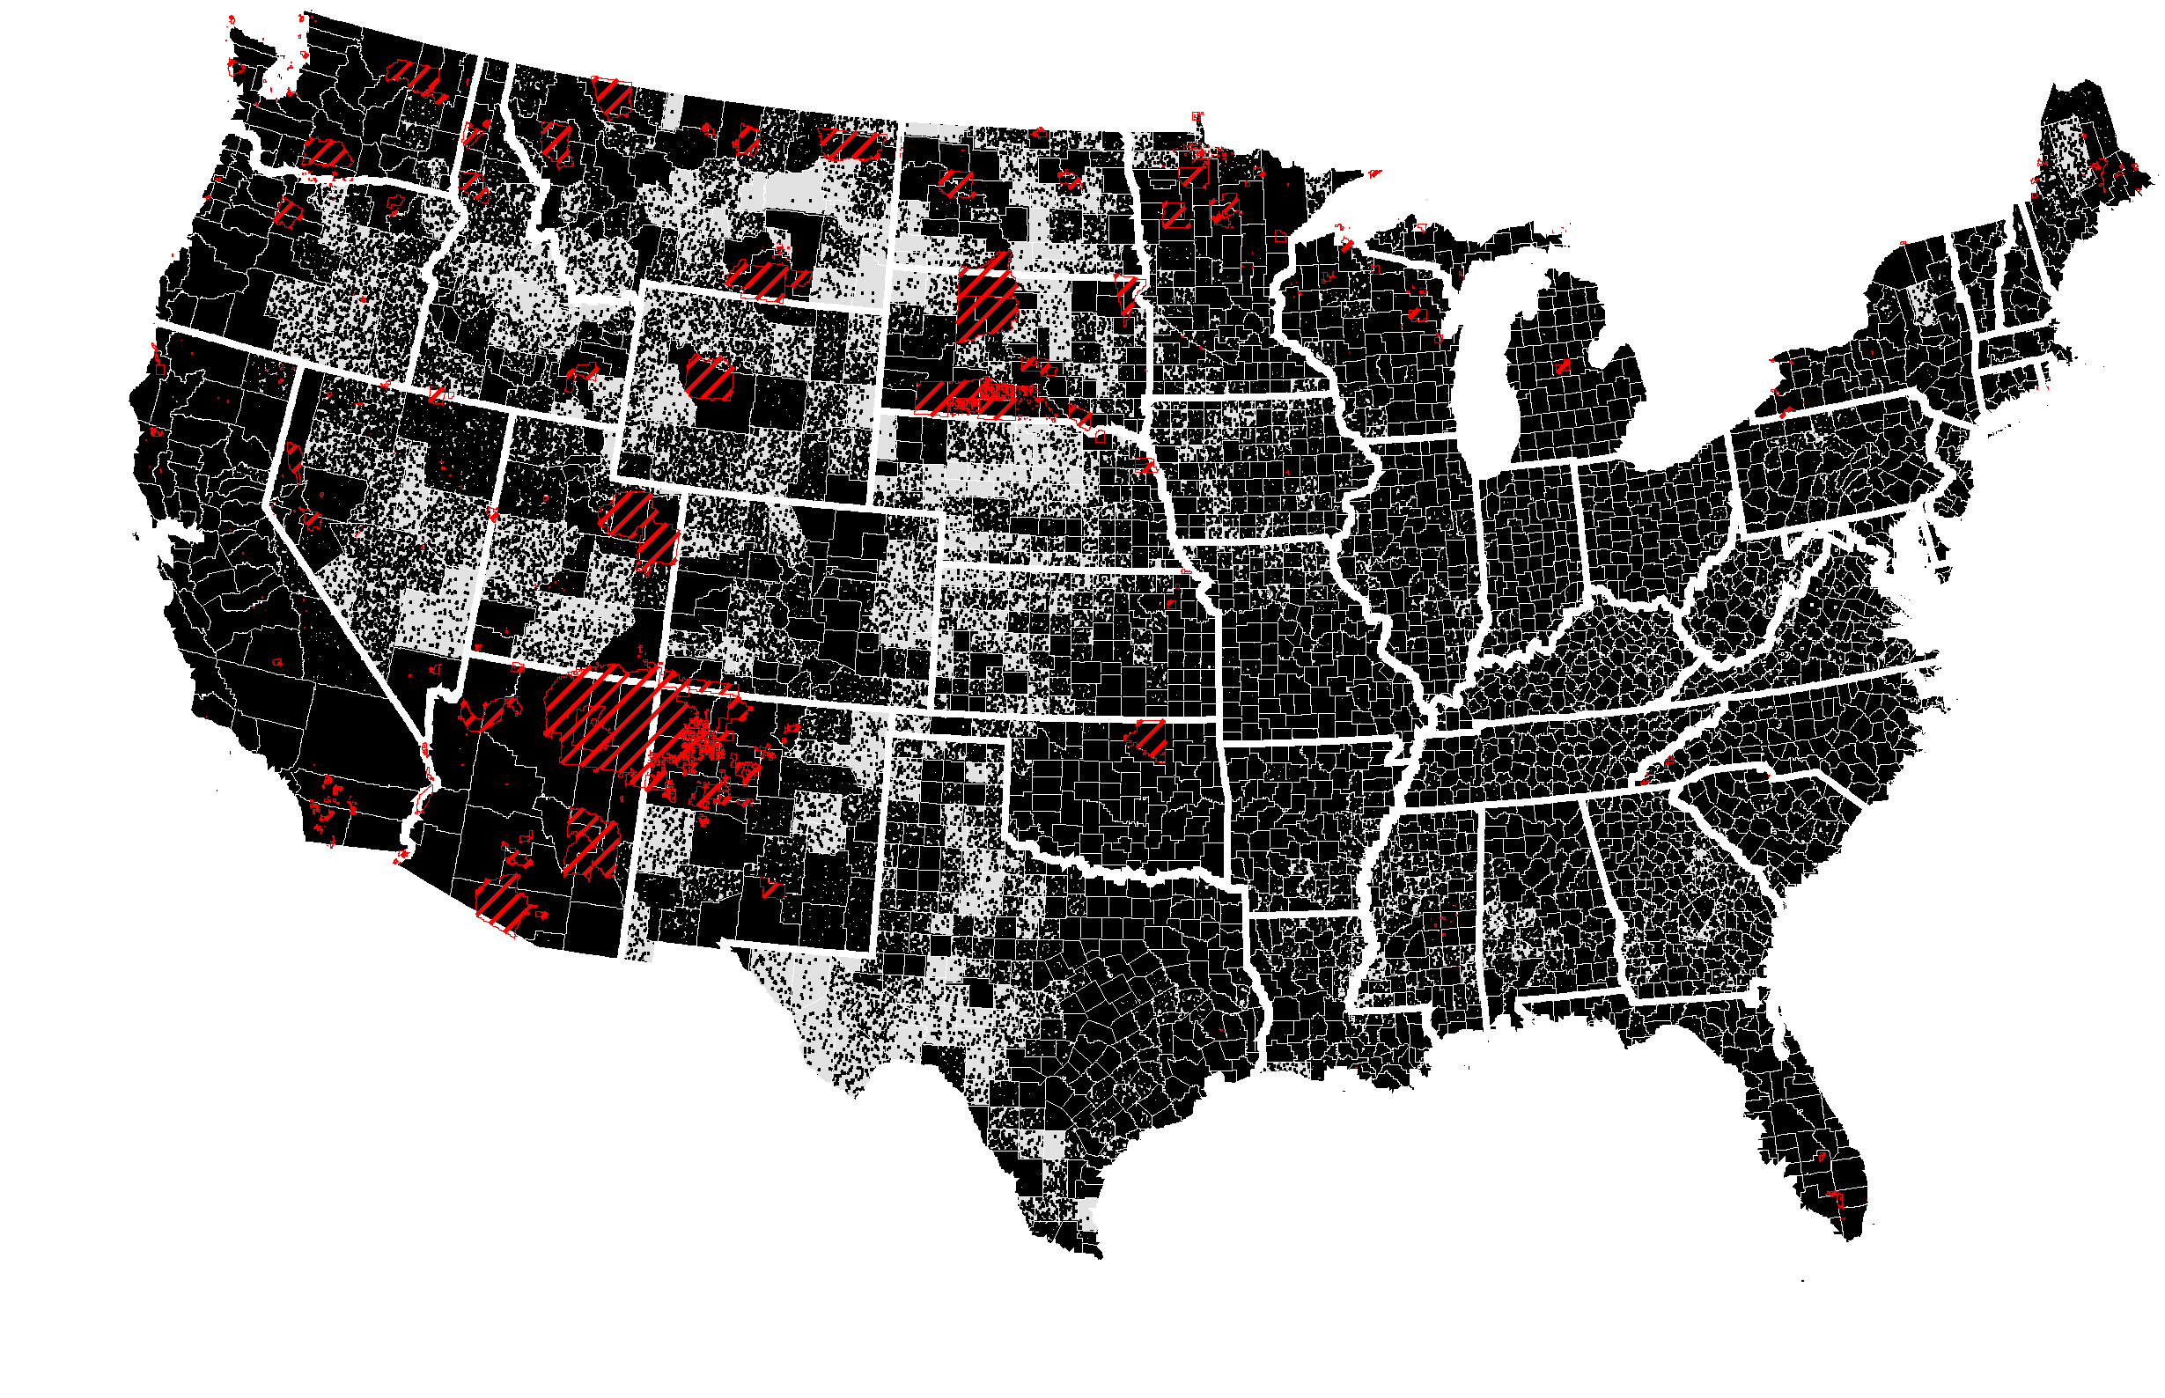
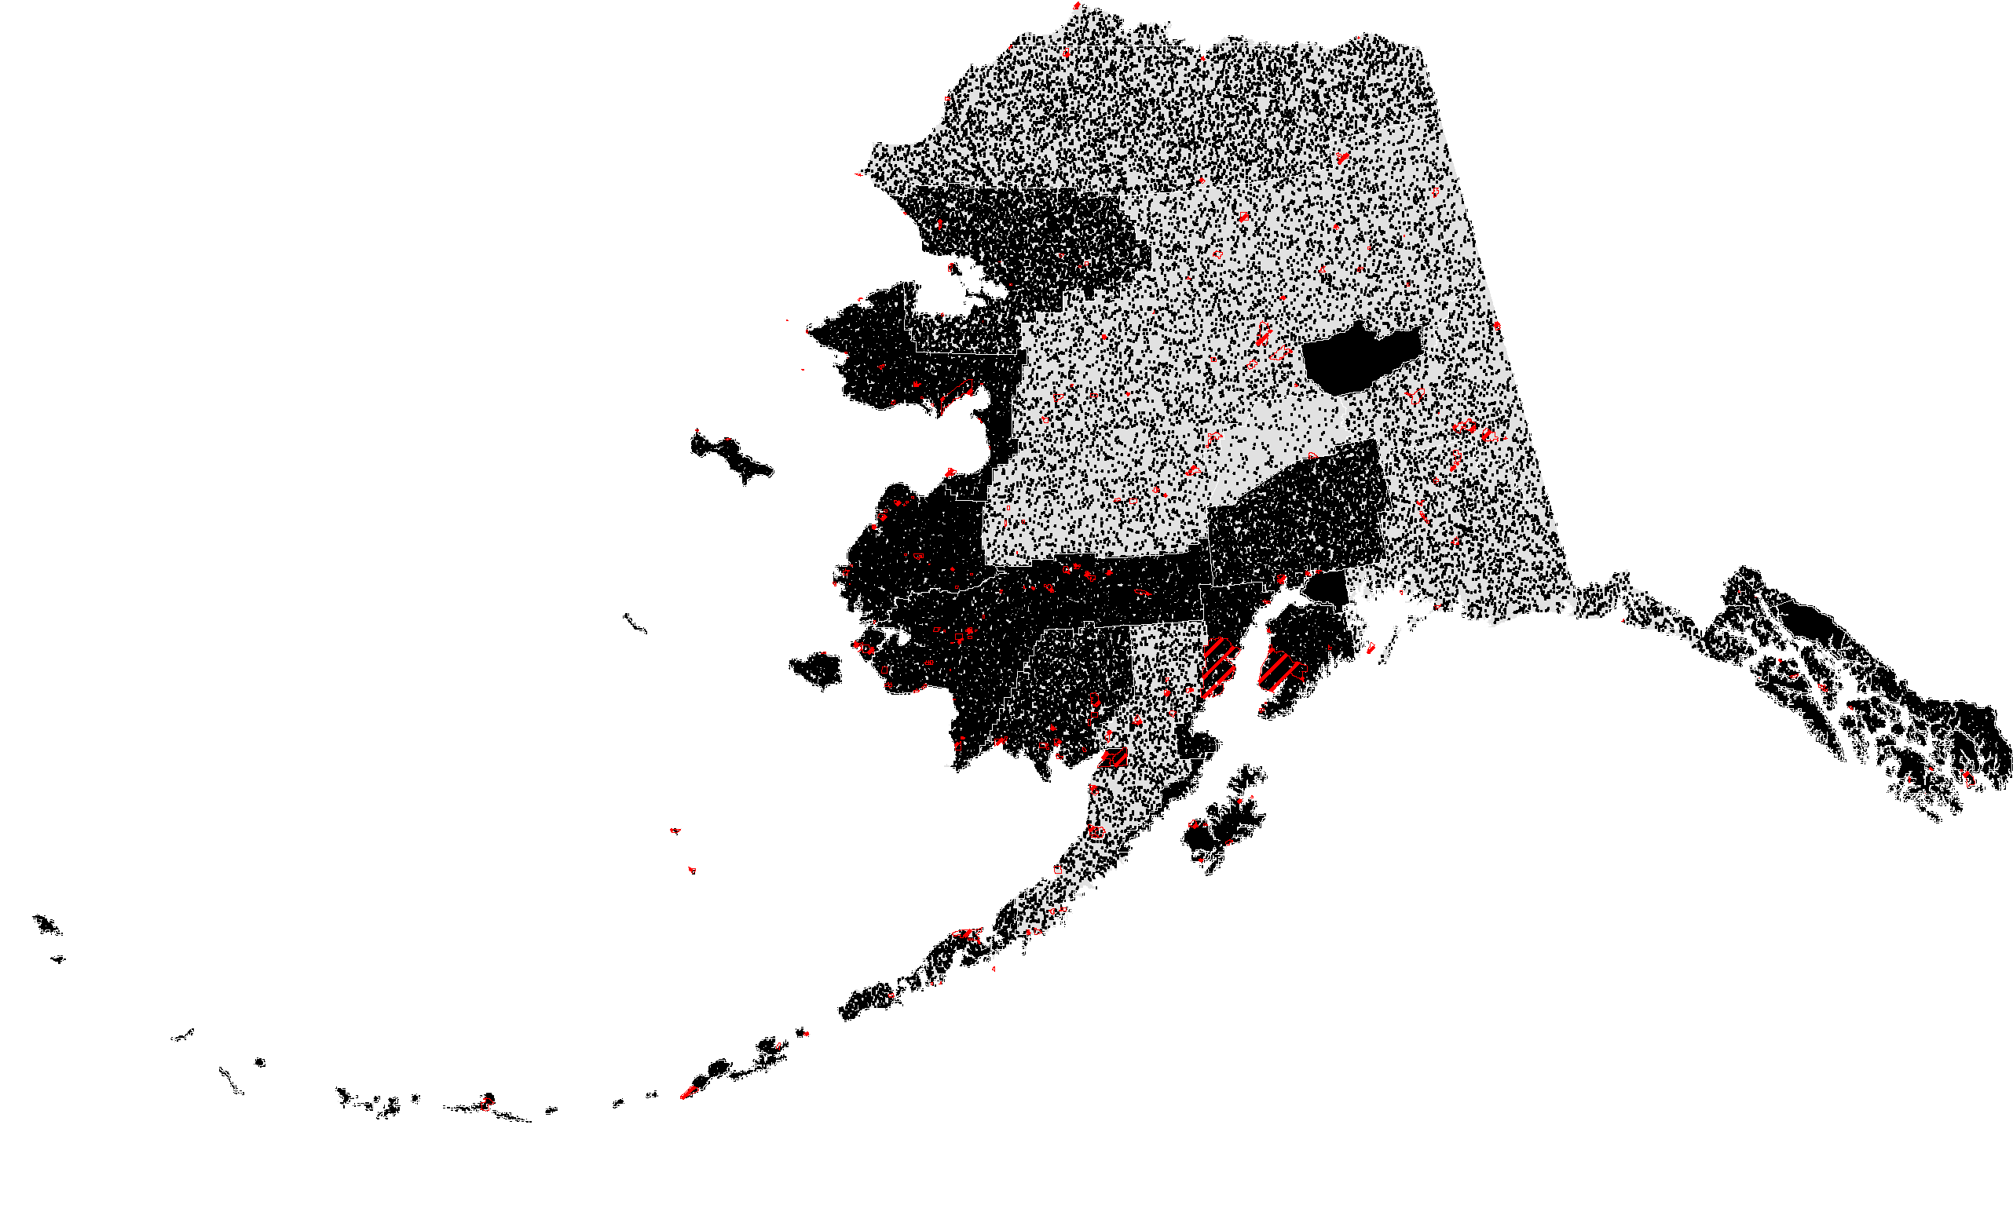

AI/ANs 2000 Census
This map shows a dot density map, where each dot represents one AI/AN dispersed by county. The red shading shows where the Indian reservations are located (most Californian Rancherias Reservations and Oklahoma Indian Trusts Lands are not shown). There were only five counties that reported no AI/ANs: Hawaii’s, Kalawao County; Nebraska’s Hayes and McPherson Counties and Texas’ Cottle and Loving Counties. The top six counties with AI/ANs are;
CA, Los Angeles (CA) with 76,988 AI/ANs; Maricopa (AZ) with 56,706; McKinley (NM) with 55,892; Apache (AZ) with 53,375; Robeson (NC) 46,896 and; Navajo (AZ) with 46,532 AI/ANs. Long Term Care services for Indian elders are more likely to be needed where such dense clusters occur.

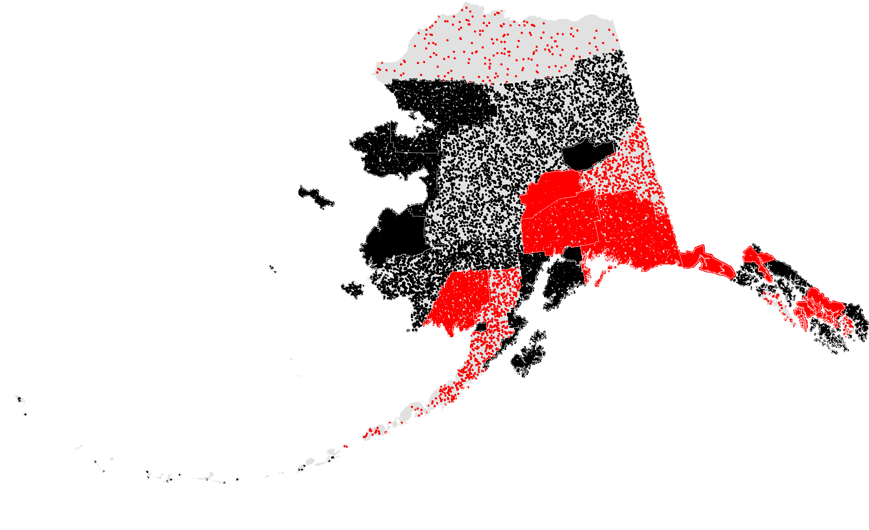
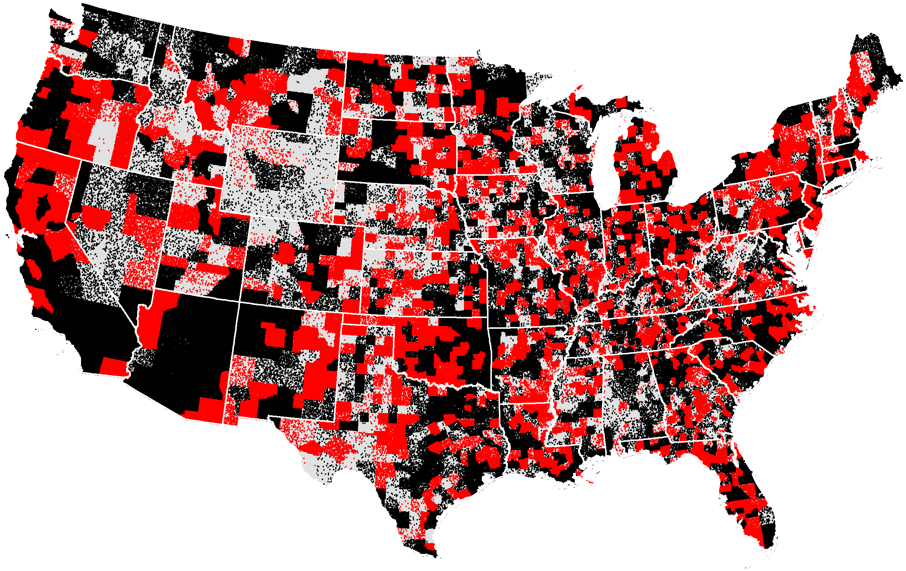
Changes in AI/ANs 1990-2000 Census
increases (black dots) decreases (red dots)
Between Censuses (1990 and 2000) AI/ANs increased by 26 percent nationally. This change did not reflect evenly across the U.S.. Some counties gained AI/ANs while others lost. This map identifies where these increases (black dots) and decreases (red dots) occurred. No general trend emerges. Neighboring counties report increases and decreases across states. In terms of planning for Long Term Care services this map shows that there is no significant migration among the AI/AN population. Today’s density clusters are likely to remain for the near future.
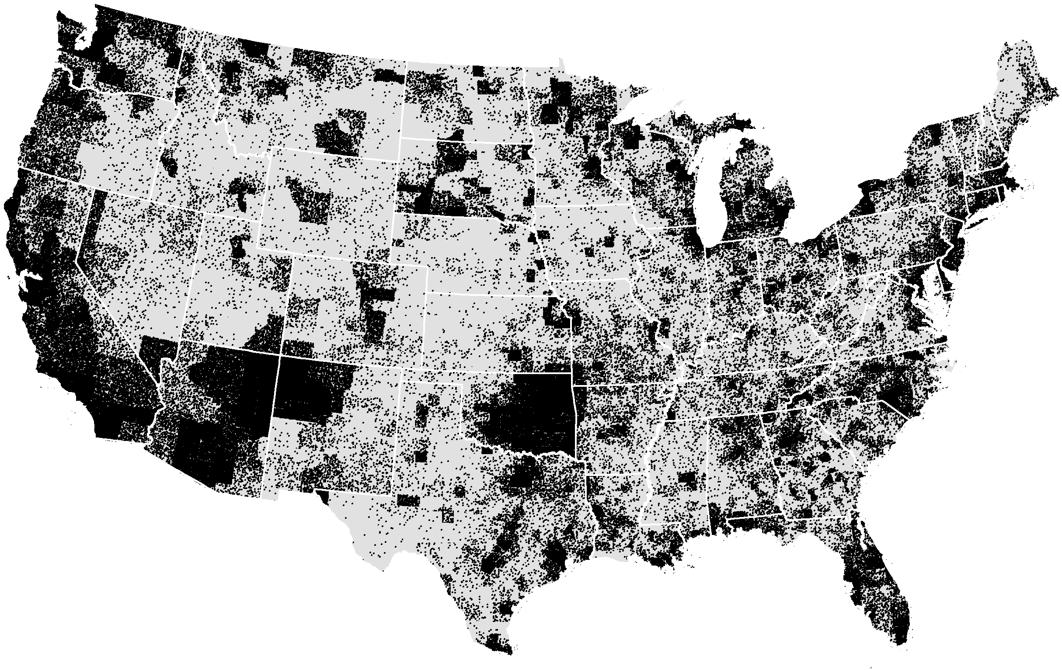
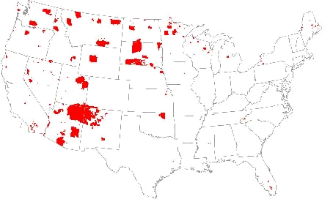
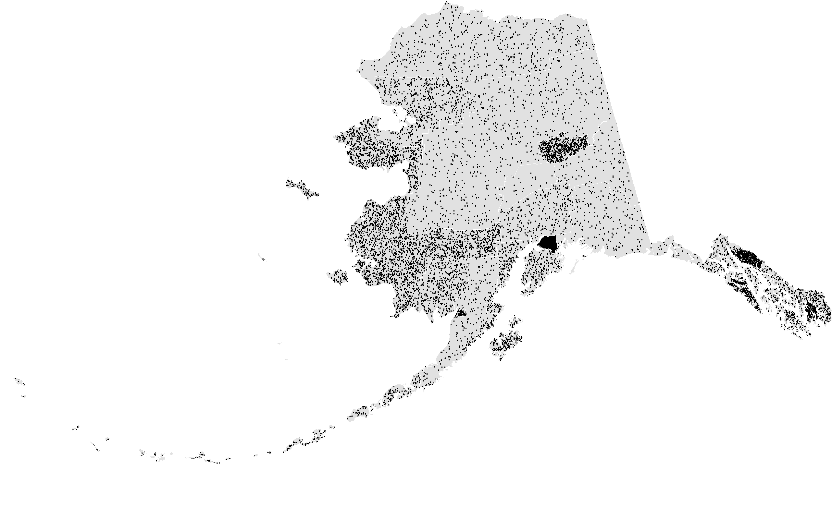

AI/ANs 55 Plus 2000 Census
Older AI/ANs tend to live on or near Indian reservations, traditional lands, and in cities. This map shows the dot density map for AI/ANs 55 years and older. Although there are still a general dispersion across the U.S. the highest concentration of AI/ANs center around traditional lands and large urban regions. Long Term Care services, similar to other types of services, will need to be close to these clusters.
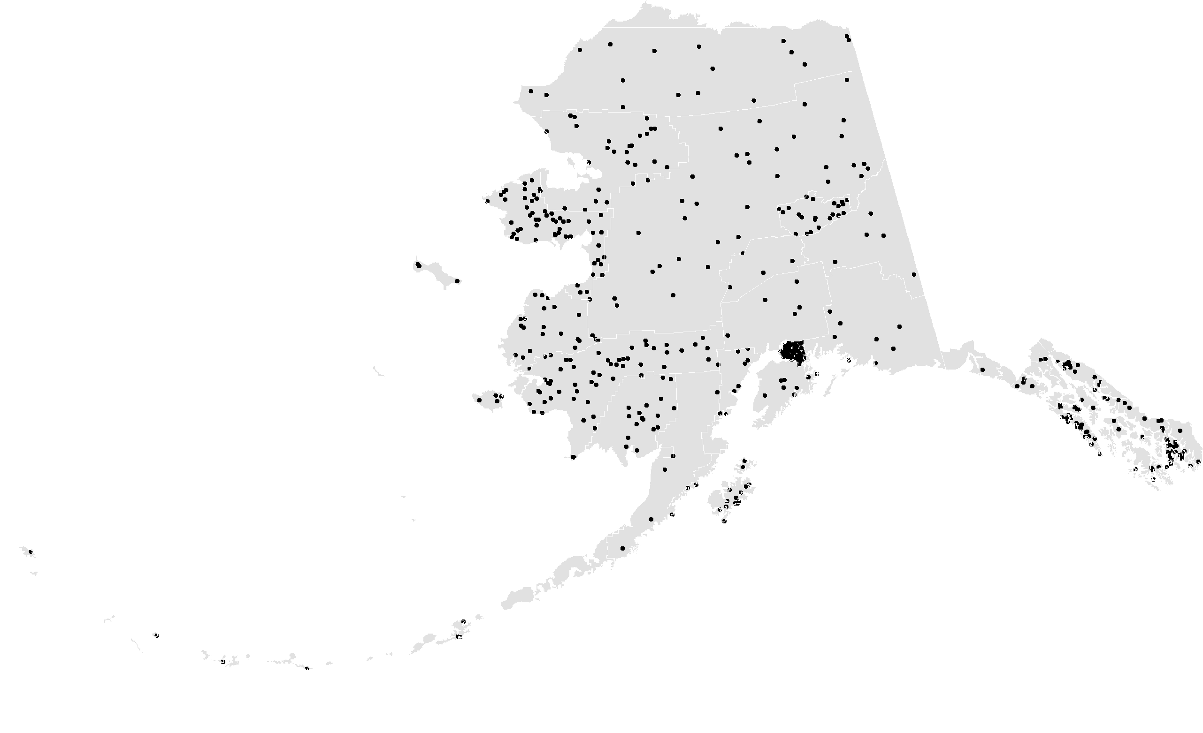
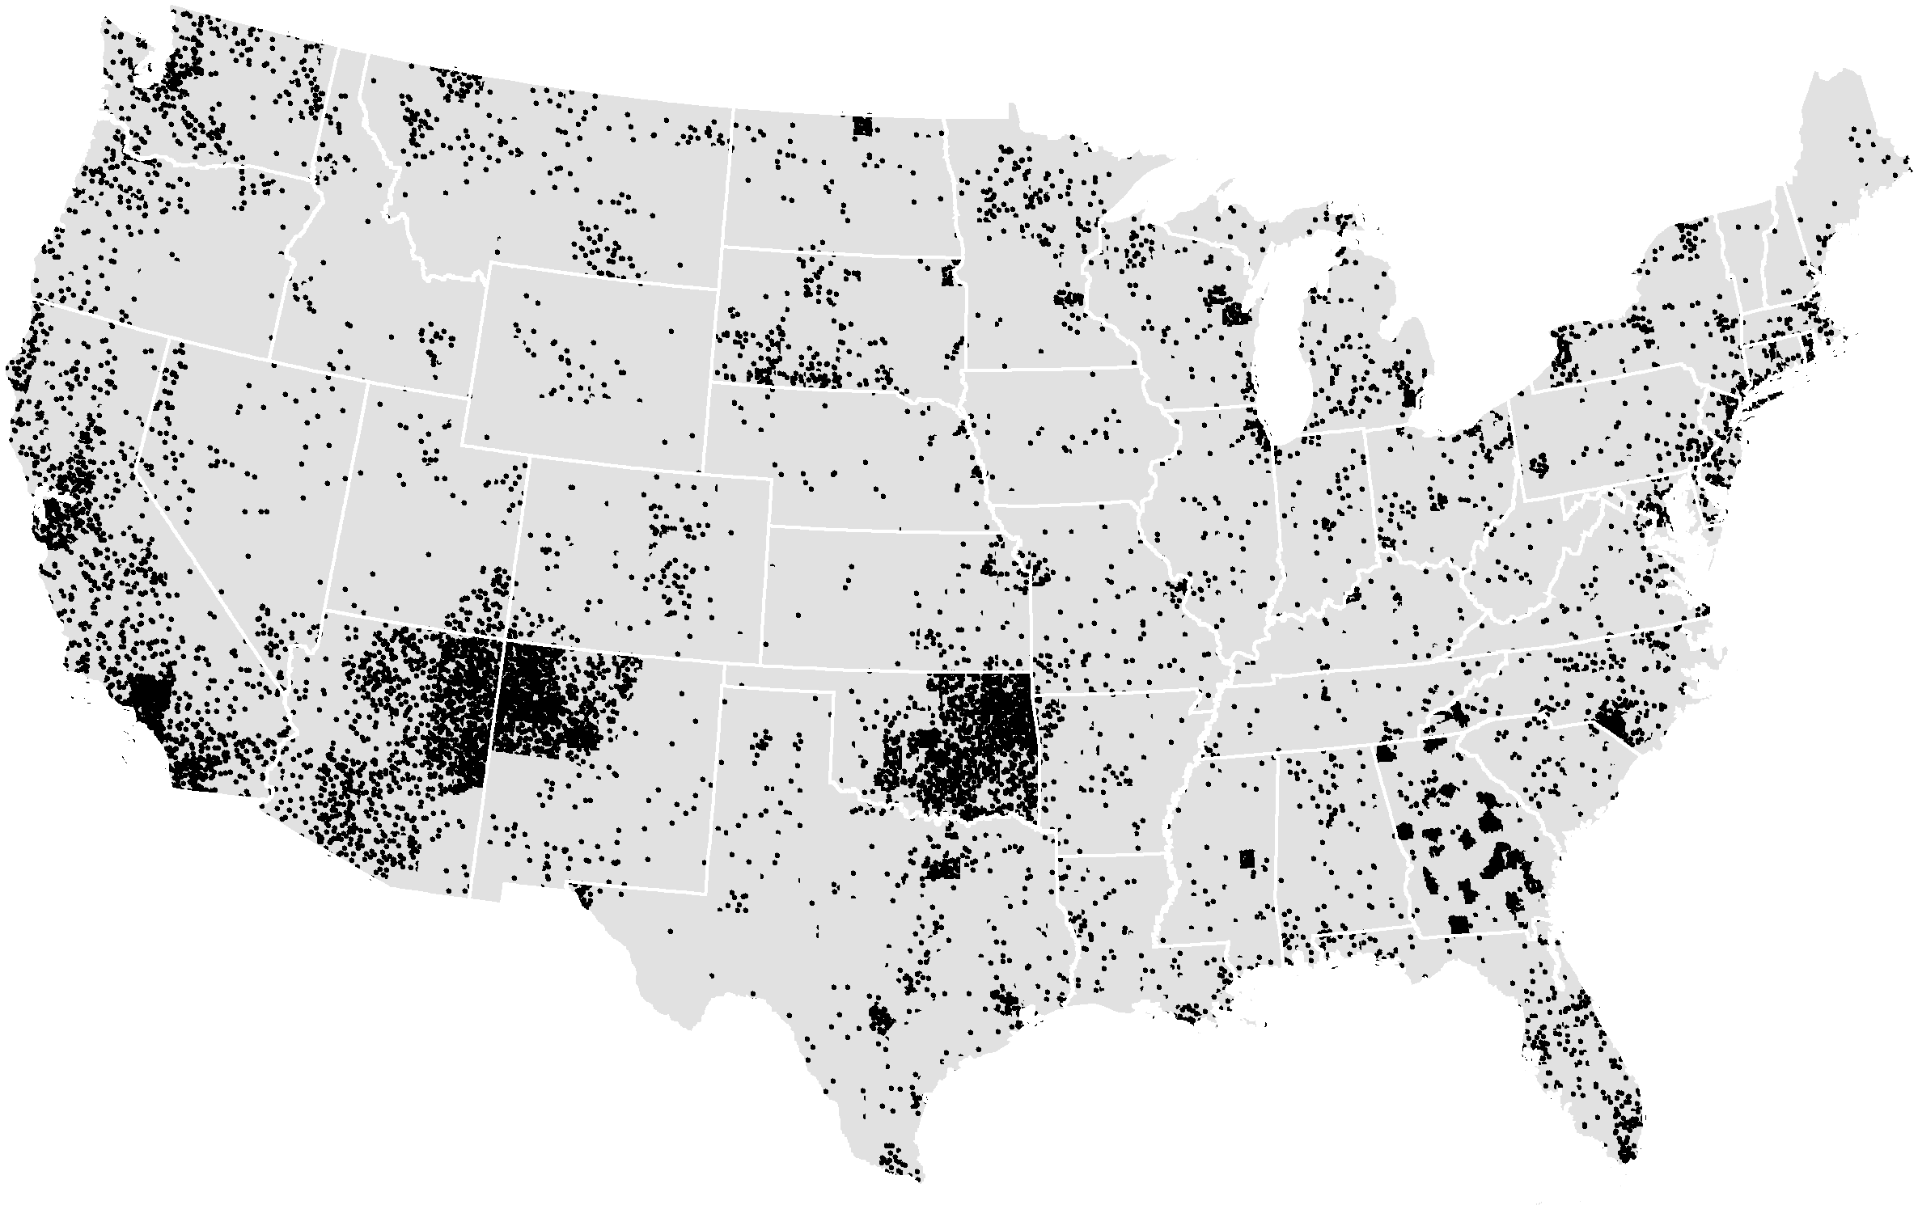

AI/ANs 85 Plus 2000 Census
Again, the concentration of AI/ANs center around traditional lands becomes more evident when we map AI/ANs who are 85 years or older. It is clear from these maps that Long Term Care services need to be based on existing Indian centers both those that reflect Indian reservations and those in large metropolitan areas.
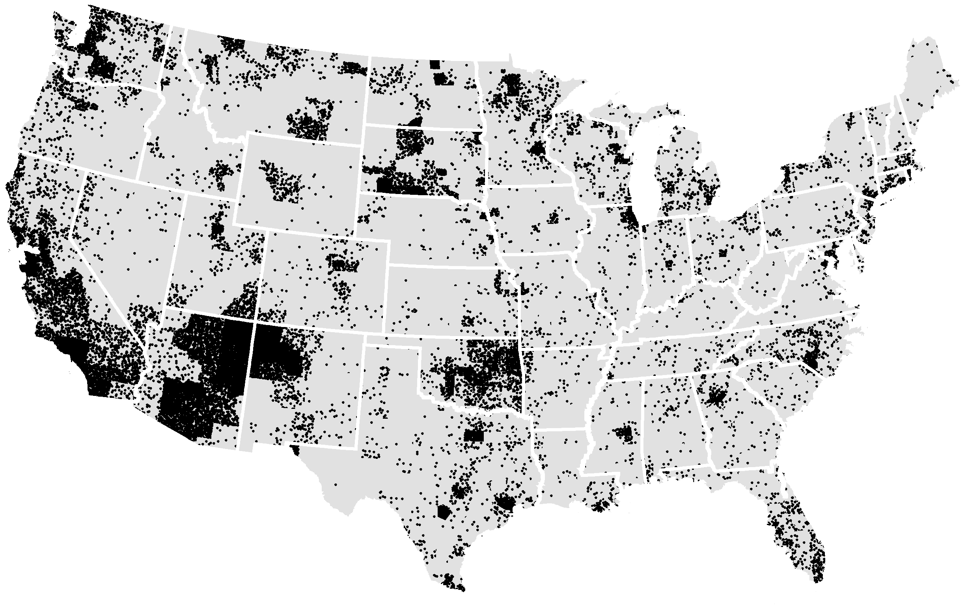
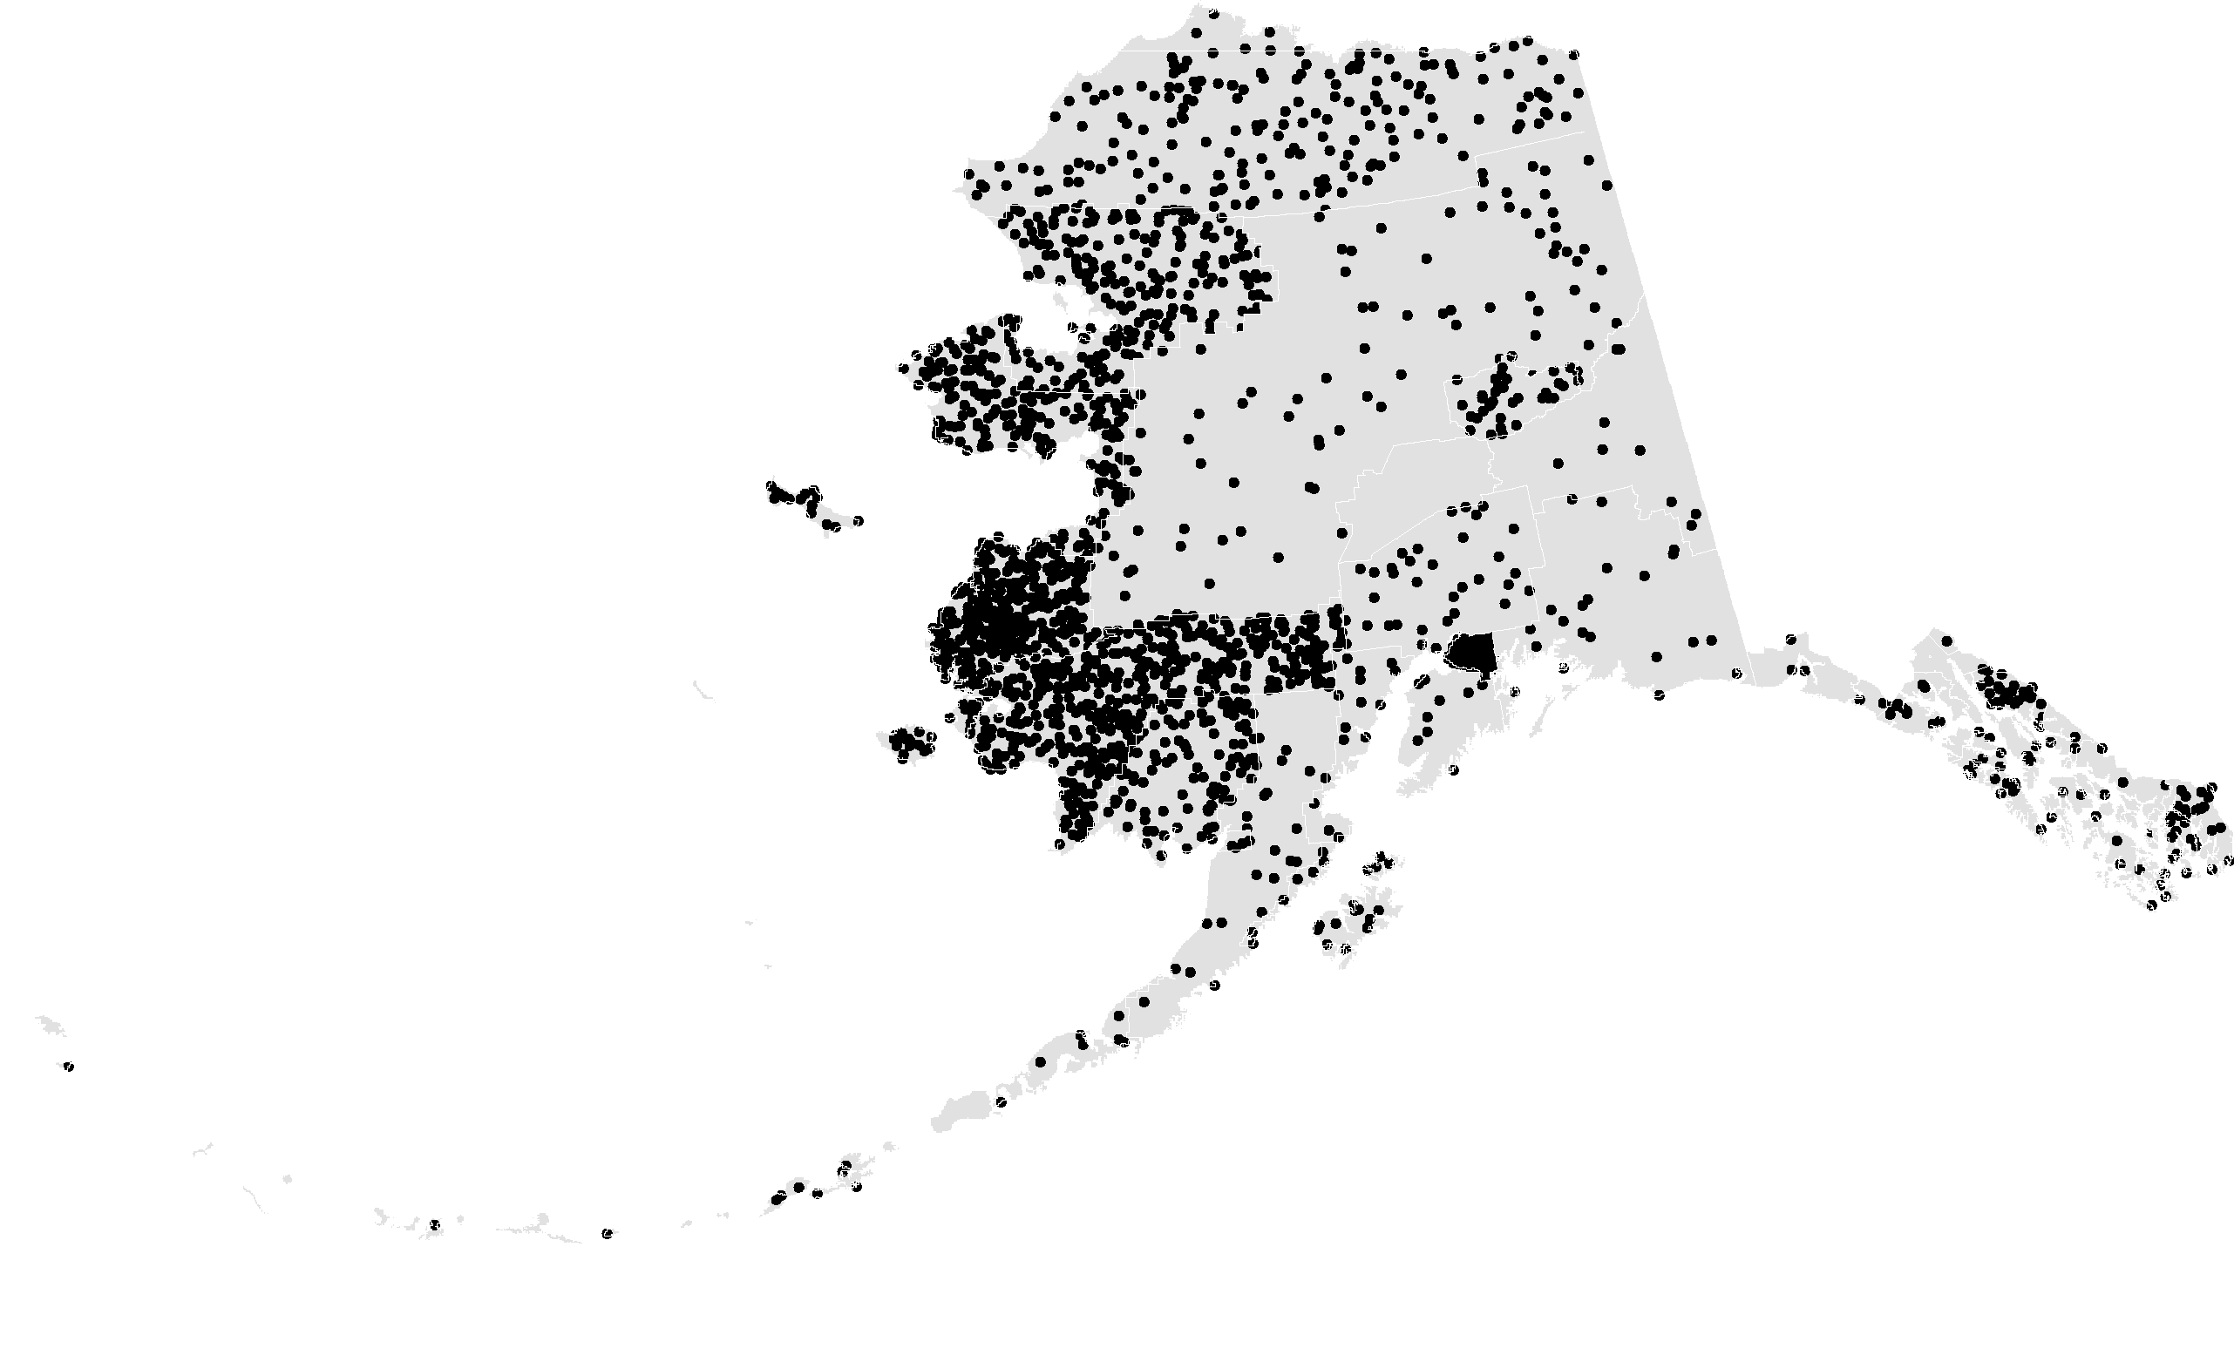

AI/AN households with 7+ persons
The same concentration is also seen for traditional family households, those households with more than seven people. Large traditional households cluster on or near Indian Reservations and also in large metropolitan centers. Large households are also indicative of poverty. The large concentrations of such households in the state of California and Washington highlight the need to address the needs of urban Indians. The need for Long Term Care services are driven both by medical needs and economic capacity of populations.
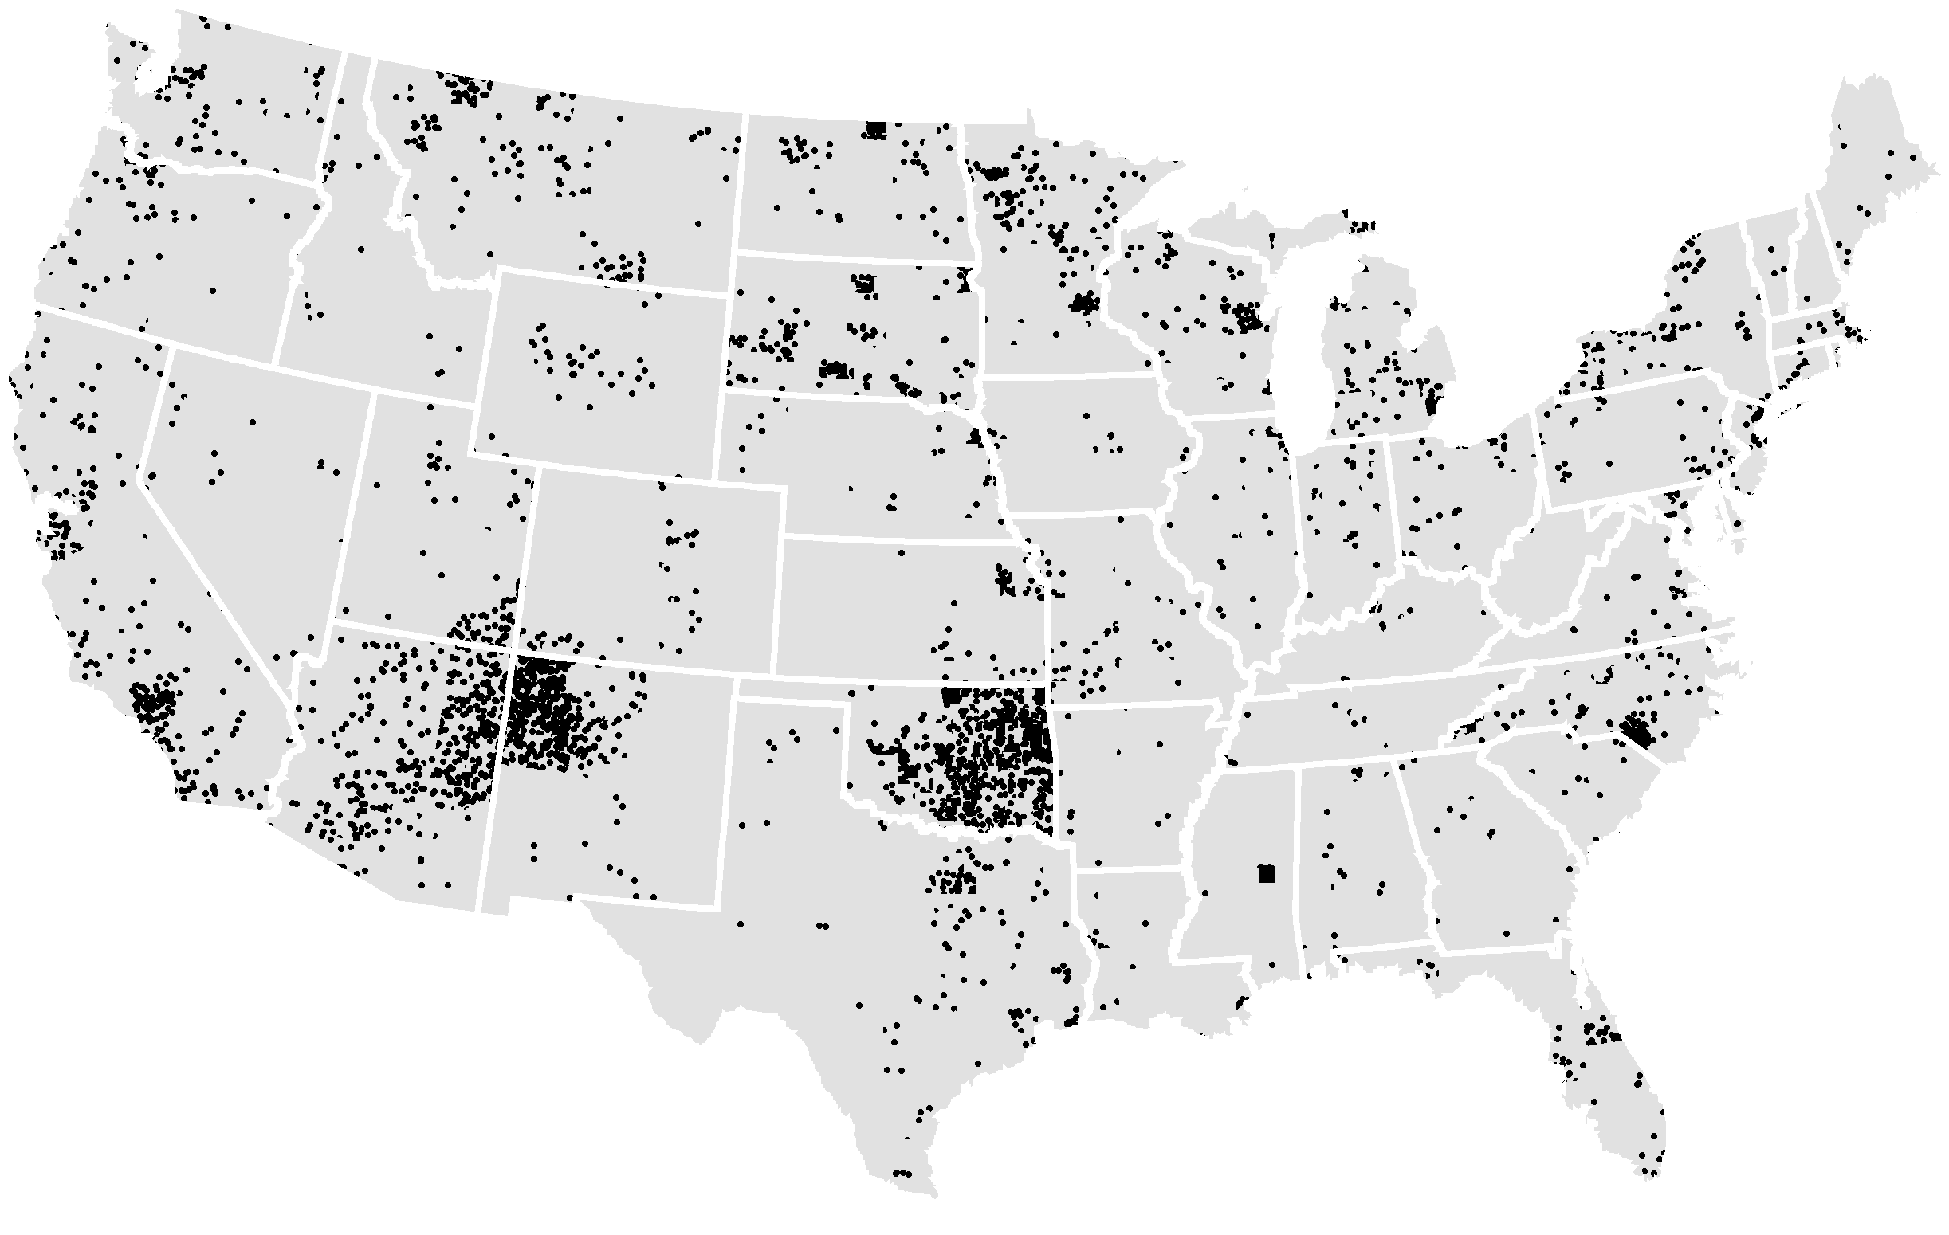
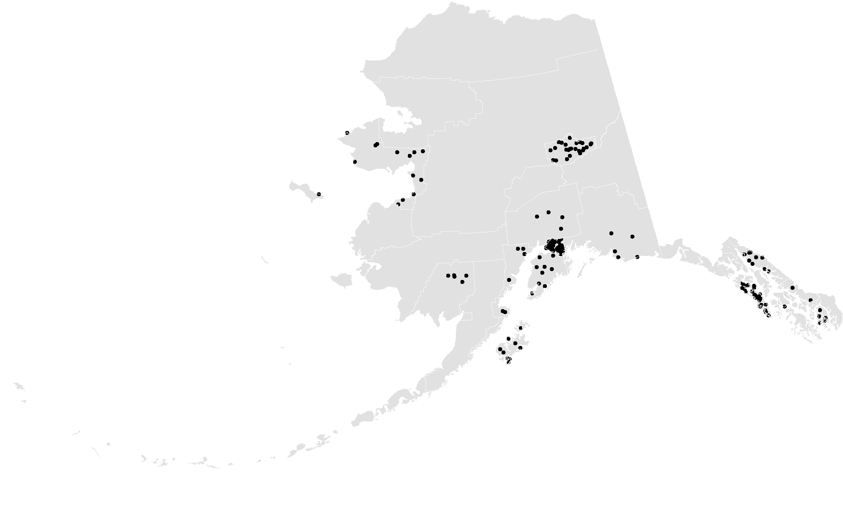
AI/AN 65+ in Institutions (NH, H, MI) 2000 Census

AI/AN Elders (65 +) in a Nursing Home, Hospital, or Mental Institution
This map portrays those AI/AN elders who report being in an institution. Although this is a broad category, elders that are identified as already needing institutional care is an extremely close proxy for local Long Term Care service needs. The pattern being reiterated here is that the need for Long Term Care services resides on or near Indian Reservations and trust lands (Oklahoma), and in large cities. The need for Long Term Care services will be exacerbated by the increase in number of AI/ANs and the rapid aging of this population. Tribes and Indian urban programs are in a prime geographic position to coordinate the development and provision of such services.

Attachment C

ECONOMIC ANALYSIS OF LONG TERM CARE

Bruce Finke, MD
ECONOMIC ANALYSIS OF LONG TERM CARE

Bruce Finke, MD

The following is a prepared response to the question:
What would be the overall funding (including staffing and equipment) that would be needed for the Indian Health Service to provide long term care for the elderly, in the form of Skilled Nursing Facilities and Nursing Home services.

Response

Using the data and assumptions detailed below, an estimate of the yearly cost of Skilled Nursing Facilities and Nursing Home services for the IHS user population is between $620,370,000 and $825,750,000.

This estimate attempts to reflect the cost of staffing, equipment, care, and ongoing capital expenses, but not initial start-up costs. It is likely that it significantly underestimates the cost involved in new construction of facilities. It is based on reimbursement levels provided by states for these services, substantially lower than those provided by private payers.

The Indian Health Service does not now provide Skilled Nursing Home and Nursing Facility services and does not have an established methodology for forecasting these costs. The estimates provided here represent a “best guess” using currently available data.

Data and Assumptions

Need for Skilled Nursing Home and Nursing Facility Care is determined by multiple factors, including elder’s functional limitations, availability of family support, elder’s preferences and values, and acceptability of available services. Functional status represents the most quantifiable and best-studied predictor of need for long term care services.

The largest available data set on the functional limitations of American Indian and Alaska Native elders suggests the following prevalence rates of need for help in activities of daily living (ADLs: bathing, dressing, eating, getting in or out of bed, walking, and using the toilet).¹

Functional Limitations | Age 55-64 | Age 65 and older
Moderate (limitations in one activity of daily living or two instrumental activities of daily living) | 18% | 23.4%
Moderately Severe (limitations in 2 activities of daily living) | 6.6% | 7.4%
Severe (limitations in 3 or more activities of daily living) | 10.7% | 14.7%

Data from a earlier, smaller sample of this population, suggests that 9.6% of AI/AN elders 55 years and older had 4 or more ADL limitations.² Data on functional limitations among nursing home residents in 1997 indicates that the mean number of ADLS with which nursing home residents needed help was 4.4%.³

Using the most recent IHS User Population data with age breakdowns available (1997)⁴, we can estimate the number of IHS beneficiaries with the following functional limitations:

Functional Limitation | Age 55-64 | Age 65 and older | Total age 55 and older
Moderate (limitations in one activity of daily living or two instrumental activities of daily living) | 12,417 | 17,461 | 29,878
Moderately Severe (limitations in 2 activities of daily living) | 4,553 | 5,522 | 10,075
Severe (limitations in 3 or more activities of daily living) | 7,381 | 10,969 | 18,350

Functional Limitation | Age 55 and older
Limitations in 4 or more ADLS (9.6%) | 13,786

The cost of care varies across a range determined by regional costs and intensity of care, but a reasonable figure derived from reimbursement schedules of several states for is $45,000 per year⁵ per client. This figure reflects the cost of staffing, equipment, care, and ongoing capital expenses, but not initial start-up costs.

Using the data and assumptions detailed below, the yearly cost of Skilled Nursing Facilities and Nursing Home services for the IHS user population can be conservatively estimated to be between $620,370,000 and $825,750,000. The lower estimate is based on the cost of services for only those elders whose functional limitations (4 or more ADLs) most closely match those of current nursing home residents in a national sample. The higher estimate is based on the cost of services for all elders who meet nursing home eligibility standards under most state Medicaid programs (3 or more ADL limitations).

This estimate attempts to reflect the cost of staffing, equipment, care, and ongoing capital expenses, but not initial start-up costs. It is likely that it significantly underestimates the cost involved in new construction of facilities.⁶ It is based on reimbursement levels provided by states for these services, substantially lower than those provided by private payers.⁵

NOTES AND REFERENCES

- The National Resource Center on Native American Aging at the University of North Dakota Center for Rural Health. The data were derived from the "Identifying Our Needs: A Survey of Elders" - a needs assessment project being conducted by tribes across the nation. The data file contain 8,560 respondents representing 83 tribes.

- Activity Limitations Among Native American Elders. Report 01-2 of the National Resource Center on Native American Aging at the University of North Dakota Center for Rural Health. October, 2001.

- Sahyoun NR et al. The Changing Profile of Nursing Home Residents: 1985-1997. Trends in Health and Aging. Aging Trends No.4. March 2001. Centers for Disease Control and Prevention. National Center for Health Statistics.

- 1997 Indian Health Service User Population. Indian Health Service Program Statistics Team. Contact: Edna Paisano, Principle Statistician, Program Statistics Team.

- Data from the states of Washington, North Dakota, and New Mexico. For comparison, the AARP published national private pay average costs for nursing home care at $4,654 per month or $55,848 per year.

- The cost of new nursing home construction in North Dakota averages $120,000 per bed when there is a mix of single and double rooms. This would place the cost of a 60 bed unit at $7.2 million. Personal conversation, Muriel Peterson, North Dakota Department of Human Services.

Further Discussion

“Long-term care is a set of health, personal care, and social services delivered over a sustained period of time to persons who have lost or never acquired some degree of functional capacity."(Kane and Kane)⁷

The long term care needs of American Indian and Alaska Native elders must be met by an array of resources which provide needed services in the least restrictive setting possible in a manner consistent with the elder’s wishes and cultural values.

While nursing homes are one element of a long term care system, they are the most restrictive and most expensive setting. In addition, the small population size and dispersed pattern of AI/AN elders makes nursing home construction and management (where economics of scale dictate larger bed capacity) less economically feasible.⁸ Finally, the removal of an elder from the home and family setting is often unacceptable and undesirable to the elder and the family. It has the potential, by removing the elder from daily interaction with the extended family, to disrupt the cultural continuity of the family and community.

Alternatives to nursing homes have taken an increasing role nationally and in AI/AN communities. Particularly promising are home and community based models that focus on the cost effective provision of services in the least restrictive setting. Services include personal care and homemaker services, meal preparation, housing modification, case management, caregiver respite and caregiver training. Settings range from the elder’s own home to small and medium sized (6-30 units) home settings for elders and the disabled in which needed personal care services can be delivered.

The data presented in the above discussion can be used to estimate the costs of provision of home and community based care to the entire population of AI/AN elders with functional limitations.

Functional Limitation | Age 55-64 | Age 65 and older | Total age 55 and older
Moderate (limitations in one activity of daily living or two instrumental activities of daily living) | 12,417 | 17,461 | 29,878
Moderately Severe (limitations in 2 activities of daily living) | 4,553 | 5,522 | 10,075
Severe (limitations in 3 or more activities of daily living) | 7,381 | 10,969 | 18,350

Cost of care assumptions can be derived from the North Dakota Department of Human Services average expenditure data for individuals with similar levels of functional limitation. We can use these cost of care assumptions to estimate the total long term care costs for the IHS user population if all eligible individuals received services.

Functional Limitation | Average expenditure per client per year in North Dakota⁹ | Projected costs  AI/AN 55 and older
Moderate (limitations in one activity of daily living or two instrumental activities of daily living) | $4,632 | $138,394,896
Moderately Severe (limitations in 2 activities of daily living) | $4,992 | $50,294,400
Severe (limitations in 3 or more activities of daily living) | $10,254 | $188,160,900

The total cost of care for home and community based services for IHS served elders with moderate, moderately severe and severe functional limitation using these estimates would be $370,850,196. This compares quite favorably to the estimated cost for skilled nursing home and nursing facility care derived above from the same set of assumptions.

These cost of care assumptions do not include housing. Some elders will not be able to be cared for in their own home and will need housing as a part of the long term care package. Housing costs can estimated by using the State of Washington average reimbursement level of $22,000 per year for housing in small and medium sized homes (up to 30 beds) under the Medicaid waiver program.¹⁰ Although we do not have data indicating the need among AI/AN elders for housing as a component of long term care, we can make an assumption for the purposes of this discussion. If we assume that 10% of the 58,303 AI/AN elders with functional limitations require housing as an element of long term care, we can add an additional $128,266,600 to the cost estimate.
This would bring a total cost of care to $499,116,796.

These cost estimates suggest that all eligible AI/AN elders in with functional limitations could be served in the community at substantially less cost than would be required to serve only the neediest 25% in nursing homes.

ADDITIONAL REFERENCES AND NOTES

- R. A. Kane & R. L. Kane. Long-term care: Principles, programs, and policies. New York, NY: Springer, 1987.

- Trends in Nursing Home Size. National Nursing Home Survey. Centers for Disease Control and Prevention. National Center for Health Statistics. http://www.cdc.gov/nchs/about/major/nnhsd/nnhs_chart.htm

- Personal communication, Muriel Peterson. North Dakota Department of Human Services.

- Personal communication, Shelly Zylstra, Washington State NWAAA.

Attachment D

FUNCTIONAL LIMITATIONS AND THE FUTURE FOR LONG TERM CARE

National Resource Center on Native American Aging at the University of North Dakota

William F. Benson of The Benson Consulting Group serves as National Policy Advisor to NICOA and president of The Benson Consulting Group and is the former head of the U.S. Administration on Aging (DHHS). The author wishes to acknowledge the contributions to this paper made by Dave Baldridge, executive director of NICOA, Eric Carlson, attorney with the National Senior Citizens Law Center, and Linda Redford, Ph.D., director of the Geriatric Education Center at the Center on Aging of the University of Kansas Medical Center.
Activity Limitations among Native American Elders. National Resource Center on Native American Aging, University of North Dakota. Report 01-2. October 2001
Ibid.
National Indian Aging Agenda for the Future. National Indian Council on Aging. 1995. Note Appendix I
The NICOA Report: Health and Long Term Care for Indian Elders. Robert John and Dave Baldridge. A report by NICOA for the National Indian Policy Center, 1996.
Indian Health in Nine State Medicaid Managed Care Programs. Mim Dixon. September 1998.
Long term Care Service Needs of American Indian Elders in the IHS Santa Fe Service Unit (draft). Catherine Hagan Hennessey, Robert John, Lonnie C. Roy. July 1998
Author’s conversation with Alan Allery, director of the NRCNAA, 2001
Home and Community-Based Long Term Care in American Indian and Alaska Native Communities. Administration on Aging, U.S. Department of Health and Human Services, Native Elder Health Care Resource Center, University of Colorado, National Resource Center on Native American Aging, University of North Dakota. December 1996.
Long term Care in Indian Country: A Project to Establish “Building Blocks” for Tribal Use in Planning for the Long term Care Needs of Indian Elders, a project of NICOA in partnership with the National Senior Citizens Law Center funded by the Retirement Research Foundation (Chicago, IL), and the Geriatric Education Center at the Center on Aging of the University of Kansas Medical Center.
It is not yet clear whether the “owned by tribe” and “operated by tribe” has overlap within the responses and if so to what extent. In other words, it may be that among the five tribes operating a nursing home 4 of them own the facility. (Question no. 5)
Designed with consultation from Dr. Bruce Finke of the IHS and administered and analyzed by Eva Gardipe and Heather Mann of NICOA.
These numbers appear skewed by OK, e.g., 10 of 11 reporting OK tribes report the availability of home health care a far greater percentage than among all other tribes
Excluding OK tribes
Please address comments on this paper to Mim Dixon, Mim Dixon and Associates, 1618 Spruce Street, Boulder, CO 80302, or via e-mail to mimdixon@hotmail.com, or by FAX at 303-443-4733, or by telephone at 303-674-9513.
This paper relies primarily on information presented in Understanding Medicaid Home and Community Services: A Primer (Smith 2000). To make the paper more readable, the only times this reference is specifically cited is when there is a direct quote that is tied to a page number. Unless other references are cited, it should be assumed that the source of information is Smith (2000).
The elderly comprise only about 10 percent of the total Medicaid beneficiaries (Wiener 2000).
Formerly the Health Care Financing Administration
For acute and chronic medical care, Congress has funded the Indian Health Service at less than 60 percent of the need, as compared the the federal employee benefit package.
Under OAA, there is great variation in long term care services from state to state and even within states by Area Agencies on Aging.
Some tribal organizations are designated as AAA, including the Inter Tribal Council of Arizona and the Navajo Nation.
According to Tilly (2001) states with large AI/AN populations that have a significantly lower percentage expenditure on institutional care include Oregon with 40-49 percent of the LTC Medicaid budget spent on institutional care; Alaska, Washington, Wyoming, and New Mexico in the 50-59% category; and California, Montana, Utah, Minnesota, Michigan and Wisconsin in the 60-69% category. At the higher than average category is Nevada with 80-89 percent of Medicaid LTC spent on institutional care.
Nationally, 71 percent of adults who require assistance receive it from unpaid caregivers (Tilly 2001). It is possible that the percentage is higher in Indian Country, but that has not been substantiated.
In 1998, 38 states had CON programs and 19 states had a moratorium on new construction of nursing homes (Wiener 2000).
The Supreme Court qualified this decision to take into account the professional judgment of the appropriateness of the placement, the preferences of the people who are affected, and the resources that are available to support the needs of the entire group of people with disabilities who are entitled to state-funded services.
Medicare was never designed as a long term care program. The Medicare reimbursement guidelines allow for only medically-directed episodic care, not the continuing or chronic care that is the hallmark of long term care.
An excellent example of this type of synergy on the national level was the passage of the Diabetes Grant funding for Indian health that was approved on the coattails of a broad campaign for diabetes funding by national advocacy groups, such as the American Diabetes Association.
Now called Centers for Medicare and Medicaid Services (CMS).
As a policy alternative, if the federal government were going to fund long term care in Indian Country through state Medicaid programs, they could carve out that funding to go directly to tribes and circumvent the costly step of negotiation and billing Medicaid. While this might be the preferred approach, it is not the subject of this paper.
At the present time, no waivers have been proposed to target tribal areas.
Some types of immigration status also qualify for Medicaid.
This ceiling for federal participation is 133.3 percent of the highest amount paid to a family of the same size that receives Aid for Families with Dependent Children (AFDC).
40 states provide Medicaid automatically to everyone who receives SSI payments in any month, while 11 states are more restrictive.
Also, the funds needed to support a disabled adult child must be deducted.
This is often considered a Medicaid Qualifying trust, designed more to assure eligibility rather than to result in recovery.
In 2000, the 300 percent of SSI was the equivalent of $1536 per month.
This includes people receiving home and community based services.
Despite a prohibition of “Medicaid estate planning” in the Balanced Budget Act of 1997, there is a thriving industry to advise middle class and wealthy individuals about how to transfer, shelter and under-report their assets to qualify for Medicaid nursing home care without the consequences of estate recovery (Weiner 2000).
Weiner (2000) regards this as an attempt by states to shift costs from Medicaid to Medicare. He points out that the Medicare program has resisted this trend, both to control costs and to protect Medicare beneficiaries’ freedom of choice of providers.

