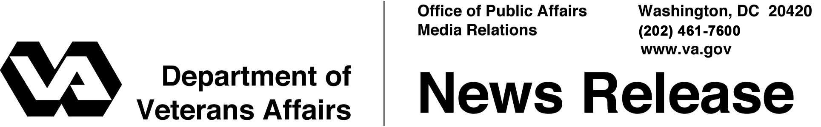

FOR IMMEDIATE RELEASE
December 31, 2008

VA Awards $3.5 Million for Bakersfield National Cemetery
Construction to Begin Early 2009
WASHINGTON – The Department of Veterans Affairs (VA) has awarded more than $2.8 million to a Jamestown, Calif., contractor to develop the first phase of the Bakersfield National Cemetery in Arvin, Calif.
“With the start of construction on this new national shrine, we move ahead on our promise to the veterans of Central California,” said Secretary of Veterans Affairs Dr. James B. Peake. “This cemetery will honor the legacy of the men and women who have honorably and faithfully served their country.”
The contract to Combined Effort Inc. is to develop a 15-acre first phase of the 500-acre site. Construction is expected to begin in early 2009.
The early burial area will provide two years of burial services and comprise approximately 1,500 full-casket gravesites and 1,800 in-ground cremation sites. The cemetery staff will work initially from a temporary office, committal service shelter and equipment facility until the construction project is completed.
In addition to the construction contract, VA awarded a $691,000 contract to complete the design of the cemetery’s first phase to Huitt-Zollars Inc. of Irvine.
The new cemetery’s site was donated by Tejon Ranch, a 426-square-mile agricultural and industrial complex along Interstate 5 in Kern County. It will serve approximately 200,000 veterans in central California.
The complete first phase of the cemetery will include roadways, an administration and public information center, a maintenance complex, an assembly area, a memorial walkway, two committal service shelters and public restrooms. Interment areas will include approximately 4,800 full-casket gravesites, 4,000 pre-placed crypts, 4,000 in-ground cremation sites and 3,000 columbarium niches. Other infrastructure improvements will include utilities, fencing, landscaping and an irrigation system.
- More -
Bakersfield NC Contracts 2/2/2/2

Veterans with a discharge other than dishonorable, their spouses and dependent children are eligible for burial in a national cemetery. Other burial benefits for eligible veterans include a burial flag, a Presidential Memorial Certificate and a government headstone or marker – even if they are not buried in a national cemetery.
In the midst of the largest cemetery expansion since the Civil War, VA operates 125 national cemeteries in 39 states and Puerto Rico, in addition to 33 soldiers' lots and monument sites. More than 3.4 million Americans, including veterans of every war and conflict — from the Revolutionary War to the current wars in Iraq and Afghanistan — are buried in VA’s national cemeteries.
Information on VA burial benefits can be obtained from national cemetery offices, from the Internet at www.cem.va.gov or by calling VA regional offices toll-free at
1-800-827-1000.
Information about the Bakersfield National Cemetery is available by calling the cemetery at (661) 632-1894.

# # #

