Final
Damage Assessment and Restoration Plan/Environmental Assessment
for the
DuPont Newport Superfund Site, Newport, Delaware

December 2006

Prepared by:
National Oceanic and Atmospheric Administration
Delaware Department of Natural Resources and Environmental Control
and
The United States Fish and Wildlife Service
on behalf of the
U.S. Department of the Interior

Contact Information:
Jane Biggs Sanger
Delaware Department of Natural Resources and Environmental Control
Division of Air and Waste Management
Site Investigation and Restoration Branch
391 Lukens Drive
New Castle, Delaware 19720
Phone: 302-395-2600
Fax: 302-395-2601
Table of Contents

1.0 Introduction 1-2
1.1 Authority 1-2
1.2 NEPA Compliance 1-2
1.3 Public Participation 1-2
1.4 Administrative Record 1-2
2.0 Purpose and Need for Restoration 2-2
2.1 Overview of the Site 2-2
Human Use Characteristics 2-2
Surface Water Characteristics 2-2
Habitat Characteristics 2-2
2.2 Summary of Response Actions 2-2
2.3 Assessment of Resource Injuries and Compensation Requirements 2-2
Injury Determination and Quantification 2-2
Injury Assessment Strategy 2-2
Preliminary Restoration Strategy 2-2
Restoration Scaling Strategy 2-2
3.0 The Affected Environment 3-2
3.1 The Physical Environment 3-2
3.2 The Biological Environment 3-2
3.3 The Cultural and Human Environment 3-2
4.0 Injury and Service Loss Evaluation 4-2
4.1 Pathways of Contamination to Trust Resources 4-2
4.2 Contaminants of Concern (COCs) 4-2
Lead 4-2
Zinc 4-2
Cadmium 4-2
4.3 Injury Assessment & Findings 4-2
Habitat Equivalency Analysis Background 4-2
Habitat Equivalency Analysis Debit Model 4-2
Onsite Restoration Credit 4-2
Cross Habitat Comparison 4-2
HEA Debit Model Result 4-2
5.0 the Restoration Planning process 5-2
5.1 Restoration Objective 5-2
5.2 Restoration Selection Criteria 5-2
5.3 Restoration Credit – Newport North and South Wetlands 5-2
5.4 First Tier Screening of Restoration Alternatives 5-2
5.5 Second Tier - Evaluation of Restoration Alternatives 5-2
5.6 Selected Restoration Alternative – Pike Property Restoration and Easement 5-2
5.7 The Pike Property 5-2
History and Description 5-2
Easement and Restoration Options: 5-2
5.8 Scaling the Preferred Restoration Project 5-2
Habitat Equivalency Analysis Credit Model 5-2
5.9 Summary of Settlement 5-2
5.10 Geographic Proximity of Projects 5-2
6.0 NEPA, Endangered SPECIES ACT, & Essential FISH Habitat: Analysis and Preliminary Finding of No Significant Impact 6-2
6.1 Likely Impacts of the Preferred Alternatives (Pike Property Restoration and Easement) 6-2
Nature of Likely Impacts 6-2
Effects on public health and safety 6-2
Unique characteristics of the geographic area 6-2
Controversial aspects of the project or its effects 6-2
Uncertain effects or unknown risks 6-2
Precedential effects of implementing the project 6-2
Possible, significant cumulative impacts 6-2
Effects on National Historic Sites or nationally significant cultural, scientific or historic resources 6-2
Effects on endangered or threatened species 6-2
Violation of environmental protection laws 6-2
6.2 Final Conclusion & Finding of No Significant Impact on the Quality of the Human Environment 6-2
6.3 Endangered and Threatened Species 6-2
6.4 Essential Fish Habitat 6-2
Effect on Essential Fish Habitat 6-2
Effects on the Managed Species, and Associated Species by Life History Stage. 6-2
The Federal Agency’s Views Regarding The Effects Of The Action On EFH 6-2
Conclusion of Effects on EFH 6-2
7.0 Compliance with Other Key Statutes, Regulations and Policies 7-2
7.1 Clean Water Act (CWA), 33 U.S.C. § 1251 et seq. 7-2
7.2 Rivers and Harbors Act, 33 U.S.C. § 401 et seq. 7-2
7.3 Coastal Zone Management Act (CZMA), 16 U.S.C. § 1451 et seq., 15 C.F.R. Part 923 7-2
7.4 Fish and Wildlife Conservation Act, 16 U.S.C. § 2901 et seq. 7-2
7.5 Fish and Wildlife Coordination Act (FWCA), 16 U.S.C. § 661 et seq. 7-2
7.6 Marine Mammal Protection Act, 16 U.S.C. § 1361 et seq. 7-2
7.7 Migratory Bird Conservation Act, 16 U.S.C. § 715 et seq. 7-2
7.8 National Historic Preservation Act, 16 U.S.C. § 470 et seq. 7-2
7.9 Information Quality Guidelines issued pursuant to Public Law 106-554 7-2
7.10 Executive Order 12898 (59 Fed. Reg. 7629) - Environmental Justice 7-2
7.11 Executive Order Number 11514 (35 Fed. Reg. 4247) - Protection and Enhancement of Environmental Quality 7-2
7.12 Executive Order Number 11990 (42 Fed. Reg. 26,961) - Protection of Wetlands 7-2
7.13 Executive Order Number 12962 (60 Fed. Reg. 30,769) - Recreational Fisheries 7-2
8.0 Literature Cited 8-2
9.0 List of Persons/Agencies Consulted 9-2
10.0 List of Preparers 10-2
11.0 Declaration 11-2

List of Figures
Figure 2-1 - The DuPont Newport Superfund Site, New Castle County, Delaware 2-2
Figure 2-2. North Wetlands – Pre-remediation 2-2
Figure 2-3 - North Wetlands – Post Restoration 2-2
Figure 2-4 - South Wetland – Pre-remediation 2-2
Figure 2-5 - South Wetlands – Post Restoration 2-2
Figure 5-1 - restoration candidate sites (retain?? see p 5-7)
Figure 5-2- Pike Property, Existing conditions (URS, 2005) 5-2

List of Tables
Table 2-1 - Summary of ROD Requirements for DuPont Newport Site 2-2
Table 4-1 Logistic Regression Model – P-Max scores vs. predicted Ampelisca percent mortality (Field, 2001) and estimated percent Loss of Services (% LOS) 4-2
Table 4-2 - Habitat Equivalency Analysis debit input parameter values for Newport Site habitats 4-2
Table 5-1 - HEA input parameters for Newport Wetlands Restoration Enhancement (early, onsite implementation) 5-2
Table 5-2 - Potential Restoration Alternatives- Screening Results (Bold and shaded → tier 2) 5-2
Table 5-3 - Summary - Trustees’ Evaluation of Restoration Alternatives 5-2
Table 5-4 - DSAY Credit that will be produced by the Pike Property Enhancements 5-2
Table 6-1 - Federal Endangered or Threatened Species in Delaware 6-2

Introduction
This Final Damage Assessment and Restoration Plan/Environmental Assessment (Final DARP/EA) has been developed by the Delaware Department of Natural Resources and Environmental Control (DNREC), the National Oceanic and Atmospheric Administration (NOAA) of the U. S. Department of Commerce, and the United States Fish and Wildlife Service (USFWS) on behalf of the U.S. Department of the Interior (DOI), (collectively, "the Trustees") to address natural resources, including ecological services, injured, lost, or destroyed due to releases of contamination from the DuPont Newport Superfund Site (“Newport Site” or “Site”) in New Castle County, Delaware.

The Final DARP/EA identifies the restoration action(s) taken by DuPont as part of the site remediation, and actions that the Trustees will implement as part of a natural resource settlement that the Trustees jointly recovered for natural resource damages attributed to the Newport Site. The natural resource settlement is the result of a cooperative natural resource damage assessment between E.I. du Pont de Nemours and Company (DuPont) and the Trustees. During this cooperative process, the Trustees and DuPont reached a mutually acceptable natural resource damages settlement. In this final damage assessment and restoration plan, the Trustees’ natural resource damages claim is compensated, in part, by the DuPont restoration activities that were completed at the time of the remedial action. In addition, DuPont will provide funding to implement the preferred alternative and purchase a conservation easement on property in Delaware. The restoration and funding thereof will be overseen by the Trustees pursuant to a Consent Decree (hereafter, “Consent Decree”). Under applicable laws and the terms of the Consent Decree, the damages to be recovered by the Trustees may only be used to plan, implement and oversee a plan providing for the preservation and enhancement of tidal wetlands as a means of restoring natural resources and services comparable to those injured or lost. In this case, the natural resource damages will be compensated by the restoration and enhancement of the tidal wetlands at the Newport Site, and by the preservation and enhancement of tidal wetland habitat and its services in Milford, Delaware, under Trustee supervision.

Authority
This Final DARP/EA was prepared jointly by the Trustees pursuant to their respective authority and responsibilities as natural resource trustees under the Comprehensive Environmental Response, Compensation and Liability Act (CERCLA), 42 U.S.C. § 9601 et seq.; the Federal Water Pollution Control Act, 33 U.S.C. § 1251, et seq.) (also known as the Clean Water Act or CWA), and other applicable federal or state laws, including Subpart G of the National Oil and Hazardous Substances Contingency Plan (NCP), at 40 C.F.R. §§ 300.600 through 300.615, and DOI’s CERCLA natural resource damage assessment regulations at 43 C.F.R. Part 11 (NRDA regulations) which provide guidance for this restoration planning process under CERCLA.

NEPA Compliance
Actions undertaken by the Trustees to restore natural resources or services under CERCLA and other federal laws are subject to the National Environmental Policy Act (NEPA), 42 U.S.C. § 4321 et seq., and the regulations guiding its implementation at 40 C.F.R. Parts 1500 through 1517. In general, federal agencies contemplating implementation of a major federal action must produce an environmental impact statement (EIS) if the action is expected to have significant impacts on the quality of the human environment. When it is uncertain whether a contemplated action is likely to have significant impacts, federal agencies prepare an environmental assessment (EA) to evaluate the need for an EIS. If the EA demonstrates that the proposed action will not significantly impact the quality of the human environment, the agency issues a Finding of No Significant Impact (FONSI), which satisfies the requirements of NEPA, and no EIS is required. For a proposed restoration plan, if a FONSI determination is made, the Trustees may then issue a final restoration plan describing the selected restoration action(s).

In accordance with NEPA and its implementing regulations, this Final DARP/EA

- Summarizes the current environmental setting and that resulting from the restoration activities,
- Describes the purpose and need for additional restoration actions,
- Identifies alternative actions, assesses their applicability and potential impact on the quality of the physical, biological and cultural environment, and
- Summarizes the opportunity the Trustees provided for public participation in the decision-making process.

Based on the Draft EA integrated into this Final DARP/EA, the federal Trustees – NOAA and USFWS – have determined that the selected restoration actions do not meet the threshold requiring an EIS and a FONSI has been issued.

Public Participation
The Trustees have prepared this Final DARP/EA to:
- Provide the public with information on the natural resources injuries and services losses assessed in connection with the Site,
- Present the restoration already completed on the part of DuPont,
- Provide the restoration objectives which have guided the Trustees in developing this plan,
- Present the restoration alternatives which have been considered,
- Discuss the process used by the Trustees to identify preferred restoration alternatives and the rationale for their selection, and
- Provide the public with information on the final selected restoration.

Public review of the restoration plan proposed in this Final DARP/EA was integral and an important part of the restoration planning and selection process and the public review was consistent with all applicable state and federal laws and regulations, including NEPA and its implementing regulations, and the guidance for restoration planning found within 40 C.F.R. Part 11.

The restoration plan in this Final DARP/EA was made available for review and comment by the public for a period of 30 days. The 30-day comment period started on Wednesday, October 4, 2006 and closed on Friday, November 3, 2006. The 30-day comment period was specified in one or more public notices announcing the availability of the Draft DARP/EA for public review and comment. Notices appeared in publications (the News Journal and the Delaware State News) and on the Internet (the Delaware Online Web and the Web site for the State of Delaware). The notices directed comments to be submitted in writing to:

Jane Biggs Sanger
Delaware Department of Natural Resources and Environmental Control
Division of Air and Waste Management
Site Investigation and Restoration Branch
391 Lukens Drive
New Castle, Delaware 19720
Voice: 302 395-2600
Fax: 302-395-2601

The Trustees were to consider all written comments received during the public comment period prior to approving and adopting a Final Damage Assessment and Restoration Plan/Environmental Assessment (Final DARP/EA). The written comments and the Trustees' responses to those comments, whether in the form of plan revisions or written explanations, were to be summarized in the Final DARP/EA. However, no comments on the Draft Final DARP/EA were received.

Administrative Record
The Trustees have maintained records documenting the information considered and actions taken by the Trustees during this restoration planning process, and these records collectively comprise the Trustees’ administrative record (AR) supporting the Final DARP/EA. Information and documents, as well as the Final DARP/EA, are included in this AR as received or completed. These records are available for review by interested members of the public. Interested persons can access or view these records at the offices of:

Delaware Department of Natural Resources and Environmental Control
Division of Air and Waste Management
Site Investigation and Restoration Branch
391 Lukens Drive
New Castle, Delaware 19720
Phone: 302-395-2600
Fax: 302-395-2601

Arrangements must be made in advance to review or to obtain copies of these records by contacting the office listed above. Access to and copying of these records are subject to all applicable laws and policies including, but not limited to, laws and policies relating to copying fees and the reproduction or use of any material that is copyrighted.

Purpose and Need for Restoration
This section generally describes the Site, summarizes the response actions which were undertaken, summarizes the Trustees’ assessment of resource injuries and compensation requirements related to the Site, and provides more detailed information on the physical, biological, and cultural environments in the area affected by releases of contaminants from the Site.

Overview of the Site
The Newport Site is located along the Christina River in Newport, Delaware near the I-95, I-495, and Delaware State 141 interchange. The approximately 120-acre Site consists of a pigment manufacturing plant now owned by CIBA Specialty Chemicals Corporation (CIBA), a former chromium dioxide production facility (DuPont Holly Run Plant), two inactive landfills separated by the Christina River, a small recreational area (Ballpark), and associated wetland areas and segment of the Christina River. (Figure 2-1)
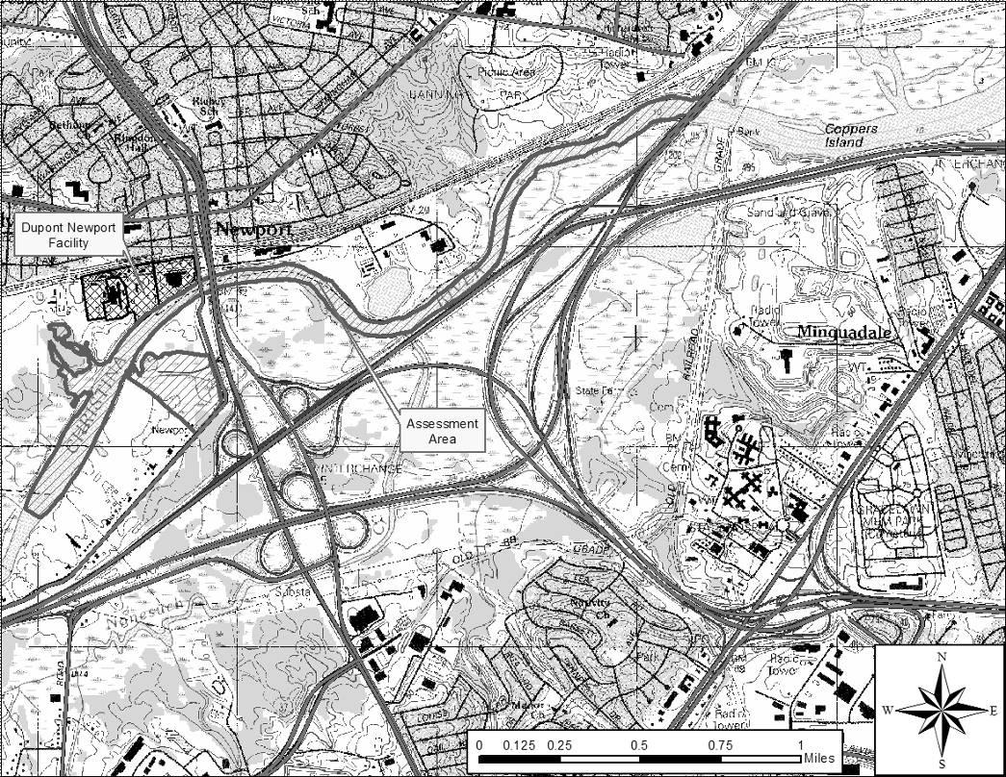
Figure 2-1 - The DuPont Newport Superfund Site, New Castle County, Delaware

Pigment manufacturing began at the Site in 1902 when the site was owned and operated by Henrik J. Krebs. Krebs manufactured Lithopone, a white inorganic pigment, until 1929 when DuPont purchased the plant. Lithopone was produced until approximately 1952. The site then transitioned to manufacturing titanium dioxide as a paint pigment. DuPont also manufactured copper phthalocyanine (CPC) and quinacridone (QA), both organic pigments. Historical operations also included the production of chromium dioxide, high-purity silicon, and other organic and inorganic pigments. The pigment manufacturing operations were purchased by CIBA-GEIGY in 1984 and continue to operate today. DuPont retained the chromium dioxide magnetic recording tape operation at the Holly Run Plant. However, the Holly Run Plant ceased operation in 2000.

During plant operations, two portions of the site bordering the Christina River were used as waste disposal landfills. Landfilling occurred in the North Disposal site and the South Disposal site. The North Disposal site (approximately 7.6 acres) was used for disposal of general refuse and process waste from early 1902 until 1974. After disposal ceased in 1974, the North Disposal site was capped with approximately 2 feet of clayey material. The South Disposal site (approximately 17 acres) was operated from approximately 1902 to 1953. Material deposited in this landfill primarily consisted of insoluble residues of zinc and barite ores that were pumped as slurry through a pipeline across the Christina River.

Two organic pigments (CPC and QA) were manufactured at the site between 1948 and 1958. The presence of tetrachloroethene (PCE) and trichloroethene (TCE) in the soil and groundwater is believed to be associated with the historical use of these organic solvents in the production of these pigments.

In 1987, the United States Environmental Protection Agency (“EPA”) proposed the inclusion of the Site to the National Priorities List ("NPL") based on the release or threatened release of contaminants, making it a priority Site for investigation and potential clean-up under CERCLA. The site was listed in 1990. In 1988, DuPont entered into an Administrative Order by Consent with EPA whereby DuPont agreed to perform a Remedial Investigation and Feasibility Study (RI/FS) for the site. The RI/FS was conducted between August 1988 and August 1992. The EPA Record of Decision was released in August 1993. A Remedial Design/Remedial Action Work Plan was completed in 1994 (DuPont Environmental Remediation Services, 1994). The Site was broken down into 7 operable units. Remedial actions began in 1996 and were completed in 2002.

Human Use Characteristics
Current land uses at the Site include: CIBA manufacturing operations, a pump and treat system on the former Holly Run Plant, landfills, wetlands, and wooded upland areas. Manufacturing operations are located to the north of the Christina River. Access to the northern part of the Site is restricted by CIBA security. Access to the areas south of the Christina River is restricted by institutional controls (i.e., fencing and vegetative barrier). The existing land uses at CIBA, Newport-associate landfills and wetlands are expected to continue indefinitely.

Surface Water Characteristics
The surface water hydrology in the area of the Newport Site is highly influenced by the tidal water flow of the Christina River with a tidal range of approximately 4 to 5 feet. Surface water characteristics are different for both the North and South Wetlands, and have changed as a result of the remedial and restoration activities. Remedial/restoration activities completed at the site have enhanced both the retention and tidal water exchange within these wetland areas.

Prior to remedial activities, the North Wetlands consisted mostly of high marsh habitat (Figure 2-2). The marsh was inundated by high tides, except when the river base flow was low. At low tide, the North Wetlands would drain completely. Typically, the marsh would be regularly inundated only for several days during the spring high tides. The restoration of the North Wetlands provided a permanent pool of water by removal of additional sediment material and the construction of a water control structure at the river berm. This design allowed the wetland to be inundated daily with high tide. Re-enforcement/stabilization of the river berm ensured the longer-term protection of the wetlands. (Figure 2-3)

The South Wetlands mostly consisted of high marsh habitat. During the Remedial Investigation, potential sources of water for the wetlands were considered to be precipitation, groundwater discharge, and surface runoff. During the Remedial Design phase, it was discovered that the South Wetlands were tidally influenced. River water would enter into the wetlands from culverts located under Old Airport Road. Water would then slowly exit at these culverts or through the tidal gate directly into the Christina River. (The tide gate restricts inflow but allows outflow.) The monotypic stand of Phragmites concealed the tidal water flow through the wetlands. In addition, the dense root mass and stand of Phragmites throughout the wetland area restricted water movement through the wetland area (Figure 2-4). Similar to the North Wetlands, the marsh was inundated by high tides, except when the river base flow was low.

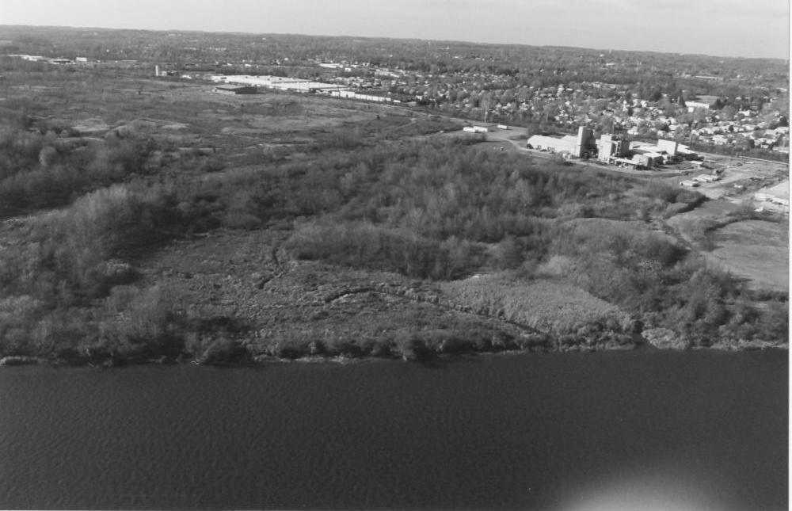
Figure 2-2. North Wetlands – Pre-remediation

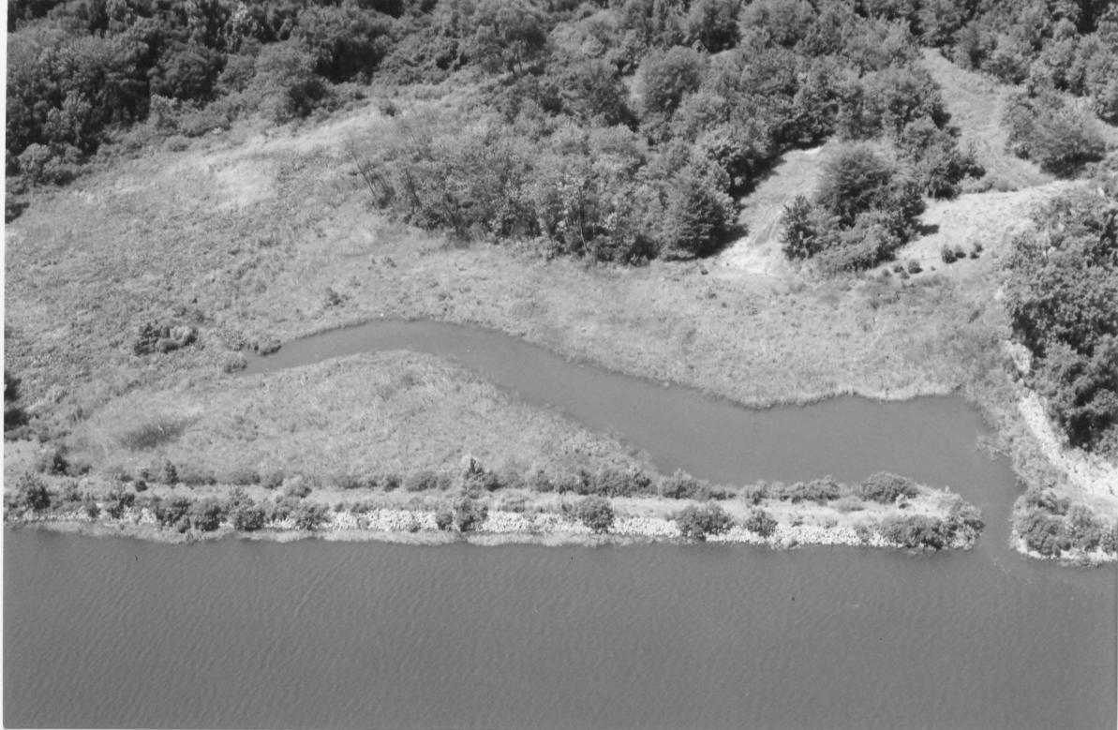
Figure 2-3 - North Wetlands – Post Restoration

A raised upland berm extended across the marsh from east to west and bisected the emergent marsh into a northern non-tidal portion and a southern tidal portion. Permanent standing water within the South Wetlands was limited to the South Pond. The South Pond, located north of the berm, was approximately two feet deep and one acre in size. The pond was isolated from adjacent drainages and was engulfed by a dense stand of Phragmites. In the warmer months, the surface water in the pond was choked with spatterdock and duckweed. Precipitation, groundwater discharge, and surface runoff were the primary sources of water for the pond. Because it is isolated from the adjacent drainages, the pond had limited recruitment of, and establishment of indigenous fish populations (Woodward-Clyde, 1992).

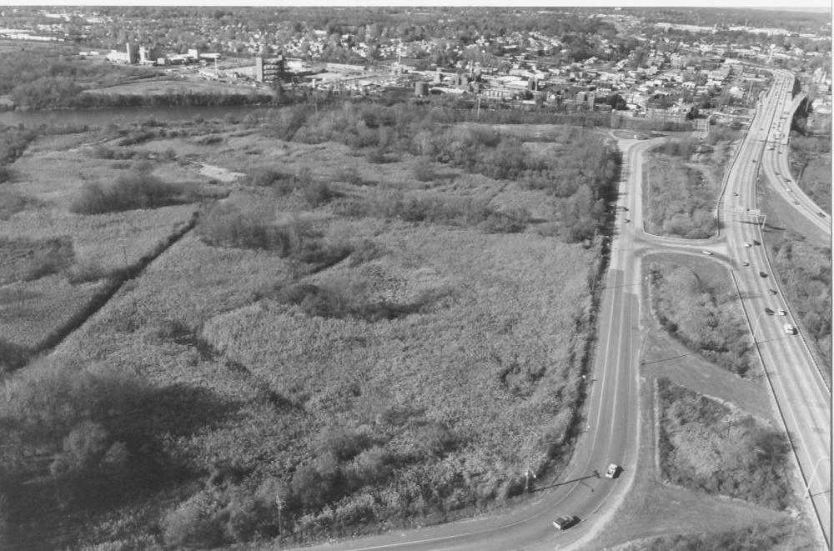
Figure 2-4 - South Wetland – Pre-remediation (looking from the S).

During the remediation of the South Wetlands, portions of the berm up to 11 feet in depth were removed to create hummocks. Berm removal resulted in the opportunity to open the South Pond to tidal influence. The South Pond did not require remediation, however two feet were excavated to remove fine-grained sediments. It also was recontoured to provide a more gradual intertidal zone that was vegetated with emergent vegetation forms. Drainage features were added to facilitate sufficient water storage between high-tide cycles and develop more direct access to improve the tidal exchange throughout the South Wetlands. Tidal habitat was significantly improved by the removal of additional materials from the wetlands, berm, and South Pond areas, in conjunction with the enhancement of drainage features (Figure 2-5).
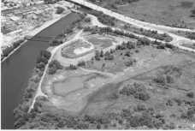
Figure 2-5 - South Wetlands – Post Restoration (looking from the SE).

Habitat Characteristics
Pigment manufacturing continues at the CIBA Plant on the north side of the Christina River. The former Holly Run Plant has been reduced to an office trailer and a warehouse that contains the groundwater pump and treatment operation for the Site. As part of the ROD, the manufacturing areas have been paved to minimize infiltration. The North and South Landfill areas also have been covered as part of the ROD requirements and have been planted with warm season grasses. The Ballpark is located off-site. A small quantity of soil was removed as part of the remedial action. The Ballpark is currently owned by the City of Newport and is being used for recreational activities. The remaining property consists of the North and South Wetlands that are bisected by the Christina River.

Prior to remedial activities, the North and South Wetland areas were classified as high marsh. Surface water exchange and influence by the tidal waters of the Christina River were limited. The vegetation within these wetlands was typical for the Christina River watershed. Phragmites dominated a large portion of the North Wetlands and almost the entire South Wetlands. The remainder consisted largely of a simple herbaceous layer with limited vegetation strata and cover types. Because of this limited strata, cover types, and open water, the potential functional capacity for wildlife was limited. Dense stands of Phragmites also provided limited benefit to wildlife and eliminated vegetation of higher wildlife value (DuPont Environmental Remediation Services 1997a, and 1997b).

Remedial and restoration activities greatly enhanced the overall habitat; providing a higher functioning wetland habitat that continues to improve over time. DuPont proactively evaluated and incorporated additional restoration options beyond those required in the ROD. As part of this process, DuPont met with representatives of the United States Environmental Protection Agency, Delaware Department of Natural Resources and Environmental Control (DNREC), National Oceanic and Atmospheric Administration (NOAA), and the United States Fish and Wildlife Service (USFWS) to define additional potential restoration options that would be considered valuable to the stakeholders. The identified restoration options were then evaluated using the Evaluation of Planned Wetlands (EPW) to develop a restoration plan that best balanced the different potential wetland functions. Descriptions of the current North and South Wetlands are provided below.

North Wetlands

The North Wetlands now consist of equal proportions of high and low marsh habitat that includes four cover types. Palustrine Emergent Marsh (PEM) is the dominant cover type and includes mudflats that are exposed a low tide, and aquatic beds that support rooted and submerged aquatic vegetation. The marsh is regularly inundated by high tides and contains a permanent pool. The Phragmites control program has been successful in minimizing its presence. Vegetation within the North Wetlands has become increasingly more diverse structurally with added strata, cover types, and greater vegetation/water interspersion. The plant community species richness for the entire North Wetlands is composed of 88 taxa (10 planted species and 78 naturally recruited species). This species richness greatly surpasses that observed in the reference area (Banning Marsh) in which only 39 species were noted (DuPont Corporate Remediation Group (CRG), 2002a).

Successful restoration of the North Wetland has vastly improved the functional capacity of this wetland to support fish communities in the Christina River. Fisheries surveys conducted in 1999, 2001, and 2002 have proven that the North Wetland supports a healthy diverse fish community comprised of freshwater and estuarine species. The installation of a water control structure has successfully created a tidal open water habitat that maintains a continuous pool of water within the North Wetland and also allows for tidal flushing back into dense and diverse marsh vegetation. The increased (and increasing) complexity of this habitat type within the marsh provides niches for fish from all life stages (mature, mature spawning, juvenile, young-of-the-year, and larval fish). Currently, fisheries survey results suggests that one of the North Wetland’s primary functions is a fish community nursery area. The collection of fishes from all life stages indicates that the aquatic habitat also functions as spawning and feeding grounds for numerous species. Overall, the abundance and structure of this fish community clearly demonstrate that the North Wetlands have been successfully restored to a level where the aquatic habitat now functions as an integral part of fisheries development and recruitment within the Christina River Watershed. (DuPont CRG, 2002a).

The well-established fish and benthic communities provide a substantial food source for birds that now frequent the area. Historically, the low quality habitat provided little niche space that resulted in low overall species richness. Use of the wetlands has increased over time and the bird community has become an integral part of the complex wetland food web. Both migratory and resident bird species that fill various trophic levels have been observed including piscivores (e.g., great egrets, osprey), invertivores (e.g., American robin, swallows), and granivores (e.g., red-winged blackbirds, sparrows). Many of these birds rely on the wetlands for foraging, nesting, breeding, and shelter.

South Wetlands
Similar to the North Wetlands, the South Wetlands now consists of equal proportions of high and low marsh habitat. The marsh and pond are twice daily inundated by high tides and contain several permanent pools. Palustrine Emergent Marsh (PEM) is the dominant cover type and includes mudflats that are exposed at low tide, and aquatic beds that support rooted and submerged aquatic vegetation. Vegetation within the South Wetlands has become more diverse structurally with added strata, cover types, and greater vegetation/water interspersion. The plant community species richness for the South Wetlands is composed of 71 taxa (5 planted species and 66 naturally recruited species). This species richness greatly surpasses that observed in the reference area (Nonesuch Creek) in which only 26 species were noted (DuPont CRG, 2003b). Successful establishment of diverse wetlands vegetation cover has provided the basis for increasing functional capacity for providing sediment stabilization, water quality and wildlife functions (DuPont CRG 2002c). The Phragmites control program has been successful in minimizing its presence.

Successful restoration of the South Wetland has vastly improved the functional capacity of this wetland to support fish communities in the Christina River. The drainage features continue to promote tidal flushing of the South Wetlands and water exchange within the South Pond. Fisheries surveys conducted annually in 2000, 2002, and 2003 have indicated that the South Wetland supports a healthy diverse fish community comprised primarily of freshwater species with occasional use by estuarine species. The removal of dense stands of Phragmites, coupled with the restoration of drainage systems in the wetland have successfully created a tidally contiguous, open water habitat that regularly inundates the surrounding vegetation. The increased diversity of aquatic habitat types currently accessible to fish communities has provided niches for numerous species from all life stages (mature, mature spawning, juvenile, young-of-the-year, and larval fish). The presence of these various life stages indicates that the functional capacity of the South Wetland now includes spawning, feeding, and rearing grounds for fish communities. In addition, this wetland has continued to develop, attracting and supporting new species including obligate wetland fish such as the eastern mudminnow (Umbra pygmaea), collected in 2003. Overall, the abundance and structure of this fish community clearly demonstrates that the South Wetlands have been successfully restored to a level where the aquatic habitat now functions as an integral part of fisheries development, diversity, and recruitment within the Christina River Watershed (DuPont CRG 2002c).

The dramatic change in vegetative cover types has resulted in habitat opportunities for a variety of migratory and resident bird species. In addition, the well-established fish and benthic communities provide a substantial food source for birds that now frequent the area. Where the original monotypic stand of Phragmites provided poor bird habitat, the current habitat provides space for all trophic levels of birds. Many of these birds rely on the wetlands for foraging, nesting, breeding, and shelter.

Summary of Response Actions
In 1988, DuPont entered into an Administrative Consent Order (ACO) with the EPA to complete investigations for the Newport Site in accordance with the Comprehensive Environmental Response, Compensation, and Liability Act (CERCLA) and Superfund Amendments and Reauthorization Act (SARA). The site was included on the National Priorities List (NPL) in early 1990. A RI/FS was conducted in three phases between August 1988 and August 1992. In August 1993, a ROD that specified the remedial actions for seven operable units was issued. A summary of these units and the Selected Remedy is listed in Table 2-1.

Table 2-1 - Summary of ROD Requirements for DuPont Newport Site
Unit | Selected Remedy | Purpose
Ballpark | Excavation of soil above 500 mg/kg total lead; disposal in North Landfill | Prevent exposure to elevated levels of lead
North Landfill and Wetlands | Capping; wetlands remediation, restoration and monitoring; waste pile stabilization and consolidation in the North Landfill; vertical barrier wall installation to the base of the  Columbia aquifer; groundwater recovery and treatment | Prevent continued contaminant releases to the groundwater that discharges to the river and the North Wetlands; cleanup areas of unacceptable environmental impact in the North Wetlands; prevent exposure of plant and terrestrial life to contaminated soil
South Landfill | Excavation and consolidation of contaminated soil underneath and to the east of Basin Road or South James Street onto the South Landfill | Prevent continued contaminant releases to the groundwater that discharges to the Christina River and the South Wetlands; prevent unacceptable human exposure to the contaminated soil from the South Landfill
South Wetlands | Excavation; sediment disposal in the South Landfill; restoration; monitoring | Prevent unacceptable impact to environmental receptors
Christina River | Dredging; sediment dewatering and disposal in North or South Landfill; monitoring | Prevent unacceptable impact to environmental receptors
Ciba-Geigy and DuPont Holly Run Plants | Vertical barrier wall installation along the Christina River at the Ciba-Geigy Plant; paving the unpaved ground within the contaminated Plant Areas; recovery and treatment of the groundwater upgradient of the barrier wall; instituting special Health and Safety Plans (HASPs) for intrusive work | Prevent continued releases of contaminants to the groundwater that discharges to the Christina River; prevent unacceptable human exposure to contaminated soil
Groundwater | Monitoring; providing public water supply along Old Airport Road; establishing a groundwater management zone; invoking the ARARs Wavier | Prevent potential future human exposure to the site-related contaminated groundwater; prevent further contamination of the Columbia and Potomac aquifers; protect the South Wetlands

In 1994, DuPont submitted a Remedial Design/Remedial Action Work Plan, as directed by the ROD and ACO. Incorporated in this work plan was an initial value-engineering assessment that identified the most cost-effective implementation of remedies specified in the ROD that are also protective of human health and the environment. Pre-design investigations were outlined for the North and South Wetlands and the Christina River to delineate areas for sediment removal. A phased sampling strategy was developed and implemented to fulfill the ROD requirements. The ROD required delineation of three metals (cadmium, lead, and zinc) that were associated with the pigment manufacturing at Newport. Two sets of criteria were provided in the ROD: EPA site-specific sediment cleanup criteria (SSCC) and apparent effects threshold (AET) values. Sediment concentrations exceeding the SSCC in the sediments would need to be excavated, while sediment concentrations below the AET values could be left in place. Those concentrations detected between these two criteria may have required additional investigation.

Delineation investigation, remedial action and restoration of the wetlands and river areas were completed sequentially. The pre-design investigations for the wetlands were completed before the river. Remedial action and restoration was completed for the North Wetlands, followed by the South Wetlands, and then the Christina River. The actions are summarized below.

North and South Wetlands
Delineation investigations for the North and South Wetlands were completed between December 1994 and December 1995. Based on this data, the delineated excavation footprints were approved by EPA by February 1996. Excavation and restoration were completed in accordance with the approved 100 percent Design Plans for each of the wetlands (DuPont Environmental Remediation Services, 1997a and b).

As part of the restoration design, DuPont proactively evaluated and incorporated additional restoration options beyond those required in the ROD. As part of this process, DuPont met with representatives of the EPA, DNREC, NOAA and USFWS to define additional potential restoration options that would be considered valuable to the stakeholders. The identified restoration options were then evaluated using the Evaluation of Planned Wetlands (EPW) (Bartoldus, et. al, 1994) to develop a restoration plan that best balanced the different functions that the wetlands could potentially perform. The EPW was recommended by the USFWS for the Newport wetlands restoration as a tool to demonstrate overall habitat improvements compared to the pre-remediation condition (DuPont Environmental Remediation Services, 1997a and b, and DuPont CRG, 1998).

Implementation of the ROD requirements would have returned the wetland areas to their original baseline conditions. However, the additional restoration enhancements implemented above the ROD requirements, and developed with input of the stakeholders have resulted in the creation of a significantly improved habitat with markedly increased functional capabilities for several wetland functions. This increase in function was used by the Trustees to offset the injuries and service losses (the NRD) that were estimated for the Newport Site.

Restoration Options – North Wetlands
Remediation activities in the North Wetlands began in 1997 and restoration was completed in 1998. The EPA signed the Remedial Action Completion Report in June 1998. Maintenance and monitoring of the restoration began in June1998 in accordance with the approved Maintenance and Monitoring Plan (DuPont CRG, 1998). The North Wetlands has passed its sixth year post restoration (1998 to 2003). Success metrics for vegetative cover, sediment stabilization, and invasive species were met within 3 years post-restoration. The site exceeds regional reference locations in terms of vegetative diversity and use by wildlife. Extensive data and information on the wetlands restoration progress has been collected from 1998 to the present as part of the annual and routine monthly inspections outlined in the Maintenance and Monitoring Plan (DuPont CRG, 1998) and Addendum (DuPont CRG 2002a).

As presented in DuPont Environmental Remediation Services 1997a, the North Wetlands remediation and restoration consisted of the following basic components that were not part of the ROD requirements:

- Stabilization of the river berm
- Shoreline erosion protection
- Sediment excavation to a greater depth and backfilling
- Construction of a water control structure
- Sediment stabilization with erosion matting
- Phragmites control program

Stabilizing the river berm and providing shoreline bank erosion protection improved the drainageway habitat, stabilized sediment, increased the amount of open water at high tide, improved water quality, and provided better forage and cover for fish and wildlife. More importantly, river berm stabilization will ensure long-term wetlands protection, and prevent the loss of the berm and the wetlands.

For excavation, the ROD required removing 1-foot of sediment from the wetlands. DuPont removed all sediment down to the marsh clay deposit layer (approximately 2 to 3 feet) to eliminate any potential future concerns of recontamination from sediments left in place. Removal of the additional material, in conjunction with the water control structure, allowed for a permanent pool of water to be a part of the final design. In addition, the design allowed the wetland to be inundated daily during high tide. Thus, this design creates a clean, permanent open water habitat that was not previously present.

The Phragmites eradication program consisted of spraying and burning, and physical destruction of the root mass. Increased saline circulation in the marsh is expected to exclude future invasion by Phragmites. Control of Phragmites and other invasive species helped promote colonization of the marsh habitat by a more diverse assemblage of native plants. A diverse plant assemblage provides for better animal forage and enhances the functional capacity of the restored marsh to support wildlife.

Restoration Options – South Wetlands
Remediation activities and restoration were completed in 1998 for the South Wetlands. The EPA signed the Remedial Action Completion Report in January 1999. Maintenance and monitoring of the restoration began in January 1999 in accordance with the approved Maintenance and Monitoring Plan (DuPont CRG, 1999). The South Wetlands has past its fifth year post-restoration (1999 to 2003). Success metrics for vegetative cover, sediment stabilization, and invasive species were met within the first three years post restoration. As with the North Wetlands, the South Wetlands exceeds regional reference locations in terms of vegetative diversity and use by wildlife. Extensive data and information on the wetlands restoration progress has been collected as part of the annual and routine inspections as outlined in the Maintenance and Monitoring Plan (DuPont CRG, 1999) and Addendum (DuPont CRG, 2002a).

The South Wetlands remediation and restoration were similar to that of the North Wetlands in that DuPont proactively included the following basic components that were above and beyond the ROD requirements in an attempt to optimize functions and values that could be provided by the restoration site (DuPont Environmental Remediation Services, 1997b):

- Sediment excavation to a greater depth and backfilling
- Hummock construction and planting
- Sediment stabilization with erosion matting
- Removal of berm
- South Pond enhancement
- Phragmites control program

As with the North Wetlands, DuPont exceeded the 1-foot sediment removal depth required by the ROD and removed all sediment down to the marsh clay deposit layer (approximately 2 feet) to eliminate any potential future concerns of recontamination from sediments left in place. Portions of the berm, up to 11 feet in depth, were removed to create hummocks. The creation of the hummocks increased cover type diversity, and vertical stratification of the wetlands.

Erosion matting increased sediment stabilization and proved effective during severe storm events. The matting also facilitated the development of a substrate for colonization by benthic invertebrate fauna and vegetation.

Removal of the berm resulted in the opportunity to open the South Pond to tidal influence. The South Pond did not require remediation, however it was excavated down two feet to remove fine-grained sediments. It was also recontoured to provide a more gradual intertidal zone that was vegetated with emergent vegetation. Drainage features were also added to facilitate sufficient water storage between high-tide cycles and develop more of a direct access to improve the tidal exchange throughout the South Wetlands.

Control of Phragmites and other invasive species helped promote colonization of the marsh habitat by a more diverse assemblage of native plants. A diverse plant assemblage provides for better animal forage and enhances the functional capacity of the restored marsh to support wildlife.

Removal of the additional materials from the wetlands, berm and South Pond areas, in conjunction with the enhancement of drainage features, allowed for a significantly improved tidal habitat than previously was present. The increased tidal water storage and the daily inundation of the wetlands at high tide and the water exchange in the South Pond has increased the functional capacity for benthos, fish, birds and wildlife. These physical changes along with the Phragmites control program also minimized the amount of Phragmites in the South Wetlands.

Christina River

The Christina River study area consisted of 3.5 miles of river (1 mile upriver of the north drainageway, 0.5 mile along the site, and 2 miles down river of the site). The pre-design delineation investigation was completed between March 1995 and February 1996. Based on these data, five areas requiring remediation were identified. These areas were later consolidated into three areas (Area 1, Area 2/3, and Area 4/5). Removal of sediment from these Areas effectively lowered sediment contamination for the river (June 17, 1996 letter from DuPont to EPA). EPA approved the delineation in August 1996. Subsequent confirmation sampling for the remedial areas was conducted and submitted to EPA in October 1996. A Sediment Removal Value Engineering Workshop was held in May 1997. Additional sediment sampling was completed in December 1997 to support the remedial design. Excavation began in 1998 and restoration was completed in 1999. Maintenance and monitoring began in September 1999 in accordance with the approved Maintenance and Monitoring Plan. The EPA signed the Remedial Action Completion Report in February 2000.

All success metrics established for the Christina River Area were met within with the first few years of monitoring. All Areas remained stable with increases in vegetative cover and species richness. Natural recruitment of plants resulted in the successful establishment of a diverse emergent plant community. In 2003, DNREC activities on the Christina River resulted in the disruption of Area 4/5. A 10-foot wide mosquito control ditch was cut through the restoration site. Because this action was undertaken by the State, no corrective actions by DuPont will be required.

Assessment of Resource Injuries and Compensation Requirements
This section begins with an overview describing the Trustees’ assessment strategy, including the approaches used to determine potential injury to specific resources affected by contaminant releases from the Site. The remainder of the section describes the approach used to estimate the ecological service losses and presents the results of these assessments. The term ecological services means the “physical and biological functions performed by the resource including the human uses of those functions. These services are the result of the physical, chemical, or biological quality of the resource” (43 C.F.R. § 11.14(nn)).

Injury Determination and Quantification
The Trustees’ assessment of alleged resource injuries focused on identifying the injuries or losses of natural resources which were likely or known to have resulted from the Site contamination, including due to the remedies undertaken. Metals were the primary contaminants of potential concern (COPCs) at the Site for natural resource damage assessment purposes. These COPCs were found in sediments of the wetlands and river adjacent to the Site.

Using data and other information developed as part of the remedial investigation process and pre-design investigations, as well as information on these contaminants in the existing scientific literature and their own knowledge of and experience in freshwater tidal ecosystems, the Trustees assessed impacts to natural resources.

The Trustees found that resources or resource services were injured and/or lost due to:
- The historic release of contaminants in certain areas of the Site,
- The migration of contaminants into the North and South Wetlands and the Christina River, and
- The excavation and capping undertaken as part of the remedy.

The Trustees then used this information to conservatively (in favor of the natural resources) estimate the total potential loss of discounted, wetland service acre-years represented by the natural resource injuries associated with the Site. The analysis does not address natural resource injuries or service losses that may have resulted from releases of contaminants into the Christina River and adjacent aquatic and semi-aquatic environments by any other party, however it is intended to include all natural resource injuries due to releases of contaminants that have come to be located within the confines of the study area, regardless of source.

Injury Assessment Strategy
The goal of this assessment is to determine the nature and extent of injuries to natural resources and to quantify the resulting resource and service losses, thus providing a technical basis for evaluating the need for, type of, and scale of restoration actions. As described above in Section 1.1, this assessment process is guided by the NRDA regulations under CERCLA (43 C.F.R. § 11). For the Newport Superfund Site, the Trustees pursued an assessment approach in cooperation with DuPont. Existing data collected was shared between DuPont and the Trustees resulting in time and/or cost savings. Moreover, efforts taken by DuPont in consultation with the Trustees prior to restorations and the resulting enhancements above the ROD-required restoration were considered by the Trustees as credits towards offsetting the NRDA. In addition, the cooperative NRDA approach avoids costly litigation and expedites the restoration of the environment.

The injury assessment process occurs in two stages: 1) injury evaluation and 2) resource and service loss quantification. To evaluate potential injury to resources, the Trustees reviewed existing information, including remedial investigation data, ecological risk assessments, and scientific literature. Based on information from all these sources and with an understanding of the function of the terrestrial and aquatic ecosystems at and near the Site, the Trustees evaluated injury to natural resources. The Trustees considered several factors when making this evaluation, including, but not limited to:

- the specific natural resource and ecological services of concern;
- evidence indicating exposure, pathway and injury;
- the mechanism by which injury occurred;
- the type, degree, spatial and temporal extent of injury; and
- types of restoration actions that are appropriate and feasible.

For each resource category (either a group of organisms or a habitat type) that was potentially affected, the Trustees identified a pathway linking the injury to releases from the Site, determined whether an injury is likely to or has occurred, and identified the nature of the injury. To undertake this effort, an understanding of the important contaminants is necessary. The evaluation of the COPCs and their pathways to ecological receptors is described in the next two sections. Following the identification of the contaminants, it is possible to evaluate those resources that have been adversely affected by releases from the Site.

As a result of the cooperative NRDA approach, the Trustees used the data provided by DuPont to create a spatial representation of the locations of the contaminated areas by plotting the data on aerial photographs using a custom built personal computer based database and GIS package (NOAA Query Manager/MS Access/ArcView 3.3). Once the concentrations of contaminants in each habitat were plotted and the amount of affected acreage was determined for each habitat type, the Trustees used the peer-reviewed scientific literature and best professional judgments to develop estimates of the percentage of injury to each habitat. The Trustees focused the injury assessment from the entire Site and/or adjacent areas. The Trustees used the year 1981 to begin the calculation of time-based injury duration. The Trustees also made conservative estimations of the duration of the monitored natural recovery period for the individual areas based on contaminant concentration. If no remediation was conducted for a given area, for calculation purposes, it will remain injured in perpetuity.

Preliminary Restoration Strategy
This assessment was designed for injury assessment and restoration planning to occur simultaneously, utilizing a restoration-based approach. Under a restoration-based approach, the focus of the assessment is on quantifying the injuries and/or losses in natural resources and ecological services in ways that facilitate the identification of restoration projects that will compensate the public with the same level, type and quality of resources and ecological services that were lost. This restoration-based assessment approach is consistent with the CERCLA NRDA regulations, which allow restoration planning to be included as part of the Assessment Plan Phase where available data are sufficient to support their concurrent development (43 C.F.R. § 11.31).

Restoration Scaling Strategy
Habitat Equivalency Analysis (HEA), scientific literature, and knowledge of Delaware wetlands were used to determine how much credit could be realized from a restoration project, such as enhancing a degraded environment or preserving an existing environment. Various inputs are considered, such as the level of ecological services currently provided at the proposed location, the threat of destruction of the habitat by human encroachment and the potential for inundation. The analysis calculation shows how many discounted service acre years (DSAYs) can be credited for a given restoration project. The DSAYs are then converted to the amount of acreage that, if constructed at the Site, would be necessary for compensation for a specific type of habitat. If the project is preserved rather than constructed, the amount of acreage necessary for compensation usually increases.

The Affected Environment
This section describes the physical, biological, and cultural environments in the vicinity of the Newport Superfund site. Resource areas described in this section correspond to the range of resource areas addressed in Section 5, “Restoration Alternatives Comparison.” Resource areas addressed include wildlife, fish and invertebrates, essential fish habitat, threatened and endangered species, farmland and urban development, recreation resources, water and sediment quality, air quality, cultural resources, hazardous and toxic waste, and environmental justice.

This subsection provides additional information on the physical, biological and cultural environments in the area affected by releases of hazardous substances from the DuPont Newport Superfund Site and in which restoration action(s) selected in this Final DARP/EA will occur.

The Physical Environment
The Christina River Basin lies within the greater Delaware River Basin. The Christina River Basin drains portions of Pennsylvania, Delaware, and Maryland, and includes the Christina River (which eventually flows into the Delaware River in Wilmington, Del.), Brandywine Creek, White Clay Creek, and Red Clay Creek. These four major streams drain a 565 square mile area and provide more than 100 million gallons of water a day for more than half a million people in three states. The Christina River Basin provides 75% of the water supply for residents in New Castle County, Delaware, and more than 40% of the water supply for residents in Chester County, Pennsylvania. The upper two-thirds of the basin is situated in southeast Pennsylvania, while the downstream one-third is situated in northern Delaware.
In addition to providing significant water supplies, the watershed also provides important wildlife habitat, recreational opportunities, and is a place of natural beauty for many to enjoy. In addition, the White Clay Creek is listed as a National Wild and Scenic River.

Rapid growth in areas within the watershed and, in part, from the cities of Wilmington and Philadelphia, is causing the Christina Basin to experience water quality concerns including nutrient pollution and the presence of toxic substances. The water quality and overall health of the Christina Basin is less than optimal because of a range in sources (i.e., municipal, industrial, and recreational use).

The Biological Environment
The Christina River supports a wide variety of anadromous, catadromous, and estuarine species (Miller personal communication 1990; Saveikis, personal communication 1990; Shirey, personal communication 1990). Blueback herring, alewife, white perch, striped bass, American eel, Atlantic menhaden, bay anchovy, and spot are species of particular interest to NOAA in the Christina and Delaware rivers due to their commercial importance or abundance. Alewife, blueback herring, and white perch spawn in the Christina River, and striped bass use it as a nursery area (Miller, personal communication 1990).

Juvenile life stages of estuarine-dependent species such as Atlantic menhaden, bay anchovy, and spot use the Christina River seasonally. The catadromous American eel is present throughout the entire Delaware basin, and uses a variety of habitats as adult foraging grounds (Shirey, personal communication 1990). Blue crabs are common in the Christina and Delaware rivers.

Blue crab, American shad, and striped bass are fished commercially in the Delaware River near its confluence with the Christina River. Important recreational fisheries for blue crab, American shad, striped bass, and white perch occur in the Christina River and in the lower reaches of the Delaware River (Miller, personal communication 1990). In addition, large freshwater fisheries on both rivers harvest channel catfish, largemouth bass, yellow perch, black crappie, and sunfish.

The Cultural and Human Environment
Delaware is rich in cultural resources dating back to the 1600s when Sweden had settled in the area of the Newport Site. Cultural resource studies were prepared as part of the remedial investigation and prior to the remedial actions taken at the site to ensure that Delaware cultural resources were protected. Provided below is a summary of the cultural history of the Christina watershed area.

The Delaware Valley's earliest permanent Old World settlement began in 1638 when the Kalmar Nyckel, a Swedish warship landed at "The Rocks," a natural wharf in the Minquas Kill (soon renamed the Christina River). Settlers, under the command of Peter Minuit, former Dutch governor of New Amsterdam, met with local Lenni Lenape chiefs, signed a treaty, and founded the colony of New Sweden. The Europeans gained rights to the land along the western bank of the Delaware River, approximately 30 miles north and south of the mouth of the Minquas Kill and began Fort Christina.

Agriculture and fur trading with Native American trappers were the first industries in the area. By the end of the 1600s mills for grinding corn and wheat had been established along the Brandywine River (Brandywine Village). With fertile land, abundant forests, and well-protected access to the Delaware River and the Atlantic Ocean, a center of milling, distribution, and shipbuilding was created.

In the late 1700s, paper and cotton mills were added to the Brandywine Village's existing flourmills. Fleeing the excesses of the French Revolution, Eleuthère Irénée du Pont de Nemours settled here in 1802, purchasing property along the Brandywine from the Hagley family and opening his black powder mill. From 1802 to 1921, these and other local mills produced powder for America's hunters, soldiers and construction projects. From these gunpowder mills sprang the modern chemical industry, which is still headquartered in Delaware—the DuPont Company, Hercules, Inc., and ICI Americas, however active facilities have greatly reduced in number.

Early in the 20th century, a business-friendly operating climate began to attract businesses to incorporate in Delaware. Today, the majority of Fortune 500 corporations are incorporated in The First State and the decisions of the state Court of Chancery wield national and international influence. In the 1980s, credit card banks also began moving here and Wilmington has become a major electronic banking center for America.

Injury and Service Loss Evaluation

Pathways of Contamination to Trust Resources
A pathway is defined as the route or medium (for example, water or soil) through which hazardous substances are transported from the source of contamination to the natural resource of concern (34 C.F.R. § 11.14). For the Newport Site, historic disposal occurred within the landfills adjacent to the wetland areas. Surface migration via runoff and groundwater migration have contaminated sediments within sections of the North and South Wetlands, and specific areas within the study area for the Christina River. These pathways have resulted in the presence of contamination within areas utilized by wildlife and other ecological receptors of interest. Data collected during the RI/FS and pre-design investigations indicated that sediments were contaminated with several site-related metals.

Contaminants of Concern (COCs)
Several metals were historically used on-site in the manufacturing of pigments. Cadmium, lead, and zinc were found to be the most prevalent and the focus of post-ROD activities to delineate areas for sediment removal. The Trustees determined that these and others associated with the manufacturing activities might have potentially injured the trust natural resources at the DuPont Newport Superfund Site. These metals were found in the wetland and river sediments at or near the Site at elevated concentrations (i.e., exceeding ecological benchmark concentrations.)

Lead
Although lead may be released into the environment from natural sources, most of the lead that occurs in aquatic systems has been released due to human activities. Depending on the form that is discharged, lead can remain dissolved in the water column or become associated with sediments upon release to aquatic systems.

Lead has been shown to be neither essential, nor beneficial to living organisms. While dissolved lead is not acutely toxic to aquatic organisms, longer-term exposure to relatively low levels of this substance may adversely affect the survival, growth, and reproduction of fish, invertebrates, and, to a lesser extent, aquatic plants. Exposure to elevated levels of sediment-associated lead may cause acute and chronic toxicity to sediment-dwelling organisms. In birds and mammals, dietary exposure to elevated lead levels can cause damage to the nervous system and major organs, reduced growth, impaired reproduction, and death.

Zinc
Zinc is released into the environment as a result of various human activities, including electroplating, smelting and ore processing, mining, municipal wastewater treatment, combustion of fossil fuels and solid wastes, and disposal of zinc-containing materials. In aquatic systems, zinc can be found in several forms, including the toxic ionic form, dissolved forms (i.e., salts), and various inorganic and organic complexes. Most zinc introduced into aquatic systems is partitioned into the sediments by sorption onto hydrous iron and manganese oxides, clay mineral and naturally occurring organics. While zinc can form associations with particulate matter and be deposited on bottom sediments, sediment-associated zinc can also be remobilized in response to changes in physical-chemical conditions in the water body.

The acute toxicity of dissolved zinc is strongly dependent on water hardness; however, chronic toxicity is not. While zinc is an essential element, long-term exposure to elevated dissolved zinc concentrations has been shown to adversely affect the survival, growth, and reproduction of fish, invertebrates, and aquatic plants. Exposure to sediment-bound zinc may cause reduced survival and behavioral alterations in sediment-dwelling organisms.

Cadmium
Cadmium is a relatively rare element that is concentrated in zinc-bearing sulfide ores. Compared to other metals, cadmium is relatively mobile in aquatic environments. Precipitation and sorption to mineral surfaces, hydrous metal oxides, and organic material are the most important processes for removal of cadmium to bed sediments. Adsorption and desorption are the most important factors in controlling the concentration of cadmium in water. Rates for adsorption and desorption are dependant on pH, redox potential, salinity, and sediment composition.

Long-term exposure to elevated dissolved cadmium concentrations has been shown to adversely affect the survival, growth, and reproduction of fish, invertebrates, and aquatic plants. Aquatic and terrestrial organisms bioaccumulate cadmium. Bioconcentration in fish depends on pH and the humic content of water. For vertebrates, accumulation of cadmium in the liver and kidneys can result from dietary exposure to elevated concentrations of cadmium.

Injury Assessment & Findings
Injuries to the natural resources at the Newport Site were quantified by calculating the reduction in ecological services from the injured resource and loss of services resulting from releases of contamination at the Site. This quantification includes accounting for the time required for the injured resources to recover through natural or enhanced means to their pre-release condition.

The Trustee’s assessment included site visits, presentations of remedial and restoration activities, review of annual maintenance and monitoring reports, and environmental data provided by DuPont. A Reasonably Conservative Injury Evaluation (RCIE) approach was used to assess potential injury that may have resulted from Site releases. The RCIE approach uses data from site investigations, literature values and a Habitat Equivalency Analysis, or HEA, to estimate natural resource injuries and the scale of compensatory restoration.

After reviewing the remedial investigation and ecological risk assessment for the site and evaluating entire site and adjacent areas, the Trustees focused on a number of specific habitat types for further assessment. These habitats were specific natural resource types (e.g., wetlands) that were utilized by natural resource species (e.g., benthic organisms, fish, birds). The habitats/operable unit combinations that underwent assessment included the remediated and unremediated wetlands, open water, riparian and riverine (Table 2-1).

The Trustees in collaboration with DuPont compiled a database of sediment chemistry and toxicity test results from environmental investigations of the Christina watershed using NOAA’s Query Manager software (QM), a FoxPro relational database containing query tools (http://response.restoration.noaa.gov/cpr/watershed/watershedtools.html#qm). Metals associated with the Newport Site (i.e., cadmium, lead, zinc) were identified as exceeding relevant sediment quality guidelines (Buchman, 1998) in the North and South Wetlands and the Christina River and were therefore the COCs for this site.

To assess injury to benthos in the tidally influenced sediments affected by the Site, the Trustees used logistic regression modeling (Field et al, 2002). Site-specific toxicity data was spatially limited. Logistic regression modeling was applied to predict the probability of toxicity from the existing sediment chemistry concentrations measured at each station on the Site. QM was used to calculate logistical regression P-Max scores, where the P-max value is the maximum of the probabilities of toxicity of each modeled hazardous substance in the sample. Field (personal comm., 2001) developed a mathematical model based on a large dataset from coastal US habitats to predict mortality in Ampelisca abdita, a marine/estuarine shrimp-like amphipod that is an important food source for many fish species. For the purposes of this particular site evaluation, the Trustees and DuPont agreed that predicted mortality would serve as the estimated measure of injury to wetland benthos, i.e. if the P-Max score from the logistic regression model predicted that the probability of observing mortality of 40% of the amphipods at that sample station, then the service loss was set to 40% (Table 4-1). The Trustees then determined the total area-weighted average loss of wetland benthos services for each of the relevant habitat/operable unit combinations at the site.

Table 4-2 Logistic Regression Model – P-Max scores vs. predicted Ampelisca percent mortality (Field, 2001) and estimated percent Loss of Services (% LOS)
LRM P-Max Score | Predicted Ampelisca Mortality | % LOS
0.0 – 0.4 | 0.0-0.15 | 0%
0.4 – 0.5 | 0.15-0.20 | 18%
0.5 - 0.6 | 0.20-0.25 | 23%
0.7 - 0.8 | 0.25-0.30 | 28%
0.8 – 0.9 | 0.30-0.35 | 33%
0.9 – 1.0 | 0.35-0.40 | 38%

Habitat Equivalency Analysis Background
Habitat Equivalency Analysis, or HEA, (NOAA, 2000) is a calculation tool used to determine the amount of compensation (in the form of lost discounted service acre years (DSAYs)) needed to replace an injured habitat. The scale, or size, of a restoration project should be such that it provides enough ecological service gains to offset the total of the losses.

Losses are quantified as lost resource habitat area and ecological services. Restoration habitats of the same type, quality, and of comparable ecological value are usually chosen to compensate for the resource and service losses. This method allows scaling the value of the total loss to the value of restoration benefit. Restoration projects are scaled to provide comparable habitat resources and ecological services (equivalency) between the lost and restored habitat resources and ecological services.

In general, the HEA is a technique that balances “debits” (injured habitat or other) that have occurred as a result of releases of contaminants or hazardous substances against compensatory “credits” (habitat restoration projects) and uses a discount factor to account for the difference in time that the restoration services are delivered. Because the losses occur in different time periods, the relevant losses are not directly comparable. To make the losses that occur in different time periods comparable, a discount factor is applied to the losses to determine “discounted service-acre-years” or DSAYs (NOAA, 1999).

Habitat Equivalency Analysis Debit Model
Inputs to the HEA for the Newport Site were based on sediment chemistry analytical results and conservative assumptions. A number of generic assumptions were associated with all of the areas that were assessed: 1) the HEA is an appropriate assessment tool, 2) the discount rate is 3%, 3) the base year (the year from which a discount is applied) is the year 2003, 4) the onset of injury was calculated beginning in 1981, and 5) the date restoration was initiated varied for the various habitat types, ranging from 1996 to 2000. Other specific values used in the HEA debit model are shown in

Onsite Restoration Credit
Prior to remediation, DuPont proactively evaluated and incorporated additional restoration options beyond those required in the ROD. As part of this process, DuPont met with representatives of the EPA, DNREC, NOAA and USFWS to define additional potential restoration options that would be considered valuable to the stakeholders. Consistent with the Trustees’ preference for restoration at the site of the injury (onsite restoration), the Trustees identified potential restoration options to enhance the habitat value in portions of the North & South Wetlands Remediated Areas Habitat subsequent to remedial activities, i.e., “onsite restoration”, in addition to the remediation and site rehabilitation that the response agencies required. DuPont did the work with the understanding that service increases realized from the enhancements would be used in the future to offset some of the Site’s natural resource service losses. To document maturation of the restored onsite wetlands, DuPont conducted its Evaluation of Planned Wetlands monitoring effort under EPA oversight (EPW URS, 2003) .

The Trustees interpreted EPW monitoring scores and made the determination that the enhancements delivered approximately 40% additional resources and services. This number was generated based on selected quantitative measures of fish habitat improvement and increases in habitat diversity implemented at each of the areas (EPW URS, 2003). Credit calculations revealed that the enhancements to the North & South Wetlands Remediated Areas generated 36.4 and 78.64 DSAYs for a total of 115 DSAYs above the post remediation baseline condition, respectively.

Table 4-3 - Habitat Equivalency Analysis debit input parameter values for Newport Site habitats
Input Parameter

Assessment Area | Riverine | Riparian | N Remediated  Wetland | N Wetland unremediated | S Wetland  Remediated | S Wetland  Unremed-iated | Riverine Dredged Area | Open Water  Remediated
Habitat Equivalency Factor | 4.51:1 | 1 | 1 | 1 | 1 | 1 | 4.51:1 | 4.51:1
Acres Injured | 88.78 | 0.922 | 2.431 | 2.699 | 5.412 | 9.383 | 4.01 | 1.684
Levels of Ecological Services at Time of Injury  (baseline) | 100% | 100% | 100% | 100% | 100% | 100% | 100% | 100%
Initial Level of Injury (LOS) | 23% | 25% | 29% | 30% | 38% | 38% | 38% | 38%
Years Until Recovery | 20 | ∞ | 3 | 20 | 3 | 3 | 3 | 3
Restored Habitat  Level of Ecological Services | 100% | 100% | 100% | 100% | 100% | 100% | 100% | 100%
Remediated Area  Ecological Service level after Recovery | 100% | 100% | 100%  +40% onsite* | 100% | 100%  +40% onsite * | 100% | 100% | 100%
Total Lost DSAYs | 760.8 | 43 | 22.1  (credit 36.4) | 29.3 | 63  (credit 78.64) | 129 | 4.0 | 20.5
Total Net Lost EqDSAYs | 168.7 |  | -14.3* | 29.3 | -15.3* | 129 | 0.9 | 4.5
* - 40% increase in ecological function, over the post-remediation baseline condition, was achieved by construction of habitat enhancements to the N & S wetland areas.

Cross Habitat Comparison
Comparing DSAYs generated in different habitat types is complicated because of the different functions they may provide. A factor for relative habitat productivity was applied to allow comparison across habitat types. The Trustees decided that the habitat productivity of each area could be compared to the habitat productivity of a natural wetland. The Trustees reviewed the method used to develop a wetland conversion factor for the Lavaca Bay NPL Case (marsh equivalency factor; MEF, 4.51 acres of water bottom = 1 acre of tidal wetland) (Texas Trustees, 2000). Trustees, using their professional knowledge of local tidal ecosystems, decided that the same ratio could be used as a conversion factor for Delaware Bay wetlands because similar wetland functions were represented. Multiplying the “raw” DSAYs by the MEF converts the losses to comparable units, i.e., EqDSAYs. In the north and south on-site restoration areas, no conversion is necessary as these units are tidal marshes.

HEA Debit Model Result
The debit calculation included injuries to benthic resources in Riverine, Riparian, N Remediated Wetland, N Unremediated Wetland, S Remediated Wetland, S Unremediated Wetland, Dredged Riverine Area and the Open Water Remediated Areas (Table 4-2). Approximately 303 additional wetland equivalent DSAYs (net after crediting early onsite restoration) and 43 riparian corridor DSAYs are needed to compensate for injuries at the Newport Site.

the Restoration Planning process

Restoration Objective
The overall objective of the restoration planning process is to identify restoration alternatives that are appropriate to restore, rehabilitate, replace or acquire natural resources and their services equivalent to natural resources injured or lost as a result of site-related contamination. The restoration planning process may involve two components: primary restoration and compensatory restoration. Primary restoration actions are designed to assist or accelerate the return of resources and services to their pre-injury or baseline levels. In contrast, compensatory restoration actions are actions taken to compensate for interim losses of natural resources and services, pending return of the resources and their services to baseline levels.

For the Newport Superfund Site, the remedial and restoration actions undertaken at the Site (e.g. excavation of contaminated sediment and wetland restoration) protect natural resources at, and in the vicinity of the Site, from further or future harm. Natural resources at the site have not only returned to pre-injury or baseline conditions within a reasonable period of time, but have been enhanced above former baseline conditions.

The objective of compensatory restoration under this Final DARP/EA is provided by the underlying assessment: the enhancement and preservation of tidal wetland habitat to assure flows of ecological services into the future. These additional actions are provided to compensate for the service losses attributed to the former contaminant releases at the Newport Site.

In accordance with NRDA regulations, the Trustees identified and evaluated a reasonable range of project alternatives suitable to compensate for injuries and losses to tidal wetland, riverine, and riparian habitat in the Christina River watershed. These projects were identified by DNREC in consultation with a number of Delaware State agencies, and conservation groups. Because of the limited potential to timely implement projects within the Christina River watershed and New Castle County, potential projects were identified in other counties in the State of Delaware.

The Trustees reviewed the available information and consulted with individuals with knowledge of these specific projects, including the potential benefits and feasibility of these alternatives. In identifying and evaluating these alternatives, the Trustees sought options capable of providing multiple benefits or services and the greatest overall benefit to the public. The Trustees used the criteria outlined below to carefully consider the restoration project alternatives identified. Each project alternative, the results of that evaluation and the restoration action that the Trustees selected, based on this evaluation are identified below.

Restoration Selection Criteria
In accordance with the NRDA regulations, the following criteria were used to evaluate restoration project alternatives and identify the project(s) selected for implementation under this plan:
- The extent to which each alternative is expected to meet the Trustees’ restoration goals and objectives: The primary goal of any compensatory restoration project is to provide a level and quality of resources and services comparable to those lost. Benefits of restoration actions need to be related or similar to the natural resource injuries and service losses at the Site. The Trustees evaluate the potential relative productivity of existing habitat and the likelihood that this habitat would exist in the future with the increased trends of societal development. Future management of the site is less of a consideration since a conservation restriction would preserve the habitat into the future. Some management may be necessary in the future as opportunities to increase ecological structure, diversity or service flows are identified.
- The cost to carry out the alternative: The benefits of a project relative to its cost are a major factor in evaluating restoration alternatives. Additionally, the Trustees consider the total cost of the project and the availability of matching funds. Factors that can affect and increase the costs of implementing the restoration alternatives may include project timing, access to the restoration site (for example with heavy equipment), acquisition of state or federal permits, and acquisition of the land needed to complete a project and the potential liability from project construction.
- The likelihood of success of each project alternative: The Trustees consider technical factors that represent risk to successful project construction, successful project function, or long-term viability of the restored habitat. For example, high rates of subsidence at a project site are considered a risk to long-term existence of constructed habitats. Alternatives that are susceptible to future degradation or loss through contaminant releases or erosion are considered less viable. The Trustees also consider whether difficulties in project implementation are likely and whether long-term maintenance of project features is likely to be necessary and feasible. Sustainability of a given restoration action is a measure of the vulnerability of a given restoration action to natural or human-induced stresses following implementation and the need for future maintenance actions to achieve restoration objectives.
- The extent to which each alternative will avoid collateral injury to natural resources as a result of implementing the alternative: Restoration actions should not result in additional losses of natural resources and should minimize the potential to affect surrounding resources during implementation. Projects with less potential to adversely impact surrounding resources are generally viewed more favorably. Compatibility of the project with the surrounding land use and potential conflicts with any endangered species are also considered.
- The extent to which each alternative benefits more than one natural resource or service: This criterion addresses the interrelationships among natural resources, and between natural resources and the services they provide. Projects that provide benefits to more than one resource and/or yield more beneficial services overall, are viewed more favorably. For example, although recreational benefits are not an explicit objective in this Draft DARP/EA, the opportunity for a restoration project to enhance recreational use of an area was considered favorably.
- The effect of each alternative on public health and safety: Projects that would negatively affect public health or safety are not appropriate.

The NRDA regulations give the Trustees discretion to prioritize these criteria and to use additional criteria as appropriate. In this Final DARP/EA, the first criterion listed was a primary consideration, because it is key to ensuring the restoration action funded by the Trustees will assure compensation to the public for injuries to resources attributed to Site releases, consistent with the assessment of compensation requirements for the Site. The evaluation of projects according to the criteria involved a balancing of interests to determine the best way to meet the restoration objective.

The Trustees also recognized the importance of public participation in the restoration planning process, as well as the acceptance of the projects by the community. During the development of the alternatives list, community and conservation groups were contacted to submit ideas for projects. Alternatives were considered more favorably if complementary with other community development plans/goals.

NEPA and the NRDA regulations required the Trustees to evaluate the “No Action” alternative, which for compensatory restoration equates to “No Compensation.” Under this alternative, the Trustees would take no action to compensate for interim losses associated with the evaluated natural resources.

Restoration Credit – Newport North and South Wetlands
Implementation of the ROD requirements would have returned the Newport Superfund Site wetland areas to their original baseline conditions. However, the additional restoration enhancements developed with input of the stakeholders (i.e., Trustees) and implemented by DuPont resulted in the creation of a significantly improved habitat with markedly increased functional capabilities, and ecological services above baseline conditions. Remediation of the North and South Wetlands began in 1997/98 and the enhanced wetlands are past their sixth year post-restoration. Table 5-4 summarizes the input parameters for giving service credit for the wetlands enhancements. The result of the analysis was that 115 DSAYs (credit) have accrued from the restoration action.

Table 5-4 - HEA input parameters for Newport Wetlands Restoration Enhancement (early, onsite implementation)
Replacement Habitat Type | North Wetlands | South Wetlands
Initial level of ecological services | 50 | 25
Year creation/replacement project starts | 1997 | 1998
Year ecological services start increasing | 1998 | 1998
Year in which maximum ecological service level is reached | 2001 | 2001
Maximum ecological service level | 100% (recovery) + 40% enhancement | 100% (recovery) + 40% enhancement
Shape of recovery function | Linear | Linear
Expected length of service increase | Perpetuity | Perpetuity
DSAYs | 36.4 | 78.6
TOTAL DSAYs | 115.0

First Tier Screening of Restoration Alternatives
Because this NRDA was undertaken in a cooperative manner, the Trustees and DuPont first developed a list of potential alternatives for consideration to compensate for service losses at or adjacent to the Newport Superfund Site. The Trustees also listed questions that were used as comparison criteria to evaluate the alternatives. A number value was assigned for the responses to the questions. These values were summed to provide an overall total score. Similar to those listed in Section 4.2, the list of screening criteria used included:

- Timing –There was a preference for restoration projects that could be implemented in the short term (1-3 yrs). In addition, the timeframe for the alternative itself needed to be considered. Several projects needed to be implemented in a short timeframe (weeks - months) and this timeframe conflicted with the DARP/EA process.

- In-Kind Restoration – There was a preference for restoration projects with a strong nexus to the respective service losses. Projects within the Christina River watershed associated with tidal or freshwater wetlands, riverine habitat, or the potential to improve water quality were considered more favorable.

- High Likelihood of Success – There was a preference for the restoration projects that had a high likelihood of success. The Trustees and DuPont favored projects that didn’t require extensive initial investigation to determine if a project was feasible, or those that required extensive maintenance and monitoring into the future.

- Limiting Disruption to Existing Resources – The preference was for restoration projects that did not disrupt existing resources. Removal of existing mature habitat (i.e., forest) to create a different, and less mature habitat (i.e., wetlands) was not considered favorable. Additionally, the preference was to leave the onsite primary restoration undisturbed.

- Long-term Benefit for the State – The Trustees are interested in alternatives that would provide long-term benefit to the people of Delaware. Many rural and forested areas of Delaware are threatened by housing and/or commercial development. Losses of such valuable land through development have been quantified and show an alarming increase over time. The Trustees acknowledge the value of preserving land near or adjacent to State-owned wildlife areas that are threatened by development. These properties provide high functioning ecological services or have the capacity to be developed to provide diverse, high functioning ecological services.

With the use of the screening criteria, the Trustees eliminated many of the restoration alternatives. Many of the initial alternatives were inappropriate because of the uncertainty about timely implementation. Some projects were too large and not scaleable to the needs of these assessment and restoration effort. The results of the preliminary screen are presented in Table 5-5.

The Trustees have approached restoration planning with the view that the injured natural resources/lost services are part of an integrated ecological system and that the greater 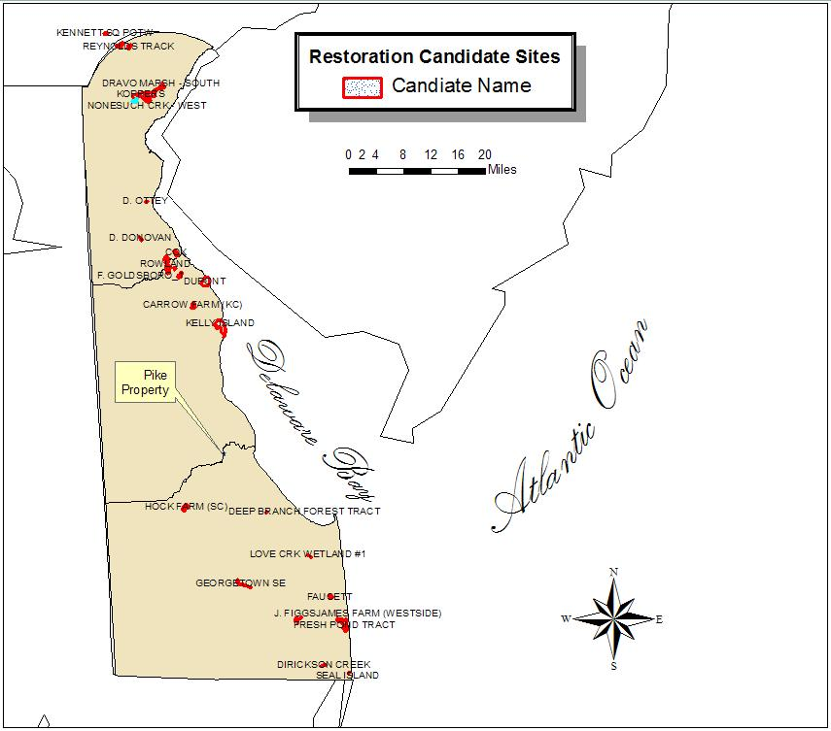
Figure 5-6 Restoration Candidate Project Locations
Delaware River Estuary (including the Christina River) represents the relevant geographical area for siting restoration actions. For those alternatives involving wetlands restoration/enhancements in the Christina River watershed (i.e., Dravo Marsh, Nonesuch Creek Marsh), the existing information suggested that extensive investigation and cleanup would be necessary, limiting restoration feasibility in those areas due to concern about sediment contamination. Therefore, restoration opportunities within the preferred Christina River sub-watershed and nearby areas within the estuary were not feasible.

Selecting restoration opportunities outside the Christina sub-watershed was considered a reasonable and equivalent alternative because of the life history requirements of the natural resources injured by the site. The life history of several of the highly valued natural resources such as blue crab, Atlantic herring, spot, and striped bass require the use of the entire Delaware estuary and its rivers (e.g., the Christina and Mispillion Rivers) as spawning and nursery area. For example, after mating blue crab females migrate to the lower estuary to release larvae on the out going tide where they drift out to sea to feed and grow. After they have molted through zoeal and megalopal stages, blue crab juveniles, “first crabs”, gradually migrate into shallower, less-saline waters in upper estuaries and rivers, where they grow and mature (Hill et al., 1989). Similarly, Atlantic herring and spot spawn offshore and move into coastal rivers to grow. Atlantic shad is one of the few species to exhibit spawning site fidelity, i.e., return to their natal streams to breed. Most of the target resources use the whole estuary, such as herring, spot, blue crab, and striped bass and therefore will benefit from improved habitat within the larger watershed, not just the Christina sub-watershed.

The goal of the first tier screening process is to identify and implement prompt and cost-effective restoration actions. To meet this goal, the restoration benefits must be an appropriate link to the natural resources and resource service losses at the Site. To ensure this proper nexus, the Trustees must determine that the preferred restoration alternative has an ecological and a geographical relationship to injured resources and lost services. As stated earlier, the Upper Delaware Estuary, including the Christina River, is considered to be the appropriate geographic/ecological unit. The Trustee preference is to perform on-site restoration. On-site restoration with enhancements has already been complete. However, additional in kind projects in the lower Christina River were not favored because contamination issues remain and it is uncertain when site investigations and response decisions will be made.

Table 5-5 - Potential Restoration Alternatives- Screening Results (Bold → tier 2)
Restoration Alternative | Timing?  (1-3 years) | In Kind Restoration? | High Likelihood of Success? | Limited Disruption to Environment? | Long-term benefit to State? | Retain for detailed analysis?
Junk Yard Alley - restore habitat for ecological receptors | N | Y | Y | Y | Y | N
Dravo Marsh - restore habitat for ecological receptors | N | Y | N | N | Y | N
Nonesuch Creek - restore habitat for ecological receptors | N | Y | N | N | Y | N
Christina Tide Lands, Calvin Tract – ownership/conservation easement | N | N | Y | Y | Y | N
Remaining DuPont Newport South Wetland Marsh –enhancement | Y | Y | Y | N | Y | Y
Bog Turtles – ownership/conservation easement | Y | N | Y | Y | Y | N
Phragmites Control – improve/restore wetlands statewide | N | N | N | N | Y | N
Reynolds Tract DNS ownership/conservation easement | N | N | Y | Y | Y | N
Auburn Heights DNS ownership/conservation easement | N | N | Y | Y | Y | N
Pennsylvania Auburn Heights DNS ownership/conservation easement | N | N | Y | Y | Y | N
Walter Carpenter Park Tract, DNS – ownership/conservation easement | N | N | Y | Y | Y | N
Capano Property Tract, DNS – ownership/conservation easement | N | Y | Y | Y | Y | N
Kennett Waste Water Treatment Plant (WWTP) - Point source removal/stream cleanup/100 acres for drip irrigation | Y | N | Maybe | Y | Y | Y
Manure Management Watershed RCVA - help cleanup streams/wetlands | N | N | Y | Y | Y | N
Artesian's Churchman's Forest – ownership/conservation easement | N | N | N | Y | Y | N
Endowment to DNS, RCVA, BVA - conservation easements | N | N | Y | Y | Y | N
Hock Farm (Prime Hook) – ownership/conservation easement | N | N | N | N | Y | N
Deep Branch Forest (Prime Hook) – ownership/conservation easement | N | N | Y | Y | Y | N
Kelly Island (Bombay Hook) – ownership/conservation easement | N | Y | N | N | Y | N
Carrow Tract (Bombay Hook) – ownership/conservation easement | Y | Y | Y | Y | Y | Y
Gladfelter Pulp Wood Co. – ownership/conservation easement | N | N | Y | N | Y | N
Bread and Cheese Island (NCC) – ownership/conservation easement | N | Y | Y | Y | Y | N
Rowland Tract – ownership/conservation easement | N | N | Y | Y | Y | N
Elmer Cox Tract (NCC) – ownership/conservation easement | N | N | Y | Y | Y | N
Benjamin Cataldi – ownership/conservation easement | N | Y | N | Y | Y | N
Fred Goldsboro #1 – ownership/conservation easement | N | Y | Y | Y | Y | N
Margaret Goldsboro – ownership/conservation easement | N | Y | N | N | Y | N
Fred Goldsboro #2 – ownership/conservation easement | N | N | Y | Y | Y | N
Fred Goldsboro #3 – ownership/conservation easement | Y | Y | N | N | Y | N
Carol Simpson – ownership/conservation easement | Y | N | N | Y | Y | N
Red Clay Valley - Heavy Equipment cleanup of floodplain | N | N | Y | N | Y | N
City of Newark - Restoration of upper Christina River | N | Y | Y | Y | Y | N
David Donovan – ownership/ conservation easement | N | N | Y | Y | Y | N
Pike Property – Crab, fish & wildlife habitat improvements & conservation easement | Y | Y | Y | Y | Y | Y
No Action | N | N | N | N | N | Y

* no action is retained per restoration planning and NEPA analysis requirements

Second Tier - Evaluation of Restoration Alternatives
Five alternative restoration projects retained for further evaluation in Tier 2 included: enhancement in the Dupont South Wetland marsh; upgrading the Kennett WWTP; acquisition and preservation of the Carrow Tract near Bombay Hook NWR; acquisition and preservation of the Cox Property, acquisition, enhancement and preservation of the Pike Property, and the No Action alternative. This evaluation eliminated several of the remaining alternatives. The Newport South Marsh was not considered a viable alternative because the restored Newport South Wetlands would be disturbed by the restoration activities. Restoring the remainder of the South Wetland marsh would have a high likelihood for success; however the associated high costs would result in limited incremental benefit to the resources. Following the successful restoration of the South wetlands, increasing the acreage of quality wetlands by a small amount would provide little benefit to the State as a whole.

The Kennett Wastewater Treatment Plant is located in Kennett, Pennsylvania just above the Delaware-Pennsylvania border. Improving the quality of treated wastewater would directly benefit the Red and White Clay Creek watersheds that receives this discharge and then flows into the Christina River. Reducing nutrient loading and discharge volume from the Kennett Wastewater Treatment Plant would indirectly benefit the tidal wetlands of the Christina River Watershed by improving surface water quality. However, the treatment plant upgrade is too costly and there is no guaranteed start time. Multiple funding sources and the timing of funding availability additionally would complicate implementation of this option. Timing, cost, and other complicating factors, eliminated this alternative from further consideration.

Within the State of Delaware, the creation and expansion of highways has increased the demand for land along these thoroughfares. Much of the land that was once rural and forested is now a complex of residential and commercial tracts. Trends over the past decade have shown an alarming rate of development in Delaware, particularly southern New Castle County. NOAA analyzed land use data in this area (http://www.udel.edu/FREC/spatlab/). Due to the high rate of irreversible development revealed by the analysis, the State of Delaware and the other Trustees acknowledge the value of preserving land near or adjacent to State-owned wildlife areas that are threatened by development. These adjacent properties provide high functioning ecological services or have the capacity to be developed to provide diverse, high functioning ecological services. Several restoration alternatives retained for further evaluation consisted of these privately owned properties near or adjacent to State-owned property. The Carrow, Pike, and Cox Properties (Table 5-2) were selected for further consideration. However, only the Pike Property was currently available and had high interest from the property owner. The alternatives are evaluated separately and summarized in Table 5-6.

Table 5-6 - Summary - Trustees’ Evaluation of Restoration Alternatives
Restoration  Alternative | Consistency with Restoration Objective (incl. future management) | Likelihood of Success (incl. technical feasibility) | Cost of Restoration | Avoid - Minimize Resource Injury | Maximize Resource Benefits | Effect on Public Safety
Pike Property Phragmites Eradication | + | + | ++ | 0 | + | 0
Pike Property Shoreline stabilization | ++ | ++ | - | 0 | ++ | 0
Pike Property Circulation Improvements | ++ | ++ | 0 | + | ++ | 0
Elmer Cox Tract (NCC) ownership/conservation easement Preservation & Restoration | + | - | - | + | + | 0
Kennett Waste Water Treatment Plant - Point source removal/stream cleanup/100 acres for drip irrigation | + | 0 | -- | ++ | 0 | +
Remaining DuPont Newport South Wetlands Marsh – enhancement | + | + | - | -- | + | 0
Carrow Tract (Bombay Hook) – ownership/conservation easement | + | - | - | + | 0 | 0
No Action | -- | 0 | ++ | 0 | 0 | 0

Legend for Table 5-3
++ | Very positive
+ | Positive
0 | Neither Positive or negative
- | Negative
-- | Very Negative

Selected Restoration Alternative – Pike Property Restoration and Easement
Consistent with CERCLA NRDA regulations and NEPA, the selection of the restoration alternative was finalized following public review and comment on the Draft DARP/EA. The 30-day comment period closed on November 3, 2006, with no comments being received. Information supporting the Trustees' selected restoration alternative is provided throughout the remainder of this Section.

The selected restoration project includes upland and emergent tidal wetlands on a privately owned 56-acre property located on the Kent and Sussex county line, approximately 55 miles down Delaware Bay from the Christina River. The property is situated along the Mispillion River, which flows generally eastward from Milford, DE into the Delaware Bay. During the first half of the 20th century, the Mispillion River served as a vital transportation route for commerce moving to and from Milford. In an effort to improve navigability, the U.S. Corps of Engineers conducted dredging activities in the 1930s to straighten, widen, and deepen the river’s channel. By changing the river’s morphology, the interior wetland portion of a river meander, including the property, was eroded by a heavily used navigation and floodwater conveyance channel. Over time, this has caused shoreline erosion on the western side of the property and a decline in hydraulic tidal flow in the project area. The decline in tidal flow has negatively impacted fish function and led to a significant reduction in the channel footprint of an oxbow that was created as a result of the dredging work. At low tide, there is relatively little water in the oxbow. The selected alternative includes invasive species removal, shoreline stabilization, and tidal exchange improvements all under the long-term protection of a perpetual conservation easement held by a trustee. The Conservation Easement will be held by the State.

The Pike Property

History and Description
The 56-acre property is located near Milford, Delaware on the Mispillion River. The Mispillion River connects several inland ponds and streams to the Delaware Bay ten miles east of Milford, and divides Kent and Sussex Counties. This section of the River is tidal with an exchange of approximately 4 feet. Historically, the Mispillion had a wider flood plain and wetlands system, but the banks have been filled in and the river channelized. In the 1930s, the U.S. Army Corps of Engineers (COE) channelized this section of the River, cutting-off the meanders or oxbow from the newly straightened mainstem.

The Pike property consists of one of the River’s original meanders (Figure 5-7). The site is located on the eastern, or right bank of the River with approximately 1,960 feet of frontage. A small area (0.5 acres) is located on the northern or left bank consisting of approximately 370 feet of frontage. The site is divided into three sections and an open water area (Figure 5-7): 1) North of the oxbow (15 acres) consists of marsh and 4.5 acres of forest; 2) Central oxbow consists of 22 acres of marsh; 3) North bank consists of 0.5 acres of marsh; and 4) the Oxbow which consists of 8 acres of open water and aquatic bed habitats. The main feature of the site is the 41.5-acre tidal marsh and oxbow. The remainder of the site is predominately deciduous riparian forest and freshwater wetlands with palustrine emergent marsh (PEM), forested (PFO1), and scrub/shrub (PSS1) National Wetlands Inventory (NWI) habitat classifications.
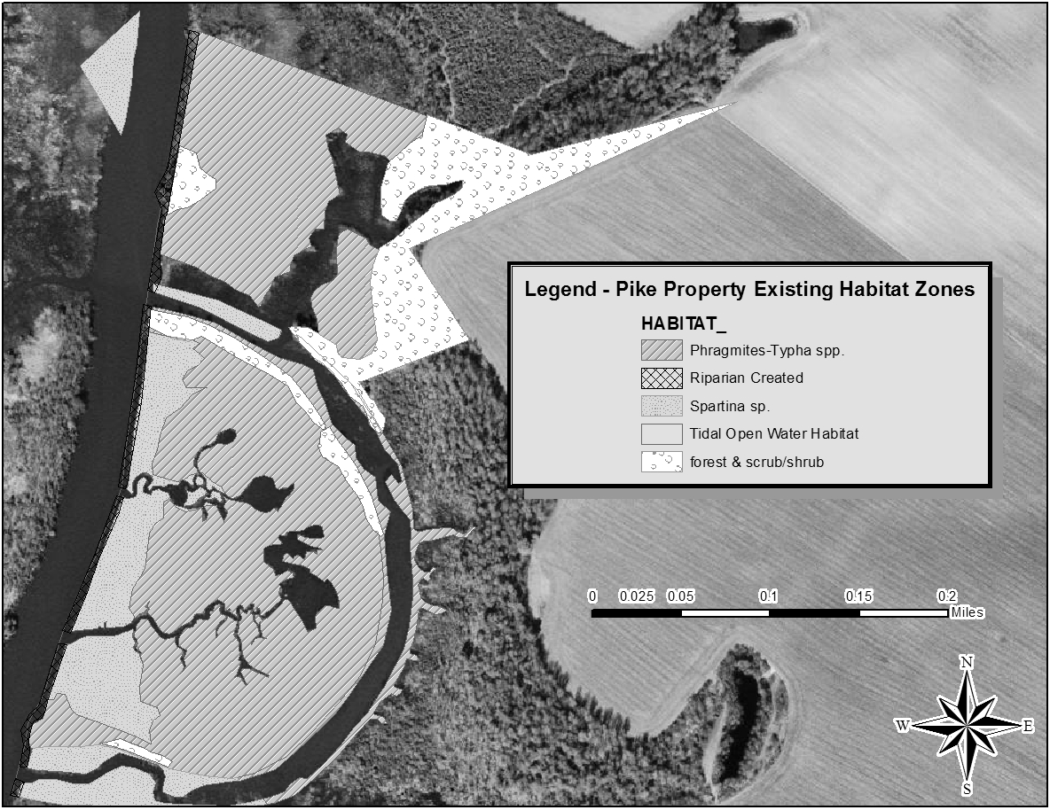
Figure 5-7- Pike Property, Existing conditions.
Reduction in tidal flow has caused the sedimentation of the interior portion of the oxbow until it is no longer navigable. Saltwater has been replaced by freshwater supporting the spread of the invasive reed Phragmites. Approximately a third of the property is currently covered in Phragmites. Because of the boat traffic and a lack of woody vegetation, the riverbank is eroding. Several feet of shoreline are now gone.

Easement and Restoration Activities:
A perpetual easement will be purchased from the landowner. The landowner will maintain ownership of the property until restoration activities are completed. Once restoration is completed, the easement will be transferred to the Delaware Fish and Wildlife, however, the landowner will be permitted to reside on and hunt on the property until his death. Restoration activities for this site include:

Shoreline Stabilization
This section of the Mispillion River is experiencing substantial erosion. There is a more significant loss on the eastern bank of the River because of the softer substrate and lower elevation resulting when the USACE exposed the interior marsh to forces in the new channel. Erosion of the shoreline is caused by a combination of gradual channel migration toward the east and boat wake/wave action. This was determined by cross-sections that show a gradual slope from the vegetated marsh surface toward the main channel.

Alternative shoreline stabilization measures were evaluated, including sheet pile wall, riprap, and rock groins, but it was determined that such intensive engineering was not needed. Instead, a less intrusive, bioengineering method was chosen. The preferred method involves placing coir logs (made of coconut fiber) rows of 2 or 3 along the 2,238-foot shoreline. Sediment will accrete between and behind the logs where Spartina alternaflora will be planted. The resulting Spartina stand will reduce erosion and provide a diversity of habitat. Riparian areas adjacent to the oxbow channel will be enhanced with native trees and shrubs. Wave dampening fence (along the entire shoreline) will be installed to further reduce erosion and protect the restored shoreline for the first year.

Vegetation Planting and Management
Spartina will be planted in the tidal marsh areas and a mixture of herbaceous and woody vegetation (e.g. Saltbush, Baccharis halmifolia) will be planted on the upland areas. This vegetation will provide habitat and food for birds and other wildlife. Phragmites is a highly invasive emergent plant species of little value to wildlife. Its ubiquitous presence throughout the northern Delaware basin has significantly degraded the functions and values of many of region’s wetland resources. A fundamental restoration objective is to increase the diversity and abundance of other beneficial vegetative species, such as Spartina, through control of Phragmites. To reduce Phragmites density, the landowner sprayed an herbicide, glyphosate, for 3 years and burned the dead plants. Phragmites will continue to be controlled by increases in salinity “spiking” resulting from improvements to the hydraulic efficiency of channels. Additionally, Phragmites root mats will be macerated using a “cookie cutter” dredge head.

Fish Habitat and Tidal Exchange
Channelization of the river and subsequent sedimentation within the oxbow has cut off the oxbow from tidal flushing. Opening the oxbow to tidal flushing and increasing the amount of tidal flushing to the interior will enhance the habitat by 1) providing increased nursery, foraging, and cover habitat for critical fish and shellfish species that inhabit the area 2) improving water circulation and nutrient exchange; and; 3) controlling the growth of Phragmites; Tidal flushing will be accomplished using Open Marsh Water Management (OMWM) techniques that have been used extensively in Delaware. These techniques involve cutting channels into the marsh using a rotary excavator and creating shallow pools. The depth and location of these channels will be identified through a hydrologic survey of the marsh and the river.

OMWM will be implemented using equipment that cuts into the marsh and broadcasts a thin layer of sediment and water over the marsh surface. The proper use of this method provides for the disposal of the excavated material over a wide area without changing the upper elevation of the marsh. It is important not to raise the elevation significantly because it will interfere with the tidal exchange and exacerbate the colonization of the marsh by Phragmites.

Scaling the Preferred Restoration Project

Habitat Equivalency Analysis Credit Model
The Trustees evaluated the selected habitat restoration projects (above) to determine the credit that would potentially be generated by the actions to be undertaken at the Pike Property. Using these assumptions, the Trustees used HEA calculations to determine the number of DSAYs given by each component of the restoration at the selected site (Table 5-7).

Table 5-7 - DSAY Credit that will be produced by the Pike Property Enhancements
Enhancement Area | Increase in Service Flow | Acres | DSAYs
Riparian Enhancement | 10% | 6.7 | 22
Riparian Creation | 100% | 0.9 | 22
Phragmites dominated converted to Spartina marsh | 35% | 24.7 | 284
Enhancement of existing Spartina Marsh | 10% | 6.6 | 21
Enhancement of Open water Habitat (oxbow) | 5% | 9.0 | 4

In total 303 wetland EqDSAYs (all habitats combined) and 43 riparian habitat DSAYs were lost. Thus, the credit analysis conducted by the trustees indicates that the preferred restoration options when constructed will provide sufficient compensatory credit.

Summary of Settlement
The settlement of natural resource damage claims is embodied in a consent decree among the United States, Delaware and DuPont (United States of America and the State of Delaware v. DuPont) (the “Consent Decree”); details of the settlement can be found in that document. This Final DARP/EA selects a set of actions, including DuPont’s purchase of a conservation easement and the provision of funding for the Trustees to undertake the restoration actions, as part of a settlement of natural resource liability.

Pursuant to the Consent Decree, DuPont will purchase a conservation easement. Furthermore, DuPont will provide funding to the Trustees to undertake the restoration actions described in the selected restoration alternative. DuPont will monitor the compensatory restoration pursuant to an agreed upon monitoring plan and, subject to the Trustees’ review and approval, undertake corrective actions as appropriate.

Geographic Proximity of Projects
Geographically, all of the restoration alternatives are within the Delaware Bay watershed.

NEPA, Endangered SPECIES ACT, & Essential FISH Habitat: Analysis and Finding of No Significant Impact
Pursuant to the National Environmental Policy Act (NEPA), 42 U.S.C. § 4371, et seq., and the implementing regulations at 40 C.F.R. Parts 1500 - 1517 (the NEPA regulations), federal agencies contemplating implementation of a major federal action must produce an environmental impact statement (EIS) if the action is expected to have significant impacts on the quality of the human environment. NEPA defines the human environment comprehensively to include the “natural and physical environment and the relationship of people with that environment” (40 C.F.R. § 1508.14). All reasonably foreseeable direct and indirect effects of implementing a project, including beneficial effects, must be evaluated (40 C.F.R. § 1508.8). Federal agencies may conduct an environmental assessment (EA) to evaluate the need for an EIS. If the EA demonstrates that the proposed action will not significantly impact the quality of the human environment, the agency issues a Finding of No Significant Impact (FONSI), which satisfies the requirements of NEPA, and no EIS is required.

Section 1508.27 of the NEPA regulations describes the minimum criteria that federal agencies should consider in evaluating the potential significance of the selected actions. The regulations explain that significance embodies considerations of both context and intensity. In the case of site-specific actions such as those selected in this Final EA/RP, the appropriate context for considering significance of action is local, as opposed to national or worldwide.

With respect to intensity of the impacts of a proposed restoration action, the NEPA regulations suggest consideration of ten factors:

- likely impacts of the proposed project,
- likely effects of the project on public health and safety,
- unique characteristics of the geographic area in which the project is to be implemented,
- controversial aspects of the project or its likely effects,
- degree to which possible effects of implementing the project are highly uncertain or involve unknown risks,
- precedential effect of the project on future actions that may significantly affect the human environment,
- possible significance of cumulative impacts from implementing this and other similar projects,
- effects of the project on National Historic Places, or likely impacts to significant cultural, scientific or historic resources,
- degree to which the project may adversely affect endangered or threatened species or their critical habitat, and
- likely violations of environmental protection laws.

40 C.F.R. § 1508.27. These factors, along with the federal Trustees’ conclusions concerning the likely significance of impacts of the selected restoration alternative, are discussed in detail below. Based on the analysis and the public review process for the Draft DARP/EA, the Trustees determined that the restoration actions proposed in the Draft DARP/EA (and selected in this document) did not meet the threshold requiring an EIS; instead the actions received a Finding of No Significant Impact (FONSI) (see Appendix __).

Likely Impacts of the Selected Restoration Alternative (Pike Property Restoration and Easement)

Nature of Likely Impacts
The selected restoration alternative for injuries to natural resources at the Site consists of coastal marsh habitat enhancement and restoration along with creation of riparian habitat. The tidal circulation enhancements and shoreline stabilization at the Pike tract would generally benefit the low salinity tidal ecosystem within the lower Mispillion River by providing increased nursery, foraging, and cover habitat for critical fish and shellfish species that inhabit the area. Increased habitat support for birds and other wildlife species would also benefit recreational uses of the area.

Marsh restoration and shoreline bio-stabilization at the Pike tract would result in some impacts to existing habitats, such as open water and unvegetated, subtidal sediments. Marsh restoration provides many similar services as unvegetated sub-tidal sediments, but is a much more productive habitat and would result in additional services. Wetlands provide a source of organic carbon, which supplies needed energy to support the estuarine food web.

Wetland enhancement as selected would result in a net improvement to about 60 acres of existing wetland habitat. Currently the DNREC is using chemical herbicides to control undesirable freshwater wetland vegetation. However, the need for chemical control will be reduced by the influx of salt water made available through the proposed water control structures. In addition, the diversity of the wetland vegetation would increase resulting in a richer habitat to support wildlife.

Effects on public health and safety
The Trustees do not expect the tidal circulation enhancements and shoreline stabilization to have any impacts on public health and safety. The habitat improvement that would result from implementation of the restoration project would not present any unique physical hazards to humans. No toxic discharges would be associated with the tidal circulation enhancements and shoreline stabilization. Efforts will be taken to minimize any sediment releases during construction.

Unique characteristics of the geographic area
Open water, unvegetated subtidal benthic sediments, and emergent marsh are degraded because of the ongoing erosion of the shoreline and the invasive growth of phragmites. These habitats are not unique to the Mispillion River near Milford. Degraded marsh and open water are displacing highly functional wetland habitat resulting in a net loss of habitat productivity. Therefore, no unique or rare habitat would be destroyed due to restoration of wetlands to those areas that previously supported wetlands.

Controversial aspects of the project or its effects
The Trustees do not expect any controversy to arise in connection with wetland enhancement with respect to the project approach. Wetland enhancement through phragmites control and circulation improvement has been implemented, by these and other Trustees in Delaware, with no adverse reaction from the public. Current governmental policy supports restoring wetlands along the middle Atlantic Coast. The Trustees anticipate that the citizens of Delaware would support both of these wetland restoration projects.

Uncertain effects or unknown risks
The Trustees do not believe there are uncertain effects or unknown risks to the environment associated with implementing the selected restoration actions. The Trustees would conduct a thorough site survey and engineering analysis to address any significant uncertainties before implementing the selected restoration actions.

Precedential effects of implementing the project
The Trustees have pursued wetland restoration projects to compensate for other natural resource damages claims in Delaware. Wetland restoration projects are regularly implemented along the Delaware coast to protect against erosion, control invasive species, and to preserve or restore coastal habitats, and such projects have used techniques to be used here. The selected restoration actions, therefore, set no precedents for future actions of a type that would significantly affect the quality of the human environment.

Possible, significant cumulative impacts
Project effects will be cumulative in the sense that the creation of marsh will provide resource services into the future. The Trustees, however, know of no impacts to the environment to which the selected restoration actions would contribute that, cumulatively, would constitute a significant impact on the quality of the human environment. All selected projects would only restore a habitat type – low salinity marsh – that originally existed and naturally occurred in the area where the enhancements are intended . Further, the actions selected in this Final DARP/EA are intended to restore habitat services to offset the natural resource loss of equivalent habitat services attributable to the Dupont Newport NPL Site. The restoration of these services is designed to make the public whole, i.e. compensation for injuries to natural resources. The selected restoration actions also are not part of any systematic or comprehensive program or plan to address the conditions along the Delaware coast or in the Delaware Bay drainage area.

Effects on National Historic Sites or nationally significant cultural, scientific or historic resources
The Trustees, after consultation with the Delaware Department of State, Division of Historical and Cultural Affairs, and the State Historic Preservation Office, are aware of no previously recorded archeological sites located in the area of the proposed projects. Further, as a fairly remote aquatic environment, the topographical setting of the area has a low potential for resources of cultural or historic significance. The Trustees believe the selected restoration actions will not affect any designated National Historic Site or any nationally significant cultural, scientific, or historic resources.

Effects on endangered or threatened species
The Trustees know of no direct or indirect impacts of the selected restoration actions on threatened or endangered species, or their designated critical habitats. The general locale where the restoration actions would be sited is not critical habitat for any listed species.

Violation of environmental protection laws
The selected restoration actions do not require nor do the Trustees anticipate any violation of federal, state or local laws, designed to protect the environment incident to or as a consequence of the implementation of either of the selected actions. The restoration actions selected can be implemented in compliance with all applicable environmental laws.

Final Conclusion & Finding of No Significant Impact on the Quality of the Human Environment
Under 40 C.F.R. §§ 1501.5 and 1501.6 for the purposes of this NEPA analysis, NOAA is the lead agency and USFWS is a cooperating agency. Based on the analysis and the other information and analyses included throughout the Final DARP/EA as part of the environmental review process for the selected restoration actions, the federal Trustees conclude that the tidal circulation enhancements and shoreline stabilization at the Pike tract (“Selected Restoration Alternative”) will not, if implemented, result in any significant impacts on the quality of the human environment. The selected restoration projects would provide habitat beneficial to the biological environment found within the selected project areas. The selected restoration projects will not impact the cultural and human environment except for providing for increased opportunities for recreation and commercial fishing by improving estuary habitats for fish dependent and other aquatic organism dependent upon estuarine environments. As a result, the Trustees concluded significant impacts are not expected from the selected restoration alternative.

The Draft DARP/EA was made available for public review and comment for 30 days and no comments concerning the FONSI were received. Based on the FONSI, an environmental impact statement (EIS) is not required for the restoration actions.

Endangered and Threatened Species
The Endangered Species Act of 1973 instructs federal agencies to carry out programs for the conservation of endangered and threatened species and to conserve the ecosystems upon which these species depend. Numerous endangered and threatened species are seasonal or occasional visitors to the Christina and Mispillion River sections of the Delaware Bay estuarine ecosystem.

- Endangered and threatened species known to occur in the Christina and Mispillion River sections of the Delaware Bay estuarine ecosystem are listed in (Table 6-8: USFWS, 2005; Delaware Division of Fish & Wildlife, 2000). Contiguous forests and wetlands provide habitat for several Federal or State-listed endangered or threatened species:

  - o Bog Turtle (Clemmys muhlenbergi)
  - o Cerulean Warbler (Dendroica cerulea)
  - o Long-tailed Salamander (Eurycea longicauda)
  - o Bald Eagle (haliaeetus leucocephalas)

The ESA directs all federal agencies to conserve endangered and threatened species and their habitats to the extent their authority allows. Protection of wildlife and preservation of habitat are central objectives in this effort. Under the ESA, the Department of Commerce (through NOAA) and the Department of the Interior (through USFWS) publish lists of endangered and threatened species. Section 7 of the Act requires federal agencies to consult with these departments to minimize the effects of federal actions on these listed species. The selected restoration actions described in the Final DARP/EA are not expected to adversely impact any threatened or endangered species. The selected restoration actions will create or enhance habitats beneficial to supporting ecosystems for any such species. Informal consultation procedures have been initiated with the USFWS and with the National Marine Fisheries Service (NOAA Fisheries) in order to ensure the restoration actions are implemented in accordance with applicable provisions of the ESA.

Table 6-8 - Federal Endangered or Threatened Species in Delaware
Federal Status | Listing
T | Eagle, bald (lower 48 States) ( Haliaeetus leucocephalus)
T | Plover, piping (except Great Lakes watershed) (Charadrius melodus)
E | Puma (=cougar), eastern (Puma (=Felis) concolor couguar)
T | Sea turtle, green (except where endangered) (Chelonia mydas)
E | Sea turtle, hawksbill (Eretmochelys imbricata)
E | Sea turtle, Kemp's ridley (Lepidochelys kempii)
E | Sea turtle, leatherback (Dermochelys coriacea)
T | Sea turtle, loggerhead (Caretta caretta)
E | Squirrel, Delmarva Peninsula fox (Sciurus niger cinereus)
E | Sturgeon, shortnose (Acipenser brevirostrum)
T | Turtle, bog (=Muhlenberg) (northern) ( Clemmys muhlenbergii)
E | Whale, finback (Balaenoptera physalus)
E | Whale, humpback (Megaptera novaeangliae)
E | Whale, right (Balaena glacialis (incl. australis))

Plants
T | Amaranth, seabeach (Amaranthus pumilus)
T | Pink, swamp ( Helonias bullata)
T | Pogonia, small whorled ( Isotria medeoloides)
E | Dropwort, Canby's ( Oxypolis canbyi)
T | Beaked-rush, Knieskern's ( Rhynchospora knieskernii)
State Status | Listing

Amphibians
E | Eastern Tiger Salamander (Ambystoma tigrinum tigrinum)
E | Barking Treefrog (Hyla gratiosa)

Birds
E | Brown Creeper (Certhia americana)
E | Bald Eagle (Haliaeetus leucocephalus)
E | Pied-billed Grebe (Podilymbus podiceps)
E | Northern Harrier (Circus cyaneus)
E | Cooper’s Hawk (Accipiter cooperii)
E | Black-Crowned Night-Heron (Nycticorax nycticorax)
E | Yellow-Crowned Night-Heron (Nyctanassa violacea)
E | Northern Parula (Parula americana)
E | Piping Plover (Charadrius melodus)
E | Short-eared Owl (Asio flammeus)
E | American Oystercatcher (Haematopus palliatus)
E | Black Rail (Laterallus jamaicensis)
E | Upland Sandpiper (Bartramia longicauda)
E | Loggerhead Shrike (Lanius ludovicianus)
E | Black Skimmer (Rynchops niger
E | Sparrow, Henslow's (Ammodramus henslowii)
E | Common Tern (Sterna hirundo)
E | Forster’s Tern (Sterna forsteri)
E | Least Tern (Sterna antillarum)
E | Cerulean Warbler (Dendroica cerulea)
E | Hooded Warbler (Wilsonia citrina)
E | Swainson’s Warbler (Limnothlypis swainsonii)
E | Red-headed Woodpecker (Melanerpes erythrocephalus)
E | Sedge Wren (Cistothorus platensis)

Fish
E | Atlantic Sturgeon (Acipenser oxyrhynchus)

Insects
E | Little White Tiger Beetle (Cicindela lepida)
E | White Tiger Beetle (Cicindela dorsalis)
E | Seth Forest Scavenger Beetle (Hydrochus spp.)
E | Frosted Elfin (Incisalia irus)
E | Bethany Firefly (Photuris bethaniensis)
E | Hessel’s Hairstreak (Mitoura hesseli)
E | King’s Hairstreak (Satyrium kingi)
E | Rare Skipper (Problema bulenta)
E | Mulberry Wing (Poanes massasoit chermocki)

Mammals
E | Delmarva Fox Squirrel (Sciurus niger cinereus)

Mollusks
E | Yellow Lampmussel (Lampsilis cariosa)
E | Eastern Lampmussel (Lampsilis radiata)
E | Dwarf Wedgemussel (Alasmidonta heterodon)
E | Eastern Pondmussel (Ligumia nasuta)
E | Brook Floater (Alasmidonta varicosa)
E | Tidewater Mucket (Leptodea ochracea)

Reptiles
E | Leatherback Sea Turtle (Dermochelys coriacea)
E | Atlantic Ridley Sea Turtle (Lepidochelys kempii)
E | Green Sea Turtle (Chelonia mydas)
E | Loggerhead Sea Turtle (Caretta caretta)
E | Bog Turtle (Clemmys muhlenbergii)
E | Corn Snake (Elaphe guttata guttata)

Essential Fish Habitat
Congress enacted amendments to the Magnuson-Stevens Fishery Conservation and Management Act (MSFCMA) (Public Law 94-265) in 1996 that established procedures for identifying Essential Fish Habitat (EFH) and required interagency coordination to further the conservation of Federally managed fisheries. Rules published by the NOAA Fisheries (50 C.F.R. §§ 600.805 - 600.930) specify that any Federal agency that authorizes, funds or undertakes, or proposes to authorize, fund, or undertake an activity which could adversely affect EFH is subject to the consultation provisions of the above-mentioned act and identifies consultation requirements. This section was prepared to meet these requirements.

The Mid-Atlantic Fishery Management Council has identified Essential Fish Habitat (EFH) for bluefish - Pomatomus saltatrix, summer flounder - Paralichthys dentatus, scup - Stenotomus chrysops, black sea bass - Centropristus striata, spiny dogfish - Squalus acanthias, tilefish - Lopholatilus chamaeleonticeps, surf clam - Spisula solidissima, ocean quahog - Artica islandica, long finned squid - Loligo pealei, short finned squid - Illex illecebrosus, Atlantic butterfish - Peprilus triacanthus, and Atlantic mackerel - Scomber scombrus. The Pike Property Tract, however, has not been designated as EFH for any of these species.

Effect on “Essential” Fish Habitat
The restoration project will affect approximately 60 acres of marsh habitat providing increased nursery, foraging, and cover habitat for critical fish and shellfish species that inhabit the area. This habitat, however, has not been designated as EFH for purposes of the MSFCMA. Some benthos will recover relatively fast, but the benthic assemblage in bottom sediments may permanently change. There will be an initial loss of estuarine water column and estuarine mud bottoms. While they are being filled, the area within them will not be available for aquatic organism use. It will take some time before the marsh is established; however, the estuarine nature of the new marsh, once established, will provide habitat for numerous species, which utilize estuaries during different life stages. The designed features, which will allow circulation of waters through the marsh, make this a potentially exceptionally productive estuarine area. While there will be impacts to the benthos, some of which will be irreversible, there will be an overall gain in the ecology of the Mispillion River system from the creation of the restoration features. This project is expected to provide improved habitats, which are likely to increase fisheries populations within the project area.

Effects on the Managed Species, and Associated Species by Life History Stage.
No managed species are expected to be affected therefore, no mitigation is required.

The Federal Agency’s Views Regarding The Effects Of The Action On EFH
It is the opinion of the federal trustees that the selected project will not have a significant adverse effect upon EFH. While there will be some loss of bottom area, the beneficial use plans will have an overall effect of benefiting the managed species and should provide an overall increase in marsh habitats.

Conclusion of Effects on EFH
Though initial, significant impacts on habitat (which is not designated as EFH) are expected due to loss of estuarine water column and mud bottoms, the Trustees believe that the selected restoration alternative will have no adverse effect on EFH. In addition, there will be a net benefit to the ecology of the Mispillion River system from the creation of the restoration features.

Compliance with Other Key Statutes, Regulations and Policies

Clean Water Act (CWA), 33 U.S.C. § 1251 et seq.
The CWA is the principal law governing pollution control and water quality of the nation’s waterways. Section 404 of the law authorizes a permit program for the beneficial uses of dredged or fill material. The Army Corps of Engineers (USACE) administers the program. In general, restoration projects, which move significant amounts of material into or out of waters or wetlands, for example, hydrologic restoration of marshes, require 404 permits. A CWA 404 permit will be obtained, if required, in order to implement any restoration action selected in this Final DARP/EA.

Rivers and Harbors Act, 33 U.S.C. § 401 et seq.
The Rivers and Harbors Act regulates development and use of the nation’s navigable waterways. Section 10 of the Act prohibits unauthorized obstruction or alteration of navigable waters and vests the Corps with authority to regulate discharges of fill and other materials into such waters. Restoration actions that must comply with the substantive requirements of Section 404 must also comply with the substantive requirements of Section 10. Any such permit would be obtained, as required, in order to implement any restoration action selected in this Final DARP/EA.

Coastal Zone Management Act (CZMA), 16 U.S.C. § 1451 et seq., 15 C.F.R. Part 923
The goal of the CZMA is to encourage states to preserve, protect, develop, and, where possible, restore and enhance the nation’s coastal resources. Under Section 1456 of the CZMA, restoration actions undertaken or authorized by federal agencies within a state’s coastal zone are required to comply, to the maximum extent practicable, with the enforceable policies of a state’s federally approved Coastal Zone Management Program. NOAA and the USFWS found the restoration actions identified in this Final DARP/EA to be consistent with the Delaware Coastal Zone Management Program, and a determination of consistency will be submitted to the appropriate state agencies for review in conjunction with the release of the Final DARP/EA.

Fish and Wildlife Conservation Act, 16 U.S.C. § 2901 et seq.
The restoration actions described herein will encourage the conservation of non-game fish and wildlife.

Fish and Wildlife Coordination Act (FWCA), 16 U.S.C. § 661 et seq.
The FWCA requires that federal agencies consult with USFWS, NOAA Fisheries, and state wildlife agencies regarding activities that affect, control, or modify waters of any stream or bodies of water, in order to minimize the adverse impacts of such actions on fish and wildlife resources and habitat utilizing these aquatic environments. Coordination is taking place by and between NOAA Fisheries, the USFWS and DNREC, the appropriate state wildlife agency. This coordination is also incorporated into compliance processes used to address the requirements of other applicable statutes, such as Section 404 of the CWA. The restoration actions described herein will have a positive effect on fish and wildlife resources.

Marine Mammal Protection Act, 16 U.S.C. § 1361 et seq.
The Marine Mammal Protection Act provides for the long-term management of and research programs for marine mammals. It places a moratorium on the taking and importing of marine mammals and marine mammal products, with limited exceptions. The Department of Commerce is responsible for whales, porpoise, seals, and sea lions. The Department of the Interior is responsible for all other marine mammals. The restoration actions described in this Final DARP/EA will not result in any adverse effect to marine mammals.

Migratory Bird Conservation Act, 16 U.S.C. § 715 et seq.
The selected restoration action will have no adverse effect on migratory birds that are likely to benefit from the establishment of new marsh habitat.

National Historic Preservation Act, 16 U.S.C. § 470 et seq.
The Trustees know of no known cultural or historic resources within or in the vicinity of the selected restoration sites.

Information Quality Guidelines issued pursuant to Public Law 106-554
Information disseminated by federal agencies to the public after October 1, 2002, is subject to information quality guidelines developed by each agency pursuant to Section 515 of Public Law 106-554 that are intended to ensure and maximize the quality of such information (i.e., the objectivity, utility and integrity of such information). The Final DARP/EA, upon release as a draft, was identified as an information product covered by information quality guidelines established by NOAA and DOI for this purpose. The information contained herein complies with applicable guidelines.

Executive Order 12898 (59 Fed. Reg. 7629) - Environmental Justice
This Executive Order requires each federal agency to identify and address, as appropriate, disproportionately high and adverse human health or environmental effects of its programs, policies, and activities on minority and low-income populations. EPA and the Council on Environmental Quality (CEQ) have emphasized the importance of incorporating environmental justice review in the analyses conducted by federal agencies under NEPA and of developing mitigation measures that avoid disproportionate environmental effects on minority and low-income populations. The Trustees have concluded that no low income or ethnic minority communities will be adversely affected by the restoration projects identified herein.

Executive Order Number 11514 (35 Fed. Reg. 4247) - Protection and Enhancement of Environmental Quality
A Final Environmental Assessment is integrated within this Final DARP/EA. Environmental analyses and coordination have taken place as required by NEPA.

Executive Order Number 11990 (42 Fed. Reg. 26,961) - Protection of Wetlands
The selected restoration actions will not result in adverse effects on wetlands or the services they provide, but rather will provide for the enhancement and protection of wetlands and wetland services.

Executive Order Number 12962 (60 Fed. Reg. 30,769) - Recreational Fisheries
The selected restoration actions will not result in adverse effects on recreational fisheries but will help ensure the enhancement and protection of such fisheries.

Literature Cited
Bartoldus, C.C., E.W. Garbisch, and M.L. Kraus. 1994. Evaluation for Planned Wetlands (EPW). Environmental Concern Inc., St. Michaels, Maryland. 327pp.

Buchman, M.F. 1998. NOAA Screening Quick Reference Tables, NOAA HAZMAT Report 97-2. Seattle, WA, Hazardous Materials Response & Assessment Division, National Oceanic and Atmospheric Admisistration. 12 pp.

Delaware Division of Fish & Wildlife. 2000. Endangered Species of Delaware. Website http://www.dnrec.state.de.us/fw/telist.htm

DuPont Corporate Remediation Group (CRG). 2002a. 2002 Annual Inspection Report – North Wetlands, Newport Superfund Site, Newport, Delaware.

DuPont CRG. 2002b. 2002 Annual Inspection Report – South Wetlands, Newport Superfund Site, Newport, Delaware.

DuPont CRG. 2003a. 2003 Annual Inspection Report – North Wetlands, Newport Superfund Site, Newport, Delaware.

DuPont CRG. 2003b. 2003 Annual Inspection Report – South Wetlands, Newport Superfund Site, Newport, Delaware.

DuPont CRG. 1999. Monitoring and Maintenance Plan – South Wetlands, Newport Superfund Site, Newport, Delaware.

DuPont CRG. 1998. Monitoring and Maintenance Plan – North Wetlands, Newport Superfund Site, Newport, Delaware.

DuPont Environmental Remediation Services. 1997a. North Wetlands Remediation 100 Percent Design Plan. April 1997.

DuPont Environmental Remediation Services. 1997b. South Wetlands Remediation 100 Percent Design Plan. October 1997.

Field, L. J., D. D. MacDonald, S. B. Norton, C. G. Ingersoll, C. G. Severn, D. Smorong and R. Lindskoog. 2002. Predicting amphipod toxicity from sediment chemistry using logistic regression models. Environmental Toxicology and Chemistry 21(9): 1993–2005.

Field, L.J. Coastal Protection and Restoration Division, Office of Response and Restoration, NOAA, personal communication, 2001.

Hill, J., D L. Fowler, and M J. Van Den Avyle. 1989. Species Profiles: Life Histories and Environmental Requirements of Coastal Fishes and Invertebrates (Mid-Atlantic) Blue Crab. Georgia Cooperative Fish and Wildlife Research Unit School of Forest Resources University of Georgia Athens, GA. Biological Report 82(11.100) TR EL82-4.

Miller, R., Delaware Department of Natural Resources, Division of Fish and Wildlife, Little Creek, Delaware, personal communication, February 28, 1990.

NOAA. 2000. Habitat Equivalency Analysis: An Overview, Damage Assessment and Restoration Program, National Oceanic and Atmospheric Administration, Department of Commerce. 23 pp. http://www.darp.noaa.gov/library/pdf/heaoverv.pdf

NOAA. 1999. Discounting and the treatment of uncertainty in natural resource damage assessment. Technical Paper 99-1. National Oceanic and Atmospheric Administration, Damage Assessment and Restoration Program. Website http://www.darp.noaa.gov/library/pdf/discpdf2.pdf

Saveikis, D. Delaware Department of Natural Resources, Division of Water Resources, Dover, Delaware, personal communication, February 28, 1990.

Shirey, C. Delaware Department of Natural Resources, Division of Fish and Wildlife, Little Creek, Delaware, personal communication, February 28, 1990.

Texas Trustees. 2000. Relative Habitat Service Provision Exercise. Technical Memorandum. Lavaca Bay Administrative Record.

US Fish and Wildlife Service (USFWS). 2005. Threatened and Endangered Species System (TESS) http://ecos.fws.gov/tess_public/servlet/gov.doi.tess_public.servlets.UsaLists?state=DE

List of Persons/Agencies Consulted
National Oceanic and Atmospheric Administration
Ron Gouguet
Peter Knight
Carl Alderson

Delaware Department of Natural Resources and Environmental Control
Jane Biggs Sanger
Robert Hossler
Phil Carpenter
Karrisa Hendershot

Fish and Wildlife Service, United States Department of the Interior
Sherry Krest
Al Rizzo

List of Preparers

National Oceanic and Atmospheric Administration
Ron Gouguet
Peter Knight

Delaware Department of Natural Resources and Environmental Control
Jane Biggs Sanger

Fish and Wildlife Service, United States Department of the Interior
Sherry Krest

E.I. du Pont de Nemours and Company
Maryann J. Nicholson
Ralph Stahl
Al Boettler

Declaration
The Final Damage Assessment and Restoration Plan/Environmental Assessment for the natural resource damages attributed to the Dupont Newport Federal Superfund Site in New Castle County, Delaware is compliant and consistent with the respective authority and requirements of the the Comprehensive Environmental Response, Compensation and Liability Act (CERCLA), 42 U.S.C. § 9601 et seq.; the Federal Water Pollution Control Act, 33 U.S.C. § 1251, et seq.) (also known as the Clean Water Act or CWA), and other applicable federal or state laws, including Subpart G of the National Oil and Hazardous Substances Contingency Plan (NCP), at 40 C.F.R. §§ 300.600 through 300.615, and DOI’s CERCLA natural resource damage assessment regulations at 43 C.F.R. Part 11 (NRDA regulations) which provide guidance for this restoration planning process under CERCLA and the Delaware Hazardous Substance Cleanup Act, 7 Del. C. Ch. 91.

The term” conservative assumption” indicates that the value of the parameter in question would tend to favor the natural resource and the public’s interests in injured natural resources when used in the analysis. The assumed value therefore leads to an upper-end estimate of how much injury occurred or how much restoration is required. Often these assumptions are used in initial analyses to guide the Trustees in determining the appropriate level of effort to apply in obtaining more refined estimates. Sometimes, as is the case for most of the assumptions used in this injury assessment, the cost of developing refined estimates for parameters would exceed the potential reduction in the cost of restoration. In these instances, the use of conservative assumptions in the final analysis, rather than developing more precise point estimates, results in an overall cost savings to the potentially responsible parties (PRPs) while still protecting the public’s interest in obtaining sufficient restoration for the injuries.

