Review of the Office of Postsecondary Education’s Awarding of Prior Experience Points in the 2006 Educational Opportunity Centers and Talent Search
Grant Competitions

FINAL INSPECTION REPORT

ED-OIG/I13I0001
September 2008

Our mission is to promote the efficiency, effectiveness, and integrity of the Department's programs and operations. |  | U.S Department of Education  Office of Inspector General  Washington, D.C.

Statements that managerial practices need improvements, as well as other conclusions and recommendations in this report, represent the opinions of the Office of Inspector General. Determinations of corrective action to be taken will be made by the appropriate Department of Education officials.

In accordance with the Freedom of Information Act (5 U.S.C. § 552), reports issued by the Office of Inspector General are available to members of the press and general public to the extent information contained therein is not subject to exemptions in the Act.

UNITED STATES DEPARTMENT OF EDUCATION
OFFICE OF INSPECTOR GENERAL

September 8, 2008

Memorandum

TO: Cheryl Oldham
Acting Assistant Secretary
Office of Postsecondary Education

FROM: Wanda A. Scott /s/
Assistant Inspector General
Evaluation, Inspection, and Management Services

SUBJECT: Final Inspection Report
Review of the Office of Postsecondary Education’s Awarding of Prior Experience Points in the 2006 Educational Opportunity Centers and Talent Search Grant Competitions (Control Number ED-OIG/I13I0001)

Attached is the final inspection report of our Review of the Office of Postsecondary Education’s Awarding of Prior Experience Points in the 2006 Educational Opportunity Centers and Talent Search Grant Competitions. We received your comments to our draft report on July 11, 2008. A copy of your response to the draft report in its entirety is attached.

Corrective actions proposed (resolution phase) and implemented (closure phase) will be monitored and tracked through the Department's Audit Accountability and Resolution Tracking System (AARTS). Department policy requires that you develop a proposed corrective action plan for our review in the automated system within 30 days of the issuance of this report. The corrective action plan should set forth the specific action items, and targeted completion dates, necessary to implement final corrective actions on the findings and recommendations contained in this final inspection report.

In accordance with the Inspector General Act of 1978, as amended, the Office of Inspector General is required to report to Congress twice a year on the reports that remain unresolved after six months from the date of issuance.

In accordance with the Freedom of Information Act (5 U.S.C. § 552), reports issued by the Office of Inspector General are available to members of the press and general public to the extent information contained therein is not subject to exemptions in the Act.

We appreciate the cooperation given us during this review. If you or your staff have any questions, please contact Christopher Wilson, Acting Assistant Director, Evaluation and Inspection Services at 202-245-7061.

Enclosure

TABLE OF CONTENTS

Page

EXECUTIVE SUMMARY 1
BACKGROUND 1
INSPECTION RESULTS 1
FINDING NO. 1 – OPE’s Awarding of Prior Experience Points was Not in Compliance with the Regulations 1
FINDING NO. 2 – OPE Awarded Points to Grantees that Did Not Meet Minimum Program Requirements 1
FINDING NO. 3 – OPE Made Errors in the Execution of its Prior Experience Points Assessment 1
FINDING NO. 4 – OPE Changed its Process for Awarding Prior Experience Points without Having the Appropriate Data to Evaluate Grantees 1
DEPARTMENT COMMENTS 1
OBJECTIVE, SCOPE, AND METHODOLOGY 1
APPENDICES 1
Appendix 1 Educational Opportunity Centers (EOC) Issues by Finding (Sample of 20) 1
Appendix 2 Talent Search Issues by Finding (Sample of 20) 1
Appendix 3 EOC Grantees with Differences in Total Points Between the Assessment Form and Funding Slate 1
Appendix 4 EOC Grantees with Point Gains Due to Math and Transcription Errors 1
Appendix 5 EOC Grantees with Point Losses Due to Math and Transcription Errors 1

EXECUTIVE SUMMARY

The objective of our inspection was to evaluate the appropriateness of the Office of Postsecondary Education’s (OPE) awarding of prior experience points in the 2006 Educational Opportunity Centers (EOC) and Talent Search grant competitions. Our inspection is the result of a request from Congress, dated October 2, 2007.

We found that OPE inappropriately awarded prior experience points for the 2006 EOC and Talent Search grant competitions. As a result, some grantees without prior experience near the funding threshold may have been wrongly denied funding and some grantees above the funding threshold may have been inappropriately awarded funding. Specifically, we found that —

- OPE’s awarding of prior experience points was not in compliance with the regulations because OPE:
- Improperly awarded partial points, and
- Did not evaluate an objective in the Talent Search competition.

- OPE awarded points to grantees that did not meet minimum program requirements.

- OPE made errors in the execution of its prior experience points assessment.
- In the EOC competition, OPE used incorrect source data, made documentation errors, and made math and transcription errors, and
- In the Talent Search competition, OPE made documentation errors.

- OPE changed its process for awarding prior experience points without having the appropriate data to evaluate grantees.
- In the EOC competition:
- Annual performance reports (APRs) lacked data for combined objectives,
- OPE automatically awarded points due to lack of data, and
- Grantee objectives did not correspond with the prior experience assessment.
- In the Talent Search competition:
- Grantee objectives did not correspond with the prior experience assessment.

We recommend that the Assistant Secretary for Postsecondary Education —

- Cease awarding partial prior experience points for Criterion 1 for future EOC and Talent Search grant competitions.
- Develop a methodology for assessing prior experience for reentry in accordance with 34 C.F.R. § 643.22(b)(2) for future Talent Search grant competitions.
- Cease awarding prior experience points to grantees for years that they do not meet minimum program requirements for future EOC and Talent Search grant competitions.
- Develop a quality assurance process for the assessment of prior experience for future EOC competitions to ensure accountability and the accuracy of data and calculations.
- Ensure that the data used to assess prior experience is clearly identified and sufficiently documented to support the calculation for future EOC and Talent Search grant competitions.
- Ensure that the objectives used to assess prior experience correspond to grantees’ application objectives for future EOC and Talent Search grant competitions.

We provided OPE with a copy of our draft report for comment. Based on OPE’s comments, we separated the first finding in the draft report into two findings (Finding 1 and Finding 2), re-numbered the remaining findings, and made various clarifications.

The recent reauthorization of the Federal TRIO programs by the Higher Education Opportunity Act, Pub. L. 110-315 (enacted August 14, 2008), specified changes to the criteria for evaluating prior experience that may affect OPE’s implementation of the recommendations made in this report.
BACKGROUND

On October 2, 2007, 15 members of Congress expressed concern that the Department of Education (Department) inappropriately awarded prior experience points in the 2006 Educational Opportunity Centers (EOC) and Talent Search grant competitions and requested that we review this matter.

The EOC and Talent Search programs are part of the Federal TRIO outreach programs designed to support students from disadvantaged backgrounds. These programs, implemented by the Department’s Office of Postsecondary Education (OPE), are targeted to serve and assist low-income, first-generation college students and students with disabilities. Both the EOC and Talent Search programs serve low-income, first generation college students. The EOC program provides counseling and information on college admissions to qualified adults who want to enter or continue a program of postsecondary education. The Talent Search program provides academic, career, and financial counseling to its participants from disadvantaged backgrounds and encourages them to graduate from high school and continue on to a postsecondary institution. The regulations at 34 C.F.R. § 644.32(b) specify that an EOC grantee shall serve a minimum of 1,000 participants in each year, while the regulations at 34 C.F.R. § 643.32(b) specify that a Talent Search grantee shall serve a minimum of 600 participants in each year.

The EOC and Talent Search programs hold grant competitions every four years. The Secretary evaluates an application for a new grant based on the project’s need, objectives, plan of operation, applicant and community support, quality of personnel, budget, and evaluation plan. The maximum application score for these criteria is 100 points.

The Secretary also awards a maximum of 15 additional points for prior grant experience. Unlike the application scores determined by individuals serving as field readers who are external to the Department, prior experience points are determined by Department staff. The Higher Education Act of 1965, as amended (HEA), specifies that the Department should remain historically consistent in its application of prior experience points for future competitions by not varying from the level of consideration provided to grant applicants during fiscal years 1994 through 1997. The number of points awarded for prior experience has remained consistent since the specified period of time. Although OPE modified its formula for evaluating prior experience for both the EOC and Talent Search competitions in 2006, it did not change the maximum number of points grantees were eligible to earn.

For the 2006 competitions, OPE assessed grantees for their prior experience in fiscal years 2002-03, 2003-04, and 2004-05. The regulations at 34 C.F.R. § 644.22(b) for the EOC program and 34 C.F.R. § 643.22(b) for the Talent Search program specify that the Secretary evaluate prior experience based on three sets of criteria. Criterion 1 for both programs, with a maximum score of three points, requires that the Secretary evaluate whether the applicant provided services to the number of participants required to be served and whether two-thirds of all participants served were low-income individuals and potential first-generation college students.

Criteria 2 and 3 for both programs require the Secretary to evaluate specific subsets of the population served by the applicant. Each criterion is worth a maximum of six points. Under Criterion 2 for the EOC program, the Secretary evaluates the extent to which the applicant met or exceeded its objectives regarding the provision of assistance to individuals in applying for admission to, or financial aid for, programs of postsecondary education. Under Criterion 3, the Secretary evaluates the extent to which the applicant met or exceeded its objectives regarding the admission or reentry of participants to programs of postsecondary education. Under Criterion 2 for the Talent Search program, the Secretary evaluates the extent to which the applicant met or exceeded its objectives regarding the retention, reentry, and graduation levels of secondary school participants, while under Criterion 3, the Secretary evaluates the extent to which the applicant met or exceeded its objectives regarding the admission or reentry of participants to programs of postsecondary education.

OPE had 335 grant applicants for the 2006 EOC competition and funded 125. All funded applicants were eligible for and received prior experience points. There were a total of 137 EOC grantees that were assessed for prior experience. The funding threshold for the 2006 EOC competition was 100.33 points out of a maximum of 115 points.

OPE had 772 grant applicants in the 2006 Talent Search competition and funded 468. Of these, 400 were eligible for and received prior experience points, and one was eligible but did not earn any points. There were 457 Talent Search grantees that were assessed for prior experience and eligible for funding. The threshold for the 2006 Talent Search competition was 98.33 points out of a total of 115 points.

The recent reauthorization of the Federal TRIO programs by the Higher Education Opportunity Act, Pub. L. 110-315 (enacted August 14, 2008), specified changes to the criteria for evaluating prior experience that may affect OPE’s methodology for awarding prior experience points.
INSPECTION RESULTS

The objective of our inspection was to evaluate the appropriateness of OPE’s awarding of prior experience points in the 2006 EOC and Talent Search grant competitions. We found that OPE inappropriately awarded prior experience points for the 2006 EOC and Talent Search grant competitions. As a result, some grantees without prior experience near the funding threshold may have been wrongly denied funding and some grantees above the funding threshold may have been inappropriately awarded funding.

We found that (1) OPE’s awarding of prior experience points was not in compliance with the regulations, (2) OPE awarded points to grantees that did not meet minimum program requirements, (3) OPE made errors in the execution of its prior experience points assessment, and (4) OPE changed its process for awarding prior experience points without having the appropriate data to evaluate grantees.

FINDING NO. 1 – OPE’s Awarding of Prior Experience Points was Not in Compliance with the Regulations

We found that OPE improperly awarded partial points in both the EOC and Talent Search competitions. In our sample of 20 EOC grantees, we found that OPE did not award prior experience points in compliance with the regulations for 4 of the grantees (see Appendix 1). We also found that OPE did not evaluate an objective in the Talent Search competition. In our sample of 20 Talent Search grantees, we found that OPE did not award prior experience points in compliance with the regulations for 16 of the grantees (see Appendix 2).

OPE Improperly Awarded Partial Points
The EOC regulations at 34 C.F.R. § 644.22(b)(1) state that the Secretary should evaluate prior experience for Criterion 1 based on the following:

(i) Whether the applicant provided services to the required number of participants who resided in the target area; and (ii) Whether two-thirds of all participants served were low-income individuals and potential first-generation college students [emphasis added].

OPE evaluated Criterion 1 in two parts for the EOC competition. The regulations at 34 C.F.R.
§ 644.22(b)(1)(i) correspond to Criterion 1a of the EOC assessment, and the regulations at 34 C.F.R. § 644.22(b)(1)(ii) correspond to Criterion 1b.

The Talent Search regulations at 34 C.F.R. § 643.22(b)(1) similarly state that the Secretary should evaluate prior experience for Criterion 1 based on the following:

(i) Whether the applicant provided services to the number of participants required to be served under the approved application; and (ii) Whether two-thirds of all participants served were low-income individuals and potential first-generation college students [emphasis added].

Like the EOC competition, OPE evaluated Criterion 1 in two parts for the Talent Search competition. The regulations at 34 C.F.R. § 643.22(b)(1)(i) correspond to Criterion 1a of the Talent Search assessment. The regulations at 34 C.F.R. § 643.22(b)(1)(ii) correspond to Criterion 1b.

OPE awarded partial points for Criterion 1 in both the EOC and Talent Search competitions. A grantee could earn a maximum of 1.5 points for meeting Criterion 1a, and another 1.5 points for meeting Criterion 1b. The regulations, however, state that an applicant should be awarded three points for meeting both part (i) and part (ii).

In the 2002 EOC and Talent Search competitions, when a grantee did not serve the number of participants it was funded to serve (funded to serve number), OPE used two-thirds of the actual number of participants served for Criterion 1b. This method rewarded some grantees with prior experience points although they did not meet the terms of their grant agreements. For the 2006 EOC and Talent Search competitions OPE used the larger of the actual number served or the funded to serve number to calculate Criterion 1b. This new method made it more difficult for grantees to earn prior experience points in 2006 by appropriately requiring grantees to serve the required minimum number of low-income and potential first-generation college students in order to receive points under Criterion 1b; however, the method still allowed some grantees to receive prior experience points without meeting the terms of their grant agreement identified in Criterion 1a. Of the 20 EOC grantees in our sample, 4 received partial points for Criterion 1. Of the 20 Talent Search grantees in our sample, 7 received partial points.

Like the 2002 competitions, OPE continued to award partial points to grantees for Criterion 1. OPE did not correctly interpret the inclusive nature of the “and” in the regulations for Criterion 1 for both the EOC and Talent Search programs. OPE’s practice of awarding partial points has not considered the requirement in the regulations that both conditions, parts (i) and (ii), must be met to earn prior experience points. Grantees that earned partial points had an advantage over new applicants that did not have prior experience. As the regulation is written, a grantee should not be able to earn prior experience points for Criterion 1 without meeting the requirements of both Criterion 1a and Criterion 1b.

OPE Did Not Evaluate Reentry in the Talent Search Competition
The Talent Search regulations at 34 C.F.R. § 643.22(b)(2) state that the Secretary should evaluate prior experience for Criterion 2 based on “[t]he extent to which the applicant met or exceeded its objectives regarding the retention, reentry, and graduation levels of secondary school participants.” In the 2006 Talent Search competition, OPE evaluated prior experience only for retention and graduation, even though the regulations provide that all three objectives should be evaluated. An OPE official stated that reentry was not evaluated because not every grantee had a reentry objective. There were applicants in the competition, however, that had reentry objectives stated in their applications. Of the 20 Talent Search grantees in our sample, 12 had a reentry objective percentage for Criterion 2. Because OPE did not evaluate reentry, grantees with reentry objectives were not properly evaluated for this criterion and may not have received the correct number of prior experience points.

Recommendations

We recommend that the Assistant Secretary for Postsecondary Education —

- Cease awarding partial prior experience points for Criterion 1 for future EOC and Talent Search grant competitions.
- Develop a methodology for assessing prior experience for reentry in accordance with 34 C.F.R. § 643.22(b)(2) for future Talent Search grant competitions.

FINDING NO. 2 – OPE Awarded Points to Grantees that Did Not Meet Minimum Program Requirements

In both the EOC and Talent Search grant competitions, OPE awarded prior experience points to grantees that did not comply with the minimum program requirements. The EOC program requires grantees to serve a minimum of 1,000 participants, while the Talent Search program requires a minimum of 600 participants. Grantees that failed to serve the minimum number of program participants did not comply with the basic requirements of the grant and should not be awarded prior experience points for any of the criteria in those years. Therefore, OPE provided these grantees with an advantage by awarding points for years where they did not meet minimum requirements. Of the 20 EOC grantees in our sample, 5 received prior experience points in years where they did not meet the minimum requirement. Of the 20 Talent Search grantees in our sample, 2 received such points in years where they did not meet the minimum requirement.

Recommendation

We recommend that the Assistant Secretary for Postsecondary Education —

- Cease awarding prior experience points to grantees for years that they do not meet minimum program requirements for future EOC and Talent Search grant competitions.

FINDING NO. 3 – OPE Made Errors in the Execution of its Prior Experience Points Assessment

We found that OPE made execution errors in assessing prior experience for the EOC and Talent Search competitions. In our sample of 20 EOC grantees, we found that OPE made execution errors in assessing prior experience for 16 of the grantees (see Appendix 1). In our sample of 20 Talent Search grantees, we found that OPE made execution errors in assessing prior experience for 7 of the grantees (see Appendix 2).

OPE Made Execution Errors in Assessing Prior Experience for the EOC Competition
In the EOC competition, OPE program specialists manually performed the assessment calculations. The prior experience assessments for the EOC competition contained incorrect source data, lacked documentation, and had math and transcription errors.

Incorrect source data. The prior experience assessment forms in the EOC competition contained incorrect data obtained from the applications, the annual performance reports (APRs), and a spreadsheet containing data for Criterion 1. Errors included program specialists transcribing a number incorrectly from the source document to the assessment form and using the wrong data element from the source document to evaluate a criterion on the assessment form. These errors resulted in inaccurate assessments of prior experience because incorrect numbers were used in the calculations. OPE did not have an adequate quality assurance process in place to check for these errors. Of the 20 EOC grantees in our sample, 12 had source data errors.

Lack of documentation. The prior experience assessment forms in the EOC competition lacked sufficient documentation. Of the 137 EOC prior experience assessments, we found that 34 assessments (25%) had insufficient documentation of the scoring on the assessment form to determine whether the criteria were appropriately evaluated. Program specialists’ documentation errors on the assessment form included determining achievement rates but not providing all of the information necessary to perform the calculation and not including the objective percentages from the application. Without adequate documentation of the assessment scoring, there is no assurance that the data used to evaluate prior experience is accurate and appropriate.

In addition to the issues we identified on the assessment forms, there was also a lack of documentation for changes from the total prior experience points stated on the assessment form to the total points stated on OPE’s slate used for funding grantees. We found that for 12 of the 137 EOC prior experience assessments (9%), the grantee’s total prior experience points on the assessment form did not match the total points on the slate (see Appendix 3). A program official stated that the Director of TRIO at the time randomly selected grantees to review and based on the review personally made changes to some scores. Without documentation, however, we were unable to determine whether these differences were the result of a deliberate change and, if so, whether the change was justified; or whether there was a transcription error.

Six of the 20 grantees in our sample had discrepancies between the funded to serve number requested in the application and the number contained in the spreadsheet provided to program specialists for evaluating Criterion 1. For four discrepancies, OPE used an incorrect number to assess prior experience. The grantee files did not contain documentation explaining the discrepancy. OPE officials stated that for some discrepancies between the funded to serve number requested in the application and the number used to evaluate prior experience, it was common practice to reduce the funded to serve number from the application to the funded to serve number from the prior grant cycle if the grantee did not receive the additional funds it requested in its application. OPE explained that the other two discrepancies resulted from this practice. The grantee files did not contain written approval to document and justify the change to the number funded to serve. Without written justification, there is no assurance that the funded to serve number used to evaluate prior experience was accurate.

Math and transcription errors. Of the 137 EOC prior experience assessments, 76 (55%) contained mathematical errors. Thirty-eight had errors that resulted in OPE inappropriately awarding prior experience points. Of these, 17 grantees gained points that they had not earned and 21 grantees lost points that they had earned (see Appendices 4 and 5). Some grantees had significant changes in points. For example, four grantees gained three or more points due to errors, while nine grantees lost three or more points.

Program specialists’ math and transcription errors included:

- Making calculation errors such as addition, multiplication, and division errors,
- Determining the correct achievement rate but awarding the wrong number of points,
- Reversing the numerator and the denominator in a calculation,
- Transcribing the wrong number from the calculation sheets to the cover sheet, and
- Incorrectly totaling the points on the cover sheet.

Execution errors in the assessment of prior experience were caused by inadequate internal controls. The EOC prior experience assessment lacked an adequate quality assurance process. OPE officials stated that there was no comprehensive review of the program specialists’ work on the prior experience assessment forms. The control activities discussed in the Government Accountability Office (GAO) Standards for Internal Control in the Federal Government specify that there should be controls over information processing, which include activities such as edit checks of data entered. OPE did not have any controls in place to ensure data integrity.

In addition, many program specialists did not sign and date their completed assessment forms. Failure to ensure completion of this certification requirement indicates a control environment that lacks accountability.

OPE Made Execution Errors in Assessing Prior Experience for the Talent Search Competition
Lack of documentation. OPE used an automated spreadsheet to calculate prior experience points for the Talent Search competition. There were discrepancies between the funded to serve number requested in the application and the number used in the spreadsheet for 7 of the 20 grantees in our sample. For one discrepancy, OPE used an incorrect number to assess prior experience. The grantee file did not contain documentation explaining this discrepancy. For another discrepancy, OPE stated that it used the funded to serve number from the previous grant cycle because the grantee reduced the funded to serve number requested in its application without prior approval. As noted above, OPE officials stated that in some other cases it was common practice to reduce the funded to serve number from the application to the funded to serve number used in the prior grant cycle if the grantee did not receive the additional funds it requested in its application. OPE explained that the other five discrepancies resulted from this practice. The grantee files did not contain written approval to document and justify the change to the number funded to serve. As stated earlier, without written justification, there is no assurance that the number funded to serve used to evaluate prior experience was accurate.

Recommendations

We recommend that the Assistant Secretary for Postsecondary Education —

- Develop a quality assurance process for the assessment of prior experience for future EOC competitions to ensure accountability and the accuracy of data and calculations.
- Ensure that the data used to assess prior experience is clearly identified and sufficiently documented to support the calculation for future EOC and Talent Search grant competitions.

FINDING NO. 4 – OPE Changed its Process for Awarding Prior Experience Points without Having the Appropriate Data to Evaluate Grantees

OPE modified the methodology for awarding prior experience points for the 2006 EOC and Talent Search grant competitions. In making this change, however, OPE failed to take into account the limitations of the data it collected from grantees and did not have the data needed to support the modified methodology. In our sample of 20 EOC grantees, we found that 5 had an issue that resulted from OPE changing its process for awarding prior experience points without having the appropriate data to evaluate grantees (see Appendix 1). In our sample of 20 Talent Search grantees, we found that 8 had an issue (see Appendix 2).

OPE Changed its Process without Having the Appropriate Data in the EOC Competition
Under Criterion 2 for the EOC program, the Secretary evaluates the extent to which the applicant met or exceeded its objectives regarding the provision of assistance to individuals in applying for admission to, or financial aid for, programs of postsecondary education. For this criterion, OPE provided program specialists with different methods to calculate prior experience for 2002-03 and 2003-04. A grantee could be awarded prior experience points for each individual objective of assisting participants with applying for postsecondary admissions and for financial aid or the objectives could be combined into one objective to award the points.

Under Criterion 3, the Secretary evaluates the extent to which the applicant met or exceeded its objectives regarding the admission or reentry of participants to programs of postsecondary education. For this criterion, OPE also provided program specialists with different methods to calculate prior experience for 2002-03 and 2003-04. A grantee could be awarded prior experience points for each individual objective of enrollment in postsecondary education and reentry to postsecondary education; enrollment only in postsecondary education; or the objectives for enrollment in postsecondary education and reentry to postsecondary education could be combined into one objective.

Annual Performance Reports (APRs) Lacked Data for Combined Objectives. To determine the number of students a grantee assisted under both criteria, program specialists were instructed to take the corresponding number of participants assisted for each objective from the APR. Because the APR did not have a specific field for grantees to report on combined objectives, OPE instructed program specialists to add the numbers for each objective to determine the combined number assisted under each criterion. Since an individual could receive assistance under both objectives for each criterion, these numbers could overlap, leading to double counting. The numerator for the combined objective was not adjusted to account for the double counting, resulting in 40 of the 137 EOC grantees (29%) evaluated for prior experience having an achievement rate greater than 100 percent. Program specialists had flexibility in determining whether an objective should be evaluated as separate or combined. In cases where a program specialist used a combined objective, grantees had the benefit of double counting, making it easier to earn prior experience points.

OPE Automatically Awarded Points Due to Lack of Data. OPE decided to automatically award prior experience points to all EOC applicants with prior grant experience for Criteria 2 and 3 for 2004-05. OPE automatically awarded all grantees with prior experience 4 of the 15 prior experience points, giving them an advantage over applicants without any prior experience. OPE awarded these points without evaluating whether the grantee had achieved the two criteria for that year. OPE made this decision because it did not request one of the data elements in the 2004-05 APR that was necessary to determine whether the grantee had earned prior experience points for these two criteria. An OPE official stated that OPE eliminated the data element from the APR because grantees had different interpretations of the data element and the data collected was considered unreliable. Although OPE did not consider the data reliable and eliminated the data element from the APR for 2004-05, OPE used it to calculate prior experience points for 2002-03 and 2003-04.

For the 2006 competition, all of the grant applicants that were funded were prior grantees who earned prior experience points. The funding threshold in 2006 was 100.33 points. There were 19 grantees that were not eligible for prior experience points, but had perfect application scores of 100. These grantees with perfect application scores may have received funding had OPE not automatically awarded points because grantees with prior experience may have fallen below the funding threshold.

Grantee Objectives Did Not Correspond with the Prior Experience Assessment. Though OPE modified the methodology for calculating prior experience points in 2006, the grantees’ original application objectives were written for the 2002 competition and did not necessarily correspond with the new methodology. In some cases where the grantees’ objectives did not correspond with the prior experience assessment, program specialists would give grantees the benefit of the doubt by looking for similar objectives or using key words to find other objectives to use in the prior experience assessment. In other cases, program specialists would use objective percentages from the APR that were not stated in the grantees’ original approved applications. Without precise data and standardized objectives, there is no assurance that grantees were appropriately evaluated for the objectives stated in their applications. In our random sample of 20 EOC grantees, 2 grantees had objectives in their applications that did not correspond with the objectives used to evaluate prior experience.

OPE Changed its Process without Having the Appropriate Data in the Talent Search Competition
Under Criterion 2 for the Talent Search program, the Secretary evaluates the extent to which the applicant met or exceeded its objectives regarding the retention, reentry, and graduation levels of secondary school participants, while under Criterion 3, the Secretary evaluates the extent to which the applicant met or exceeded its objectives regarding the admission or reentry of participants to programs of postsecondary education.

Grantee Objectives Did Not Correspond with the Prior Experience Assessment. In our sample of 20 Talent Search grantees, 5 provided more than one percentage for a single objective in the application. In these cases, the number chosen for the prior experience assessment depended on the program specialist performing the calculation. In some cases program specialists would average the numbers, while in other instances they would just select one of the numbers. Four Talent Search grantees in our sample of 20 had application objectives that did not correspond with the modified methodology for calculating prior experience points in 2006. As noted above, in some cases program specialists would give grantees the benefit of the doubt when the grantees’ objectives did not correspond with the prior experience assessment. Therefore, there is no assurance that grantees were appropriately evaluated for the objectives stated in their application.

Changes to the Grant Applications for the EOC and Talent Search Grant Competitions
OPE has taken steps to address issues we identified in the 2006 EOC and Talent Search grant competitions. The prior experience assessments for the next grant competitions will use data from the 2006 EOC and Talent Search grant applications. Unlike the 2002 grant competitions, in 2006 OPE required all applicants to use specific, standardized objectives stated in the application form. An OPE official stated that these standardized objectives will be used to evaluate prior experience in future EOC and Talent Search competitions. Using these standardized objectives should reduce variations in grantees’ objectives and eliminate problems associated with evaluating combined objectives. In addition, OPE revised the 2006 EOC grant application form to define the data elements used in the standardized objectives.

Recommendation

We recommend that the Assistant Secretary for Postsecondary Education —

- Ensure that the objectives used to assess prior experience correspond to grantees’ application objectives for future EOC and Talent Search grant competitions.
DEPARTMENT COMMENTS

On June 5, 2008, we provided OPE with a copy of our draft report for comment. OPE provided its comments to the report on July 11, 2008. Based on OPE’s comments, we separated the first finding in the draft report into two findings: Finding 1 and Finding 2. As a result, we renumbered Finding 2, Finding 3, and their corresponding recommendations. OPE did not agree with Finding 1 of the draft report and agreed with Findings 2 and 3. A copy of OPE’s comments, in their entirety, is attached to this report.

The recent reauthorization of the Federal TRIO programs by the Higher Education Opportunity Act, Pub. L. 110-315 (enacted August 14, 2008), specified changes to the criteria for evaluating prior experience that may affect OPE’s implementation of the recommendations made in this report.

Finding 1
OPE did not agree with Finding 1 or with Recommendations 1.1, 1.2 (now 2.1), and 1.3 (now 1.2). OPE stated the draft report did not provide any significant legal or policy rationale for the interpretation of the regulations.

Recommendation 1.1
Cease awarding partial prior experience points for Criterion 1 for future EOC and Talent Search grant competitions.

OPE Comments
OPE did not agree with our recommendation. OPE stated that the OIG’s interpretation of the Department’s regulations was that an applicant can receive only the specific number of prior experience points for each criterion or zero. OPE stated that the Department has interpreted its regulations as providing a maximum number of points for each criterion.

OIG Response
No changes have been made to the finding and recommendation based on OPE’s comments to Recommendation 1.1; however, we clarified the discussion of OPE’s scoring of Criterion 1b in the 2006 competitions.

We recognize that the Department has the discretion to interpret its regulations, and is entitled to deference if the interpretation is reasonable. Our finding describes in detail our conclusion that the plain text of the regulation and the use of “and” to link the two parts of Criterion 1 requires that both parts of the provision be satisfied to earn any of the three available points under Criterion 1. OPE did not provide any explanation as to why its interpretation and application were considered reasonable in light of the plain text of the regulation. The EOC and Talent Search programs are targeted to serve and assist low-income, first-generation college students. OPE funds EOC and Talent Search grant applicants based on the number of participants the grantees will serve. In their applications, grantees agree that two-thirds of those participants will be low-income, first-generation college students. OPE’s methodology of awarding points allows grantees to receive points without meeting the terms of their grant agreement. For example, in one case a grantee served the number of participants it was funded to serve, but only four percent of those students were low-income, first-generation college students. OPE awarded points for Criterion 1 although the grantee had not served the targeted students. Points should be awarded to fully support and reinforce program objectives.

Recommendation 1.2
Cease awarding prior experience points to grantees for years that they do not meet minimum program requirements for future EOC and Talent Search grant competitions.

OPE Comments
OPE did not agree with our recommendation. OPE stated that the prior experience sections of the regulations do not cite the minimum number of participants. OPE stated that the Department has concluded that it would not be appropriate to deny all prior experience points to a grantee who may have been just short of the minimum number of participants. As noted above, OPE stated that the draft report did not provide a legal or policy rationale for the interpretation of the regulations.

OIG Response
No changes have been made to the recommendation. We agree in part with OPE’s statement that the prior experience sections of the regulations do not specifically reference the required minimum number of program participants. For the EOC and Talent Search programs, Criteria 2 and 3 (34 C.F.R. § 644.22(b)(2) & (3) and 34 C.F.R. § 643.22(b)(2) & (3), respectively) are not explicitly linked to a grantee serving the minimum number of participants; however, eligibility for prior experience points under Criterion 1 for both programs is conditioned on the grantee serving the minimum number of program participants. The regulations at 34 C.F.R. § 644.32 require that an EOC grantee serve a minimum of 1,000 participants, and the regulations at 34 C.F.R. § 643.32 require that a Talent Search grantee serve a minimum of 600 participants. If a grantee has not served the minimum number of participants specified in the regulations, then the grantee has not met the requirements of the program. In cases where a grantee does not comply with grant requirements, the Department’s Handbook for the Discretionary Grant Process states that program staff can initiate action to suspend or terminate the grant. Therefore, awarding prior experience points for years where the fundamental program requirements were not met undermines the integrity of the minimum program requirements.

As a result of OPE’s policy of awarding of prior experience points, program funds may not be targeted in the most effective way at the intended program beneficiaries. OPE’s policy of awarding prior experience points to grantees that have failed to meet minimum program requirements inappropriately provides these grantees with an advantage. This policy may exclude worthy new grant applicants with the ability to serve the disadvantaged student population targeted by the program statute from receiving a grant. OPE stated that it would not be appropriate to deny all prior experience points to a grantee who may have been just short of the minimum number of participants; however, OPE awarded points to grantees in years where they served far below the minimum number. For example, in the 2006 Talent Search competition, 12 grantees were funded at the minimum program requirement but failed to meet this requirement by more than 50 participants. These grantees still received prior experience points for that year.

If OPE believes that the minimum program requirement is not achieving the intended program results, OPE should amend the regulations to better align its current activities with the EOC and Talent Search program objectives.

Recommendation 1.3
Develop a methodology for assessing prior experience for reentry in accordance with 34 C.F.R.
§ 643.22(b)(2) for future Talent Search grant competitions.

OPE Comments
OPE did not agree with our recommendation. OPE stated that the recommendation misstated the conclusion of the draft report. OPE stated that the draft report does not say that OPE did not have a methodology for assessing prior experience for reentry, but noted that the Department did not consider reentry as a criterion during the 2006 Talent Search competition. OPE stated that it did have a methodology for assessing prior experience for reentry by determining that it was more appropriate to consider awarding prior experience points only when the prior experience related to a shared goal of all grantees and when all grantees could be considered on an equal basis.

OIG Response
No changes have been made to the finding and recommendation based on OPE’s comments to Recommendation 1.3. We disagree with OPE’s statement that our recommendation misstated the conclusion of the draft report. As stated in our report, OPE did not evaluate reentry in its assessment of prior experience. The regulations at 34 C.F.R. § 643.22(b)(2) state that the Department must evaluate “[t]he extent to which the applicant met or exceeded its objectives regarding the retention, reentry, and graduation levels of secondary school participants.” Our recommendation is that OPE develop a methodology for assessing prior experience for reentry in accordance with 34 C.F.R. § 643.22(b)(2) for future Talent Search grant competitions.

OPE stated that it was more appropriate to award prior experience points when all grantees had a shared goal and could be considered on an equal basis; however, the regulations require that OPE evaluate reentry when the applicant had the objective in its application. As stated in our report, OPE did not evaluate reentry even for applicants that had reentry objectives in their applications.

Finding 2 (now Finding 3)
Recommendation 2.1
Develop a quality assurance process for the assessment of prior experience for future EOC competitions to ensure accountability and the accuracy of data and calculations.

OPE Comments
OPE agreed with Finding 2 in the draft report, but noted that it implemented several quality assurance measures to ensure accountability and the accuracy of data calculations for the Upward Bound and Ronald E. McNair Postbaccalaureate Achievement (McNair) prior experience assessment processes.

OIG Response
No changes have been made to the finding and recommendation. Although OPE has implemented measures that may improve the quality assurance process for the Upward Bound and McNair Programs, OPE should also develop a quality assurance process specifically for the assessment of prior experience in future EOC competitions.

Recommendation 2.2
Ensure that the data used to assess prior experience is clearly identified and sufficiently documented to support the calculation for future EOC and Talent Search grant competitions.

OPE Comments
OPE noted that it developed extensive instructions to provide guidance and policies for assessing prior experience for the Upward Bound and McNair programs. OPE also stated that it used a “buddy system” to promote quality assurance and provided extensive training on prior experience assessment to staff.

OIG Response
No changes have been made to the finding and recommendation. OPE may have improved quality assurance and provided guidance to program specialists on how to identify and document support for prior experience calculations in the Upward Bound and McNair Programs; however, OPE should also implement measures in the EOC and Talent Search competitions to ensure that the data used to assess prior experience is clearly identified and sufficiently documented.

Finding 3 (now Finding 4)
Recommendation 3.1
Ensure that the objectives used to assess prior experience correspond to grantees’ application objectives for future EOC and Talent Search grant competitions.

OPE Comments
OPE agreed with Finding 3 in the draft report, but noted that it implemented the following improvements to address this recommendation: (1) established standard mandatory objectives for all Talent Search and EOC applicants, (2) required grantees to establish the number of participants to be served each year and the targets for each of the standard objectives that will be used to assess prior experience points, (3) revised the APR for the new grant cycle to conform to the data reporting requirements of the new standard objectives, and (4) pre-populated the approved objectives into the 2006-07 APR.

OIG Response
No changes have been made to the finding and recommendation. Although OPE may have established standard mandatory objectives and revised the APR, OPE should ensure that the objectives used to assess prior experience correspond to the mandatory objectives in the grantees’ application.

OBJECTIVE, SCOPE, AND METHODOLOGY

The objective of our inspection was to evaluate the appropriateness of the Office of Postsecondary Education’s (OPE) awarding of prior experience points in the 2006 Educational Opportunity Centers (EOC) and Talent Search grant competitions.

We began our fieldwork on November 30, 2007, and conducted an exit conference on May 14, 2008.

We reviewed applicable laws and regulations related to determining prior experience for the EOC and Talent Search programs and interviewed Department staff in OPE and OGC. We also reviewed the following documentation provided by OPE:

- EOC APRs for 2002-03 and 2003-04
- Talent Search APRs for 2002-03, 2003-04, and 2004-05
- 2006 EOC and Talent Search Slates
- EOC Prior Experience Assessment Forms
- EOC Spreadsheet for Criterion 1
- Talent Search Prior Experience Calculation Spreadsheet

To answer our objective, we selected a random sample of 20 grant applicants from a total of 137 EOC prior grantees that were assessed for prior experience in the 2006 grant competition. We also selected a random sample of 20 grant applicants from a total of 457 Talent Search prior grantees that were eligible for funding and assessed for prior experience in the 2006 grant competition.

To determine if OPE used the appropriate information to assess prior experience for EOC, we compared the information in the EOC prior experience assessment forms to the grant applications, the APRs, and the EOC spreadsheet for Criterion 1 for the 20 grantees in our sample. We replaced two of the grantees in our original EOC sample because OPE was unable to locate all of the documentation for these grantees at the time of our review. We did not report the missing files as an issue because OPE subsequently informed us that they were able to locate the files.

To determine if OPE used the appropriate information to assess prior experience for Talent Search, we compared the information in the Talent Search prior experience calculation spreadsheet to the grant applications and the APRs for the 20 grantees in our sample.

To determine if OPE appropriately calculated prior experience points, we verified the calculations on all 137 EOC prior experience assessment forms and evaluated the formula used in the Talent Search PE calculation spreadsheet.

To verify the accuracy of the total prior experience scores stated in the 2006 EOC and Talent Search slates, we compared the total prior experience scores in the slates to the total prior experience scores on the 137 EOC prior experience assessment forms and for the 457 Talent Search grantees in the prior experience calculation spreadsheet.

Our inspection was performed in accordance with the 2005 President’s Council on Integrity and Efficiency Quality Standards for Inspections appropriate to the scope of the inspection described above.
APPENDICES

Appendix 1. Educational Opportunity Centers (EOC) Issues by Finding (Sample of 20)

 |  | Finding
Application No. | Grantee | 1 | 2 | 3 | 4
P066A060140 | College Board |  |  | X
P066A060329 | Connecticut Talent Assistance Cooperative |  |  | X
P066A060309 | Montgomery College |  | X | X
P066A060069 | East Central University |  |  | X
P066A060146 | Southeastern Louisiana University
P066A060230 | South Carolina State University |  |  |  | X
P066A060135 | Ohio Appalachian Center for Higher Ed. | X |  | X
P066A060224 | Victoria County Junior College District |  | X | X
P066A060030 | Inter American University of Puerto Rico |  |  |  | X
P066A060201 | Southwest Tennessee Community College | X | X | X
P066A060270 | University of Maine |  |  | X
P066A060145 | University of Cincinnati |  |  | X
P066A060193 | Mount Wachusett Community College | X | X
P066A060039 | Inter American University of Puerto Rico/ Arecibo |  |  | X
P066A060068 | Lake Michigan College | X |  | X
P066A060134 | Inter American University of Puerto Rico |  |  | X
P066A060158 | University of Wyoming |  |  | X
P066A060113 | University of Georgia |  |  | X | X
P066A060281 | Atlanta Metropolitan College |  | X | X | X
P066A060303 | Piedmont Community College |  |  | X | X
 | Total: | 4 | 5 | 16 | 5

Finding 1 OPE’s awarding of prior experience points was not in compliance with the regulations.
Issue: 1. OPE improperly awarded partial points.

Finding 2 OPE awarded points to grantees that did not meet minimum program requirements.
Issue: 1. OPE awarded points to grantees that did not meet minimum program requirements.

Finding 3 OPE made errors in the execution of its prior experience points assessment.
Issues: 1. OPE used incorrect source data.
2. OPE made documentation errors.
3. OPE made math and transcription errors.

Finding 4 OPE changed its process for awarding prior experience points without having the appropriate data to evaluate grantees.
Issues: 1. Double counting of number assisted resulted in an achievement rate greater than 100%.
2. Grantee objectives did not correspond with the prior experience assessment.
Appendix 2. Talent Search Issues by Finding (Sample of 20)

 |  | Finding
Application No. | Grantee | 1 | 2 | 3 | 4
P044A060076 | New Mexico Junior College | X |  | X | X
P044A060191 | National League of Cuban American Community Based Centers |  |  | X | X
P044A060027 | Robert Morris College | X |  | X | X
P044A060580 | Douglas Cherokee Economic Authority, Inc. | X
P044A060137 | SUNY/Potsdam | X |  | X
P044A060073 | Tuskegee University
P044A060068 | Santa Fe Community College | X
P044A060576 | Tri-County Technical College | X | X |  | X
P044A060879 | Seton Hall University | X
P044A060642 | Greater Erie Community Action Committee | X
P044A060674 | Philadelphia Education Fund | X
P044A060810 | National-Louis University | X | X | X
P044A060104 | Shelton State Community College
P044A060051 | Labette Community College | X |  |  | X
P044A060401 | University of South Alabama
P044A060052 | Inter American University of Puerto Rico/San German | X |  |  | X
P044A060566 | Canisius College | X |  | X
P044A060542 | University of Notre Dame | X |  |  | X
P044A060207 | University of Wisconsin/Milwaukee | X
P044A060122 | University of Arkansas/Fayetteville | X |  | X | X
 | Total: | 16 | 2 | 7 | 8

Finding 1 OPE’s awarding of prior experience points was not in compliance with the regulations.
Issues: 1. OPE improperly awarded partial points.
2. OPE did not evaluate grantees’ reentry objective.

Finding 2 OPE awarded points to grantees that did not meet minimum program requirements
Issue: 1. OPE awarded points to grantees that did not meet minimum program requirements.

Finding 3 OPE made errors in the execution of its prior experience points assessment.
Issue: 1. OPE made documentation errors.

Finding 4 OPE changed its process for awarding prior experience points without having the appropriate data to evaluate grantees.
Issue: 1. Grantee objectives did not correspond with the prior experience assessment.

Appendix 3. EOC Grantees with Differences in Total Points Between the Assessment Form and Funding Slate

 |  | Total PE Points
Application No. | Grantee | Form | Slate
P066A060127 | Pensacola Junior College | 12 | 11
P066A060284 | Applied Information Management (AIM) Institute | 8 | 7
P066A060140 | College Entrance Examination Board | 9 | 14
P066A060238 | Marshall University | 12 | 15
P066A060200 | Northern Arizona University | 13 | 15
P066A060195 | University of Tennessee/Knoxville | 7 | 13
P066A060243 | National Scholarship Service | 7 | 13
P066A060070 | Arizona State University/Tempe | 14.5 | 15
P066A060348 | Fort Valley State University | 11 | 13
P066A060373 | Malcolm X College | 10.5 | 15
P066A060157 | University of New Mexico | 8.5 | 13.5
P066A060337 | University of Washington | 8 | 6

Appendix 4. EOC Grantees with Point Gains Due to Math and Transcription Errors

Application No. | Grantee | Points Gained
P066A060039 | Inter American University of Puerto Rico | 1.0
P066A060261 | University of Pennsylvania | 3.0
P066A060224 | Victoria County Junior College District | 1.0
P066A060258 | Texas Southern University | 1.0
P066A060301 | Colorado State University | 1.5
P066A060329 | CT Talent Assistance Corp. | 1.0
P066A060214 | Southwest VA Community College | 0.5
P066A060033 | VA Tidewater Consortium for Higher Education | 1.0
P066A060061 | Cincinnati State Tech. and Community College | 1.0
P066A060262 | Cuyahoga Community College | 5.0
P066A060015 | North Arkansas College | 3.0
P066A060056 | Educational Partners, Inc. | 3.0
P066A060067 | Mid-South Community College | 2.0
P066A060060 | Eastern New Mexico University | 1.0
P066A060045 | University of Kansas | 1.0
P066A060087 | University of South Carolina | 1.0
P066A060135 | Shawnee State University | 0.5

Appendix 5. EOC Grantees with Point Losses Due to Math and Transcription Errors

Application No. | Grantee | Points Lost
P066A060126 | University of Wisconsin System/Milwaukee | 3.0
P066A060142 | Halifax Community College | 2.0
P066A060057 | Odessa College | 2.0
P066A060204 | Southwest Texas Junior College | 1.0
P066A060349 | LEARN Inc. | 2.0
P066A060257 | Texas Association of Developing Colleges | 4.0
P066A060303 | Piedmont Community College | 3.0
P066A060339 | Texas State Technical College/Harlingen | 1.0
P066A060012 | Rogers State University | 4.0
P066A060157 | University of New Mexico | 3.0
P066A060172 | University of Northern Iowa | 3.0
P066A060175 | Creighton University | 3.0
P066A060078 | Delta Sigma Theta, Inc. | 3.0
P066A060127 | Pensacola Junior College | 2.0
P066A060197 | Palm Beach Community College | 2.0
P066A060058 | Morehead State University | 1.0
P066A060255 | Tougaloo College | 4.0
P066A060284 | Applied Information Management Institute | 1.0
P066A060309 | Montgomery College | 1.0
P066A060238 | Marshall University | 1.0
P066A060281 | Atlanta Metropolitan College | 1.0

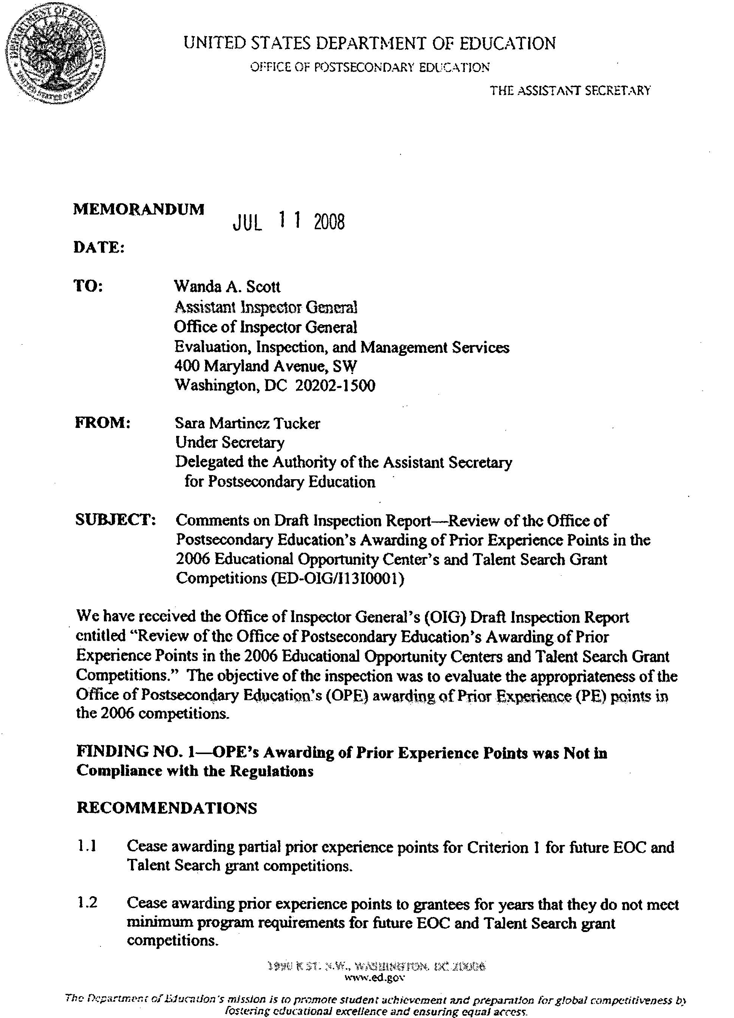
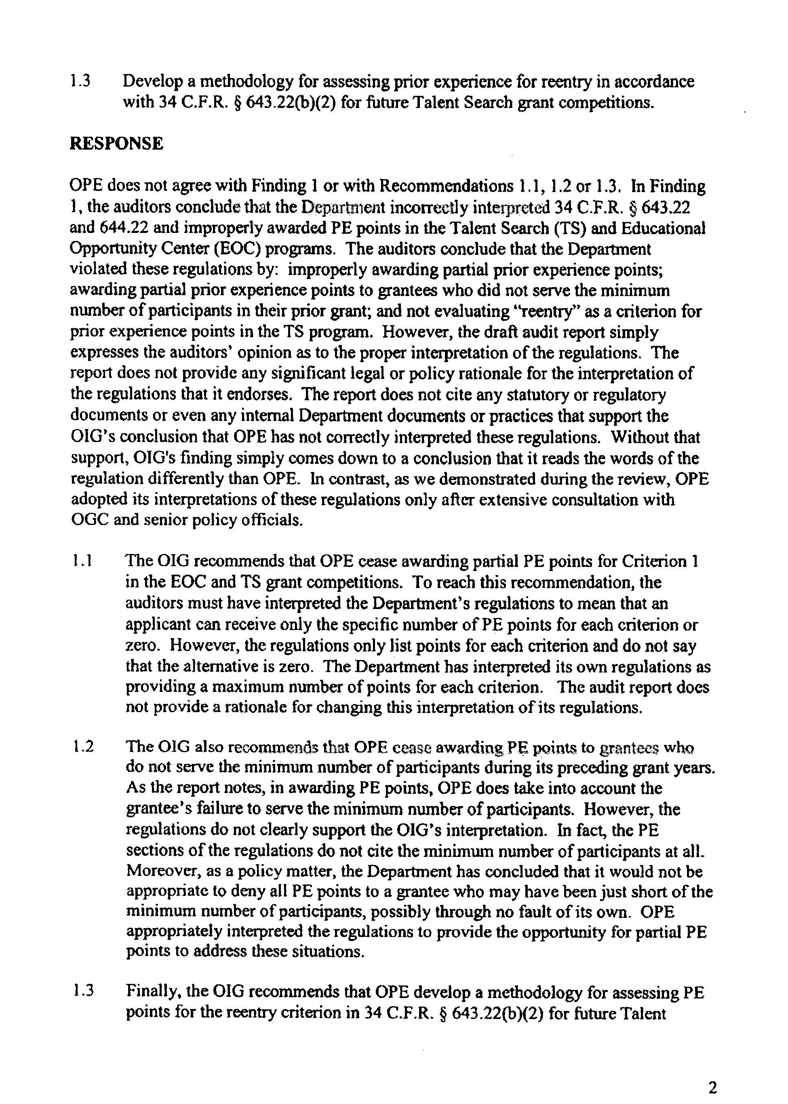
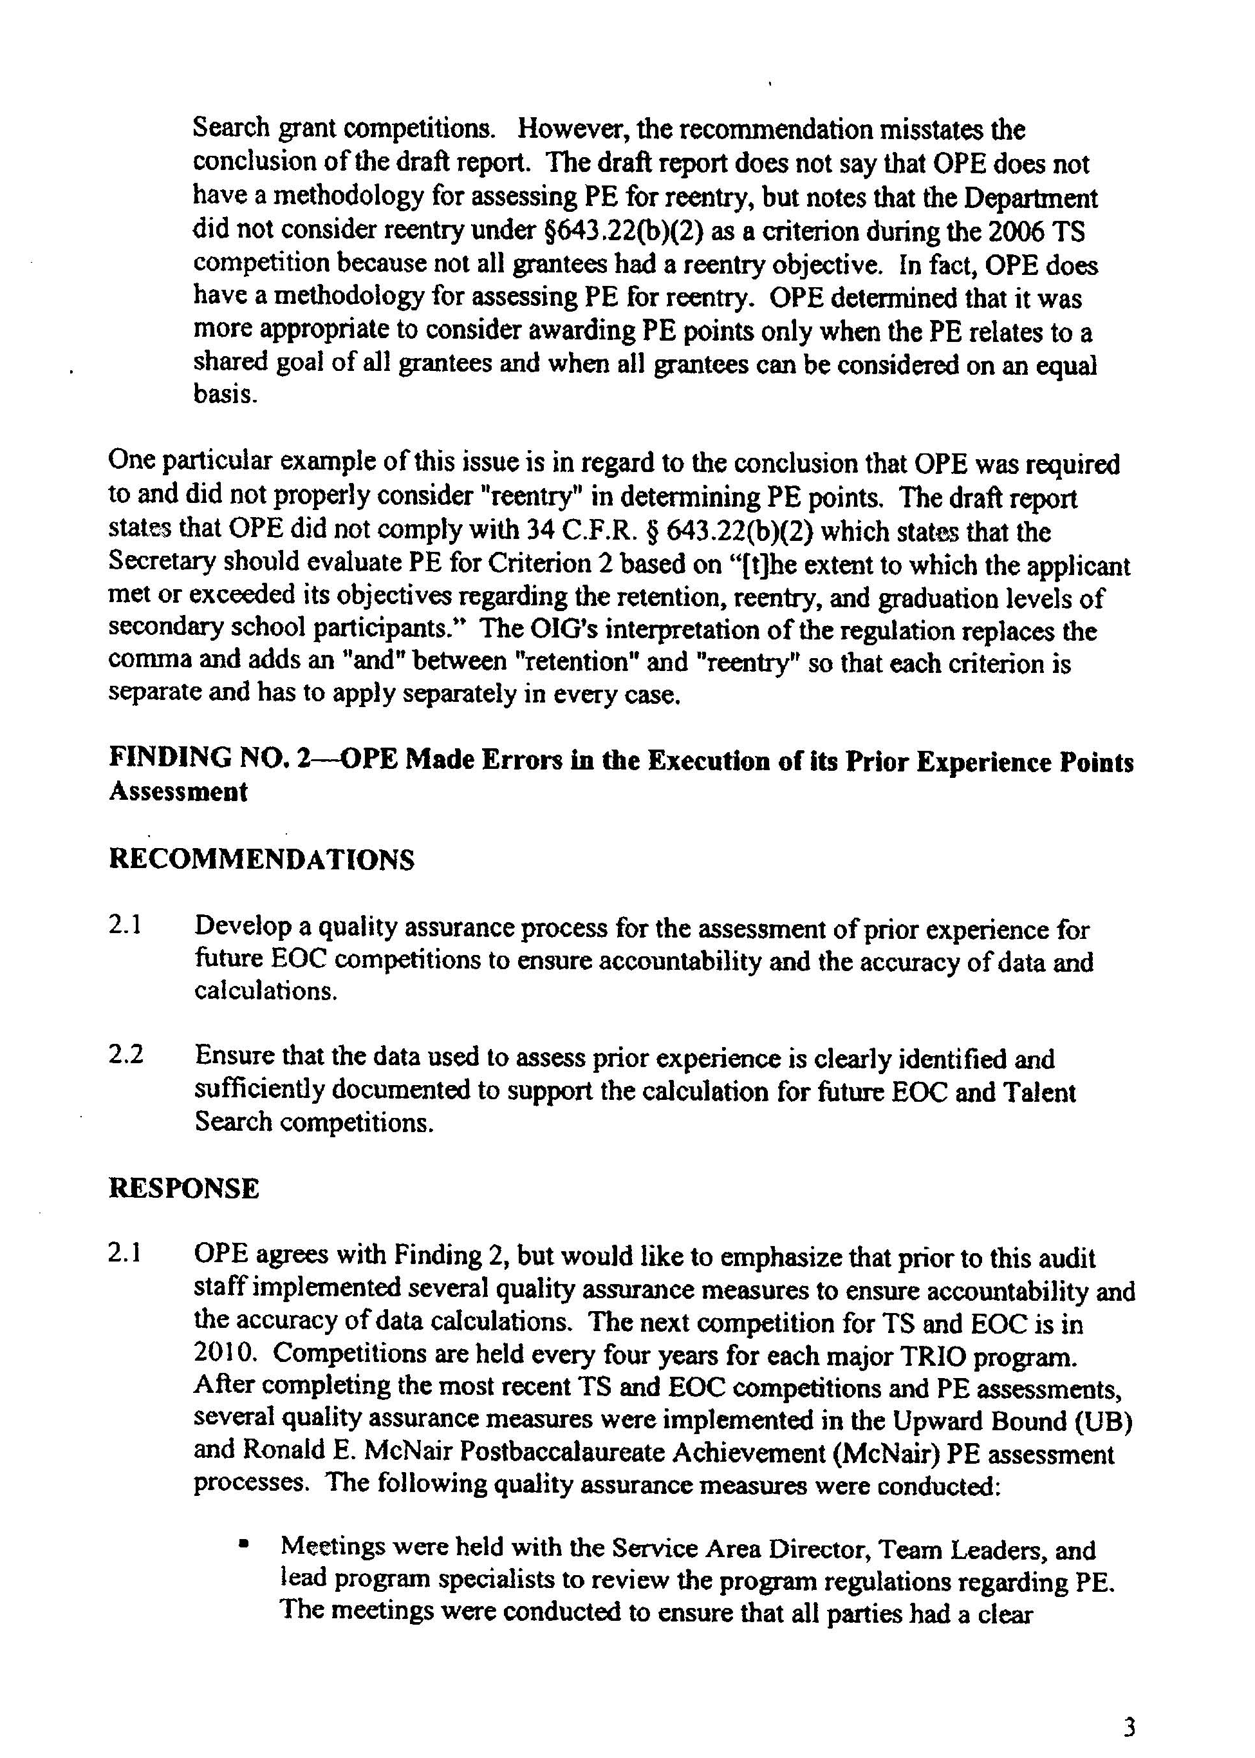
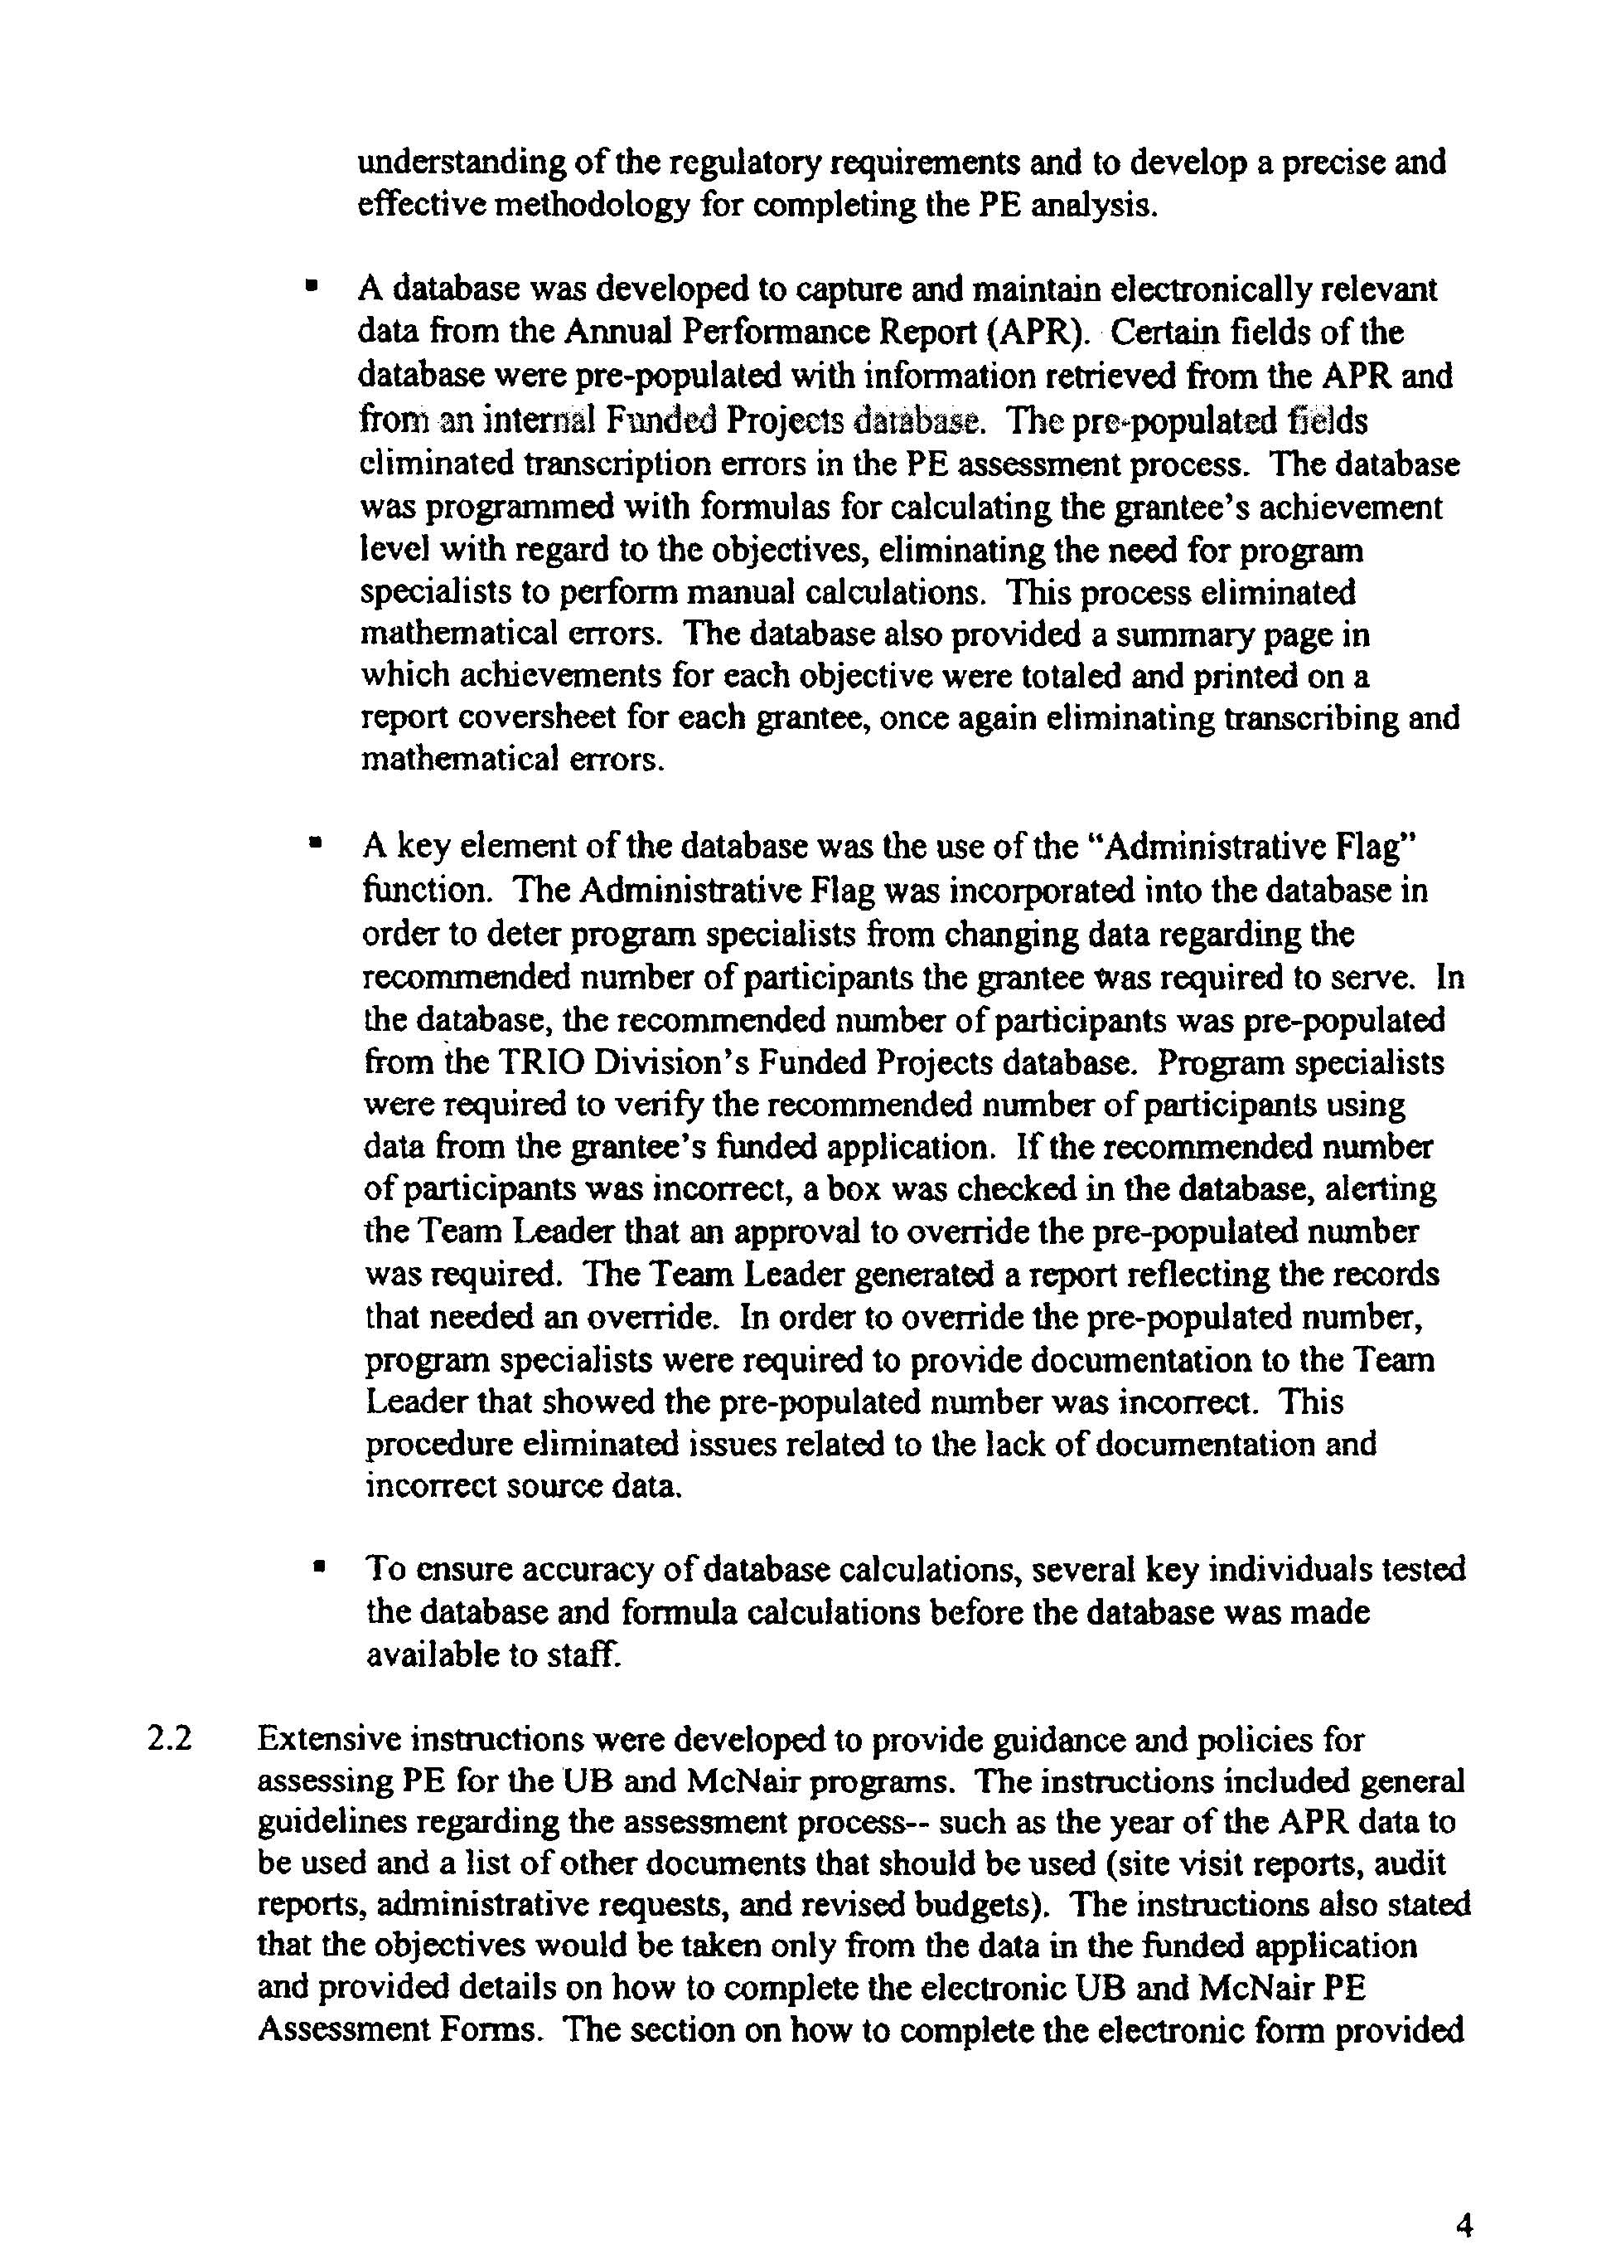
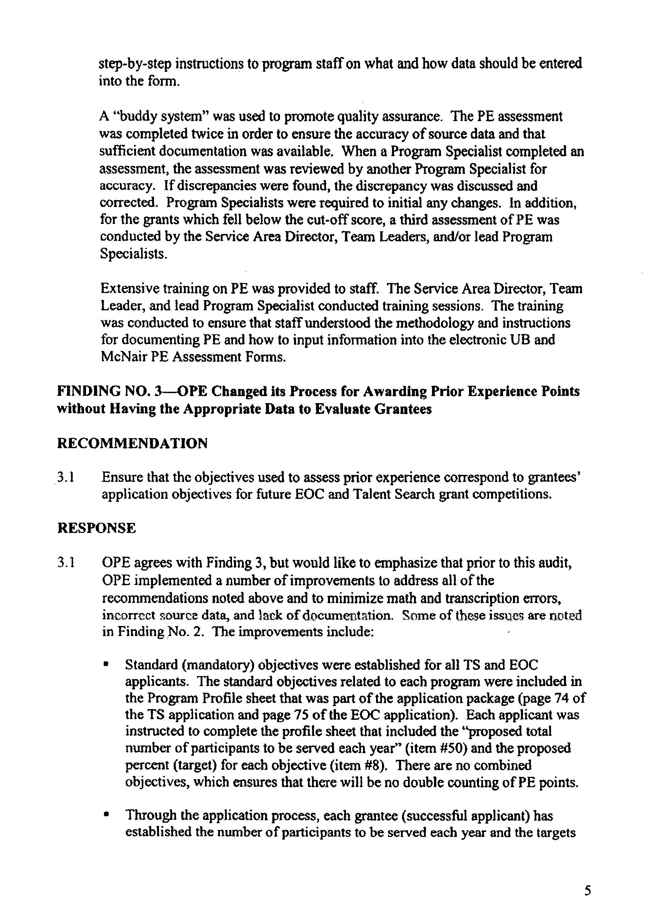
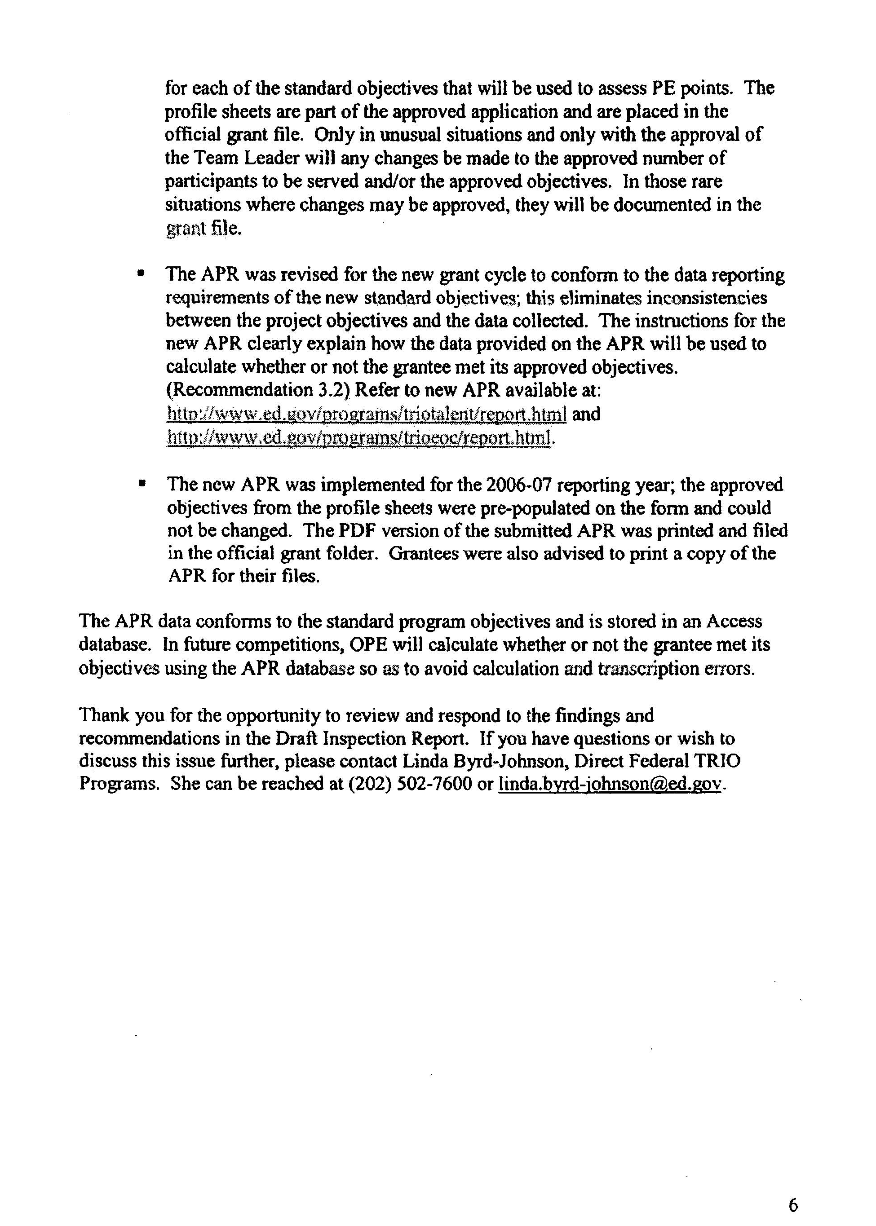

For example, if a hypothetical grantee in the 2002 Talent Search competition was funded to serve 600 participants and actually served 450—300 of whom were low-income and potential first-generation college students—that grantee would receive points under Criterion 1b, as 300 is 2/3 of the 450 participants actually served. In order to receive points under Criterion 1b in 2006, that grantee would have needed to serve at least 400 low-income and potential first-generation college students (2/3 of the 600 participants funded to serve).
Under both programs, the Department can reduce the minimum number of participants a grantee is required to serve if the amount of the grant for the budget period is less than $180,000. None of the exceptions we noted involved a grantee with a reduced participant number and a grant amount of less than $180,000.
The spreadsheet was an OPE-created document that contained the number of participants a grantee was funded to serve and the actual number it served. OPE instructed program specialists to use the spreadsheet as the source data for completing Criterion 1 on the prior experience assessment form.
The Department can reduce the minimum number of participants a grantee is required to serve if the amount of the grant for the budget period is less than $180,000.

