Tropical Cyclone Report
Hurricane Fausto
(EP072008)
16-22 July 2008

John L. Beven II
National Hurricane Center
19 November 2008

Fausto was a category 1 hurricane on the Saffir-Simpson Hurricane Scale that passed near the Mexican islands of Clarion and Socorro.

- Synoptic History

A tropical wave moved westward from the coast of Africa on 4 July. The wave uneventfully traversed the tropical Atlantic and reached the eastern Pacific on 12 July. The associated shower activity first showed signs of organization on 13 July. However, the subsequent development was slow while the system moved erratically westward on 14-15 July. Development began in earnest late on 15 July, and it is estimated that a tropical depression formed near 0600 UTC 16 July about 480 n mi southeast of Acapulco, Mexico. The depression became a tropical storm six hours later. The “best track” chart of the tropical cyclone’s path is given in Fig. 1, with the wind and pressure histories shown in Figs. 2 and 3, respectively. The best track positions and intensities are listed in Table 1.

The cyclone moved west-northwestward and then westward at about 20 kt through 16 July, then began a west-northwestward motion at a slower forward speed to the south of a mid-level ridge on 17 July. Fausto initially had a relatively large core structure, with the primary convection in bands 60-90 n mi from the center on 17 July. As the storm consolidated, it slowly strengthened and became a hurricane on 18 July about 370 n mi south-southwest of Manzanillo, Mexico. Fausto turned to the northwest toward a weakness in the ridge on 19 July, and it continued northwestward the next day. The hurricane reached an estimated peak intensity of 80 kt on 29 July as it passed between Socorro and Clarion Islands.

Fausto weakened to a tropical storm on 21 July as it moved west-northwestward over decreasing sea surface temperatures. It weakened to a tropical depression the next day and then became a non-convective remnant low on 23 July about 665 n mi west of Cabo San Lucas, Mexico. The low dissipated on 24 July about 925 n mi west of Cabo San Lucas.

- Meteorological Statistics

Observations in Fausto (Figs. 2 and 3) include satellite-based Dvorak technique intensity estimates from the Tropical Analysis and Forecast Branch (TAFB) and the Satellite Analysis Branch (SAB). Data and imagery from NOAA polar-orbiting satellites, the NASA Tropical Rainfall Measuring Mission (TRMM), the NASA QuikSCAT, and Defense Meteorological Satellite Program (DMSP) satellites, among others, were also useful in tracking Fausto.

While the 80-kt peak intensity of Fausto is based on a blend of Dvorak intensity estimates from TAFB and SAB, the time of the peak intensity is somewhat uncertain. Microwave imagery shows that the eyewall was best developed near 1200 UTC 20 July (Figure 4), with less convective organization present at other times. In addition, intensity estimates from the Advanced Microwave Sounding Unit reached a maximum near that time with estimates of 87 and 82 kt. Thus, the best track indicates the peak intensity occurring at 1200 UTC 20 July. It should be noted this is out of sync with the Dvorak estimates, which showed higher intensities before and after that time.

There were two observations of tropical storm-force or greater winds from Fausto. The Mexican automated station on Clarion Island reported sustained winds of 56 kt with a gust of 82 kt at 1814 UTC 20 July. These winds occurred several hours before the closest approach of the center, and later observations are unavailable. Additionally, the Mexican automated station on Socorro Island reported sustained winds of 69 kt at 1013 UTC 20 July, with a gust of 95 kt at 1213 UTC that day. This report appears somewhat suspect, as the closest approach of Fausto’s center to Socorro was about 100 n mi.

- Casualty and Damage Statistics

There were no reports of damage or casualties associated with Fausto.

- Forecast and Warning Critique

The genesis of Fausto was generally well anticipated. The tropical wave was first noted in the Tropical Weather Outlook on 13 July, and later that day the potential for the system to become a depression was noted. This was about 48 h before genesis occurred. An experimental genesis forecast reached the “high” category (greater than 50% chance of tropical cyclone formation within 48 h) about 36 h before genesis occurred. However, the genesis forecast dropped to the “medium” category (20-50% chance of tropical cyclone formation within 48 h) about 18 h before genesis, and did not return to the “high” category until the time of genesis.

A verification of official and guidance model track forecasts is given in Table 2. Average official track errors for Fausto were 40, 53, 65, 79, 126, 169, and 206 n mi for the 12, 24, 36, 48, 72, 96, and 120 h forecasts, respectively. The number of forecasts ranged from 25 at 12 h to 7 at 120 h. These errors are lower than the average long-term official track errors (Table 4) except at the 12 h time. Examination of the individual forecasts (not shown) indicates that many of the forecast tracks were south of the actual track. The GFDI, EMXI, TCON, TVCN, and GUNA guidance models generally had lower average errors than the official forecasts.

A verification of official and guidance model intensity forecasts is given in Table 3. Average official intensity errors were 5, 7, 8, 5, 6, 11, and 11 kt for the 12, 24, 36, 48, 72, 96, and 120 h forecasts, respectively. For comparison, the average long-term official intensity errors are 6, 10, 14, 16, 19, 19, and 19 kt, respectively. While these errors are better than the long-term average, the Florida State University Superensemble (FSSE) had lower average errors than the official forecast.

Watches and warnings were not issued for Fausto.
Table 1. Best track for Hurricane Fausto, 16-22 July 2008.

Date/Time  (UTC) | Latitude  (°N) | Longitude  (°W) | Pressure  (mb) | Wind Speed  (kt) | Stage
16 / 0600 | 10.0 | 95.2 | 1006 | 30 | tropical depression
16 / 1200 | 11.0 | 96.9 | 1005 | 35 | tropical storm
16 / 1800 | 11.3 | 98.9 | 1005 | 35 | "
17 / 0000 | 11.5 | 101.0 | 1002 | 40 | "
17 / 0600 | 11.7 | 102.1 | 998 | 50 | "
17 / 1200 | 12.0 | 103.2 | 998 | 50 | "
17 / 1800 | 12.5 | 104.4 | 998 | 55 | "
18 / 0000 | 12.9 | 105.4 | 994 | 60 | "
18 / 0600 | 13.2 | 106.4 | 993 | 60 | "
18 / 1200 | 13.5 | 107.2 | 987 | 65 | hurricane
18 / 1800 | 13.9 | 108.0 | 987 | 65 | "
19 / 0000 | 14.2 | 108.6 | 985 | 70 | "
19 / 0600 | 14.6 | 109.1 | 980 | 75 | "
19 / 1200 | 14.9 | 109.6 | 980 | 75 | "
19 / 1800 | 15.4 | 110.0 | 980 | 75 | "
20 / 0000 | 16.0 | 110.6 | 980 | 75 | "
20 / 0600 | 16.8 | 111.3 | 980 | 75 | "
20 / 1200 | 17.5 | 112.2 | 977 | 80 | "
20 / 1800 | 18.3 | 113.0 | 977 | 80 | "
21 / 0000 | 18.9 | 114.0 | 977 | 80 | "
21 / 0600 | 19.5 | 115.0 | 981 | 75 | "
21 / 1200 | 20.0 | 116.2 | 984 | 70 | "
21 / 1800 | 20.3 | 117.2 | 990 | 60 | tropical storm
22 / 0000 | 20.5 | 118.1 | 994 | 55 | "
22 / 0600 | 20.9 | 119.1 | 997 | 50 | "
22 / 1200 | 21.3 | 120.0 | 1002 | 40 | "
22 / 1800 | 21.7 | 121.0 | 1007 | 30 | tropical depression
23 / 0000 | 22.1 | 121.9 | 1008 | 30 | remnant low
23 / 0600 | 22.6 | 123.0 | 1008 | 25 | "
23 / 1200 | 23.0 | 123.7 | 1009 | 25 | "
23 / 1800 | 23.8 | 124.6 | 1009 | 25 | "
24 / 0000 | 24.0 | 125.7 | 1010 | 25 | "
24 / 0600 | 24.4 | 126.7 | 1013 | 20 | "
24 / 1200 |  |  |  |  | dissipated
20 / 1200 | 17.5 | 112.2 | 977 | 80 | minimum pressure

Table 2. Track forecast evaluation (heterogeneous sample) for Hurricane Fausto, 16-22 July 2008. Forecast errors (n mi) are followed by the number of forecasts in parentheses. Errors smaller than the NHC official forecast are shown in boldface type.

Forecast Technique | Forecast Period (h)
Forecast Technique | 12 | 24 | 36 | 48 | 72 | 96 | 120
CLP5 | 58 (25) | 98 (23) | 145 (21) | 192 (19) | 266 (15) | 313 (11) | 411 ( 7)
GFNI | 40 (16) | 67 (14) | 102 (12) | 131 (10) | 140 ( 6) | 149 ( 2)
GFDI | 34 (25) | 38 (22) | 48 (20) | 66 (18) | 133 (14) | 162 (10) | 189 ( 6)
HWFI | 36 (25) | 48 (23) | 65 (21) | 88 (19) | 139 (15) | 198 (11) | 271 ( 7)
NAMI | 40 (11) | 54 ( 9) | 56 ( 7) | 78 ( 5) | 187 ( 1)
AFWI | 46 (13) | 72 (12) | 92 (11) | 116 (10) | 191 ( 8)
GFSI | 34 (25) | 54 (21) | 73 (19) | 101 (18) | 165 (14) | 223 (11) | 254 ( 7)
AEMI | 31 (25) | 54 (23) | 83 (21) | 110 (19) | 170 (15) | 220 (11) | 239 ( 7)
NGPI | 44 (21) | 71 (19) | 89 (17) | 106 (15) | 134 (11) | 178 ( 7) | 172 ( 3)
UKMI | 39 (19) | 60 (18) | 81 (17) | 111 (15) | 169 (12) | 219 ( 9) | 255 ( 5)
EGRI | 41 (23) | 64 (21) | 86 (19) | 116 (17) | 174 (13) | 219 ( 9) | 238 ( 5)
EMXI | 33 (21) | 37 (20) | 47 (18) | 58 (16) | 86 (12) | 122 ( 8) | 143 ( 5)
JGSI | 36 (21) | 49 (19) | 65 (17) | 77 (15) | 93 (11)
BAMD | 51 (25) | 85 (23) | 119 (21) | 152 (19) | 206 (15) | 226 (11) | 198 ( 7)
BAMM | 52 (24) | 88 (22) | 123 (20) | 161 (18) | 232 (14) | 277 (10) | 296 ( 7)
BAMS | 41 (23) | 60 (21) | 84 (19) | 110 (17) | 171 (13) | 228 (10) | 248 ( 7)
LBAR | 50 (23) | 98 (21) | 152 (19) | 212 (17) | 354 (13) | 462 (10) | 375 ( 7)
TCON | 25 (19) | 36 (15) | 51 (13) | 67 (12) | 117 ( 8) | 168 ( 5) | 187 ( 1)
TVCN | 34 (25) | 44 (23) | 55 (21) | 70 (19) | 114 (15) | 167 (11) | 186 ( 7)
TVCC | 38 (25) | 54 (23) | 70 (21) | 94 (19) | 134 (15) | 224 (11) | 348 ( 7)
GUNA | 25 (19) | 37 (15) | 52 (13) | 69 (12) | 118 ( 8) | 171 ( 5) | 161 ( 1)
FSSE | 32 (23) | 47 (21) | 58 (19) | 80 (17) | 142 (13) | 209 ( 9) | 213 ( 5)
OFCL | 40 (25) | 53 (23) | 65 (21) | 79 (19) | 126 (15) | 169 (11) | 206 ( 7)
NHC Official  (2003-2007 mean) | 31.9 (1282) | 55.1 (1129) | 77.4 (979) | 97.9 (849) | 136.2 (620) | 180.1 (439) | 226.1 (293)

Table 3. Intensity forecast evaluation (heterogeneous sample) for Hurricane Fausto, 16-22 July 2008. Forecast errors (kt) are followed by the number of forecasts in parentheses. Errors smaller than the NHC official forecast are shown in boldface type.

Forecast Technique | Forecast Period (h)
Forecast Technique | 12 | 24 | 36 | 48 | 72 | 96 | 120
OCD5 | 5.8 (25) | 7.7 (23) | 8.6 (21) | 10.5 (19) | 11.0 (15) | 13.3 (11) | 13.3 ( 7)
GHMI | 5.9 (25) | 6.5 (22) | 5.7 (20) | 5.9 (18) | 6.5 (14) | 10.8 (10) | 20.3 ( 6)
GFNI | 7.7 (16) | 11.9 (14) | 14.0 (12) | 8.7 (10) | 13.3 ( 6) | 19.5 ( 2)
HWFI | 5.9 (25) | 7.9 (23) | 10.7 (21) | 11.5 (19) | 19.3 (15) | 25.0 (11) | 20.4 ( 7)
LGEM | 5.5 (24) | 7.6 (22) | 10.3 (20) | 10.7 (18) | 13.6 (14) | 14.3 (10) | 13.3 ( 7)
DSHP | 4.5 (24) | 5.5 (22) | 8.1 (20) | 9.2 (18) | 10.3 (14) | 7.1 (10) | 11.4 ( 7)
FSSE | 4.7 (23) | 5.1 (21) | 5.1 (19) | 5.1 (17) | 5.8 (13) | 7.7 ( 9) | 5.2 ( 5)
ICON | 4.5 (24) | 5.5 (21) | 6.8 (19) | 6.8 (17) | 7.5 (13) | 8.9 ( 9) | 13.5 ( 6)
IVCN | 4.5 (25) | 6.2 (23) | 7.7 (21) | 6.8 (19) | 9.9 (15) | 11.8 (11) | 14.6 ( 7)
OFCL | 5.0 (25) | 7.2 (23) | 7.6 (21) | 5.3 (19) | 6.3 (15) | 10.9 (11) | 11.4 ( 7)
NHC Official  (2003-2007 mean) | 6.2 (1282) | 10.4 (1129) | 13.9 (979) | 16.3 (848) | 18.7 (620) | 19.2 (439) | 19.1 (293)

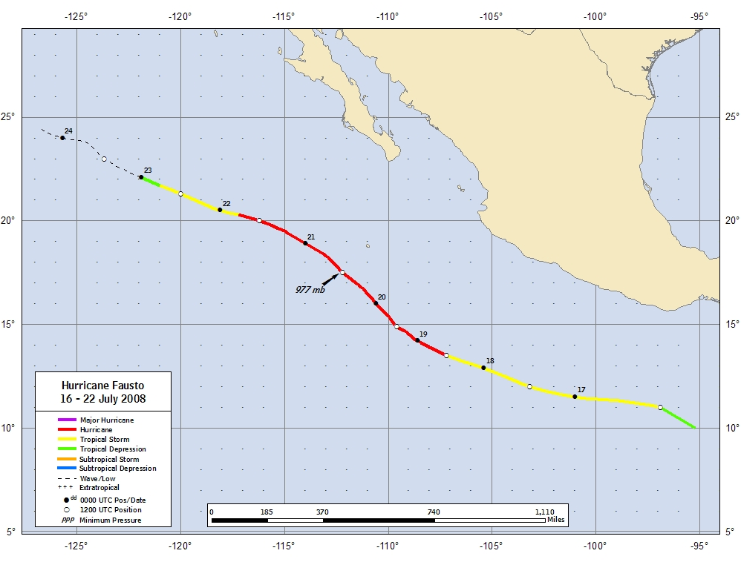
Figure 1. Best track positions for Hurricane Fausto, 16-22 July 2008.
Figure 2. Selected wind observations and best track maximum sustained surface wind speed curve for Hurricane Fausto, 16-22 July 2008. Dashed vertical lines correspond to 0000 UTC.
Figure 3. Selected pressure observations and best track minimum central pressure curve for Hurricane Fausto, 16-22 July 2008. Dashed vertical lines correspond to 0000 UTC.
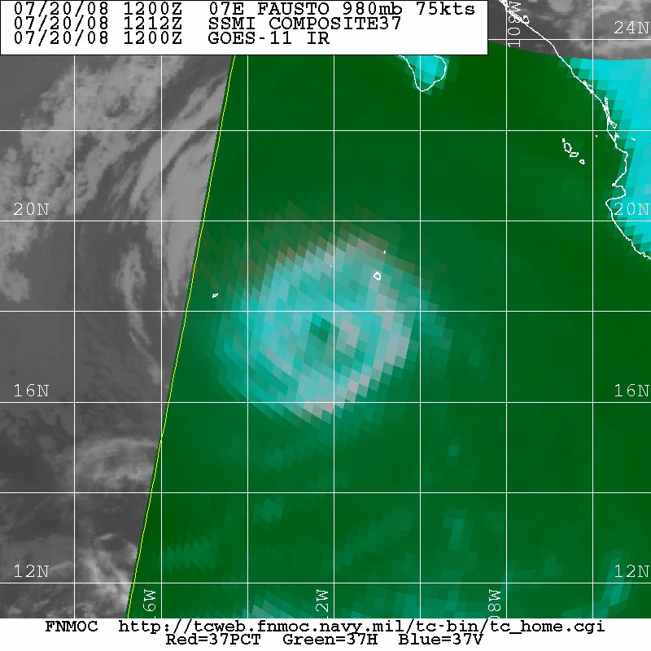
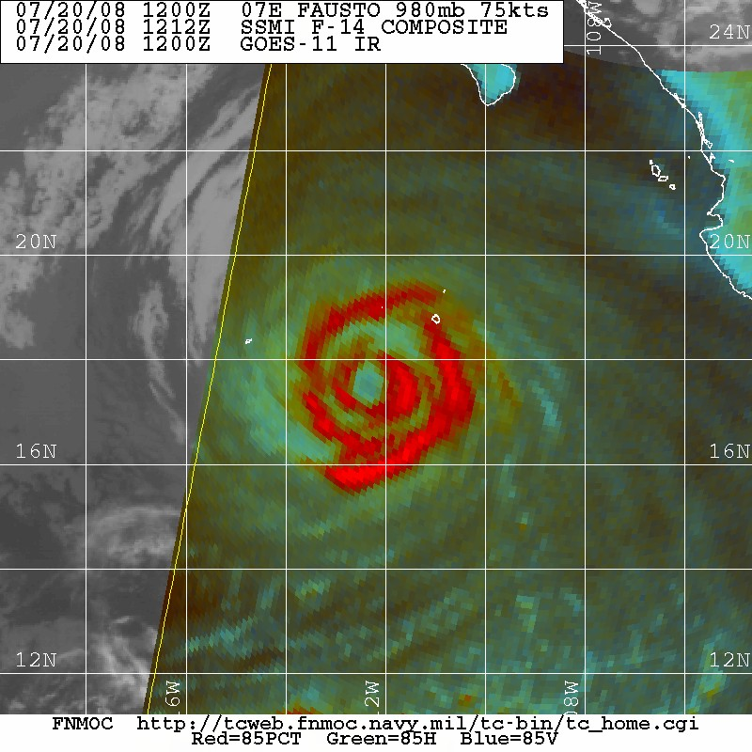

Figure 4. Special Sensor Microwave Imager imagery of Fausto at 1212 UTC 20 July 2008. An 85 Ghz composite image is on the left, and a 37 GHz composite is on the right. Image courtesy of the Naval Research Laboratory Marine Meteorology Division Tropical Cyclone Page (http://www.nrlmry.navy.mil/tc_pages/tc_home.html).

A digital record of the complete best track, including wind radii, can be found on line at ftp://ftp.nhc.noaa.gov/atcf. Data for the current year’s storms are located in the btk directory, while previous years’ data are located in the archive directory.

