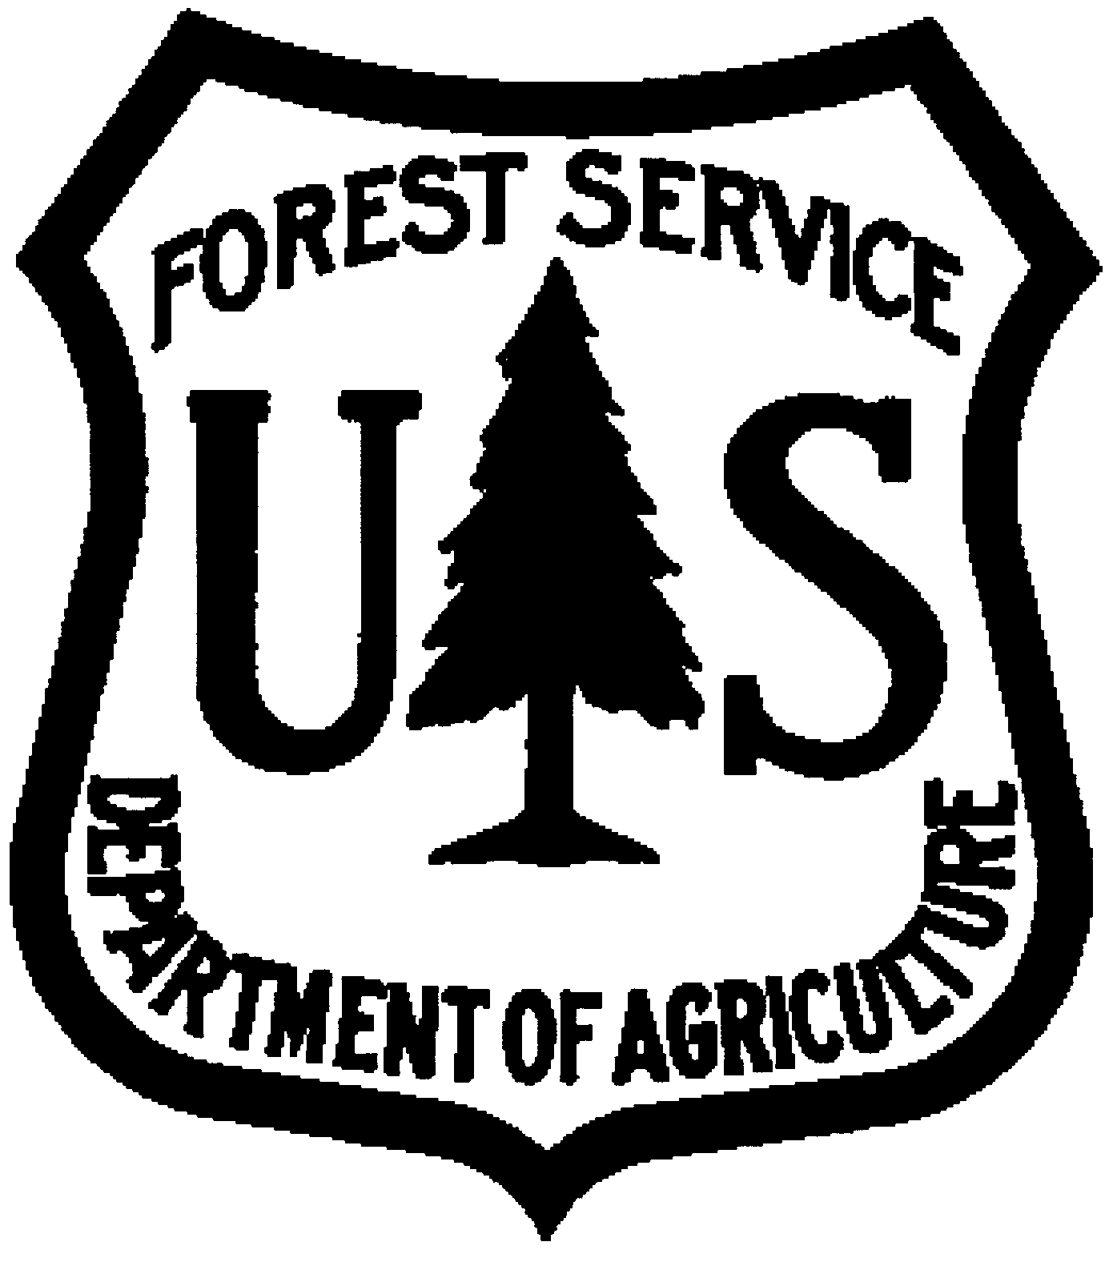 | USDA FOREST SERVICE  Eastern Region  STUDENT CAREER EMPLOYMENT PROGRAM  STUDENT TEMPORARY EMPLOYMENT PROGRAM
2009 RECRUITMENT BULLETIN

RECRUITMENT BULLETIN NUMBER: SCEP_STEP-2009ER OPEN: October 1, 2008 CLOSES: DECEMBER 31, 2008

WHAT IS THE STUDENT CAREER PROGRAM?
The Student Career Experience Program (SCEP) (formerly the Cooperative Education Program) is designed to integrate classroom study with paid work experience to prepare students for responsible placement into the Forest Service’s permanent workforce. The Student Temporary Employment Program (STEP) also offers students work experience in the Forest Service, but does not offer placement into it’s permanent workforce. Successful STEP students can be placed into the SCEP program at the Forest Services’ discretion.

WHO DOES THE EASTERN REGION RECRUIT USING THE STUDENT CAREER PROGRAM?
This bulletin is aimed primarily at sophomore and junior students pursuing a bachelor’s degree, and those students pursuing a master's or doctorate degree in a field which, upon graduation, will provide the academic background, knowledges, and skills required for the target position. Students must complete a minimum of 640 hours of work experience prior to graduation. See SCEP Eligibility Section.

WHAT ACADEMIC MAJORS/OCCUPATIONS DOES THE EASTERN REGION RECRUIT?
The following is a list of potential academic majors and corresponding occupations the Eastern Region is currently recruiting for employment. You must be pursuing an academic major that directly relates to our target occupations. Applicants may be assigned to field duty locations at the Eastern Region National Forest locations listed below. Although you may be trained at one location, if you are converted you may be placed in a different location to meet Regional skill needs.

MARK  (X) | ACADEMIC MAJOR | TARGET OCCUPATION | NUMBER OF | POSITIONS
 |  |  | SCEP | STEP
 | Biology | Biologist | 1
 | Botany | Botanist | 1
 | Business Admin/Mgmt* | Realty Specialist | 2
 | Civil Engineering | Civil Engineer | 1
 |  | Civil Engineer Technician | 1 | 1
 | Forestry (Nat. Res. Mgmt) | Forester (General Forest Mgmt) | 3
 | Forestry (Nat. Res. Mgmt) | Forestry Technician | 6
 | Forestry (Nat. Res. Mgmt) | Forestry Technican (Timber) | 1 | 2
 | Forestry (Recreation Management) | Forester (Recreation) | 1 | 2
 | Forestry (Fuels Management) | Forestry Technician (Fuels) | 1 | 2
 | Journalism | Public Affairs Specialist |  | 1
 | Criminal Justice | Law Enforcement Officer |  | 2
 | Soil Science | Soil Scientist | 1
 | Wildlife Biology | Wildlife Biologist | 3

*Other academic majors will be accepted for this occupation.

WHERE ARE THE EASTERN REGION LOCATIONS?
Illinois, Indiana, Maine, Michigan, Minnesota, Missouri, New Hampshire, New York, Ohio, Pennsylvania, Vermont, West Virgina and Wisconsin.

HOW TO APPLY:
Complete and submit the following documents via either email, or fax or surface mail (one method only). The forms may be obtained at www.fs.fed.us/r9/employment or from the address listed in the “Where to Send” section. You must submit the following documents in order to consider your application complete to:

USDA – Forest Service
Eastern Region
Attn: Terry J. West, Sr.
626 East Wisconsin Avenue, Suite 800
Milwaukee, WI 53202
Phone: (414) 297-3021 FAX: (414) 944-3938

- Student Career Supplemental Information Sheet.
- Optional Form 612, (Application for Federal Employment) or Resume. If using a resume it must include the following information (in addition to specific information requested elsewhere in this recruitment bulletin): recruitment bulletin number SCEP_STEP-2009ER, veteran’s preference (if claiming), social security number, all work experience (with start and end dates using month/year), education, training, self-development, awards, commendations, outside activities, or other information relevant to the target occupation.
- Copy of college transcript(s) (official or unofficial) or letter of acceptance of enrollment.
- Copy of DD-214, Report of Separation from Active duty, must be received with your application package if you are claming veterans’ preference and must show an honorable discharge. Additional documentation may be required. Generally, preference is granted to veterans who entered military service prior to October 14, 1976; or served on active duty during the period from August 2, 1990, through January 2, 1992, and who are otherwise eligible; or who have served in a military action for which they received a Campaign Badge or Expeditionary Medal. This includes the Armed Forces Expeditionary Medal (AFEM) awarded to those who participated in Operation Joint Endeavor or Operation Joint Guard.
- SF-15, Claim for 10-Point Veteran, as well as proof required on the form, if you are claiming compensable disability preference. Individuals may be entitled to veterans’ preference if you are a disabled veteran; you have received a Purple Heart; you are the spouse or mother of a disabled veteran; or you are the widow, widower, or mother of a deceased veteran
- AD-1086, USDA Applicant Supplement Sheet (optional).

Your application package must be postmarked on or before December 31, 2008.

Students may periodically check with the career/placement center, student services, or counseling office to determine if a Forest Service recruiter is scheduled to be on campus prior to the closing date of this bulletin.

If you do not receive a job offer by May 1, 2009, you may assume you were not selected.

WHERE TO SEND:

Application packages will be accepted via email, or fax, or surface mail. Submit using one method only.
- Surface Mail: If using surface mail, submit a separate and complete application package for EACH Eastern Region National Forest or Regional Office location of interest (example: If you are applying for three positions, send three complete application packages and specify the location for each on the Student Career Supplemental Information Sheet).
- Fax / Email: If using fax or email to submit your application package, submit one application package for EACH position you wish to be considered for and be sure to indicate this on the Student Career Supplemental Information Sheet.

USDA – Forest Service -OR-
Eastern Region E-mail: r9_scep_@fs.fed.us
Attn: Terry J. West, Sr. SUBJECT: SCEP_STEP-2009ER
626 East Wisconsin Avenue, Suite 800
Milwaukee, WI 53202
Phone: (414) 297-3021

-OR-
Fax: 414-944-3938
Subject: SCEP_STEP-2009ER

Applicants with disabilities will receive consideration for reasonable accommodations in the hiring process for any physical, mental, or emotional impairment. Applicants should submit requests for reasonable accommodation with their job applications and provide supporting medical documentation. The decision on granting reasonable accommodation will be on a case-by-case basis. Reasonable Accommodation Contact: Florence Pridgen, (414) 297-1069.

The U.S. Department of Agriculture (USDA) prohibits discrimination in all its programs and activities on the basis of race, color, national origin, gender, religion, age, disability, political beliefs, sexual orientation, and marital or family status. (Not all prohibited bases apply to all programs.) Persons with disabilities who require alternative means for communication of program information (Braille, large print, audiotape, etc.) should contact USDA’s TARGET Center at 202-720-2600 (voice and TDD).

To file a complaint of discrimination, write USDA, Director, Office of Civil Rights, Room 326-W, Whitten Building, 14th and Independence Avenue SW, Washington, DC 20250-9410 or call 202-720-5964 (voice or TDD). USDA is an equal opportunity provider and employer.

STUDENT PROGRAM INFORMATION AND ELIGIBILITY REQUIREMENTS:
- Eligibility Requirements:
- Must be at least 16 years old.
- Must be enrolled in or accepted to (with the intent to attend) an accredited 4-year college or university, graduate or professional school; and carry at a minimum, a half-time course load as defined by the institution. Must be in a degree seeking academic program.
- Enrolled in an academic major that is related to the occupation you wish to be considered for.
- Must be able to complete required occupation-related work experience (640 hours) prior to or concurrently with the completion of course requirements for the degree.
- Must be a United States citizen or national (resident of American Samoa or Swains island). If you are not a citizen, you may participate if you are legally admitted to the United States as a permanent resident, and are able to meet citizenship requirements prior to completion of your degree.
- Must be in good academic standing. Cannot be on academic probation.
- If selected, must sign Student Career Experience Program, Mobility, and Developmental agreements; furnish course registration information at the start of each school term; provide verification of academic status at the end of each academic term (transcript); must meet academic standards as set forth by the school they are attending; maintain satisfactory progress in completing academic requirements; and demonstrate satisfactory performance and conduct. Students will be required to complete all academic requirements for the target position as required by the Office of Personnel Management Qualification Standards.

- Salary (current 2008 rates) and Benefits:
Salary may vary from GS-3/$9.78 per hour, GS-4/$10.97 per hour (Baccalaureate Progam); GS-5/$12.28 per hour, GS-7/$15.21 per hour (Graduate Program); GS-9/$18.60 per hour, GS-11/$22.51 per hour (Doctorate Program). A variety of health insurance plans; retirement system with investment options; paid holidays; paid sick leave and vacations; life insurance; incentive systems, etc. are available.

- Duties of Student Trainees:
Trainees work under the guidance of and will assist professional or administrative personnel in non-routine and progressively responsible duties which are directly related to the students academic studies and occupational career goals. Individual will perform well-defined tasks in various aspects of the occupational speciality. Specific duties will be dependent upon the occupational specialty that corresponds to the college major in preparation for more difficult tasks as a professional/administrative trainee after graduation.

- Periods of Employment/Work Requirements:
Most periods of employment occur during the summer. However, work schedules can vary. A specific work and study schedule will be established at the time of employment. Students must complete a minimum of 640 hours of career-related experience prior to or concurrently with the completion of the course requirements for their degree. A physical exam, work capacity test, and driver’s license may be required for some student positions.

- Requirements for Employment After Graduation:
Within 120 days after completion of course requirements for a degree, students will be eligible for non-competitive conversion to a permanent career-conditional appointment at the GS-5 or GS-7 level (Bachelor Degree); GS-9 (Masters Degree); or GS-11 (Doctorate Degree) as outlined in the Student Career Agreement. Students converted at the lower grades are eligible for advancement through progressive promotions to the GS-9 level contingent upon satisfactory performance. Research scientists may be promoted based on a periodic peer review of their scientific accomplishments. Students must be U. S. citizens at the time of conversion to a permanent (career-conditional) appointment. Students who successfully complete work and study requirements are eligible for permanent positions with the Forest Service.

CONTACT LIST (INFORMATION ONLY)

Region 9, Eastern Region E-mail: r9_scep@fs.fed.us
626 East Wisconsin Ave Ste 800 Phone: (414) 297-1069 or (414) 530-1795 (cell)
Milwaukee, WI 53202 E-mail: r9_scep@fs.fed.us
Contact: Florence Pridgen Fax: (414) 944-3938

Reasonable Accommodations Contact: Florence Pridgen
E-mail: fpriden@fs.fed.us
Phone: (414) 297-1069
USDA FOREST SERVICE
STUDENT CAREER SUPPLEMENTAL INFORMATION
STUDENT CAREER EXPERIENCE PROGRAM
Forms available at: www.fs.fed.us/r9/employment
(Submit this questionnaire along with OF-612 or resume, and copy of transcript)
NAME |  |  |  |  |  |  |  |  |  |  |  |  |  |  | SOCIAL SECURITY #
(Last, First, MI)
UNIVERSITY OR COLLEGE:
PERMANENT RESIDENCE ADDRESS:
SCHOOL RESIDENCE ADDRESS:
E-MAIL ADDRESS |  |  |  |  |  |  |  |  |  |  |  | COUNTRY OF CITIZENSHIP
CLAIMING VETERAN PREFERENCE: |  |  |  |  |  |  | No |  |  | Yes |  |  |  |  |  |  |  | If yes, DD-214 must be submitted.
HOME TELEPHONE # |  |  |  |  |  |  |  |  |  |  | SCHOOL TELEPHONE #
DEGREE PROGRAM: |  |  |  |  |  | BA/BS |  |  |  |  |  |  |  |  |  | MA/MS |  |  |  |  |  |  |  |  |  | PhD
PROJECTED GRADUATION DATE: (MONTH/YEAR)
MAJOR:
TARGET OCCUPATION FOR WHICH YOU ARE INTERESTED:
(Select target occupation(s) from list below)
CUMULATIVE GPA |  |  |  |  |  |  |  | MAJOR
Are you willing to work in rural/small communities: |  |  |  |  |  |  |  |  |  |  |  |  | Yes |  |  |  |  |  | No |  |  | Population Size:
MARK THE TARGET OCCUPATION THAT YOU ARE INTERESTED IN APPLYING TO:
*NOTE – YOU MUST SUBMIT A COMPLETE APPLICATION FOR EACH SCEP/STEP POSITION YOU WISH TO BE CONSIDERED FOR.

MARK  (X) | ACADEMIC MAJOR | TARGET OCCUPATION | NUMBER OF | POSITIONS
 |  |  | SCEP | STEP
 | Biology | Biologist | 1
 | Botany | Botanist | 1
 | Business Admin/Mgmt* | Realty Specialist | 2
 | Civil Engineering | Civil Engineer | 1
 |  | Civil Engineer Technician | 1 | 1
 | Forestry (Nat. Res. Mgmt) | Forester (General Forest Mgmt) | 3
 | Forestry (Nat. Res. Mgmt) | Forestry Technician | 6
 | Forestry (Nat. Res. Mgmt) | Forestry Technican (Timber) | 1 | 2
 | Forestry (Recreation Management) | Forester (Recreation) | 1 | 2
 | Forestry (Fuels Management) | Forestry Technician (Fuels) | 1 | 2
 | Journalism | Public Affairs Specialist |  | 1
 | Criminal Justice | Law Enforcement Officer |  | 2
 | Soil Science | Soil Scientist | 1
 | Wildlife Biology | Wildlife Biologist | 3

*Other academic majors will be accepted for this occupation

BRIEFLY DESCRIBE WHY YOU ARE INTERESTED IN A CAREER WITH THE FOREST SERVICE:

BRIEFLY DESCRIBE YOUR CAREER GOALS:

BRIEFLY DESCRIBE ANY VOLUNTEER WORK, INTERESTS, INVOLVEMENT IN ORGANIZATIONS, LANGUAGES SPOKEN, AWARDS/RECOGNITION RECEIVED, or TRAINING THAT HIGHLIGHTS YOUR SKILLS AND ABILITIES:

BRIEFLY DESCRIBE WORK EXPERIENCE RELATED TO MAJOR FIELD OF STUDY:

IDENTIFY HOW YOU LEARNED OF THESE OPPORTUNITIES:
 | Career Fair/ Event |  | USDA FS Recruiter(name if known)
 | Forest Service School Liaison |  | School Counselor/Career Services Office
 | Friend/Relative working for agency |  | Eastern Region Website
 | Other

(Applicant's Signature) |  | (Date)

OPTIONAL DEMOGRAPHIC SUPPLEMENTAL SHEET

Applicants for positions with the Eastern Region Student Career Experience Program (SCEP) are requested to provide the following information for statistical purposes only. The information will be used to evaluate the Eastern Region recruitment and hiring activities. Public Law 93-579 (Privacy Act of 1974) permits solicitation of personal information. SUBMISSION OF THIS INFORMATION IS VOLUNTARY. Your failure to do so will not affect the processing of your application. Your cooperation is appreciated.

1. Which of the following best describes your current education status? (Check no more than two.)

01 Doctorate Degree Program
02 4-Year Baccalaureate Degree program
03 2-Year Associate Degree Program

2. Which of the following describes your veteran preference status? (Check One.)

 | 01 None |  | 04 10 point compensable
 | 02 5 point |  | 05 10 point other
 | 03 10 point disability |  | 06 10 point/30%compensable

3. Which of the following describes your race/national origin? (Check one.)

A American Indian/Alaskan Native
B Asian or Pacific Islander
C Black, not of Hispanic origin
D Hispanic
E White, not of Hispanic Origin
Y Not Hispanic, Puerto Rico
Q All Other Asian or Pacific Islander in Hawaii

4. Which of the following best describes your disability status? (Select all that apply.)

 | 01 No disability |  | 06 Complete paralysis
 | 02 Hearing impairment |  | 07 Convulsive disorder
 | 03 Vision impairment |  | 08 Mental retardation
 | 04 Missing extremities |  | 09 Mental or emotional illness
 | 05 Partial paralysis |  | 10 Severe distortion of limbs and/or spine
 | 11 I have a disability not listed

5. Are you: (Check one.) ___ Male ___ Female

THANK YOU FOR FILLING OUT THIS FORM

THE DEPARTMENT OF AGRICULTURE IS AN EQUAL OPPORTUNITY EMPLOYER
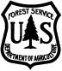
Caring for the Land and Serving People

