Using the National Environmental Public Health Performance Standards to Improve Services in Four Florida Counties

2007 - 2008

Environmental Public Health Leadership Institute Fellow(s):

Keith Keene
Environmental Administrator,
DeSoto County Health Department
34 S. Baldwin Ave.,
Arcadia, FL 34266
863-993-4604
Keith_Keene@doh.state.fl.us

Trevor Coke
Miami-Dade County Health Department
1725 NW 167th St
Miami Florida, 33056
305-623-3500
Trevor_Coke@doh.state.fl.us

David Overfield
Environmental Administrator
Orange County Health Department
800 N Mercy Drive STE 1
Orlando FL 32808
407 445-5466
David_Overfield@doh.state.fl.us

Elizabeth Miller
Florida Department of Environmental Protection
(formerly Madison County Health Department)
2600 Blair Stone Road
Tallahassee, FL 32399-2400
(850) 245-8159
Elizabeth.Miller@dep.state.fl.us

Mentor:

Dr. Sarah Kotchian, EdM, MPH, PhD
Public Health Consultant, formerly Research Assistant Professor and Associate Director for Planning, UNM Institute for Public Health

(Acknowledgements):
Dr. Lisa Conti, DVM, MPH,
Director
Division of Environmental Health
Florida Department of Health

Carl Osaki, RS, RS, MSPH
Northwest Center for Public Health Practice

David Stroh, MA
Bridgeway Partners

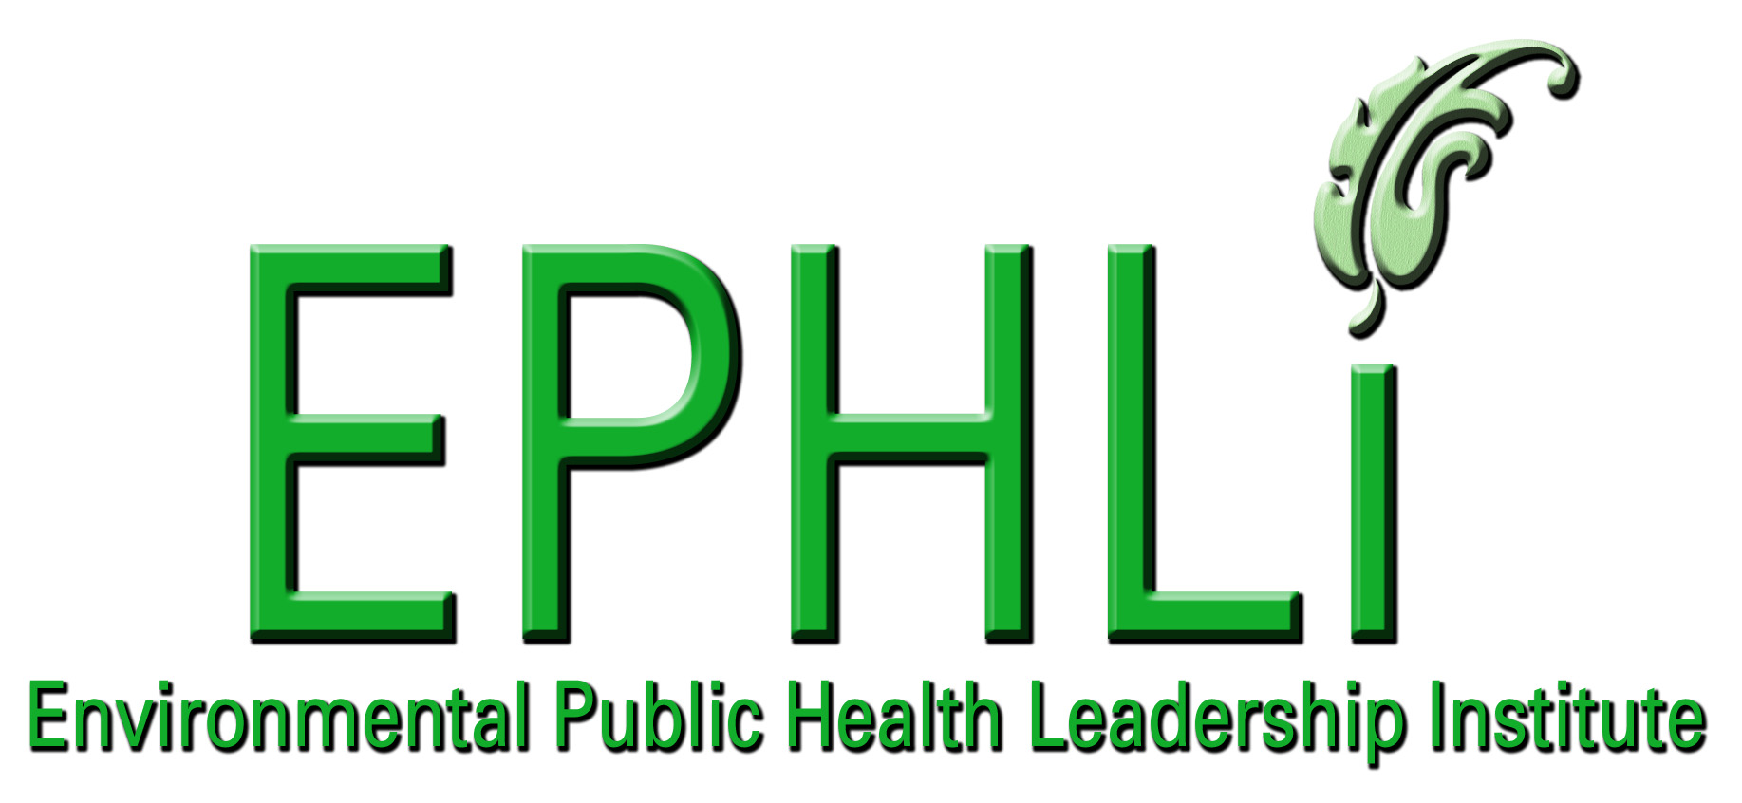

EXECUTIVE SUMMARY:

As Florida is a global destination with an ever increasing population, there is a corresponding increase in risk to public health and the environment. Environmental Health in Florida has primarily focused on regulatory functions. This approach has caused Environmental Health staff to be reactive to new and emerging threats rather than building capacity to prepare for and prevent those threats, and keeps the public from receiving the full complement of environmental health services to which they are entitled.

Four EPHLI Fellows, who were all Environmental Health Supervisors from counties with different demographics within the State of Florida, applied systems thinking to specify the root of this problem, possible solutions and limits to success. They applied the National Environmental Public Health Performance Standards (EnvPHPS) Local Environmental Health Program Self Assessment Instrument to their individual counties to complete a gap analysis of the Ten Essential Environmental Health Services (EEHS).

The assessment results and county demographics were compared to look for trends associated with each county’s ability to provide the Ten Essential Environmental Health Services. The team of Fellows developed action plans to address the gaps identified, and concurred on a set of conclusions and recommendations regarding the value and use of the tool to build environmental health capacity.

To become proactive, Environmental Public Health programs must educate and empower stakeholders to demand the health status and quality of life that more comprehensive Environmental Health services can ensure. The use of the EnvPHPS assessment tool provides an opportunity to educate staff and the community and produces data that can be used to advocate for additional resources and address gaps in environmental health activities. With the assessment results, adequate funding and appropriate staffing, Environmental Health will be better able to prepare for and address emerging threats in order to protect the environment to prevent human illness, injury and loss of life.

INTRODUCTION/BACKGROUND:

While environmental threats to public health have increased, funding to address those threats has not increased at the same rate. Efforts to increase the level of enforcement for violations of environmental public health regulations have not significantly improved health status nor have they allowed time for the provision of the full complement of the ten essential services. Local county health departments do not have a good measure of what level of service they are providing or how effective those services are at protecting public health.

Problem Statement:
The unintended consequence of a classic regulatory approach to Environmental Health issues in Florida is that citizens do not receive the full complement of services needed to protect their health and safety.

Behavior Over Time Graph: 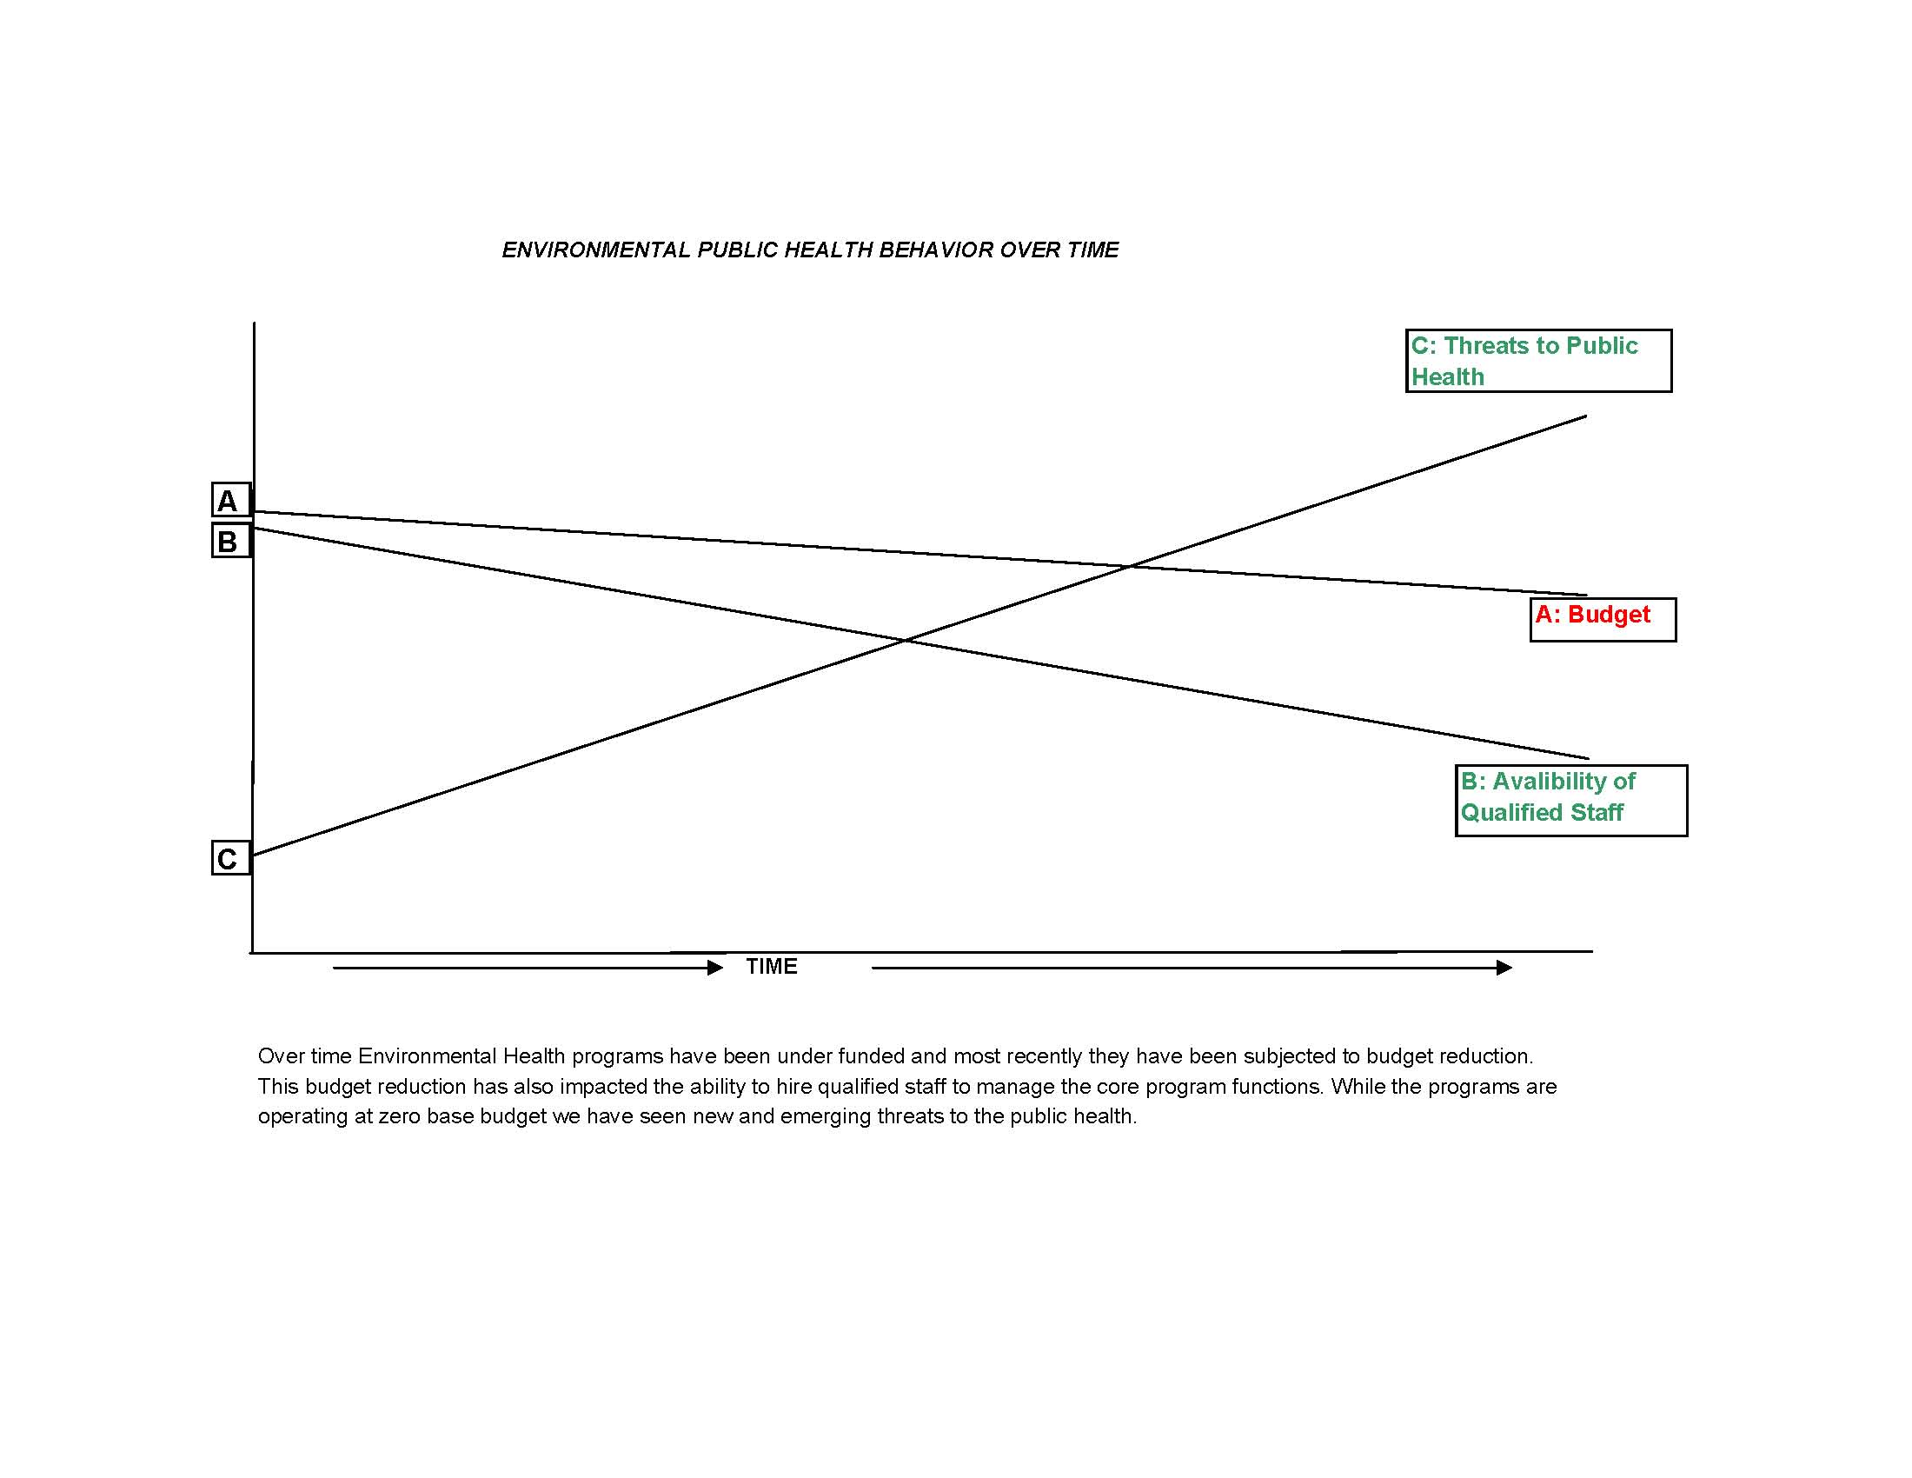

Causal Loop Diagrams and applicable archetypes:

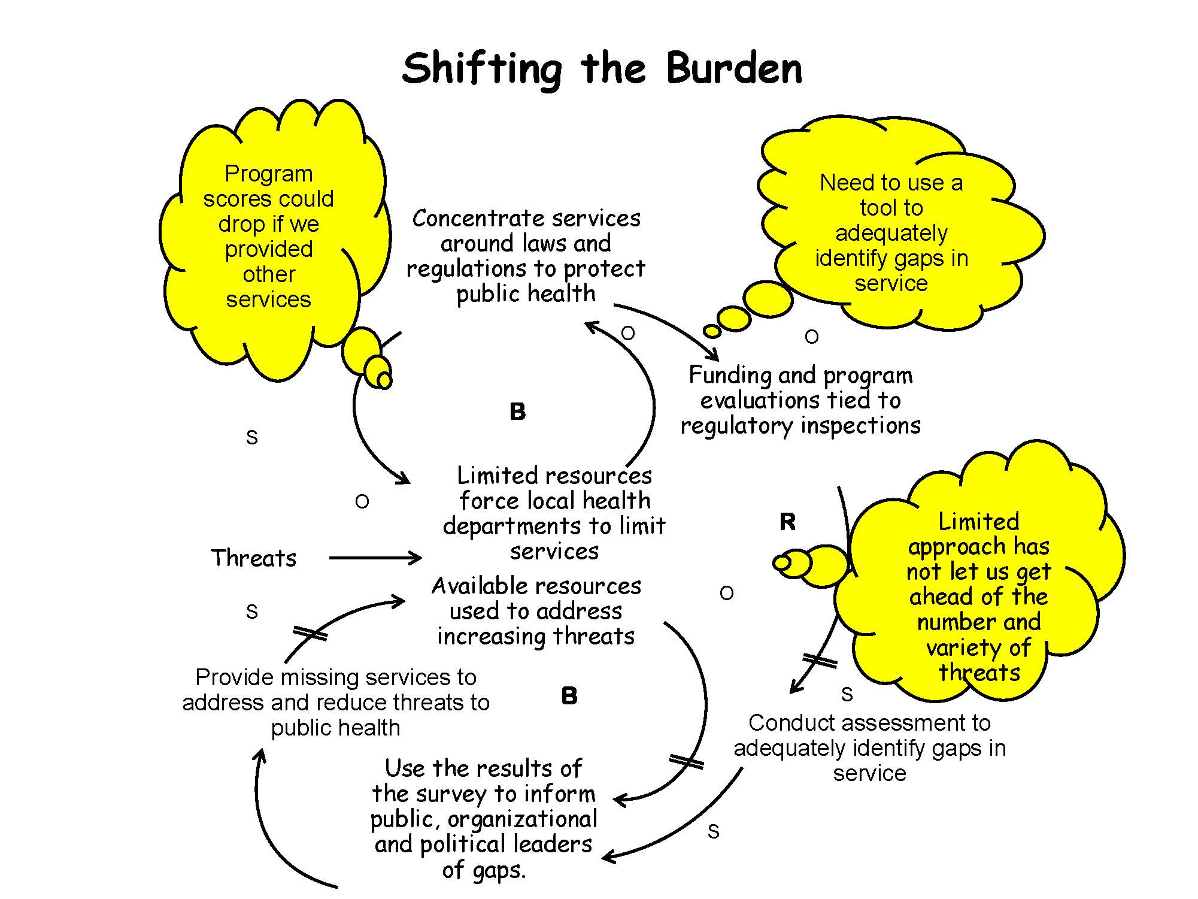

10 Essential Environmental Health Services:
This project seeks to aid Florida County Health Departments in providing all of the 10 Essential Environmental Public Health Services by applying the Local Environmental Health Programs Assessment Instrument to the Environmental Health sections. The goal is to identify areas of strengths and weaknesses as well as to identify areas where services are not currently being provided. By involving community partners in these assessments, the local county environmental health sections can accomplish the above mentioned goal while concurrently educating community partners about the scope of services possible. Once our community partners become aware of the scope of services, public demand for these services will lead to more dialogue and potentially more resources being allocated towards the provision of the services.

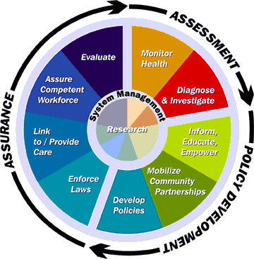
Figure 1: This picture is from the Ten Essential Services of Environmental Health- as developed by Carl Osaki, RS, MSPH, and the Northwest Center for Public Health Practice.

National Goals Supported
This project, Using the National Environmental Public Health Performance Standards to Improve Services in Four Florida Counties, supports all of the CDC Health Protection Goals because Environmental Public Health is involved in every aspect of people’s lives. Our environment is critical to how we grow, learn, and develop, how safe we feel, how well we’re taken care of when we’re ill or aging, and how easy (or difficult) it is for us to incorporate physical activity into our daily lives. If the Ten Essential Environmental Public Health Services are provided, we are not only ensuring that hospitals, schools, playgrounds, neighborhoods, etc. are safe and clean but also that people are prepared for emerging health threats and natural disasters. Our physical, emotional, and mental health is greatly dependent upon our environment, whether it’s the environment where we’re born; go to school, exercise, or even the environment within our own home.

This project meets the following goals of Healthy People 2010: #8) Environmental Health, #15) Injury & Violence Prevention, #18) Mental Health & Mental Disorders, #19) Nutrition & Overweight, #20) Occupational Health & Safety, and #22) Physical Activity & Fitness. Because Environmental Public Health is involved in our schools, workplaces, assisted living facilities, mental health residential facilities, hospitals, and our communities as a whole through programs like PACE-EH, we can often serve as sentinels to observe areas where environmental public health risks may exist or potentially exist.

This project supports the National Strategy to Revitalize Environmental Public Health Services by enabling local Environmental Public Health Programs to assess themselves, identify strengths, weaknesses, and gaps in services, and create dialogue with community partners. It provides local programs with information they can use to market themselves to build capacity and better serve the community. The project contributed to a number of the outcomes on p. 33 of the Strategy, such as increasing the environmental public health capacity at the local level and implementing more effective public health programs.

The core competencies recommended in the Environmental Health Competency Project: Recommendation for Core Competencies for Local Environmental Health Practitioners, play a vital role in this project.

- Assessment -The application of the (National Environmental Public Health Performance Standards (EnvPHPS) Local Environmental Health Program Self Assessment Instrument required extensive use of assessment competency to evaluate the resulting gaps in services and develop viable action plans. Continued re-assessment is expected as we move forward with our project.

- Management – In particular, organizational knowledge and partnering are imperative to the success of this project. We must know what are current services are, what services our stakeholders deserve and partner with them and the entities that can provide support.

- Communication – a large part of this project will be with communicating and educating staff and stakeholders, especially the policy makers in government. Communicating this program to the public will need different methods of communication based upon the level of understanding.

Project Logic Model: 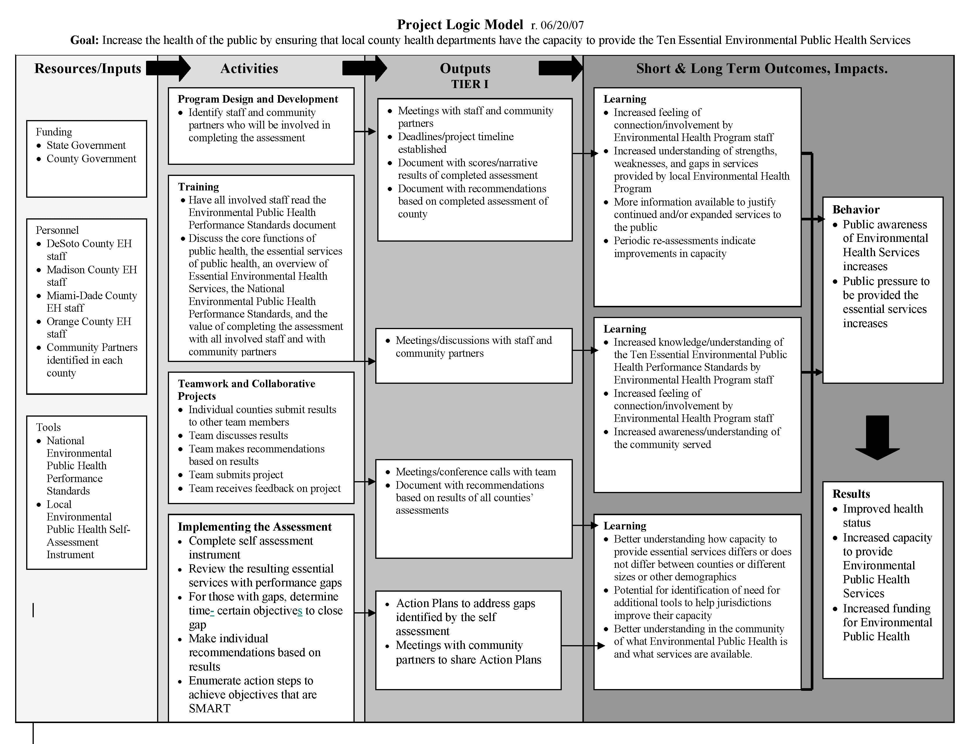

PROJECT OBJECTIVES/DESCRIPTION/DELIVERABLES:

Program Goal: Improve the health of the public by ensuring that local county health departments have the capacity to provide the ten essential environmental public health services

Health Problem: While environmental threats to public health have increased, funding to address those threats has not increased at the same rate. Efforts to increase the level of enforcement for violations of environmental public health regulations have not significantly improved health status nor have they allowed time for the provision of additional services within the ten essential services. Local county health departments do not have a good measure of what level of service they are providing or how effective those services are at protecting public health.
Outcome Objective:
Determinant: If local county health departments apply the Local Environmental Health Programs Assessment Instrument to their current operations, they can identify strengths and weaknesses in the services they provide as well as identify areas where they are not currently able to provide service.

Impact Objective: By December 31st, 2007, a pilot set of Florida counties, including DeSoto, Madison, Miami-Dade, and Orange, will use the Local Environmental Health Programs Assessment Instrument to assess their Environmental Health Programs.

Contributing Factors:
- Lack of public awareness regarding the scope and level of services that are available to them under the umbrella of Environmental Health Services.
- Lack of knowledge in the local county health department’s Environmental Health Programs of what level of service is being provided, what the gaps in service are, and what effect services are having on public health.

Process Objectives:
- By September 30, 2007, DeSoto, Madison, Miami-Dade, and Orange Counties in Florida will have applied the National Environmental Health Performance Standards Assessment Tool to their Environmental Health Programs.
  - Introduce individual staff members to the Ten Essential Environmental Public Health Services
- By October 31, 2007, each environmental health program will have reviewed results of self assessment tool, identifying gaps and creating an action plan to meet objective of closing at least one of the gaps.
- By November 31, 2007, compare the results of the survey to determine commonalities and difference to see what relationship exists for programs of different size.
- By December 31, 2007, each of these Environmental Health Programs will also identify whether or not additional tools are needed to properly assess their programs since each county’s needs may differ because of size, location, and other demographics of the county.
- Prepare feedback to the CDC Environmental Health Services Branch on the usefulness of the EnvPHPS Assessment tool and any recommended improvements.

METHODOLOGY:

Events and Activities
In order to begin this project, the team first worked to identify mental models that perpetuate the problem statement and lead us away from implementing a long term fix.
Fellow, Keith Keene, participated in the NEnvPHPS Workshop: Building Local and National Excellence at the NEHA meeting in June 2007. He applied the EnvPHPS Assessment tool to his local environmental Health program. He shared his results with the team fellows, and the instructions for completing the assessment. During the months of September through November, the other three county environmental health directors applied the tool to their individual environmental health programs. We shared our results with each other and collaborated on scoring of the results to ensure that we were all using the same scoring criteria. For each performance gap identified, each director mapped out an action plan to address that gap. Results for each county were graphed to compare results. Demographics for each of the four counties were also graphed to look for trends in the performance results that might be correlated to demographics (i.e. population, staffing and budget). The team then participated in several conference calls to discuss the results, observations, recommendations and further steps to be taken.

RESULTS:
- In implementing the assessment, those of us who did not attend the NEnvPHPS Workshop realized that we weren’t sure how to score the results of our assessment. In order to be consistent amongst ourselves, we agreed to assign 100 points (100%) to each Standard within the assessment. Those 100 points were then equally distributed to each Indicator within a Standard. For instance, for Essential Environmental Public Health Service #1, there were six indicators. Therefore, each indicator was worth 16.67 points each. Within in indicator were sub-indicators. If a program met only a portion of those sub-indicators, that 16.67 points had to be further subdivided. We all agreed that to a certain extent our scoring was subjective based on our perception of whether our program met a standard or not. This emphasizes the importance of involving all environmental health staff in the assessment and the value of having community partners complete the assessment as well to see what outside perceptions are. We all agreed that scoring needs to be addressed more clearly and completely in the instructions for completing the assessment.
- Once we identified the value in involving community partners in the assessment, we also realized that the assessment could be used as an opportunity for some public relations work with our community partners. If we can raise awareness in the community of what Environmental Public Health means and all of the services that it includes, that would inspire our citizens to demand these services. The down side of that public pressure is that, due to budget constraints, we probably would not be able to immediately provide these services. There is a certain amount of fear among Environmental Public Health professionals when we realize what we may be getting ourselves into.
- As we worked through the assessment, we also realized that by involving our environmental inspectors in the assessment, we can also use it as a training tool to educate and inform our inspectors about the many facets of environmental public health. When a new inspector begins, they spend countless hours in training on how to conduct inspections; how to apply statutes in different program areas and the technical aspects of some of the methods they must perform in order to do their job. By participating in the assessment, they will be better informed about the scope of services that environmental public health covers and in turn, they will be better inspectors.
- Results of the assessment and county demographics are attached as Figure 2 and Figure 3 below.

Figure 2

Figure 3

CONCLUSIONS:

The results applying the EnvPHPS, when used in the proper context, will provide local environmental health programs with valuable insight into their strengths and weaknesses. The tool provides provide information that can be used to educate and inform not only environmental health professionals but also community partners who may not be aware of the full scope of services potentially available. When community partners and the public become aware of these services and the benefits to having these services, they will begin to put pressure on lawmakers and regulators to provide those services. Strengthened awareness by these stakeholders is what is needed for them to become advocates for support.

Because Environmental Health Departments are evaluated almost exclusively on our ability to conduct regulatory activities, the process of evaluation will need to be adjusted to match the 10 Essential Environmental Public Health Services. Using the EnvPHPS is a broader way to evaluate the performance of environmental health related to public health outcomes rather than outputs. By basing our responsibility and evaluation on the big picture we will be better prepared to adapt to emerging threats without fear of under performing. Although the growing pains that may be experienced between public demand and resources being allocated to enable environmental health programs to build capacity may be uncomfortable, in the end, it will lead to a safe and healthier public. In addition Public Health will never be truly public health until all communities are working jointly with the health division to create a healthy community through collaboration.

LEADERSHIP DEVELOPMENT OPPORTUNITIES:

Keith Keene
I am extremely blessed to have participated in Cohort III of the Environmental Public Health Leadership Institute. The lessons learned have made me an effective leader in the work place and my community. The Skillscope 360 and resulting individual development plan has proved invaluable. I have achieved many of my goals and continue to seek out areas for additional self improvement. The systems thinking approach is a tool I use each day as I meet the ever increasing issues facing environmental health. The opportunity to network with my peers from around the country and the relationships that have resulted from working on a team project are priceless. The principles and skills learned have definitely enhanced my leadership ability in environmental health. Participating in EPHLI has enriched my life professionally and personally.

David Overfield
What a wonderful experience. When I applied to the Environmental Public Health Leadership Institute, I assumed they would help me examine one of the problems I am working on for my County Health Department. I never dreamed how much they would teach me about myself or the tools they would give me to solve many of my department’s challenges, truly teaching a man to fish. I learned about my personality, my leadership style, problem solving, leverage, systems thinking, negotiation and had the privilege of meeting and networking with Public Health professionals from all over the United States. This opportunity afforded me the ability to learn how things are done else where as well as share my challenges and successes with other health minded individuals. I was incredibly fortunate to be paired with Trevor, Liz, Keith and our Mentor Sarah. Without their input, guidance and support, this project and my growth as a Leader and Health Professional would not have been possible. I wish to thank my team, mentor, coach, the staff of EPHLI, instructors, Cohort III and the CDC making this experience possible.

Elizabeth Miller
Participation in the Environmental Public Health Leadership Institute has challenged by mind in many ways. I’ve learned to think through problems differently, and I’ve learned that some of my characteristics that I thought were weaknesses are only weaknesses if I don’t understand them and know how to make them work for me. During the course of this program, I left the Department of Health and returned to my previous job at the Department of Environmental Protection. As a result of working in Environmental Health for three years and participating in this program, I am much more aware of the intertwining responsibilities of the two agencies, and I have many more connections. I know that the leadership skills I have learned will be valuable to me wherever I go. Working with the team I was blessed to be associated with has been a wonderful experience. We meshed so well as a group, and we understood and supported each others strengths and weaknesses. I am truly grateful to Keith Keene, David Overfield, Trevor Coke, and Dr. Sarah Kotchian for their support and the way in which they challenged me to think.

Trevor Coke
Over the last year, I have been very pleased to be a part of this most prestigious institute. The knowledge gained through my coach, my mentor and my team has been just awesome. I learned tips through several classes on how to manage time and most importantly on how not to be caught in fixes that backfire. I have also learned to manage time better by delegating some of my responsibilities. This has helped me greatly in accomplishing more work during the day. The contacts made with fellow cohorts have been very valuable to me and my local health department. Due to collaborations with fellow cohorts I was successful in getting a grant for a rodent control program worth $700,000 dollars.

ABOUT THE EPHLI FELLOW(s)

Keith Keene

Keith Keene is the Environmental Administrator of the DeSoto County Health Department in Arcadia, Florida. He holds a Bachelor of Chemistry degree from the University of South Florida. He began his career as an Environmental Health Specialist at the Charlotte County Florida Health Department in 1989. His has oversight of environmental health programs including but not limited to onsite wastewater, migrant housing, swimming pools and mobile home parks, and petroleum storage systems. He is in the second year of a PACE-EH program in two local communities. Additionally, the epidemiology programs (EH, STD and TB) and the WIC program report to him. Mr. Keene is member of the Florida and the National Environmental Health Associations. He is the Environmental Health Section Co-Chair for the Florida Public Health Association. He serves as the Florida Department of Health representative on the Peace River Basin Management Advisory Committee.

David Overfield

David Overfield has been employed by the Orange County Health Department since 1999. His current position is that of Environmental Administrator. His current duties include the management of the Orange County Health Department’s office of Environmental Health. David served as a Corpsman for the United States Navy, received his Bachelor of Science degree in Biology from the University of Central Florida and was most recently selected to attend the 2007 Environmental Public Health Leadership Institute. Some of his most recent accomplishments include the establishment of County fees for Environmental Health, participation on Orange County’s Meth Lab Taskforce, management of the 2006 Incident Command Center for the Apopka mouse invasion and participation on the Orange County Climate Change Summit.. When not working, he enjoys attending church, running, astronomy and spending time with his wife and children.

Trevor Coke is an Environmental Supervisor II with the Miami Dade County Health Department, Environmental Health and Engineering Division. He has worked at the MDCHD for 27 years. He is the program manager for the community hygiene program funded by a grant from the county. This program focuses on improving the hygiene in low moderate income communities throughout unincorporated Miami Dade County. In addition he is in charge of disaster preparedness for Environmental Health, Continuity of Operations Plan, Rodent Control program, and Dead bird collection, On Call for Environmental Health, work across all core programs and special projects for environmental health.

Elizabeth Miller

Elizabeth Miller is currently an Environmental Manager in the Biology Laboratory of the Florida Department of Environmental Protection in Tallahassee, Florida. She holds a Bachelor degree in Biology from Florida State University. She began her work in Environmental Health in June, 2004 as an Environmental Health Inspector with the Madison County Health Department. After a year, she was promoted to the position of Environmental Health Director and served in that position until October, 2007 when she decided to return to her position at Environmental Protection where she had previously worked for 14 years. Ms. Miller is a member of the Florida Environmental Health Association. In her current position, she is responsible for supervision of taxonomists in the laboratory, writing and reviewing technical reports dealing with surface water quality, and has been chosen to be involved with the Harmful Algal Bloom Task Force, which involves several different state agencies including Environmental Protection, Health, and Agricultures. She also acts as assistant programmer of the Statewide Biological Database, which houses taxonomic and water quality data for water bodies that have been sampled in the state of Florida.

REFERENCES

- Osaki C, RS, MSPH, Northwest Center for Public Health Practice, Essential Services of Environmental Health.
- Rowitz L., PhD, Public Health Leadership-Putting Principles into Practice, Jones and Bartlett Publishers, Inc, 2003
- Goodman M, Stroh D, Immediato S, “Introduction to Systems Thinking”, Bridgeway Partners and Innovation Associates Organizational Learning.
- Senge PM, Kleiner A, Roberts C, Ross RB, Smith BJ. The Fifth Discipline Field Book. New York, NY, Doubleday;
- CDC Health Protection Goals, http://www.cdc.gov/about/goals/default.htm
- Healthy People 2010 Objectives, http://www.cdc.gov/nchs/about/otheract/hpdata2010/abouthp.htm
- National Strategy to Revitalize Environmental Public Health Services, http://www.cdc.gov/nceh/ehs/Docs/nationalstrategy2003.pdf.
- Environmental Health Competency Project: Recommendation for Core Competencies for Local Environmental Health Practitioners, http://www.apha.org/programs/standards/healthcompproject/corenontechnicalcompetencies.htm.

