Monitoring and warning system for recreational waters in New Hanover County, North Carolina

Environmental Public Health Leadership Institute Fellow:

Jeffrey E. Suggs, B.A., R.S., R.E.H.S.
Environmental Health Specialist, New Hanover County Health Department
Environmental Health Services
230 Marketplace Drive, Suite 140
Wilmington, N.C. 28403
(910) 798-6661
jsuggs@nhcgov.com

Mentor:

CAPT. Mike Herring, R.E.H.S., M.P.H.
Senior Environmental Health Officer
Centers for Disease Control and Prevention
National Center for Environmental Health
Division of Emergency and Environmental Health Services
Environmental Health Services Branch

Acknowledgements:

Dianne Harvell, R.S., R.E.H.S.
Environmental Health Services Manager; New Hanover County Health Department

Ricky Gibbs, R.S.
Senior Environmental Health Program Specialist: New Hanover County Health Department

Alicia Pickett, R.S., R.E.H.S., C.F.S.P.
Environmental Health Program Specialist: New Hanover County Health Department

EXECUTIVE SUMMARY:

Due to recent mechanical failures of public sewer systems along the Atlantic Intercoastal Waterway and surrounding creeks, bays and coves, recreational water users have been exposed to harmful levels of bacteria and other contaminates that could jeopardize the public health within New Hanover County, North Carolina.
This project details the design phase of a monitoring and warning system for the recreational waters within the boundaries of New Hanover County. It includes the development of a response protocol to contamination events resulting from mechanical failures and natural disasters. The protocol was created from a “systems thinking” approach to solving the problem of the public using contaminated recreational waters.
Although no results are reported, this paper explains the monitoring methodology for the project’s success after implementation.
Through implementation at a later date, it is projected that the system designed during this project will be a model for all coastal counties in North Carolina.

INTRODUCTION/BACKGROUND:

On July 1, 2005 a major raw sewage spill occurred at the Hewlett’s Creek pump station. The resultant 3 million or more gallons of raw sewage that entered the marine estuaries caused an imminent environmental health hazard for humans and wildlife. Delays in discovery of the spill and public notification created an uproar within the citizenry of New Hanover County. Having happened during the July 4th holiday weekend, numerous people were exposed to potential contaminants in the recreational waters surrounding New Hanover County.

At the time of the incident, there was no established regular protocol for the monitoring of recreational waters in New Hanover County. As a result there also was not a system in place for proper public notification of potential hazards to bathers, boaters, and beach combers.

Historically, interagency cooperation has been minimal, and existing resources were not being used.

Since the July 4th incident, there have been several smaller spills form sewage pump stations that infiltrated the recreational waters of the surrounding area. In addition, the community has experienced multiple natural flooding events that have caused unhealthy levels of bacterial intrusion into these same recreational waters.

Problem Statement: Residents and tourists have been exposed to harmful levels of bacteria in the recreational waters of New Hanover County due to sewage spills and natural disasters.

Behavior Over Time Graph:

Causal Loop Diagrams and applicable archetypes:

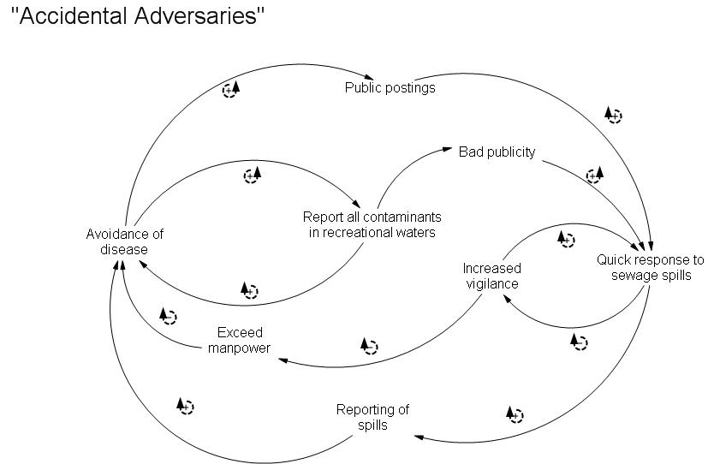

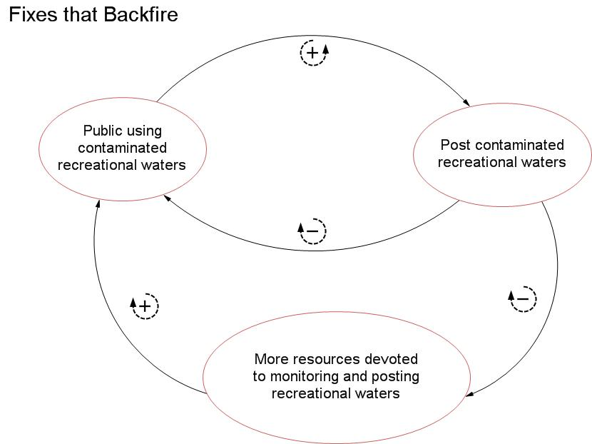

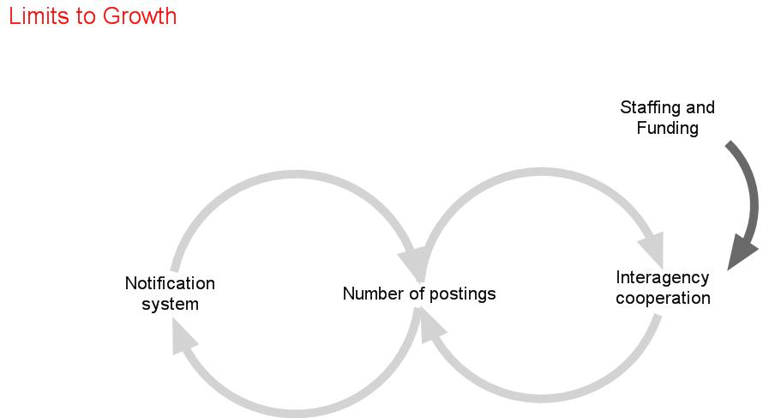

10 Essential Environmental Health Services:
This project seeks to fulfill one of the 10 Essential Environmental Health Services as identified by the Environmental Health Services Branch of the Centers for Disease Control.

Inform, educate and empower people about health issues: Through public advisories of particular recreational waters, the public is informed of risks of exposure to potential pathogens. Public service announcements and educational forums can reduce the risk of exposure in recreational waters, as well as alleviate some of the fears caused by exposure. Education and notification may reduce the occurrence of illness post exposure by informing the public of prevention and treatment.

National Goals Supported

The Centers for Disease Control’s Health Protection Goals that this project addresses are Healthy Travel and Recreation and People Prepared for Emerging Health Threats.

By monitoring the recreational waters of New Hanover County, North Carolina it is supposed that the residents and tourists of the area will have limited exposure to contaminated waters and thus would reduce the incidence of illness. This would fulfill the guideline of Prevention as monitoring and posting of recreational waters would act as a form of intervention.

Through developing partnerships between the local Health Department, the local university, public works, the N.C. Department of Environment and Natural Resources, and the media it is hoped that there will be a decrease in the time needed to detect and report dangerous levels of contaminants in recreational waters.

As seen in the past, many inaccuracies have occurred in the information given to the public and increased the potential for disease in New Hanover County. This accounts for an increase in the time period before proper health guidance can be disseminated. Therefore, this project is geared toward decreasing the time needed to issue health guidance and effect proper risk reduction procedures.

This project highlights the goal of Communicate and Market as expressed in the CDC’s National Strategy to Revitalize Environmental Health Services. The enhanced communication between government agencies, academia and the media fostered by this project has increased perception and necessity of Environmental Health Services. Lead by the public outcry over health consequences of exposure to contaminated recreational waters, policy makers have turned to environmental health for the role of education and notification, as well as the base for team-building.

Project Logic Model:
Logic Plan for New Hanover County’s Notification System for Recreational Waters

The Program | The Outcomes
Desired Results  Reduce the potential for illness in New Hanover County due to exposure to harmful levels of bacteria in coastal recreational waters.  Increase the exposure of Environmental Health within New Hanover County. | Indicators  Reduced rate of enteric illness due to exposure to contaminated recreational waters  Establishment of a communication network with all stakeholders involved in monitoring and notification  Protocol developed for notification placement
Motivating Conditions and Causes  History of raw sewage spills into tidal creeks and recreational waters  History of severe weather conditions (e.g. Hurricanes)  Lack of public knowledge regarding the dangers of swimming in contaminated waters  Use of unfamiliar landmarks to define areas  Low level of required notifications after disaster  No established protocol for information dissemination | Short-term  Identification of needed partnerships  Identification of resources outside of the department  Identification of outside funding  Intermediate  Enhanced communication between different divisions  Lessen citizen concerns over exposure to potential pathogens in recreational waters
Program Strategies  Information clearinghouse for potential environmental hazards  Spoil island survey protocol  Public Information office  GIS/GPS applications | Long-term  A program that is a model for other coastal counties to follow  A sustained and “automatic” response system in place
Program Activities  Respond to citizen complaints involving environmental health concerns  Monitor reportable illness due to environmental exposures  Public Service Announcements | Performance Measures  Number of citizen calls for information  Number of postings on the waters  Number of cases of enteric infections from swimming in contaminated water

PROJECT OBJECTIVES/DESCRIPTION/DELIVERABLES:

Program Goal: To reduce the potential for enteric illness in New Hanover County due to exposure to harmful bacteria in recreational waters.

Health Problem: Residents and tourists can be exposed to harmful levels of bacteria in the recreational waters of New Hanover County due to sewage spills.

Outcome Objective: By May 1, 2006, a notification protocol will be in place to alert the public to potential hazards caused by sewage spills into the recreational waters in New Hanover County.

Determinant: The number of warnings posted and public notifications for recreational waters in New Hanover County.

Impact Objective: By May1, 2006, any above normal Coliform readings in recreational waters will result in public notification of the defined area .

Contributing Factors:
- Historical documentation of sewer line ruptures and lift station failures that have allowed the introduction of raw sewage into recreational waters.
- State protocol does not require that affected areas be posted with advisories.
- Heavy tourist influx during summer months that may not utilize local media for information.
- Lack of network communication among stakeholders.
- Information from scientific community has not been utilized.

Process Objectives: Establish a network for information flow that allows open communication between agencies.

METHODOLOGY:

Events and Activities
July 1, 2005 three million gallons of raw sewage spilled into Hewlett’s creek and infiltrated the Atlantic Intercoastal Waterway and surrounding islands.

July 2, 2005 a small press release was issued by the Division of Water Quality alerting people to avoid swimming in an established plume range.

July 14, 2005 the Environmental Health Committee for the New Hanover County Board of Health met to discuss posting, sampling and public notification. Key players were introduced including Public Information Officers and State government officials. Ideas were discussed relating to public information dissemination to reach the majority of the residents and tourists in New Hanover County.

July 20, 2005 a public forum was held to discuss the issues that included State and local agencies, scientists and physicians.

August 2005 discussions were held with faculty from the University of North Carolina at Wilmington relating to the Center for Marine Science sampling procedures within New Hanover County. It was discovered that UNCW may share sampling data with Environmental Health as ongoing studies are checking for bacteria levels in recreational waters on a routine basis.

October 8, 2005 fourteen inches of rain fell within a 24 hour period causing the lake at Carolina Beach to flood. Pumping commenced from the lake and discharged onto the beach. Signage was posted with swim advisories. This occurred during the Carolina beach Surf Fishing Tournament.

October 18, 2005 a meeting was held to discuss notifying the public of sewage spills.

December 12, 2005 a permanent number for sewage spill information was established and is to be monitored by Environmental Health Services.

Future Endeavors:

A solidification of protocol and flow from monitoring to information release.
Development of signage to be posted in affected recreational waters due to sewage spills or natural disasters.

LEADERSHIP DEVELOPMENT OPPORTUNITIES:

Jeffrey E. Suggs

When I was accepted into the EPHLI, I was not sure exactly what the Institute was about. At first I thought that it would be a series of information seminars, but soon discovered that it was geared toward self-study and self-development. Later, I further realized that it was not only a chance for me to grow, but for the Institute develop. It seems that both the Institute and myself experienced a few “growing pains.”

Working on my project has taught me the value of listening to others’ ideas and combine them into smaller, but more complete visions. The networking involved in both my project and the Institute has shown me the complexities of team building and the benefits of collaborative efforts.

ABOUT THE EPHLI FELLOW

Jeffrey E. Suggs, RS, REHS, is an Environmental Health Specialist with the New Hanover County Health Department in Wilmington, NC. He has a Bachelor of Science degree from the University of North Carolina, Wilmington in psychology, with a heavy concentration in microbiology and earth sciences.

He has worked in public health for over six years as a regulator in most facets of Environmental Health Law and Vector Control. Prior to working in public health, he was a technician in the environmental engineering field, which afforded him the opportunity to work in soil and air sampling (asbestos).

Mr. Suggs conducts regulatory inspections for the Food, Lodging, and Institutions Program. Childcare centers, nursing homes, schools, and hospitals are among the various institutions he inspects. Presently, he directs the environmental health component of the Childhood Lead Poisoning Prevention Program, and public swimming pools. Also, Mr. Suggs is specializes in plan review for all food handling establishments. Along with the aforementioned inspection duties, he collect samples for the Environmental Protection Agency’s ERAMS air and rainwater monitoring program, as well as the State of North Carolina’s air and radiation sampling project.

REFERENCES

- This should be the first record you site in your document.
- Smith J, Canton EM, Weight-based administration of dalteparin in obese patients. Am J Health–Syst Pharm. 2003; 60-683-7.
- So on and so forth.

