New Deliverables for Virginia’s Onsite Sewage & Water Supply Programs: A Roadmap for Changing Services

2005 - 2006

Environmental Public Health Leadership Institute Fellow:

Dwayne Roadcap, REHS, CPSS, AOSE
Program Manager; Division of Onsite Sewage and Water Services,
Virginia Department of Health
109 Governor Street, 5th Floor, Richmond, Virginia 23219, (804) 864-7462, droadcap@vdh.virginia.gov

Mentor:

Brian Hubbard, M.P.H.
Environmental Health Services Branch, Centers for Disease Control and Prevention

(Acknowledgements):

Robert Hicks
Director, Office of Environmental Health Services, Virginia Department of Health

Donald J. Alexander
Director, Division of Onsite Sewage and Water Services, Virginia Department of Health

Allen Knapp
Program Manager, Division of Onsite Sewage and Water Services, Virginia Department of Health

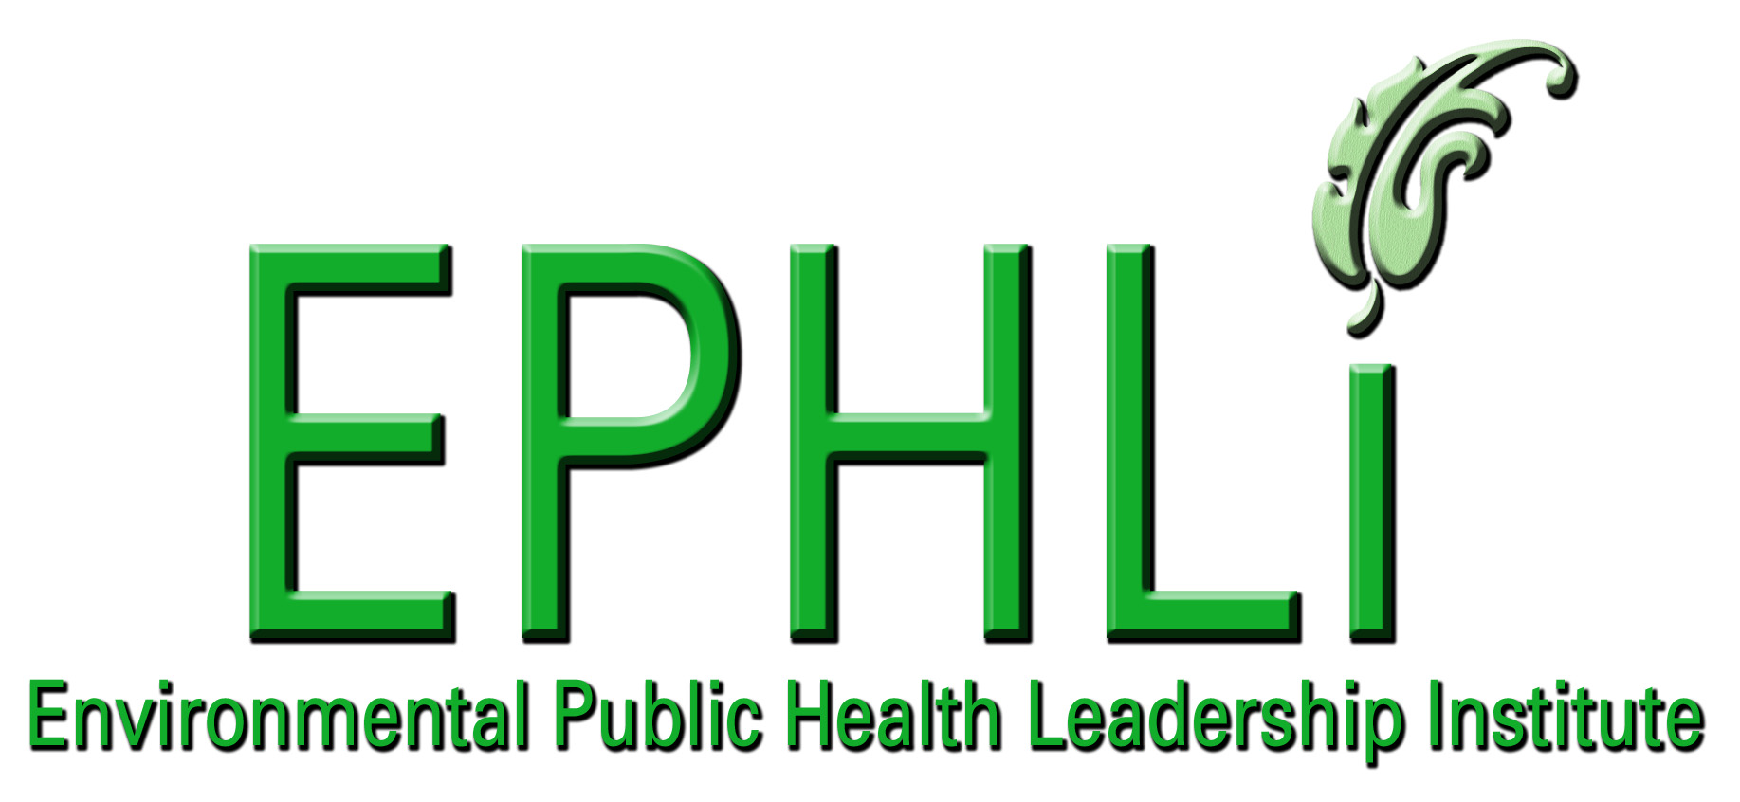

EXECUTIVE SUMMARY:

The Virginia Department of Health (VDH) has used a business model developed over 50 years ago to assure that residential and commercial buildings, which are not served by public sewer, have adequate facilities for water and sewer. This business model has focused agency resources on direct service delivery so that applications for well and sewage system construction permits are timely processed. While this business model may have served the community many years ago, it no longer adequately promotes the government’s interest to protect general welfare and public health nor does it sufficiently address consumer needs. By focusing on the 10 Essential Public Health and Environmental Health Services, the Division of Onsite Sewage and Water Services (DOSWS) seeks to change the health department’s outdated business model. The new business model will improve program performance and address unmet public health needs by developing community partnerships and private sector networks for direct service delivery. Using systems thinking tools, buy-in for change in a new business model can best be leveraged by addressing mental models of health department staff and redefining programmatic goals.

INTRODUCTION/BACKGROUND:

The Board of Health, through the Virginia Department of Health (VDH), has supervision and control for onsite sewage systems and water supplies in the Commonwealth of Virginia. Their mission is to protect public health and groundwater supplies in the Commonwealth (§32.1-163 et. seq. of the Code of Virginia, 1950). VDH completes its mission by performing site and soil evaluations, designing and inspecting onsite systems and wells, and promulgating regulations and policies.

The law does not dictate how VDH should accomplish its mission; rather VDH receives broad authority under law to implement regulations and policies as it deems necessary. In 1972, VDH published its first set of regulations, which were prescriptive and codified how VDH staff had been processing applications before 1972 (when there were no official rules). In 1984 and again in 2000, VDH updated the prescriptive regulations for onsite sewage systems. In 1992, the Board of Health adopted the Private Well Regulations and regulations for sewage systems that discharged into streams or dry ditches. For all of the subsequent regulatory updates, the business model and the prescriptive regulatory principles in place prior to 1972 never changed.

Through a network of 35 health districts and comprising over 100 local health departments, about 325 VDH staff approve approximately 25,000 construction permits, 5,000 certification letters, and 10,000 new subdivision lot approvals, some of which have proposed or actual sewage flows greater than 500,000 gallons per day. The Division of Onsite Sewage and Water Services (DOSWS) estimates there are 1,000,000 onsite sewage systems and water supplies in the Commonwealth with 25,000 new sewage systems and wells being constructed each year. More than 300 billion gallons of water is drawn from underground aquifers and returned back into the soil through onsite sewage systems. Moving through the hydrologic cycle, treated wastewater will eventually mix with groundwater and surface water. Pathogenic bacteria and viruses, nitrates, phosphates, pharmaceuticals, and various chemicals from cleaners and other products in the wastewater can migrate into drinking water and ground water resources. Pathogens can cause numerous illnesses such as viral hepatitis, sporadic viral gastroenteritis, salmonellosis, or cholera. High nitrate concentrations in drinking water may cause methemoglobinemia, or “blue baby’s syndrome” and pharmaceuticals and chemicals may also have effects on health.

Given the risk of groundwater contamination and adverse public health impacts from contaminants in onsite sewage systems, many are surprised to learn that VDH’s business model remains focused on processing applications. The most pressing question asked of environmental health staff on a daily basis is: where’s my permit, or why is it taking so long to get my permit. VDH answers these questions but cannot address other questions about how onsite systems might be affecting groundwater supplies or impacting public health risk. Below is a depiction of where VDH resources are focused and how its business model looks:

When resources are focused on trying to process applications within 15 working days (the blue line above), the biggest customer complaint is about delays in processing. In 1999, the legislature addressed this consumer complaint by adding language to the Code of Virginia that required VDH to accept site evaluations and sewage system designs from private sector service providers. In July 2002, VDH published final regulations that identified who in the private sector could submit work to VDH and what their reporting requirements were for site and soil evaluations and designs. On January 4, 2002, VDH also gave its 5-year status report to the Governor and General Assembly (Senate Document #21) and noted several programmatic challenges:

- Private Sector vs. Public Sector Roles and Responsibilities: VDH noted that the quantity of work being done by private sector service providers was increasing exponentially. Many issues remained about the practice of engineering and what review of private sector work was needed.

- Persistent problems with backlogs: VDH noted that citizens continued to experience significant delays in obtaining permits or other approvals through local health departments, in spite of its best efforts.

- Lack of Data (includes collection, analysis, and management): VDH wrote that it did not have the comprehensive data needed to more effectively manage the programs. VDH had been working with a contractor for about two years to develop an information system, but much more work remained.

Since writing the 5-year status report in 2002, VDH has seen little improvement in backlogs or data collection and evaluation. This paper outlines why backlogs will continue to plague VDH as long as agency resources are focused on processing applications. With the authority under law to accept work from private sector service providers, this paper also suggests a roadmap for how VDH might transform itself from a permitting agency that processes construction permits to a public health agency that focuses resources on risk assessment, policy development, and assurance. The paper concludes that with a change in its business model, VDH will improve its ability to minimize the risk of human exposure to disease agents in the environment that are associated with onsite sewage systems than if it were to continue with its current business model.

In July 2003, the Virginia legislature created the Council on Virginia’s Future (www.future.virginia.gov), which designs the roadmap for Virginia's future through a planning and accountability process on government services most vital to Virginia's future. The Council consists of industry and political leaders. Through this committee and by approval from the Honorable Governor Mark Warner, VDH received funds to assess its business model. VDH hired a consultant, EL Hamm & Associates, to assess its business model and offer ideas to improve VDH’s onsite sewage and water programs. EL Hamm’s final report will be available in March 2006 and will help garner support from VDH leadership and political leaders for a business model change.

Problem Statement:

VDH has not significantly reduced complaints about backlogs or improved the length of time staff need to process construction applications for onsite sewage systems and water supplies. VDH has long recognized it needed an inventory of systems and wells installed in Virginia and to monitor the effects of sewage systems on groundwater supplies and public health. Despite this recognition, VDH has not made much progress in its effort to develop a statewide inventory.

- Despite the agency’s best efforts, why can’t VDH shorten, reduce, or control its backlogs?

- Why is processing applications slower and more difficult than five years ago?

- Why can’t VDH find the resources to research and monitor trends and effects of onsite sewage systems on groundwater supplies?

- Why is VDH’s staff turnover so high in the onsite sewage and water supply program?

Behaviors Over Time Graphs:

Figure 1: Providers vs. Service Needs

Time
Number
Requests for services
VDH staff performing services
Private sector performing services

As shown by Figure 1, the number of VDH staff performing work is not keeping pace with the requests for approval. Because of the increased workload in the private sector, the most experienced VDH staff are being lured into private firms. Given the trend shown by Figure 1, what business model could VDH develop to meet the growing demand in services and the expanding private sector? Why is VDH not closing the gap between resources and growing demand? How can VDH fill the gap?

In Figure 2, “bare applications” refer to work that is not supported by private sector consultation. Processing bare applications is more time consuming than processing applications with supporting private sector work. “Bare applications” require 4 to 5 hours of VDH work at a cost of $350.00 to $450.00 dollars per application. Processing applications with supporting work takes 30 to 60 minutes with an estimated cost of $150.00 per application. The percentage of bare application requests is decreasing relative to the percentage of work supported by the private sector.

In Figure 3, alternative systems refer to sewage system designs that require advanced treatment, typically achieved with a proprietary, pre-engineered treatment device (i.e., aerobic treatment, sequencing batch reactor, or fixed media). Conventional systems refer to systems that use a septic tank and require no advanced treatment. Alternative systems reduce pollutants in sewage more effectively than conventional systems but usually need more monitoring because of their more complicated design. Alternative systems usually require more consultation than conventional designs because they are more complex and have more features from which to choose. The percentage of alternative system approvals is increasing relative to the number of conventional systems being approved. VDH staff only design conventional systems because a conflict of interest arises from both approving alternative technology and designing it for use. As shown in Figure 3, alternative systems are increasing at a faster rate than conventional systems.

Figure 2: Type of Applications Received by VDH
Time
Percentage
"Bare Applications"
Applications with supporting private sector work

Figure 3: Conventional and Alternative System Design Rates

Time
Number
"Alternative Systems"
"Conventional Systems"

Figure 4 illustrates how VDH’s expertise to manage and monitor alternative systems is being reduced over time as its experience level of staff declines. As VDH continues to lose its experienced employees to the private sector, more resources are spent on training and staff development for inexperienced employees. Hence, VDH is losing its field expertise regarding complex systems, while the percentage of alternative systems is increasing relative to conventional systems. In 1994, VDH defined backlogs and gave guidance on processing applications. Since then, VDH has clarified processes through new policies and interpretations (See Figure 5). Figure 6 explains why backlogs will not improve and how a vicious cycle has formed over time.

Figure 4: Relative Years of Experience of VDH Staff over Time
Time
Years of VDH staff experience

Figure 5: Backlogs and Policies

Time
Number
Backlogs
Policies to deal with backlogs

Figure 6: Backlogs Fuel Vicious Cycle

Creates low employee morale.
Significant Backlogs.
Customer complaints & drama cases increase
Hire new & untrained staff

Increase private sector input.
Increased time to process and more workload demand.
Lack of quality in product.
Mistrust of private sector work.
Inappropriate skill mix. Insufficient training.

More complicated rules & systems. Increased volume of work.
Increased complaints & time dealing with unhappy customers.
High employee turnover. Private sector hires employees.
Hire new & untrained staff

Causal Loop Diagrams and Applicable Archetypes:

Figure 7 describes how a negative productivity impact happened to VDH over the long-term after initially receiving a short-term benefit from private sector input. In the short-run, backlogs were reduced with added private sector resources; however, the short-term benefits led to a negative productivity impact and strained VDH’s ability to train new employees. As work demand increased in the private sector, employers were able to increase pay to reflect demand and skills needed. VDH salaries, on the other hand, could not change to reflect increased demand as the private sector could do. Private sector employers are able to hire newly trained VDH employees for salaries ranging from $40,000 to $45,000 while VDH pays $28,000 to $32,000. Experienced and certified VDH employees make about $38,000 while they can receive $50,000 to $58,000 in the private sector.

Since 2000, VDH has trained 175 new employees to work in the onsite sewage and water supply program, which is more than a 50 percent turnover rate from a total staff of about 325 professionals. Of the 175 new employees trained, 38 percent have already left VDH employment. VDH estimates that it has spent 3.5 million to 4.0 million dollars training these new employees.

Figure 7: Fixes that Backfire

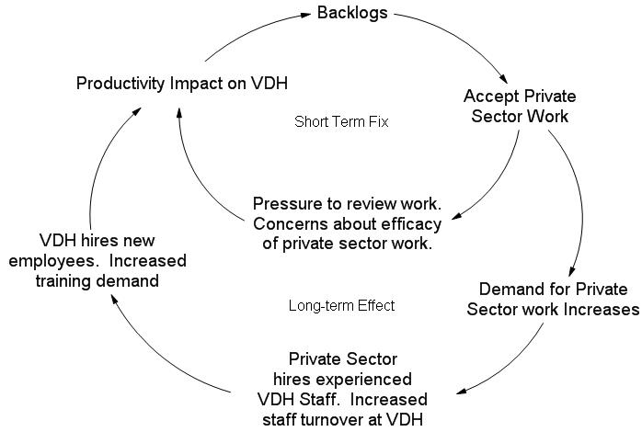

Figure 8 depicts how making a fundamental change in VDH’s business model is more difficult as VDH focuses energy and resources on processing applications. From a systems perspective, where are the bottlenecks that create backlogs? Where should VDH spend its energy to effect change in the system? Where are the leverage points in the system? (See Figure 9)

Figure 8: Shifting the Burden

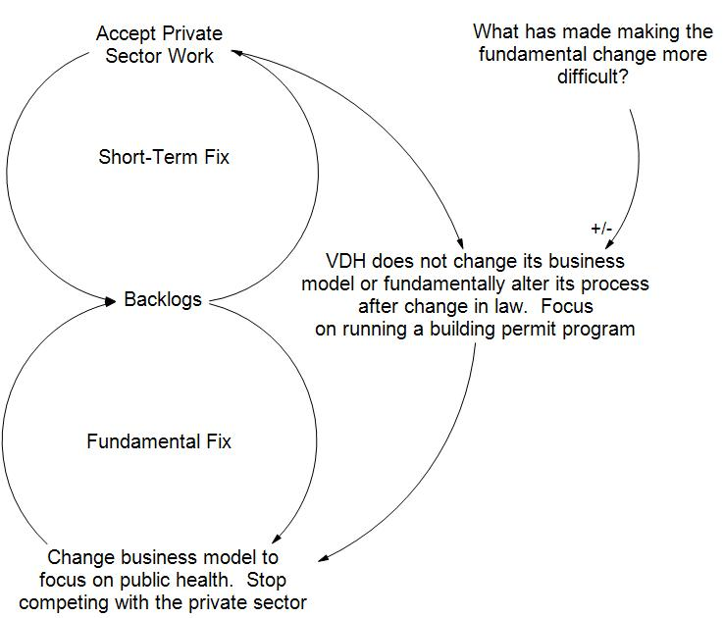

Figure 9: Determining Leverage Points in the System

There are numerous mental models that are helping VDH to remain focused on short-term solutions. Field staff report: I’m doing what customers want: processing applications and inspecting systems. How can VDH move to an alternate future when all available resources are already consumed by providing the mandated services?

A VDH Manager wrote: I believe taking VDH out of the on-site permitting process would be a mistake. The public depends on VDH for the knowledge, expertise and unbiased decisions in regards to the on-site program. VDH as you well know sells a service and is not driven by monetary gains unlike our counterparts in the private sector. Whereas the private sector is concerned with the monetary ambitions of his client (developer), we are concerned about the public health impact of the systems installed for the home owner. This has brought about long sought respect and the labeling of professionalism from the community.

Another VDH Manager wrote:

First of all we are an Environmental Health Division of Public Health. One needs to review the essential services of an Environmental Health Division, which may or may not correlate with essential public health services. Second our mission is not one of research. Our mission is basically one of prevention.

A third VDH Manager said:

I could not agree more. Anyone believing that [the private sector] will not be influenced by economic factors rather than sound public health practices is deluding themselves. I feel that few, if any, field E.H. Managers believe the program is headed down the right path. If we do not have a say as to what system is being put into the ground we will inevitably have to fix it later.

Under VDH’s current business model paradigm and as expressed by the above mental models, the real goal of the program appears to be to process applications for construction permits better and faster (See Figure 10). Field staff and field managers view processing applications as prevention of public health hazards.

Figures 10 depicts the goal in VDH’s current business model. Under the current business model, VDH is running a building permit program with elements of health and safety. Many field staff and field managers believe that this model serves the Commonwealth’s needs and adequately prevents system failures. Under this paradigm, all VDH resources are focused on permitting and installation activities which occur before the well or the sewage systems are used. Once the construction permit is issued and the system is inspected and approved, the work is completed and agency resources are shifted to focus on processing the next application.

This current business model does not address the risks to water resources and human health that occur after the “first flush”. Figure 11 depicts how shifting from the current business model (a building permit program with elements of health and safety) to a new business model that incorporates the 10 Essential Services might allow VDH to shift resources and energy to activities after sewage systems and wells are used.

Figure 10: Goal of VDH’s Current Business Model

Figure 11: VDH’s Future Goal for a Business Model Change

10 Essential Environmental Health Services:

This project is meant to actively use the 10 Essential Services to change the agency’s business model. VDH’s future role is in assessment, policy development, and assurance. To properly assess the community’s needs, VDH must develop an inventory of the sewage systems and water supplies being used in the Commonwealth of Virginia. Without such data, VDH cannot monitor the health status of the community or adequately investigate and diagnose community issues. VDH must establish a system to collect and analyze environmentally related health information from onsite sewage systems that contributes to human illness. Presently, the agency is focused on processing applications instead of focusing resources toward public health goals and initiatives.

National Goals Supported

The roadmap for changing the onsite sewage and water program’s business model aligns itself to CDC’s Health Protection Goals. One goal, “Healthy People in Healthy Places”, which includes “Healthy Communities”, “Healthy Homes”, “Healthy Workplaces” and “Healthy Travel and Recreation”, is promoted. The new business model would focus VDH resources in the 10 Essential Services and allow for capacity building to assess the effects of onsite sewage systems on groundwater supplies and public health. Focusing on health effects from onsite sewage systems will assure that people live in healthy homes and communities and are safe in workplaces and during recreational activities. With a new business model, VDH could develop rules that manage the risks learned from assessment and assure that people are safe from disease agents and other contaminants found in sewage. VDH’s staff will understand the 10 Essential Services and better understand how to assess and manage risks from onsite sewage systems. Staff will be able to communicate health information to decision-makers.

Project Logic Model:

What VDH Staff Would Do: |  | What VDH Would Want to Accomplish:
Resources/Inputs | Program Activities | Short-Term Outputs | Intermediate Outputs and Outcomes | Long-term / Community Impact  Outcomes
32 EH Managers in 35 Health Districts  325 FTEs (field and office staff)  6 FTEs (central office)  State-wide Database  300 private sector service providers | - Train new VDH practitioners in the 10 Essential Services, risk assessment, and risk management.  - Investigate water and sewage complaints.  - Collect data. Develop accurate inventory of systems.  - Manipulate data and assess community health status.  - Write community health status reports.  - Assure systems are working in accordance with their approvals and assess their effects on health status.  - Monitor private sector activities and enforce regulations.  - Observe trends in community health status.  - Develop coalitions to share and have access to relevant health and environmental data | - Draft regulations and policies based on community assessments.  - Health department services directed toward risk management.  - Private sector service providers are held accountable to their work. | - Appropriately trained staff in environmental public health that can promote the 10 Essential Services.  - Decision-makers have adequate information of health status for policy development.  - Collaboration among stakeholders.  - Reports to community leaders on health status.  - Public informed about water & sewer issues. | - Humans, animals, and insects not exposed to untreated sewage.  - Population has safe drinking water supply from private wells.
Political Will  VDH Management Commitment  Broad legal authority under the Code of VA |  | - Re-engineering report to Governor.  - Community needs identified. | - VDH recognized as authority on health status and impacts from onsite sewage systems and water supplies. | - VDH becomes public health leader in onsite sewage and private well program.  - Trained staff and private sector practitioners.  - Low VDH staff turnover.

PROJECT OBJECTIVES/DESCRIPTION/DELIVERABLES:

Program Goal: | To minimize the risk of human exposure to disease agents in the environment that are associated with onsite sewage systems by using the 10 Essential Public Health Services.
Health Problem: | The rate and number of sewage system failures in Virginia as well as their effect on ground and surface water is unknown. VDH does not know what effect onsite sewage systems may be having on groundwater supplies used as drinking water.  From a survey of VDH Managers in 2001, managers reported that 10-15 percent of their applications comprised failed onsite sewage systems. VDH estimates that over 25 percent of sewage systems and water supplies (about 235,000 systems) are more than 30 years old. The effect of these older and failed systems on groundwater and health status is unknown. Regulations and policies may not adequately reflect community needs because insufficient data exists.
Outcome Objective: | - By July 1, 2015, VDH staff will be able to document that 90 percent of private wells installed in Virginia do not receive any bacterial or viral agents from onsite sewage systems.  - By July 1, 2015, VDH staff will have the ability to assess nutrient, pharmaceutical, and chemical impacts to private water supplies from onsite sewage systems.  - By July 1, 2015, VDH staff will be able to communicate the risks and manage those risks to ground water and surface water from onsite sewage systems.
Determinant: | From a random sampling of 9,343 private wells across Virginia, Dr. Blake Ross reported that 44.2 percent were coliform positive and 11.6 percent were fecal coliform positive. Dr. Ross also reported that the average water sample had 1.2 mg/l of chlorides, which is a constituent found in wastewater and is used to track effluent plumes.²
Impact Objective: | - On September 15, 2005, the Virginia Department of Health will met with E.L. Hamm, a private consulting firm, to perform a business review of Virginia’s onsite sewage program.  - By March 15, 2006, the Virginia Department will receive recommendations from E.L. Hamm and begin implementing process improvements and changes to its business model.  - By July 1, 2006, the Virginia Department of Health will begin the regulatory adoption process for adopting more simplified regulations for onsite sewage systems.  - By July 1, 2007, VDH will have developed a roadmap to change its business model through collaboration with stakeholders.  - By July 1, 2010, VDH managers of local health districts will have a complete inventory of onsite sewage systems and water supplies in their district and be able to communicate that data and their analysis of it with the public and key stakeholders.  - By July 1, 2012, VDH will be able to use data and anecdotal information collected by field staff to support regulations and policy changes.  - By July 1, 2015, VDH will have fully integrated a different business model to meet its business need while at the same time allow staff to collect and analyze data on the effects of onsite sewage systems with respect to drinking water wells located within a 200-foot radius of installed systems.
Contributing Factors: | VDH resources are fully expended on tasks and activities that prevent data collection or its analysis for onsite sewage systems and water supplies. VDH does not train staff how to collect data or how to determine what data to collect. Management does not emphasize the importance of data collection and VDH training for new employees is focused on teaching students how to perform direct services. VDH staffing levels over the past five years have remained constant or slightly more while applications received and customer demand for VDH services has increased by at least 30 percent. Rules and regulations are complex and there is a 10 to 20 percent turnover in VDH field level staff; hence, a high percentage of agency resources are dedicated to training and disseminating information to stakeholders and new staff. Local health districts within VDH adopt procedures and processes in addition to the state rules, which adds another level of complexity and need for training.
Process Objective: | - By June 15, 2006, develop a strategy and awareness campaign for VDH staff to understand the virtues of data collection, its analysis, and the enforcement for non-compliant sewage systems.  - By November 15, 2006, identify community partnerships and organizations that could assist VDH in developing data collection and analysis for onsite sewage systems and private water supplies.  - By November 1, 2007, form a task force of community partners and other pertinent stakeholders (such as the Virginia Onsite Recycling Association) to collaborate and develop buy-in for rule changes.  - By November 1, 2007, VDH will develop performance measures for each of the 10 Essential Services.  - By November 1, 2008, VDH will train staff on data collection and assessment, and how to communicate that information in routine reports to decision-makers.
Events: | - On July 9, 2005, VDH published the “Request for Proposal” (RFP) to accept vendor ideas on the re-engineering initiative.  - On July 22, 2005, VDH staff will met with potential vendors on the RFP.  - On August 9, 2005, the RFP closed and E.L. Hamm & Associates was selected to assess the onsite sewage program’s current reality and vision to direct resources toward public health activities rather than building permit functions.  - VDH formed an advisory committee, which has met three times to date (8/3/05, 11/10/05, and 1/17/06). Meetings are planned every two months through 2006. The advisory committee has made several recommendations regarding VDH policy changes.  - On November 16 and 17, 2005, Dwayne Roadcap presented the 10 Essential Services to VDH Managers. E.L. Hamm interviewed managers.  - In January 2006, the Division of Onsite Sewage and Water Services began holding weekly meetings with stakeholders to develop goals and issues the future regulations should address.
Activities: | - Develop regulation and rule changes.  - Work with selected vendor to develop recommendations for changing VDH roles and responsibilities while fully integrating private sector service providers.  - Evaluate vendor recommendations and decide on a plan to implement changes.  - Evaluate whether increased services from the private sector can allow VDH staff to concentrate on data collection and analysis services in the onsite program.  - Determine whether data collection and analysis services will translate into less risk of sewage exposure to failing systems and what relationship, if any, exists between failing systems and nearby drinking water wells.  - Identify community partnerships that need developing to measure the effects of sewage systems on nearby drinking water wells.  - Develop graphs and charts using models in “systems thinking” to help promote organizational change and identify leverage points.  - Develop training and education program for staff and other appropriate stakeholders so that they can understand the need for data collection and analysis.  - Develop a draft employee work profile (EWP) so that staff might see what a future change in role and responsibility might look like.  - Form stakeholder group to discuss re-engineering initiative and offer ideas to develop new capacity and leadership within VDH.

CONCLUSION and NEXT STEPS:

Many ask why change and allow the private sector to perform direct services that VDH has historically been doing? The answer is simple: because VDH has better uses for its resources and the legislature has said that VDH must accept private sector work.

VDH’s current reality consists of high staff turnover, low morale, and conflict (amongst itself and with private sector professionals). VDH regulates private sector service providers while simultaneously performing the same services. VDH’s business model focuses resources before sewage systems are used and when there is no risk to public health. When VDH was the sole service provider, this model made sense. Now, a new model is needed because private sector service providers can perform direct services, which allows VDH to shift resources toward risk assessment and risk management—a previously ignored community need. By inculcating the 10 Essential Services into VDH training and requiring VDH field managers to assess their programmatic activities using the 10 Essential Service, it become self-evident to staff that VDH’s historical role does not adequately promote healthy homes, workplaces, or communities.

To move VDH toward risk assessment and risk management, any change must incorporate the 10 Essential Services and requires support from VDH leadership and political leaders. Political leaders must be apprised of the need for change and given a clear vision for VDH’s potential with a new business model. Without support from VDH and political leadership, any process to redirect agency resources will fail. Along with long-term leadership support, VDH must change mental models and re-define VDH’s perceived goal (from processing applications to minimizing risk from onsite sewage systems).

Many field staff believe that VDH’s current business model adequately reflects customer needs. To these staff, VDH’s primary role is consumer protection because agency decisions are not clouded by a desire for profit. These staff believe that backlogs can be reduced with better policy and regulatory guidance and by hiring more bodies. These mental models, however, do not recognize the realty of the political landscape. VDH staffing cannot be changed without legislative action, which is unlikely to happen because the legislature addressed the manpower need by requiring VDH to accept private sector work.

VDH hires persons with backgrounds in soil science and trains them to perform direct services (site and soil evaluations, sewage system design and inspection). To begin a change to VDH’s business model and start integrating the 10 Essential Services into its onsite sewage and well programs, VDH must first address staff mental models and develop buy-in for a new goal. At present, staff are mainly focused on how to process applications better and faster rather than collecting data, analyzing it for trends, and communicating health status.

Presently, staff are not trained in data collection and analysis, so they are resistant to changes in their roles and responsibilities. New roles and responsibilities would be inevitable with a new focus on data collection. Staff do not know how future role and responsibility changes could enhance public health protection in the onsite sewage and private water supply programs and staff have historically shunned and procrastinated enforcement activities, which would likely increase if data collection and analysis were emphasized in future roles and responsibilities. Some staff enjoy their present roles and responsibilities and would resist any change that involves different activities.

VDH’s business model and regulations cannot change without significant political and leadership energy invested to reshape the program. Leadership has stated that VDH must develop new performance measures that are meaningful and that address what citizens and staff deem important. These performance measures must be inculcated into the daily activities of VDH field staff. New performance measures and changes to employees’ work profiles will help change mental models along with regular discussions about agency activities to minimize and manage risks from onsite sewage systems.

EL Hamm will likely suggest that VDH stop competing with private sector service providers and focus its resources on risk assessment and risk management. The EL Hamm report should prompt staff discussion and support from VDH leadership and the Council on Virginia’s Future. This support will be crucial as several legislative changes may be necessary to help gradually shift VDH resources away from providing direct services to a new role of risk management and regulatory oversight. For example, one legislative change might require VDH to charge for its actual cost of service delivery. Right now, consumers preferentially seek VDH services because costs for such service are tax-subsidized and much lower. Assuring that users are charged for actual service delivery will take away a strong incentive to seek VDH assistance. With political and VDH leadership support, VDH may be able to limit its activities for proposed subdivision, which could be best handled in the private sector. For example, in some counties, VDH staff actually perform the site and soil work for proposed subdivisions because owners file multiple applications in anticipation of dividing the property.

Next steps for this project include:

- Completing the VDH Re-engineering study from a private consultant. VDH should receive the report by March 2006.

- Building capacity within VDH to implement a new program goal using the 10 Essential Services as a means to achieve the goal. By May 2006, VDH leadership has asked DOSWS to develop a detailed plan with VDH stakeholders to address the program’s goals, mental models, and activities. Working with key VDH stakeholders, DOSWS will develop performance measures using the 10 Essential Services.

- Adjusting VDH training to emphasize the 10 Essential Services and how staff can better manage risks from onsite sewage systems. The VDH training coordinator recently acquired new staff support and should be able to use the new resources to develop new training in the 10 Essential Services.

- Improving collaboration and networking with private sector service providers to assure that direct delivery of service is adequately performed in a timely manner. DOSWS will continue to collaborate with the advisory board every two months.

- Developing a new set of regulations to reflect the agency’s future roles and responsibilities along with anticipated future roles and responsibilities for private sector service providers. In January 2006, DOSWS began holding weekly stakeholder meetings to change the regulations. New rules are expected to take two years to develop.

- Building capacity in the private sector to assure that adequate and timely delivery of service is available to the public. VDH has formed a training task force committee and is working with a community college to provide future training for college credit.

LEADERSHIP DEVELOPMENT OPPORTUNITIES:

Dwayne Roadcap

The EPHLI changed how I look at problems and how to solve them. With new tools like logic models and systems thinking available for use, I am now equipped to better understand the root cause of a problem and develop a broader approach to address it. Before learning about these tools, I was prone to make quicker decisions to reflect short-term needs. Now, I look at short-term and long-term goals to assure that decisions made today do not undermine long-term solutions. My new thinking is how can I address the challenge in the short-term and still promote the fundamental solution needed. I use the 10 Essential Services to assess whether decisions and measures are important. My primary objective is to instill the information I learned through the EPHLI with other staff. By sharing new tools available for problem-solving, I hope that staff can also address fundamental needs and use the 10 Essential Services to assess and improve their work. I believe that my broader perspective to problem solving fosters leadership in decision-making. The EPHLI has caused me to re-think what is important in my programs and to focus on leverage points in the system to effect change. I hope others will learn the importance of these tools so that they can have renewed energy on how to problem-solve their community’s public health problems and needs.

ABOUT THE EPHLI FELLOW(s)

Dwayne Roadcap, REHS, is a program manager with the Virginia Department of Health, Office of Environmental Health Services, Division of Onsite Sewage and Water Services. Mr. Roadcap holds a bachelors degree from the University of Virginia in Environmental Sciences and is certified in Virginia as a professional soil scientist and is also registered as an authorized on-site soil evaluator. Mr. Roadcap began his career working as an Environmental Health Specialist in a local county and later as an Environmental Health Supervisor for a health district. He has over 13 years of experience working in Virginia’s onsite sewage and well program. He is a member of the Virginia Environmental Health Association, the Virginia Onsite Wastewater Recycling Association, and the National Environmental Health Association.

REFERENCES

- Stroube, Robert. Health and Environmental Considerations in Evaluating Applications for Onsite Sewage Disposal Systems. Memorandum to the Virginia Department of Health. 1992.
- B.B. Ross, M.P. Hudgins, E.M. Daniel, K.R. Parrott, N.M. Herbert Evaluation of Household Water Quality, all counties in Virginia,. 1994 – 2000.

