Ensuring a Competent Workforce and Sustaining Program Improvements in Environmental Health

2006 - 2007

Environmental Public Health Leadership Institute Fellow(s):

Jennifer L. Pinnow, REHS/RS
Assistant Environmental Health Director,
Yellowstone City-County Health Department
P.O. Box 35035, Billings, Montana, 59107
(406) 256-2770, jenniferp@ycchd.org

Mentor(s):

Sarah B. Kotchian, EdM, MPH, PhD
Research Assistant Professor; Department of Family and Community Medicine,
University of New Mexico School of Medicine; Associate Director for Planning, Institute for Public Health

(Acknowledgements):

John Felton
Chief Operating Officer; Yellowstone City-County Health Department

Doug Moore, MD
Chief of Public Health Services; Yellowstone City-County Health Department

Ted Kylander, REHS/RS
Environmental Health Director; Yellowstone City-County Health Department

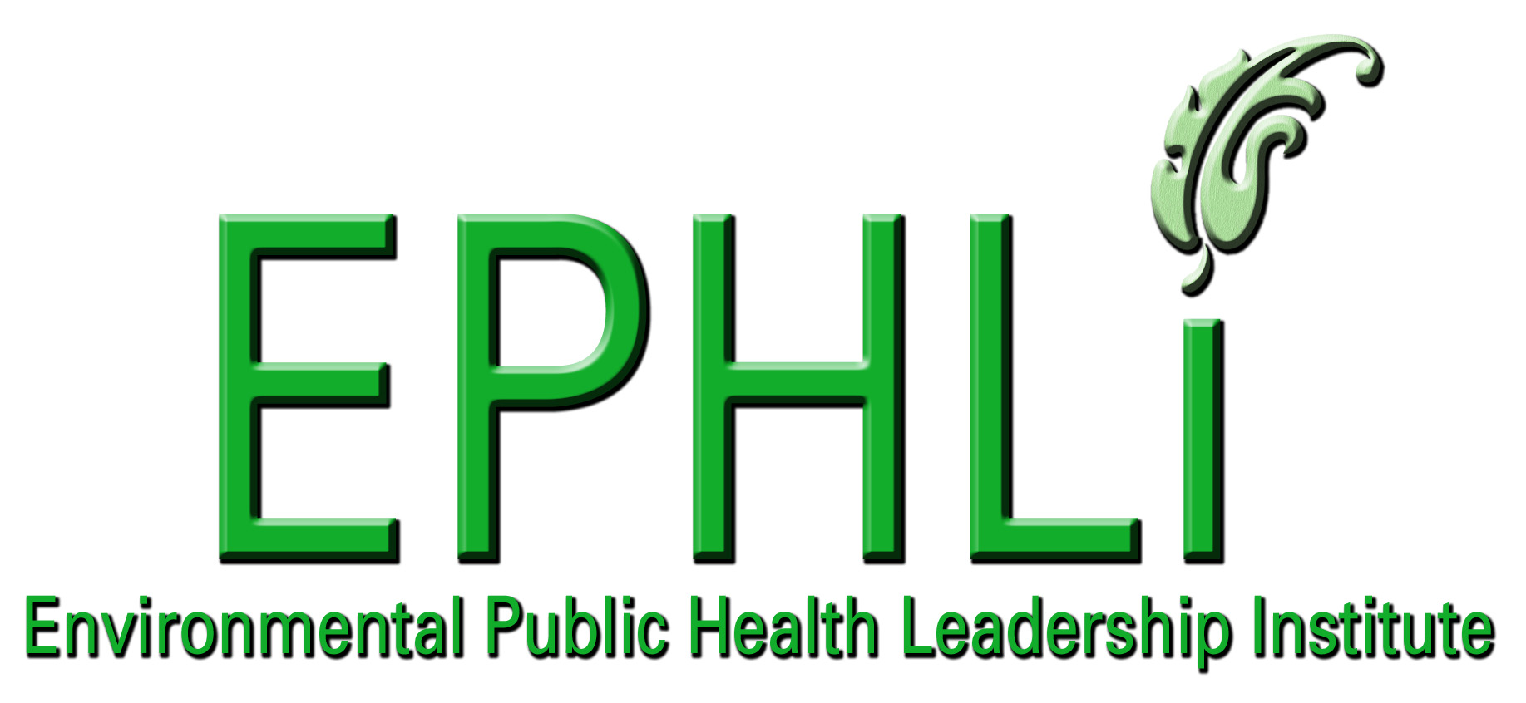

EXECUTIVE SUMMARY:

If an environmental health program lacks competent staff or the capacity to provide essential environmental health services, the community doesn’t have adequate protection from environmental health risks. In an effort to ensure a competent workforce and sustain program improvements, the agency undertook an initiative to create workforce development plans and individual professional development plans. A system was developed to annually assess employee competency. In addition, a reporting format was developed for routinely documenting and reviewing the integration of the Ten Essential Environmental Health Services in an attempt to build program capacity. Establishing a system to routinely assess staff competencies and program improvements through integration of the Ten Essential Environmental Health Services and the Core Competencies for Environmental Public Health Professionals is essential in ensuring a competent workforce and sustaining program improvements.

INTRODUCTION/BACKGROUND:

On November 5, 2002, Yellowstone County voters passed a 4.75 mill increase for public health activities. The Yellowstone City-County Health Department was the first health department in the State of Montana to pursue a voter approved mill levy. To assure appropriate utilization of the local tax dollars the goal was to improve access to and availability of health department services. In an effort to accomplish this goal, additional staff were needed with a specific knowledge of and focus on public health.

Since May 2003, the Yellowstone City-County Health Department’s Environmental Health (EH) Program has grown from 4.0 FTE Registered Sanitarians and .5 FTE support staff to 8.0 registered Sanitarians, 1.0 FTE Environmental Specialist and 1.5 FTE support staff.

During this same time period, the EH budget increased from $221,500 in fiscal year 2002-03 to nearly $800,000 in fiscal year 2005-2006. Prior to the increases in the staff and funding, the number of activities required of EH staff had grown to a level where minimum standards were being met, but the quality of service and ability to take a proactive approach to local environmental health concerns were beginning to suffer.

Adding staff positions was essential to meeting the goals of improving access and availability, but with the addition of staff came the challenge of ensuring a competent workforce and demonstrating sustainable program improvement. The organization did not anticipate the additional struggles related to training, continuing education, assessing competency and measuring improvement that emerged once the positions had been filled.

Problem Statement:
Without a competent staff or the capacity to provide essential environmental health services, a community doesn’t have adequate protection from environmental health risks.

Behavior Over Time Graph:

As the number of registered sanitarians in the program increased, so did the community expectation to provide quality service. However, without a system to measure staff competency and integrate training into practice, program improvements were not sustained.

Causal Loop Diagrams and applicable archetype:

Traditionally employee development problems were solved by sending employees to training classes (B1) rather than developing and implementing an overall EH workforce development plan (B2). Over time, staff thought that attendance at trainings equaled increased knowledge and competency which reduced their commitment to participating in an ongoing workforce development program, and also increased program dependence on training attendance as a way to increase employee competency (R1).

10 Essential Environmental Health Services:
The primary focus of this project was assuring a competent workforce; in addition emphasis was placed on program assessment & development based on the overall integration of all of the Ten Essential Environmental Health Services.

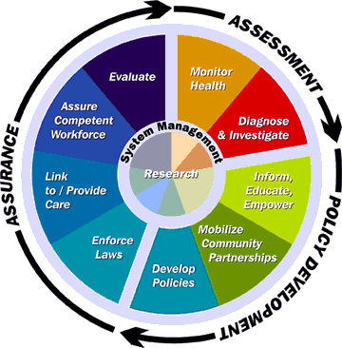

National Goals Supported

National Strategy to Revitalize Environmental Public Health Services

Goal I (Build Capacity) intends to improve and support environmental public health services. This project supports the integration of the Ten Essential Environmental Health Services as a means to build capacity in a local environmental health program.

Goal V (Develop the Workforce) promotes the development of a competent and effective environmental public health workforce including defining performance standards and competencies. The goals of this project directly support the assessment of workforce competency and improving the environmental health professional’s ability to perform the recommended core competencies.

Environmental Health Competency Project: Recommendation for Core Competencies for Local Environmental Health Practitioners
The competency assessment used in this project is based on each employee’s ability to perform the 14 recommended Core Competencies for Local Environmental Health Practitioners. This allows agencies to identify overall development opportunities for their environmental health workforce and allows individuals to customize personal development plans based on their need to improve their ability to perform these competencies.

PROJECT OBJECTIVES/DESCRIPTION/DELIVERABLES:

Program Goal
Ensure a competent workforce and sustain program improvements in environmental health

Health Problem
If an environmental health program doesn’t have competent staff or the capacity to provide essential environmental health services, the community doesn’t have adequate protection from environmental health risks.

Outcome Objective
Create workforce development plans and individual professional development plans for environmental health staff and align these with program needs and goals through integration of the Ten Essential Environmental Health Services and the Core Competencies for Environmental Public Health Professionals.

Determinant
The number of employees that demonstrate an increase in their ability to perform the Core Competencies for Environmental Public Health Professionals and integrate the Ten Essential Environmental Health Services into their daily work.

Impact Objective
By January 1, 2008 establish a system to routinely assess staff competencies and program improvements through integration of the Ten Essential Environmental Health Services and the Core Competencies for Environmental Public Health Professionals. By January 1, 2008 establish a standardized training program for newly hired environmental health professionals.

Contributing Factors
There has been no standardized procedure for defining training needs according to agency goals, for training new staff, or a systematic approach to providing continuing education. In addition the agency did not routinely assess staff competency, as performance evaluations are not aligned with the Core Competencies for Environmental Public Health Professionals. There is limited opportunity to formally share new materials amongst staff and ensure that this material is incorporated into program activities.

Although the current budget supports staff training and educational opportunities there is currently no systematic approach to assessing staff competencies, or seeking opportunities to improve these competencies.

By developing a systematic approach to determining who attends what training sessions, an agency can better develop their workforce, share the information learned, and get the most out of their education budget. These issues can be addressed through the use of an ongoing workforce development plan which aligns the goals of the agency with the individual development needs of employees. This reduces the perception of favoritism that can occur when there is no systematic way of selecting training attendees. This type of plan provides a consistent understanding of how and why employees are selected to attend trainings. Helping employees manage their careers, builds loyalty and trust; makes for more efficient workers; and can help manage conflict, reduce stress, and improve staff attitudes¹.

Process Objectives
1. By December 31, 2006 100% of Environmental Health staff shall demonstrate the ability to integrate the Ten Essential Environmental Health Services into their areas of responsibility.

2. By July 1, 2007 75% of environmental health staff shall participate in workforce development through improving core competencies.

3. By July 1, 2007 a systematic approach will be used for all training and continuing education activities.

4. By December 31, 2007 workforce development plans will be developed for 75% of environmental health staff.

METHODOLOGY:

Activities:

1. Integration of Ten Essential Environmental Health Services
- Conduct an assessment of employee’s current knowledge of the Ten Essential Environmental Health Services
- Educate staff on the Ten Essential Environmental Health Services
- Conduct a post-assessment of employee’s knowledge of the Ten Essential Environmental Health Services
- Develop a system to routinely review how the Ten Essential Environmental Health Services are being integrated into environmental health programs

2. Core Competency Assessment & Development
- Educate staff on Core Competencies for Environmental Public Health Professionals
- Establish a routine method of assessing staff abilities to perform the Core Competencies for Environmental Public Health Professionals (self-report & supervisor review)
- Conduct a gap analysis for each EH professional to identify which trainings are highest priority for each sanitarian
- Help employees formulate an individual development plan to improve core competencies
- Develop a system to follow-up with employees, including management oversight

RESULTS:
1. Integration of Ten Essential Environmental Health Services
The Knowledge and Practice Questionnaire and Pre/Post Test of Training provided in the Essential Services of Environmental Health: A Training Module Developed by Carl Osaki, RS, MSPH² were used to evaluate each employee’s current knowledge of the Ten Essential Environmental Health Services. This Training Module was then used to provide education on the Ten Essential Environmental Health Services. Average test scores increased from 68.3% to 84.9% from the pre-test to the post-test indicating an increase in knowledge gained from the training. Monthly reporting documents were developed to assist staff in tracking their program activities in terms of the Ten Essential Environmental Health Services. All staff members are responsible for the completion of these documents. Two individual Environmental Health staff have been assigned the responsibility of summarizing these activities by program, and will be involved in the assessment, gap analysis, and development of action plans to further integrate the Ten Essential Environmental Services into the programs for which they have oversight.

Next Step: Quarterly assessments of these monthly activity reports will be used to identify gaps and develop action plans to further integrate the Ten Essential Environmental Services into each program area.

2. Core Competency Assessment & Development
Employees were presented with the Recommendations for Core Competencies for Local Environmental Health Professionals³. A questionnaire was designed as an objective, non-performance based assessment of each individual’s ability to perform the non-technical core competencies for Environmental Health professionals. Self assessments were conducted by each of the staff members, and the EH Director completed an assessment of each person as well. Each person was asked to indicate the level of one’s ability to perform each competency in terms of no ability, some ability, significant or complete ability.

The results of the individual assessments were averaged to identify development needs of the environmental health staff as a group. In addition, each employee was able to identify their individual competencies that need further development.

An annual staff development calendar was created to address the competency areas identified as needing the most improvement. Each staff member also selected an individual core competency and created an individual development plan outlining activities that will assist them with the goal of improving their ability to perform this competency over the next year.

Next Step: The self-assessment and supervisor assessments will be used annually to identify program and individual development needs. An annual staff development plan and individual development plans will be created annually as a means to continuously improve employee ability to perform the Core Competencies for Local Environmental Health Professionals. Comparisons will be made with the previous year’s assessment to monitor improvement in these areas.

FUTURE ACTIVITIES:

3. Staff Training & Continuing Education
- Develop programmatic goals and conduct a gap analysis to identify which training is highest priority for the organization
- Develop a standardized training model for new hires.
- Align continuing education opportunities with programmatic goals and develop systems to measure program improvement
- Involve staff in designing a system to support ongoing continuing education
- Integrate new learning into procedures and activities
- Ensure new learning is shared with other staff

4. Workforce Development Plans
- Routinely assess agency vision, employee professional and personal goals, and provide feedback on skills and abilities
- Help employees formulate individual development plans
- Select training and other opportunities that match job/organizational needs and employee career development objectives
- Follow-up with employees after a learning experience to integrate new skills and acquired knowledge into their responsibilities
- Implement a system to share new knowledge with the rest of the staff

CONCLUSIONS:
Establishing a system to routinely assess staff competencies and program improvements through integration of the Ten Essential Environmental Health Services and the Core Competencies for Environmental Public Health Professionals is essential in ensuring a competent workforce and sustaining program improvements. Such a system assists employees in managing their careers, provides a platform to measure employee growth in non-technical competencies, and establishes a workforce development program that offers on-going program improvement. This type of system requires cooperation and commitment from all staff involved. Thoroughly educating staff in the areas of the Core Competencies and Ten Essential Environmental Health Services is important in establishing a strong framework upon which to build future improvement plans.

LEADERSHIP DEVELOPMENT OPPORTUNITIES:

Jennifer L. Pinnow
Participation in the Institute provided a platform to develop ideas and provided credibility and support for these initiatives. By encouraging me to engage an executive sponsor to provide feedback for my project, the Institute presented me with the opportunity to network with our department’s upper adminsitration. This increased my confidence in presenting new ideas and solutions to long-standing problems.

The time we spent in self-reflection was very enlightening. The self-assesment tools and use of a personal coach provided by the Institute not only gave me the opportunity to understand myself better, but additionally provided examples and suggestions for implementing long-term change. Not only did I learn from the curriculum, self-study, instructors, my wonderful mentor and supportive team, but also from other fellows, and ultimately myself.

Special thanks to the Yellowstone City-County Health Department, it’s administration and my program director for not only nominating me for the Insitute, but also for giving me the time and support needed to get the most out of this wonderful experience. I will continue to use the systems thinking methods and problem solving abilities I’ve gained from the Institute to research, develop, and implement innovative solutions to environmental health problems. I’d also like to thank the many agencies involved in supporting and administering the Institute for their commitment to education and developing future leaders in environmental public health.

ABOUT THE EPHLI FELLOW(s)

Jennifer Pinnow has been a Registered Sanitarian with the Yellowstone City-County Health Department since 1992 and holds a Registered Environmental Health Specialist credential from the National Environmental Health Association. She has served as Assistant Environmental Health Director since 2000. Ms. Pinnow is a certified instructor with the National Restaurant Association’s Educational Foundation ServSafe Program, a National Environmental Health Association Certified Food Safety Professional, and a Certified Pool Operator. Her current duties include workforce and program development, coordinating industry and staff trainings in the areas food service and children’s environmental health, and general oversight of the food service program.

She was responsible for the 2003 Yellowstone County Environmental Health Needs Assessment, and the subsequent formation of the Yellowstone County Food Safety Advisory Group which solicits broad spectrum input as to specific local concerns as they related to food safety in Yellowstone County.

Ms. Pinnow was recently awarded the 2006 William G. Walter Outstanding Sanitarian Award from the Montana Environmental Health Association.

REFERENCES

- Campbell, Mark. Society of Professional Consultants. “Ten Keys for Successfully Coaching Employees”. [Online] Available at http://www.spconsultants.org/articles/mcampbell.htm

- University of Washington. Northwest Center for Public Health Practice, School of Public Health & Community Medicine. Essential Services of Environmental Health, A Training Module Developed by Carl Osaki, R.S., MSPH. [Online] Available at http://www.nwcphp.org

- CDC. Environmental Health Competency Project: Recommendations for Core Competencies for Local Environmental Health Practitioners. Atlanta (GA):Dept. of Health and Human Services (US), CDC; 2001

ADDITIONAL RESOURCES

Atchison, Tom. Followership: Aligning Leaders and Followers, Chicago (IL): Foundation of the American College of Healthcare Executives; 2004.

CDC. A National Strategy to Revitalize Environmental Public Health Services. Atlanta (GA): Dept. of Health and Human Services (US) CDC; 2003. [Online] Available at http://www.cdc.gov/nceh/ehs/Docs/nationalstrategy2003.pdf

