What Can Be Done To Improve the Air Quality in San Antonio
2006 - 2007

Environmental Public Health Leadership Institute Fellow:

Monty J. McGuffin; BS, RS
Senior Sanitarian
Food & Environmental Division
San Antonio Metropolitan Health Department
332 W. Commerce St.
San Antonio, Texas 78205
210-207-8853
monty.mcguffin@sanantonio.gov

Mentor:

Lisa Conti; DVM, MPH, ACVPM, CEHP
Director, Division of Environmental Health; Florida Department of Health

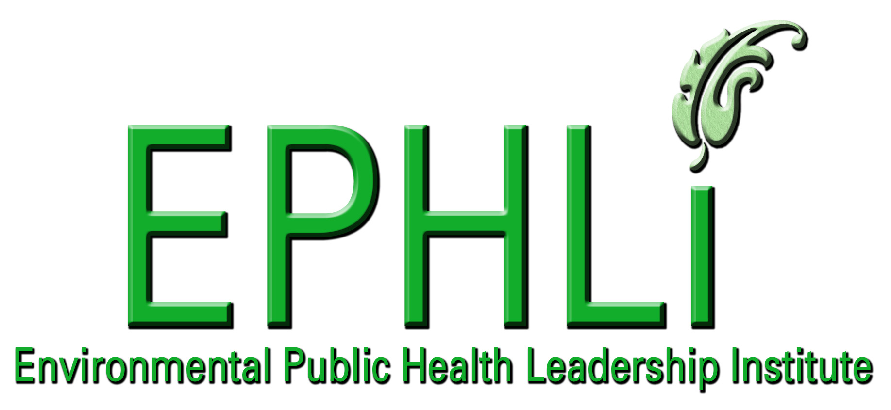

EXECUTIVE SUMMARY:

The Expanding population and explosive growth in industry are making San Antonio one of the fastest growing cities in the state. With all the benefits that come with a growing population and a prosperous local economy, there is always a downside. For the San Antonio Metro area that down side is Air Quality. The goal of this project is to show where we are now and what we need to do to help improve the situation.

INTRODUCTION/BACKGROUND:

The citizens and leadership of the city of San Antonio have long made famous the idea that we are a big city with small town charm, however, in a time when the environment and climate are changing so fast it’s almost impossible to keep up with, it is imperative for people to try to make our city a healthier place to live.

Over the previous five to ten years, the metro area has grown in astronomical proportions in regards to population and housing development. This exponential growth can be contributed to the fast growing job market in this region, as this once laid back small town has grown into an industrialized city. With an ever growing economy, industry, and population, the city of San Antonio and its surrounding counties now have an Air Quality issue to deal with. This problem is one that has plagued other large industrialized cities for years.

Along with the explosion of growth, more construction and more people mean more pollution. The fast growing economy and population have rapidly put the San Antonio region on course to be categorized as a non-attainment city by the EPA. Now that the issue of air quality is sitting in the lap of citizens and government officials, it’s time to consider what options we have to help improve the situation.

Two main issues that come with a region suffering from poor air quality are extremely poor health effects and the EPA rating of a non-attainment city. These are two items that can severely hamper the life of a city. The poor health effects will contribute major problems to persons with asthma, emphysema, and overall poor respiratory functions. This, in return, can put a strain on the health care systems in the metro area. The implementation of various control measures that would be placed upon the businesses and citizens of the San Antonio metro area could also be a hindrance to lifestyle. The implementation of Stage II vapor recovery systems at all fuels stations, emissions check on automobiles, and special fuel blends would all put an immediate financial strain on the people in the region. The EPA could place stern restrictions on the amount of omissions on current and future businesses that decide to call this area home. This would be a huge deterrent to any further industrialized development in the area, which would have adverse effects on the economy.

The point of focus will be toward educating the public and private industry regarding the effects of becoming a non-attainment city. Through education, teaching people and companies various things they can do personally at home and at work to help reduce ozone levels would be tantamount to success. With additional funding, we could possibly improve upon the City of San Antonio Metro Health’s current Air Inspection program. The goal would be to strengthen the ordinance already in place and increase the number of facilities licensed and inspected. This would also allow us to better monitor and educate these facilities with the goal of making them better stewards of the environment.

These ideas and any action, of course, will require support from city, county, and state leaders as well as the Alamo Area Council of Governments. This will have to be a group effort to help keep the entire region out of a pending predicament and must include funding for additional staff and continuous training to stay abreast of current state and federal mandates.

All of these factors will place both personal and economical tolls on the residents in the affected city/region that would be labeled non-attainment. Working this project, I will outline just a few things both citizens and companies can do differently to hopefully change the course the city of San Antonio and the metro area are facing in the future.

Problem Statement:

What can be done to improve the Air Quality in the San Antonio Metro Area?

Behavior over Time Graph

The demands on government over the past few decades have caused a shift in being able to support various programs. The City of San Antonio at one time had a model Air Pollution/Inspection Program. With the TCEQ taking the lead on monitoring and the inspection of facilities in the Metro area, the program was reduced to the current status. With the current growth in both population and business the city is poised to revive the Air Pollution/Inspection Program.

In the past, the amount of monies going into the Air Pollution Program is equivalent with facilities located within the city of San Antonio. With the current there is a rise in the number of facilities and a decrease in funding and staffing in the Air Inspections Program.

Causal Loop Diagrams and applicable archetypes:

10 Essential Environmental Health Services
This project has several components to fulfill the goals of the10 Essential Environmental Health Services.

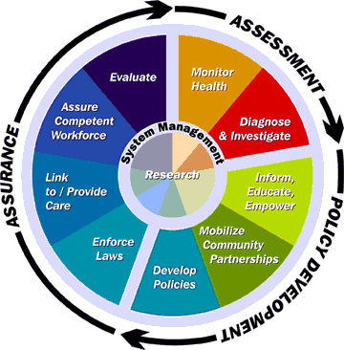
Figure 1: The Linkage of Essential Services to Core Functions
By Carl Osaki, RS, MSPH, Northwest Center of Public Health Practice¹

- Monitor environmental and health status to identify community environmental health problems
- Monitor local cases of asthma and respiratory related issues

- Diagnose and investigate health problems and hazards
- Investigate issues/complaints in regards to Air Quality

- Inform, educate, and empower people about environmental issues
- Provide information to citizen through pamphlets, public access television, community meetings, and public outreach events

- Mobilize community partnerships to identify and solve environmental health problems
- Collaborate with city, county, and state regulator authorizes
- Work in conjunction with the Alamo Area Council of Governments to educate and inform citizens

- Enforce laws and regulations that protect health and ensure safety
- Enforce Ordinances passed bye the City of San Antonio
- Prevent unlicensed facilities from operating within the City
- Prevent facilities from operation that are not in compliance
- Reduce the amount of pollutants discharged from facilities

- Link people to needed services and assure the provision of health care when otherwise not available
- Strengthen relationships/partnerships with local, county, and state agencies
- Form a dialogue with local University Health System

- Assure a competent workforce
- Provide for staff to train with technical experts from the state
- Provide for staff to attend Visible Omissions Training
- Provide for staff to attend Continuing Training Courses

- Evaluate the effectiveness, accessibility and quality of personal and population based environmental health services
- Provide statistics on new facilities licensed
- Review cases of asthma and respiratory related issues

National Goals Supported
This project relates to two of the CDC Health Protection Goals:

Healthy Communities:
- Increase the number of communities that have high quality air, water, food, and waste disposal, and are safe from toxic chemicals, infectious disease, and other health hazards
- Support equitable access to and receipt of essential good health promotion, good health education, public health, and available medical services

Healthy Workplaces:
- Assessing worker exposures to toxic chemicals

This project supports three goals set forth by the National Strategy to revitalize Environmental Public Health Services

Communicate and Market: Improve communication and information sharing among environmental public health agencies, communities, strategic partners, and other stakeholders as well as better market environmental public health services to policy makers and the public.

Develop the Workforce: Promote the development of a competent and effective environmental public health services workforce

Create Strategic Partnerships: Foster interactions among agencies and organizations that influence environmental public health services. This project has the potential to follow all of the recommendations for core competencies for local environmental health practitioners.

Assessment:
- Information Gathering: The capacity to identify sources and compile relevant and appropriate information when needed, and the knowledge of where to go to obtain the information
- Data Analysis and Interpretation: The capacity to analyze data, recognize meaningful test results, interpret results, and present the results in an appropriate way to different types of audiences
- Evaluation: The capacity to evaluate the effectiveness of performance of procedures, interventions, and programs

Management:
- Problem Solving: The capacity to develop insight into and appropriate solutions to environmental health problems
- Economic and Political Issues: The capacity to understand and appropriately utilize information concerning the economic and political implications of decisions
- Organizational Knowledge and Behavior: The capacity to function effectively within the culture of the organization and to be an effective team player
- Project Management: The capacity to plan, implement, and maintain fiscally responsible programs/projects using appropriate skills, and prioritize projects across the employee’s entire workload
- Computer & Information Technology: The capacity to utilize information technology as needed to produce work products
- Reporting, Documentation, and Record-Keeping: The capacity to produce reports to document actions, keep records, and inform appropriate parties
- Collaboration: The capacity to form partnerships and alliances with other individuals and organizations in order to enhance performance on the job

Communication:
- Educate: The capacity to use the environmental health practitioner’s front-line role to effectively educate the public on environmental health issues and the public health rationale for recommendations
- Communicate: The capacity to effectively communicate risk and exchange information with colleagues, other practitioners, clients, policy-makers, interest groups, media, and the public through routine activities, public speaking, print and electronic media, and interpersonal relations
- Conflict Resolution: The capacity to facilitate the resolution of conflicts within the agency, in the community, and with regulated parties
- Marketing: The capacity to articulate basic concepts of environmental health and public health and convey an understanding of their value and importance to clients and the public

Activities
Resources/Inputs
Short & Long Term Outcomes, Impacts

Outputs

Learning
- Improved understanding of all agencies
- Increased number of trained and educated staff
- Increased collaboration between partners
- Improved interaction between agencies
- Increased ability to assess training needs
- Improved understanding of related health effects
- Improved funding for Air Pollution Programs

Results
- Improved Air Quality for San Antonio Metro Area
- Decline in Respiratory related illness
- Not being labeled non-attainment
- Deciding who be lead agency
- Who will be primary on scene
- Who will develop standards
- Who will provide uniformed Training
- What roles and job description will each agencies play

Involvement
- Federal
- State
- County
- City

Funding
- Federal
- State
- County
- City
- Number of persons trained to do inspection
- Number of Educational Programs Held
- Number of cases reported/detected due to respiratory effect
- Number of facilities found in violation
- Number of facilities brought into compliance

Behavior
- Increased understanding for what role all agency’s undertake
- Better understanding of Environmental implications
- Improved Environmental Stewardship by industry and citizens
Planning and Development
- Design a check list of every service an agency can provide
- Develop a plan for what services will be provided
- Develop a unified inspection to meet a city, state, and federal requirements
- Develop a system to convey all information to parties involved
- Develop an educational program to educate business and general population

Training
- Visible Emissions Training
- Standard Protocols for Equipment operation
- Conduct training so all parties will know exactly what every agencies role will be
- Conduct training on enforcement procedures
- Educate courts system on importance of enforcement and fines

Learning
- Public Health agencies assess individual operation capacity
- Public Health agencies gain knowledge and skills
- Increased partnerships between PH agencies and community
- Increase in projects addressing needs of underserved communities and/or populations being affected
- Improved understanding of potential adverse health effects

Learning
- Increase cooperation between local and state agencies
- Increase collaboration between private industry
- Improved communication between government and community

- Number of joint meetings between agencies
- Number of large industries reached

Scenarios and Events
- Hold joint planning and development meetings with all involved agencies
- Hold quarterly information sharing sessions
- Collaboration with area industry
Project Logic Model
Goal: What can be done to improve the Air Quality in the San Antonio Metro Area

Personnel
- Sanitarians
- Environmental Specialist
- Program Specialist
- Epidemiologist

PROJECT OBJECTIVES/DESCRIPTION/DELIVERABLES:

Program Goal: Improve the Air Quality in the San Antonio Metro Area.

Health Problem: The various health effects that come with an area suffering with poor air quality. The increasingly high number of reported cases in regards to asthma or respiratory related issues.

Outcome Objectives: By the end of fiscal year 2007, try to secure addition funding to improve the current Air Pollution Program for the City of San Antonio.

Determinant: The main hold up is securing the addition funding for staff and training. We hope to show that after the initial start up process, within two years the program could be self-sustaining. This will be accomplished through the license fee collected from the additional sources added to the inspection program.

Impact Objective: Secure funding for an expanded air pollution program for the city of San Antonio within FY08-FY09

Contributing Factors:
- The ability to secure funding
- The ability to improve upon the existing ordinance to encompass all facilities
- The acceptance of an ordinance change by facilities that would be affected
- The ability to hire and train new or existing staff
- The ability to be a self-sustaining division

Process Objectives:
- Continue to strengthen partnerships with other agencies
- Secure funding for program
- Expand and improve Air Pollution ordinance
- Develop and train staff
- Educate and inspect facilities
- Educate and inform public

METHODOLOGY:

Events and Activities
- Continue to meet with City Counsel Member to secure additional funding
- Continue to collaborate with city, county, state, and outside agencies to see what we can do in regards to Air Quality

RESULTS:
The ground work for this project to become a reality is complete. The reasoning, cost, and need have been expressed to the target audience. The next phase of the project will be the securing of funding. Once that it is in place, we will be able to move into the implementation stage of the project. This will include the hiring of additional staff, training, and ordinance revisions. Once the new staff is totally trained, it will be time to attempt to license, inspect, and educate the businesses and citizens of San Antonio.

CONCLUSIONS/EXPECTED OUTCOMES:

The success of this project relies solely on securing additional funding from the city of San Antonio. If funding cannot be secured from the city, we will continue to look for additional funds from the state of Texas and available grant opportunities.

LEADERSHIP DEVELOPMENT OPPORTUNITIES:

Monty Joe McGuffin

This awesome opportunity to be a part of EPHLI has been a huge eye-opener and change from my normal routine. My typical day consists of answering questions and solving problems that require an immediate response. The inspection of facilities, answering impromptu questions from citizens, and solving health issues all have to be accomplished at the same time I’m trying to train and develop a competent staff. The division I manage is the catch-all for the city’s health issues. If no one else on the city’s staff can help, citizens’ complaints are referred to my department to review, analyze and solve. Since I work in an environment that expects immediate responses and results, I readily don’t have time to analyze a problem in a systems thinking manner. EPHLI has given me tools to look at situations in a different sight picture, and I will share these tools and ideas with my staff to recognize better problem solving techniques.

I also am thankful for the new friends and “professional contacts” I have met. I plan to use the tools given me to expand my role in environmental health, thereby increasing my department’s value, knowledge, skills and ability.

ABOUT THE EPHLI FELLOW

Monty Joe McGuffin, BS, RS, is the Environmental Services Manager for the San Antonio Metropolitan Health District, Environmental Division for Food and Environmental Health Services.

Mr. McGuffin is currently responsible for supervising a staff of six field agents plus six clerical staff. They conduct routine investigations for swimming pools, mobile home parks, rendering plants, air pollution sources, carriage companies, horse stables, and school surveys. His staff also investigates complaints in regards to illegal dumping, recreational water pollution, hotel/motel complaints, lead based paint, air quality, water quality, and waste removal. The staff also inspects and investigates all environmental and food issues that take place in the unincorporated areas of Bexar County.

Previously, Mr. McGuffin worked in the Food Safety Division of San Antonio for two years receiving his certification as a Registered Sanitarian in 2002.

Mr. McGuffin has been responsible for a myriad of tasks including being a key team member for displaced people during the Katrina/Rita catastrophes that impacted over twenty thousand individuals from the gulf coast region; being a key member of a Bio-terrorism Response Team; aiding in the developing of an automated inspection program for sanitarians and also presenting briefings regarding environmental health issues to companies and community groups.

Mr. McGuffin has received recognition for his professionalism and devotion in his work in the arena of environmental health. He was 2005-2006 Central Texas Chapter President of the Texas Environmental Health Association (TEHA). He is a member of various professional organizations including the Alamo Air & Waste Management Association (A&WMA), Alamo Chapter. He is a member of the National Environmental Health Association (NEHA). Mr. McGuffin is also a certified Pool Operator and a certified Lead Risk Assessor. Mr. McGuffin received his undergraduate degree in Animal Science/Science from Sam Houston State University.

REFERENCES

- Carl Osaki, RA, MSPH, Northwest Center for Pubic Health Practice, Essential Services of Environmental Health, Available at: http://www.sboh.wa.gov/Meetings/Meetings_2002/2002-09_11/documents/Tab11_OsakiPresentation.pdf
- Robert H. Friis, Essentials of Environmental Health, 1st ed., Jones and Bartlett Publishers, 2006.
- Peter M. Senge, Art Kleiner, Charlotte Roberts, Richard B. Ross, Bryan J. Smith, The Fifth Discipline Fieldbook, Currency Doubleday, 1994.

