Public Health Significance of Unregulated and Untested Private Potable Wells

2007 - 2008

Environmental Public Health Leadership Institute Fellow:

Albert C. Gray, MPH
Environmental Manager; Hernando County Health Department
300 South Main Street
Brooksville, FL 34601
(352) 540-6840
Fax (352) 754-4486
Albert_Gray@doh.state.fl.us

Mentor:

CAPT Steve Inserra, REHS, MPH
Environmental Epidemiologist; Agency for Toxic Substances and Disease Registry
Department of Homeland Security
Health Investigations Branch

Acknowledgements:

Lillian E. Greco
Administrative Assistant I, Hernando County Health Department

Rose M. Marcone
Senior Clerk, Hernando County Health Department

Jay Fazakerley,
Senior Clerk, Hernando County Health Department

Elizabeth A. Callaghan, MS, LD
Administrator and CEO, Hernando County Health Department/Nature Coast Community Health Center

Ann-Gayl Ellis, MPH
Health Education Program Manager, Hernando County Health Department

Becky Martin
Administrative Assistant II, Hernando County Health Department

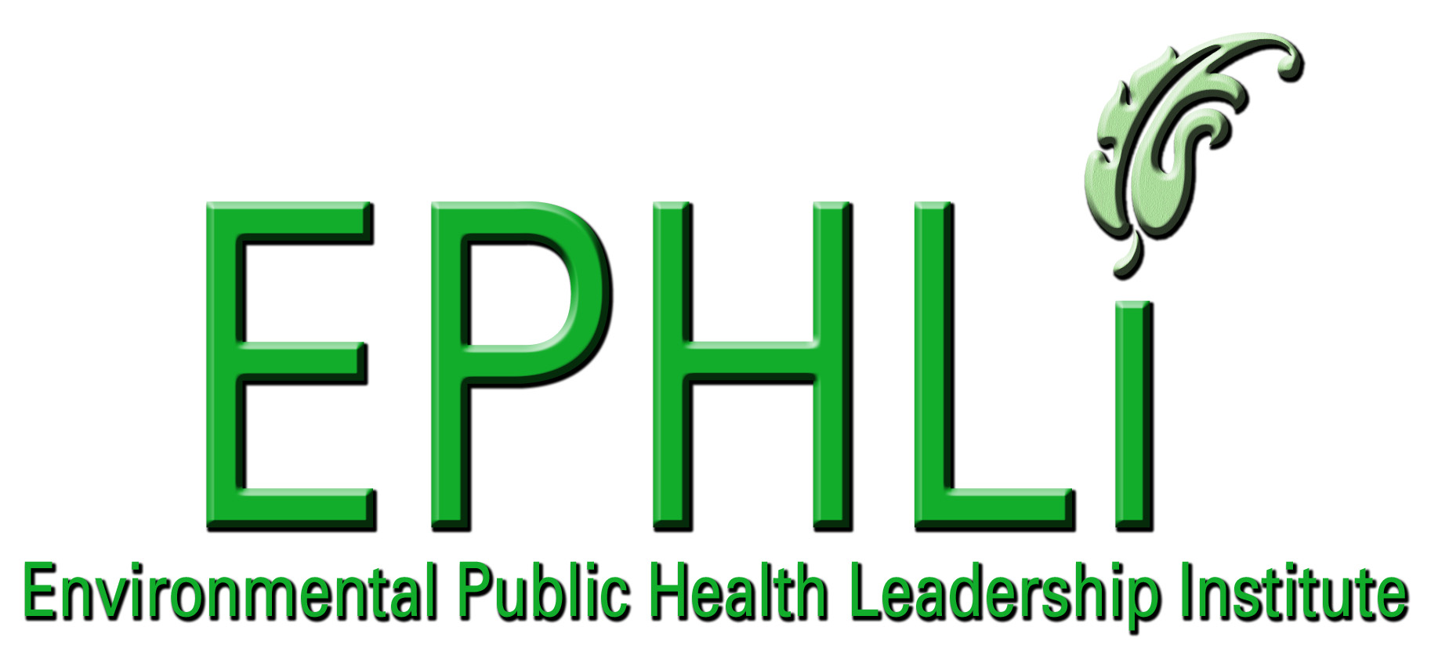

EXECUTIVE SUMMARY:

Private potable wells in Florida are generally unregulated and untested. This project attempted to examine the public health significance of the lack of regulation and testing of these wells and the level of concern by private well owners.

Thirty private potable wells in Hernando County, Florida were sampled for nitrate and fecal coliform bacteria. Global Positioning Satellite (GPS) coordinates were determined for each well. Florida Unique Identification (FLUID) tags were affixed to each well, and sanitary surveys were conducted. The public health significance of any problems revealed by the sanitary surveys was discussed with the well owner/resident. Educational materials specifically designed for private well owners were distributed.

Two of the 30 wells were positive for fecal coliform bacteria. These wells were not remediated. Three of the 30 wells initially sampled for nitrate were above the Maximum Contaminant Level (MCL). Per the Department of Environmental Protection (DEP) protocol, additional wells were sampled within a quarter mile radius of the chemically contaminated wells. Three of the 15 additional wells sampled were also above the MCL for nitrate. All six of the nitrate contaminated wells have been remediated by the installation of under-the-sink reverse osmosis filters.

The findings of this project suggest the need for additional and ongoing educational efforts directed at private well owners. The existence of both chemical and bacteriological contamination of the private wells sampled indicates a need for monitoring of private wells for contaminants. Together, these activities will reduce potential risk for water-borne illness for people served by these suspect private wells.

INTRODUCTION/BACKGROUND:

Problem Statement: There is a risk of water-borne illness from drinking potentially contaminated water from private potable wells. The well owners and public health officials may be unaware of this risk.

Behavior Over Time Graph:

A = Knowledge of public concerning private water wells due to influx of individuals who have traditionally consumed disinfected public water.
B = Sources of well contamination - sludge and septage land application sites, fertilizer and pesticides applied to crops (mainly citrus), golf courses, chicken farm manure.
C = Residential and private well development and density.
 |  |  |  |  |  |  | C
Amount |  |  |  |  |  |  | B
 |  |  |  |  |  |  | A
 |  |  |  | Time
Shifting the Burden Causal Loop Diagram

Problem Statement: What is the public health significance of unregulated
and untested private potable wells, and why is concern by well owners limited?
We do not inspect private wells, so no need for concern. (Health Department Personnel)
I have no money or desire to do these repairs on my well and/or septic tank system. (Private well owners)

 |  |  |  |  |  |  |  |  |  | Side Effects
Quick Fix
Disinfect well
 |  |  |  |  |  |  |  |  | Lack of resources at Health Department (regulatory responsibility takes precedent)
 |  |  |  |  |  | B
 |  |  | Well remediation (filter, repair/ replace well surface water protection) or septic tank drainfield repair
Cause
Lack of knowledge concerning significance of private well contamination.
Correcting
Process

 |  |  |  |  |  | Problem Symptoms  - contaminated wells  - water-borne illness |  |  |  |  | No regulations of wells = no fee support
 |  |  |  |  |  |  |  |  | R
 |  |  |  |  |  |  |  |  |  |  | Lack of private well data
 |  |  | Sanitary surveys
Health Department not notified by Department of Environmental Protection when filter installed. |  |  |  |  |  |  |  |  |  |  | Ground water pollution
Unintended Consequences
Some residents are renters, not the owners of the wells; therefore, they are not responsible for well or septic tank system repairs.

Private Well and Storage Tank in Hernando County, Florida

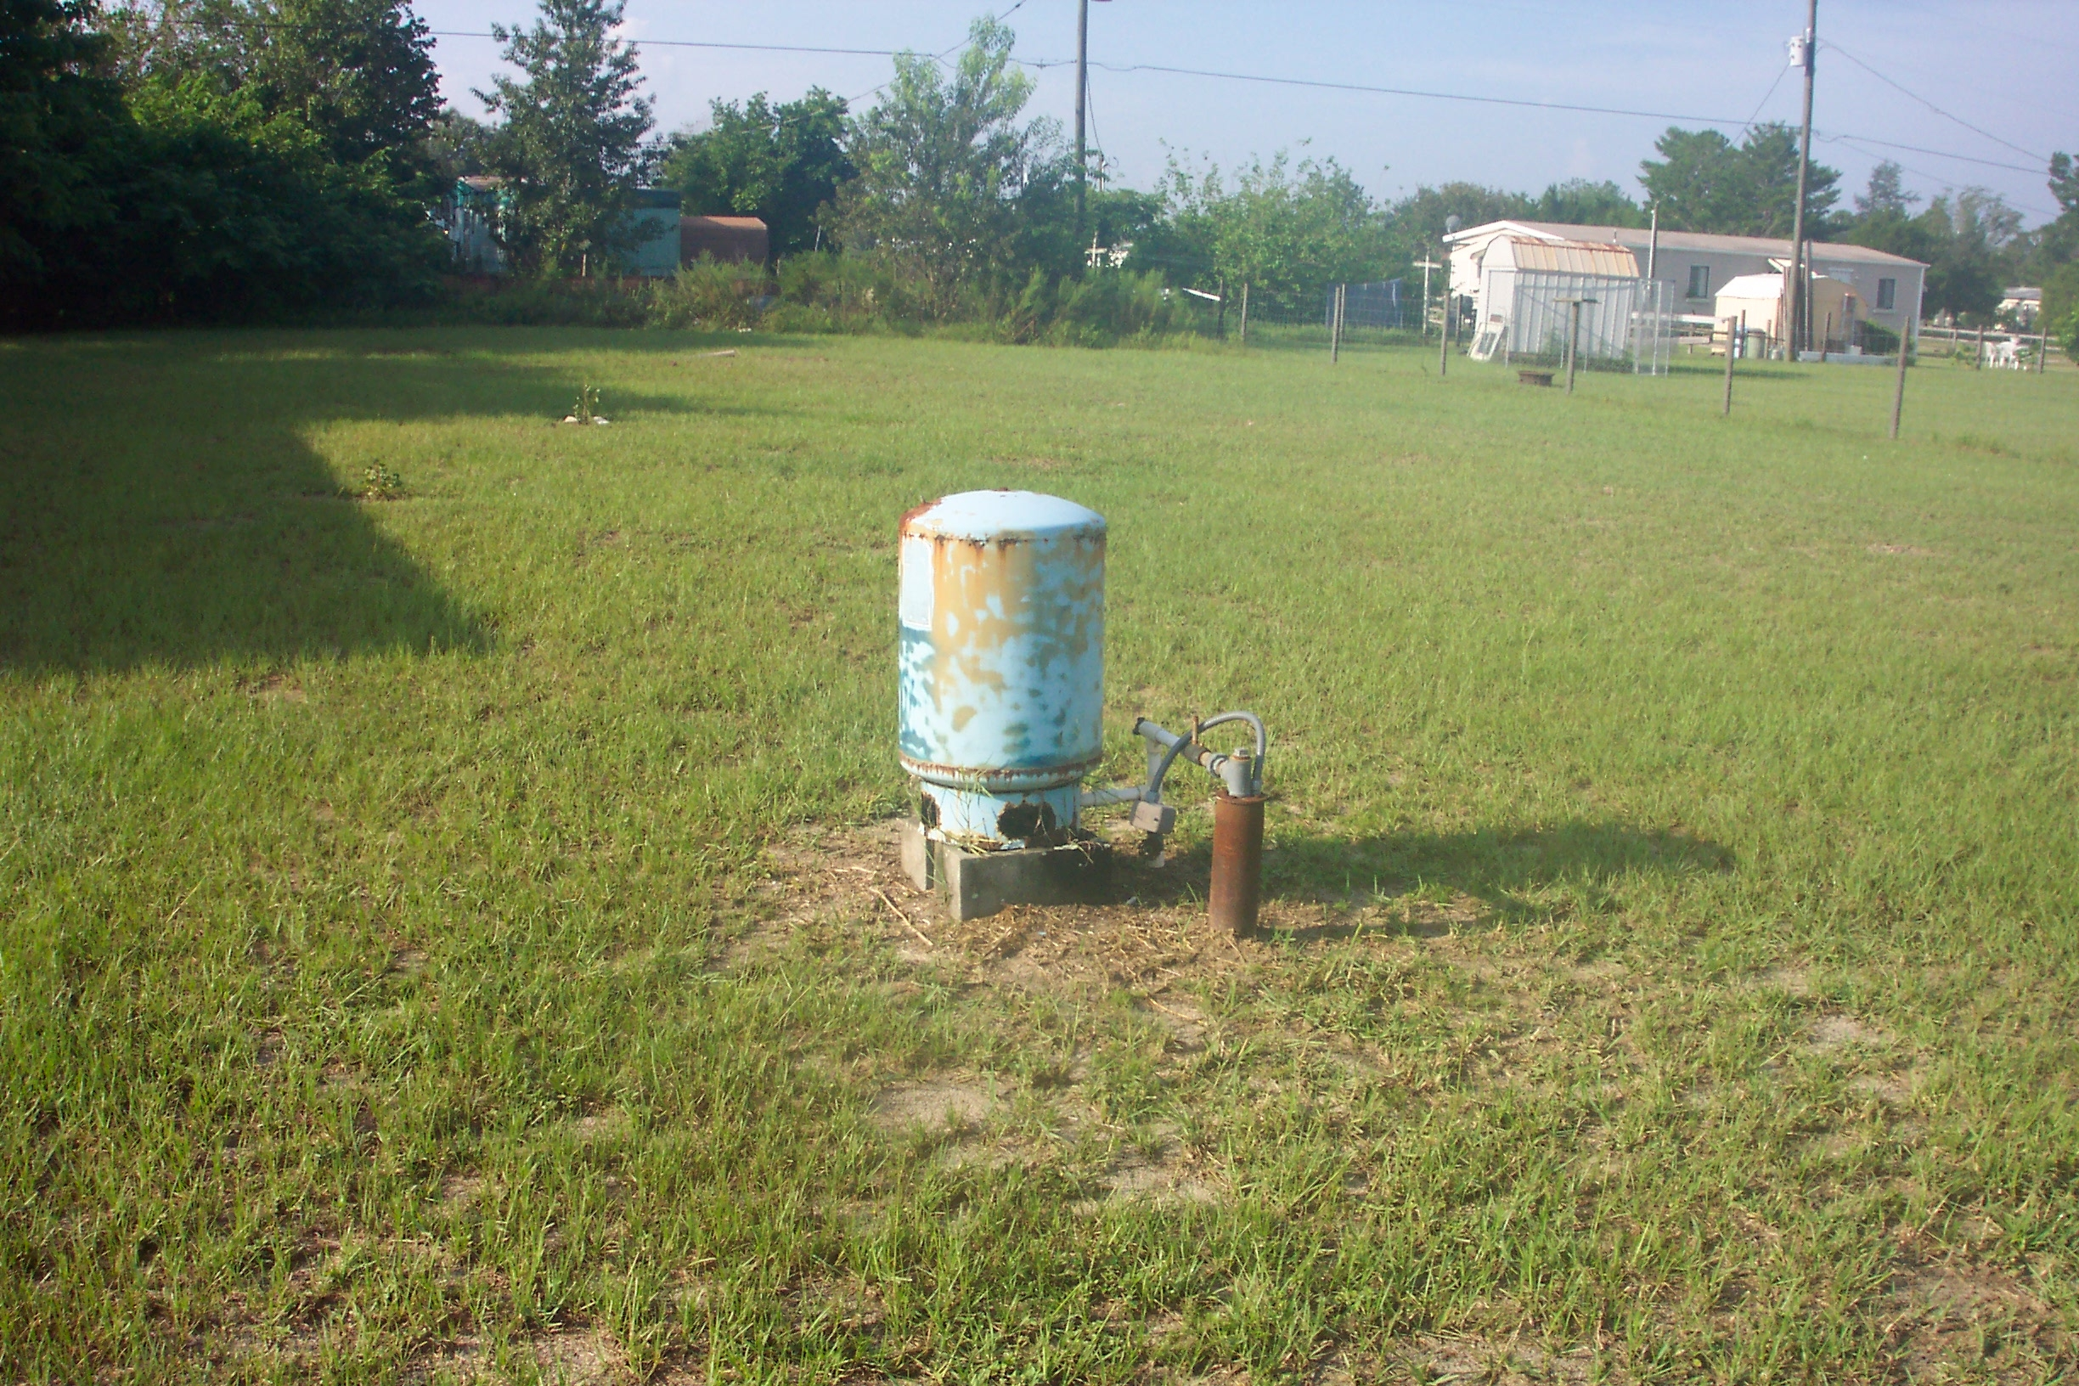

10 Essential Environmental Health Services:

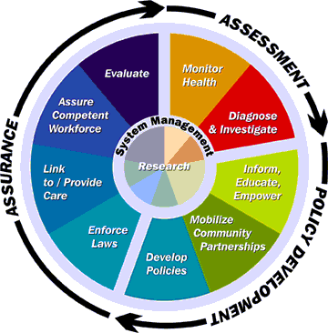
Figure 1: This picture is reprinted from CDC’s “National Strategy to Revitalize Environmental Public Health Services”¹

Essential Environmental Health Services Addressed:

- Monitor environmental and health status to identify community environmental health problems by:
Sampling of private potable wells for nitrate and fecal coliform bacteria.

- Diagnose and investigate environmental health problems and health hazards in the community by:
Performing sanitary surveys of private potable wells.

- Inform, educate, and empower people about environmental health issues by:
Explaining the results and public health significance of monitoring for nitrate and fecal coliform bacteria and any hazards discovered during the sanitary surveys.

- Mobilize community partnerships to identify and solve environmental health problems by:
Assisting well owners in the remediation of contaminated private wells.

- Develop policies and plans that support individual and community environmental health efforts by:
Developing local policies regarding assisting private well owners in determining the cause of well contamination and facilitating remediation of these wells.

- Enforce environmental health laws and regulations by:
Ensuring that statutory and rule setbacks for private wells are enforced for septic tank systems and other sanitary hazards.

- Link people to needed environmental health services and assure the provision of environmental health services when otherwise unavailable by:
Providing the public utilizing private potable wells with information concerning the quality of their drinking water supply, and how to properly test and/or remediate their well.

- Assure a competent environmental health workforce by:
Properly training environmental health staff to instruct private well owners regarding testing, disinfecting and remediating their wells.

Project Logic Model:

Resources/Inputs  Funding  - Florida Department of Environmental Protection (FDEP) funds for sampling and analysis of nitrate samples  Staff  - Albert C. Gray, Environmental Manager, Hernando County Health Department  - Mark E. Springer, Environmental Specialist II, Hernando County Health Department  - Steve Inserra, EPHLI Mentor  - Mike Goodman, Systems Thinking Coach  - EPHLI Team  - FDEP Staff  Equipment  - Ranger GPS Equipment  - Nitrate Sample Bottles  - Bacteriological Bags and Forms  - Shipping Containers  - Nitrate Field Test Kit and Reagents  - Sanitary Survey Forms | Activities  - Request funding from FDEP concerning nitrate sampling in Hernando County  - GPS wells  - Tag wells with Florida Unique ID’s  - Sample wells for nitrate and total and fecal coliform bacteria  - Conduct sanitary surveys of wells  - Perform statistical analysis of data  - During sanitary surveys and subsequently, educate private well owners concerning contamination issues and corrective action  - Develop causal loop diagram and behavior over time graph | Outputs  - Number of private wells surveyed  - Number of private wells sampled for total and fecal coliform bacteria  - Number of private wells sampled for nitrate  - Number of private wells GPS’d and tagged  - Number of sanitary surveys conducted  - Number of educational brochures distributed  - Number of wells referred to DEP for remediation  - Number of health consults resulting from sanitary surveys | Short & Long Term Outcomes and Impacts  Short Term Outcomes  - Educate homeowners concerning sampling and disinfection of their wells  - Educate homeowners of possible sanitary hazards to their wells and how to remediate these hazards  - Identify sources of contamination of private wells  - Reduce potential risk for water-borne illness  Long Term Outcomes  - Decrease bacterial and chemical contamination of private drinking water wells in Hernando County  Impacts  - Increase awareness of sources of well contamination by private well owners  - Knowledge of prevention/remediation strategies by private well owners  - Reduce risk for water-borne illness

PROJECT OBJECTIVES/DESCRIPTION/DELIVERABLES:

Program Goal
Increase public knowledge and concern about private potable wells.

Health Problem
There is a risk of water-borne illness from drinking potentially contaminated water from private potable wells. The well owners/users and public health officials may be unaware of this risk.

Outcome Objective
By October 1, 2007, at least 30 private potable well owners in Hernando County will have their wells sampled and tested at least three times for nitrate and fecal coliform bacteria.

Determinant
Private wells in disrepair or improperly constructed. Failed septic tank drainfields, commercial or residential fertilizer contamination (self-applied or from nearby commercial nurseries), septage and sludge land spreading sites.

Impact Objective
By September 1, 2007, conduct sanitary surveys on at least 30 private potable wells in Hernando County to determine the existence of sources of contamination or maintenance/operational problems with the well.

Contributing Factors
- Lack of knowledge and concern about private potable wells.
- Failure to maintain private potable wells.
- Failure to repair or maintain septic tank systems.
- Misuse/overuse of fertilizers by homeowners.

Process Objectives
- By September 1, 2007, discuss results of initial bacteriological and nitrate testing with 30 private well owners in Hernando County
- By September 1, 2007, discuss results of sanitary surveys with 30 private well owners in Hernando County.
- By July 1, 2008, assure that any failed septic tank drainfields discovered during the sanitary surveys have been repaired.
- By September 1, 2007, instruct homeowners how to properly apply fertilizers if applicable.

METHODOLOGY:

Thirty private potable wells in two areas of Hernando County, Florida were sampled three times each for nitrate (EPA Method 353.2) and fecal coliform bacteria (Standard Method 9223B)². Sampling was performed by Florida Department of Health personnel over a 90 day period in the summer of 2007 at no cost to the well owner. Global positioning Satellite (GPS) coordinates were determined and Florida Unique Identification (FLUID) tags were affixed to each well. Sanitary surveys were conducted for each well to assess well construction and maintenance integrity. The public health significance of any problems revealed by the sanitary surveys was discussed with the well owner/resident. Educational materials specifically designed for private well owners were distributed. (Appendix 1)

RESULTS:

Thirty private wells in Hernando County were identified for voluntary participation. Two of the 30 wells were positive for the health risk indicator, fecal coliform bacteria. These wells were not remediated due to lack of interest or feasibility by the household. Three of the 30 wells initially sampled for nitrate were slightly to moderately above the Maximum Contaminant Level (MCL) of 10.0 parts per million (ppm). Wells contaminated with nitrate above 10.0 ppm pose a health risk to infants due to induction of methemoglobinemia. The range of results was 0.02 to 15.00 ppm. Fifteen additional wells were sampled within a quarter mile radius of these nitrate contaminated wells. Three of these 15 additional wells were also above the MCL for nitrate. All six of the nitrate contaminated wells have been remediated by the installation of under the sink reverse osmosis filters at no cost to the homeowner. Well owners tended to display false assumptions concerning the safety of their drinking water.

Short Term Outcomes
- Educate homeowners concerning sampling and disinfection of their wells.
- Educate homeowners of possible sanitary hazards to their wells and how to remediate these hazards.
- Identify sources of contamination of private wells.
- Asses level of interest or concern of users of unregulated private wells.

Long Term Outcomes
- Decrease bacterial and chemical contamination of private drinking water wells in Hernando County

Impacts
- Increase awareness of sources of well contamination by private well owners.
- Knowledge of prevention/remediation strategies by private well owners.

CONCLUSIONS:

The findings and implications of this project suggest the need for additional and ongoing educational efforts directed at private well owners in Hernando County and statewide. Since well owners tended to display false assumptions concerning the safety of their drinking water, more education by environmental public health workers is required for this group. The existence of both chemical and bacteriological contamination in private wells sampled indicates a need for monitoring of private wells for contaminants, and long-term remediation of those wells found to be contaminated. Health risks should be communicated for groups or individuals at risk.

Are You “Well” Aware? Appendix 1

What Every Well Owner Should Know

Because we live in Florida, we are lucky to have a plentiful source of ground water. Ground water fills the cracks and pores in sand, soil, and rocks that lie beneath the surface of the earth, much like water saturates a sponge. These saturated layers of earth are called aquifers, and they are the primary source of drinking water in Florida. Due to its protected location underground, most ground water is naturally clean and free of contaminants. Unfortunately, Florida’s aquifers can also be vulnerable to contamination by chemicals and bacteria that can cause illness and disease. Bacteria and nitrate can reach the ground water through poorly maintained septic systems, livestock and agricultural areas, or as a result of poorly constructed wells. Chemicals can enter into the ground water from leaking gasoline storage tanks, pesticides, landfills, and improper disposal of toxic and hazardous wastes. In fact, there are over 31,000 areas of known groundwater contamination in Florida. As a private well owner, you should be aware of these potential risks to your household water supply.

Do you know what’s in the water that comes from your household well? If you don’t, there is one sure way to find out. Have your well water tested once a year. And don’t let myths stand in your way of getting the information you need to keep your water “well” and your family healthy.

Here are some myths we’ve busted to urge you to make that call to your local water testing laboratory or your local county health department to have your well water tested and to find out for sure that your drinking water is safe.

1.
MYTH: I haven’t seen, smelled, or tasted anything bad in my well water, so it must be safe to drink.
FACT: You can’t tell from appearance, smell and taste alone. Harmful contaminants like bacteria and nitrate can be invisible. Bacteria and nitrate can get into the groundwater and eventually into your well water from septic systems and runoff from yards and farms. Bacteria and other germs can cause illnesses with symptoms including diarrhea, nausea, and vomiting. Nitrate can be especially harmful to fetuses and babies one year old and younger.

2.
MYTH: Nobody's gotten sick from my well water, so it must be safe to drink.
FACT: Just because nobody’s gotten sick, doesn’t mean your well water is contaminant free or that someone won’t get sick in the future. Some contaminants can take many years to make you sick. It’s important to test your water now before it becomes a bigger problem, especially when you and your family’s health is at risk.

3.
MYTH: My well was inspected and it passed a water test when it was first constructed, so it is safe to drink.
FACT: Well water quality can change over time, so it’s smart to test the water on a regular basis, or whenever you notice a change in the water.

4.
MYTH: Private well water is safer than public water since it comes from a natural source.
FACT: Public water (city, county, or municipal) is routinely monitored and tested by state officials and utility personnel. If a problem is discovered by a public water system, they take action to fix the problem. However, testing of YOUR private household well is YOUR responsibility. This means unchecked private wells can carry harmful germs and nitrate that can make you and your family sick.

5.
MYTH: Testing my private well water is too expensive to have done. Everyone knows hiring any private company can be costly.
FACT: Actually, bacteria and nitrate testing can be as affordable as $10.00 to $20.00 per test. Annual testing is the best way to ensure that your well water remains safe for drinking and to help prevent larger and more expensive problems in the future. Contact your county health department for information on recommended tests, sampling instructions and prices. If problems with your well water are found, your county health department will help you find quick and affordable solutions.

Well Owner Checklist:

DO:
- Have your well water tested once a year for bacteria and nitrate.
- Ask your county health department if they recommend testing for other contaminants.
- Use a state certified laboratory to ensure that your test results are valid.
- Make sure your well’s sanitary seal is intact and water-tight.
- Check your well head and aboveground pipes each year for cracks, leaks and corrosion.
- If your well head is underground, mark the location with a permanent stake or above-ground marker.
- Keep the area surrounding your well clean, clear and well-maintained.
- Keep trash and contaminants like chemicals, pesticides, fertilizers and fuels away from your well.
- Securely cap unused or abandoned wells until properly plugged by a licensed well contractor.
- Maintain equipment such as water softeners and iron filters per the manufacturer’s instructions.
- Pump your septic tank and inspect it as often as the health department recommends.
- Keep a maintenance log of all inspections and tests on your well and septic system.

DON’T:
- Dispose of wastes in dry or abandoned wells.
- Pour toxic chemicals down household drains.
- Mix or store pesticides, fertilizers, fuels or other chemicals near your well.
- Dispose of water softener or washing machine discharge near your well.
- Let rainfall puddle or settle around your well.
- Dig near your underground water lines.
- Buy treatment equipment unless your test results are found to be unsatisfactory by a certified laboratory.
- Forget to have your well water tested every year!!!

For more information about private wells and water testing, visit the Department of Health’s private well owner information website at www.myfloridaeh.com/water/privatewells.htm or call your local county health department.

LEADERSHIP DEVELOPMENT OPPORTUNITIES:

Albert C. Gray, M.P.H.

Being a member of the Environmental Public Health Leadership Institute has provided me with a wealth of leadership tools. The systems thinking and other problem-solving strategies learned during the course of this fellowship are applicable to my job responsibilities and I have been able to incorporate them into work on various projects. Networking with the other fellows has taught me that even though we come from many different areas of the country and work for diverse institutions, we all face the same types of problems.

ABOUT THE EPHLI FELLOW

Albert C. Gray has been employed by the Florida Department of Health or it’s predecessors since 1982. He is currently the Environmental Manager for the Hernando County Health Department and has been the Director of Environmental Health since 1994. His duties include supervising programs in onsite wastewater disposal, food hygiene, coastal beach monitoring, body art, group care facilities, mobile home and recreational vehicle parks, public water systems, public swimming pools, freshwater swimming areas, biomedical waste disposal, sanitary nuisance investigations, rabies surveillance, and tanning facilities.

He holds State of Florida Professional Certifications in Onsite Sewage Disposal and Food Hygiene and is a National Swimming Pool Foundation Certified Pool Operator. He was awarded the Florida Environmental Health Association’s Golden Pen Award for 2001.

Mr. Gray holds a Bachelor of Science degree in Biology/Chemistry from Florida State University and a Master of Public Health in Environmental Health from the University of South Florida.

REFERENCES

- Centers for Disease Control. A National Strategy to Revitalize Environmental Public Health Services. Atlanta, GA: Department of Health and Human Services. Centers for Disease Control; September 2003.

- Eaton, Andrew D. (Editor), Clesceri, Lenore S. (Editor), Greenburg, Arnold E. (Editor), Franson, Mary Ann H. (Editor) Standard Methods for the Examination of Water and Wastewater. 21st Edition. American Public health Association (APHA), American Water Works Association (AWWA), & Water Environmental Federation (WEF); 2005.

