State Environmental Health Directors Association

2005 - 2006

Environmental Public Health Leadership Institute Fellow:

Lisa Conti; DVM, MPH, ACVPM, CEHP
Director, Division of Environmental Health; Florida Department of Health
4052 Bald Cypress Way, Tallahassee, FL 32399, 850-245-4250, lisa_conti@doh.state.fl.us

Mentor(s):

Sarah Kotchian; EdM, MPH, PhD
Research Assistant Professor; Department of Family and Community Medicine University of New Mexico School of Medicine and Associate Director for Planning, UNM Institute for Public Health

Acknowledgements:

Megan Weil Latshaw; PhD, MHS
Senior Director, Environmental Health Policy; Association of State and Territorial Health Officials (ASTHO)

Bonita Sorensen; MD, MBA
Deputy Secretary for Health; Florida Department of and Health

Amanda Raziano;
Policy Analyst, Environmental Health Services; ASTHO

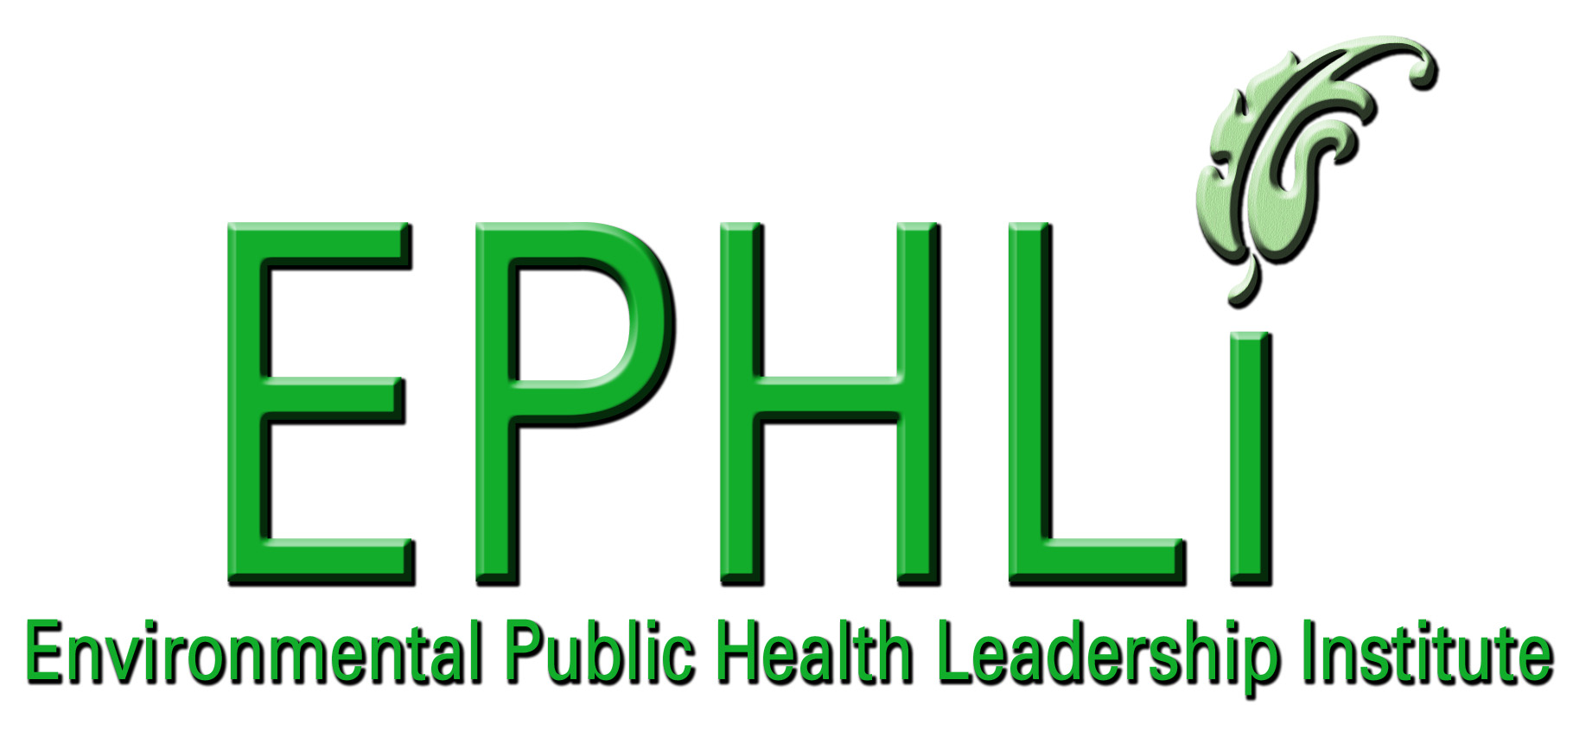

EXECUTIVE SUMMARY:

Environmental health (EH) programs vary from state to state. Some states’ EH programs are housed in environmental protection or other agencies than health departments. Because of this, it may be challenging to designate the “State EH Director” (SEHD) in some states and the group as a whole has not had a national “home,” though many EH leaders belong to various environmental or public health organizations. In a number of arenas where state program directors have joined together, they have benefited from each other’s experiences and have gained a national voice (e.g., State AIDS Directors, State Preparedness Directors, National Association of State Public Health Veterinarians, Council of State and Territorial Epidemiologists). There is considerable value in creating a formal association of SEHDs to build relationships and to create a national identity for state-based environmental health.

Through the leadership of the Association of State and Territorial Health Officers (ASTHO) and a core group of SEHDs (in cooperation with the Centers for Disease Control and Prevention, Association of Public Health Laboratories, Council for State and Territorial Epidemiologists, Environmental Protection Agency, National Environmental Health Association, Environmental Council of the States, and the National Association of County and City Health Officials), several steps have been taken to create a State Environmental Health Directors’ Association (SEHDA). From a meeting convened in April 2005, continuing with four planning conference calls in August, September and December 2005 and January 2006, the group has drafted Principles of Operation upon which to solicit state designees from all State Health Officials. Future plans for the Association include an annual national meeting, coordinating calls and the creation of an active listserv.

It is envisioned that SEHDA will help standardize environmental public health systems and approaches, support attainment of national goals such as Healthy People 2010, increase leadership capacity of SEHDs, establish a national identity for state-based EH, save resources and improve effectiveness by sharing information and best practices, and enhance advocacy for needed environmental health protections.

INTRODUCTION/BACKGROUND:

Immersion in our environment is necessary yet not without risk. Many diseases of environmental public health origin can be prevented with education and personal/community behavior modification. State Environmental Health officials need to be capacitated to effectively impart knowledge to their general populations in order to empower the public to be responsible for their own health and quality of life.

Problem Statement: A formal association of state environmental health directors is needed to build relationships and to create a national identity for state-based environmental health. A network of SEHDs will help standardize environmental public health systems and approaches, save resources by sharing information, and enhance advocacy for needed environmental health protections

Behavior Over Time Graph and Causal Loop Diagrams and applicable archetypes:

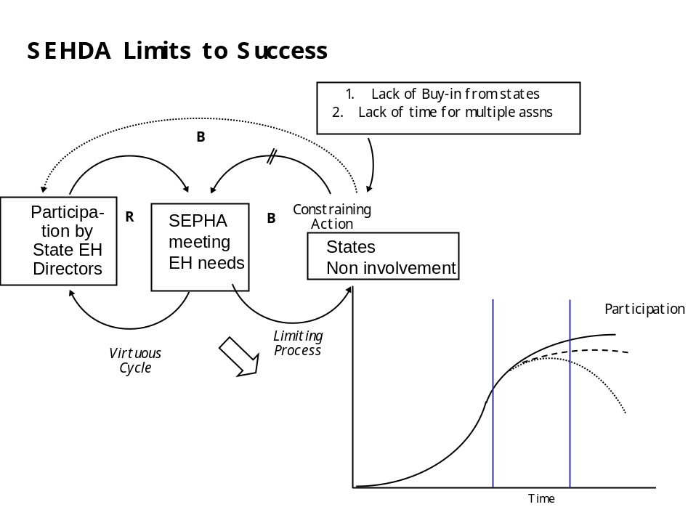
SEHD

10 Essential Environmental Health (EH) Services:
This project addresses many of the 10 Essential Environmental Health Services, namely:
- Inform, educate, and empower people about EH issues
- Develop policies and plans that support individual and community EH efforts
- Enforce laws and regulations that protect health and ensure safety
- Mobilize community partnerships to identify and solve EH problems
- Assure a competent EH workforce
- Evaluate the effectiveness, accessibility and quality of personal and population based EH services.
SEHDs play a vital role in the delivery and evaluation of EH services throughout the nation. The principle programs operated, funded, and/or regulated by SEHDA members serve everyone everyday. SEHDA, in collaborating with other EH organizations, can set the agenda and determine the direction of state EH interests across the country. The association can provide members with the opportunity to exchange diverse views and experiences, learning from one another in areas vital to effective public policy development and implementation. SEHDA can provide a broad array of services designed to identify and respond to critical policy issues, including (?)cutting-edge consultation, training, and technical assistance.

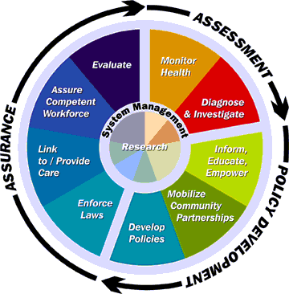
Figure 1: Source: Public Health Functions Steering Committee, Members (July 1995)

National Goals Supported
This project supports the CDC Health Protection Goal of Healthy People in Healthy Places: The places where people live, work, learn, and play will protect and promote their health and safety, especially those at greater risk of health disparities. This would occur through the focus on sharing excellent national environmental health practices, including built environment issues. Howard Frumkin, the Director for the National Center of Environmental Health, recently wrote about (?)how Environmental Health is rediscovering its roots in geography and urban planning, rediscovering the public health roots of modern zoning. Public health officials and urban planners needs to ensure not only that communities are free of toxic exposures; they also need to ensure that communities are well designed, well built, attractive, and functional for all people who live, work, learn, and play in them.
- Healthy Communities: Increase the number of communities that protect, and promote health and safety and prevent illness and injury in all their members.
- Healthy Homes: Protect and promote health through safe and healthy home environments.
- Healthy Schools: Increase the number of schools that protect and promote the health, safety and development of all students, and protect and promote the health and safety of all staff. (e.g. – healthy food vending, physical activity programs).
- Healthy Workplaces: Promote and protect the health and safety of people who work by preventing workplace-related fatalities, illnesses, injuries, and personal health risks.
- Healthy Healthcare Settings: Increase the number of healthcare settings that provide safe, effective, and satisfying patient care.
- Healthy Institutions: Increase the number of institutions that provide safe, healthy, and equitable environments for their residents, clients or inmates.
- Healthy Travel and Recreation: Ensure that environments enhance health and prevent illness and injury during travel and recreation.
Additionally, a successful SEHDA will support all of the goals of the National Strategy to Revitalize Environmental Public Health Services, below, as a key partner in this considerable undertaking.
Goal I Build Capacity: Strengthen and support environmental public health services at the state, tribal, territorial, and local levels.

Goal II Support Research: Support research to define effective approaches to enhance environmental public health services.

Goal III Foster Leadership: Foster leadership to enhance environmental public health services.

Goal IV Communicate and Market: Improve communication and information sharing among environmental public health agencies, communities, strategic partners, and other stakeholders and better market environmental public health services to policy makers and the public.

Goal V: Develop the workforce: Promote the development of a competent and effective environmental public health services workforce.

Goal VI: Create strategic partnerships: Foster interactions among agencies, organizations, and interests that influence environmental public health services.

Environmental health professionals must be well prepared to adequately address the nation’s increasingly complex environmental health threats. States’ environmental health programs are the backbone of these efforts working in varied partnerships. This Association aims to provide clear leadership, direction and vision for states’ environmental health programs.

Project Logic Model:

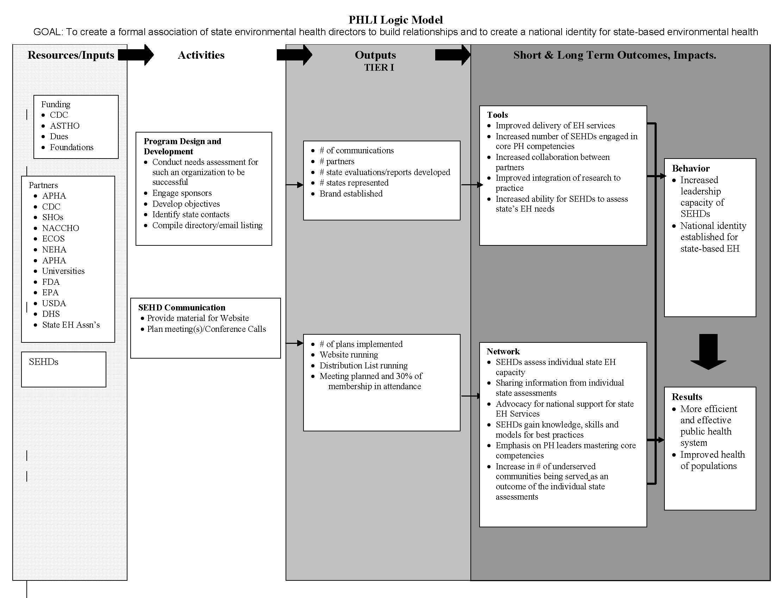

PROJECT OBJECTIVES/DESCRIPTION/DELIVERABLES:

Program Goal To create a formal association of state environmental health directors to build relationships and to create a national identity for state-based environmental health. A network of SEHDs will help standardize environmental public health systems and approaches, save resources by sharing information, and enhance advocacy for needed environmental health protections

Health Problem Immersion in our environment is necessary yet not without risk. Many diseases of environmental public health origin can be prevented with education and personal/community behavior modification. State Environmental Health officials need to be capacitated to effectively impart knowledge to their general populations in order to empower the public to be responsible for their own health and quality of life.

Outcome Objective Healthy People 2010 Objectives related to environmental health will be met.

Determinant The number of reported diseases of environmental origin per year.

Impact Objective By June 30, 2006 60% of the states will be aligned in working toward meeting Healthy People 2010 Environmental Health Objectives

Contributing Factors
- Risk management poses a challenge to state environmental health programs. Health agencies recognize the need for integration of disciplines and approaches as well as the need for a balance between risk assessment and risk management. A crucial problem is the current zero-risk tolerance approach - the public expects health agencies to limit risks from multiple sectors without understanding the complexity of environmental exposures. A separate but related problem is conflicting standards regarding the economic value of life and inconsistent risk trade-offs.

- Risk Communication and Educating the Public – additional training is needed in connecting with the public. There is a lack of advocates/supporters of environmental health.

- Model Standards – There is a lack of guidance for some of the state environmental health directors’ major concerns, including indoor air, private drinking water, and on-site sewage. The lack of national guidelines and policies forces each state to address these issues individually. Variations in state policies can create unique problems for neighboring states, as is the case with air emissions.

- Marketing Environmental Health – Marketing the value of environmental public health is both a challenge and a goal for many states. The efforts and accomplishments of the environmental health community need to be appreciated and public benefits need to be valued in the same way as individual health services are. Some state environmental health programs are using the media to increase the public’s awareness of environmental health services. Other states are looking for ways to market environmental health not only to the public, but also to policy makers who control budgets.

- Land-Use Development – Land-use development and the built environment affect many aspects of community environmental health. Development forces states and local health agencies to deal with on-site sewage concerns, private drinking water quality, and air pollution issues. A larger issue in land-use development is planning for healthy communities, and developing ways to assess the health of a community.

- Regulatory vs. Public Health Agency – Environmental health agencies are often perceived as being solely regulatory agencies. The public is becoming increasingly anti-regulatory, and state agencies themselves believe that other tools should be pursued to complement or replace the emphasis on enforcement.

- Research Agenda – A national research agenda is useful to address environmental health data gaps. The agenda would benefit states and help to direct policy, program, and budget decisions. SEHDs also recognize that state health agencies could develop their own research agendas and work in collaboration with universities.

Process Objectives (outcomes?)States that participate in SEHDA activities each year.

- Identify stakeholders interested in establishing and supporting a State Environmental Health Director Association by October 31, 2005
- By January 30, 2006, each state will be encouraged to identify a designated State Environmental Health Director.
- By June 30, 2006, launch a nationally recognized State Environmental Health Directors Association

METHODOLOGY:

Event: Conference call among SEHDA stakeholders
Activities:
  - Consult ASTHO, CDC, Environmental Council of the States (ECOS), the National Association of County and City Health Officials (NACCHO), the National Environmental Health Association (NEHA) and the American Public Health Association (APHA).
  - Create agreement on the definition of SEHD
  - Define barriers to developing an organization and work through them
  - Identify a funding source to assist with the group’s sustainability

Event: Establishment of working SEHDA
Activities:
- Compile a listing of designated SEHDs
- Establish a distribution list with ASTHO as the parent organization

Event: SEHDA will hold its first meeting (via electronic, telephonic or face-to-face means)
Activities:
- Develop charter for SEHDA
- Select Officers and roles
- Define expectations
- Participate in an annual meeting of SEHDA

RESULTS:
- ASTHO staff have actively promoted the genesis of this association through a facilitated meeting of 14 SEHD in April 2005 and four planning conference calls in August, September and December 2005 and January 2006
- The group has drafted Principles of Operation upon which to solicit state designees from all State Health Officials.
- CDC NCEH staff has supported this concept of this neonatal organization.
- A meeting is being planned for April 2006, further developing the SEHDA infrastructure and setting a strategic plan of action.
- NEHA, ECOS, NACCHO and EPA officials support the concept of this association

CONCLUSIONS:
Success of this association will be manifested in the combined expertise of members and other key constituents to include:
- advancing intergovernmental cooperation
- promoting efficient and effective management strategies
- supporting state, local, and jurisdictional relationships and activities
- providing policy analysis and development, technical assistance, and training in critical areas of policy and practice
- responding effectively to changing organizational, practice, and finance trends
- identifying and sharing models of excellence on a myriad of topics and issues.
We intend for SEHDA activities to combine high-level professional and academic expertise with practical perspectives, experience and expertise. As a result, policy development can occur with a full understanding of stakeholder interests and potential implementation barriers.

LEADERSHIP DEVELOPMENT OPPORTUNITIES:

Fellow Name: Lisa Conti

As Division Director of Environmental Health since March 2003 in the fourth most populous state, I am hungry for opportunities to learn and hone skill sets that make me an effective leader of the programs entrusted to me. I come away from this EPHLI experience with three fundamental areas of achievement I can continue to build upon. EPHLI has:
- heightened my awareness to make targeted self improvements
- exposed me to concepts of systems thinking, and
- afforded me an opportunity to meet valued peer professionals, mentors and trainers, with whom I intend to continue the forged friendships.
I have incorporated lessons learned from EPHLI directly into my leadership role. I am thankful for the opportunity to have had such a wonderful experience with my team and I look forward to sharing the wealth.

ABOUT THE EPHLI FELLOW

Dr. Lisa Conti currently serves as the Division Director of Environmental Health at the Department of Health. She leads four Bureaus: Onsite Sewage Programs, Community Environmental Health, Water Programs, Radiation Control and the Office of Environmental Public Health Medicine. She has been with the Florida State Health Office since 1988, and was previously the Florida State Public Health Veterinarian. She has authored or co-authored numerous journal articles on HIV/AIDS surveillance, public health, vector-borne diseases and zoonoses.

She earned her Doctor of Veterinary Medical degree from the University of Florida (UF), Master of Public Health (Public Health Administration) from the University of South Florida and Bachelor of Science (Chemistry/Math) from the University of Miami. She has taught Epidemiology at Florida State University and Anatomy and Physiology at Tallahassee Community College and is an adjunct instructor at UF.

She has been an active member of her local, state and national environmental health, public health and veterinary medical associations for many years. She was an Executive Board member of the Florida Veterinary Medical Association and established and chaired the Public Health Committee since 1995. In 1997, Dr. Conti was elected to the American Veterinary Medical Association Council on Public Relations representing Public Health. She also works as a clinical veterinarian on weekends.

REFERENCES
Carl Osaki, RS, MSPH, Northwest Center for Public Health Practice, 10 Essential Environmental Health Services.
CDC NOW: Health Protection Goals Fact Sheet-Goals for the 21st Century, http://www.cdc.gov/about/goals/default.htm
CDC National Strategy to Revitalize Environmental Public Health Services, http://www.cdc.gov/nceh/ehs/Docs/nationalstrategy2003.pdf

