United States
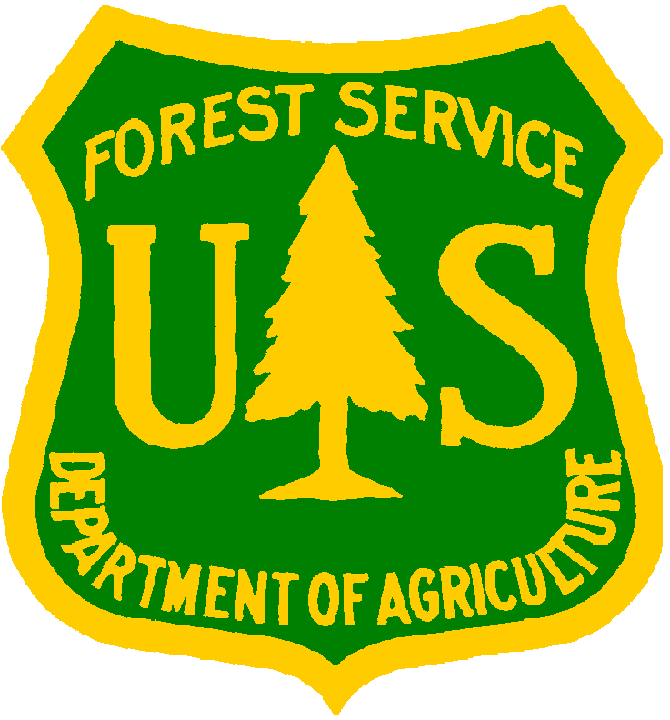
Department of Agriculture
Forest Service
Caribbean National Forest

Camping Permit

Permission is hereby granted, subject to the conditions and the applicable regulations of the USDA Forest Service included in the attached brochure “Camping in the Caribbean National Forest” to:
Last Name | First Name
Postal Address
City | State/Country | Zip Code
Drivers License Number | Expiration Date
Total number of people on this camping permit:
Camping Dates: from | to
Name of person to call in case of emergency: |  | Telephone
Tag number if using a vehicle:
Camping site selected:
Forest Official Name (Please print)
__________________________________
Forest Official Signature | Date
__________________________________
Permit Holder Signature | Date
Telephone: 787-888-1880
FAX: 787-888-5685
Website: http://www.fs.fed.us/r8/caribbean

