Breastfeeding Best Practices

Why is breastfeeding important to diabetes care?
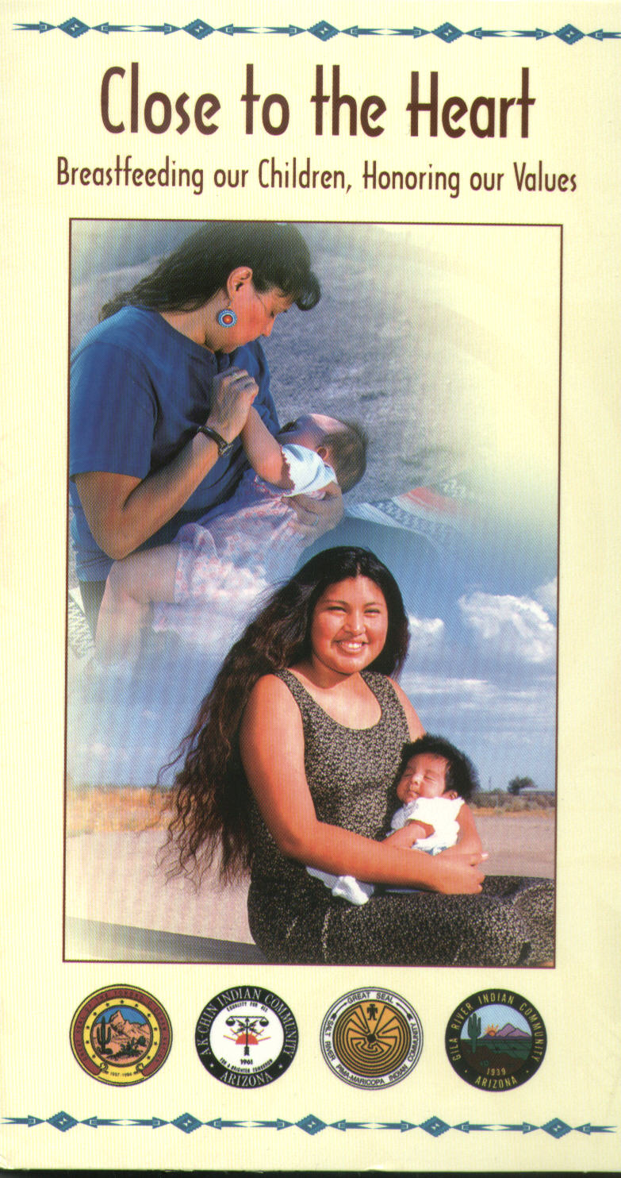
Breastfeeding has many benefits for the baby and mother. Mothers who exclusively breastfeed their babies for at least two months can protect their babies from developing diabetes and overweight.

Why is breastfeeding important to American Indian and Alaska Native communities?
Breastfeeding is important to American Indian and Alaska Native communities for several reasons:
- Exclusive breastfeeding for the first two months of life is associated with a 60% reduction in type 2 diabetes among some American Indian communities.
- Babies who were breastfed are less overweight as adults. Longer duration of breastfeeding was associated with less overweight.

The good news is that breastfeeding offers an important opportunity for intervention because it can be done for a fairly short period of time—a minimum of two months—yet have life-long benefits. It is even better for your baby if you breastfeed longer. Breastfeeding interventions appear to be an ideal primary prevention intervention for type 2 diabetes and overweight.


How can you work together?
Community programs, health care providers, clinic administrators, special diabetes grants program for Indians providers and tribal leadership need to work together to develop breastfeeding programs. Here are some tips to help you work together:

Who?
⬧
Why?

How?
Who can help? Ask for and enlist the support of local programs such as WIC (Women’s Infants and Children) programs, Head Start and Early Head Start programs, Healthy Start initiatives, childcare centers, birthing classes, Boys and Girls Clubs, local breastfeeding experts, and other health care providers.

Why work together? Working with experts in the community, health care providers, and breastfeeding support groups will help you leverage resources; avoid duplicating services; share staff, ideas, and resources; and work together to improve the health of your community.

How can you work together? Share what you are doing, plan to contact each other regularly, determine what each partner will do, and assign tasks and timelines. Work with your partners to plan and establish programs and activities, develop and implement goals and objectives, and design evaluation plans. Remember to talk to each other!

What can your program do?
Your program can… | How? | Who?
 |  | Community programs | Health care providers | Organization leadership
Promote and support breastfeeding, and raise awareness about the importance of breastfeeding | - Promote breastfeeding in clinical and community programs and as a cultural norm.  - Provide resources for breastfeeding support, and encourage family and community support for breastfeeding.  - Refer to the National Diabetes Education Program (NDEP) for strategies on starting community campaigns: http://ndep.nih.gov/campaigns/starting.htm |  |  | 
Provide education to health care providers | - Provide health care providers with the current knowledge and skills to encourage and clinically manage breastfeeding through formal programs, workshops, clinical rotations, and other activities.  - Consult with your Health Service Advisory Committee. |  |  | 
Provide education to mothers, their families, and the community | - Conduct an inventory of available breastfeeding education programs.  - Provide information on national, state, and local breastfeeding support hotlines.  - Provide breastfeeding education as part of pregnancy classes and through home visits. |  | 
Provide early and ongoing expertise and support  IHS Head Start Program 2006 | - Assist pregnant women and mothers with breastfeeding.  - Provide one-on-one counseling.  - Work collaboratively with breastfeeding support groups and other resources. |  | 
Implement system and programmatic changes | - Establish written policies and procedures to support breastfeeding in clinics, workplaces, and other public areas. |  |  | 

