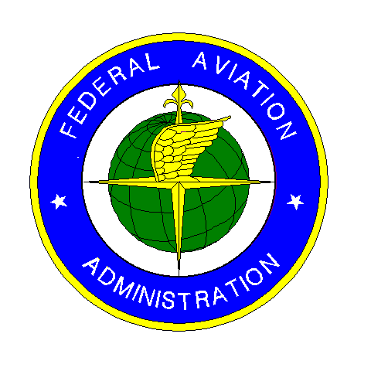 |  |  | CONSTRUCTION PROGRESS AND INSPECTION REPORT |  |  | Period Ending
U.S. Department  of Transportation  Federal Aviation  Administration |  |  | AIRPORT GRANT PROGRAM |  |  | Project Number
Airport Name

Project Description |  |  |  | Contractor’s Name
1. Rough Estimate of Percent Completion to Date of Construction Phases (Include items such as clearing, grading, drainage, base, surface, lighting, etc.)

2. Work Completed or in Progress this period

3. Brief Weather Summary This Period Including Approximate Rainfall and Periods of Below Freezing Temperature
(On earthwork jobs include soil conditions)

4. Contract Time |  |  | 5. Summary of Laboratory and Field Testing This Period (note failing tests and any retests Summarize out-of-tolerance
No Days Charged To Date | Last Working Day Charged  (Date) |  | material. Identify material subject to pay reduction.)
6. Describe Anticipated Work by Contractor for Next Period

7. Problem Areas/Other Comments (Revisions to plans and specifications approved or denied, delays, difficulties, etc. and actions taken.)

SPONSOR’S INSPECTOR OR REPRESENTATIVE
Date |  | Typed of Printed Name and Title |  |  | Signature
FAA Form 5370-1 (8-89) Supersedes Previous Edition

INSTRUCTIONS FOR PREPARATION OF FAA FORM 5370-1 (8-89)
CONSTRUCTION PROGRESS AND INSPECTION REPORT
AIRPORT GRANT PROGRAM
This preaddressed form is to be filled out, with ballpoint pen or typewriter by the Sponsor’s Inspector on the project, folded with return address out, fastened, and mailed to the address shown below. No postage is required since the postage has been prepaid by the Federal Aviation Administration.

Submit one copy for each report. If additional space is required to complete any of the items, continue on a separate sheet of plain paper, identifying it with the project number, fold and insert inside the report before mailing.

If additional blank copies of the form are required, submit your request to the address provided below.

 U.S. GPO:1989-261-335/03364

1st
Fold

2nd
Fold
U.S. Department  of Transportation  Federal Aviation  Administration |  |  |  |  |  |  |  |  | NO POSTAGE  NECESSARY  IF MAILED  IN THE  UNITED STATES
800 Independence Avenue, S.W.  Washington, D.C. 20591 | BUSINESS REPLY MAIL  FIRST CLASS PERMIT NO. 12438 WASHINGTON, D.C.
Official Business  Penalty for Private Use $200 | POSTAGE WILL BE PAID BY THE FEDERAL AVIATION ADMINISTRATION  Federal Aviation Administration  Airports

