Tropical Cyclone Report
Hurricane Bertha
(AL022008)
3-20 July 2008

Jamie R. Rhome
National Hurricane Center
15 October 2008

Bertha was an early season category 3 hurricane (on the Saffir-Simpson Hurricane Scale) that brought tropical storm conditions to Bermuda and became the longest-lived Atlantic July tropical cyclone on record.

- Synoptic History

Bertha developed from a well-defined tropical wave that crossed the west coast of Africa on 1 July. The wave was accompanied by a closed surface low and a large area of convection even before it emerged into the Atlantic. Within an environment of light vertical shear but marginally warm sea surface temperatures, the wave slowly developed and by 0600 UTC 3 July had acquired enough organized convection to be designated a tropical depression about 220 n mi south-southeast of the Cape Verde Islands. The organization of the depression continued to increase, and the cyclone strengthened to a tropical storm six hours later while passing south of the Cape Verde Islands. Bertha’s strength changed little during the next couple of days as the storm moved west-northwestward. Bertha reached warmer waters by 6 July and became the first hurricane of the 2008 season early on 7 July while centered about 750 n mi east of the northern Leeward Islands.
During the next several days, Bertha’s intensity fluctuated due to varying atmospheric conditions. On 7 July, as the cyclone turned northwest into a weakness in the subtropical ridge, Bertha underwent a period of rapid intensification, with the maximum sustained winds increasing 45 kt during the 15-h period beginning at 0600 UTC. Bertha became a major hurricane with a peak intensity of 110 kt at 2100 UTC that day. Bertha then encountered an environment of strong vertical shear on 8 July, resulting in a period of rapid weakening with maximum sustained winds decreasing 40 kt during the 24-h period ending at 0600 UTC 9 July. The shear weakened on 9 July, however, and Bertha once again quickly intensified with maximum sustained winds increasing from 65 kt to 90 kt during the 18-h period beginning at 0600 UTC 9 July. By 10 July, an outer convective band began to wrap around the center forming a second outer eyewall (Fig. 1) and associated wind maximum. As the cyclone continued moving northward, the inner eyewall weakened and dissipated by 12 July. The completion of the eyewall replacement cycle coupled with slightly cooler waters resulted in gradual weakening, and the cyclone became a tropical storm early on the 13th.
Bertha moved into an area with light steering currents, resulting in a slowing of the cyclone’s forward speed on the 12th, and became nearly stationary on the 13th near Bermuda. On 14 July, Bertha resumed its northward motion and brought tropical storm conditions to the island while its center passed about 40 n mi to the island’s east. The cyclone then turned eastward and southeastward on the 16th and 17th while it moved cyclonically around a large deep-layer low over the central Atlantic. Bertha accelerated northeastward on the 18th in strong southwesterly flow ahead of a trough moving off the east coast of the United States. The cyclone became a hurricane once again during that period. Bertha passed about 400 n mi southeast of Cape Race, Newfoundland, on the 19th and became an extratropical cyclone over the north Atlantic on 20 July. The extratropical low continued northeastward toward Iceland, where it merged with a larger mid-latitude low pressure area on 21 July.
The “best track” chart of the tropical cyclone’s path is given in Fig. 2, with the wind and pressure histories shown in Figs. 3 and 4, respectively. The best track positions and intensities are listed in Table 1.

- Meteorological Statistics

Observations in Bertha (Figs. 3 and 4) include satellite-based Dvorak technique intensity estimates from the Tropical Analysis and Forecast Branch (TAFB) and the Satellite Analysis Branch (SAB), as well as flight-level, stepped frequency microwave radiometer (SFMR), and dropwindsonde observations from four flights of the 53rd Weather Reconnaissance Squadron of the U. S. Air Force Reserve Command. Data and imagery from NOAA polar-orbiting satellites, the NASA Tropical Rainfall Measuring Mission (TRMM), the NASA QuikSCAT, and Defense Meteorological Satellite Program (DMSP) satellites, among others, were also useful in tracking Bertha. The maximum intensity and minimum pressure at 2100 UTC 7 July are based on 3-h objective Dvorak intensity estimates, which peaked between 1800 UTC 7 July and 0000 UTC 8 July.
Ship reports of tropical storm force winds associated with Bertha are given in Table 2, and selected surface observations from land stations and data buoys are given in Table 3. The highest ship-reported wind was 44 kt from the ship WDC692 at 0600 UTC 20 July.
Bertha brought tropical storm conditions to Bermuda on 14 July (Table 3). An elevated instrument at the Bermuda Maritime Operations Centre reported a peak 1-minute sustained wind of 59 kt at 2035 UTC and a wind gust of 79 kt.

- Casualty and Damage Statistics

Bertha produced tropical storm conditions over Bermuda as it passed east of the island, resulting in broken tree branches, downed power lines, and scattered power outages. A total of 4.76 inches of rain fell at the Bermuda International Airport, resulting in the flooding of a few roads. Many commercial flights into and out of Bermuda were disrupted on 14 July.
Long-period swells generated by Bertha caused dangerous surf conditions and rip currents along much of the east coast of the United States. Over 1500 ocean rescues were reported in Ocean City, New Jersey, during a seven-day period beginning on 9 July, and 3 persons drowned along the New Jersey coast during the height of the event.

- Forecast and Warning Critique

The genesis of Bertha was well anticipated, as the tropical wave that ultimately spawned Bertha was first mentioned in the Atlantic Tropical Weather Outlook (TWO) at 0600 UTC 1 July, approximately 48 h prior to genesis. At that time, the TWO noted that environmental conditions could allow for some slow development. The first mention of the potential formation of a tropical depression occurred 24 h in advance of genesis. At this time, the pre-Bertha disturbance was given a “medium” probability of tropical cyclone formation, corresponding to a 20-50% probability of genesis in the experimental graphical TWO. Subsequent TWOs continued to show a “medium” probability of genesis.
A verification of official and guidance model track forecasts is given in Table 4. Average official track errors for Bertha were 24, 43, 61, 82, 118, 164, and 200 n mi for the 12, 24, 36, 48, 72, 96, and 120 h forecasts, respectively. The number of forecasts ranged from 67 at 12 h to 49 at 120 h. These errors are considerably lower than the average long-term official track errors (Table 4) and represent a 21-29% improvement over the average track error. However, the official forecast was bested by the dynamical model consensus, TVCN, at nearly all forecast times. Of the dynamical models, the GFDL had the lowest track errors and beat the official forecast for the 12-h through 72-h time periods.
Average official intensity errors were 6, 11, 12, 11, 11, 11 and 10 kt for the 12, 24, 36, 48, 72, 96, and 120 h forecasts, respectively. For comparison, the average long-term official intensity errors are 7, 10, 12, 14, 18, 20, and 22 kt, respectively. With the exception of the 12-h forecast error, the official forecast errors were much smaller than the long-term average intensity errors despite the challenges associated with Bertha’s rapid intensity fluctuations during the 3-day period of 7-10 July. The average intensity errors at 96 and 120 h were 49% and 53% better than the long-term average error for those forecast times.
Watches and warnings associated with Bertha are given in Table 5. A tropical storm warning was issued for Bermuda at 1500 UTC July 12, approximately 36 h prior to the arrival of tropical storm force winds. As Bertha began pulling away from Bermuda late on the 14th, it strengthened to just below hurricane strength prompting the issuance of a hurricane watch at 1900 UTC that day.

Acknowledgements

Mark Guishard of the Bermuda Weather Service provided the data on Bertha’s impact on Bermuda.
Table 1. Best track for Hurricane Bertha, 3-20 July 2008.

Date/Time  (UTC) | Latitude  (°N) | Longitude  (°W) | Pressure  (mb) | Wind Speed  (kt) | Stage
03 / 0600 | 12.7 | 22.9 | 1008 | 30 | tropical depression
03 / 1200 | 13.1 | 24.0 | 1006 | 35 | tropical storm
03 / 1800 | 13.2 | 25.2 | 1006 | 35 | "
04 / 0000 | 13.4 | 26.5 | 1006 | 40 | "
04 / 0600 | 14.0 | 27.8 | 1003 | 40 | "
04 / 1200 | 14.8 | 29.2 | 1000 | 45 | "
04 / 1800 | 15.4 | 30.8 | 1000 | 45 | "
05 / 0000 | 15.8 | 32.6 | 1000 | 45 | "
05 / 0600 | 16.3 | 34.4 | 1000 | 45 | "
05 / 1200 | 16.4 | 36.4 | 1000 | 45 | "
05 / 1800 | 16.6 | 38.4 | 1000 | 45 | "
06 / 0000 | 16.8 | 40.3 | 1000 | 45 | "
06 / 0600 | 17.0 | 42.3 | 1000 | 45 | "
06 / 1200 | 17.6 | 44.3 | 1000 | 45 | "
06 / 1800 | 18.4 | 46.2 | 1000 | 45 | "
07 / 0000 | 18.8 | 47.9 | 994 | 55 | "
07 / 0600 | 19.1 | 49.4 | 987 | 65 | hurricane
07 / 1200 | 19.4 | 50.7 | 975 | 80 | "
07 / 1800 | 19.9 | 51.6 | 960 | 100 | "
07 / 2100 | 20.3 | 51.9 | 952 | 110 | "
08 / 0000 | 20.6 | 52.2 | 955 | 105 | "
08 / 0600 | 21.1 | 52.9 | 955 | 105 | "
08 / 1200 | 21.8 | 53.5 | 970 | 90 | "
08 / 1800 | 22.4 | 54.4 | 980 | 75 | "
09 / 0000 | 22.7 | 55.2 | 985 | 70 | "
09 / 0600 | 23.2 | 56.1 | 987 | 65 | "
09 / 1200 | 23.8 | 57.0 | 987 | 65 | "
09 / 1800 | 24.5 | 57.8 | 974 | 85 | "
10 / 0000 | 25.2 | 58.6 | 970 | 90 | "
10 / 0600 | 25.7 | 59.1 | 970 | 90 | "
10 / 1200 | 26.3 | 59.8 | 977 | 80 | "
10 / 1800 | 26.9 | 60.5 | 980 | 75 | "
11 / 0000 | 27.4 | 61.0 | 980 | 75 | "
11 / 0600 | 27.8 | 61.5 | 980 | 75 | "
11 / 1200 | 28.3 | 61.8 | 980 | 75 | "
11 / 1800 | 28.8 | 62.1 | 976 | 80 | "
12 / 0000 | 29.3 | 62.3 | 976 | 80 | "
12 / 0600 | 29.5 | 62.5 | 976 | 80 | "
12 / 1200 | 29.7 | 62.5 | 976 | 75 | "
12 / 1800 | 29.9 | 62.5 | 983 | 65 | "
13 / 0000 | 29.9 | 62.4 | 984 | 65 | "
13 / 0600 | 29.8 | 62.5 | 985 | 65 | "
13 / 1200 | 29.9 | 62.7 | 988 | 60 | tropical storm
13 / 1800 | 30.1 | 62.9 | 991 | 55 | "
14 / 0000 | 30.5 | 63.1 | 990 | 55 | "
14 / 0600 | 31.0 | 63.5 | 990 | 55 | "
14 / 1200 | 31.6 | 63.8 | 994 | 55 | "
14 / 1800 | 32.5 | 64.1 | 995 | 60 | "
15 / 0000 | 33.5 | 63.8 | 995 | 60 | "
15 / 0600 | 34.3 | 63.5 | 995 | 60 | "
15 / 1200 | 35.3 | 63.0 | 995 | 60 | "
15 / 1800 | 36.2 | 62.5 | 995 | 60 | "
16 / 0000 | 36.7 | 61.8 | 995 | 60 | "
16 / 0600 | 36.8 | 61.3 | 995 | 60 | "
16 / 1200 | 36.8 | 60.9 | 995 | 60 | "
16 / 1800 | 36.3 | 60.7 | 995 | 60 | "
17 / 0000 | 35.7 | 60.3 | 996 | 55 | "
17 / 0600 | 34.9 | 59.7 | 997 | 50 | "
17 / 1200 | 34.3 | 58.9 | 997 | 50 | "
17 / 1800 | 33.9 | 57.8 | 997 | 50 | "
18 / 0000 | 33.7 | 56.0 | 997 | 50 | "
18 / 0600 | 34.4 | 54.4 | 995 | 55 | "
18 / 1200 | 35.5 | 53.0 | 995 | 55 | "
18 / 1800 | 36.9 | 51.5 | 989 | 65 | hurricane
19 / 0000 | 38.6 | 49.7 | 989 | 65 | "
19 / 0600 | 40.4 | 48.0 | 989 | 65 | "
19 / 1200 | 42.1 | 46.3 | 989 | 65 | "
19 / 1800 | 43.7 | 44.3 | 989 | 65 | "
20 / 0000 | 45.3 | 42.4 | 990 | 60 | tropical storm
20 / 0600 | 47.6 | 40.0 | 985 | 60 | "
20 / 1200 | 50.0 | 37.0 | 985 | 60 | extratropical
20 / 1800 | 53.0 | 34.0 | 990 | 55 | "
21 / 0000 | 55.1 | 31.0 | 990 | 50 | "
21 / 0600 | 58.5 | 27.0 | 990 | 45 | "
21 / 1200 |  |  |  |  | merged
07 / 2100 | 20.3 | 51.9 | 952 | 110 | minimum pressure

Table 2. Selected ship reports with winds of at least 34 kt for Hurricane Bertha, 3-20 July 2008.

Date/Time (UTC) | Ship call sign | Latitude  (°N) | Longitude  (°W) | Wind  dir/speed (kt) | Pressure  (mb)
18 / 0600 | DHZR | 30.3 | 52.1 | 200 / 35 | 1015.1
18 / 1200 | DHZR | 29.9 | 54.2 | 210 / 36 | 1015.5
19 / 1200 | SBLW | 48.2 | 40.3 | 180 / 35 | 1014.4
20 / 0600 | WDC692 | 47.8 | 40.5 | 080 / 44 | 989.5
20 / 0900 | PHPO | 47.1 | 34.8 | 180 / 37 | 1014.3
20 / 1100 | WDC692 | 48.1 | 39.2 | 280 / 41 | 1000.0

Table 3. Selected surface observations for Hurricane Bertha, 3-20 July 2008.

Location | Minimum Sea Level Pressure |  | Maximum Surface  Wind Speed |  |  | Storm surge  (ft)^{c} | Storm  tide  (ft)^{d} | Total  rain  (in)
Location | Date/  time  (UTC) | Press.  (mb) | Date/  time  (UTC)ª | Sustained  (kt)^{b} | Gust  (kt) | Storm surge  (ft)^{c} | Storm  tide  (ft)^{d} | Total  rain  (in)
Bermuda
Bermuda Airport (TXKF) ^{e} |  | 988 | 14/2011 | 43 | 59 |  |  | 4.76
Bermuda Maritime ^{fg} Operations Centre |  |  | 14/2035 | 59 | 72
Fort Prospect ^{eh} |  |  | 14/2010 | 43 | 63
St. David’s ^{ei} |  |  | 14/1910 | 42 | 67
Commisioner’s Point ^{ej} |  |  | 14/1610 | 54 | 79

ª Date/time is for sustained wind when both sustained and gust are listed.
^{b} Except as noted, sustained wind averaging periods for C-MAN and land-based ASOS reports are 2 min; buoy averaging periods are 8 min.
^{c} Storm surge is water height above normal astronomical tide level.
^{d} Storm tide is water height above National Geodetic Vertical Datum (1929 mean sea level).
^{e} 10-minute average wind
^{f} 1-minute average wind speed.
^{g} Instrument height 255 ft above mean seal level.
^{h} Instrument height 230 ft above mean seal level.
^{i} Instrument height 159 ft above mean seal level.
^{j} Instrument height 262 ft above mean seal level.

Table 4. Track forecast evaluation (heterogeneous sample) for Hurricane Bertha, 3-20 July 2008. Forecast errors (n mi) are followed by the number of forecasts in parentheses. Errors smaller than the NHC official forecast are shown in boldface type.

Forecast Technique | Forecast Period (h)
Forecast Technique | 12 | 24 | 36 | 48 | 72 | 96 | 120
CLP5 | 42 (67) | 99 (65) | 168 (63) | 229 (61) | 280 (57) | 286 (53) | 341 (49)
GFNI | 33 (53) | 60 (51) | 88 (49) | 113 (47) | 162 (43) | 225 (34) | 249 (29)
GFDI | 23 (66) | 36 (65) | 52 (63) | 72 (61) | 110 (57) | 175 (53) | 230 (49)
HWFI | 30 (67) | 56 (65) | 81 (63) | 107 (61) | 132 (57) | 191 (53) | 235 (49)
GFSI | 25 (67) | 43 (65) | 65 (63) | 95 (61) | 153 (57) | 219 (53) | 262 (49)
AEMI | 32 (67) | 59 (65) | 87 (63) | 117 (61) | 154 (49) | 180 (37) | 180 (30)
NGPI | 32 (56) | 54 (54) | 77 (52) | 106 (50) | 176 (46) | 249 (42) | 246 (36)
UKMI | 29 (58) | 55 (57) | 87 (55) | 127 (53) | 208 (49) | 289 (43) | 366 (39)
BAMD | 33 (67) | 61 (65) | 94 (63) | 132 (61) | 198 (57) | 304 (53) | 414 (49)
BAMM | 38 (66) | 74 (64) | 113 (62) | 153 (60) | 224 (56) | 309 (52) | 375 (48)
BAMS | 45 (66) | 90 (64) | 136 (62) | 181 (60) | 284 (56) | 390 (52) | 457 (48)
TVCN | 24 (67) | 39 (65) | 56 (63) | 77 (61) | 111 (57) | 161 (53) | 188 (49)
GUNA | 24 (53) | 39 (51) | 59 (50) | 86 (48) | 145 (43) | 199 (37) | 202 (31)
FSSE | 23 (66) | 39 (64) | 60 (62) | 87 (60) | 133 (56) | 179 (52) | 222 (48)
OFCL | 24 (67) | 43 (65) | 61 (63) | 82 (61) | 118 (57) | 164 (53) | 200 (49)
NHC Official  (2003-2007 mean) | 34.0 (1742) | 58.2 (1574) | 82.2 (1407) | 106.2 (1254) | 154.2 (996) | 207.5 (787) | 272.5 (627)

Table 5. Intensity forecast evaluation (heterogeneous sample) for Hurricane Bertha, 3-20 July 2008. Forecast errors (kt) are followed by the number of forecasts in parentheses. Errors smaller than the NHC official forecast are shown in boldface type.

Forecast Technique | Forecast Period (h)
Forecast Technique | 12 | 24 | 36 | 48 | 72 | 96 | 120
SHF5 | 6.7 (67) | 11.3 (65) | 12.5 (63) | 12.0 (61) | 11.4 (57) | 9.9 (53) | 10.7 (49)
GHMI | 7.0 (66) | 9.5 (65) | 9.6 (63) | 10.5 (61) | 14.5 (57) | 13.1 (53) | 10.7 (49)
HWFI | 7.4 (67) | 11.3 (65) | 12.4 (63) | 12.9 (61) | 17.0 (57) | 17.2 (53) | 18.6 (49)
SHIP | 6.0 (66) | 10.1 (64) | 11.9 (62) | 12.1 (60) | 13.4 (56) | 12.4 (52) | 11.9 (48)
DSHP | 6.0 (66) | 10.1 (64) | 11.9 (62) | 12.1 (60) | 13.4 (56) | 12.4 (52) | 11.9 (48)
FSSE | 6.0 (66) | 9.9 (64) | 11.1 (62) | 10.8 (60) | 12.9 (56) | 10.2 (52) | 9.4 (48)
ICON | 6.2 (65) | 9.3 (64) | 10.2 (62) | 9.4 (60) | 12.0 (56) | 9.4 (52) | 7.7 (48)
OFCL | 6.4 (67) | 10.7 (65) | 11.5 (63) | 10.7 (61) | 11.2 (57) | 10.9 (53) | 10.3 (49)
NHC Official  (2003-2007 mean) | 6.7 (1742) | 10.0 (1574) | 12.3 (1407) | 14.3 (1254) | 18.2 (996) | 19.7 (787) | 21.8 (627)

Table 6. Watch and warning summary for Hurricane Bertha, 3-20 July 2008.

Date/Time (UTC) | Action |  | Location
12/1500 |  | Tropical Storm Warning issued |  | Bermuda
14/1900 |  | Hurricane Watch issued |  | Bermuda
15/0300 |  | Hurricane Watch Discontinued |  | Bermuda
15/0600 |  | Tropical Storm Warning Discontinued |  | Bermuda

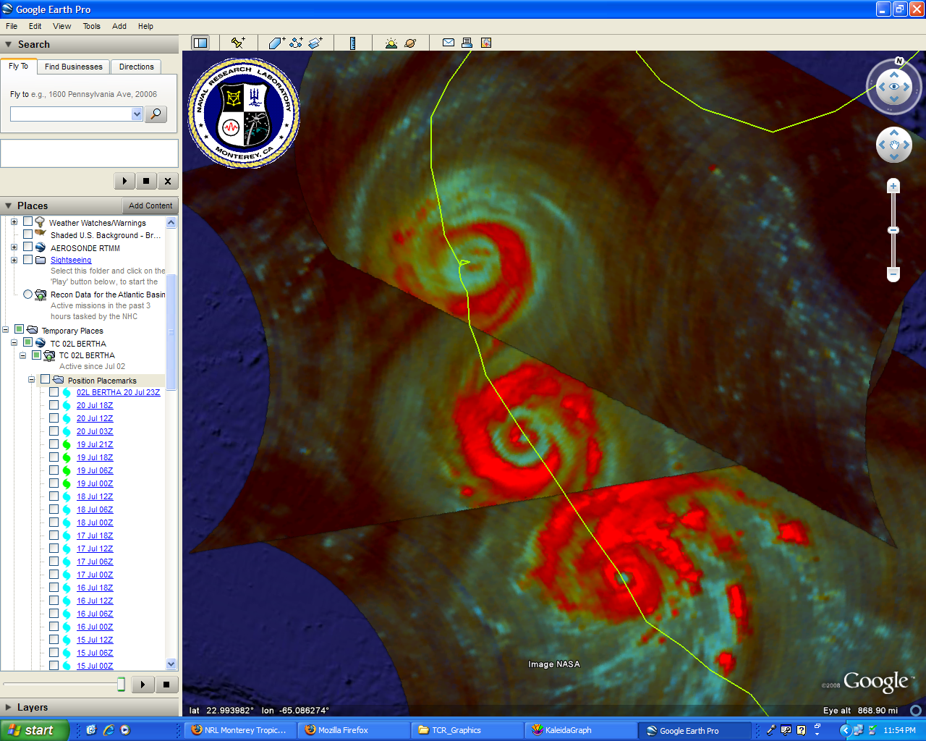

Figure 1. Series of 85 GHz color composite images from the NASA Tropical Rainfall Measuring Mission satellite showing the evolution of Bertha’s eyewall replacement between 9-12 July. From bottom to top, microwave passes correspond to the following times: 1646 UTC 9 July, 1728 UTC 10 July, and 2031 UTC 12 July. The solid green line represents the advisory positions that do not precisely correspond to the final NHC best track.
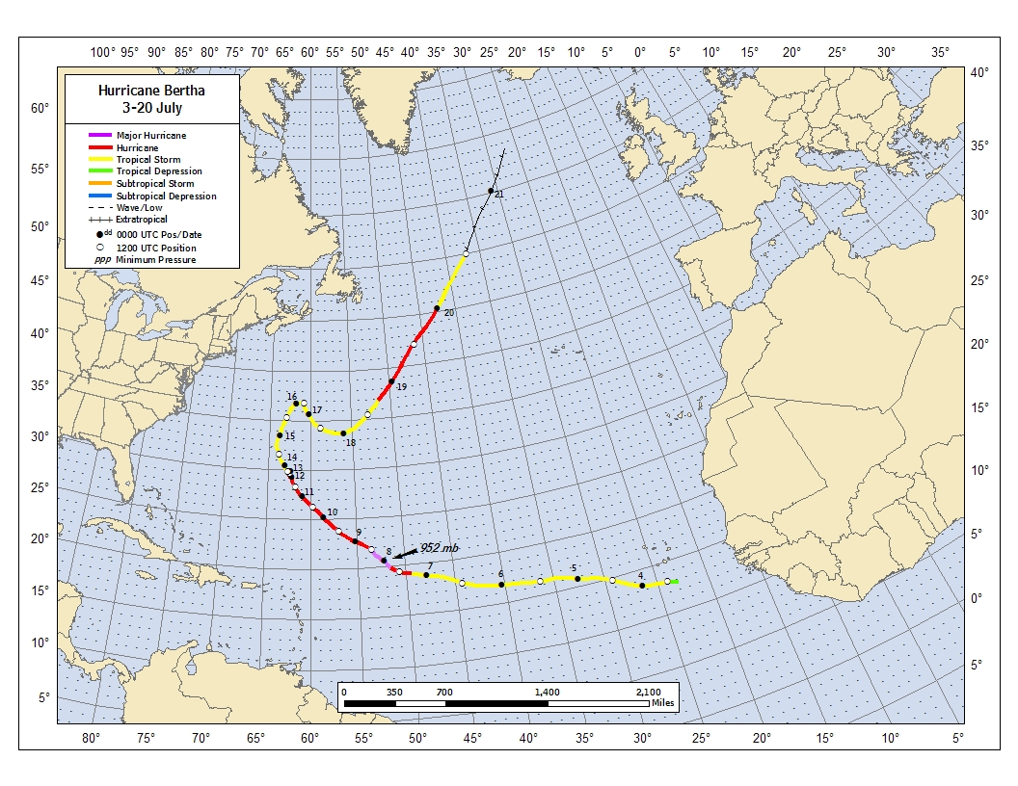
Figure 2. Best track positions for Hurricane Bertha, 3-20 July 2008. Track during the extratropical stage is based on analyses from the NOAA Ocean Prediction Center.
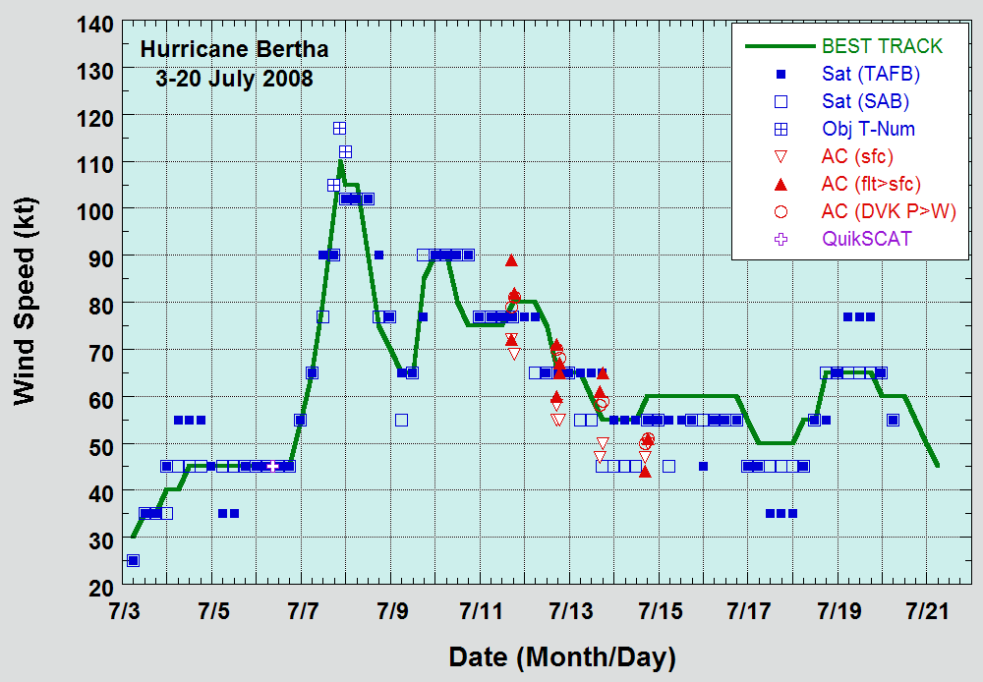
Figure 3. Selected wind observations and best track maximum sustained surface wind speed curve for Hurricane Bertha, 3-20 July 2008. Aircraft observations have been adjusted for elevation using 90%, 80%, and 80% reduction factors for observations from 700 mb, 850 mb, and 1500 ft, respectively. Objective Dvorak estimates represent linear averages over a three-hour period centered on the nominal observation time. Estimates during the extratropical stage are based on analyses from the NOAA Ocean Prediction Center.
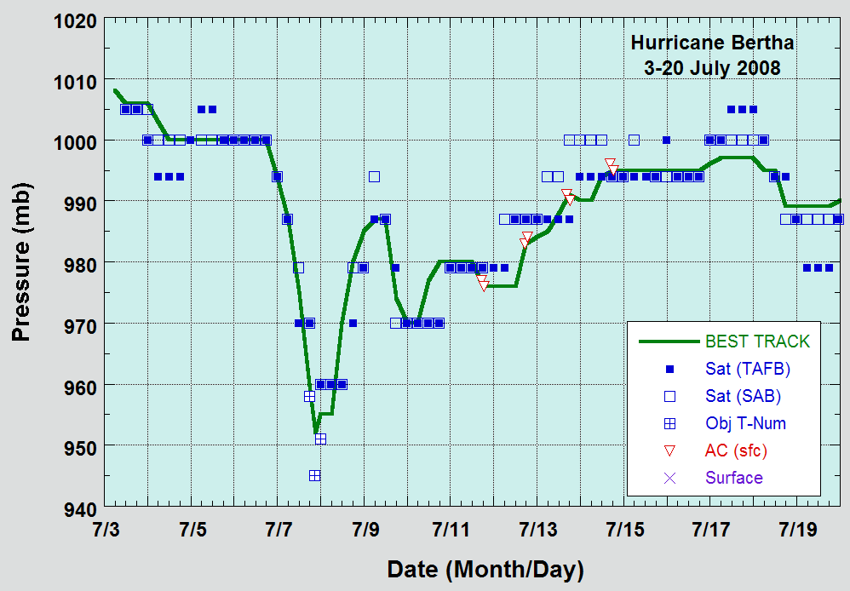
Figure 4. Selected pressure observations and best track minimum central pressure curve for Hurricane Bertha, 3-20 July 2008. Objective Dvorak estimates represent linear averages over a three-hour period centered on the nominal observation time. Estimates during the extratropical stage are based on analyses from the NOAA Ocean Prediction Center. Dashed vertical lines correspond to 0000 UTC.

A digital record of the complete best track, including wind radii, can be found on line at ftp://ftp.nhc.noaa.gov/atcf. Data for the current year’s storms are located in the btk directory, while previous year’s data are located in the archive directory.

