Prepared by
Kathleen S. Morse April 2000
Regional Economist
.
.
.
.
.
.
.
.
.

USDA Forest Service

..........
.
.
.
.
.
.
.
.
.
.

Region 10
Responding to the Market Demand for Tongass Timber
Using Adaptive Management to Implement Sec. 101 of the 1990 Tongass Timber Reform Act

Preface

.
.
.
.
.
.
.
.
.
.

Section 101 of the Tongass Timber Reform Act amended the Alaska National Interest Lands Conservation Act (ANILCA; P.L. 96-487) by deleting the following provision:
Sec. 705. (a) The Congress authorizes and directs that the Secretary of the Treasury shall make available to the Secretary of Agriculture the sum of at least $40,000,000 annually or as much as the Secretary of Agriculture finds is necessary to maintain the timber supply from the Tongass National Forest to dependent industry at a rate of four billion five hundred million board feet measure per decade. Such sums will be drawn from receipts from oil, gas, timber, coal, and other natural resources collected by the Secretary of Agriculture and the Secretary of the Interior notwithstanding any other law providing for the distribution of such receipts: Provided, That such funds shall not be subject to deferral or recission under the Budget Impoundment and Control Act of 1974, and such funds shall not be subject to annual appropriation.
and inserting:
Sec. 705. (a) Subject to appropriations, other applicable law, and the requirements of the National Forest Management Act (P.L. 94-588); except as provided in subsection 9d) of this section, the Secretary shall, to the extent consistent with providing for the multiple use and sustained yield of all renewable forest resources, seek to provide a supply of timber from the Tongass National Forest which (1) meets the annual market demand for timber from such forest and (2) meets the market demand from such forest for each planning cycle.
Economics texts illustrate “meeting market demand” in the classic sense of a supply curve meeting a demand curve to define the optimal, or equilibrium level of output. However, the timber industry in Southeast Alaska is in the midst of a complete structural change and the data required to build a formal economic model of demand are limited. Moreover, it is a well-established economic principle that in highly concentrated markets—such as the Southeast Alaska stumpage market—prices and quantities are indeterminate in terms of formal supply and demand curves.
Seeking to meet the market demand for timber under these conditions requires a great deal of professional judgement, along with a commitment to monitor key parameters of the emerging timber market and to incorporate this information in timber sale planning. The following pages document the rationale used to set short-term goals for the Tongass timber sale program and to establish a framework for systematically collecting, evaluating, and incorporating the information needed to refine this approach.

Table of Contents
.
.
.
.
.
.
.
.
.
.

Preface i
Introduction 1
Public Comments on Draft Procedures 2
Background 3
Historical Development of the Industry 3
Market Demand Over the Planning Cycle 6
The Tongass Forest Plan and Timber Supply 6
Ten-Year Harvest Projections 8
Annual Market Demand 11
Factors Influencing Timber Demand in the Short-Run 11
Overview of Tongass Timber Sale Procedures 12
Timber Market Analysis 22
Estimating Likely Timber Purchases—Example Application 28
Determining the Volume of Timber to Offer—Example cont. 30
Implementation Schedule 30

Revising Timber Sale Schedules 31

Monitoring 32
Management Issues 33
Validation of Models and Assumptions 34
Database Development 36
Appendix—Public Comment on Draft Procedures 39

List of Tables
.
.
.
.
.
.
.
.
.
.

Table 1. Projected National Forest Timber Harvest – Alaska 9
Table 2. Values for Key Elements of the “Low”, “Medium”, and “High”
Timber Harvest Forecast Scenarios 10
Table 3. Summary of Available Data on Sawmill Capacity in Southeast Alaska 14
Table 4. Sawmills, Lumber Output and Capacity Utilization --
Estimates for Southeast Alaska 16
Table 5. Capacity and Output Utilization Estimates for Selected Western States 17
Table 6. Timber Utilization in Southeast Alaska sawmills 18
Table 7. Tongass Independent Sale Program Statistics 20
Table 8. Lead Time for Selected Tongass Timber Sales 21
Table 9. Tongass Timber Sale Statistics—Weighted Averages 23
Table 10. Blue Lake National Forest Likely Purchase Volumes 29

Introduction
.
.
.
.
.
.
.
.
.
.

In the May 1997 Record of Decision (ROD) for the Tongass Land Management Plan Revision, a commitment was made to “develop procedures to ensure that annual timber sale offerings are consistent with market demand.” Draft procedures were developed and circulated for comment at the end of 1998. In April 1999, a new ROD for the Tongass Plan was issued by Under Secretary Lyons. The 1999 ROD referenced the draft procedures, finding them to be “an appropriate methodology for the purposes of implementing the ‘seek to meet market demand’ language of the TTRA.” This final version of the sale procedures sets forth the process that will be used by the Forest Service to implement the timber demand provisions of the Tongass Timber Reform Act.
The original draft of this paper (dated September 28, 1998) was made available for public review and comment through January 1999. A Notice of Availability was published in the Federal Register on November 27, 1998. In response to the comments received, some changes were made to the report, primarily for clarification and to strengthen the analytical basis for the conclusions.
The procedures described here are designed to address the uncertainty associated with forecasting market conditions while the region’s timber industry is undergoing a structural transformation. They also account for the fact that the Forest Service cannot respond quickly to market fluctuations, as it may take several years to prepare timber for offer. The basic approach used in the procedures is to allow the industry to accumulate an adequate “volume under contract” (a supply of uncut volume), then to monitor industry behavior and adjust timber program levels to keep pace with harvest activity.
The procedures described here require systematic monitoring of key economic indicators and regional stumpage market conditions. Information collected by the Pacific Northwest Research Station and the Forest Service Alaska Regional Office will be used to test assumptions about the relationships among the performance of the timber industry, economic conditions, and the Tongass timber sale program. As more knowledge is gained, some hypotheses may be modified, the predictive model may be refined, and/or changes may be made to the overall management strategy. Thus, the approach described here embodies the essence of adaptive management; a continual cycle of hypothesis--feedback--adjustment.
The paper begins with a summary of the comments received on the draft procedures during the formal comment period. This is followed by an overview of the historical development of the timber industry in Southeast Alaska and the events preceding the passage of the Tongass Timber Reform Act. The paper continues with a description of the timber supply outlook under the Tongass Land Management Plan and the methodology used to quantify the demand for Tongass timber over the planning cycle. The next sections focus on annual timber demand and explain the procedures used to determine a reasonable amount of timber to offer during highly unstable market conditions. Finally, the paper addresses the essential elements of monitoring and evaluation. The monitoring plan describes how a program of data collection and analysis will be used to verify some of the assumptions made in earlier projections of market demand and to further refine these procedures.

Public Comments on Draft Procedures
.
.
.
.
.
.
.
.
.

On November 27, 1998, a notice in the Federal Register informed the public of the availability of the draft timber sale procedures and invited public comment. A summary of the comments received is included in the Appendix.
Three sets of comments were received from environmental organizations and their representatives. The comments submitted by the Southeast Alaska Conservation Council (SEACC) and the Alaska Rainforest Campaign (ARC) were very similar. Consultants with ECONorthwest reviewed the document for ARC and both SEACC and ARC concurred with their findings. SEACC submitted additional comments.
Two sets of comments were received from timber industry members and their representatives. The McDowell Group reviewed the document for the Alaska Forest Association (AFA) and AFA Executive Director, Jack Phelps submitted a cover memo concurring with McDowell’s findings. A representative from Silver Bay Logging sent comments in a separate letter.
Four principal areas of concern surfaced during the public comment period:
- The accuracy of using historical data to project future activity—especially given the likelihood of market distortion caused by the Tongass long-term timber contracts and the complete structural change in the industry.
- The need to incorporate the relationship between end product prices, production costs and industry output directly into the procedures.
- The uncertainty about the long-term timber supply in general and the effect of this uncertainty on investment decisions.
- Legal and procedural issues, including the validity of the Forest Service’s interpretation of the Tongass Timber Reform Act and compliance with the Administrative Procedures Act.
The information received during the public comment period was carefully considered by the Forest Service and used to modify this report. The final report provides a clearer explanation of the rationale the Forest Service will use to choose among three different market scenarios for timber sale planning. In particular, greater attention was given to the economics of timber sale operations on the Tongass and the effects that changes in prices and costs may have on industry viability. This information is included in a new section called “Timber Market Analysis”, beginning on page 22.
Readers will note that the example application in the final report (page 28) no longer refers to the Tongass National Forest. The use of location-specific numbers in the draft report, suggested to some that, by publishing this document, a firm offer level was being proposed for the Tongass National Forest. To eliminate this source of confusion, the final report includes only the methodology and the detailed explanation of the assumptions underlying this approach. The actual application of the procedures to annual timber sale planning for the Tongass will be done via a series of companion documents containing the calculations specific to each year.

Background
.
.
.
.
.
.
.
.
.
.

Historical Development of the Industry
Established in 1917, the Tongass is the largest National Forest in the United States. Roughly, 85 percent of the land area in Southeast Alaska—a region 500 miles long and 100 miles wide—is included within its borders. At the time the National Forest was established, logging activity supplied the needs of the resident population and supported expansion of the fishing and mining industries. Local timber supplies were used for fish traps, piling, packing cases, mine timbers, dock piling and timbers, and housing materials.
World War I increased the demand for Alaska’s Sitka spruce for airplane manufacture. By 1920, approximately 20 million board feet (MMBF) of timber was harvested from the Tongass each year, including a large volume of free-use wood for the Alaska Railroad and other entities. Even at this time, mills in the Puget Sound area posed a threat to local processors, as large volumes of Douglas fir lumber were being shipped to Alaska at a competitive price. Eventually, despite relatively high operating costs, the Alaska timber industry was able to increase its stronghold in the State. During the 1930’s, local manufacturers supplied 84 percent of Alaska’s total wood consumption, a significantly larger percentage than in prior years (estimated at 32 percent).
Logging activity in Southeast Alaska intensified in the 1940’s, once again in response to the demand for aircraft parts made from Sitka spruce. After World War II, severe setbacks in the mining and fishing industries prompted a vigorous effort by the United States to enlarge the scale and manufacturing capabilities of the region’s wood products industry. Wood pulping facilities were targeted to meet the dual objectives of utilizing a vast timber supply and providing stable, year-round employment.
In 1951, after several years of concerted effort to recruit wood-based industry to Southeast Alaska, an agreement was reached with the Louisiana Pacific Corporation to build and operate the region’s first pulp mill in Ketchikan. As part of the agreement, the company received a fifty-year contract for some 8.5 billion board feet (BBF) of timber from the Tongass National Forest. At the time it was built, the mill cost nearly $52.5 million and represented the single largest industrial investment made in the Territory of Alaska.
A second fifty-year contract for Tongass timber was awarded to Alaska Lumber and Pulp Company, Inc. (ALP) in 1957. As part of this agreement, ALP constructed and operated a pulp mill in Sitka, Alaska. The mill was completed in November 1959 at an approximate cost of $66 million to a Japanese parent firm, Alaska Pulp Company, Ltd. The Sitka pulp mill was the first major foreign investment made by Japan after World War II.
The fifty-year timber contracts represented a commitment by the Forest Service to make a substantial and consistent supply of timber available to the industry. Years later, Congress bolstered this timber supply commitment with Section 705(a) of the Alaska National Interest Lands Conservation Act (ANILCA; P.L. 96-487, Dec. 2, 1980) which read as follows:
Sec. 705. (a) The Congress authorizes and directs that the Secretary of the Treasury shall make available to the Secretary of Agriculture the sum of at least $40,000,000 annually or as much as the Secretary of Agriculture finds is necessary to maintain the timber supply from the Tongass National Forest to dependent industry at a rate of four billion five hundred million board feet measure per decade.
Under ANILCA, Congress attempted to set aside large areas of the Tongass for wilderness while ensuring that employment in the timber industry would be maintained. To offset the impact to the commercial timber supply from the associated wilderness designations and land selections by the State and Alaska Native Corporations, Congress included the Tongass Timber Supply Fund. The purpose of this $40 million annual earmark was to fund pre-roading, cultural treatments, and innovative logging systems to achieve an offer level of 4.5 BBF (billion board feet) per decade. However, the subsequent decline in timber industry employment was testimony to the fact that an ample supply of national forest timber alone could not guarantee prosperity in the region’s timber industry. Market conditions and the demand for wood products were equally important.
In the years following the passage of ANILCA, several significant changes took place in Alaska’s stumpage markets and international wood product markets. Alaska began losing market share in the Pacific Rim during the 1980’s and the State’s foothold in the Japanese market has been weakened substantially. From 1972 to 1985, Alaska’s share of North American softwood lumber exports to Japan dropped from 42 percent to six percent. The volume of lumber exported declined from a high of 340 MMBF to 87 MMBF. The diminished role of Alaskan mills in the lumber export market was attributed to a coincident drop in Japanese housing starts (along with a decline in the share of wood-based houses) and increasing competition from lumber producers in the Pacific Northwest and British Columbia.
While lumber production steadily declined in Alaska, the Forest Service continued to offer timber sales consistent with the direction set forth in ANILCA Section 705(a). From 1980-1987, the Forest Service prepared and offered an annual of 467 MMBF of timber each year while the volume sold and harvested averaged 280 MMBF. Witnessing the apparent disparity between supply and demand, an intense debate broke out among interest groups as to whether the 4.5 BBF referenced in ANILCA was intended to be a cut level, an offer level, a ceiling, or a floor. Although the market rebounded in later years, the stage had already been set for Congress to revisit the controversial timber provisions of ANILCA.
In 1990, Congress passed the Tongass Timber Reform Act “to make management of the Tongass consistent with the management of the other 155 forests in the National Forest System.” In doing so, the unique timber supply provisions and fixed appropriations included in Section 705(a) of ANILCA were repealed and replaced with the following more general direction in Section 101:
(a) Subject to appropriations, other applicable law, and the requirements of the National Forest Management Act (P.L. 94-588); except as provided in subsection 9d) of this section, the Secretary shall, to the extent consistent with providing for the multiple use and sustained yield of all renewable forest resources, seek to provide a supply of timber from the Tongass National Forest which (1) meets the annual market demand for timber from such forest and (2) meets the market demand from such forest for each planning cycle.
The judicial interpretation of Section 101 of the Tongass Timber Reform Act (TTRA) is documented in two court decisions. The Ninth Circuit found in Alaska Wilderness Recreation and Tourism Ass’n v. Morrison that “TTRA envisions not an inflexible harvest level, but a balancing of the market, the law, and other uses, including preservation. It thus gives the Forest Service leeway to choose among various site-specific plans, provided it follows the procedural requirements of the applicable statutes.” The District Court of Alaska likewise found in Alaska Forest Association v. United States of America that “[a]llocating timber for sale is simply one of many factors which the Forest Service is to consider within its discretion in determining whether to make timber in the Tongass available for sale.” The court also held that “ TTRA’s reference to seek to meet market demand was not a mandate. Instead, it was an admonition to be considered together with other goals in establishing a timber plan for the Tongass.”
After the Tongass Timber Reform Act passed, the long-term contracts between the Forest Service and the pulp companies continued to offer some assurance of stability in the supply of timber made available each year. However, a guaranteed timber supply was not enough to ensure the viability of these operations in the face of increasingly competitive markets. In a letter to the Forest Service dated June 30, 1993, the Alaska Pulp Corporation (APC) announced its intent to suspend the operation of its Sitka, Alaska pulp mill effective September 30, 1994. The company cited adverse world market pulp conditions, increasing production costs, and a shortfall in the amount of timber available at an affordable price as reasons for the suspension. The pulp mill closure led to the Regional Forester’s decision to terminate APC’s long-term timber contract on April 14, 1994.
In the fall of 1996, the Ketchikan Pulp Company (KPC) announced its intent to close its Ketchikan, Alaska pulp mill on March 24, 1997. The announcement prompted discussions between the company and the federal government as to the fate of the company’s long-term contract and the resolution of pending claims against the United States government. On February 21, 1997, an agreement was reached between the two parties to cancel KPC’s long-term timber contract and to release all legal claims between the company and the federal government. As part of the agreement, KPC would receive 300 MMBF of timber over a three-year period to be used for the continued operation of the company’s sawmills. The U.S. also agreed to pay KPC $140 million to resolve all past and future legal claims against the federal government.
Absent the long-term contracts and the timber supply mandate of ANILCA, the Tongass timber program is, for the first time, comparable to that of other National Forests. While the Forest Service still plans to put forth a regular and stable timber program, the agency will do so without the force of statutory or contractual obligation. Among industry members, there is now a higher level of uncertainty with regard to future timber supplies. However, it is also true that without the processing requirements in the long-term contracts, the industry has greater latitude in determining the rate at which timber is purchased and processed. In any case, movement away from maintenance of an industry structure planned in the 1950’s to an industry structure linked to the competitive market is likely to be a lengthy and difficult process. Many of the obstacles the industry faced in the 1950’s remain and others have emerged. Given Alaska’s small population base, distance from markets, and relatively high operating costs, success in the wood products industry remains a challenge for even the most talented of entrepreneurs.

Market Demand over the Planning Cycle
.
.
.
.
.
.
.
.
.
.

.
.
.
.
.
.
.
.
.
.

The Tongass Forest Plan and Timber Supply
On May 23, 1997, Regional Forester Phil Janik issued a Record of Decision (1997 ROD) approving the “Revised Land and Resource Management Plan for the Tongass National Forest” (1997 Forest Plan). The 1997 Forest Plan was based on Alternative 11 in the “Tongass Land and Resource Plan Revision Final Environmental Impact Statement (EIS),” with modifications as documented in the 1997 ROD. The decision to approve the 1997 Forest Plan was subject to appeal in accordance with Forest Service appeal regulations at 36 CFR 217. Thirty-three individual notices of appeal were filed on the Regional Forester’s decision. In addition, two lawsuits were filed that involve the 1997 Forest Plan and subsequent administrative appeals, and the 1997 Forest Plan was implicated in at least one other lawsuit.
Agriculture Under Secretary Jim Lyons elected to conduct a discretionary review of the administrative appeals relating to the 1997 Forest Plan. Subsequently, in April 1999, he modified the 1997 ROD and issued a new Record of Decision (1999 ROD). The additional management direction specified in the 1999 ROD along with the 1997 Forest Plan now comprise what is referred to as the Modified 1997 Forest Plan. As stated in the 1999 ROD:
“A primary goal of the Modified 1997 Forest Plan is to provide for the sustainability of the resources of the Tongass National Forest, while directing the coordination of multiple uses, such as outdoor recreation, timber, wildlife, fish, watershed and wilderness.”
Thus, the Forest Plan established the framework needed to develop a timber program that was consistent with the multiple use provisions in Section 101 of the Tongass Timber Reform Act. The Forest Plan classifies lands suitable for timber production and determines where timber harvesting should be allowed, in accordance with the regulations of the National Forest Management Act (NFMA), 36 CFR 291.14(a), and Section 102 of the Tongass Timber Reform Act. Tentatively suitable lands have the biological capability, and availability, to produce commercial wood products. The tentatively suitable land base on the Tongass is currently 2.4 million acres.
Land Use Designations (LUDs) in the Forest Plan further define where specific management activities may occur and ensure the biological integrity of the forest ecosystem. To provide for a full spectrum of forest ecosystem conditions and resource uses, some of the LUDs restrict timber harvest activity on lands otherwise suitable for commercial timber production. Finally, even within LUDs where timber harvest is permitted, there may be unanticipated factors that effectively reduce the suitable landbase on a case-by-case basis. Based on past experiences with this project-level “falldown”, the Forest Service was able to estimate the cumulative effect on the suitable landbase in the Forest Plan. After complying with all legal mandates, providing for the sustainability of forest ecosystems and ecosystem processes, and allowing for unforeseen events in Plan implementation, roughly 576,000 acres are considered suitable and available for commercial timber production.
The allowable sale quantity (ASQ) is the maximum amount of timber that may be scheduled for sale from the suitable lands on the Forest over the next ten years (36 CFR 219.3). It is usually expressed as an annual average. The Tongass Land Management Plan provides for an ASQ of 1.87 BBF per decade, the equivalent of 187 MMBF per year. Although sale volumes may exceed 187 MMBF in any given year, the total program must remain within the ASQ for the decade.
The ASQ consists of two separate “Non-Interchangeable Components” (NICs) referred to as NIC I (1.53 BBF) and NIC II (.34 BBF). The term “non-interchangeable” refers to the fact that lower sale levels in one component in the course of the decade may not be compensated for by higher sale levels in the other. As with the ASQ, the NIC limitations are binding on a decadal basis. The NIC I component includes timberlands that can be harvested with normal logging systems. The NIC II component includes timberlands with relatively high logging costs due to isolation or special equipment requirements. Relative to historic sale patterns, a larger proportion of the ASQ (about 20 percent) will be offered from areas of the Tongass with the highest logging costs.
The ASQ is an upper limit on the volume of timber sold over a ten-year period. It is not a future sale projection or a target and does not reflect all of the factors that may influence future sale levels. With regard to the timber provisions of the Tongass Timber Reform Act, the ASQ represents the maximum timber supply the Forest Service can make available to meet market demand over the next decade. Just as timber demand is more accurately represented by a curve, timber supply is also more accurately represented as a set of price/volume relationships. Because the available timber supply is limited by the ASQ and by the Federal appropriation process, timber supply curves from the Tongass tend to be relatively inelastic with respect to price. Although higher stumpage prices may initially bring the timber from the NIC II component into the market, continued price increases cannot be expected to bring forth additional supplies.
The species and grade distribution for the commercial timberlands of the Tongass is roughly as shown in Figure 1. Although the composition of a specific timber sale may vary considerably from this forestwide average, it is important to note that lower grade #3 and utility logs account for approximately 42 percent of the timber inventory. Until recently, the region’s pulp industry provided an outlet for this material. For at least the next few decades, the future of the industry rests on finding a way economically process or otherwise dispose of this component of the wood supply.

Figure 1. Species and Grade Distribution – Tongass National Forest Suitable Landbase
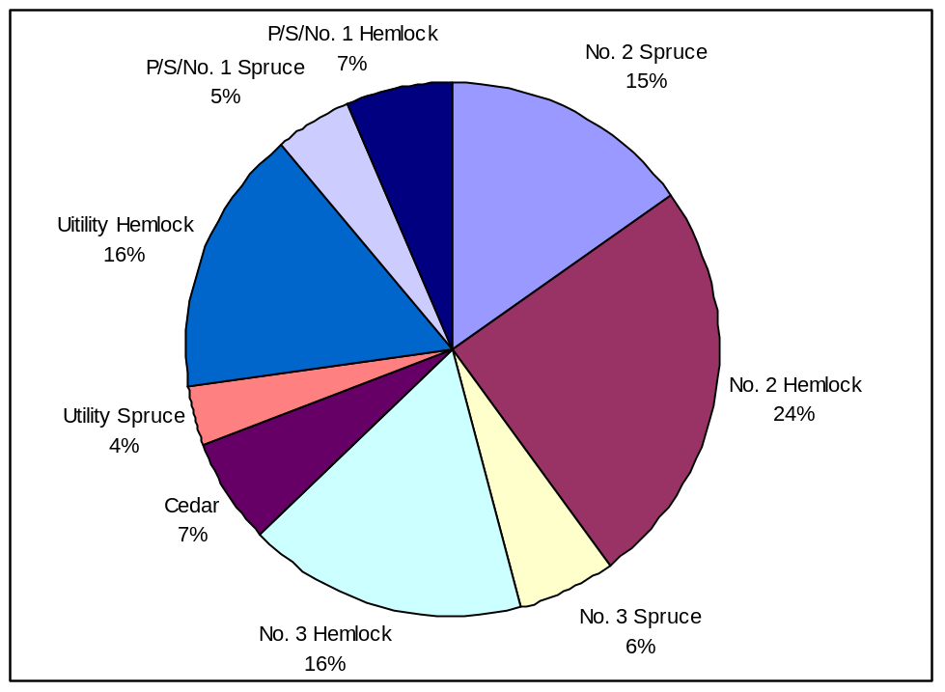

Ten-Year Harvest Projections
Over the ten- to fifteen-year planning cycle, the number of firms in an industry may increase or decrease in response to trends in industry performance and profitability. Thus, when projecting market demand over this period of time, it must be assumed that all inputs to the manufacturing process--including the number and type of processing facilities in the region--are subject to change. Other changes in the industry within this timeframe may include technological improvements, productivity gains, increased utilization of raw materials, and the addition of new processing capacity and capability to older facilities.
As the Tongass Land Management Plan was being revised in 1997, research economists at the Pacific Northwest Research Station (PNW) were asked to update their earlier projections of Alaska timber products output and timber harvest by ownership. The most recent projections of timber harvest over the planning cycle account for several dramatic changes in the region’s manufacturing capabilities, increased competition from a number of sources, and the steady erosion of North America’s share of Japanese timber markets.
Three scenarios--labeled “Low”, “Medium”, and “High”--were developed to display alternative futures for Alaska’s forest sector and the resulting demand for National Forest timber (Table 1). The values of key parameters for each forecast scenario are compared in Table 2. In the “Low” scenario, Alaska’s market share is limited by increasing stumpage costs and higher logging and manufacturing costs. Moreover, the North American share of the Japanese market is not expected to increase appreciably. In contrast, under the “High” scenario, Alaska is expected to develop a more efficient, competitive lumber industry, and to participate in a somewhat broader array of markets. Gains in efficiency are assumed to increase overrun ratios and reduce raw material input per unit of lumber output. The overall effect is a modest increase in timber harvest relative to the “Low” scenario.

Table 1. Projected National Forest Timber Harvest – Alaska

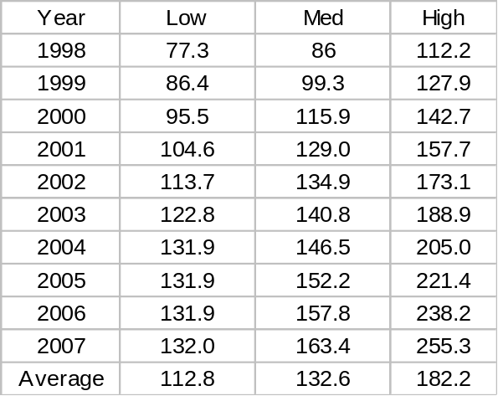 (million board feet, sawlog + utility volume)
Source: Timber Products Output and Timber Harvests in Alaska: Projections for 1997-2010, Gen. Tech. Rep. PNW-GTR-409, Portland, OR, USDA Forest Service, Pacific Northwest Research Station, 1997.
In their report, the researchers emphasized the uncertainty inherent in predicting the future demand for National Forest Timber:
We characterize the future demand for National Forest timber as having a high degree of uncertainty because of the magnitude of recent changes in the Alaska forest sector, and because many of the factors that will determine the size and type of industry in the future cannot be predicted. The level and reliability of timber supplies from Alaska National Forests are only two among a number of sources of uncertainty; rates of economic growth in key markets, changing technology and tastes and preferences of consumers, and the strength of competition are among other sources of uncertainty.

As discussed later in this paper, the Alaska Region, in cooperation with the PNW Research Station, will continue to monitor trends in international timber markets and the way in which the Southeast Alaska timber industry responds to those trends. Significant changes in Alaska’s manufacturing capacity, product mix, or competitive position, may warrant revision and reconsideration of the long-range harvest projections in the context of overall management goals.

Table 2. Values for Key Elements of the “Low”, “Medium”, and “High” Timber Harvest Forecast Scenarios

 | Fiscal Year | Alaska’s Share of N. American Softwood Lumber Shipments to Japan (Percent) |  |  | N. America Share of Japanese Softwood Lumber Imports (Percent) |  |  | Share of Alaska Softwood Lumber Production to Export Markets (Proportion) |  |  | Overrun in Lumber Production (MBF l.t./MBF l.s.)
Historic 1985-1996 | 1985 | 5.5 |  |  | 81.4 |  |  | 0.95 |  |  | 1.186
Historic 1985-1996 | 1986 | 6.5 |  |  | 86.6 |  |  | 0.95 |  |  | 1.175
Historic 1985-1996 | 1987 | 5.2 |  |  | 92.0 |  |  | 0.95 |  |  | 1.198
Historic 1985-1996 | 1988 | 5.6 |  |  | 93.5 |  |  | 0.95 |  |  | 1.220
Historic 1985-1996 | 1989 | 5.6 |  |  | 94.6 |  |  | 0.95 |  |  | 1.220
Historic 1985-1996 | 1990 | 6.8 |  |  | 85.7 |  |  | 0.95 |  |  | 1.220
Historic 1985-1996 | 1991 | 5.2 |  |  | 86.5 |  |  | 0.85 |  |  | 1.220
Historic 1985-1996 | 1992 | 4.1 |  |  | 86.9 |  |  | 0.60 |  |  | 1.220
Historic 1985-1996 | 1993 | 4.1 |  |  | 84.7 |  |  | 0.70 |  |  | 1.220
Historic 1985-1996 | 1994 | 3.2 |  |  | 79.8 |  |  | 0.60 |  |  | 1.220
Historic 1985-1996 | 1995 | 1.4 |  |  | 72.0 |  |  | 0.82 |  |  | 1.220
Historic 1985-1996 | 1996 | 0.7 |  |  | 70.4 |  |  | 0.71 |  |  | 1.220
Projected 1997-2010 |  | LOW | MED | HIGH | LOW | MED | HIGH | LOW | MED | HIGH | LOW | MED | HIGH
Projected 1997-2010 | 1997 | 0.9 | 1.0 | 1.5 | 70.0 | 70.0 | 70.0 | 0.85 | 0.75 | 0.65 | 1.226 | 1.237 | 1.247
Projected 1997-2010 | 1998 | 1.0 | 1.4 | 1.8 | 70.0 | 70.0 | 70.0 | 0.85 | 0.75 | 0.65 | 1.233 | 1.255 | 1.274
Projected 1997-2010 | 1999 | 1.1 | 1.6 | 2.0 | 70.0 | 70.0 | 70.5 | 0.85 | 0.75 | 0.65 | 1.239 | 1.272 | 1.301
Projected 1997-2010 | 2000 | 1.2 | 1.8 | 2.2 | 70.0 | 72.0 | 71.0 | 0.85 | 0.75 | 0.65 | 1.245 | 1.290 | 1.329
Projected 1997-2010 | 2001 | 1.3 | 2.0 | 2.4 | 70.0 | 72.0 | 71.5 | 0.85 | 0.75 | 0.65 | 1.251 | 1.307 | 1.356
Projected 1997-2010 | 2002 | 1.4 | 2.1 | 2.5 | 70.0 | 72.0 | 72.0 | 0.85 | 0.75 | 0.65 | 1.258 | 1.325 | 1.383
Projected 1997-2010 | 2003 | 1.5 | 2.2 | 2.7 | 70.0 | 72.0 | 72.5 | 0.85 | 0.75 | 0.65 | 1.264 | 1.342 | 1.410
Projected 1997-2010 | 2004 | 1.6 | 2.3 | 2.9 | 70.0 | 72.0 | 73.0 | 0.85 | 0.75 | 0.65 | 1.270 | 1.359 | 1.437
Projected 1997-2010 | 2005 | 1.6 | 2.4 | 3.1 | 70.0 | 72.0 | 73.5 | 0.85 | 0.75 | 0.65 | 1.276 | 1.377 | 1.464
Projected 1997-2010 | 2006 | 1.6 | 2.5 | 3.3 | 70.0 | 72.0 | 74.0 | 0.85 | 0.75 | 0.65 | 1.283 | 1.394 | 1.491
Projected 1997-2010 | 2007 | 1.6 | 2.6 | 3.5 | 70.0 | 72.0 | 74.5 | 0.85 | 0.75 | 0.65 | 1.289 | 1.412 | 1.519
Projected 1997-2010 | 2008 | 1.6 | 2.7 | 3.6 | 70.0 | 72.0 | 75.0 | 0.85 | 0.75 | 0.65 | 1.295 | 1.429 | 1.546
Projected 1997-2010 | 2009 | 1.6 | 2.8 | 3.8 | 70.0 | 72.0 | 75.5 | 0.85 | 0.75 | 0.65 | 1.301 | 1.447 | 1.573
Projected 1997-2010 | 2010 | 1.6 | 2.9 | 4.0 | 70.0 | 72.0 | 76.0 | 0.85 | 0.75 | 0.65 | 1.314 | 1.464 | 1.600
Source: Brooks and Haynes, 1997, pg. 10.

Annual Market Demand
.
.
.
.
.
.
.
.
.
.

Factors Influencing Timber Demand in the Short-Run
As specified in the Tongass Timber Reform Act, the Forest Service must also consider the annual market demand for timber from the Tongass. Economic theory suggests that the activities of individual firms and--by extension--the demand for inputs to production, depend upon the time frame examined. Over the period of a ten-fifteen year planning cycle, all inputs to production are variable. Sawmills open and close, as different players enter the scene. In contrast, the annual market demand for timber depends upon the short-run performance of a particular set of firms.
The short-term objective for most manufacturers is to use their existing capital to maximize profits or minimize losses. For example, a sawmill owner may change the amount of wood processed or the number of shifts employed, but will generally not invest large sums or enter or exit a market on the basis of short-run performance. In the short-run a firm may even continue to operate at a loss, as long as the variable costs of production can be covered. Finally, in the short-run it is assumed that there will be no change in the number of individual firms in the industry. Under these conditions, resource demand tends to be fairly inelastic. In other words, the existing mills will absorb a relatively wide range of prices before making significant changes in the volume of timber purchased.
The factors influencing annual demand (i.e. the operating decisions made by individual firms in the short-run) may not be predictable or, in hindsight, economically rational. Annual timber demand may well be a function of realistic or unrealistic speculation, desire to preserve market share, or some intrinsic value realized by the owner/operator who is preserving a lifestyle preference. Other factors influencing the demand for Tongass timber on an annual basis include:
- the number, capacity, and efficiency of wood processors in the region
- the volume and value of standing timber inventory owned by the firm
- the cost and availability of alternate sources of supply
- the relative cost of capital, labor, and other inputs to production
- the demand for the products manufactured in Southeast Alaska
- the technology employed in manufacturing those products
- currency exchange rates among trading partners
- contractual agreements with the purchasers of end products, and
- the extent to which government policies enhance or restrict market opportunities.

Overview of Tongass Timber Sale Procedures
The following procedures were designed to help ensure that annual timber sale offerings from the Tongass National Forest are consistent with market demand. A detailed discussion of the procedures, assumptions, and data sources is included in the following sections. In short, by allowing the industry to accumulate and maintain an adequate timber inventory, harvest activity can proceed at a pace consistent with the demand for wood products. At a minimum, the volume purchased is expected to equal the projected harvest. Under certain situations, additional volume may be purchased to rebuild inventory. The Forest Service will monitor changes in market conditions and industry activity and--within the limit of the ASQ--adjust annual timber offerings to keep pace with market behavior.

Estimating the Annual Consumption of Tongass Timber
A Forest Service timber sale is comprised of different species and grades of timber, each of which is valued and processed according to the expected product yield. The rate at which timber sales will be purchased and processed depends upon the raw material requirements of local manufacturers and the extent to which the average sale meets those requirements. Equation 1 shows how the relationship between manufacturing capability and raw material supply can be used to estimate theoretical timber consumption levels for the industry:

Equation 1. Tongass Timber Consumption, =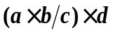
where
= Installed and operable mill capacity
= Industry rate of capacity utilization
= Percent usable wood in average timber sale
= Share of industry raw material provided by the Tongass
The following sections provide more detail on the data and assumptions used to determine the initial values for each of these parameters.
Installed and operable mill capacity. Processing capacity can be measured and reported in various ways, including:
- Design capacity. This is the maximum output that can possibly be attained.
- Effective capacity. This is the maximum output attainable given the desired product mix, scheduling considerations, machine maintenance, quality control, etc.
- Actual output. This is the rate of output actually achieved. It cannot exceed effective capacity and is often less than effective capacity because of machinery breakdowns, employee absenteeism, defective output, shortage of materials, and other problems outside the control of the operations manager.
By referring to various industry and government publications, one can get a general sense of mill capacity in Southeast Alaska, however, it is not always clear what the available data represent. Some mills report end product output vs. log throughput; others report design capacity vs. effective capacity. Consequently, there is a need for the systematic collection of information on the effective capacity of the wood product manufacturers in the region.
Industry experts estimate the effective capacity of a sawmill or other wood processing facility by looking at the installed equipment. The industry standard is to estimate log volume consumption during 250, 8-hour shifts per year. Double shifts do not necessarily double the effective mill capacity as the evening shift generally re-saws material rejected by the day shift. Given this precise standardization of capacity, most operators, in consultation with a sawmill expert, can come up with a reasonable figure for effective mill capacity. The best available information (documented in Table 3) was used to arrive at a 1998 installed processing capacity of 284 million board feet annually (log scale).
Because the emphasis here is on the short-run operating decisions of existing firms, capacity estimates for inoperative or incomplete facilities are not included. When there is evidence that new wood processing facilities (or expansions to existing mills) are moving past the planning stage to become viable wood processing entities (i.e. demonstrated financial commitment, lease or purchase of mill site, environmental permits approved, etc.) capacity figures will be increased accordingly. Conversely, permanent mill closures will trigger a downward adjustment in the reported industry capacity.
Industry rate of capacity utilization. In theory, with complete knowledge of the production functions, markets, and profit objectives for the sawmills listed in Table 3, the optimal rate of capacity utilization could be determined. In practice, this proprietary data is not likely to be made available. However, the historical operating rates for these mills and other similar operations can be used to estimate the typical level of operation for the industry.
Over the last fifteen years, the installed sawmilling capacity in Southeast Alaska has reportedly ranged from a high of 401 MMBF in 1983 to a low of 164 MMBF in 1996 (Table 4). Most of the reported capacity is associated with the sawmills owned and operated by the Ketchikan Pulp Company and the Alaska Pulp Corporation. In addition, a large sawmill at Klawock, a smaller mill in Haines, and timber operations owned by Steve Seley have been closed and reopened a number of times throughout the years. Finally, periodic surveys have thoroughly documented the existing milling operations in the region and indicate the continued presence of many small, owner-operated milling operations serving local markets for sawn products.

Table 3. Summary of Available Data on Sawmill Capacity in Southeast Alaska in 1998
NAME OF MILL | ANNUAL CAPACITY (MMBF, l.s.) | INFORMATION SOURCE
KPC Annette Sawmill | 69 | 70 MMBF l.t. capacity, 2 shifts, 5 days, 50 weeks/yr., overrun = 1.01 in 1996, Source: Louisiana-Pacific Annual Report, 1994.
KPC Ketchikan Sawmill | 64 | 60 MMBF l.t. capacity, 2 shifts, 5 days, 50 weeks/yr., underrun = .94 in 1996, Source: Louisiana-Pacific Annual Report, 1994.
Wrangell Sawmill | 40 | Personal communication (Fred Walk, Director, Forest Management, USFS, Region 10, retired) with Silver Bay Logging Company 12/5/97.
Viking Lumber Company | 35 | Personal communication (Fred Walk, Director, Forest Management, USFS, Region 10, retired) with Kirk Dahlstrom, Viking Lumber Company 12/5/97. Based on two-shift operation with new equipment to be installed Spring ’98.
Seley Corporation | 24 | 24 MMBF/year log usage as reported in “Lewis Reef permit approved for Seley project”, Ketchikan Daily News, July 16, 1997.
Pacific Rim Cedar | 9 | Personal communication (Fred Walk, Director, Forest Management, USFS, Region 10, retired) with Frank Age, Pacific Rim Cedar, 12/17/97.
Herring Bay Lumber | 5 | Personal communication (Fred Walk, Director, Forest Management, USFS, Region 10, retired) with Ben Fleenor, Herring Bay Lumber, 12/17/97.
Icy Straits Lumber | 5 | Letter from Icy Straits Lumber to Governor Knowles, 12/2/97.
Metlakatla Forest Products | 5 | Assuming 21.5 days/month, 25 MBF l.t./day, 20% overrun, as reported in Metlakatla Forest Products Business Plan.
Jim Ensely | 7 | Personal communication (Fred Walk, Director, Forest Management, USFS, Region 10, retired) with Al Rockwood, 12/17/97.
The Mill, Inc. | 6 | Estimated.
W.R.Tonsgard Lumber | 6 | Estimated.
Star Cedar Products | 2 | As reported in Governor’s Timber Task Force Report, 1997
Black Bear Cedar | 1 | As reported in Governor’s Timber Task Force Report, 1997
Misc. Small Sawmills | 6 | As reported in Governor’s Timber Task Force Report, 1997
Total | 284

Estimates of lumber output in Southeast Alaska were compiled by the PNW Research Station and are included in Table 4 to determine the historical rate of capacity utilization in Alaska’s lumber industry. As shown here, the rate of capacity utilization varies considerably and is closely linked to market conditions. For example, the data indicates that from 1983-1985, roughly 27-29 percent of the installed capacity was utilized. This is in sharp contrast to the capacity utilization rate of 62-72 percent observed during the peak of the market cycle (1991-1993).
Data from the Pacific Northwest, Alaska’s competitor region, suggests an average capacity utilization rate of 71 percent from 1985-1995 (Table 5). In contrast, Alaska mills averaged 47 percent utilization for the same time period. There are a number of possible explanations for the relatively low rate of capacity utilization in Alaska’s sawmills. As noted previously, most of the sawmills in Southeast Alaska have been in place for many years (most of the installed capacity dates back to the early 1970’s). Because the initial investment has been amortized, decision about production levels for these mills may be disproportionately influenced by short-term profitability. Therefore, given their lower fixed costs, Alaska’s mills will be more likely to close during periods of poor markets. Coupled with Alaska’s relatively high operating costs, this heightened sensitivity to market cycles serves to amplify the effect on lumber output in the region. Poor markets trigger temporary mill closures only to be followed by a surge in production after the market rebounds.
For purposes of this analysis, three alternative scenarios are considered. Each incorporates a different level of capacity utilization. At 28 percent, the “Low” scenario assumes a capacity utilization rate equivalent to the three-year average observed during the bottom of the market cycle (1983-1985). In contrast, the 66 percent capacity utilization rate of the “High” scenario is based on the three-year average observed during the peak of the market cycle (1991-1993). The “Medium” scenario is based on the average estimated utilization rate in Southeast Alaska from 1981-1997 (43 percent).

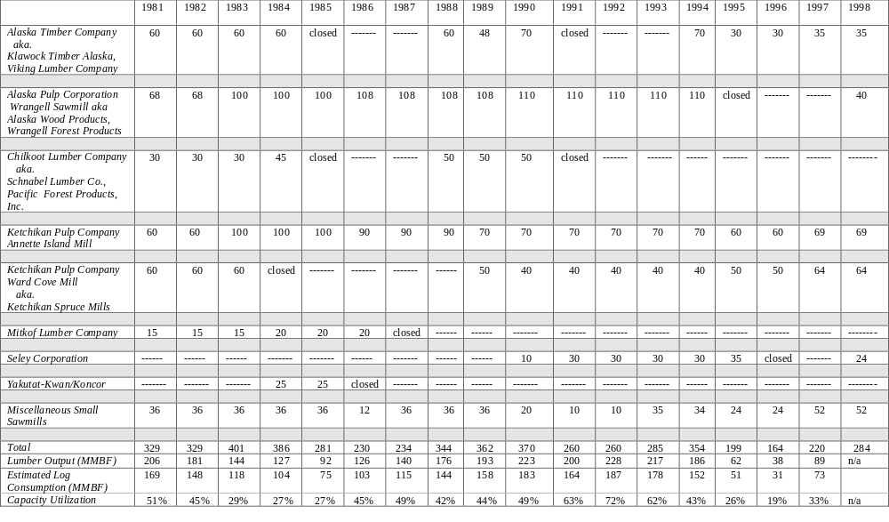Table 4. Sawmills, Lumber Output, and Capacity Utilization—Estimates for Southeast Alaska
Source Documents: Manufacturing Plants on or near National Forest Areas, Region 10 USDA Forest Service, 1959
The Primary Wood Industry in Alaska, A Directory of Loggers, Sawmills and Pulp mills in the State of Alaska, USDA Forest Service, 1967
Alaska Forest Products Industry, A directory of Loggers, Lumber Dealers, Sawmills, and other Forest Industries in the State of Alaska, USDA Forest Service, 1972
Alaska’s Forest Products Industry Sawmill Directory, USDA Forest Service, Alaska Region, 1978
Timber Supply and Demand Report, USDA Forest Service Region 10, 1984, 1985, 1986, 1992, 1994, 1996, lumber output for 1997 is estimated
Directory of Alaska Forest Products Manufacturers, Alaska Department of Commerce and Economic Development, 1988
Alaska Forest Products Manufacturer’s Directory, Alaska Department of Commerce and Economic Development, 1990

Table 5. Capacity and Utilization Estimates for Selected Western States

 | Installed 8-hour capacity | Avg. operating days | Avg. shifts per day | Two-shift capacity MMBF, l.t. (1) |  | Nominal operating capacity (2) | Production MMBF, l.t. | Utilization rate (3)

Oregon
1985 | 23,821 | 221 | 1.51 | 11,911 |  | 7,949 | 7,211 | .605
1986 |  |  |  |  |  |  | 8,149
1987 |  |  |  |  |  |  | 8,846
1988 | 24,847 | 229 | 1.57 | 12,424 |  | 8,933 | 8,601 | .692
1989 |  |  |  |  |  |  | 8,512
1990 | 24,229 |  |  | 12,115 |  |  | 7,511 | .620
1991 |  |  |  |  |  |  | 6,595
1992 | 13,737 | 231 | 1.61 | 6,869 |  | 5,109 | 6,200 | .903
1993 |  |  |  |  |  |  | 5,448
1994 | 13,670 | 244 | 1.58 | 6,835 |  | 5,270 | 5,703 | .834
1995 |  |  |  |  |  |  | 4,953

Washington
1985 |  |  |  |  |  |  | 3,419
1986 | 11,178 | 201 | 1.6 | 5,589 |  | 3,595 | 4,132 | .739
1987 |  |  |  |  |  |  | 4,645
1988 | 12,528 | 202 | 1.6 | 6,624 |  | 4,049 | 4,408 | .704
1989 |  |  |  |  |  |  | 4,274
1990 | 12,573 | 206 | 1.6 | 6,287 |  | 4,144 | 3,919 | .623
1991 |  |  |  |  |  |  | 3,820
1992 | 12,075 | 209 | 1.6 | 6,038 |  | 4,038 | 4,072 | .674
1993 |  |  |  |  |  |  | 3,863
1994 |  |  | 1.6 |  |  |  | 4,200
1995 |  |  |  |  |  |  | 4,095

California
1985 | 13,601 | 223 | 1.54 | 6,801 | 4,671 |  | 4,168 | .613
1986 |  |  |  |  |  |  | 4,865
1987 |  |  |  |  |  |  | 5,408
1988 | 15,716 | 233 | 1.59 | 7,858 | 5,822 |  | 5,671 | .722
1989 |  |  |  |  |  |  | 5,320
1990 | 15,326 |  |  | 7,663 |  |  | 4,981 | .650
1991 |  |  |  |  |  |  | 4,218
1992 | 9,997 | 230 | 1.59 | 4,999 | 3,656 |  | 3,997 | .800
1993 |  |  |  |  |  |  | 3,539
1994 | 9,331 | 236 | 1.6 | 4,666 | 3,523 |  | 3,521 | .755
1995 |  |  |  |  |  |  | 3,169
- Operating days assumed: 250
- Based on average operating days and shifts per day
- Based on two-shift capacity
Sources: Installed 8-hour capacities, operating day and shifts per day are from published mill surveys. Production data are from WWPA (reported in Warren, 1997). Capacity data for Oregon and California are estimated.

Percent usable wood in average timber sale. The extent to which the raw material in a sale will be fully utilized depends upon the technology installed in the region, the degree of processing infrastructure and integration, log export policies, and market conditions. Both Western Red Cedar and Alaska Yellow Cedar have traditionally been considered surplus to local manufacturing needs, although industry members have recently shown more interest in manufacturing Western Red Cedar. One of the new mills in the region, owned by Seley Corporation, has been designed specifically to accommodate the manufacture of products from this material. In fiscal year 1997, the Forest Service began implementing procedures to phase out the export of Western Red Cedar from the Tongass. For purposes of this analysis, it is assumed that Western Red Cedar logs will be processed locally and Alaska Yellow Cedar logs will continue to be exported in round-log form.
Special consideration must also be given to “utility-grade” logs. This material (estimated at 18 percent of average timber sale volume) is not currently used in lumber manufacture. It is assumed that utility-grade logs will be chipped in the region before shipping to other destinations.
Finally, depending on market conditions and log grade, varying percentages of the sawlog component of the harvest volume have been processed in the region’s sawmills. The percentage sawn in Alaska can be expected to increase over time as the industry acquires the equipment needed to utilize smaller diameter logs and as fewer log export permits are granted. This analysis adopts the percentages used by the PNW Research Station in their “High”, “Medium”, and “Low” timber harvest scenarios. Sawlogs that are not processed locally are typically small diameter, grades three and four. Historically, this material has been chipped for pulp manufacture.

Table 6. Timber Utilization in Southeast Alaska Sawmills
Species/Grade | Use by SE Alaska Industry | Percentage of Timber Sale Volume
Species/Grade | Use by SE Alaska Industry | -------Timber Harvest Scenario------
 |  | High | Medium | Low
Alaska Yellow Cedar | Exported in round-log form | 2% | 2% | 2%
Hemlock/Spruce/Red Cedar Utility | Chipped or exported, not processed in region’s sawmills | 18% | 18% | 18%
Hemlock/Spruce/Red Cedar Sawlogs (low-grade) | Chipped or exported, not sawn in region’s sawmills | 0% | 13% | 32%
Hemlock/Spruce/Red Cedar  Sawlogs (higher grade) | Sawn in region’s mills | 80% | 67% | 48%
Total |  | 100% | 100% | 100%

Share of industry raw material provided by the Tongass. Although the Tongass National Forest has historically provided the bulk of the timber processed in Southeast Alaska, other entities have occasionally participated in this market as well. The Alaska Native Corporations supplied Alaska’s pulp mills with pulp logs and the State of Alaska maintains a small timber program in the region. Most sawlogs from these non-federal sources have been exported from the state without processing. However, recent changes in overseas timber markets are forcing a new look at potential domestic uses for some of this timber supply. For instance, the Ketchikan Pulp Company and Sealaska (the Regional Native Corporation) have been studying the feasibility of manufacturing veneer in Southeast Alaska.
At the present time, there appears to be no compelling reason to expect private timber supplies to offset industry dependence on less expensive federal timber. The steady erosion of the hemlock log market in Asia suggests that private timber owners will be exploring every opportunity to diversify their products and markets. However, it is still not clear whether efforts to find markets for hemlock logs will lead to wood products manufacturing in Southeast Alaska as a viable outlet for private timber supplies.
In contrast, the State of Alaska has directed considerable effort toward negotiated sales and other provisions designed to encourage local processing of State timber resources. Although the smaller sales may still be exported in the round, for purposes of this analysis, it is assumed that most of this timber will receive some local processing.

Determining Timber Inventory Objectives
In addition to the timber processed in a given year, the annual demand for timber includes the volume needed to build, rebuild, or maintain an adequate “buffer stock” of uncut timber. This backlog of uncut timber is, in essence, the industry’s “dependable timber supply.” A sufficient supply of volume under contract allows the industry to adjust output in response to market conditions. It also appears to play a significant role in the stabilization of regional timber prices. Finally, basic operational considerations underscore the importance of maintaining sufficient timber inventories. For example, after a sale is awarded, it can take an operator one or more years to complete the road construction necessary to gain access to the timber. While this work is underway, the purchaser is harvesting and processing timber purchased in prior years. Consequently, timber processors generally maintain some volume under contract that is carried over from one year to the next.
What is an adequate level of uncut timber inventory? During the late 1960s and early 1970s, the ratio of uncut volume inventory to sales (roughly equivalent to harvest at that time) ran at approximately 2:1 for the Forest Service Region 6 (PNW), 3:1 in Region 5 (PSW), and 2.75:1 in the northern Rockies (Region 1). During the 1980-82 recession, the uncut/sold volume ratio increased to roughly 4.5:1. By 1987, the bulk of the timber surplus had been reconveyed to the Forest Service under special contract relief legislation and the uncut/sold volume ratio returned to the level observed in the 1970’s. Data for the Tongass independent sale program shows substantial fluctuation in this ratio. This may reflect the dominance of the two long-term timber contracts during this time period and/or periodic shortfalls in timber sale offerings (Table 7).

Table 7. Tongass Independent Sale Program Statistics (volume in million board feet)

Fiscal Year | Volume Under Contract (VUC) | Harvest  (H) | Ratio  H/VUC | Fiscal Year | Volume Under  Contract (VUC) | Harvest  (H) | Ratio  H/VUC
1981 | 157 | 142 | 1.11 | 1989 | 309 | 142 | 2.18
1982 | 173 | 150 | 1.15 | 1990 | 259 | 173 | 1.50
1983 | 103 | 55 | 1.87 | 1991 | 112 | 90 | 1.24
1984 | 129 | 71 | 1.82 | 1992 | 74 | 72 | 1.03
1985 | 108 | 36 | 3.00 | 1993 | 83 | 55 | 1.51
1986 | 114 | 60 | 1.90 | 1994 | 73 | 48 | 1.52
1987 | 243 | 72 | 3.38 | 1995 | 64 | 59 | 1.08
1988 | 339 | 100 | 3.39 | 1996 | 46 | 27 | 1.70

Planning for and managing an adequate raw materials inventory is an important business function. Precise formulas have been developed to help firms determine the appropriate level of inventory to carry given inventory carrying costs, the anticipated demand for finished products, the speed at which additional raw materials can be obtained (the lead time), and the variability in lead times. The firm will generally wish to carry a raw material inventory equal to the expected demand during lead time plus an extra buffer (or safety stock) to cover excess product demand or variation in lead time.
Some of the basic principles of inventory management can be used to calculate the optimal level of uncut volume under contract to be carried by the industry. The level of inventory (I) to carry to assure a 99 percent probability of meeting a given level of timber consumption (e) is estimated as follows:
Equation 2.
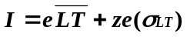

where
= Annual Tongass timber consumption
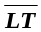 = Average lead time
 = Standard deviation of lead time
= Area under the standardized normal curve at 99% probability (i.e. 2.326)

As shown here, the level of inventory to carry is a function of the time it takes to replenish raw material supplies--the “lead time.” For purposes of this analysis, the lead time is the amount of time that passes between the sale award date and the delivery of the logs to the mill. Sale records from 22 Tongass timber sales were analyzed to determine the average elapsed time between the sale award date to the first recorded timber removals. The sales reviewed averaged a twelve-month lead time with a standard deviation of nine months (Table 8).

Table 8. Lead Time for Selected Tongass Timber Sales
Sale Name | Volume (MMBF) | Advertised Rate ($/MBF) | High Bid ($/MBF) | Miles of Road | Quarter/Year Awarded | Quarter/Year First Harvest Recorded | Elapsed Time (Lead Time, quarters) (quarters) | Purchaser
Basin | 9.1 | $ 4.60 | $ 28.10 | 4 | 4/86 | 4/89 | 12 | Spring Valley, Inc.
Outback | 14.4 | $118.45 | $118.45 | 5 | 1/90 | 4/90 | 3 | Seley, Inc.
Missionary | 4.9 | $122.41 | $169.09 | 0 | 4/91 | 1/92 | 8 | Seley, Inc.
Target | 2.0 | $150.86 | $183.82 | 0 | 1/90 | 3/91 | 6 | Mitkof Lumber, Inc.
Froot | 3.1 | $153.52 | $170.01 | 0 | 1/91 | 4/92 | 7 | Mitkof Lumber, Inc.
Old Hermit | 14.5 | $ 28.76 | $ 63.52 | 4 | 1/91 | 1/92 | 0 | Alaska Pulp Co.
Starfish |  |  |  |  | 1/93 | 3/93 | 2
White Alice Salvage | 2.1 | $ 4.57 | $113.00 | 0 | 1/93 | 2/93 | 1 | Jim Ensley
Rynda Boomstick | 4.5 | $ 4.50 | $ 7.62 | 0 | 1/94 | 2/95 | 5 | The Mill, Inc.
Twin | 3.7 | $ 25.36 | $ 31.50 | 2 | 2/93 | 4/93 | 2 | Jim Ensley
Deep Bay South | 9.7 | $ 8.63 | $ 9.00 | 4 | 1/93 | 4/94 | 7 | Fox River
Sumner Salvage | 3.0 | $ 3.25 | $ 3.25 | 0 | 2/93 | 4/95 | 6 | The Mill, Inc.
Midpoint | 5.3 | $232.53 | $232.53 | 4 | 2/94 | 1/95 | 3 | Metlakatla Forest Products
Bohemia | 35.5 | $255.20 | $315.24 | 27 | 2/96 | 4/96 | 2 | Viking Lumber Co.
Snowcat | 5.0 | $ 42.42 | $ 50.14 | 0 | 3/91 | 1/92 | 2 | Ketchikan Pulp Co.
Snow Pup | 5.3 | $ 3.26 | $ 3.44 | 4 | 3/92 | 1/94 | 6 | Cedarville
Frosty | 30.1 | $ 15.29 | $ 69.46 | 12 | 4/92 | 1/93 | 1 | Cedarville
Portage Bay Salvage | 6.0 | $ 76.52 | $105.74 | 0 | 4/92 | 1/93 | 1 | Seley, Inc.
Campbell |  |  |  |  | 4/94 | 4/95 | 4
Combination | 10.3 | $ 41.92 | $ 53.70 | 3 | 4/89 | 3/091 | 4 | Seley, Inc.
Average Lead Time: 4 quarters
Variance: 9 quarters
Standard Deviation: 3 quarters

Timber Market Analysis
During the pubic comment period on the draft procedures, reviewers expressed concern that wood product prices and timber harvest costs were not directly incorporated in the calculations. In general, people felt that the procedures would benefit from an analysis of this type of economic data. Several persons stressed the high-cost nature of doing business on the Tongass and pointed out that production costs and changes in costs are just as important to future demand as prices for end products. They requested that information about logging, road building and manufacturing costs be included in the final report.
Showing the calculations for all three scenarios at once seemed to cause confusion for some readers. They pointed out that, depending on the current market situation, all three scenarios were not equally likely to be realized. They noted that the Forest Service should consider only the scenario that reflects actual market conditions. Taking this a step further, some people wanted a clear explanation of how the Forest Service would assess market conditions in order to choose among the three market scenarios analyzed.
Finally, a concern was raised that market conditions in FY 1998 were unlike any experienced before. Given the structural changes underway in major wood product markets, one opinion was that the demand for Tongass timber was approaching a new low. Further, it was suggested that the lower level of activity would persist well into the future.
In response to these concerns, the Forest Service compiled a database of historical economic information from the independent timber sale program on the Tongass. The database includes data from 450 sales, including some 2.1 billion board feet of timber offered between FY 1981 and FY 1998. The data set includes the vast majority of sales offered under the independent sale program. The information was obtained from hard copies of the “Report of Timber Sale FS 2400-17” forms filed in the Alaska Regional office. These are the official timber sale appraisals for each sale offered in the Region and are the best available information on the logging, road, and manufacturing costs associated with individual sales, as well as their estimated value.
Production Cost Data for Tongass Timber Sales. Information from the database is summarized in Table 9 and illustrated in Figure 2. This information illustrates how prices and costs both impact the “bottom line” for wood product manufacturers. Since around 1989, average logging costs have generally followed an upward trend with some variability around individual years. However, data for FY 1998 shows a relatively large increase in average logging costs ($85/MBF). Logging costs for future sales should be monitored closely to determine if this increase represents a permanent shift in the cost of doing business on the Tongass.
While raw material costs have increased over the last few years, the variety and value of wood products manufactured in the region have decreased. At $556/MBF, the weighted average selling value for the timber offered in FY 1998 was roughly $300/MBF less than the average value of FY 1996 offerings. This substantial price drop is a consequence of very poor markets for sawn wood products. A contributing factor is the loss of the region’s pulp mills and the diminished capacity of the industry to extract maximum value from the available timber supply.

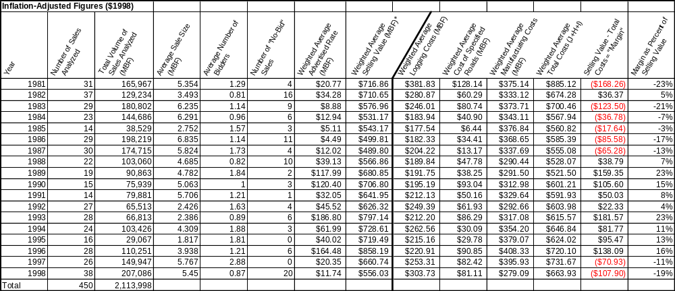
Table 9. Tongass Timber Sale Statistics – Weighted Averages

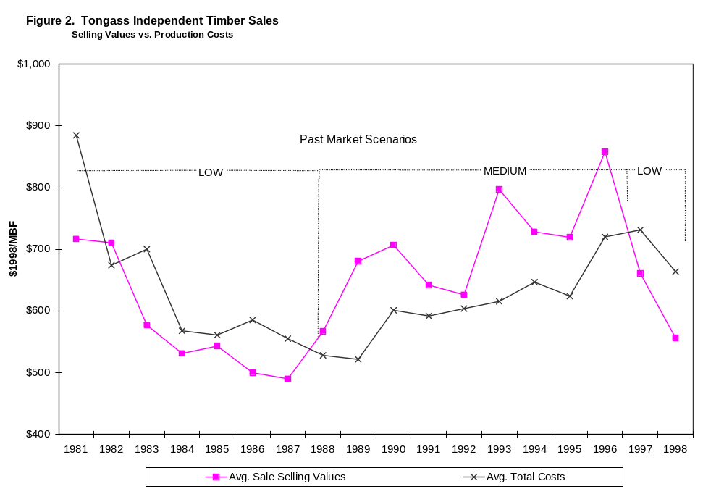

Deciding Among Market Scenarios. Tracking movements in the difference between the selling value and production costs associated with the timber sales offered is one way of determining whether the industry current faces a “Low”, “Medium”, or “High” market scenario. As shown in Figure 2, from FY 1983 through FY 1987 the cost of harvesting and processing the average independent timber sale exceeded the value of the wood products manufactured. These years are clearly indicative of the “Low” market scenario. The greatest difference was experienced in FY 1983 when costs exceeded values an average of $123/MBF. Again, in FY 1998 the difference between costs and selling values was greater than $100/MBF.
In contrast, from 1988-1996, average selling values exceeded total costs. The largest differences occurred in fiscal years 1989, 1993 and 1996 where the difference between selling values and costs ranged from $138/MBF (1996) to $181/MBF (1993).
The 1981-1998 time period can be divided into sub-periods representative of the “High”, “Medium” and “Low” market scenarios by using a profit margin index. This index is simply the ratio of the difference between selling values and total cost (excluding stumpage) and average end product selling values for the same year. The results of this calculation are shown in the last column of Table 9. This information is used below to better define each of the market scenarios and to highlight some of the economic indicators that can be used to classify markets in future years.
The “Low” Market Scenario. The low market scenario is characterized by financial difficulties in the industry. Losses are common and the financial condition of the average operation is marginal. As a result of their financially weak position, mill owners are unable to make upgrades, improve efficiency, and diversify product lines to increase and maintain market share. Traditionally, low market conditions have stemmed from weak product demand in overseas markets. More recently, the difficulty of surviving a depressed timber market conditions has been compounded by intense competition from other suppliers and alternative wood products (engineered wood, for example).
For purposes of this analysis, the “Low” market scenario is defined when average total costs exceed average selling values. Under this definition and using the profit margin index described above, the period of time from 1981-1987 and 1997-1998 would be classified as “Low.” In the early and mid-1980’s the market conditions underlying the “Low” scenario extended for seven years. It is fair to acknowledge that if the recent upward trend in harvest costs continues, the “Low” market scenario in the next decade could be both longer and more severe. However, at this time, the margin between selling values and total costs is no greater than that observed in the early 1980’s.
The “Medium” and “High” Market Scenarios. A judgement call must be made in distinguishing between the “Medium” and “High” market scenarios. Characteristics of the “High” scenario include a highly efficient and competitive industrial structure, buyers who are willing to pay a substantial premium for Alaska’s old growth timber of all species and grades, and the ability of Alaska’s manufactures to maintain a competitive position in global timber markets. In addition to relatively high margins between end product selling values and production costs, capital investment and product diversification are key indicators.
Reviewing the data from past years, it is clear that the economic conditions necessary to realize the “High” market scenario have simply not been sustained for a long enough period of time. For example, the margin between prices and costs has only exceeded 20 percent in two years; FY 1989 and FY 1993. The short duration of profitability has not been enough to encourage or support the necessary investment to achieve the conditions anticipated under the “High” scenario. This scenario is necessarily preceded by several years of profitability. For purposes of this analysis, the “High” scenario will be triggered by rising economic indicators and two to three years of highly profitable operations, along with the attendant capital investment. Conditions such as these have not been witnessed in the past.
Given the above discussion, the more profitable years in Alaska’s history are classified under the “Medium” scenario. Industry profits were being generated and the profit margin index was roughly 10 to 20 percent. Highly profitable years (profit index above 20 percent) were limited to market peaks and were of short duration. Given a stronger market for the wood products currently being manufactured in Alaska and some effort to control raw material and manufacturing costs, the “Medium” market scenario may be realized in the future. Alternatively, a shift to more profitable product lines may move the industry in this direction.

Additional Observations—Linking Economic Data with Timber Sale Activity. Table 9 and Figures 2, 3 and 4 provide some interesting insight about Southeast Alaska’s timber market. Figure 3 illustrates the relationship between average profit margins (selling values – logging and manufacturing costs) and the volume of timber sold each year. Figure 4 shows the relationship between profits and harvest activity. For both charts, profit margins are plotted against the Y-axis on the left-hand side of the graph and timber volumes are plotted against the Y-axis on the right-hand side.
- Total production costs for Tongass independent sales have increased over time. (See Figure 2.) However, until FY 1996, the combined average cost for logging, roading and manufacturing was actually lower than the same costs in early 1980’s. Since 1996, logging costs have steadily increased. It remains to be seen whether this is a one-time adjustment in response to new standards and guidelines in the Tongass National Forest Land Management Plan, or is indicative of a longer term trend.
- During low points in the market cycle, timber sale purchases tend to increase before markets recover. (See Figure 3.) At first glance, this observation may appear to be counterintuitive, but there is a simple economic explanation. In a period of low product values, the advertised value for federal timber sales in Alaska typically drops to base rates. As shown in Table 9, the average advertised rate in FY 1986 was only $12.02/MBF and the average margin between selling values and production costs was strongly negative. However, based on expectations (and perhaps, speculation) that the market was near recovery, the volume of independent timber sales purchased reached an all-time high of 189 MMBF. Similar behavior was observed in FY 1997. If buyers have reason to believe that markets will be firming up in the near term, it is to their advantage to buy an ample supply of timber at a low selling price. Thus, it cannot be assumed that poor markets will always result in a low level of timber sales. The volume sold in any given year depends, in part, on where buyers think the market is going.
- High product markets correspond to increased harvest activity but do not necessarily lead to immediate increases in the volume of timber sold. (See Figure 4.) The increased harvest is a logical outcome of the additional raw material needed to support higher production and sales levels. The correlation between selling values and harvest levels is strongest throughout the 1980’s and early 1990’s. As shown in Figure 4, harvest trends paralleled price trends throughout this period. The relationship did not hold through the 1990’s when harvest levels dropped off even as end product selling values were gradually edging up. It has been suggested that the low harvest levels were a consequence of a shortage in the volume offered under the independent sale program.
- While FY 1997 and FY 1998 were not good years for the industry, it is premature to conclude that the market has dropped to a “new low” or that the last two years represent a longer term trend. At this point in time, product prices and profitability are very poor, but not outside the boundaries of past market troughs. Wood product prices follow broader economic cycles and it is not uncommon for average prices to change by $100/MBF or more from one year to another. Currently, on the basis of product value alone, one cannot conclude the Alaskan producers face an unusual or unprecedented low market. In real dollar terms, the average estimated selling value for the timber offered in FY 1998 was roughly $556/MBF. This compares with average selling values as low as $490/MBF the mid-1980’s (Table 9). However, as previously mentioned, the upward trend in harvest costs, if sustained, has the potential to erode Alaska’s tenuous competitive position. The substantially higher costs (up $100/MBF from the mid-1980’s) could eventually drive profit margins to a new low.

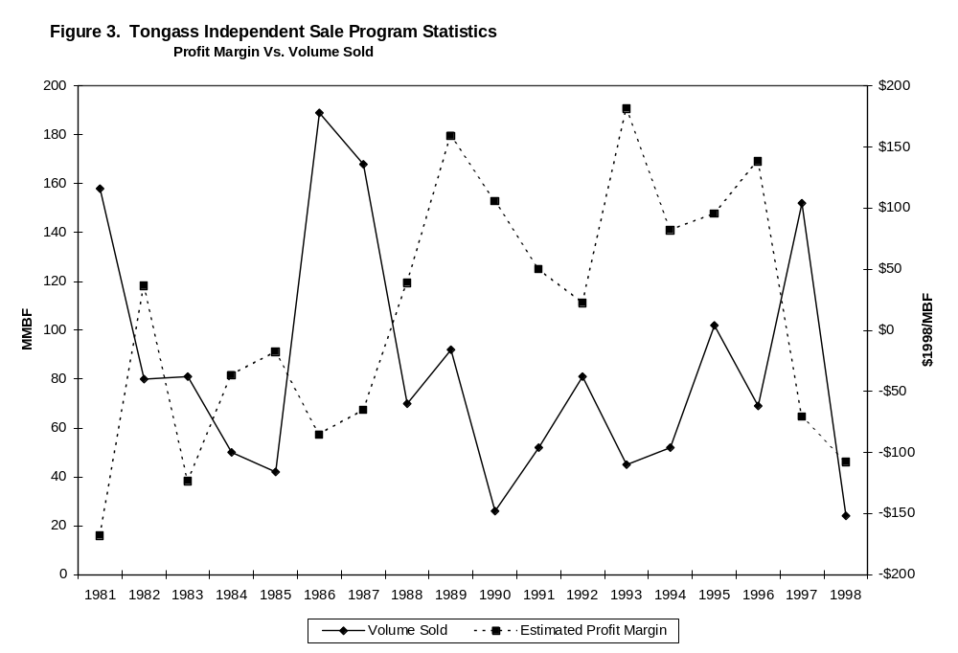

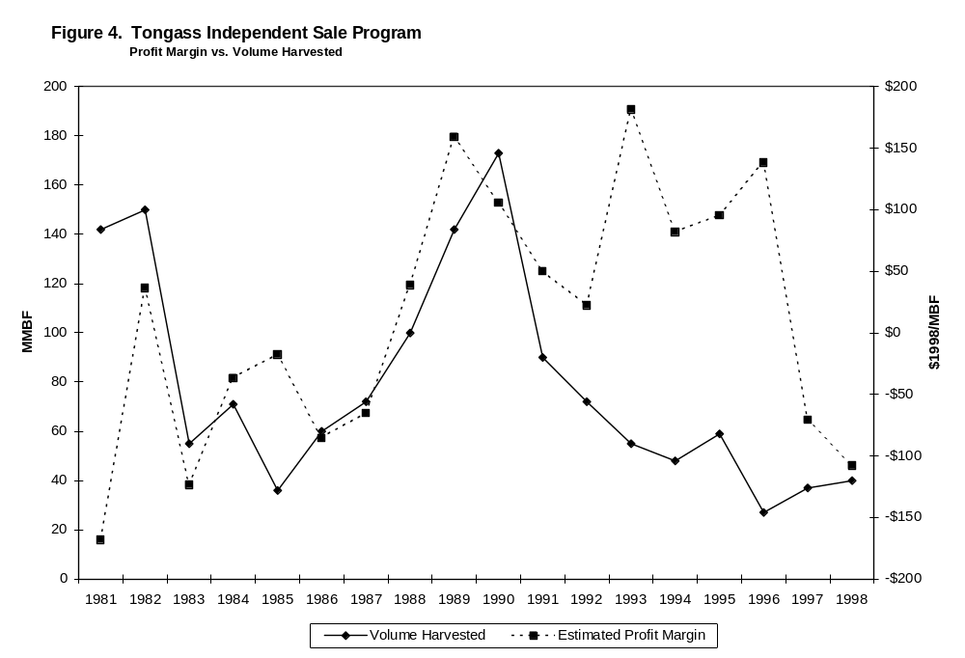

Estimating Likely Timber Purchases – Example Application
A data set for the hypothetical Blue Lake National Forest is used here to demonstrate how the procedures will be used to help managers decide how much timber to offer in a given year. The first step in the process is to multiply the estimated local mill capacity (Table 10, line 1) by the utilization rate assumed under the different market scenarios (Table 10, line 2). (Please note: the mill capacity figures used in this example are for the hypothetical Blue Lake National Forest. They are for example only.) This figure is the estimated volume of timber to be processed locally each year. These figures are then adjusted upward to account for species and grades in the Forest’s timber supply that are harvested but not processed locally (Table 10, line 3). A final adjustment is made to account for timber obtained from sources other than the Blue Lake (Table 10, line 4). Given this set of assumptions, the volume of National Forest timber consumed in this example would fall within the range of 225-338 MMBF, depending on market conditions and processing efficiency (Table 10, line 5).
The next step in the procedures is to estimate the level of uncut timber inventory that is appropriate to carry under different market conditions. As described on pages 19-21, the appropriate level of inventory to carry depends upon the volume expected to be processed each year (Table 10, line 5) and the amount of time needed to replenish inventory (lead time). The relationship is summarized in Equation 2 (page 20) and in line 9 of the “Notation” column in Table 10. Because estimates of the volume of timber processed vary by scenario, the timber inventory requirement also varies. Given the assumptions listed for each scenario, inventory objectives for this example range from 617 MMBF to 928 MMBF (Table 10, line 9).
Finally, the procedures incorporate harvest projections for the coming year (Table 10, line 12). Harvest projections developed by the PNW Research Station will be used here when the sale procedures are applied to the Tongass National Forest. The projected harvest levels shown in Table 10 are shown for example only. For each of the three market scenarios the lower end of the expected timber purchase range is simply the projected harvest level. This assumes that, at a minimum, processors will want to replace the volume removed from inventory. The upper end of each range is the sum of: 1) the volume, if any, needed to bring the existing inventory of uncut timber up to the level desired, and 2) the volume needed to replace the projected harvest.
The results for the Blue Lake National Forest are shown on line 13 of Table 10. In this example, under the “Low” market scenario, the uncut timber inventory was 17 MMBF lower than the target level (Table 10, line 9 – line 10). Therefore, estimates of the volume of timber likely to be purchased in the coming year include the sale volume needed to build the inventory, plus the sale volume needed to replace the projected harvest. Accordingly, under this scenario, timber sale purchases are estimated to range from 200 MMBF (the projected harvest) to 217 MMBF (17 MMBF to build the inventory and 200 MMBF to replace the projected harvest). Similarly, the “Medium” scenario suggests a purchase volume range of 300 MMBF to 523 MMBF (223 MMBF, inventory + 300 MMBF, harvest). Using the same methodology, the “High” scenario suggests a relatively large purchase volume range of 400 MMBF to 728 MMBF (328 MMBF, inventory + 400 MMBF, harvest).

Table 10. Blue Lake National Forest Likely Purchase Volumes |  | Market Scenarios
Element | Notation | Low | Medium | High
1. Installed and operable mill capacity (MMBF, log scale) |  | 500 | 500 | 500
2. Industry rate of capacity utilization |  | 20% | 40% | 60%
3. Percent usable wood in average timber sale |  | 40% | 60% | 80%
4. Share of industry raw material provided by the Blue Lake NF |  | 90% | 90% | 90%
5. Annual consumption of Blue Lake NF timber (MMBF) | 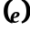= | 225 | 300 | 338
6. Standard deviation of lead time (years) |  | .75 | .75 | .75
7. Desired probability of meeting consumption level (line 5) |  | 99% | 99% | 99%
8. Value of t-statistic |  | 2.326 | 2.326 | 2.326
9. Timber inventory requirements (MMBF) | 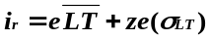 | 617 | 823 | 928
10. Current timber inventory (MMBF) |  | 600 | 600 | 600
11. Projected harvest (MMBF) |  | 200 | 300 | 400
12. Inventory shortfall (MMBF) | 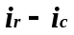 | 17 | 223 | 328
13. Range of expected timber purchases (MMBF) | 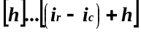 | 200-217 | 300-523 | 400-728

Determining the Volume of Timber to Offer --- Example continued.
As shown in Table 10, different assumptions about markets and industry configuration yield different outcomes and not all values within the full range displayed here are equally likely. In choosing among an array of possible offer levels, it is important to anticipate the consequences of a “wrong” decision. Again, the manager must have access to specific and current information in order to judge the outcome of future actions. In terms of short-term economic consequences, over-supplying the market is less damaging than under-supplying it. If more timber is offered than purchased in a given year, the unsold volume is still available for re-offer in future years at a minimal investment. The unsold volume would have no environmental effects because it would not be harvested. However, a shortfall in the supply of timber available for harvest in a given year can be financially devastating to the industry.
In the example calculations shown in Table 10, the industry relying on timber from the Blue Lake National Forest has enough volume under contract to meet the projected harvest for all scenarios. Decisions about the coming year’s offer level, therefore, are not likely to immediately constrain industry operations but may effect the industry’s ability to meet the market demand for products in future years. Assuming market conditions and economic indicators point to a “Low” market scenario, it would be reasonable to set the initial offer at the upper end of the expected purchase range for this scenario (in this example, 217 MMBF.) If the actual harvest level is equal to that projected for the “Low” scenario, the industry will have the opportunity to meet inventory objectives. If harvest levels are lower or higher than projected, the difference will be reflected in inventory accumulation or depletion. Any such “inventory surplus/deficit” will be accounted for in setting the offer level for future years.
In addition to economic factors, planning the annual timber program requires a realistic assessment of the likelihood of delays from permitting processes, environmental analyses, administrative appeals, and/or litigation. Sufficient contingency volume must be included in the twelve-month schedule to ensure that, to the extent possible and consistent with applicable laws, the target delivered sale volume is achieved. Finally, budget and organizational constraints limit the extent to which the Forest Service can respond to economic cycles and the associated fluctuations in timber demand. All of these factors must be considered in evaluating the annual market demand for timber and setting annual timber offerings.
In the final analysis, planning the annual timber sale program is an exercise in professional judgement. The purpose of this paper is to clearly identify the extent to which economic analysis contributes to this decision-making process. The procedures described here will allow the decision-maker to make an informed judgement about the appropriate volume of timber to offer under different market conditions.
Implementation Schedule
Using the fiscal year 2000 program as an example, the procedures for including market demand in timber sale planning would be implemented as follows:
June 1999: Estimate the likely purchase volume range for fiscal year 2000 using most current data available. Develop six-month firm and twelve-month tentative timber sale schedules for fiscal year 2000 based on budget and workforce considerations and after reviewing the timber market indicators listed above.
December 1999: Review fiscal year 2000 timber sale schedule and revise as necessary after reviewing the timber market indicators listed above.
June 2000: Estimate the likely purchase volume range for fiscal year 2001 using most current data available. Develop six-month firm and twelve-month tentative timber sale schedules for fiscal year 2001 based on budget and workforce considerations and after reviewing the timber market indicators listed above.

Revising Timber Sale Schedules
The following timber market indicators will be monitored and reviewed semi-annually to ensure that the most current market conditions and trends are considered in the development of timber sale schedules.
1. End Product Selling Values. Timber harvest activity and mill utilization rates are directly related to market cycles. A comparison of current end product selling values with the average observed over a ten-year period will help the Forest Service determine whether current market conditions are indicative of a “High”, “Medium”, or “Low” market scenario.
- Number and characteristics of unsold sale offerings. Actual purchase activity provides immediate feedback about market conditions. Consistent no-bid sales may be an indicator of excess supply. Poor markets, a disproportionately high level of volume under contract, or an excessive amount of economically marginal timber in the sale package may result in an increase in “no-bid” timber sales. Conversely, when timber is scarce relative to demand, buyers will tend to be more accepting of sale characteristics they might otherwise avoid.
- Rate of change in volume under contract. Consistent with national policy, the Region’s objective is for the industry as a whole to have two to three years of volume under contract at any point in time. This is also consistent with industry objectives of maintaining an inventory of uncut volume to carry operations through the “lead time” in acquiring new timber sales. When the volume under contract is rising, it indicates that sale offerings may be running ahead of demand. Conversely, when volume under contract is falling, it indicates that sale offerings may be lagging behind demand.
- Number of bidders for individual sales. When markets are favorable and several independent mills are in operation, bidder participation will be high. Competition, as measured by the number of bidders per sale, will also be greater when timber supplies are tight relative to production goals and when new buyers are entering the market.
- Bid ratio. The ratio of the high bid to the appraised value of a timber sale is referred to as the “bid ratio.” Bid ratios are another indicator of conditions in local timber markets. When market conditions are favorable and/or timber supply is tight, competition tends to drive bid prices up over appraised values. Consistent overbid may be an indicator of excess demand.
- Requests for contract extensions. Increases in the number of requests for timber contract extensions may signal declining timber demand.
- Recent or expected changes in Forest Service policy. Changes in log export policies or utilization requirements, for example, may affect timber demand.
- Recent or expected changes in industry structure. New mills (or mill closures) and changes in the types of products manufactured in the region may affect timber demand.
- Significant changes in consuming markets, such as Japan, or in competing regions, such as Canada, that were not anticipated when long term planning cycle projections were made.

Monitoring
.
.
.
.
.
.
.
.
.
.

Although we cannot fully eliminate the uncertainty associated with looking into the future, by following a well-designed monitoring plan we can answer important management questions and gather the information necessary to improve the accuracy of our predictions. The procedures outlined in the previous pages have been designed to allow us to move forward with a timber sale program while the industry is in a complete structural transition. They provide a starting point for timber sale planning based on our current understanding of the industry in Southeast Alaska and its competitive position in wood product markets.
The strategy set forth in this paper is our first formal attempt to estimate the market demand for timber in the coming year and plan timber offerings accordingly. As the procedures are implemented we need to ask several questions to evaluate and, perhaps, improve upon our approach. Did we do what we said we were going to do? Did we accomplish what we thought we would accomplish? How can we improve our decision-making process? The monitoring plan described below was designed to answer these questions. It establishes a system of checkpoints for determining whether the procedures we have designed are, in fact, meeting the following objective:
Subject to appropriations, other applicable law, and the requirements of the National Forest Management Act, and to the extent consistent with the direction in the Tongass Land Management Plan---offer a volume of timber each year that: 1) allows existing mills to operate at a level consistent with market conditions; 2) provides for the opening of new timber processing facilities or expansion of existing facilities; and 3) will be purchased when offered.
The monitoring plan has three primary roles. First, it provides answers to three management questions to help determine the effectiveness of the Region’s approach to timber sale planning (Section I-Management Issues). Next, it explicitly addresses the assumptions about industry operations and markets and sets up a process to systematically collect the information needed to test and revise those assumptions (Section II-Validation of Models and Assumptions). Finally, it provides a complete listing of the information needed to improve upon our understanding of--and our ability to model--regional stumpage markets (Section III-Database Development.)

I. Management Issues
 | Questions to be asked at the end of each year: | Indicator: | Follow-up action:
1. | Was the timber supply made available last year in a timely fashion and at a level comparable to that suggested by the timber sale procedures? | Report the volume and date of timber sales offered each fiscal year.  Compare the volume actually offered with the “suggested offer range” calculated in the timber sale procedures. | Cite deviation from “suggested offer”, if any, and incorporate actual offer volume into calculations for the coming year.
2. | Was there demand for the timber offered? | Report the number, size, and appraised value of any sales offer that did not receive bids each fiscal year.  Note factors that reduced marketability. For example, is the market saturated, or was the sale offered at a price the industry was unwilling to pay? | Issue summary report of findings to management to use in future sale planning.
3. | Did the Tongass timber program level constrain the operation of existing mills or the opening of new wood processing facilities? | Report the level of volume under contract at the close of each fiscal year. Note distribution of volume among individual purchasers. | If the year-end volume under contract is less than the target buffer stock, as determined by the sale procedures, ensure that offerings this year exceed projected harvest.
3. |  | Review the bidding activity and accumulated volume under contract for buyers planning new facilities.  Managers of planned facilities must begin bidding on timber sales and accumulating volume under contract. If they regularly bid on timber sales but are not acquiring timber, (and all timber is sold) the annual offer level may be a limiting factor. | If the owners of planned new mills are actively bidding on timber sales, ensure that the new mill’s capacity has been considered in the most recent application of the timber sale procedures.
3. |  | Report the number of bidders for each timber sale and the bid ratio (high bid/appraised value) for sales offered and sold each fiscal year. | When market conditions are good and/or timber supply is tight, competition tends to drive bid prices in excess of appraised prices. The number of bidders for each sale is also an indication of competition. High stumpage prices in poor markets are an indication of relative scarcity.

II. Validation of Models and Assumptions

 | Assumptions in: Brooks, David J.; Haynes, Richard W. 1997. Timber products output and timber harvests in Alaska: projections for 1997-2010, PNW-GTR-409. | Verification: | Criteria for Action:
1a. | “…Alaska mills cannot or will not compete for timber harvested from private land (Native Corporations) in Alaska.” Brooks, 1997, pg. 4 | Use on-going discussions with mill owners, media, and informal communication channels to maintain general awareness of industry developments that may invalidate this assumption. Continue to look for better information sources regarding private timber harvest levels. | If it can be documented that private timber supplies account for more than 20 percent of timber processed in the region, or if a wood processing facility is constructed primarily to manufacture timber from private lands, revise the ten-year harvest projections.
2a. | “…alternative markets, either export or domestic, can be developed for chips, low-grade saw logs, and utility grade logs. In the absence of markets, low-grade saw logs and utility logs may be left as logging residues.” Brooks, 1997, pg. 4  “…we assume that changes in policies or management practices (including harvesting practices) will enable this.” Brooks, 1997, pg. 9  “…all residues from lumber manufacturing can be marketed…” Brooks, 1997, pg. 7 | Verify actual end uses of small diameter sawlogs, utility volume, and sawmill by-products by monitoring industry investment in chipping and other methods of utilization.  Maintain awareness of Region’s policy on logging residue. | In the event that another major product line emerges to utilize low- end material (i.e. pulp mill, ethanol facility, fiberboard plant, etc) revise the ten-year harvest projections.
3a. | “…15 to 35 percent of Alaska’s lumber production will be shipped to U.S. domestic markets.” Brooks, 1997, pg. 4 | Verify actual sales destinations for wood products sawn in Southeast Alaska each fiscal year. Continue to look for better information sources regarding the domestic sales of Southeast Alaska producers. | If it can be documented that sales to domestic markets account for more than 35% of lumber production in Southeast Alaska, revise the ten-year harvest forecast.
4a. | “…overrun will increase by either as little as 10 percent (in the “low” scenario) or as much as 30 percent (in the “high” scenario) over the period 1997-2010…” Brooks, 1997, pg. 5 | Use on-going discussions with mill owners, media, and informal communication channels to maintain general awareness of industry developments that may indicate a faster or slower rate of change. On-going mill studies at the Pacific Northwest Research Station and the Forest Product Lab may provide further insight. | Incorporate the best available information when the ten-year harvest projections are revised.
5a. | “…lumber manufacturing is the primary industry in Southeast Alaska; the National Forest timber previously used for pulp is assumed to be surplus to the manufacturing requirements of Alaska mills…” Brooks, 1997, pg.9 | Verify actual product mix for Southeast Alaska mills. Contact larger mill owners for information. | The 10-year harvest projections assume that sawnwood production drives timber harvest. Softwood lumber market shares are a key factor in the projections. If other products-- such as veneer or fiberboard--emerge, revise the ten-year forecast.
6a. | “North American producers as a whole are assumed to face continuing competition from other suppliers in the Japanese market; in none of the scenarios do we assume the possibility of a return to the market shares observed in the 1980’s.” Brooks, 1997, pg. 5  North America will supply 70% to 72% of Japan’s annual softwood lumber imports through the year 2002 (see Brooks, 1997, Table 3) | Using data supplied by the Japan Wood Products Research Information Center, verify actual North American share of Japanese softwood lumber imports each year and compare with stated assumption. | The ten-year harvest projections are not especially sensitive to this variable. Consider the need to revise the ten-year harvest forecasts if there is a significant variation (+/- 25%) from the stated assumption
7a. | “…producers in Alaska will face stiff competition from larger and generally more efficient producers in the Pacific Northwest and Canada.” Brooks, 1997, pg. 15  Alaska will supply 1.4% to 2.5% of North America’s annual softwood lumber exports to Japan through the year 2002. (see Brooks, 1997, Table 3) | Using data from the U.S. Department of Commerce and the Japan Wood Products Research Information Center, compare Alaska’s actual share of North American shipments to the forecast. | If Alaska’s share of North America’s annual softwood lumber exports to Japan exceeds 2.5% for two successive years, review the ten-year harvest forecast.
8a. | The Food and Agriculture Organization [FAO] 1997 has accurately projected future lumber consumption in Japan (see Brooks, 1997, pg.1). | FAO will validate their projections and revise as necessary. | As new estimates become available from FAO, revise the ten-year harvest forecast.
 | Assumptions in: Evaluating the Demand for Tongass Timber, USDA Forest Service, Region 10, 1998. | Verification: | Action:
1b. | The buffer stock calculations accurately portray industry activity. | Review volume under contract and the rate at which it is being harvested and replenished. | Every three years, review trends in inventory management and revise model as necessary.
2b. | The installed and operable mill capacity reported in Table 1 is accurate and generally corresponds to the definition of capacity used in Table 4. | Need to document installed capacity using a consistent definition. | Revise as necessary when new information becomes available.
3b. | The rate of capacity utilization in the Pacific Northwest is characteristic of industry operations in Southeast Alaska. | On-going question. Will depend upon our ability to address (Sec. II, 2b.) and to monitor actual production in Alaska mills (Sec. II, 1b.) | Revise as necessary when new information becomes available.
4b. | The Tongass will continue to provide the bulk of timber processed in Southeast Alaska. | Refer to (1a).  Maintain awareness of timber supply and harvest from State timberlands. | If it can be documented that timber supplies from non-Tongass ownership account are not accurately represented in the timber sale procedures, make the necessary revisions.
5b. | Sixty-three percent of the timber volume sold is processed in sawmills. | Refer to (2a) and (5a).  Maintain awareness of changes to the Region’s log export policy. | Significant changes in the type of products manufactured, the extent to which low-end material is utilized, and policy and regulations pertaining to log exports and logging residue will require a revision coefficients used in the timber sale procedures.

III. Database Development
 | Information to collect | Current availability | Desired availability
Tongass National Forest
1a. | Timber sale data: volume by species, appraised unit (per mbf) value, purchaser credit unit value, high bid unit value, number of bidders, SBA sale?, date offered/awarded. Include information about sales receiving no bids. | Information for sales over $2,000 in value is available from the Regional Office. Hard copy 2400-17’s are also available from the SOs. | Electronic database that can be queried to extract the information for a particular sale or sum across sales. Updated quarterly.
2a. | Timber harvested: volume by species, unit price paid. | Quarterly cut and sold reports available from the Regional Office. | No change recommended.
3a. | Log exports: 1) permit applications granted, volume by species, purchaser, destination. 2) logs exported, volume by species, destination | Log export permits are gathered in the Regional Office. Not systematically analyzed, although some information has been entered into a computer database. | Quarterly report of export permits issued. Annual report of logs exported. Analysis of export volume activity by purchaser and country of destination.
4a. | Volume under contract: volume and value by purchaser | Volume under contract by purchaser reported quarterly by Regional Office. Time series data published annually in ANILCA 706(a) report. | Report value as well as volume to compute inventory carrying cost.
Industry Operations
1b. | Mills and mill capacity, product mix, production, wood source, employment, installed equipment. | Basic information published annually in ANILCA 706(a) report. | Complete data set collected for each mill using the same questions and definitions of terms. Published annually.
2b. | Logging costs in Southeast Alaska | Calculated as part of timber appraisal process. Not systematically compiled or analyzed. | Annual review of logging costs and trends in individual cost centers. Special need for analysis of economics of alternatives to clearcutting.
3b. | Timber offer and harvest on State and private timberlands in Southeast Alaska. | Harvest estimates are calculated and published annually in the ANILCA 706(a) report. | Report offer as well as harvest for State timber program. Continue to look for better sources of information about timber program activities of Native Corporations.
Market Conditions and Trends
1c. | Projections of lumber consumption in Japan | Not currently monitored in R10. | Review projections published by FAO.
2c. | Housing starts in Japan (total vs. wood-based) and average floorspace by type | Published annually in the ANILCA 706(a) report. | No change recommended.
3c. | Japanese softwood lumber imports by source (volume and value) | Published annually in the ANILCA 706(a) report. | No change recommended.
4c. | B.C. lumber exports, volume and unit value by destination | Not currently monitored in R10. | B.C. Ministry of Forests annual trade statistics
5c. | U.S. lumber exports, volume and unit value by destination | Not currently monitored in R10. | Review data collected and published by FAO.
6c. | PNW lumber exports, volume by species, unit value and destination | Published quarterly by PNW Research Station: “Production, Prices, Employment, and Trade in Northwest Forest Industries” | No change recommended.
7c. | PNW lumber imports, volume by species, unit value and source | Published quarterly by PNW Research Station: “Production, Prices, Employment, and Trade in Northwest Forest Industries” | No change recommended.
8c. | PNW sawmill capacity by state | WWPA mill surveys. Data available through PNW Research Station, as needed. | No change recommended.
9c. | Chip prices on export and domestic markets. | Export volumes and unit prices are published annually in the ANILCA 706(a) report. | Publish and monitor domestic chip and pulpwood unit prices as well as export.
10c. | Alaska lumber exports, volume and unit value by destination | Published annually in the ANILCA 706(a) report. | No change recommended.
11c. | Alaska lumber shipments to U.S. domestic markets, volume and unit value | Very rough estimates are published annually in the ANILCA 706(a) report. | Continue to try to find a reliable source for data on domestic sales.
12c. | U.S. currency exchange rates in Canada, Japan, South Korea, and China | Published annually in the ANILCA 706(a) report. | No change recommended.
13c. | Gross domestic product, consumer price indices, and interest rates in the U.S., Canada, Scandinavia, Japan, Korea, Taiwan, and China | Published annually in the ANILCA 706(a) report. | No change recommended.

Appendix
.
.
.
.
.
.
.
.
.
.

Public Comments on the Draft Procedures

Key Issues in Public Comments
TTRA Timber Demand Procedures

Public comments received on the September 28, 1998 draft of “Evaluating the Demand for Tongass Timber” (Draft Procedures) are summarized here.

Three sets of comments were received from environmental organizations and their representatives. Comments received from the Southeast Alaska Conservation Council (SEACC), the Alaska Rainforest Campaign (ARC), and Mr. Ed Whitelaw were very similar. Whitelaw reviewed the document and both SEACC and ARC concurred with his assessment. SEACC added some additional comments.

Two sets of comments were received from timber industry members and their representatives. The McDowell Group reviewed the document for the Alaska Forest Association (AFA) and Executive Director; Jack Phelps sent a cover letter concurring with McDowell’s findings. Brian Brown, an employee of Silver Bay Logging, sent his comments in a separate letter.

Public participation has helped us to improve the content and utility of this final report.
We want to thank those who took time to provide us with comments. A number of your suggestions have been incorporated into the Final Procedures.

Comments and Forest Service Response

1a. The long-term contracts created "artificial” market conditions in Southeast Alaska. Therefore, historical data is not a good indicator of future market behavior.

Some reviewers were concerned that the long-term contracts had a disproportionate effect on mill capacity and utilization rates. They contend that, to the extent the contracts helped shape the industry and its operations, past performance is not likely to be indicative of future performance. SEACC, ARC and Whitelaw stated that the long-term contracts provided subsidized timber that kept the industry operating at "artificially high” rate of production. Moreover, they assert that mill capacity throughout this time period was driven by the requirements of the long-term contracts.

1b. Because they are based on historic industry structure and production functions, the draft procedures will consistently overestimate demand.

ARC/Whitelaw expressed concern that the Draft Procedures were biased to overstate timber consumption and market demand. Whitelaw commented that the model used in the Draft Procedures was already out of touch with reality in that it failed to account for the "unprecedented shift in the current and future demand for Tongass timber" (Whitelaw, pg. 3). As evidence of this, he pointed to the fact that the current rate of timber consumption was below that predicted under the "Low" scenario in the model. He cautioned that "[T]he Forest Service's method of calculating current demand based on historical conditions is likely to persistently overestimate demand for Tongass timber for the foreseeable future." (Whitelaw, pg. 5)

In contrast, Brown commented that when past markets were strong, additional mill capacity would have been installed if timber supply had not been a limiting factor.

Forest Service Response:

Although Brown and Whitelaw apparently disagree about whether the procedures over- or understate historical mill capacity and utilization rates, they appear to agree, in principle, upon the validity of using these parameters as indicators of annual consumption under the short-term sale program. Thus, the disagreement boils down to the accuracy of the specific number selected as a proxy for future conditions.

These differences in opinion are to be expected. Unfortunately, there is no way to determine whether the assumptions of Brown, Whitelaw, or the Forest Service are correct a priori. While the direction of the "bias" resulting from the use of historical data is uncertain, the data represents the observed relationship between market conditions and output levels in Southeast Alaska and is unique to the region. In short, the Forest Service used the best available data to make an informed judgement about the appropriate starting point to use to begin using an adaptive process.

Perhaps more importantly, the procedures are self-correcting. If the volume under contract exceeds the target level calculated using the procedures, the volume of timber offered is reduced accordingly. Conversely, if the volume of timber harvested in a given year is higher than expected thereby drawing down the volume under contract, the volume offered the next year is increased proportionately. The procedures put boundaries around the sale program to ensure that the volume of timber made available each year is closely linked to industry and market behavior.

Finally, the procedures include a detailed monitoring section that lists the information needed to validate assumptions about the relationships among markets, mill capacity, and operating rates each year. As industry structure, markets, and timber consumption rates change, the procedures will be updated with this new information. The procedures are designed so that, over time, erroneous projections will be systematically accounted for and corrected.

- The procedures to estimate market demand should explicitly incorporate the relationship between current production costs and product values.

Brown commented that the relationship between price (cost) of timber and the quantity demanded should be explicitly incorporated into the procedures.
Whitelaw commented that capacity utilization serves as a proxy for all the market factors that influence demand. He felt that important factors such as input costs and product prices should be directly factored into the procedures. SEACC agreed and noted that the Science Consistency Review did not evaluate whether the Region applied the most relevant information for estimating market demand, including prices and costs.
Forest Service Response:
We agree that it is important to consider costs and prices explicitly, and as a fundamental part of the process of establishing the timber sale program. Our recognition of this fact is reflected in the emphasis given to prices and costs in the monitoring plan (section III, items 2a-2b, and 3c-7c, for example).
The final document contains additional data and an analysis of the average annual selling values and costs for 450 timber sales offered under the Tongass independent sale program. This information allows us to speak in general terms about the relationship between economic conditions and timber sale activity. More importantly, we are able to document patterns and trends in end product selling values and production costs and to quantify the associated changes in industry profitability. This serves to inform our judgement about which market scenario better reflects actual conditions in any given year.
We disagree with the assertion that prices and costs should be--or can be--factored into the procedures as some comments suggested. Even for circumstances where data are abundant and precise, efforts to develop models that reliably predict short-term market behavior often fall short. The science consistency review and the external peer review considered this question explicitly.
We believe that the procedures, as modified, strike an effective balance between the need for effective consideration of the factors that will influence market response, and the cost and value of more complex approaches.
3. A stable, long-term timber supply is needed to attract investment.

Comments from AFA and the McDowell Group center around the need to remove the uncertainty associated with the long-run timber supply from the Tongass, thereby creating conditions that will be conducive to investment in new and existing timber operations.

SEACC's comments suggest that the size of the timber program is not as critical as the capability of the industry to efficiently manufacture and market the timber that is made available. They assert that it is the industry's responsibility to make whatever changes are necessary to remain competitive regardless of the size of the timber program.

Forest Service Response:

The reliability, transparency, and stability afforded by the Draft Procedures are major steps toward translating the timber production component of the Forest Plan into short-term operational decisions. The adaptive nature of the procedures provides assurances to all that the program will not allow the level of volume under contract to accumulate unnecessarily or to drop low enough to stifle the growth and development of the industry.

We agree that it is necessary for the industry to become competitive regardless of the size of the timber program. By taking market conditions and current timber inventory into consideration, the Draft Procedures will directly contribute to the stability necessary to achieve this goal. However, Alaska’s competitive position will not be improved by only making changes in the size of the timber program.

In addition, the federal government is actively participating in a multi-agency partnership and research facility in Sitka, Alaska to enhance the competitive position of Alaska’s wood products industry. This direct technical assistance is a key component of successfully manufacturing and marketing wood products from whatever timber supply is made available.

4a. The Procedures should be considered a "rule" and are subject to the Administrative Procedures Act (APA).

This point is raised by SEACC and ARC.

Forest Service Response:

We agree that the Draft Procedures constitute an APA "rule" under 5 USC 551. Every piece of direction, including most memos from the Regional Forester, is an APA "rule". However, the Forest Service is not required to go through the rulemaking process described in 5 USC 553 because the matter at hand is considered an interpretive rule and/or a rule of agency practice which does not regulate any outside entity.

Finally, even if the Draft Procedures were a substantive, regulatory rule, the Forest Service has already met the requirements of 5 USC 553. Notice was published in the Federal Register (63 Fed Reg 65573) November 27, 1998, comments were received and are being considered, and final direction will be issued no less than 30 days after the notice.
4b. The Draft Procedures are not responsive to the Tongass Timber Reform Act (TTRA).

SEACC questions the extent to which the Draft Procedures meet the intent of TTRA Section 101. They make three points based on their interpretation of the Forest Service's response to legislative intent:

- The Draft Procedures establish an inflexible timber target that ignores the needs of other forest users and the mandate of TTRA.
- Under TTRA, the allowable sale quantity approved for the planning cycle must be limited to the volume of timber for which there is demand.
- Section 101 was intended to remedy the problems caused by the excess accumulation of volume under contract. The Draft Procedures violate legislative intent by prescribing a backlog of uncut timber under contact as a buffer to market fluctuations.

Forest Service Response:

- The procedures do not establish the timber sale offer level for the Tongass. The procedures will provide a range of likely purchase volumes to be considered by policy officials in deciding the volume of timber to offer each year. The policy officials will also consider appropriations, the requirements of the National Forest Management Act and other applicable laws, and other factors to ensure that the offer level is consistent with providing for the multiple use and sustained yield of all renewable forest resources.

- As discussed above, the Forest Plan addresses the sustainability of all forest resources and sets the boundaries within which the Forest Service may seek to meet the annual market demand for timber. One outcome of the Forest Plan is an estimate of the maximum sustainable timber supply that can be made available for sale over the life of the Plan, i.e. the allowable sale quantity (ASQ). The ASQ is not a timber target nor does it prescribe the volume of timber to offer each year. Outside of serving as an upper limit on the volume offered over the decade, the ASQ is not relevant to the discussion of how the Forest Service will seek to meet market demand each year.

- The procedures are designed to explicitly address the problem of an excess accumulation of volume under contract. If the volume under contract becomes excessive, the procedures will identify the problem and indicate that the Forest Service should offer a volume of timber that is less than the volume expected to be harvested, thereby ensuring that volume under contract is reduced to the proper level.

The Irland Group, Timber Demand Scenarios for Tongass National Forest 1991-2010, Report to the Alaska Region USDA Forest Service, June 1992, pg. 13.
United States Department of Agriculture, Forest Service, Tongass Land Management Plan Revision Record of Decision, R10-MB-338a, May 1997, pg. 37.
United States Department of Agriculture, Forest Service, Record of Decision, Tongass National Forest Land and Resource Management Plan, FS-639, April 1999, pg. 60.
Rogers, pg. 78.
Richard W. Haynes and David J. Brooks, An analysis of the timber situation in Alaska: 1970-2010. Gen. Tech. Rep. PNW-GTR-264. U.S. Department of Agriculture, Forest Service, Pacific Northwest Research Station, 1990.
U.S. Department of Agriculture, Forest Service, Alaska Region, “Timber Supply and Demand 1986”, April 1987. Figures cited do not include utility-grade volume.
The Irland Group, “Timber Demand Scenarios for Tongass National Forest 1991-2010: Report to Alaska Region USDA Forest Service”, June 1992, Appendix, p. 47.
U.S. House of Representatives, “Tongass Timber Reform Act”, Report of the House Committee on Interior and Insular Affairs, Rept. 100-600, Part 1, May 4, 1988, p. 4.
United States Department of Agriculture, Forest Service, Record of Decision, Tongass National Forest Land and Resource Management Plan, April 1999, pg. 3.
United States Department of Agriculture, Forest Service, Tongass Land Management Plan Revision Final Environmental Impact Statement: Part 1, R10-MB-338b, January 1997, pg. 3-250.
However, all things being equal, under better market conditions, buyers will tend to purchase and process more of this finite supply.
The “planning cycle” in TTRA is equated to the ten- to fifteen-year “planning period” referenced in the regulations implementing the National Forest Management Act (P.L. 94-588)
David J. Brooks and Richard W. Haynes, Timber products output and timber harvests in Alaska: projections for 1997-2010, Gen. Tech. Rep., PNW-GTR-409, Portland, OR: U.S. Department of Agriculture, Forest Service, Pacific Northwest Research Station, 1997, pg. 2.
William J. Stevenson, Production/Operations Management, Irwin, Illinois, 1986, 827 p.
Ken Kilborn, Wood Products Technologist, Sawmill Assistance Service, Inc., personal communication.
Some of this information has already been obtained through the State’s Manufacturing Extension Partnership Program. It is anticipated that a more complete report could be developed in one month’s time at a cost of $8,000-$12,000.
As shown in Table 4, mill capacity changes from year to year. For instance, at the time of this writing, the Ketchikan Pulp Company announced that they would close their Annette Hemlock mill in the fall of 1999. At the same time, a new timber company, Gateway Forest Products, was considering building a veneer mill in Ketchikan. As the procedures are implemented, mill capacity figures will be updated and verified.
United States Department of Agriculture, Forest Service, Tongass Land Management Plan Final Environmental Impact Statement, January 1997, pg. 3-285, Table 3-85.
David J. Brooks and Richard W. Haynes, Timber products output and timber harvests in Alaska: projections for 1997-2010, Gen. Tech. Rep., PNW-GTR-409, Portland, OR: U.S. Dept. of Agriculture, Forest Service, Pacific Northwest Research Station, 1997, pg. 14, Table 6.
See Brooks, 1997. Calculated from Table 6 (low grade and utility net of utility component).
Darius M. Adams, et al.. “Is the Level of National Forest Timber Harvest Sensitive to Price?”, Land Economics, 1991, 67(1): 74-84.
Darius M. Adams and Richard W. Haynes, “A Model of National Forest Timber Supply and Stumpage Markets in the Western United States”, Forest Science, 1989, 35(2): 401-424.
William J. Stevenson, Production/Operations Management. Irwin, Illinois, 1986, pp 499-500.
All figures have been adjusted for inflation and are reported here in 1998 dollars. Averages are volume-weighted.

