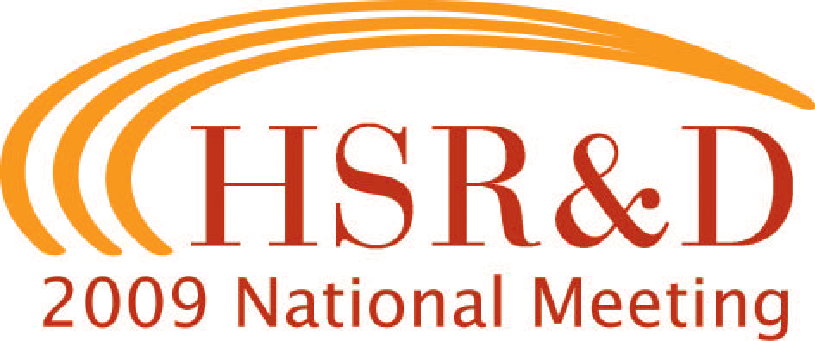

Special Interest Groups

Wednesday, February 11, 2009

6:30pm – 8:00pm

VA Women’s Health Research: Essex AB Planning for the Healthcare of Women Veterans - Networking Ideas and Research
Linda Lipson, MA

This session will be devoted to a brief summary of current funded research, recent research findings, and an update of VHA and VA ORD actions related to women veterans healthcare and women’s health research. We’ll also identify important future areas of research and strategies to expand women’s health research and support a growing network of researchers.

Thursday, February 12, 2009

7:00am – 8:00am

Applying Health Services Research Methods Grand Ballroom Salon 1
to the Study and Evaluation of Rehabilitation Services
Jay Freedman, PhD

Traditionally, rehabilitation research has focused on basic science and rehabilitation engineering, while health services research has focused on the issues surrounding the delivery of medical and mental health services. With the increased demand from the present conflicts for rehabilitation services to meet the immediate and long-term needs of veterans, there is a need for more research that addresses the issues of rehabilitation quality, cost-effectiveness of care, utilization, health outcomes, and costs. This is an opportunity for both rehabilitation and health services investigators to network and explore the unique aspects of rehabilitation in VA and address issues that facilitate or impede conducting high quality, clinically relevant health services research in rehabilitation.

Developing a VA Emergency Preparedness Research Grand Ballroom Salon 2
Agenda
Aram Dobalian, PhD, MPH, JD

VHA's Fourth Mission is to serve as a backup to the Department of Defense health system in times of war or other emergencies and as support to communities following domestic terrorist incidents and other major disasters. This interest group will facilitate the creation of an integrated plan of action for establishing a comprehensive VA emergency preparedness and response research agenda in support of this mission.

Qualitative/Mixed Methods Research Interest Group Grand Ballroom Salon 7
Barbara Bokhour, PhD
Laura Damschroder, MPH
Jane Forman, ScD

Please join us for a discussion of the use of qualitative and mixed methods in Health Services Research. We will discuss challenges of conducting qualitative and mixed methods research, issues of writing abstracts and grants using these methods, and future directions for the qualitative mixed/methods working group. Anyone with an interest in conducting qualitative/mixed methods research is welcome.

Friday, February 13, 2009

Noon – 1:00pm

Advancing Quality Measurement in VA Galena
Andrew Guccione, PT, PhD, DPT

In order for VA to maintain its position of national leadership and continue to serve as a model for other systems, HSR&D and QUERI recently held an invitational meeting of experts within and outside of VA to summarize current evidence regarding the development and application of quality measurement, identify current controversies, and review future directions in quality measure development and implementation. This follow-up meeting, which is open to anyone interested in quality measures and performance measurement, will be the first to highlight the outcomes of the meeting and open the discussion to a broader VA audience.

Noon – 2:00pm

VA/DoD Collaborations Interest Group: Grand Ballroom Salons 3/4 Strategies, Insights, Lessons Learned, and Possibilities for Improving Collaboration
Seth Eisen, MD, MSc
Mary JoPugh, PhD, RN
Abstracts of three studies will be provided, but the focus of discussions will be on the barriers overcome and the “lessons learned” from selected investigators, including: developing synergy between an ongoing DoD study and a new VA study; communication between VA and DoD researchers; effective strategies and realistic expectations for research with military populations; IRB issues; distinct military cultures; data collection from service members from the Vietnam, Desert Storm, and OEF/OIF conflicts; and the use of administrative and other databases for recruitment and shared successes. Time for discussion and interaction is being planned.

Noon – 3:30pm

Health Professions Education Research and VA: Dover C Unique Features, Challenges and Opportunities
Judy Shea, PhD
Kate Bent, RN, PhD

In this workshop we will explore how health professions education research methods and practices differ from better known clinical, epidemiological, and health services research methods. Specific objectives are to 1) acquaint participants with unique features of educational research and directions that the field of health professions education research is going, 2) discuss possible challenges to conducting health professions education research both within and outside of VA; and 3) highlight opportunities for conducting health professions education research and linking it to health services and clinical research. Some specific issues to be addressed include typical and optimal designs, interdisciplinary teams for education research, importance of moving from learning outcomes to patient/population outcomes, relevant and helpful sources of data and tools, and current ‘important’ questions. A hands-on activity will reinforce the objectives. This workshop is open to all HSR&D National Meeting attendees.

12:15pm – 2:00pm

Management Research Interest Group Essex A-C
Carol VanDeusen Lukas, EdD

The Management Research Interest Group meeting, hosted by the Center for Organization, Leadership and Management Research (COLMR), brings together health services researchers and managers who are conducting – or who are interested in -- research about how organizations are structured and function, how organizations change, and how organizational factors affect clinical research. Our focus this year will be on exploring work being done in VA outside the Research and Development Service to better understand the dynamics of VA medical center and VISN performance and the factors that affect it. All interested investigators and managers are invited to join us. Feel free to bring your lunch.

12:15pm – 2:15pm

Implementation Research Clinic Heron, Iron, James
(advance registration requested)

Brian Mittman, PhD
Cheryl Stetler, PhD
QUERI Implementation Research Coordinators

Staff from the Center for Implementation Practice and Research Support (CIPRS) and QUERI Implementation Research Coordinators will conduct an intensive implementation research clinic for current VA implementation researchers (at all levels of expertise) and prospective implementation researchers. Clinic participants will meet in small groups to discuss specific implementation research issues and challenges; groupings will be based on level of expertise and issue(s) of interest. Each group will be facilitated by one or two implementation research experts. Researchers interested in participating in the clinic should send email to CIPRS@va.gov (from a VA email account) or Cynthia.Gammage@va.gov (from a non-VA account) with the following information: Name, affiliation (VA facility, HSR&D Center, QUERI Center), self-rated level of implementation research expertise (novice, moderate, expert), area(s) of implementation research expertise (if moderate/expert), and a 3-5 sentence summary of the issue or challenge you wish to discuss. If you wish to receive assistance in responding to a specific journal or grant review, please send the abstract. CIPRS staff will contact you to request and provide additional prior to the HSR&D conference.

12:30pm – 2:00pm

Health Services Genomics Interest Group Meeting Grand Ballroom Salon 1
Pauline Sieverding, JD, PhD

All researchers interested in learning more about Health Services Genomics are invited to this initial meeting. Health Services Genomics is a NEW priority research area within the HSR&D eRA RFA. An informal discussion of HSR genomics and potential group activities will take place. If you would like to present a poster at this Interest Group Meeting, please contact Dr. Sieverding at pauline.sieverding@va.gov.

