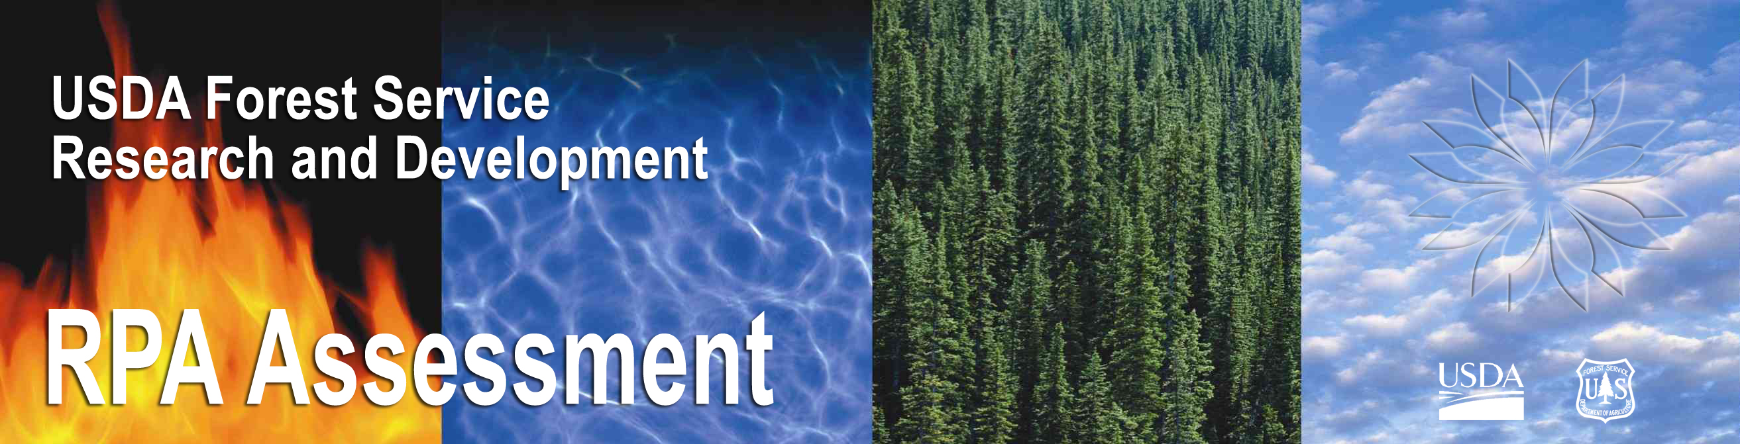

Interim Update of the 2000 RPA Assessment
Highlights

The Forest Service has updated the 2000 Resource Planning Act (RPA) Assessment of the Nation’s renewable resources.
- The Forest and Rangeland Renewable Resources Planning Act of 1974 mandates an assessment of the nation’s renewable resources on forests and rangelands every 10 years.
- The Forest Service also delivers an interim update between 10-year cycles.
- The RPA Assessment provides a snapshot of current forest and rangeland conditions and trends, and projects future uses of renewable resources and the effects on resource conditions, including the status of forests, range, wildlife and fish, water, outdoor recreation, and wilderness.
- The next RPA Assessment will be completed in 2010.
- RPA Assessment documents are available at http://www.fs.fed.us/research/rpa/.

U.S. forests can play a major role in reducing greenhouse gas emissions.
- U.S. forests will continue to sequester carbon, but at a decreasing rate.
- Use of wood products in place of alternate products can reduce emissions.
- Trees can reduce emissions if placed around buildings to reduce energy use.
- If the global oil price increases persist in the long run, large scale cellulosic ethanol production may become economically competitive, and offer one option to offset emissions from fossil fuel.

Forests play a critical role in protecting the U.S. water supply.
- About 53% of the nation’s water supply originates on forest land, 26% on agricultural land, and 8% on range land.
- About 24% of the water supply in the contiguous 48 states originates on Federal land, and 18% from land managed by the Forest Service, even though the National Forest System occupies only 11% of the surface area.
- Water withdrawals in the U.S. have nearly leveled off in recent decades and are projected to increase less than 10% between 2000 and 2050, despite a projected population increase of over 40%.
- However, in some regions of the country, water scarcity is an increasing concern both for meeting future human demands and protecting the integrity of ecosystems.

Climate change is affecting natural environments.
- Climate change has the potential to fundamentally alter the distribution of U.S. forest and rangelands, their productivity, species diversity, and ability to support ecosystem services.
- Future climate scenarios and ecological models suggest that climate change could increase productivity of U.S. forest and rangelands in the short term, and shift the distribution of plants and animals in the long term.
- Options for forest sector adaptations include interregional migration of productive capacity, substitution between wood and non-wood products, and changes in forest stand management.
- Increased seasonal fluctuations in climate strongly influence the abundance of water resources and the demand for energy.

Urban areas will continue to expand, reducing forestland in the U.S.
- U.S. area classified as urban land is projected to grow from 3.1% in 2000 to 8.1% in 2050. While urban forests can provide some of the same benefits -- such as recreation, wildlife habitat, and “carbon sinks” for cleaner air -- urban development forever changes the character of ecosystems.
- While total forestland area in the U.S. has been relatively stable in the last century, a net loss of 20 million acres (2.7%) is projected between 2000 and 2050. Most of that loss will be caused by development.

Population change and economic conditions have major influences on renewable resources.
- The U.S. population is expected to increase to over 400 million people by 2050—up from 300 million in 2006.
- Demands for forest and rangelands goods and services will continue to grow as population and incomes increase in the future.
- Population and income growth, coupled with technological advances in camping and off-road transportation are expanding the use of forests and rangelands.
- Home and resort development adjacent to public lands will increasingly limit general public access to those lands.

Globalization is changing the U.S. forest sector.
- The combination of globalization, consolidation, and structural change has caused dramatic shifts in the U.S. forest sector.
- Some types of wood processing capacity have moved to other countries, e.g. much of the U.S. furniture industry has re-located, primarily to China.
- Imports of wood products continue to grow, primarily from Canada, resulting in less domestic timber harvest.
- Even with these changes, the U.S. will continue to be a major wood producer in the future, and that production will continue to rely on private forestlands.
- Ninety-two percent of timber harvested in the U.S. comes from private lands, while only 2% comes from national forests, and 6% from other public lands.

Incentives for managing private forestland for commodity production have changed.
- Lumber prices are expected to rise more slowly than historically, while prices for paper and related products are expected to decline in real terms. Lower prices and decreased harvest levels translate to less revenue from the sale of timber and less incentive to manage forests for commodity production.
- Several significant recent trends in private forest ownership are expected to continue: the decline in forest industry-owned lands, the increase in the number of non-industrial owners (11% between 1993 and 2003), the decline in average parcel size, and the overall decline in total forestland that provides commercial wood products. The effect of these changes on future domestic wood supply is uncertain.
- Tree plantations will play an increasing role in the global and U.S. wood supply. Fast-growing industrial wood plantations occupy less than 2% of forested area worldwide, but supply 25% of all industrial roundwood.
- By 2050, U.S. plantations will supply one-third of the total U.S. wood supply, but will increase in area only from 6% to 9%. Therefore, commodity production will be concentrated on a relatively small proportion of forestland, decreasing demand for wood from natural forests, and increasing the age of natural forests.
- Declining wood processing capacity in the western U.S. limits forest management options, particularly in parts of the intermountain West. Most of the timber processing capacity and use in the West is in CA, ID, MT, OR, and WA.

