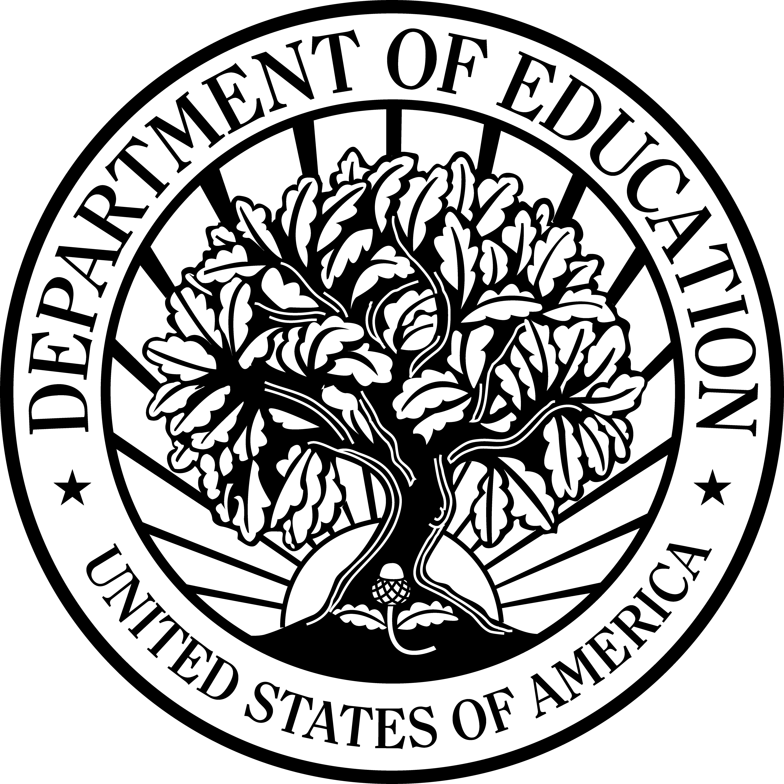
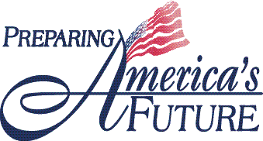

U.S. Department of Education

Office of Vocational and Adult Education
Fact Sheet Series

Adult Basic and Literacy Education

Adult Basic Education Career Connections

Background
The OVAE Fact Sheet Series highlights efforts currently underway at the Office of Vocational and Adult Education to support the principles of the President’s No Child Left Behind Act of 2001. The principles supported by this effort are checked.

- Increase Accountability and Academic Achievement
- Increase Options and Involvement for Parents and Students
- Increase Flexibility and Reduce
Bureaucracy
- Focus on What Works
It is widely acknowledged that the fastest growing jobs in the 21st century will require some level of postsecondary education. Consequently, moving more people through postsecondary programs aligned with the economic needs of a community or region is vital to our nation’s future competitiveness, security, and stability.
The Adult Basic Education (ABE) Career Connections project promotes career pathways as a framework for assisting ABE students to successfully transition to postsecondary programs and begin careers in high-demand fields.
Career pathways are a series of connected education and training strategies and support services that enable individuals to secure employment within a specific occupational sector and to advance over time to successively higher levels of education and employment in that sector. Each step on a pathway is designed to prepare the participant for the next level of education and employment.

Overview
The Office of Vocational and Adult Education (OVAE) awarded $75,000 to each of five local ABE sites to enhance efforts to provide postsecondary education and support services that help adults become employed in occupational sectors important to local economies. OVAE will provide these bridge programs training, technical assistance, and access to national experts to plan, implement, and manage career pathways. Participants include: Blue Grass Community and Technical College in Lexington, Instituto del Progresso Latino in Chicago, Jewish Vocational Service in San Francisco, Madison Area Technical College in Madison (Wisconsin), and Montgomery County College in Wheaton (Maryland).

Outcomes and Products
- ABE Career Connections manual that demonstrates how ABE programs can operate within career pathways to prepare students for higher levels of education and better jobs

Timeline
October 2006 to September 2009

Contact

Ronna.Spacone@ed.gov

