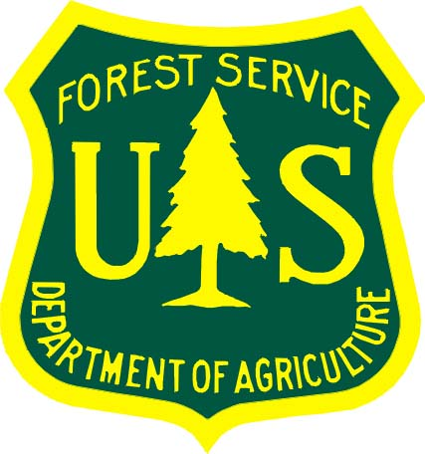

Background Paper:

Order of the Arrow, ArrowCorps5, and the Mark Twain National Forest
Order of the Arrow and the National Conservation Service Project
The Order of the Arrow (OA) is the “National Honor Society” of the Boy Scout’s of America (BSA). OA has had a long-standing interest in coordinating national service projects, utilizing the infrastructure and leadership established over many years of success at the high adventure bases such as the Philmont Scout Ranch in New Mexico.
Discussions regarding a national conservation service project with the Forest Service first began in June of 2003, when national representatives of the BSA and OA met with U.S. Department of Agriculture Under Secretary Mark Rey and former National Forest Chief Dale Bosworth. Since the BSA had decided to move their National Jamboree back a year to fall on their centennial year (2010), they asked the Forest Service if they could do a significant conservation service project for the Forest Service in 2008. This concept was endorsed by both Under Secretary Rey and Chief Bosworth, and the National Forest Foundation became a supporting partner. OA named this effort “ArrowCorps5” and committed to a significant effort in supporting the Chief of the US Forest Service’s, “More Kids in the Woods” campaign.
In 2004, every Forest Supervisor in the Forest Service was contacted and asked if they had any resource needs that could use 800 to 1,000 Scouts to accomplish a service project in 2008. Thirteen potential projects were identified. Each was assessed based on individual project needs and the four threats identified by the Chief of the Forest Service that threaten the long-term health and productivity of the Nation’s National Forests and Grasslands: 1) fuels and fires; 2) invasive species; 3) unmanaged outdoor recreation; and 4) wildlife habitat fragmentation. While OA was originally only going to do one project, they were so committed to making a difference that they selected five to do in 2008,
In April 2004 the Forest Service and OA chose five conservation service project sites to perform in 2008 and a sixth in 2007 as a training exercise. These sites are spread across America and had the greatest need and potential for long-term resource benefits.
ArrowCorps5 serves as a precursor to the Boy Scouts’ 100th anniversary celebration in 2010. National forests selected for the project, in addition to the Mark Twain (June 7-14), include the Manti-La Sal, Utah (June 14-21); George Washington-Jefferson, Virginia (June 21-28); Shasta-Trinity, California (July 12-19); and Bridger-Teton, Wyoming (July 26-August 2). The five projects include ecosystem restoration, invasive plant and tree removal, trail construction and maintenance, bridge work, campsite improvements, erosion and weed control, and fence removal. ArrowCorps5 is the largest national conservation service project undertaken by the Boy Scouts of America since World War II, and the largest volunteer service project ever for the Forest Service. It will include an estimated 5,000 members of the Order of the Arrow performing more than 250,000 man hours of service during the summer of 2008 valued at almost $5 million. For more information about ArrowCorps5 visit www.event.oa-bsa.org/events/arrowcorps5/.
ArrowCorps5 and the Mark Twain Project
The Mark Twain project began with Mark Twain National Forest Recreation Staff Officer Kris Swanson, who was the proponent for a conservation service project on the Mark Twain. It was first conceived in early 2004 by Ava-Cassville-Willow Springs Ranger District Ranger Jenny Farenbaugh and her staff who developed and drafted a proposal to remove invasive Eastern red cedar from within the Hercules Glades Wilderness area located on the district. This nonnative tree species is threatening native limestone glade ecosystems in the general area. Limestone glades are globally imperiled in Kansas, Missouri and Arkansas. This wilderness area was originally established to protect some of the last remaining limestone glades in this area of Missouri.
Multiple planning meetings were held in earnest between district, national OA and Forest Service Partnership leadership from 2004-2006. Darla Rein, District Timber Management Administrator, championed the project at these meetings. In 2006 the Mark Twain proposal was revised because of agency concerns for impacts on wilderness values, and changed to a location with indigenous limestone glades in an area off the Gladetop Trail south of Ava, Missouri. This area - Brushy Creek/Clayton Ridge (BC/CR) - had completed the environmental review process required by the National Environmental Policy Act. In July 2006, District Ranger Farenbaugh signed the NEPA decision for the BC/CR area, which authorized glade restoration related and other resource management activities. This area (BC/CR) was generally identified in the 2005 Mark Twain Land and Resource Management Plan (LRMP) as a Management Area (MA) 1.1. An MA 1.1 consists of biologically distinctive ecological areas, each differing with respect to flora and fauna, natural communities, watersheds and landforms. The prescription for MA 1.1 is primarily natural community restoration.
In June 2007, Darla Rein met with the other four site project managers in Bloomington, Indiana for additional pre-planning. In December 2007, site representatives again met at the National ArrowCorps5 conference in Dallas to solidify their respective projects.
The Mark Twain National Forest Service Project
Glade natural community types are in decline in Missouri due to a number of factors, including encroaching Eastern red cedar, invasive exotic species, overgrazing, fire suppression and development. Between 500-1000 OA members will be using handtools and chainsaws to help restore the vegetative structure and composition of up to 150 acres of glade ecosystem to their desired condition of that pre-European settlement. Once the OA project is complete, the area will be treated with multiple applications of prescribed burning.
OA has been trained in both the Incident Command System (ICS) and in Conservation USA in order to prepare for and complete this and other projects on the four other national forests. The OA hired experienced crew foremen from past OA trail crews to serve as Crew Leaders at all five of the sites, and have them certified as Conservation USA Instructors. In addition, all OA Squad Leaders have been, or are being, trained as Conservation USA Project Leaders. This would allow OA members both the advantage of participating in the rollout of Conservation USA and the ability to offer other service projects on behalf of BSA to other federal land managers in the future.
Employees on the Ava-Cassville-Willow Springs Ranger District have been integral in the onsite project pre-work, prep, and layout. The Missouri counties of Taney and Douglas have also played a significant role in this partnership effort.
For more information about the Mark Twain National Forest visit www.fs.fed.us/r9/marktwain.

