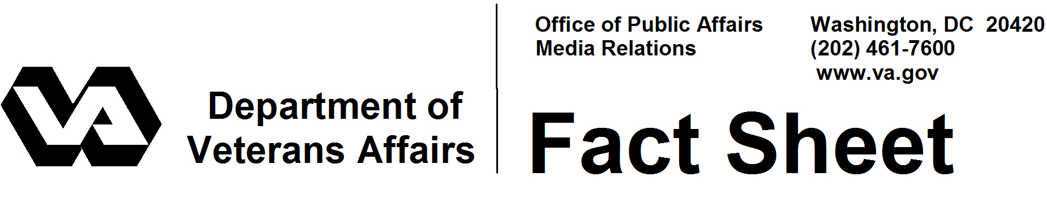
January 2009
VA’s Prosthetics and Sensory Aids

The Department of Veterans Affairs (VA) has become a world leader in prosthetics and rehabilitation through an integrated delivery system designed to provide prosthetic and sensory aids, devices, assistive aids and repairs to disabled veterans in order to facilitate treatment of their medical conditions.

VA’s Prosthetic and Sensory Aids Service (PSAS) is the largest and most comprehensive provider of durable medical equipment and prosthetic devices in the world. Although the term “prosthetic device” may suggest images of artificial limbs, it actually refers to any device that supports or replaces a body part or function.

VA provides a full range of equipment and services to veterans. These range from items worn by the veteran, such as an artificial limb or hearing aid; those that improve accessibility, such as ramps and vehicle modifications; and devices surgically placed in the veteran, such as hips and pacemakers.

The number of veterans seeking prosthetic services from VA exceeded 1.9 million in FY 2008. As the demand increased, so did the budget to provide them, going from $532 million in 2000 to $1.6 billion in 2008. Although the number of veterans seeking services continues to rise, the primary reason for the increased spending is the cost of the products and services provided, especially costs of new technologies.

VA provides items prescribed by appropriate VA clinicians. Items may range from a $2 cane tip to a $100,000 microprocessor-controlled bionic knee that replaces muscle activity to bend and straighten the knee. Regardless of cost, VA’s mission is to provide the most appropriate technology to veterans in a timely manner.

Specialists, Services, Training
One of the many avenues to providing the best devices to veterans is through VA’s prosthetic and orthotic laboratories. As of August 2007, all 63 VA prosthetic and orthotic labs earned certification by one of the two national accrediting organizations. Eight of these labs are also accredited by the National Commission on Orthotic and Prosthetic Education, enabling them to participate in residency programs of the nine prosthetic and orthotic programs in U.S. universities and colleges.

- More -

Prosthetics & Sensory Aids 2/2/2

One of those nine schools, California State University–Dominguez Hills, is relocating to the Long Beach VA Medical Center campus. This collaboration with the prosthetic educational system, which includes a contractual training program, will further strengthen clinical care by providing training courses for VA’s orthotic fitters.

VA has 131 board-certified prosthetists and orthotists working at its labs, a standard that far exceeds the private sector. After assessing a patient, an orthotist designs and fabricates a custom orthopedic appliance, such as a brace or splint, to meet the veteran’s physical challenge, and fits it to a patient’s extremity or spine. A prosthetist works with a veteran amputee to perform a mechanical assessment, design a custom prosthesis, fabricate custom sockets, order components, assemble the prosthesis and perform an alignment process to ensure that the veteran can use the prosthesis to its highest potential.

Specialized equipment in the laboratories enables the prosthetist and orthotist to design, fabricate, repair and adjust the veteran’s appliances. VA is a leader in the use of the newest computer-aided design and manufacture (CAD/CAM) equipment. Prosthetic representatives, prosthetists and medical specialists in various disciplines are part of VA medical centers’ amputation care teams, responsible for assessing a veteran’s prosthetic needs. The team prescribes a prosthesis based on the veteran’s medical condition, needs and stated goals, and evaluates its functionality after it is made and delivered to the veteran.

Whether provided by VA prosthetists or through one of more than 600 contracts with nationally accredited local prosthetists, VA pays the full cost of a limb as well as all repairs. This applies to all devices provided through prescriptions. VA prosthetists support all the specialty clinics that require a prosthetic device for a veteran, such as spinal cord injury, audiology, blind rehabilitation and podiatry.

Special Programs
In addition to providing devices, VA also administers three unique programs to assist veterans with disabilities. An annual clothing allowance is available to veterans with a service-connected condition who, because of the disability, must wear a device or use a prescribed ointment that damages outer clothing.

VA also provides a Home Improvement and Structural Alterations grant. The grant is given to alter the home of a veteran who needs access. Examples include ramps, railings, lowered countertops, flooring, widened doorways and accessible bathrooms. The one-time maximum amount ($1,200 for non-service-connected veterans and $4,100 for service-connected veterans) depends on the veteran’s service-connected rating.

- More -

Prosthetics & Sensory Aids 3/3/3

In keeping with its dedication to providing equipment to address all the needs of veterans, VA administers the Automobile Adaptive Equipment program. This program provides equipment and training that some service-connected patients need to enter, exit and operate a motor vehicle once they have been awarded an automobile grant and completed driver’s training with an approved driver evaluator. A patient who does not meet the criteria to operate a vehicle can still be approved for equipment to enter and exit a vehicle.

Iraq and Afghanistan
This wide breadth of equipment and services VA can provide is not limited to veterans of a particular period of service. VA is sensitive to the needs of the newest veterans, who comprise less than 5 percent of the work of its Prosthetics and Sensory Aids staffs nationwide. At the end of fiscal 2008, VA had provided equipment to 89,152 veterans of Operation Enduring Freedom and Operation Iraqi Freedom, in addition to millions of veterans from earlier periods. The majority of those veterans were not seriously wounded and do not require complex devices. Many require small, inexpensive devices such as braces or eyeglasses.

# # #

