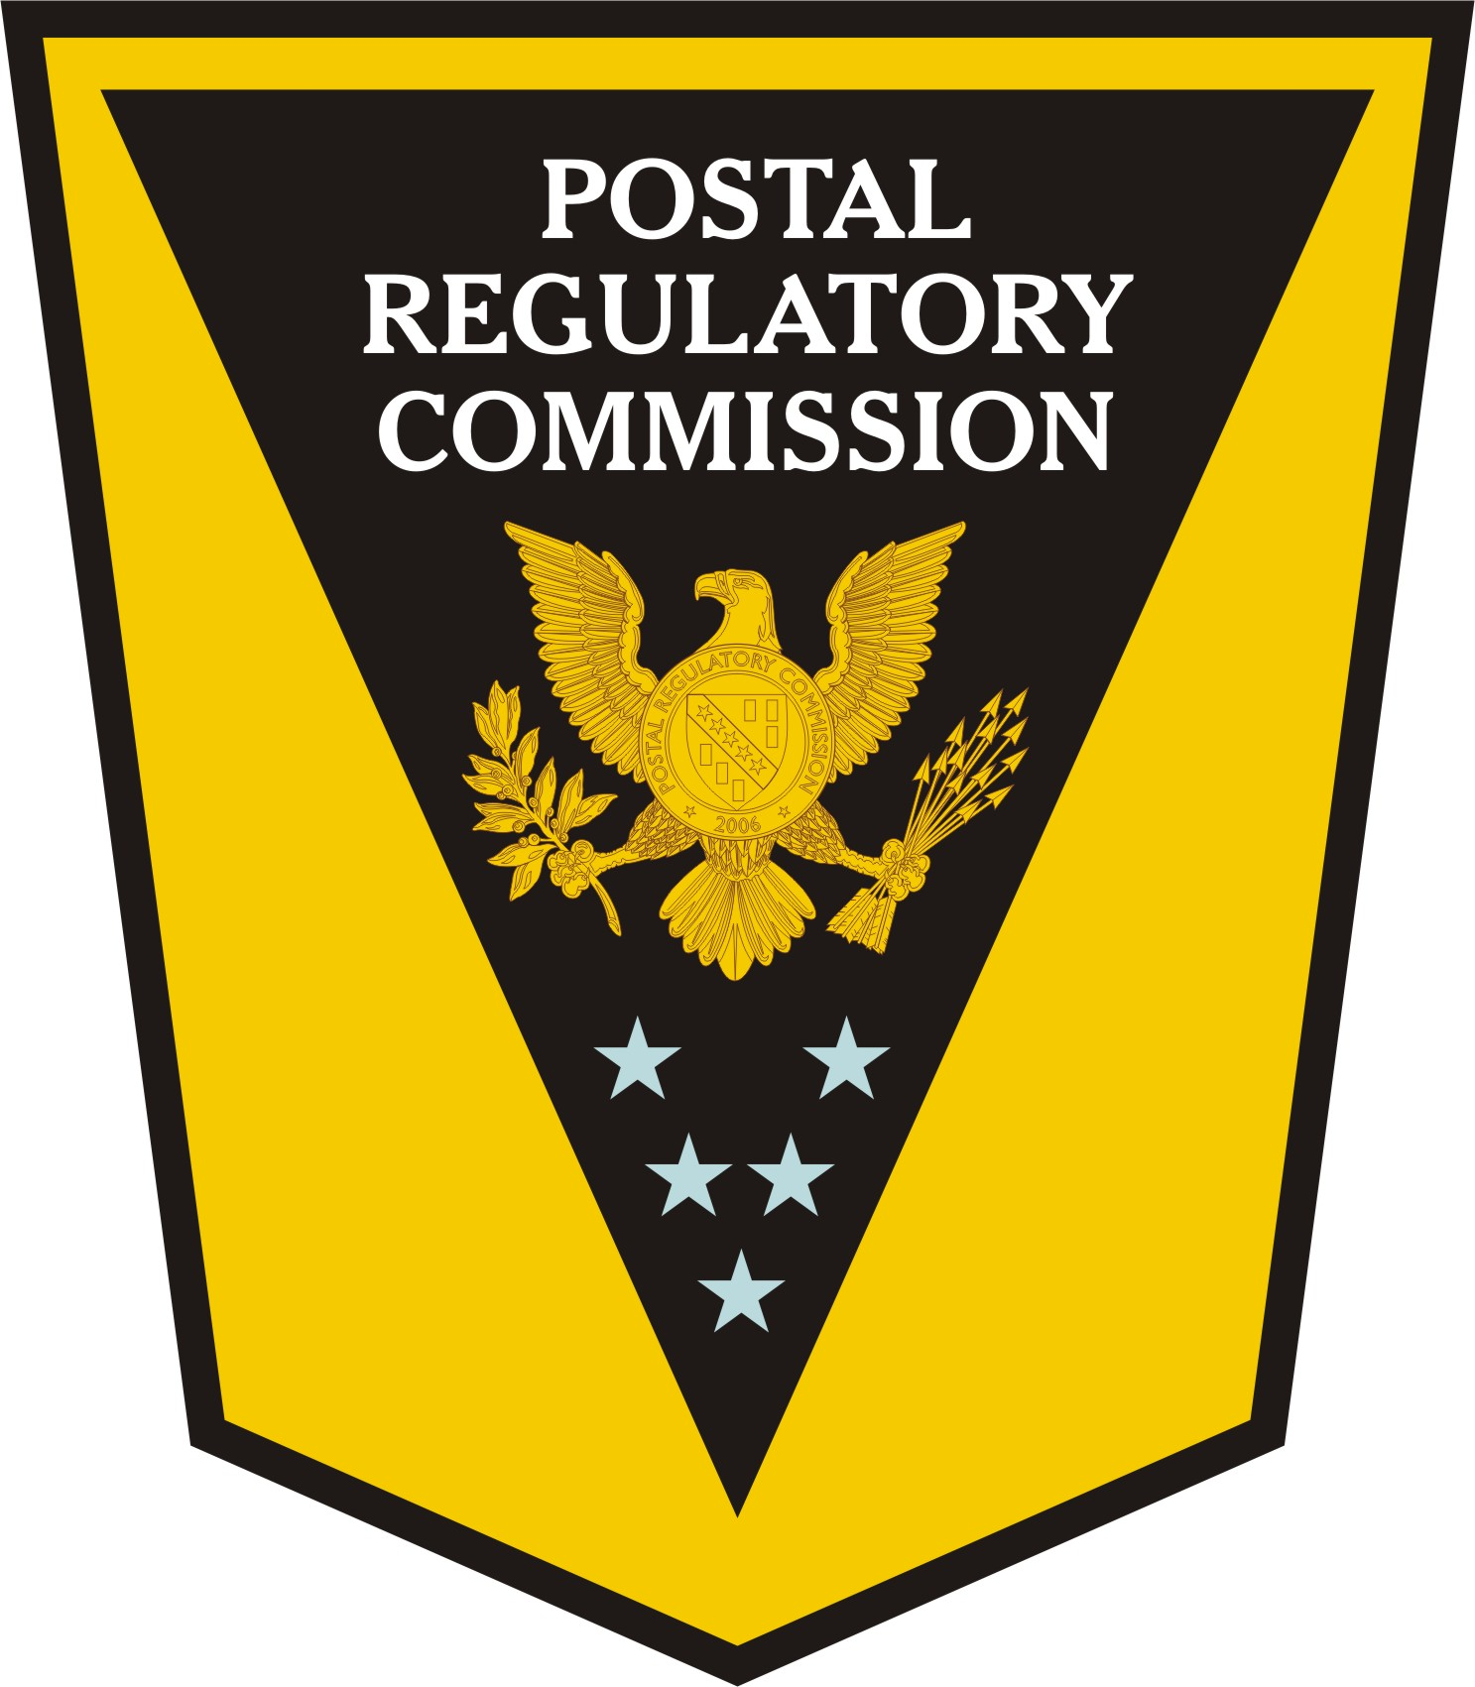

Testimony of

The Honorable Dan G. Blair, Chairman

On behalf of the

Postal Regulatory Commission

Before the

U.S. House of Representatives

Committee on Oversight

And Government Reform

Subcommittee on Federal Workforce,

Postal Service, and the District of Columbia

April 17, 2007

Chairman Davis, Ranking Member Marchant, and members of the Subcommittee on Federal Workforce, Postal Service, and the District of Columbia, thank you for the opportunity to provide testimony on the operation of the new Postal Regulatory Commission (PRC) and our strategy for the future.

I wish to particularly thank Chairman Davis, full Committee Chairman Waxman, full Committee Ranking Member Davis, and Congressman McHugh for their longtime support of the Commission and the confidence they have shown in the Commission as demonstrated by the Postal Accountability and Enhancement Act (PAEA).

The PRC is an independent agency that has exercised regulatory oversight over the Postal Service since its creation by the Postal Reorganization Act of 1970. Primarily, that oversight has consisted of conducting public, on-the-record hearings concerning proposed rate, mail classification, major service changes, and recommending decisions for action by the postal Governors.

The Postal legislation enacted on December 20, 2006, strengthens the authority of the renamed Postal Regulatory Commission and changes the form of regulatory oversight in many respects. The Postal Service is granted more autonomy in setting rates, particularly for its competitive products. However, the Service’s ability to increase rates for market-dominant products is limited ordinarily by changes in the Consumer Price Index (CPI). The law now requires the Commission to complete its review of new rates for compliance with the CPI cap within 45 days. Moreover, the PAEA streamlines the Postal Service’s ability to introduce new postal products.

To counterbalance the Postal Service’s enhanced autonomy in setting rates and introducing new services, the PAEA assigns continuing oversight responsibilities to the Commission. The law appropriately equips the PRC with authority to use new enforcement mechanisms. Oversight will consist mainly of information gathering, annual determinations of Postal Service compliance, consideration of complaints, and periodic reports on Commission operations. Enforcement tools include subpoena power, authority to direct the Postal Service to adjust rates and to take other remedial actions, and levying fines in cases of deliberate noncompliance with applicable postal laws.

The Commission is now fully engaged in implementing the strengthened regulatory functions assigned by the PAEA. This effort involves completing pending business under previous law, as well as developing an organization adapted to the Commission’s new responsibilities.

As you know, the Commission rendered its recommended decision on the Postal Service’s omnibus rate request on February 26, 2007. We audited the Postal Service’s projected revenue needs and made appropriate adjustments to their initial estimates based upon subsequent Postal Service refinements of these estimates. We also recommended improvements in the design of rates for many postal products at the Postal Service’s request, such as aligning rates more closely with shape, which affects processing costs. The Commission’s decision relied on well-established ratemaking principles, including a definitive reaffirmation of the principle that worksharing discounts should be limited to the amount of cost savings accruing to the Postal Service – the approach ratified by the PAEA.

On March 19, 2007, the Governors of the Postal Service endorsed the Commission’s rate recommendations, with three limited exceptions: rates for the Priority Mail flat rate box; for additional ounces of non-standard First-Class letters; and for Standard Rate Flats mail. On March 29, 2007, the Commission issued an Order establishing procedures for further consideration of these issues and inviting comments from interested parties before the end of this month. Because the Commission’s deliberations on these topics are ongoing, I hope you will understand that it is inappropriate for me to address them specifically at this time.

Other pending business includes two mail classification proceedings, one of which concerns a Negotiated Service Agreement or NSA. To date, the Commission has completed proceedings on six proposed NSAs and approved each of them, with the exception of one that was withdrawn at the request of the Postal Service and the
co-proponent. The Commission also issued an Advisory Opinion on December 19, 2006, on the Postal Service’s plans for reconfiguring its mail processing and transportation networks.

One of the most critical requirements the PAEA assigns to the Postal Regulatory Commission is the establishment of a modern system for regulating rates and classes of market-dominant postal products. In order to move expeditiously toward the new ratemaking system, the Commission published an Advance Notice of Proposed Rulemaking on January 30, 2007, soliciting comments on how the Commission can best fulfill its responsibilities and achieve the objectives of the PAEA. The initial round of comments was due on April 6, 2007, and reply comments will be due on May 7, 2007. To date, the Commission has received comments from 32 parties. In addition, the Commission and the Postal Service co-sponsored a summit on meeting customer needs in a changing regulatory environment, with over 200 attendees on March 13, 2007.

The PAEA directs the Postal Service, in consultation with the PRC, to establish service standards for market-dominant products, and assigns regulatory oversight to the Commission. The Act also directs the Postal Service and the PRC to consult on developing a plan for meeting these standards, including any necessary changes to the Service’s processing, transportation, delivery, and retail networks. Consequently, we will revisit these infrastructure issues in the context of service standards to be established under the PAEA. Moreover, we appreciate the opportunity for Commission personnel to observe meetings of the Mailers Technical Advisory Committee (or MTAC) to become better informed on mailers’ views of their service needs. We look forward to full consultation with the Postal Service, as envisioned by the Act, later this spring and summer.

The Commission is also advancing toward performance of its auditing and reporting responsibilities under the PAEA. During the next two years, these responsibilities will require the following essential actions:

- A comprehensive review and report examining universal postal service and the postal monopoly in all regions of the United States, including an assessment of likely future needs and recommended changes;
- A review of all non-postal products offered by the Postal Service, followed by a determination whether each of them should continue, based on an assessment of public need for the service and the private sector’s ability to meet any such need;

- Annual notice-and-comment proceedings followed by Commission determinations on whether any rates, fees, and service standards failed to comply with applicable requirements during the preceding year; and

- A report to the President and to the Congress on the first year of the Regulatory Commission’s operations.

In furtherance of these tasks, the Commission has already begun discussions with the Departments of Treasury and State, the Federal Trade Commission, U.S. Customs and Border Protection, the Postal Service’s Office of Inspector General, and the Government Accountability Office, regarding implementation of the new law.

The Commission is also moving on other fronts to meet its new regulatory responsibilities. One critical effort is organizational – adapting the Postal Rate Commission into the regulatory body envisaged in the PAEA.

With the enactment of the PAEA, the Commission will need to undergo changes in its organizational structure, workforce size and skills mix, areas of functionality and expertise, and policies and procedures. The Act outlines specific requirements that necessitate a timely and thorough analysis of the Commission’s current state, and a strategic plan of action to bridge functional gaps and to meet statutory deadlines. The PRC is working with an outside expert in this regard.

The first step in this process documented the current organizational baseline through in-depth interviews with staff to gauge what competencies were required to perform their current duties. The Commission is analyzing and identifying skill gaps between the current baseline and the requirements the Act places on the PRC.

Another key component of the Commission’s ongoing efforts is outreach: soliciting input from postal stakeholders, especially mail users, and consultation with other government agencies. Appearing before the Subcommittee today, and hearing your views and concerns, is an important part of this process. We are also progressing on schedule toward the appointment of the Commission’s first Inspector General. I would like to note that the Commission has recently created an Office of Public Affairs and Governmental Relations to maintain contact with all postal stakeholders.

The benchmarks established for the Commission by the PAEA pose some daunting challenges, especially in light of the Postal Service’s opportunity to file one last omnibus rate request under prior law. There is no question that an additional rate case would divert Postal Service and Commission resources that, in my view, would be better devoted to developing the new system of regulatory oversight. Nevertheless, the Commission is committed to timely performance of all its statutory obligations, and to doing so in a reasoned and balanced manner.

Conclusion
In closing, I wish to acknowledge the dedication and commitment of my colleagues – Vice Chairman Dawn Tisdale, Commissioners Ruth Goldway, Tony Hammond, and Mark Acton. Thank you, Mr, Chairman, on behalf of the Commission, for this opportunity to present a status report on our progress toward activating the strengthened oversight responsibilities assigned by the Postal Accountability and Enhancement Act. Your Subcommittee’s attention to these matters assists us greatly in maintaining focus on issues vital to our Nation’s postal system.

I will be happy to answer any questions you may have.

