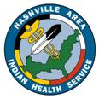
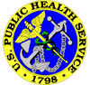
Nashville Area

OFFICE OF PUBLIC HEALTH

QUARTERLY NEWSLETTER

Volume I, Issue 1 January 2007

In this issue of the OPH Newsletter:

Click on the titles below to go directly to the articles.

Welcome 1
Health Education – Traditional Role of Tobacco 2-3
Public Health Matters – Influenza Update 3
Substance Abuse – Prenatal Substance Exposure 4
Health Promotion/Disease Prevention – Youth Obesity 5
Statistics – Immunization Information System 6
Behavioral Health – A Multi-disciplinary Approach 7
Chief Medical Officer – Pandemic Flu Preparation 8
Oral Health – Dental Sealants 9
OFFICE OF PUBLIC HEALTH DIRECTORY 10
Calendar of Events 11

WELCOME!

In late December, we in the Nashville Area Office of Public Health began to prepare our FY 2007 Work Plan, with the purpose being to reach out and provide as many services and support as possible to all of the 27 Tribes/Nations that we service.

Among the many ideas we discussed, the newsletter was re-created to provide one communication vehicle between our office and you. From what I understand, a newsletter has been published by this office before, as well as from USET, Inc., so this newest issue is merely a renewal of our commitment to facilitate communications.

We hope that you will enjoy this issue of the newsletter, and if you do have ideas on future topics, please let us know. The plan is to electronically distribute this newsletter on a quarterly basis to both Health Directors and Clinical Directors; please share it with others in your facility.

We also want to provide all of you with the opportunity to provide feedback to our office on the 2007 Work Plan. We will be sending out an individual mailing in the coming weeks, as well as meeting with you at the upcoming USET Impact Week in Arlington. However, if you wish to provide your feedback to the 2007 Work Plan prior to these dates, please send comments by e-mail to me or other OPH staff.

I look forward to meeting with all of you in the coming months, and please don’t hesitate to contact any of us in the Office of Public Health should you need assistance.

Sincerely,

Tim Ricks, D.M.D., M.P.H.
Director, Office of Public Health
Nashville Area Indian Health Service

Health Education
Mary Wachacha, Lead Consultant, IHS Health Education

Traditional Role of Tobacco

The IHS recognizes that tobacco holds a traditional and sacred role for many American Indian people and that role varies from tribe-to-tribe. Tobacco is used by American Indians for many purposes including prayer, offerings, gift-giving, & medicine. Prior to the use of commercial tobacco, tobacco consisted of a blend of natural plants such as red willow, mullein, & bearberry but today, the tobacco related health problems American Indians/ Alaska Native people suffer are caused by the chronic non-ceremonial use of commercial tobacco.

Commercial Tobacco use is considered the most preventable cause of death in the United States and across Indian Country due to its direct relationship with lung cancer, heart disease and stroke.

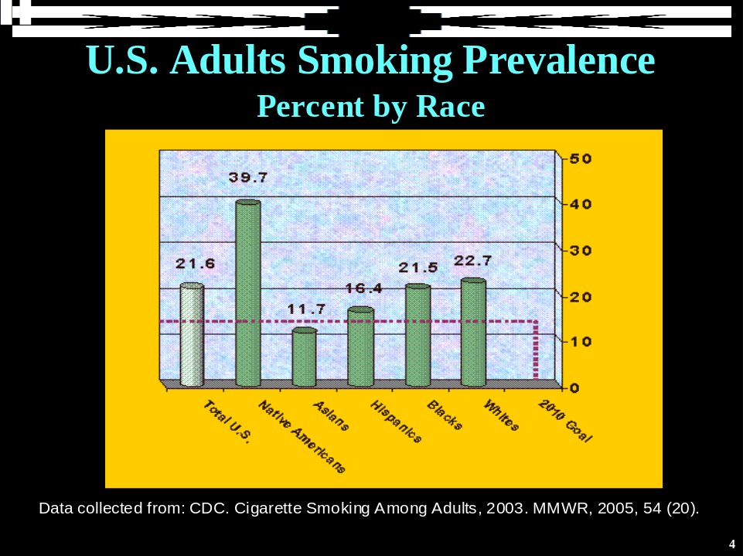

The billing for tobacco cessation services is dependent upon many variables including the type of:

Insurance - Billing is dependent upon insurance:
- Center for Medicare and Medicaid Services (CMS)
  - Medicare: Federally regulated
  - Medicaid: State regulated
- Private insurance

Provider:
CMS Recognized Providers Providers not recognized by CMS
Physicians Pharmacists
Physician assistants Nurse
Nurse practitioners CAN, LPN
Nurse midwives Physical Therapists
Clinical psychologists Laboratory Technicians
Clinical social workers Others
Facility: Billing is dependent on Facility Type:

Type of Facility Method of Payment
RHC/FQHS All-inclusive Rate (AIR) for the encounter
IHS/Tribally Owned/Operated hospital AIR
IHS/Tribally Owned/Operated non- Medicare Physician Fee Schedule (MPFS)
Hospital-based facility

Intervention: There are 3 mechanisms of billing for tobacco cessation services:
- Group visits
- Individual sessions
- Sessions incorporated into a provider visit

Documentation: Reimbursement is based upon correct documentation:
- Treatment
- Education
- Time

Public Health Matters
Posted 12/15/06 by MPHD Mail, Approved by Jim Marshall, Immunization Coordinator

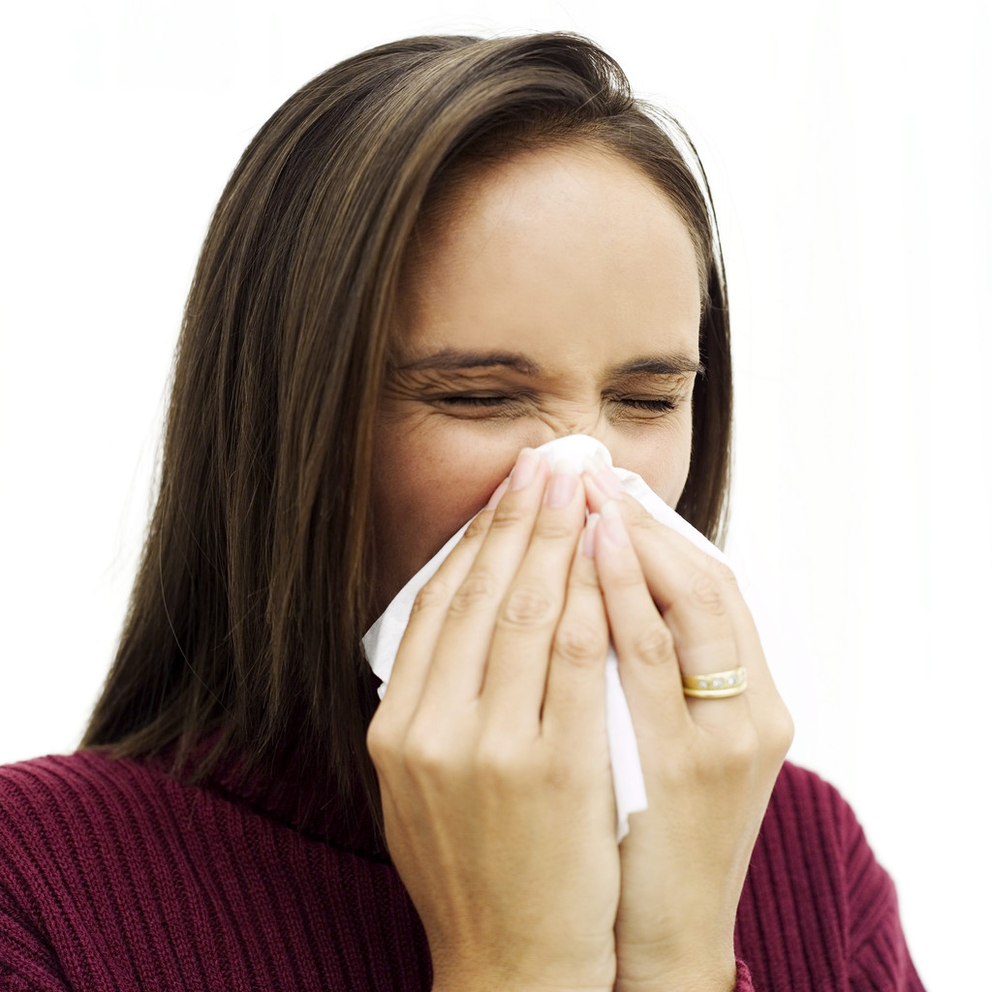
Influenza Update

Influenza (Flu) season in the Nashville Area typically begins each year in mid-December and runs through March.

According to the Centers for Disease Control and Prevention (CDC), influenza or flu-like symptoms include:

- Fever
- Muscle aches
- Headache
- Extreme tiredness
- Dry cough
- Sore throat
- Runny or stuffy nose

The best protection against influenza is to get a flu shot every year. The CDC says it is not too late to get a flu shot even after the start of the flu season. Those who do not get a flu shot should consider the following steps to prevent the spread of flu and cold germs this time of year.

- Cover your nose and mouth when coughing or sneezing, preferably using a disposable tissue.
- Use tissues to contain respiratory secretions and dispose of them after use.
- Wash hands (with soap and water or use an alcohol-based hand gel) often to remove germs.
- Keep your hands away from face (especially mouth and eyes).
- Be courteous to co-workers and classmates by staying at home if possible when you have flu-like symptoms.

Link to CDC flu website: http://www.cdc.gov/flu/weekly/usmap.htm

Substance Abuse
Elizabeth Neptune, OPH Managed Care/Substance Abuse Consultant


Prenatal Substance Exposure:
An epidemic that is hurting the Next Generation

Native people across tribal affiliation have recognized the next generation as a sacred trust. Many native traditions think of planning for the future in terms of thinking about the implications for the seventh generation. However, reservations and communities across the country are being affected by the devastating implications of prenatal Substance exposure.

The number one cause of mental retardation in the country remains the use of alcohol during pregnancy. Fetal Alcohol Spectrum Disorders are now joined with other substances in affecting the well-being of the next generation and may imperil the next seven generations unless we take a protective informed stance. SAMHSA estimates that 148,000 infants born in the United States have a history of intrauterine illicit drug exposure. The number of children with FASD is unknown. It is thought that one out of four children is born with exposure to alcohol. What we do know is that it remains rampant and is a condition that affects a child throughout their life time, Lupton, Burd and Harwood (2004) estimate that the prevention of one case of FAS saves $130,000 in health and related costs in the first 5 years of the child’s life.

Children born under the influence are at higher risk of being born preterm and with smaller head circumferences and lower birth weights. Depending on the substance they may need advance medical care. Opiate-addicted babies may experience Neonatal Abstinence Syndrome requiring extensive intervention in a neonatal intensive care unit where the baby’s substance withdrawal is managed. The impact of the drug use depends on the amount of drug used during the pregnancy and the timing of the use as well as other maternal factors.

The current rate of prenatal drug exposure makes it a major health problem. It has both an immediate impact on newborns and long term effects. In the United States the two most abused drugs are alcohol and tobacco. Alcohol impairs and alters the development of the fetal brain structure. It results in permanent damage and in large dosage is associated with growth reduction, cognitive deficits and reduced growth patterns (Fetal Alcohol Syndrome). Less obviously effected babies may have reduced cognitive function and problems with social functioning.

Exposure to tobacco leads to premature birth and low birth weights and irritability at birth. The irritable baby is at greater risk of having problems with attachment and taxes parental abilities. Additionally, tobacco exposed infants are more likely to have lower intelligence scores and higher rate of attention deficit. Many substance exposed children will have difficulties with attachment and increased medical needs whether the culprit is alcohol, tobacco, cocaine, heroin, or methamphetamine the developing brain of the child is effected.

If we are to make a difference in our communities we need to raise the level of awareness of the threat of drug and alcohol exposure and we need to be come active in the diagnosis of the effects of maternal drug use so that we can intervene. Early intervention can change the course and the outcome. It can not undo the damage but it can help the family and the child deal with the issues and ramifications changing the quality and outcome of a child’s life.

Health Promotion/Disease Prevention
Michelle Ruslavage, B.S.N., R.N., C.D.E.
Area Nursing, CHR, and HP/DP Consultant

Preventing Overweight and Obesity
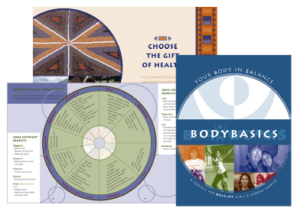
in our Native Youth

The Indian Health Service Division of Diabetes Treatment and Prevention (DDTP) has been collaborating with the DHHS Office of Women's Health (OWH) since late 2004 on adapting the general audience BodyWorks Toolkit for an American Indian/Alaska Native audience.

BodyWorks is a federal initiative developed by OWH to help prevent overweight and obesity in adolescent girls by using a family-based approach. The kit aims to help parents and caregivers of adolescent girls make changes to improve the family's eating and activity habits. The kit offers tools and action steps in addition to information about nutrition and physical activity. Strategies also focus on school and community support for adolescent girls and families.

Since that time, all toolkit components, except the DVD, have been modified for an AI/AN audience. The last piece of the toolkit, the girl's guide called 4teens, is undergoing DHHS clearance through USDA. DDTP is developing a training and evaluation plan with the IHS Nutrition and Dietetics Training Branch in Santa Fe and the IHS Health Promotion/Disease Prevention (HP/DP) Program, with input from Health Education and other IHS program staff.

It is anticipated, that once the AI/AN toolkit has undergone full DHHS clearance, that the toolkits will be printed in early 2007. A train the trainer session for 7 - 8 federal, tribal and urban Indian health pilot sites and the IHS HP/DP Area Consultants will be held in March 2007 in Albuquerque, NM. The evaluation will include data collected from the lead program staff in each pilot site as well as program participants. Sometime in FY 2008, after a report and review of the evaluation from the pilot sites, and after any needed revisions based upon the pilot, the program will be rolled out nationally.

Some toolkit components, the recipe book, the owner's guide and the girl's guide, will be available for ordering from the DDTP on-line resource catalog by late spring 2007. These items will be available for communities not participating in the pilot, or who cannot implement the full BodyWorks 10-week curriculum with support groups, but who may be interested in using some of the toolkit components as stand-alone pieces.

Statistics, Epidemiology
Kristina Rogers, Area Statistician


Immunization Information System (IIS)

Immunization Information System use has rapidly increased across the country since 1993. These computerized systems, previously known as Immunization Registries, are maintained by the American Academy of Pediatrics (AAP) to benefit children, pediatricians and communities.

They are responsible for approximately 56% of immunization records for U.S. children ages 6 and older. In 2005, 75% of public vaccination providers submitted vaccination data to the IIS and 44% of private vaccination providers submitted vaccination data to the IIS. There are currently 13 million children participating in the IIS. There is an estimated 21 million more needed to ensure a 95% participation rate by all U.S. children. These confidential electronic immunization records can be accessed regionally or nationally with the development of interstate agreements between states. Access to immunization records is limited to those who have proper security clearance and credentials. These individuals are able to track the immunizations of a child, in turn decreasing the rate of over-immunized children in the U.S.

It is not known yet whether these immunization information systems improve the rates of immunizations in children, but it is a tool that can help immunization programs and health-care providers make more informed decisions. Vaccine inventory management and routine public health surveillance are just some of the functions of IIS. The system can collect and combine vaccination data, generate reminder and recall notifications, assess vaccination coverage within a distinct geographic area and provide the opportunity for vaccine management, adverse event reporting, lifespan vaccination histories and a link to other electronic data sources.

Indian Health Service (IHS) and Immunization Information Systems (IIS)

The Indian Health Service encourages the use of immunization registries because they are an excellent way to keep track of childhood immunizations. IIS collects quality data that can be used for epidemiological and statistical research and reporting. They are helpful in distinguishing populations that are at risk for disease and useful in creating plans for managing infection and prevention during outbreaks.

The Indian Health Service Healthy People 2010 national Government Performance and Results Act (GPRA) goal for childhood immunization is a rate of 90%. Increasing the use of Immunization Information Systems and the RPMS Immunization Package may help improve GPRA childhood immunization rates and improve the health of American Indian/Alaska Native people.

The mission of the Indian Health Service is “to raise the physical, mental, social, and spiritual health of American Indians and Alaska Natives to the highest level”. Focusing on the prevention of disease will improve the health of all people. Because children are the stepping stones to culture, life and tradition, improving their health will help ensure the health of American Indian/Alaska Native adults in the years to come.

References:
http://pediatrics.aappublications.org/cgi/content/full/118/3/1293. PEDIATRICS Vol. 118 No. 3 September 2006, pp. 1293-1295 (doi:10.1542/peds.2006-1723)

http://www.cdc.gov/mmwr/preview/mmwrhtml/mm5549a3.htm?s_cid=mm5549a3_e%0d%0a. MMWR WEEKLY. December 15, 2006 / 55(49);1327-1329. Immunization Information Systems Progress --- United States, 2005

http://www.ihs.gov/PublicInfo/PublicAffairs/Welcome_Info/IHSintro.asp. Indian Health Service Introduction.

Behavioral Health
Palmeda Taylor, Ph.D., Area Behavioral Health Consultant


Adopting an integrated, multidisciplinary approach to
health care could prove beneficial

In a January 2006 American Journal of Orthopsychiatry (Volume 76, Number 1) study, Kruase et al set out to determine the feasibility of an approach, which would address the issue of the chronic and multiply comorbid, recurrent, intensive health care user.
The approach, as originally piloted in a community hospital in suburban Chicago in 1998, utilized a multidisciplinary team (a primary nurse advocate, a primary care physician, and a behavioral counselor) to perform the following functions:
- A comprehensive review of each participant’s obtainable physical, social, and psychological health history and records and an extensive whole-person interdisiciplinary intake evaluation.
- The development of measurable goals in a collaborative fashion, along with specified time frames and responsibilities (participant and team).
- Face-to-face meetings with the team and the participant as well as periodic meetings with the participant’s whole-person health program providers (e.g., a nutritionist, psychologist, financial counselor, massage therapist) and with the participant’s significant others, as needed.
- Participation and compliance tracking coordination of all health care, individual and group education, decision support, and coaching.
To determine the approach’s effectiveness, researchers surveyed high-cost utilizers with multiple chronic illnesses and psychological and socioeconomic distresses from Midwest hospitals. They administered survey instruments prior to the development of participants’ individualized treatment plans and again 1-year later. Team advocates also completed a set of diagnostic measures on each participant.
Results indicated that enrollees of this multidisciplinary team advocacy approach showed improvement in terms of: perceptions of physical functioning, physical well-being, control, self-efficacy (the belief that one can actively influence one’s environment and circumstances through personal actions), and life satisfaction. Additionally, health-related behavior changes were reported, and short-term costs were significantly lower than projected costs. Finally, the participants rated their health care services in the program as more effective than previous health care services.
Conclusion: It appears that health care systems would profit from adopting an integrated, multidisciplinary, whole-person approach to providing health care services to individuals with multiple chronic conditions. The use of such an approach is consistent with both the Native American health care philosophy of treating the “whole-person” and implementation of Dr. Grim’s Chronic Care Model.

Chief Medical Officer
Roy Kennon, M.D., NAO Chief Medical Officer

Reprinted

Pandemic Flu Preparedness

The following information is provided as a summary and review, for your convenience and ready access, regarding pandemic flu preparedness. However, please note that, "... many activities described in the Public Health Guidance for State and Local Partners are similar, if not the same as those required to combat other infectious diseases, such as Severe Acute Respiratory Syndrome (SARS) or intentionally-spread smallpox or plague.

Topics covered in the Public Health Guidance for State and Local Partners may, therefore, be relevant to—or addressed in—other emergency preparedness plans. (See, for example: Public Health Guidance for Community-Level Preparedness and Response to SARS: www.cdc.gov/ncidod/sars/guidance/; Smallpox Response Plan and Guidelines: www.bt.cdc.gov/agent/smallpox/response-plan/index.asp)."

HHS Pandemic Influenza Plan

Visit PandemicFlu.gov (http://www.PandemicFlu.gov) for one-stop access to U.S. Government avian and pandemic flu information.

The HHS Pandemic Influenza Plan is a blueprint for pandemic influenza preparation and response. It provides guidance to national, state, and local policy makers and health departments. Please also recognize that substantial benefits in preparedness for, and recovery from, many types of natural and manmade disasters will result from pandemic flu planning and preparedness.

The HHS Plan includes an overview of the threat of pandemic influenza, a description of the relationship of this document to other Federal plans and an outline of key roles and responsibilities during a pandemic. In addition, it specifies needs and opportunities to build robust preparedness for and response to pandemic influenza.

The HHS Plan has three parts. Part 1, the HHS Strategic Plan, outlines federal plans and preparation for public health and medical support in the event of a pandemic. Part 2, Public Health Guidance for State and Local Partners, provides detailed guidance to state and local health departments in 11 key areas. Part 3, which is currently under development, will consist of HHS Agencies’ Operational Plans

View and Print Entire Plan (PDF) http://www.hhs.gov/pandemicflu/plan/pdf/HHSPandemicInfluenzaPlan.pdf
(396 pages, 6MB)

For an overview of Plan: http://www.hhs.gov/pandemicflu/plan/overview.html
(PDF Version http://www.hhs.gov/pandemicflu/plan/pdf/Overview.pdf - 18 pages, 618KB)

Part 1 – HHS Strategic Plan http://www.hhs.gov/pandemicflu/plan/part1.html
(PDF Version http://www.hhs.gov/pandemicflu/plan/pdf/part1.pdf - 28 pages, 613MB)

Part 2 – Public Health Guidance for State and Local Partners http://www.hhs.gov/pandemicflu/plan/part2.html
(PDF Version http://www.hhs.gov/pandemicflu/plan/pdf/part2.pdf - 20 pages, 1MB)

Last revised: March 30, 2006

Oral Health Update
Tim Ricks, D.M.D., M.P.H., Area Dental Officer



Dental Sealants:
Effective Decay Prevention in Children AND Adults

Dental sealants were first approved by the American Dental Association in 1972.¹ Overwhelming research has demonstrated the efficacy of dental sealants in reducing dental caries (tooth decay), especially in children but not exclusively in children.

Many dentists in the public health community have advocated for the use of “universal sealants,” a term given to the application of dental sealants on both children and adults based on caries risk rather than potential third party payor reimbursements. In fact, the lack of dental insurance coverage has been cited as one of the major factors in the slow acceptance of dental sealants by dentists in private practice.²

However, data suggest that dental providers should consider placing more dental sealants on primary and permanent teeth in children and permanent teeth in adults. According to the 1999 Oral Health Survey of American Indian and Alaska Native Dental Patients³, the Nashville Area has a large proportion of both children and adults with a history of dental caries (tooth decay):

- In children 2-5 years of age, 79.7% had a history of dental caries or active caries
- In children 6-14 years of age, 62.4% had a history of dental caries or active caries
- In adolescents 15-19 years of age, 97.7% had a history of dental caries or active caries
- In adults 35-44 years of age, 68.7% had active, untreated decay
- In elders 55 years of age and older, 44.7% had active, untreated decay

What these rates demonstrate is that Native Americans in the Nashville Area, as well as throughout the Indian Health Service, continue to experience dental decay at rates significantly higher than the national average among non-Native Americans. Consequently, the application of dental sealants based upon caries risk may significantly reduce the caries burden of the populations we serve.

Last (GPRA) year, the Nashville Area provided 7,802 sealants to our patients. While this reflected an increase from the previous year when 6,748 sealants were applied, it was still slightly lower than the GPRA goal of 8,496. The goal in the current year should remain at 8,496, and dental providers are encouraged to embrace – through their own research and education – the idea of evidence-based sealant applications.

It may be noted that some dentists may use restoration codes instead of sealant codes on certain procedures. For example, a preventive resin restoration (PRR), a restoration that often involves a fissurotomy to remove incipient decay, should be coded as a dental sealant (ADA code 1351) if dentin is not penetrated during the procedure (the delivery of anesthesia and the type of material – unfilled or filled resin – is irrelevant to the coding).

¹ American Dental Association, Council on Dental Materials and Devices. Nuva-Seal pit and fissure sealant classified as provisionally accepted. J Dent Assoc 1972; 84:1109.

² Burt, B. A., and Eklund, S.A. Dentistry, Dental Practice, and the Community: 5th Edition. W.B. Saunders 1999; 26:334.

³ Indian Health Service Division of Oral Health, Department of Health and Human Services. An Oral Health Survey of American Indian and Alaska Native Dental Patients: Findings, Regional Differences, and National Comparisons. Department of Health and Human Services, 1999.

OFFICE OF PUBLIC HEALTH

DIRECTORY – 2007

711 Stewarts Ferry Pike
Nashville, TN 37214
(615) 467-1500
Fax: (615) 467-1585

OPH Director/Area Dental Officer/
Chronic Care & Electronic Health Record Contact
Dr. Tim Ricks
Office: 615-467-1508
Cell: 615-519-5099

Behavioral Health Consultant/Urban Programs Coordinator
Dr. Palmeda Taylor
Office: 615-467-1534
Cell: 615-519-6319

Health Promotion/Disease Prevention Coordinator/
Area Nursing Consultant/Area CHR Consultant
Michelle Ruslavage
Office: 615-467-1628
Cell: 615-519-3821

Area Statistician/GPRA Coordinator
Kristina Rogers
Office: 615-467-2926

Clerical Support
Rhonda Mattern
Office: 615-467-1567

Clerical Support
Charlene Billie
Office: 615-467-1600

Area/IHS Elder Care Consultant/IHS Chronic Care Lead
Dr. Bruce Finke
Cell: 615-417-4915

Area/IHS Health Education Consultant
Mary Wachacha
Cell: 828-292-1175

Area Managed Care/Substance Abuse Consultant (acting)
Elizabeth Neptune
Cell: 207-214-6524

Area Managed Care Consultant (detailed to EHR)/EHR Contact
Deborah Burkybile
Cell: 615-519-6320

OFFICE OF PUBLIC HEALTH

Calendar of Events

Date | Event | Location | Attending
Jan. 23 – 25, 2007 | Education in Palliative and End-of-Life Care for Oncology Patients | Window Rock, Arizona | Dr. Palmeda Taylor  Dr. Bruce Finke
Jan. 23 – 26,  2007 | National Nurses Leadership Council | Rockville, Maryland | Michelle Ruslavage
Jan. 23 – 24,  2007 | DMS RPMS TRAINING | NAO | Kristina Rogers
Jan. 24,  2007 | Nashville Area Dental Call 11-12 CT  (all dental programs invited) | 866-766-7230; Passcode–6920488# | Dr. Tim Ricks  (Call Leader)
Jan. 25,  2007 | IHS Open Door Forum 11-12:30 CT  (all facilities invited, Nashville Area is being highlighted) | 888-455-6771  Pass code-4860154 | Mary Wachacha  (NAO Leader)  Dr. Tim Ricks
Jan. 27 – Feb.1, 2007 | DATA TRANSMISSIONS ARE DUE AT AREA OFFICE
Jan. 29 – 31,  2007 | HP/DP, Nursing, CHR Site Visit:  St. Regis Mohawk | St. Regis Mohawk | Michelle Ruslavage
Jan. 29 – Feb. 1, 2007 | Dental Site Visits:  Poarch Creek, Alabama-Coushatta | Poarch Creek  Alabama-Coushatta | Dr. Tim Ricks  Dr. Cathy Hollister
Feb. 5,  2007 | USET – Office of Public Health  Combined Staff meeting | NAO | OPH Staff  USET Staff
Feb. 12-14,  2007 | USET Impact Week | Arlington, Virginia | All OPH Staff
Feb. 14-16,  2007 | Fundamentals of Medical Grant Writing Workshop | Ft. Lauderdale, Florida | Kristina Rogers
Feb. 26-Mar. 2,  2007 | IHS Combined Councils’ Meeting | San Diego, California | Dr. Tim Ricks
Feb. 27 – 28,  2007 | Regional HIV/AIDS Conference | Nashville, Tennessee | Dr. Palmeda Taylor
Feb. 27 – Mar.1,  2007 | DATA TRANSMISSIONS ARE DUE AT AREA OFFICE
Feb. 28,  2007 | Nashville Area Dental Call 11-12 CT  (all dental programs invited) | 866-766-7230; Passcode–6920488# | Dr. Tim Ricks  (Call Leader)
March 5 -9,  2007 | Dental Site Visits:  Passamaquoddy IT, Passamaquoddy PP,  Micmac, Penobscot, Maliseet (tentative) | Maine | Dr. Tim Ricks  Dr. Cathy Hollister
March 12-16,  2007 (tentative) | Tips and Tools for Routine Health Screening and Documentation in Primary Care | TBA | Dr. Palmeda Taylor  Mary Wachacha  (Leaders)
Mar. 27-Apr. 1,  2007 | DATA TRANSMISSIONS ARE DUE AT AREA OFFICE
March 28,  2007 | Nashville Area Dental Call 11-12 CT  (all dental programs invited) | 866-766-7230; Passcode–6920488# | Dr. Tim Ricks  (Call Leader)

