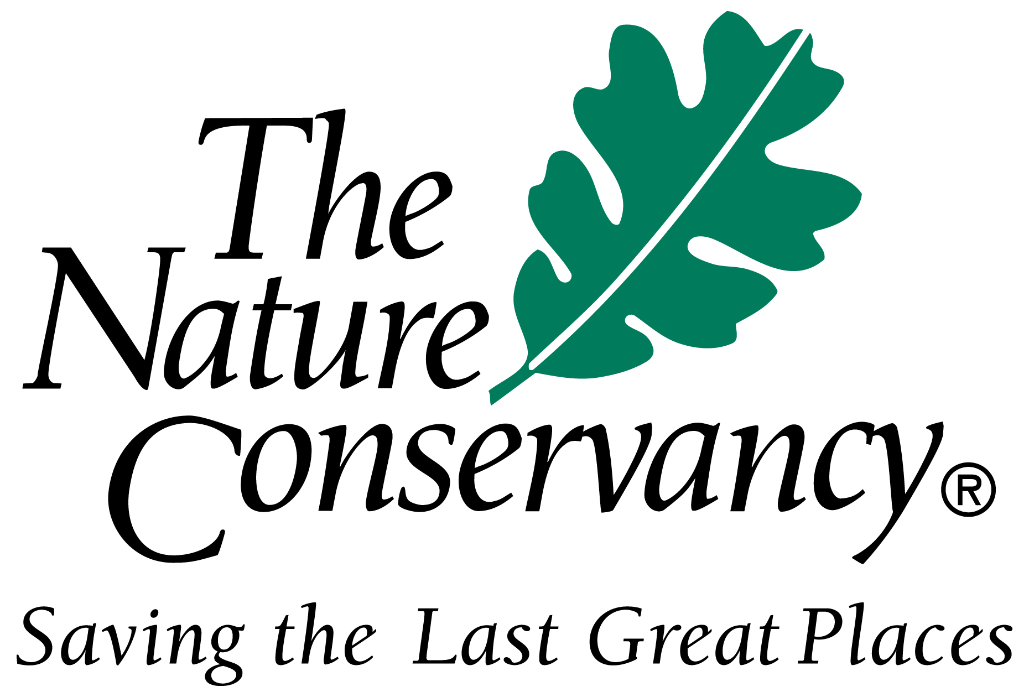 NEWS RELEASE

CONTACT: Douglas Meyer, (T) 703 841 8743 or dmeyer@tnc.org March 20, 2002

BEWARE: THERE MAY BE

BAD PLANTS IN YOUR BACKYARD

The First Day of Spring Offers Everyone an Opportunity to

Help Stop the Spread of America’s Worst Weeds

ARLINGTON, Va. – On the first day of spring, The Nature Conservancy is asking Americans to check their yards and gardens for plants that can escape cultivation and cause tremendous damage to the natural environment and the national economy.
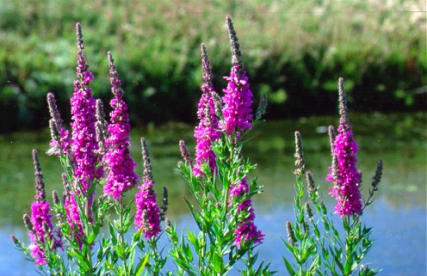

Deceptively beautiful, purple loosestrife escapes from cultivation and now chokes wetlands across the country, causing millions of dollars in damage each year

Plants such as purple loosestrife, kudzu, giant salvinia, multiflora rose and tree of heaven have been used widely in horticulture, landscaping and erosion control, and can be found in backyards and business lots across the country. At first glance these plants may look pretty, but their beauty is deceptive.

Known as invasive species, plants like these are typically transplants from distant places. Once free from the natural checks and balances that had kept them under control in their native realms, these alien invaders are able to establish themselves in new areas and proliferate and persist to the detriment of native species. They often hoard light, water and nutrients, and can even alter entire ecosystems by changing soil chemistry or hydrological processes. As a result, invasive plants can overtake native plants and, in turn, displace the animals that had relied on the native plants for food and shelter. With intentional and unintentional assistance from people, these problematic plants are spreading at an alarming rate, infecting natural areas across the United States.

“Keeping invasive plants out of America’s backyards helps the environment and the economy,” said Steve McCormick, president of The Nature Conservancy. “Taking the time to remove invasive plants and replace them with non-invasive varieties is a great example of bringing new energy to the old adage: think globally, act locally.”

“Nursery growers, landscape designers and others who make their career in horticulture have become increasingly concerned with the issue of invasive plants,” said Wayne Mezitt, vice president of the American Nursery & Landscape Association (ANLA), and chair of that organization’s Invasive Species Task Force. “Consumers look for plants that establish quickly, withstand environmental stresses and generally grow without much care. Unfortunately, these characteristics can also be the features that make plants invasive.” ANLA, the national trade association of the nursery and landscape industry, is working with the Conservancy and other organizations to develop codes of conduct to help stop the spread of invasive plants.

Plants that escape from yards and gardens are an example of the larger problem the intentional and accidental introductions of invasive plants and animals poses to the environment and the economy. Invasive species, taken as a whole, are now a threat to the survival of native plants and animals that is exceeded only by the threat of habitat loss. Invasive species are contributing to the decline of 46% of the species (57% of the plants and 39% of the animals) listed as imperiled or endangered in the United States. And, unfortunately, the cost of invasive species does not stop with the damage done to plants and animals. In fact, the cost to the national economy has been estimated as high as $137 billion per year and increasing, due primarily to losses in agriculture, forestry and fisheries, as well as the cost of clearing invasive-clogged waterways and fighting invasive-fueled fires.

Across the continental United States, five plants stand out as examples of how serious the situation can be when a plant intended for limited use escapes its intended purpose:

- Purple loosestrife, also known as the “purple plague,” an ornamental plant promoted for its purple flowers, has the ability to produce millions of seeds which spread easily by wind or water. Once limited to gardens in the Northeast, it now chokes wetlands across the country.
KEEP OUT!

PROBLEMATIC ACROSS THE CONTINENTAL U.S.

- Purple loosestrife
- Kudzu
- Giant salvinia
- Multiflora Rose
- Tree of heaven

These plants are examples of invasive species that can escape from their intended use and cause extensive damage to the environment and the economy.

If you find one of these plants already growing on your property, please remove it, and consult your local nursery for an appropriate, non-invasive replacement.

- Kudzu, which can grow as fast as a foot per day, was planted widely to combat soil erosion. Unfortunately, it grows out of control, smothers native plants and even uproots entire trees through the sheer force of its weight. Although most states have banned its sale, kudzu still has its adherents, who now sell the seeds via the Internet.
- Giant salvinia, a water fern from southeastern Brazil, has been spread to many parts of the world for use in aquariums and garden ponds. Yet, when small fragments are introduced to larger bodies of water, the plant will grow quickly out of control. It can double its numbers in as little as 2-10 days, and can completely dominate waterways, making lakes and streams look like putting greens, and eliminating opportunities for boating and fishing.
- Multiflora rose, introduced from Japan as an under-stock for ornamental roses and as a “natural fence” for farms, has escaped both of its original uses. Birds have spread the seeds, and the plant has done the rest, invading pastures and other unplowed lands, crowding out native vegetation and creating dense, impenetrable thickets.
- Tree of heaven, a Chinese tree with the ability to flourish in unfavorable conditions with little care, was a common stock in nurseries across the country as early as the 1840s. Yet, the planting of a single tree can have unintended and dramatic consequences. Each tree can produce as many as 325,000 seeds per year, and the seeds are easily dispersed by the wind. In addition, this tree may have a toxic advantage over other plants. An extract of its leaves has been shown to be toxic to 45 other species.

While the above species are examples of plants that pose problems of the most serious sort across the continental United States, there are many additional examples of plants that are cause for concern at the regional or local level. These additional examples can be provided upon request.

“Stopping the spread of invasive species is an uphill battle, but, with the combined work of organizations and individuals, success is possible,” said McCormick.

* Video footage and photographs available upon request *

The mission of The Nature Conservancy is to preserve the plants, animals and natural communities that represent the diversity of life on earth by protecting the lands and waters they need to survive. To date, the Conservancy and its more than one million members have protected more than 12 million acres in the United States and helped protect more than 80 million acres in the Americas, Asia and the Pacific. nature.org

