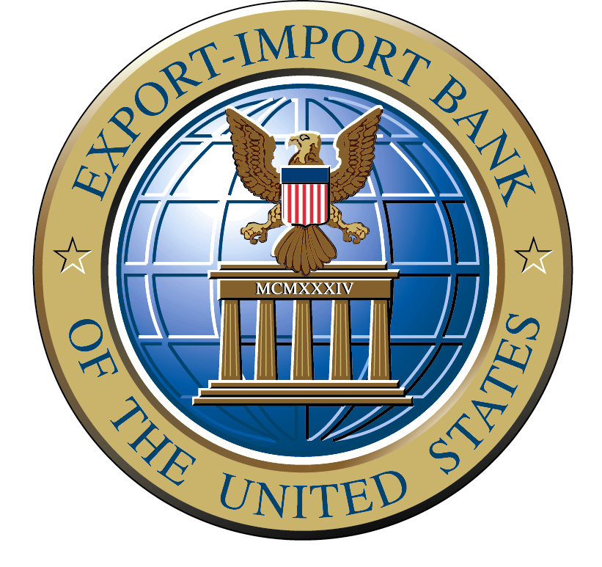
EXPORT-IMPORT BANK OF THE UNITED STATES
BENEFICIARY CERTIFICATE AND AGREEMENT
For Use With
Bank Letter of Credit Export Credit Insurance Policy or
Financial Institution Buyer Credit Export Credit Insurance Policy or
Medium Term Export Credit Insurance Policy

NOTE: This form is to be used only if the beneficiary of the letter of credit, the recipient of a funding under a direct buyer credit loan or the recipient of payment under a reimbursement loan or a payment under a supplier credit is not also the U.S. Exporter. In that situation the exporter must complete those parts of the Exporter Certificate EIB94-07 required in its instructions and the beneficiary must complete this entire certificate.
Name and Address of Policyholder: Name and Address of Beneficiary:

______________________________________ ________________________________________________________

_______________________________________ ________________________________________________________

Policy No.___________________________ ________________________________________________________
(to be completed by the policyholder, also see No.4.e) Beneficiary's Dun & Bradstreet Number _______________________
Taxpayer ID No.:__________________ Congressional District:_____
Indicate (not required) if owned by a ٱ woman, or an ٱ ethnic minority, describe____
Upon representation that the Export-Import Bank of the United States (“Ex-Im Bank”) has issued to the policyholder identified
above an export credit insurance policy, and in consideration of either (check one):
ٱ a) the payment, acceptance or negotiation of an irrevocable letter of credit in our favor; or,
ٱ b) the financing of an export,

We, the Beneficiary, hereby certify to the policyholder and to Ex-Im Bank as follows:
- The policyholder has either (check one):
ٱ a) informed us of an irrevocable letter of credit with Identification No.__________ and we have presented, or shall present, documents which are in compliance with the terms and conditions of such irrevocable letter of credit; or,

ٱ b) to our belief, established an obligation of the foreign buyer named below to make repayment of funds on a specified term in support of an export, for which we have received payment.

2. The above referenced irrevocable letter of credit or the buyer's obligation to pay the policyholder is in support of an export transaction described as follows:

a) Name and address of buyer________________________________________________________________________

b) Description and quantity of product(s)/service(s)_______________________________________________________
c) The product(s) are: ٱ New, ٱ Used. If used, attach Used Equipment Questionnaire form EBD-M-25.
d) Place of Shipment_______________________________ e) Date of Shipment__________________________________
- Contract Price to Buyer:
(i) Products/Service $__________
ii) Less discounts or similar allowances $__________
iii) Plus total insurance, freight or other
delivery charges included in the transaction $__________
Subtotal: $__________
iv) Less cash payment $__________
(minimum 15% required for MT)
(v) Total final net delivered financed portion $__________

3. To the best of our knowledge and belief, the products described above were shipped from the United States, in accordance with paragraph 2 above.

4. With respect to products
a) which could be used for military purposes,
b) which could be components of a product or equipment which could be used for military purposes,
c) which could be used to manufacture products or equipment which could be used for military purposes,
d) listed on the United States Munitions List (part 121 of Title 22 of the Code of Federal Regulations), or
e) purchased by or for use by security, military or defense organizations, ٱ we ____ have or ٱ the policyholder ____
Initial Initial
has received the written approval of the Ex-Im Bank for such sale prior to shipment of the products and attached it to this certificate. Submit a Defense Product Questionnaire EIB92-61 in order to obtain such approval.

5. The products do not consist of technology, fuel, equipment, materials or goods and services to be used in the construction, alteration, operation or maintenance of nuclear power, enrichment, reprocessing, research or heavy water production facilities.

6. To the best of our knowledge and belief the products are for use only in countries in accordance with Ex-Im Bank’s Country Limitation Schedule in effect on the date of shipment. See Ex-Im Bank’s Internet Website <www.exim.gov> Country and Fee Information.

7. Neither we, nor our Principals, have within the past 3 years been:
- debarred, suspended, declared ineligible from participating in, or voluntarily excluded from participation in, a Transaction;
- formally proposed for debarment, with a final determination still pending;
- indicted, convicted or had a civil judgment rendered against us for any of the offenses listed in the Regulations;
- delinquent on any amounts due and owing to the U.S. Government or its agencies or instrumentalities as of the date of execution of this certification; or
- the undersigned has received a written statement of exception from Ex-Im Bank attached to this certification, permitting participation in this Transaction despite an inability to make certifications 1) through 4) in this paragraph.

8. We have not and will not knowingly enter into any agreements in connection with the goods and/or services covered by this policy with any individual or entity that has been debarred, suspended, declared ineligible from participating in, or voluntarily excluded from participation in a Transaction. All capitalized terms not defined herein shall have the meanings set forth in the Government Wide Non-Procurement Suspension and Debarment Regulations - Common Rule (Regulations).

9. We will complete and submit Form-LLL (the Anti-Lobbying Declaration/Disclosure forms available at http://www.exim.gov/pub/pdf/95-10apd.pdf), Disclosure Form to Report Lobbying if, to the best of our knowledge and belief, any funds have been paid or will be paid to any person in connection with this application for influencing or attempting to influence:
(1) an officer or employee of any U.S. Government agency, or
(2) a Member of Congress or a Member’s employee, or
(3) an officer or employee of Congress. This does not apply to commissions paid by the Bank to insurance brokers.

10. We have not, and will not, engage in any activity in connection with this transaction that is a violation of 1) the Foreign Corrupt Practices Act of 1977, 15 U.S.C. 78dd-1, et seq. (which provides for civil and criminal penalties against individuals who directly or indirectly make or facilitate corrupt payments to foreign officials to obtain or keep business), 2) the Arms Export Control Act, 22 U.S.C. 2751 et seq., 3) the International Emergency Economic Powers Act, 50 U.S.C. 1701 et seq., or 4) the Export Administration Act of 1979, 50 U.S.C. 2401 et seq.; nor has it been found by a court of the United States to be in violation of any of these statutes within the preceding 12 months, and to the best of its knowledge, the performance by the parties to this transaction of their respective obligations does not violate any other applicable law.

11. The representations made and the facts stated by us in these certifications and its attachments are true, to the best of our knowledge and belief, and we have not misrepresented or omitted any material facts. We further understand that these certifications are subject to the penalties for fraud against the U.S. Government (18 USC 1001).

By:______________________________________ Signature:___________________________________
Print Name (Authorized Representative of the Beneficiary)

Title:_____________________________________ Date:______________________________________

If the beneficiary can not make any or all of the required certifications as they are presented here, Ex-Im Bank must be contacted to request written permission to delete or alter the certification, without which the insurance policy may not be valid.

Notices

The applicant is hereby notified that information requested by this application is done so under authority of the Export-Import Bank Act of 1945, as amended (12 USC 635 et. seq.); provision of this information is mandatory and failure to provide the requested information may result in Ex-Im Bank being unable to determine eligibility for support. The information provided will be reviewed to determine the participants’ ability to perform and pay under the transaction referenced in this application. Ex-Im Bank may not require the information and applicants are not required to provide information requested in this application unless a currently valid OMB control number is displayed on this form (see upper right of each page).

Public Burden Statement: Reporting for this collection of information is estimated to average 1 hour per response, including reviewing instructions, searching data sources, gathering information, completing, and reviewing the application. Send comments regarding the burden estimate, including suggestions for reducing it, to Office of Management and Budget, Paperwork Reduction Project OMB# 3048-0009, Washington, D.C. 20503.

The information provided will be held confidential subject to the Freedom of Information Act (5 USC 552) the Privacy Act of 1974 (5 USC 552a), and the Right to Financial Privacy Act of 1978 (12 USC 3401), except as otherwise required by law. Note that the Right to Financial Privacy Act of 1978 provides that Ex-Im Bank may transfer financial records included in an application for an insurance policy, or concerning a previously approved insurance policy, to another Government authority as necessary to process, service or foreclose on an insurance policy, or collect on a defaulted insurance policy.

