Chapter 10. Income Verification Match (IVM): Further Development

1. Pension and Parents’ Dependency and Indemnity Compensation (DIC) Cases Involving Unearned Income From a Financial Institution (FI)

Introduction | This topic contains information on pension and Parents’ DIC cases involving unearned income from an FI, including  - handling cases of unearned income from an FI  - worksheet review  - the 60-day verification period  - when the recipient confirms  - the match amount, or  - less than the match amount  - accepting the amount verified by recipient  - verification by use of subpoena, and  - when the recipient is the  - beneficiary and does not respond, and  - spouse and does not respond.

Change Date | February 5, 2008

a. Handling Cases of Unearned Income From an FI | Because FIs are obligated to follow the rules and procedures in 12 U.S.C. 35, Right to Financial Privacy Act, cases involving unearned income paid by a financial institution (FI) must be handled differently.  Note: The Department of Veterans Affairs (VA) can only obtain information directly from an FI by issuing a subpoena.
Continued on next page
1. Pension and Parents’ Dependency and Indemnity Compensation (DIC) Cases Involving Unearned Income From a Financial Institution (FI), Continued

b. Worksheet Review | When the worksheet is received, review it to determine if it is necessary to obtain verification of the unearned income.  - If both earned and unearned income are involved, and the earned income is enough to discontinue benefits, do not attempt to verify the unearned income.  - If unearned income combined with earned income will result in the discontinuance of benefits or greater reduction in benefits, verification is required. In addition, if unearned income is the only match income, verification is required again.

c. 60-Day Verification Period | Allow 60 days from the date the verification letter is released for the income recipient to furnish verification of unearned income from an FI.

d. Recipient Confirms the Match Amount | Send a notice of proposed adverse action based on the recipient’s report if the income recipient  - confirms the match amount  - verifies an amount that would result in termination of benefits, or  - reports more income.

e. Recipient Verifies Less Than the Match Amount | If the income recipient verifies less than the match amount, accept the amount verified by the recipient if it is within 10 percent of the match amount.  In all other cases, obtain independent verification of the match amount.
Continued on next page
1. Pension and Parents’ Dependency and Indemnity Compensation (DIC) Cases Involving Unearned Income From a Financial Institution (FI), Continued

f. Verification by Use of Subpoena | Verification may be accomplished by  - use of a subpoena to the FI  - a field examination request, or  - other locally determined means.  Reference: For more information on the efforts to clarify disputed amounts, see M21-1MR, Part X, 10.2.

g. Recipient Is Beneficiary and Does Not Respond | If the income recipient is the beneficiary and does not respond to VA’s verification request, send a subpoena to the FI.

h. Recipient is Spouse and Does Not Respond | If the income recipient is the spouse of the veteran and does not respond to VA’s verification request, send a notice of proposed adverse action  - proposing to adjust based on the matched income amount, and  - providing the beneficiary the opportunity to provide evidence to show that the information is incorrect.  Allow 60 days for the beneficiary to respond; if there is no response, adjust based on the match income amount.  If the beneficiary denies receipt of the income or verifies a lesser amount that would not result in discontinuance of benefits, a subpoena must be issued to obtain FI records.

If … | Then …
there is no response | adjust based on the match income amount.
- beneficiary denies receipt, or  - verifies a lesser entry | issue a subpoena to obtain FI records.

2. Efforts to Clarify Disputed Amounts

Introduction | This topic contains information on efforts to clarify disputed amounts, including  - clarifying disputed amounts  - when the information provided does not agree with Internal Revenue Service (IRS)  - when the criteria is not met for referral to Office of Inspector General (OIG)  - when a potential fraud case meets OIG criteria  - administrative and FI subpoenas  - subpoena enforcement  - when evidence proving IRS or Social Security Administration (SSA) data is incorrect  - delay of letter, and  - when the end product (EP) is pending.

Change Date | February 5, 2008

a. Clarifying Disputed Amounts | If the amount of money reported in the Income Verification Match (IVM) is disputed, either in whole or in part, during the verification process or during due process and that disputed amount will adversely affect the amount of VA benefits payable, further effort should be undertaken to clarify the discrepancy.

b. Information Provided Does Not Agree With the IRS | VA may notify the payer, income recipient, or both, that the information provided does not agree with information obtained from the Internal Revenue Service (IRS) and request clarification with supporting documentation.  Likewise, if the income recipient is the spouse, VA may attempt to verify the information with the VA beneficiary.
Continued on next page
2. Efforts to Clarify Disputed Amounts, Continued

c. Criteria Not Met for Referral to OIG | If the case does not meet the criteria for referral to the Office of Inspector General (OIG), the Veterans Service Representative (VSR) may request that a Field Examiner contact the income recipient and obtain copies of needed income tax returns, supporting documents and any other evidence that might be needed.  Reference: For more information on fraud and forfeiture discontinuance provisions, see  - M21-1MR, Part III, Subpart vi, 5.A, and  - M21-1MR, Part III, Subpart vi, 5.B.

d. Potential Fraud Case Meets OIG Criteria | If the case is a potential fraud case and meets the criteria for referral to the OIG, a field examination could compromise the case as far as the U.S. Attorney or the OIG is concerned. The Veterans Services Center Manager (VSCM) shall contact the local OIG to see if they would be willing to conduct any needed investigation.  If the OIG chooses not to conduct an investigation, the regional office (RO) may request a field examination.

e. Administrative and FI Subpoenas | VA may use an administrative or FI subpoena to obtain information.  An administrative subpoena may be sent directly to a non-FI income payer.  References: For more information on  - VA’s authority to issue subpoenas, see 38 U.S.C. 5711, and  - issuing subpoenas to FIs, see M21-1MR, Part X, 10.12.

f. Subpoena Enforcement | Direct any questions regarding the issuance or enforcement of a subpoena to the local Regional Counsel.  If the respondent does not reply to an administrative subpoena within 14 days, contact the Regional Counsel for enforcement.
Continued on next page
2. Efforts to Clarify Disputed Amounts, Continued

g. Evidence Proving IRS or SSA Data Incorrect | If evidence is received proving the IRS or Social Security Administration (SSA) data are incorrect, adjudicate the claim based on the evidence of record.

h. Delay of Letter | When it is necessary to clarify a disputed amount, if possible, the notice of proposed adverse action should not be sent until the issue is resolved.  Multiple notices of proposed adverse action, award actions, and final notification letters may confuse the beneficiary.

i. EP Pending | Although the end product (EP) must be left pending until the issue is finalized, it should not adversely affect timeliness.  If it appears that there will be a long delay while resolving the discrepancy, and the evidence indicates that current benefits are also being overpaid  - send a notice of proposed adverse action, and  - take interim award action on a verified amount pending resolution of any disputed amount.

3. Due Process

Introduction | This topic contains information on due process, including  - due process requirements  - separate income verification  - when pension benefits began during year of match, and  - an example of due process.

Change Date | February 5, 2008

a. Due Process Requirements | After the income is verified, due process procedures require VA to give the beneficiary a 60-day opportunity period to submit evidence to show why a reduction or termination should not be made.  Reference: For more information on due process, see M21-1MR, Part I, 2.A.

b. Separate Income Verification | Separate income verification by the income recipient, who is also the VA beneficiary, does not eliminate the need for due process. VA’s agreement with the IRS states that VA shall provide a notice of proposed adverse action in all cases, no matter who provides the separate verification.  This is an exception to the normal rule that a notice of proposed adverse action is not required if the adjustment is based on self-reported information.

c. Pension Benefits Began During Year of Match | In cases where pension benefits began during the year of the match, the notice of proposed adverse action must inform the beneficiary that, in the absence of information to the contrary, the income will be annualized over the entire year.  The letter also will inform the beneficiary that if the income terminated prior to the effective date of the award or the amount varied from month to month, the beneficiary should  - provide evidence to explain the income termination date, or  - the monthly income variation.
Continued on next page
3. Due Process, Continued

d. Example: Due Process | Situation:  - September 1, 2007: Veteran is awarded Improved Pension benefits and shows no interest income.  - 2007: The IVM indicates that the beneficiary received $1,500 in interest income.  - 2007: The beneficiary signs VA Form 21-0159, Income Certification confirming receipt of $1,500 interest.  Result: The notice of proposed adverse action  - must include development for the initial year and from all subsequent years to the present, and  - advise the beneficiary that VA will count the income for the initial year and each subsequent year unless he/she provides evidence to support a change.

4. Recipient Claims Income that Belongs to Someone Else

Introduction | This topic contains information on recipient claims that income belongs to someone else, including  - the income statement  - when there is no response within 60 days  - jointly owned property, and  - funds paid or credited to recipient.

Change Date | February 5, 2008

a. Income Statement | Instances may arise where the income recipient indicates that income identified by the match was  - the income of another person, possibly a relative, or  - shared jointly between the recipient and the other person.  In these situations, ask the income recipient to furnish a statement from the FI or other source of the income. The statement should show the names of the owner or owners of the funds or property which generated the income during the time frames in question.  Provide 60 days for a response.

b. No Response within 60 Days | If no response is received within 60 days, treat the income as that of the income recipient.

c. Jointly Owned Property | If the income recipient submits a statement from the FI or other source of the income showing that the income recipient and another person or persons jointly owned the property generating the income, count only the income recipient’s proportional share of the income on partial transfer of property by a claimant.  Reference: For more information partial transfer of property by a claimant, see M21-1MR, Part V, Subpart iii, 1.I.65.
Continued on next page
4. Recipient Claims Income that Belongs to Someone Else, Continued

d. Funds Paid or Credited to Recipient | If funds were paid to the income recipient or credited to the income recipient’s account, the income recipient’s proportional share of the income must be counted in determining eligibility for VA benefits, irrespective of any informal arrangements that might have existed.

5. Limitation on Fiduciary Contact

Introduction | This topic contains information on limitations on fiduciary contact, including  - IRS limits on the Department of Veterans Affairs (VA)  - worksheets  - a court-appointed guardian  - when the payee is a Federal fiduciary, and  - VA fiduciary underreported income.

Change Date | July 23, 2004

a. IRS Limits on VA | IRS regulations do not permit VA to contact a fiduciary for verification of the tax return information unless the fiduciary is a court-appointed guardian.  Note: If the master record shows the beneficiary is incompetent and not paid directly, the Benefits Delivery Network (BDN)  - will not send verification letters to a beneficiary or a beneficiary’s spouse, and  - will send letters to the payers of earned income.

b. Worksheets | Worksheets for fiduciary cases will be sent separately to the PMCs with a transmittal stating that the referrals are fiduciary cases. These cases must be reviewed to determine which have court-appointed guardians.

c. Court-Appointed Guardian | If there is a court-appointed guardian, ask the guardian to verify the information on the worksheet. Allow 60 days for a response.

d. Payee Is a Federal Fiduciary | If the payee is a Federal fiduciary who is appointed by VA only, ask the income recipient to verify the information on the worksheet.
Continued on next page
5. Limitation on Fiduciary Contact, Continued

e. VA Fiduciary Underreported Income | If it is determined that a VA fiduciary underreported income, notify the fiduciary activity at the time of reduction or discontinuance.

6. Identification of Overpayments for Reporting Requirements

Introduction | This topic contains information on identification of overpayments for reporting requirements, including  - the Debt Management Center (DMC)  - fraud cases referred to the OIG  - the special conditions indicator (SCI), and  - changing the SCI code.

Change Date | July 23, 2004

a. DMC | The Debt Management Center (DMC) is responsible for generating reports concerning overpayments created and recovered as a result of the IVM computer match. To identify these cases, reason code 46 must be used for award or stop actions, except where potential fraud is shown.

b. Fraud Cases Referred to the OIG | Use reason code 38 for potential fraud cases referred to the OIG. Once a case has been declined by the OIG, the DMC must be notified.  - Notify the finance activity by e-mail or telephone that the case will not be pursued and is now an IVM case.  - The finance activity will then notify the DMC via e-mail that the case is now an IVM case (reason code 46), permitting the DMC to initiate collection action and include these cases in the monthly reports.
Continued on next page
6. Identification of Overpayments for Reporting Requirements, Continued

c. SCI | A special conditions indicator (SCI) has been installed in compensation and pension (C&P) master records. There are 36 SCI Codes. Codes A-Z are reserved for field stations, and 1-9 for VACO.  Setting the SCI  - The indicator is initially set as zero in all master records.  - For each IVM case, the SCI is automatically changed to one.  Beneficiary eligibility verification report (BEVR) processing is modified to refer an eligibility verification report (EVR) if this indicator is set to one.

d. Changing the SCI Code | VSRs must not change the SCI code until after completing IVM action. At that time stations must zero out the indicator using the correction of master record (CORR) transaction or may use codes A–Z. If this is not done, EVRs continue to be referred.

7. Congressional Inquiries

Introduction | This topic contains information on Congressional inquiries, including  - releasing tax information to a Member of Congress, and  - releasing non-tax information.

Change Date | July 23, 2004

a. Releasing Tax Information to a Member of Congress | Do not release tax return information to a Member of Congress. If a Congressional inquiry is received as a result of a proposal to reduce or terminate benefits or after benefits have been reduced or discontinued, inform the Representative or Senator that  - the beneficiary’s benefits have been reduced or discontinued, or VA is proposing to reduce or discontinue benefits because of a change in family income, and  Note: The exact amount of reduction may be furnished.  - IRC 6103 prohibits VA from releasing tax return information, but VA has provided the veteran or beneficiary with complete information concerning the reduction or termination or the proposed reduction or discontinuance.

b. Releasing Non-Tax Information | Information which is not tax return information, including income information provided to VA by an income payer, may be released to a Member of Congress only when the Member seeks the  - information at the request of the beneficiary or someone authorized to exercise the beneficiary’s access right under these statutes, or  - records on behalf of a Congressional committee with VA oversight jurisdiction for committee business.

8. Security and Restrictions on Release of Tax Data

Introduction | This topic contains information on security and restrictions on release of tax data, including  - required safeguards  - security briefings  - penalties for tax information disclosure  - taxpayer civil suit  - maintaining IVM files  - returning IVM files  - disclosure to power of attorney (POA)  - disclosure purpose  - authorization on activity  - inspection of security procedures  - committee waivers decisions  - pre-releasing information over the telephone  - inspection of security procedures  - inspection reports, and  - inspection records.

Change Date | February 5, 2008

a. Required Safeguards | As a condition of receiving tax return information, VA must establish and maintain, to the satisfaction of the IRS, certain safeguards that are designed to prevent unauthorized uses of the information and to protect the confidentiality of the information.
Continued on next page
8. Security and Restrictions on Release of Tax Data, Continued

b. Security Briefings | The VSCM shall ensure that all PMC employees who handle IVM information are briefed annually on  - IRS safeguard requirements, and  - the provisions of IRC Sections 7213(a) and 7431 concerning criminal and civil penalties for unauthorized disclosure of tax data.  A security briefing must be held for each new employee as soon as he/she reports for duty.  Employee List  A list of the employees attending the briefing must be maintained for two years. After subsequent briefings, the list from two years prior will be destroyed under RCS VB-1, 13-100.300.

c. Penalties for Tax Information Disclosure | 26 USC 7213(a)(1) provides that any Federal employee who willfully and unlawfully discloses tax return information may be  - fined, not in excess of $5,000  - imprisoned, not in excess of five years, or  - both.  It also provides that the employee shall be discharged from employment upon conviction for an unlawful disclosure.

d. Taxpayer Civil Suit | 26 U.S.C. 7431(a)(1) permits a taxpayer to bring a civil suit for damages against the United States if any Federal employee knowingly or negligently discloses any tax return information in violation of IRC 6103.
Continued on next page
8. Security and Restrictions on Release of Tax Data, Continued

e. Maintaining IVM Files | Maintain IVM files in a “double lock” environment. This may consist of a locked file cabinet in a secured room or a locked file cabinet with secondary locking ability.  When the file is needed, it may be obtained, but only by employees with a “need to know.”  Need To Know  “Need to know” means that the file is needed by a Veterans Service Center (VSC) employee when the income recipient is in the office and is asking to see the information. Employees of the Board of Veterans’ Appeals (BVA) are considered to have a “need to know” if an IVM issue is appealed.  Reference: For more information on transferring IVM files on an appeal issue, see M21-1MR, Part X, 10.9.f.

f. Returning IVM Files | The IVM file must be returned to the locked files at the end of each day.  There are no exceptions.  Charge Cards  Charge cards must be used to maintain a complete record of charge-outs and must also reflect the date files are returned to storage.  Reference: For more information on the maintenance and release of locked files, see M21-1MR, Part III, Subpart ii, 4.A.3.
Continued on next page
8. Security and Restrictions on Release of Tax Data, Continued

g. Disclosure to POA | VA may disclose tax return information to an individual or a service organization. For IVM purposes, the assignment of a service organization as power of attorney (POA) is restricted to five years from the date the VA Form 21-22 is signed. In IVM cases, place a flash in the file as follows:  “POA in favor of [name]. Not valid for review of IVM material after [date].”  VA is responsible for verifying the identity, credentials, and authorization of any individual seeking access to the veteran’s income information. The individual representative of a veteran’s service organization need not be a named individual. It is sufficient that VA Form 21-22 contain the job title, for example, “any DAV service officer,” of the service organization representative.  Note: If a specific person is named on VA Form 21-22, access should be limited to only that individual.  Important: The confidentiality of federal tax information is best maintained if the POA is assigned to a particular position or job title within a service organization, as opposed to the service organization as a whole.

h. Disclosure Purpose | The disclosure must be for the purpose of determining eligibility for, or the correct amount of, benefits under one of the following VA benefit programs:  - pension  - compensation based on unemployability, or  - Parents’ Dependency and Indemnity Compensation (DIC).  No other disclosures are authorized.
Continued on next page
8. Security and Restrictions on Release of Tax Data, Continued

i. Authorization | The authorization must be signed and dated by the income recipient and must have been made within the last five years. If the beneficiary and his/her spouse are both income recipients for the same tax year match, each must execute a separate POA.  If IVM development action appears necessary and the authorization’s age exceeds five years, or will likely be so before the IVM action is completed, then forward the claimant a new VA Form 21-22 to complete.  The authorization must contain the following:  - name and address of the income recipient  - income recipient’s Social Security number (SSN)  - authorization permission (that is, authorization for VA to disclose information in its possession from the IRS tax return information), and  - the name or title of the individual and/or the service organization’s name, to whom the income recipient is authorizing disclosure.

j. Releasing Information Over the Telephone | Do not release tax return information over the telephone.

k. Committee on Waivers Decisions | Copies of Committee on Waivers decisions, including relevant tax return information, may be referred to the DMC.

l. Inspection of Security Procedures | Once a year, a person designated by the Director must conduct an independent inspection of security procedures. This review must be conducted by someone who is not in the VSC and who has no authority or responsibility for maintenance of claims files.  Example: A management analyst in the Director’s office.
Continued on next page
8. Security and Restrictions on Release of Tax Data, Continued

m. Inspection Reports | Include the following items in the written report:  - verification that Federal tax information has not been commingled with other information in such a way that its confidentiality could be inadvertently compromised  - a statement to the effect that personnel with access to tax return information were briefed on the criminal and civil penalties for unauthorized disclosure of tax return information  - an assessment of facility security features  - an analysis of security procedures and instructions to employees  - an audit of the charge cards showing charge-outs and charge-ins, and  - a review of  - the storage and handling of Federal tax information  - how access to Federal tax information is granted to employees  - after-hours security  - the list of employees who attended the last two yearly briefings to ensure that all employees attended and that briefings are being conducted annually, and  - the disposal log.  Reference: For a sample of the inspection report format, see M21-1MR, Part X, 10.20.

n. Inspection Records | The inspection records will be filed in a separate file and for purposes of meeting IRC 6103(p)(4) requirements, will be retained for a period of three full years (even if reviewed by the IRS). At that time the inspection records may be destroyed.

9. IVM Locked File Versus Claims Folder

Introduction | This topic contains information on the IVM locked file versus the claims folder including  - Federal tax return information  - award prints  - due process and award letters  - destroying contents of the IVM file  - disposal log  - transferring IRS material or files  - handling claims files containing Federal tax return information, and  - providing a claims file to a service organization.

Change Date | February 7, 2007

a. Federal Tax Return Information | Consider all IVM-related materials except for award prints to be Federal tax return information. This includes worksheets and initial letters that were mailed from VA. Keep all Federal tax return information in the IVM locked files.

b. Award Prints | Keep IVM-related award prints in the claims file. Annotate the award prints “See IVM Folder” to alert others that the documentation supporting the award action is in the IVM folder.

c. Due Process and Award Letters | Keep IVM-related due process and award letters in the IVM folder only.
Continued on next page
9. IVM Locked File Versus Claims Folder, Continued

d. Destroying Contents of the IVM File | An IVM file and its contents may be destroyed three years after a final decision, based on Federal tax return information, has been made by the PMC or appellate body. Any identifying information on the file will be shredded.  The contents of the file must be destroyed by shredding. The IRS requires the documents be shredded into 5/16-inch wide or smaller strips and the paper be inserted into the shredder so that the lines are perpendicular to the cutting edge.

e. Disposal Log | A disposal log must be kept to document the destruction of IVM files and their contents. The designee of the PMC Manager must maintain the log.  If all Federal tax return materials for a particular year are destroyed, the disposal log does not have to identify each individual record destroyed. It is adequate to document that all tax returns for a particular year were destroyed in accordance with established procedures.  If less than all tax materials for a particular year are destroyed, the disposal log must record the  - claim number  - veteran’s name  - date the document was destroyed, and  - manner of destruction  Destroying the Log  The log may be destroyed five years after the destruction of the last item entered in the log.
Continued on next page
9. IVM Locked File Versus Claims Folder, Continued

f. Transferring IRS Material or Files | If the claims folder is transferred to another PMC, the IVM file must be transferred with it.  If the claims folder is transferred to a compensation activity at a RO for compensation claims processing, or if compensation is awarded as the greater benefit, the PMC retains the IVM file.  If tax return information or the IVM file is transferred, place the material or file in two envelopes. Mark both envelopes  - “IVM Material (or File) Enclosed,” and  - “To Be Opened by the VSCM” (the VSCM may designate a person to perform this function).  If a claims folder is transferred to the BVA on an appeal issue involving the IVM, the IVM file should accompany the claims folder.

g. Handling Claims Files Containing Federal Tax Return Information | Follow the steps below to determine what action to take when routinely handling claims files which contain Federal tax return information.

Step | Action
1 | Has the IVM folder been destroyed?  - If yes, destroy the IVM-related materials.  Exception: Do not destroy the IVM-related materials if it has been less than three years since a final decision, based on tax return information, has been made by the PMC or appellate body.  - If no, follow steps 2 and 3 below.
2 | Remove all IVM-related materials from the claims file and file them in the IVM folder.  Exception: Do not remove IVM-related award prints from the claims file.
3 | Annotate the IVM-related award prints “See IVM Folder”.
Continued on next page
9. IVM Locked File Versus Claims Folder, Continued

h. Providing a Claims File to a Service Organization | Follow the steps below to determine what action to take before providing a claims file to a service organization.

Step | Action
1 | Review the claims file for the existence of IVM-related materials.
2 | Remove all IVM-related materials from the claims file and file them in the IVM folder.  Exception: Do not remove IVM-related award prints from the claims file.
3 | Annotate the IVM-related award prints “See IVM Folder”.

10. Freedom of Information Act (FOIA) Requests

Introduction | This topic contains information on FOIA requests, including  - releasing tax return information, and  - FOIA requests for tax information by someone other than a taxpayer.

Change Date | July 23, 2004

a. Releasing Tax Return Information | Tax return information can be released only as permitted by IRC 6103. Generally, tax return information may be released to the taxpayer, usually the income payer or income recipient.

b. FOIA Request for Tax Information by Someone Other than Taxpayer | If a Freedom of Information Act (FOIA) request for tax return information is received from someone other than the tax payer, the written reply to the FOIA request must tell the requester that IRC 6103 prohibits disclosure of tax return information in response to a FOIA request and cite FOIA exemption (b)(3).  The reply also must advise the requester of the right to appeal the withholding of this information to VA General Counsel. Questions concerning the release of tax return information to anyone other than the taxpayer should be referred to the Regional Counsel.

11. Report Requirements

Introduction | This topic contains information on report requirements, including  - the savings report  - the safeguard activity report, and  - where to  - send reports, and  - direct questions.

Change Date | February 5, 2008

a. Savings Report | Use the RCS 20-0834 format to report savings on a monthly basis.

b. Safeguard Activity Report | RCS 20-0893, the Internal Revenue Service Safeguard Activity Report, will include  - a copy of the results of the internal inspection of IVM security procedures  - a summary  - identifying any IVM documents destroyed during the year, and  - showing the date and manner of destruction, and  - a statement indicating that personnel with access to tax return information were briefed on the criminal and civil penalties for unauthorized disclosure of the tax return information.  Notes:  - It is not necessary to submit a copy of the disposal log with RCS 20-0893.  - A negative safeguard activity report is required by an office that  - does not have any IVM files on station at the end of the calendar year in question, and  - did not destroy any IVM materials during that calendar year.  When Due  The Internal Revenue Service Safeguard Activity Report is due by COB November 30 of each year.  Reference: For a sample of the safeguard activity report format, see M21-1MR, Part X, 10.20.
Continued on next page
11. Report Requirements, Continued

c. Where to Send Reports | Send the savings and safeguard activity reports to the Director, Compensation and Pension Service (212A) or by e-mail to VAVBAWAS\CO\212A.

d. Where to Direct Questions | Direct questions on the savings and safeguard activity reports to the Compensation and Pension Service via e-mail at VAVBAWAS\CO\212A.

12. Issuing Subpoenas to FIs

Introduction | This topic contains information on issuing subpoenas to FIs, including  - subpoena authority  - issuing subpoenas to FIs  - what to do before issuing a subpoena to an FI  - sending a subpoena to an FI  - when a motion to quash is denied  - copies of the notice letter and attachments  - district courts for filing motion to quash  - subpoena certification  - the format for a subpoena  - subpoena enclosures  - delivery of subpoena  - the time frame for FIs, and  - when there is no reply within 34 days.

Change Date | August 10, 2005

a. Subpoena Authority | The subpoena authority of 38 U.S.C. 5711 is delegated to RO directors by 38 CFR 2.1, which requires the exercise of discretion in the use of this authority.  Use letterhead stationery when preparing subpoenas for FI records.  References: For more information on  - the efforts to clarify disputed amounts, see M21-1MR, Part X, 10.2  - VA’s authority to issue subpoenas, see 38 U.S.C. 5711  - delegation of authority to issue subpoenas, see 38 CFR 2.1  - requesting financial records from FIs, see Right to Financial Privacy Act (RFPA) of 1978, and  - the RFPA, see 12 U.S.C. 3401-3422.

b. Procedures for Issuing Subpoenas to FIs | The RFPA of 1978 provides detailed procedures and requirements for issuing subpoenas ordering FIs to provide customers’ transaction and income data.
Continued on next page
12. Issuing Subpoenas to FIs, Continued

c. Before the Subpoena Is Issued | Before a subpoena can be issued to an FI, VA must notify the income recipient of  - the planned subpoena action  - the procedures for filing a motion in a Federal District Court to have the subpoena quashed, and  - that in the absence of a motion to quash, a subpoena will be sent to the FI upon the expiration of  - 10 days from the date of service of the subpoena, or  - 14 days from the date of mailing of the notice letter.

d. Issuing a Subpoena to an FI | Use the table below to issue a subpoena in relation to a motion to quash.  Note: These waiting periods include four extra days to allow time for VA to receive a copy of any motion which the income recipient may have sent timely to VA by mail.

If a motion to quash is … | Then …
filed | VA must wait until the court rules on the motion.
not filed within 14 days following the date of delivery of the notice letter | send the subpoena.  Important: Evidence of date of delivery must be on record prior to sending it.
not filed within 18 days following the date of mailing of the notice letter | send the subpoena.

e. Motion to Quash Denied | If a motion to quash is filed, but the Court rules not to quash the subpoena, then issue it.  Reference: For more information on a sample notice letter with all required attachments, including a copy of the subpoena, see M21-1MR, Part X, 10.15.
Continued on next page
12. Issuing Subpoenas to FIs, Continued

f. Copies of Notice Letter and Attachments | Copies of the notice letter and all attachments, except the subpoena, may be sent to the holder of the income recipient’s POA.  The subpoena, containing the name and address of the income payer (IRS tax return information), may only be released to the income recipient. The copy of the subpoena sent to the recipient should not include VA’s certification referred to in M21-1MR, Part X, 10.12.h.

g. District Courts for Filing Motion to Quash | The income recipient has the option of filing the motion to quash, along with a sworn statement, with any one of the following:  - the U.S. District Court in the District of Columbia (DC)  - the U.S. District Court where the FI is located  - the U.S. District Court where the recipient is located, or  - the U.S. District Court where the PMC is located.  The VA notice letter must provide the address of each court. The DC Court address is provided in the sample.

h. Subpoena Certification | The subpoena will contain a certification that  - VA has complied with all provisions of the RFPA  - the recipient has or has not filed a motion to quash and, if filed, the Court has ruled in favor of VA, and  - the institution may rely on this certification as relief from liability for disclosing the recipient’s income information.  Note: This certification should not be included on the copy sent to the recipient.
Continued on next page
12. Issuing Subpoenas to FIs, Continued

i. Format for Subpoena | Reference: For information on the appropriate subpoena format where a motion was  - filed and the Court ruled in favor of VA, see M21-1MR, Part X, 10.15 and  - not filed, see M21-1MR, Part X, 10.14.  Statement Regarding Gross Income  Add to the body of the subpoena, above the Director’s signature, a statement of how soon and where the statement of gross income should be delivered.

j. Subpoena Enclosures | Enclose a post paid, business reply envelope, clearly marked as “IVM Material” with the subpoena.

k. Delivery of Subpoena | If physical delivery of the subpoena to the FI is not feasible, use return receipt requested and deliver via  - registered, or  - certified mail.  The return receipt should be retained as proof of delivery.  Make sure that mailroom personnel are alerted to  - expect subpoena responses, and  - handle them as IVM material.

l. Time Frame for FIs | Allow each FI 30 days from the date of the subpoena to produce the data.

m. No Reply within 34 Days | If no reply has been received from the FI within 34 days, consult with the Regional Counsel for steps to take to force compliance with the subpoena.  When the requested data is received, proceed to adjust the award on the basis of the facts found after following due process procedures.

13. Exhibit 1: Right to Financial Privacy Act (RFPA) Notice

Introduction | This topic contains a RFPA notice.

Change Date | July 23, 2004

a. RFPA Notice – Page 1 | 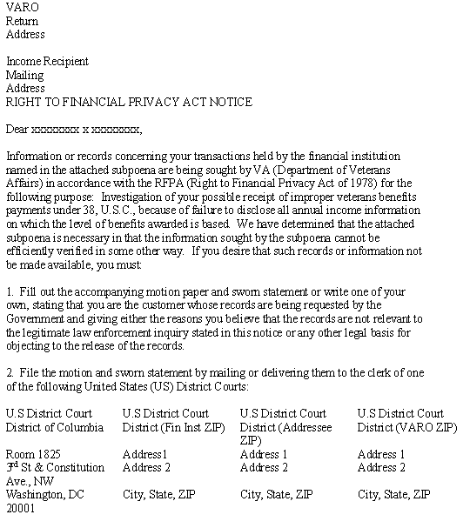
Continued on next page
13. Exhibit 1: Right to Financial Privacy Act (RFPA) Notice, Continued

b. RFPA Notice – Page 2 | 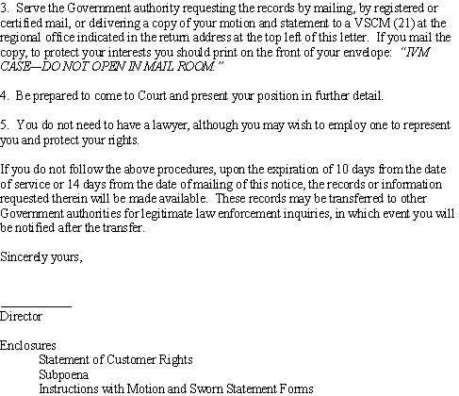

14. Exhibit 2: Statement of Pertinent Customer Rights

Change Date | July 23, 2004
Continued on next page
14. Exhibit 2: Statement of Pertinent Customer Rights, Continued

a. Statement of Pertinent Customer Rights

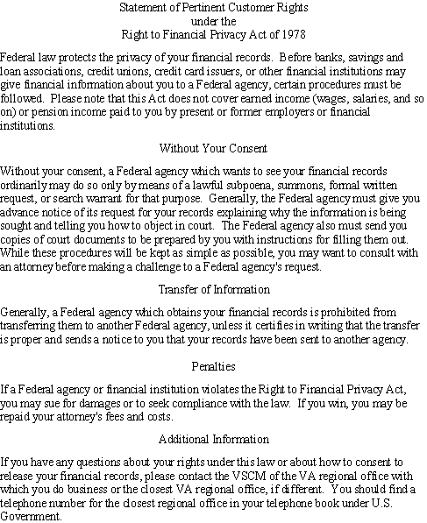

15. Exhibit 3: Subpoena for Income Information

Change Date | July 23, 2004

a. Subpoena for Income Information | 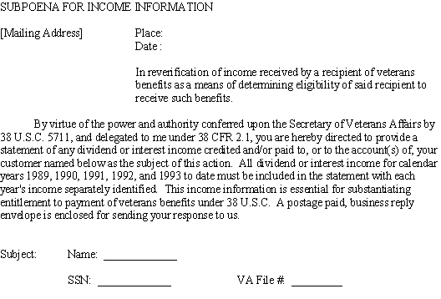

16. Exhibit 4: Instructions for Completing and Filing the Attached Motion and Sworn Statement

Change Date | July 23, 2004

a. Instructions for Completing and filing the Attached Motion and Sworn Statement | 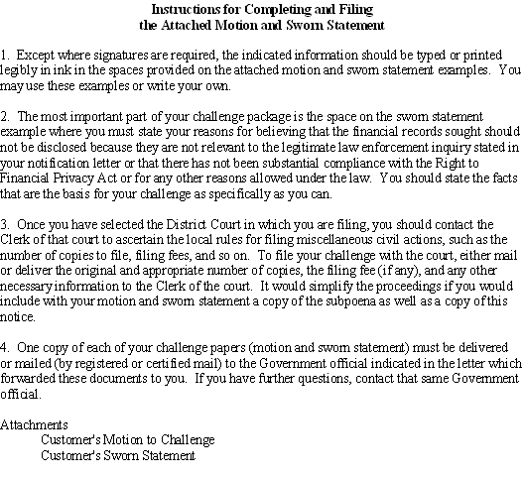

17. Exhibit 5: Customer’s Motion to Challenge

Introduction | This topic contains a customer’s motion to challenge.

Change Date | July 23, 2004

a. Customer’s Motion to Challenge – Page 1 | 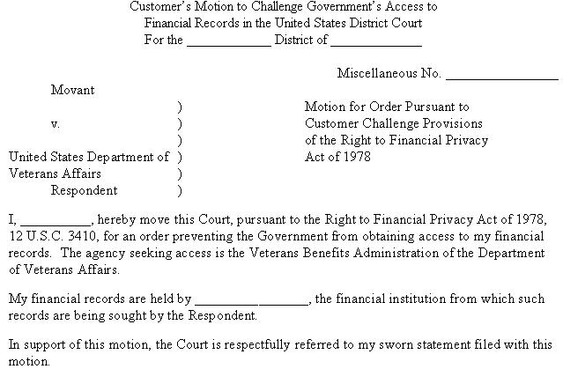
Continued on next page
17. Exhibit 5: Customer’s Motion to Challenge, Continued

b. Customer’s Motion to Challenge – Page 2 | 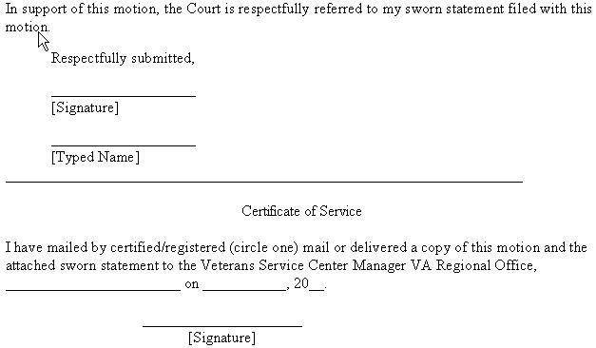

18. Exhibit 6: Customer’s Sworn Statement

Introduction | This topic contains a customer’s sworn statement.

Change Date | July 23, 2004

a. Customer’s Sworn Statement – Page 1 | 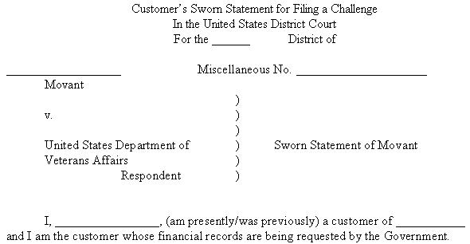

b. Customer’s Sworn Statement – Page 2 | 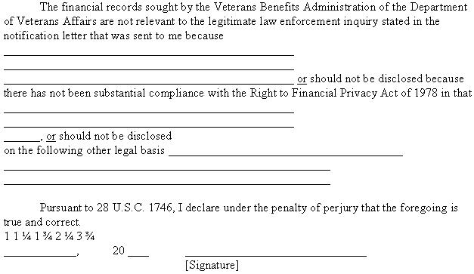

19. Exhibit 7: Subpoena for Income Information With Sections of Title 38 Attached

Change Date | July 23, 2004

a. Subpoena for Income Information With Sections of Title 38 Attached | 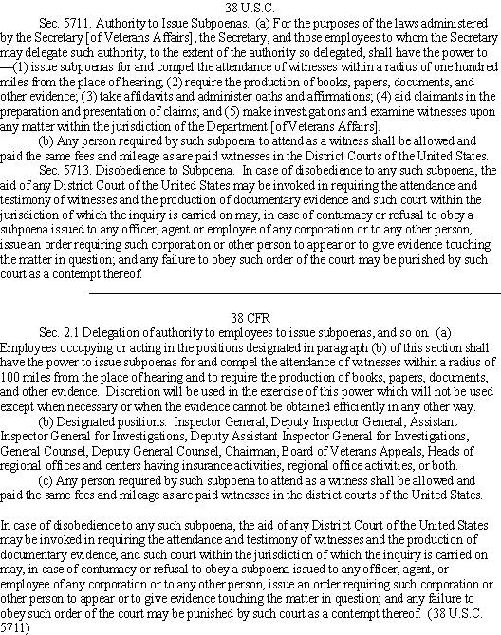

20. Exhibit 8: Internal Revenue Service (IRS) Safeguard Activity Report

Introduction | This topic contains a sample of RCS 20-0893, IRS Safeguard Activity Report.

Change Date | February 5, 2008

a. IRS Safeguard Activity Report – Page 1 | A sample of Page 1 of an IRS Safeguard Activity Report is shown below.

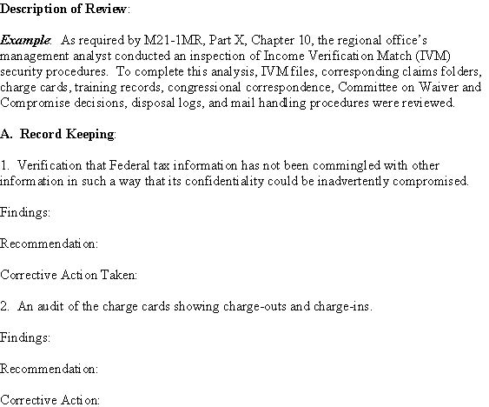
Continued on next page
20. Exhibit 8: Internal Revenue Service (IRS) Safeguard Activity Report, Continued

b. IRS Safeguard Activity Report – Page 2 | A sample of Page 2 of an IRS Safeguard Activity Report is shown below.

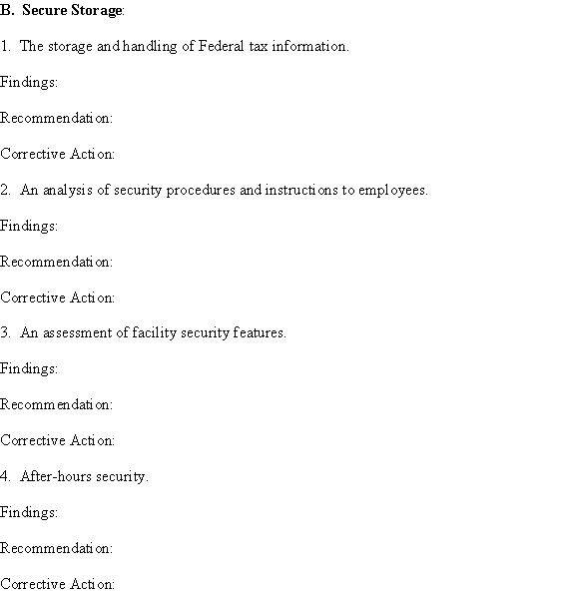
Continued on next page
20. Exhibit 8: Internal Revenue Service (IRS) Safeguard Activity Report, Continued

c. IRS Safeguard Activity Report – Page 3 | A sample of Page 3 of an IRS Safeguard Activity Report is shown below.

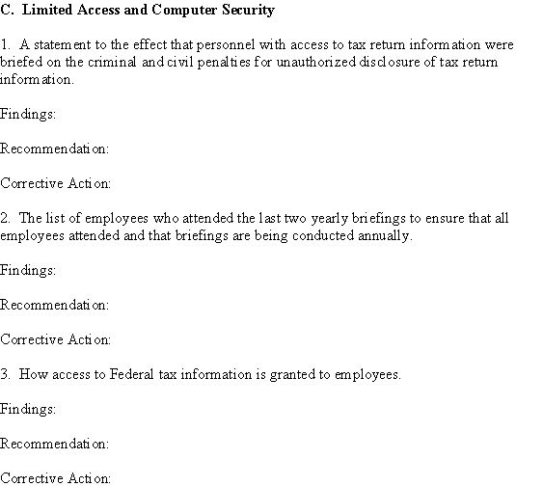
Continued on next page
20. Exhibit 8: Internal Revenue Service (IRS) Safeguard Activity Report, Continued

d. IRS Safeguard Activity Report – Page 4 | A sample of Page 4 of an IRS Safeguard Activity Report is shown below.

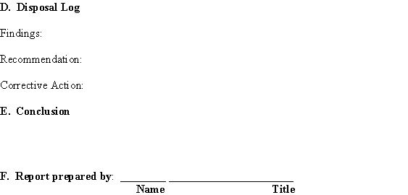

Note: If any unresolved deficiencies are noted during the reporting period, the RO management analyst (or designee) will
- annotate the current IRS Safeguard Activity Report with the projected date of resolution of the deficiencies, and
- in the next annual IRS Safeguard Activity Report, document the action taken to resolve the deficiencies.

