Hurricane Ike Situation Report # 3

September 15, 2008 (10:00 AM EDT)

http://www.oe.netl.doe.gov/emergency_sit_rpt.aspx

Summary
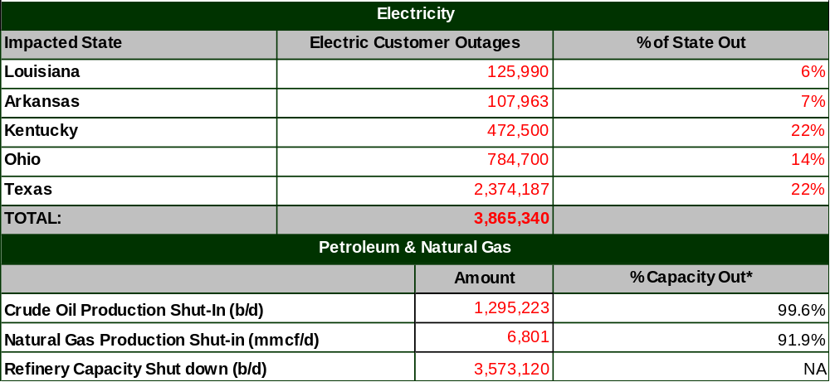

Notes:
Total state customers are based on 2006 EIA Customer Data.
Note: due to a large number of service providers, including investor owned utilities and cooperatives, the number of customer outages reported may not be comprehensive.
Source:
Crude Oil and Natural Gas Production Data from Minerals Management Service.
Refinery Status confirmed by company or on company web site and through various trade press sources.

* % capacity out represents percent of production capacity in the Gulf of Mexico.

Highlights:

- As of 10:00 AM EDT September 15, there are an estimated 3,865,340 customers reported without power in five States affected by Ike: Texas, Louisiana, Arkansas, Ohio and Kentucky. As the Ike system moved north, it caused additional outages in States throughout the Ohio Valley and into the Northeast. The largest outages are in Texas where 2,374,187 customers remain without power. Since Ike Situation Report No. 2 power has been restored to approximately 100,000 customers in Texas and 75,000 customers in Louisiana.

- The U.S. Department of Energy reported on September 14 that the Strategic Petroleum Reserve began delivery of 200,000 barrels of emergency exchange oil to ConocoPhillips’ Wood River refinery along the Capline pipeline system and an additional 109,000 barrels of emergency exchange oil to Placid Oil’s Port Allen refinery along a Shell pipeline in Louisiana.

- As of 09:30 AM EDT September 15, Gulf Ports and waterways are still closed from Freeport, TX east to Lake Charles, LA. This includes the Gulf Intracoastal Waterway, which also has additional restrictions east of Lake Charles. As of September 14, draft restrictions were lifted for Corpus Christi, Texas. The Lower Mississippi River has a safety zone from mile marker 113 to 115 and is open to one way traffic in this area.

- As of 1:45 AM EDT September 15, the LOOP resumed tanker offloadings. The LOOP continues to make deliveries to customers from its Clovelly storage facility.

- As of this 7:15 AM EDT September 15, Colonial pipeline is maintaining operations at reduced flow, ready to receive supply.

ESF 12 Actions:

- ESF-12 is working to facilitate restoration of critical assets in the affected area. ESF-12 also is working closely with those conducting assessments of physical energy infrastructure in the field which will assist in developing restoration estimates. On September 14, ESF-12 worked with DHS to facilitate air-based damage assessments of the CenterPoint and Entergy electric transmission systems. ESF-12 responders participated in the flights to assist in these assessments.

- ESF-12 is staffing the FEMA Region VI Regional Response Coordination Center (RRCC) in Denton, TX, the FEMA Region VI Joint Field Office (JFO) in Austin, TX, the FEMA Region VI (JFO) in Baton Rouge, LA, and the National Response Coordination Center (NRCC) in Washington, DC. In addition, a petroleum expert has been deployed to San Antonio, TX to serve as part of FEMA's National Incident Management Assistance Team (IMAT) and an electricity expert has been deployed to join the Region IV IMAT in Houston, TX.

Situation Report Detail

Petroleum & Gas Information
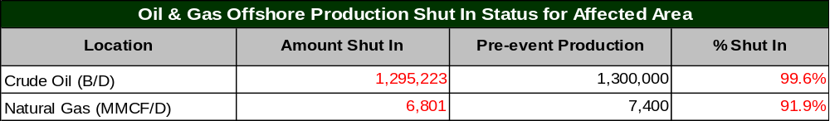Source: Minerals Management Service

- As of September 14, the Minerals Management Service (MMS) reports 6,801 million cubic feet per day (MMcf/d) of the Gulf’s natural gas production remains shut-in, equivalent to 91.9 percent of the Gulf production. MMS reports 1,295,223 barrels/day of the Gulf’s crude production remains shut-in, equivalent to 99.6 percent of the Gulf’s crude production. A total of 591 production platforms, or 82.4 percent of the Gulf’s 717 manned platforms, have been evacuated. Personnel from 92 rigs, representing 76.0 percent of those operating in the region, have been removed.

- On September 15, the head of Louisiana’s Department of Natural Resources reports that the “basic infrastructure of the state’s oil and gas industry appears to have weathered the storm with almost no damage." The Department also reported that only 18,621 barrels/day or 12 percent of the normal Louisiana production has been restored. Operators in 17 parishes and in State offshore areas normally produce 155,767 barrels/day (the numbers are in addition to MMS reports of Federal offshore production). On September 15, 80,978 barrel/day or 52 percent of the normal production remains shut-in and status is unknown for 56,167 barrels/day.

- As of 9:00 AM EDT September 15, fourteen refineries in Texas and Louisiana are reported shut down due to Hurricane Ike. These refineries located in Lake Charles/Port Arthur and Houston/Texas City, and have a total operable capacity of 3.6 million b/d. (See table below.)

- Shell reports as of 7:00 PM September 14 that 30 to 40 percent of our company-branded stations in Houston and Beaumont are now open, and it is anticipated that an additional 20 stations will be open by the end of September 14. The safety review of the Beaumont Terminal was completed and operations resumed on the evening of September 14.

- Oil refineries suffered minimal damage from Hurricane Ike and are making preparations to restart operations. Valero reports no significant structural damage. The company’s Houston refinery has some power, but its Texas City and Port Arthur refineries still need electricity supply restored Shell is still assessing its Deer Park and Port Arthur refineries. Deer Park sustained some damage and as of last night, Deer Park still had no electricity service. ConocoPhillips said its Sweeny, Texas, refinery has power and the company's Lake Charles refinery is operating at reduced rates. Exxon Mobil said its Beaumont, Texas refinery is without power.

- Chevron reports that numerous retail stations in Houston and Galveston are reporting power outages. They are deploying generators to repower key stations and provide fuel to customers. Additional Chevron transport trucks are being sent into the Houston area to speed refueling at stations.

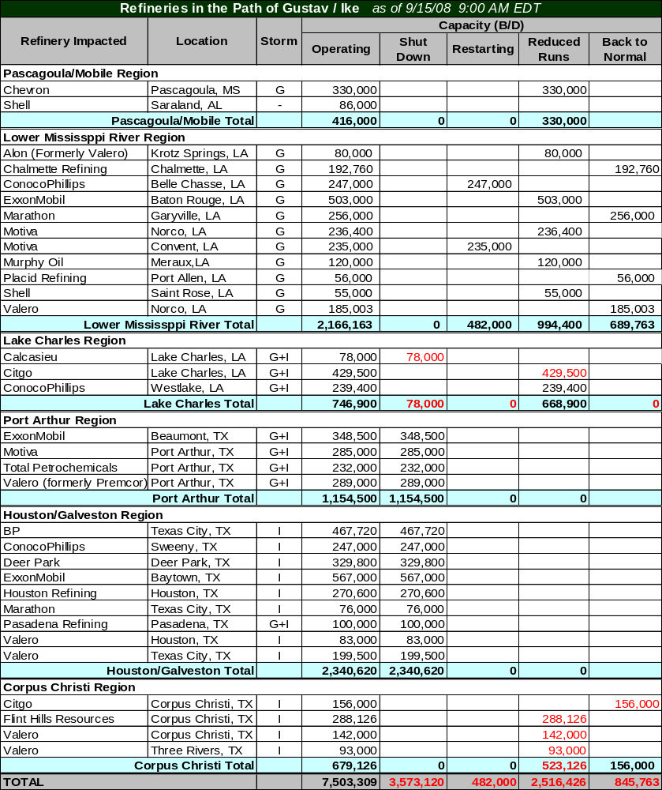
Note: The table does not include all refineries in the PADD III, Gulf Coast Region.
Storm column indicates hurricanes impacting refineries: G = Gustav; I = Ike, G+I = Both storms, and - = no impact.
Sources: Confirmed by company or on company web site. Various trade press sources.

- ConocoPhillips reports that outlets along evacuation routes in the south Texas area are a priority for fuel supply. The company reports that additional fuel supplies have been made available for outlets in those areas. While they report a few spot retail store outages in the area, most outages have been reported in Louisiana which were due to Hurricane Gustav.

- As of 10:00 AM EDT September 14, the Strategic Petroleum Reserve (SPR) sites at Bryan Mound, TX, Big Hill, TX, and West Hackberry, LA remain shut down. The Bayou Choctaw SPR site is operational.

- Major crude pipelines originating in Texas and Louisiana shut down operations in advance of Hurricane Ike, and many remain shut. Colonial pipeline reported at 7:15 AM EDT September 15, that the pipeline is ready to receive injects from storage facilities and refineries. Portable generators have been delivered to Beaumont where, after hookup today, they will be used to draw barrels from refineries in Port Arthur and Hebert on September 16. Explorer announced that it has conducted an initial assessment of its Gulf Coast facilities, which appear to have no damage. (See table below.)

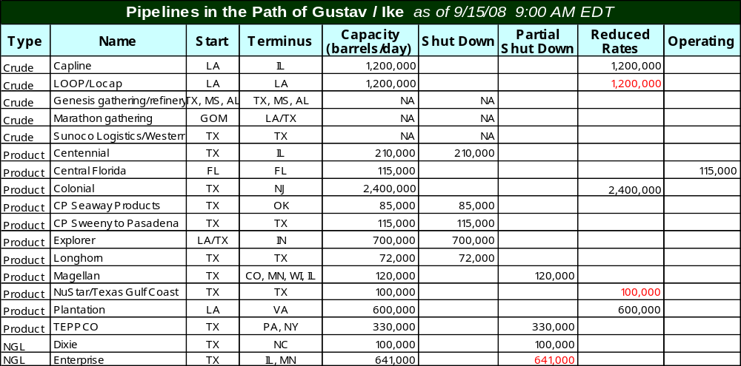Source: Status of pipelines from Association of Oil Pipe Lines; Capacity data from company web sites.

- The Independence Hub platform, located about 150 miles offshore LA in Mississippi Canyon reported gas flow of over 600 million cubic feet on September 14, 2008. This platform is the largest producing platform representing approximately 12% of the offshore Gulf of Mexico natural gas production and in July 2008, production from the Hub averaged over 800 MMcf/d.

- As of 8:00 AM EDT September 15, there have been no reports of any significant damage to natural gas pipelines or production infrastructure. Pipeline personnel are beginning to return to facilities and have started damage assessments.

- Texas Eastern Transmission reports the mainline capacity in south TX has been restored to pre-Hurricane Ike levels, but has notified customers that several Gulf Coast area compression facilities are operating on emergency backup generators as commercial power is unavailable. Texas Eastern also reports there is no significant damage to the pipeline’s facilities due to Ike, but those offshore points from Gustav remain shut-in pending additional damage assessments.

- As of 7:55 PM EDT September 14, Destin Pipeline Company notified its customers that the Force Majeure event in affect since Gustav (August 30) is now terminated and all receipt points along the system will accept gas flow starting September 15. Destin extends 195-miles of 36-inch diameter pipeline from deepwater offshore to the Pascagoula processing plant in MS.

- There are 39 major natural gas processing plants in the path of Hurricane Ike with a total operating capacity of 17.6 billion cubic feet per day (Bcf/d). As of 10:00 AM EDT, September 15, twenty-seven of these plants have been confirmed as shut down which includes those plants still impacted from Gustav. This is a decrease of 3 plants that were reported as shut down in Situation Repot #2 where all three plants are now capable to restart once power is restored and/or upstream gas flow is available. The total shut down operating capacity is 13.85 Bcf/d. In addition, 8 plants with total capacity of 2.9 Bcf/d, have been confirmed as operating at reduced or normal levels and currently there is no information on the status on 1 plant with capacity of less then 0.2 Bcf/d. See table below.

- As of 10 AM EDT, September 14, many gas processing plants have reported that detailed damage assessments will take place over the next few days. Recovery rates will likely vary from facility to facility and are also dependant on recovery of upstream and downstream flows.

- DCP Midstream report that some of the company’s facilities have sustained minor building damage. In addition, as electrical power and natural gas liquids takeaway service providers are restored, the company’s facilities will be brought back online slowly.

- Enterprise Products Partners announced that initial inspections of their facilities indicate minimal to no visible damage to its onshore assets on the TX and LA Gulf Coast. Enterprise expects that most of its facilities will quickly resume normal operations. The loss of commercial power at the company’s facilities in TX represents the most significant challenge facing Enterprise Products Partners in the recover from Hurricane Ike.

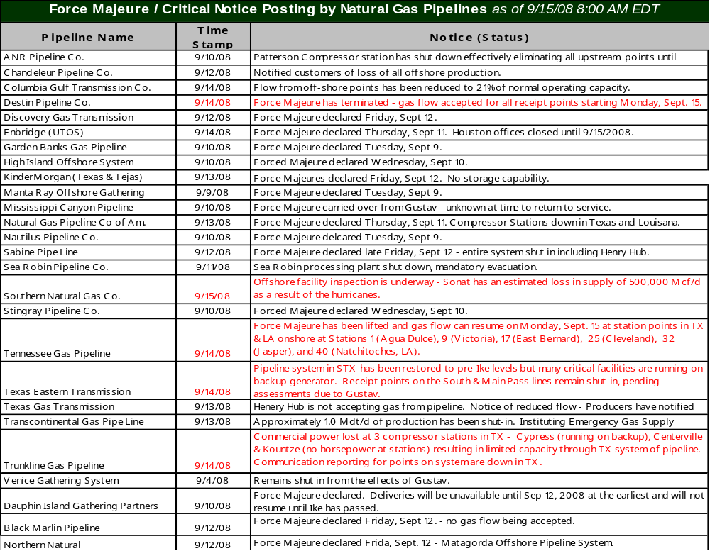

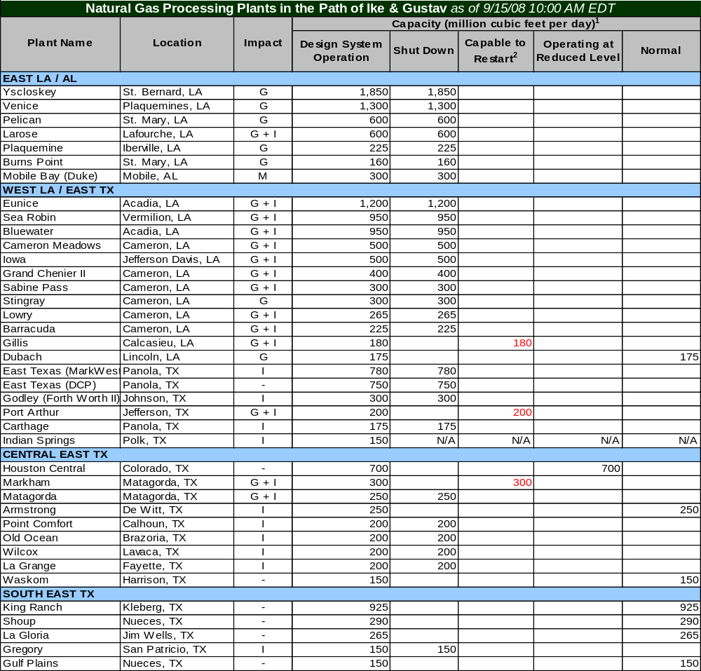Note: Storm column indicates hurricanes impacting processing plant: G = Gustav; I = Ike, G+I = Both storms, and M = Maintenance
“N/A” (Not Available or Confirmed) identifies those plants that are in the path of Ike that have not yet been confirmed of their status. ¹ The capacity represents the design capacity of the plants and does not represent the actual gas flow through these plants.
² Confirmed plants capable to restart after electricity is restored or when upstream gas flow commences service.
Sources: Confirmed by company or on company web site. Various trade press sources.

Electricity Updates:
Louisiana: |  | 
As of: | 9/15/2008 6:00 AM EDT

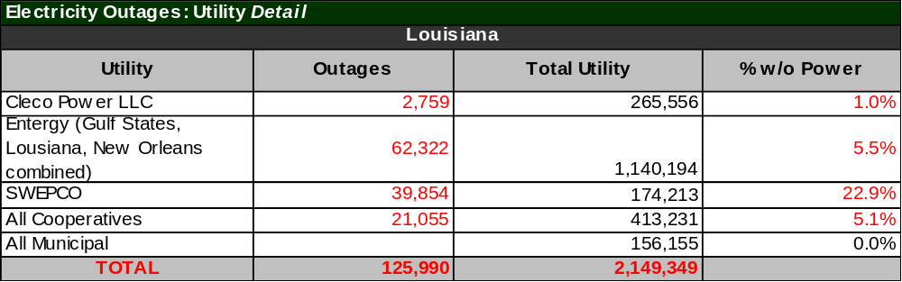Total state and utility customers are based on 2006 EIA Customer Data; Electric Cooperative customer totals provided by Louisiana Public Service Commission.
Note: due to a large number of service providers, including investor owned utilities and cooperatives, the number of customer outages reported may not be comprehensive.

- As of 6:00 AM EDT September 15, there are 125,990 customers without power in Louisiana. Of these outages, 114,129 are due to Ike. Gustav-related outages are down to 11,861.

- In Louisiana, Ike caused outages for 37 lines and 51 substations of which 19 lines and 15 substations have been restored. Remaining Gustav damage to the transmission system includes 16 lines and nine substations out of service.

Texas:
As of: | 9/15/2008 8:00 AM EDT

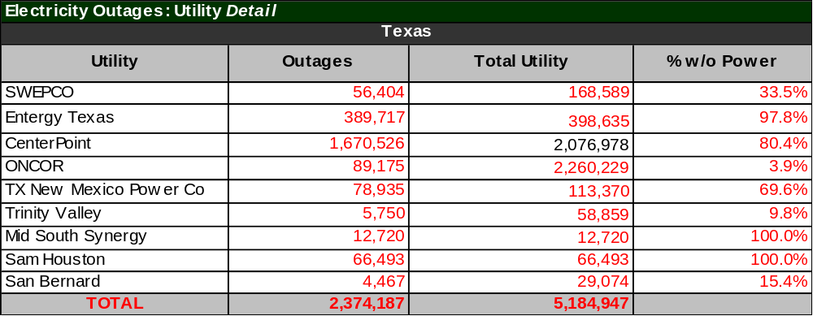Total utility customers are based on field reports.
Note: due to a large number of service providers, including investor owned utilities and cooperatives, the number of customer outages reported may not be comprehensive.

- In Texas, over 2.3 million people are reported without power. The majority of these are customers of CenterPoint and Entergy.

- Centerpoint reports that 1,129 distribution circuits, out of a total of 1,492, are out. There are 66 transmission lines out. Eight substations are without transmission service. There is no report at this time of any transmission tower being down, only wood poles.

- Entergy reports transmission outages caused by Ike include 278 of 312 substations and 183 of 187 transmission lines out of service in Texas. Entergy’s Lewis Creek plant in Montgomery County, Texas, has shut down as a result of storm damage. The plant will be able to restart within a few hours after offsite power is restored. Hurricane Ike flooded Entergy’s Sabine Power plant in Bridge City, Texas, with up to four feet of water. The flood has caused extensive damage to the plant that could take weeks to repair.

Additional State Reports:

- There are an estimated 107,963 customers in Arkansas who remain without power. Entergy reports 101,441 customers without power as of 6:00 AM EDT September 15, and SWEPCO reports 6,522 without power as of 10:00 PM EDT September 14. Entergy reports the majority of repairs should be complete within a few days. More difficult cases may take up to a week. Entergy has restored 38 of the 39 substations in Arkansas, and four of the eleven transmission lines affected by Hurricane Ike.
- As of 7:45 EDT September 15, approximately 472,500 or 22 percent of total customers in Kentucky are without power. A majority of these outages are occurring in Duke Energy, Louisville Gas & Electric and Kentucky Utilities service territories.

- As of 7:45 EDT September 15, approximately 784,700 or 14 percent of total customers in Ohio are without power. A majority of these outages are occurring in the Duke Energy and AEP Ohio service territories.

Restoration Updates:

- As of 10:00 PM EDT September 14, CenterPoint had restored power to more than 425,000 customers. 250 circuits have been restored out of the original 1,379 that were out. 28 transmission lines have been restored out of the original 94 that were out. CenterPoint reports that full restoration may take four weeks or longer, pending full assessments.

- CenterPoint reports that 7,000 mutual assistance personnel began to arrive September 14 to assist in restoration. Highlights of CenterPoint restoration to date include:
  - The Katy, Richmond and Rosenberg areas
  - Hobby Airport and Ellington Field
  - Coastal Water Authority Lynchburg water pumping station, a major source of water for the City of Houston and other smaller communities in the area
  - Service restoration for one water treatment facility and one wastewater treatment plant in the City of Houston
  - Several area hospitals

- Entergy is shifting crews from Louisiana to Texas. Entergy’s total restoration workforce to 14,500, with 7,000 in Texas, 6,700 in Louisiana and 900 in Arkansas

