NINR Focus:
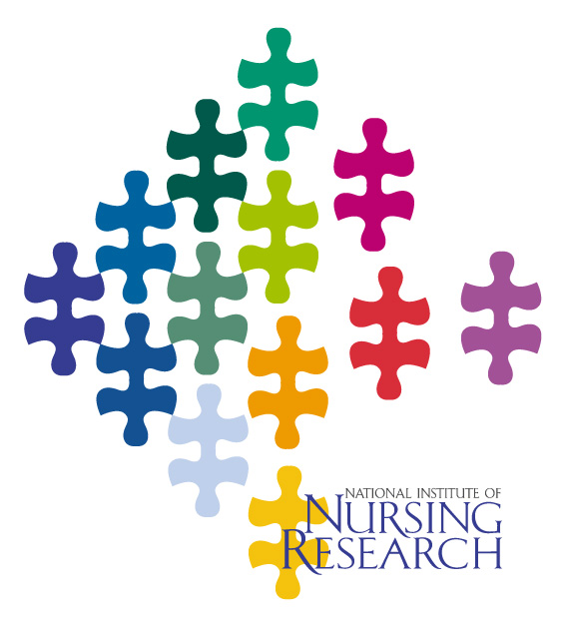
Managing Asthma
one in a series of focus papers on research directions
and NINR-funded research advances


Asthma, a chronic inflammatory disease of the airways, affects over 20 million Americans, and accounts for an estimated $14 billion in health expenditures and lost productivity per year. It is the most common chronic illness among children. Low-income populations, minorities, and inner-city children suffer disproportionate rates of asthma-related hospitalizations and deaths. Despite advances in our understanding of asthma, 12 million people reported an asthma attack in 2004. Asthma management requires recognition and monitoring of symptoms, lifestyle modifications, environmental changes, adherence to treatment and medication plans, and access to appropriate health care. Preventive efforts and intervention programs targeted towards high-risk populations should be culturally and developmentally appropriate.

NINR-Supported Studies on the Management of Asthma

- Caregivers of asthmatic children. In a survey, many caregivers of young children with asthma reported that their child suffered frequent coughing, wheezing, and shortness of breath. Three-quarters of the children had required a recent emergency room (ER) visit, despite having regular care from a physician or clinic and appropriate prescriptions for asthma medications. While most caregivers practiced good asthma management overall, many failed to give medications for coughing, which can be an early sign of an asthma attack, and only half used a peak flow meter to help assess their child’s breathing problems. Caregivers may need more education on early assessment and management of asthma. Butz, Johns Hopkins University, 2004.

- Asthma care in rural families. Among rural families of young children with asthma, nine out of ten reported having health insurance, although in some families only the children were covered. Most of the children reported mild to moderate asthma severity, with asthma triggers including respiratory infections, weather changes, allergies, physical activity, and cigarette smoke. Over the previous year, 40% of the children had visited an ER, while 10% had not seen a physician at all. While almost all were prescribed a quick relief inhaler only half used it properly for episodic symptoms. Parents reported a moderate amount of effort to prevent or treat the symptoms of asthma at home. Having a peak flow meter for home management helped improve preventive and management strategies. Horner, University of Texas, 2003.

- Asthma descriptors among low-income families. When asked to describe their asthma symptoms, a group of children from low-income families used many nonstandard descriptive words such as sore throat, weakness, dizziness, and feeling frightened, panicked, or worried about dying. Their parents also used nonstandard descriptors for symptoms they saw in their child, including fatigue, malaise, headache or stomachache, stuffiness, itchy throat, paleness, sweating, fever, or coldness. Roughly two-thirds of parents whose child had moderate to severe asthma reported that they felt their child’s symptoms were under good control. Asthmatic children and their parents use a wide range of symptom descriptors, and parents may underestimate the severity of their child’s condition. Yoos, University of Rochester, 2005.

The My Asthma Coloring Book© and Asthma Education

As part of a self-management program for children with asthma living in rural areas, a research team developed the My Asthma Coloring Book©. These children have a high prevalence of asthma, but often have limited access to health care and poor understanding of asthma medications or preventive strategies. The book presents positive images that allow the children to focus on specific topics as they read the stories and color the pictures, and instructs the children in a three-step process to follow when an asthma attack starts: (1) tell an adult, (2) use a quick-relief asthma medication, (3) sit down and relax. The book was used as part of an asthma education program for a group of rural-dwelling elementary school children with asthma and their primary caregivers. The children attended classes led by an asthma nurse to teach them about asthma anatomy, asthma medications, warning signs of an attack, use of a peak flow meter and a metered-dose-inhaler (MDI), and factors that could trigger or exacerbate an attack. Their parents also received instruction, which focused on the early signs of an asthma attack, levels of asthma severity, medications, how to avoid environmental triggers, and how to use an asthma action plan. At a 10-month follow-up, children in the education program had a significant decline in asthma symptoms and an increase in self-efficacy, and the younger children showed improved asthma knowledge. The parents also improved their asthma knowledge, especially about the purpose and use of medications, and use of a peak flow meter. Huss, Johns Hopkins University, 2004; Butz, Johns Hopkins University, 2005.

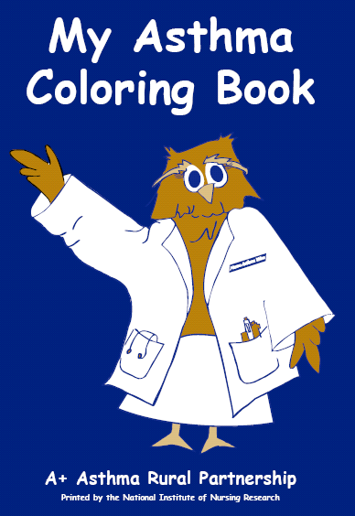

Revised 2/06

The National Institute of Nursing Research (NINR) supports clinical and basic research to establish a scientific basis for the care of individuals across the life span. NINR-supported research seeks to improve the management of patients during illness and recovery, reduce the risks for disease and disability, promote healthy lifestyles, enhance clinical care settings, and ease the problems encountered by families and caregivers. To accomplish its mission, NINR funds peer-reviewed research projects from individual scientists; research training for pre- and postdoctoral nurses; and center grants to universities and other organizations. NINR also conducts intramural research and research training on the campus of the National Institutes of Health. By fostering multidisciplinary/interdisciplinary collaborations, NINR helps to ensure a comprehensive approach to research on health promotion, illness, and disabling conditions. NINR emphasizes the special needs of at-risk and underserved populations, with the ongoing goal of implementing knowledge to reduce health disparities.

National Institute of Nursing Research
Office of Science Policy and Public Liaison
31 Center Drive – MSC 2178
Building 31, Room 5B10
Bethesda, MD 20892-2178

Phone: 301-496-0207
FAX: 301-480-8845
Website: http://ninr.nih.gov/ninr/

