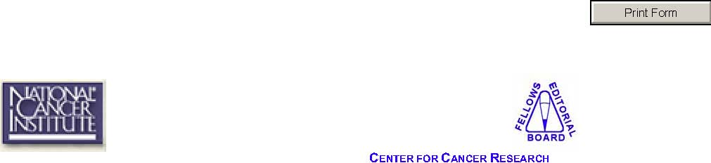
Manuscript Submission Form
Submit documents in their entirety. Please include all figures, tables, legends, and references along with the text document in ONE PDF FILE.
Before submitting to FEB, have you:
- Submitted your text and figures as a single PDF document?
- Submitted a Manuscript Submission Form?
- Run spell-check on your manuscript?
- Numbered the pages?
- Checked the instructions to authors for the intended journal of
submission for formatting and organization?
- Defined all acronyms upon first use?
- Checked that figures and figure legends correspond appropriately?
- Acknowledged NIH intramural funding support?

Name: ________________________
Date: ________________________
Telephone: ________________________
FAX:_________________________
E-mail:___________________________
Building / Room / Mail Code: ____________________________
Manuscript Title: __________________________________
Type: Grant Application (funding agency: _________________________)
Journal (intended journal: ____________________) Full Article Brief Communication
Other (Describe: _______________________________________)



Please provide a brief (3-5 sentence) summary of the important message you wish to convey with this manuscript (i.e. the story you are trying to tell). This summary should be written using terminology that is readily understandable to an individual who is scientifically literate, but not a specialist in your field.


- Please check here if you do not authorize FEB to cite the published manuscript on the FEB web site.

- Please check here if you would like to pick up the hard copy report from the Senior Editor, Bldg. 37, Room 5050. Otherwise, the hard copy will be sent through inter-office mail.

Please send submissions by e-mail to Dr. Jennifer Dickey (ncieditors@mail.nih.gov), in Adobe Acrobat (PDF) format.
All submissions to, and communications with, the NCI, CCR Fellows Editorial Board will be kept strictly confidential.
For further questions please e-mail Dr. Jennifer Dickey, Senior Editor, NCI,
CCR Fellows Editorial Board atncieditors@mail.nih.gov or check our web site
at http://ccr.nci.nih.gov/careers/FEB/.

