Cataloger’s Desktop:

A Comparison of the

CD-ROM and Web Versions

Anna M. Ferris
University Libraries
University of Colorado at Boulder
Norlin Library, Cataloging Dept.

October 28, 2004
The purpose of what follows is to highlight the differences between the
CD-ROM and Web versions of Cataloger’s Desktop.

1. Login

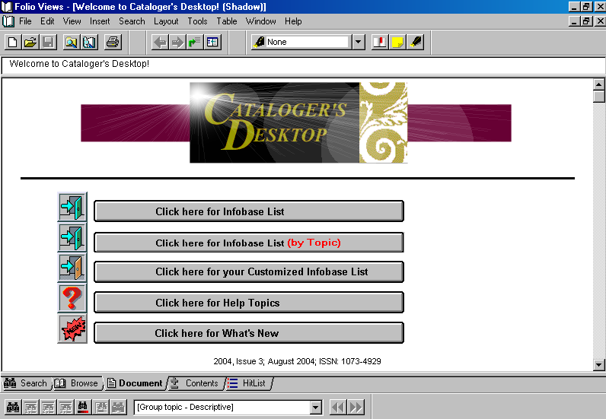
(CD-ROM)

The first notable difference occurs upon opening the program:
The CD-ROM version opens
directly from the Welcome Screen.
The Web version uses two login windows and requires a pre-assigned user ID and password to open the program.

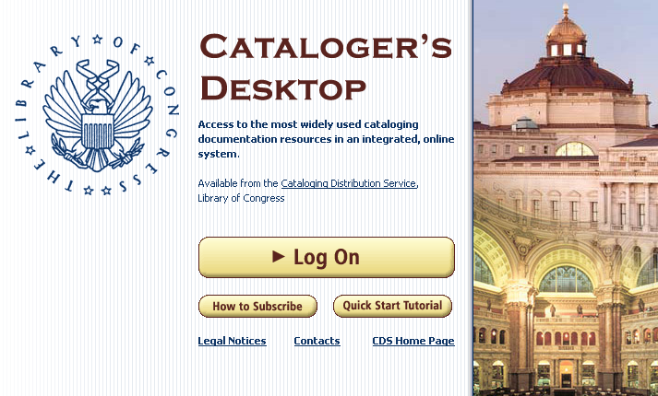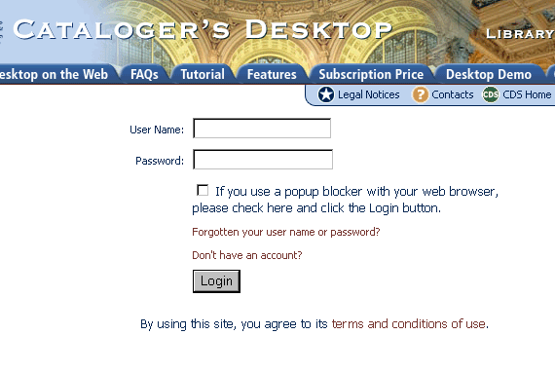
(WEB: Login Window #1) (WEB: Login Window #2)
(This window can be closed once login is completed.)

2. Views

Certain views are similar in both the CD-ROM and Web versions:

The Browse View displays the Contents and Document panes together.

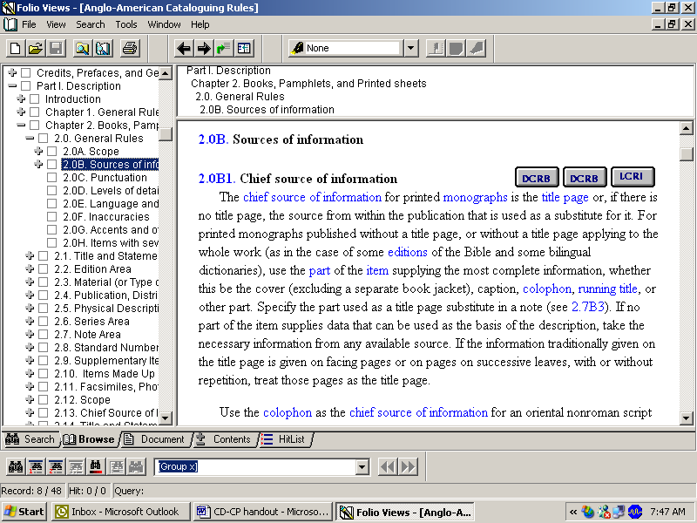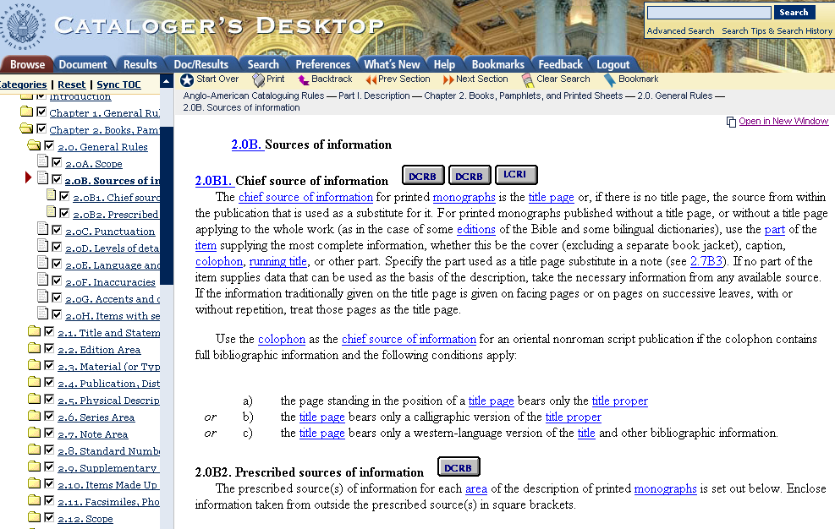
(CD-ROM) (WEB)
The Document View displays the full-text document utilizing the entire screen.

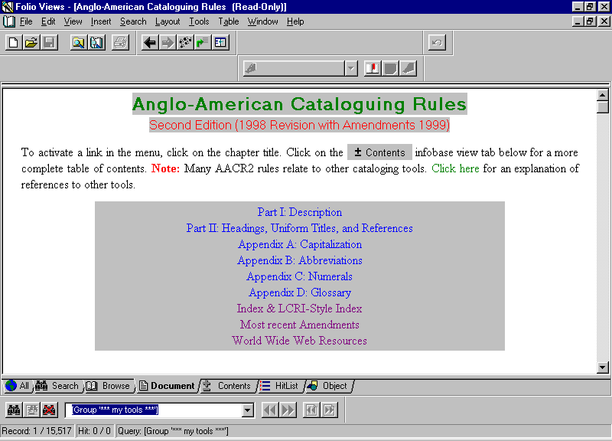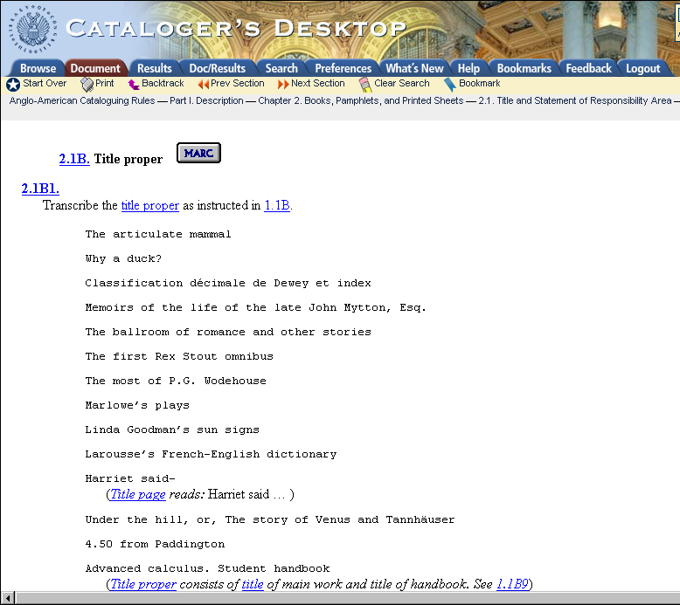
(CD-ROM) (WEB)

The Hit List (CD-ROM) & Results (WEB) Views display lists of search results.

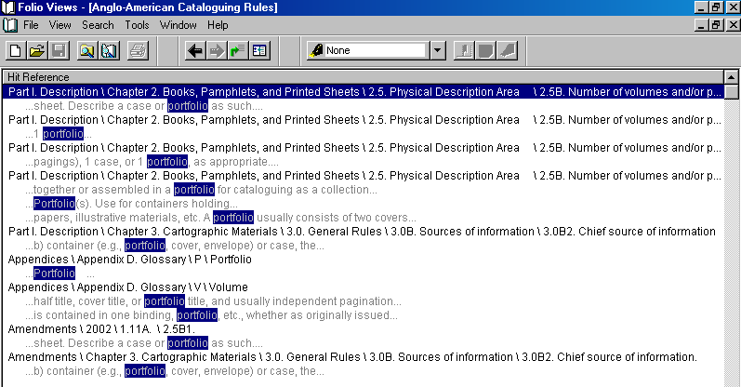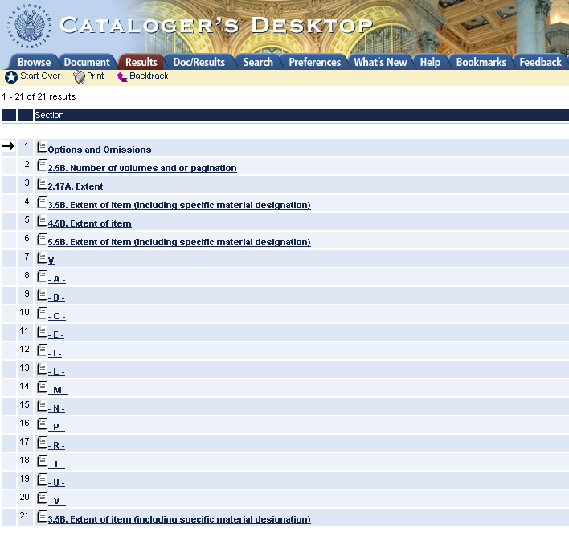
(CD-ROM) (WEB)

The Web version, however, offers two options for viewing the search result hits:

1. Out of context, without surrounding words (select NONE).
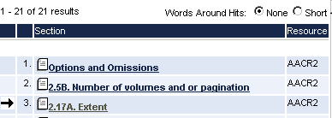
2. In context, with surrounding words (select SHORT).
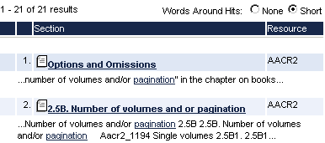

(WEB)
The Contents View illustrates another notable difference:

In the CD-ROM version, the entire table of contents is displayed in a separate screen.

In the Web version, the table of contents only appears on the left side of the screen in the Browse and Search views.
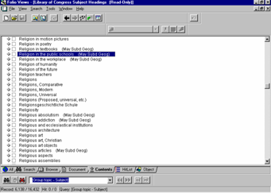
(CD-ROM)

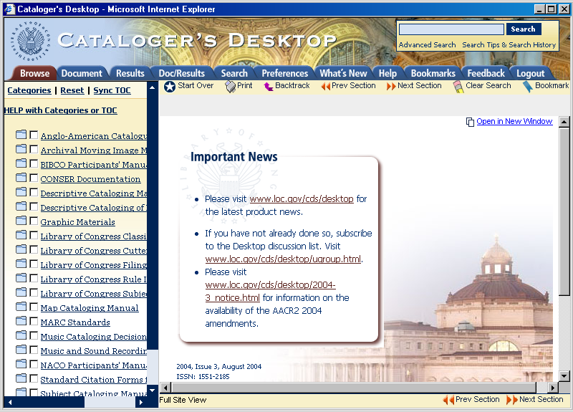
(WEB)
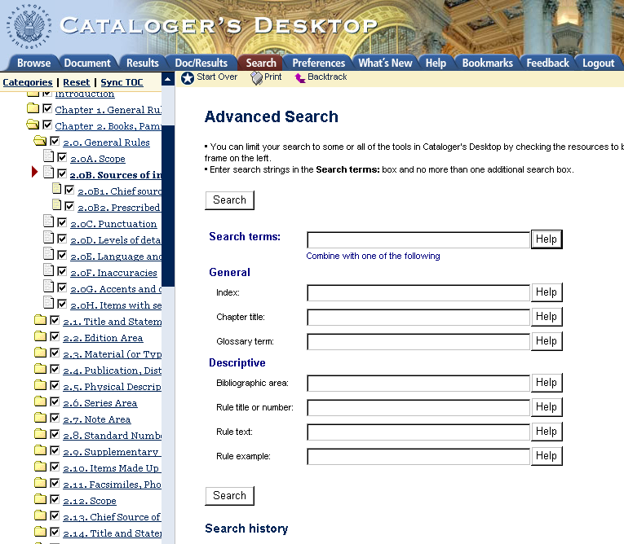
(WEB)

There is a notable difference in how much of each resource is displayed at one time:

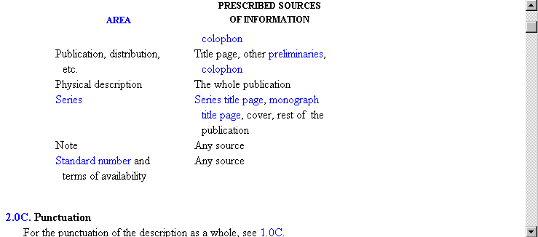
(CD-ROM)

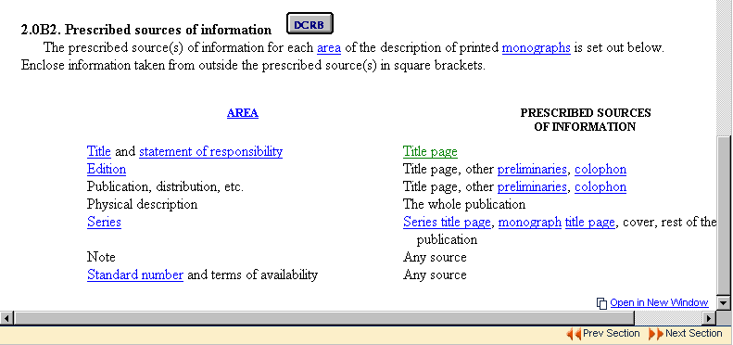
(Web)

The CD-ROM version shows
each resource in a continuous, scrollable display.

The Web version displays
resources in pre-defined sections, requiring the use of “Previous/Next Section” buttons to backtrack or advance to another section.

3. Searching
There are slight variations in the way searches are performed in both versions:

Where the CD-ROM version provides a variety of query templates,

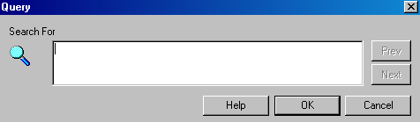
(CD-ROM: Simple Query)

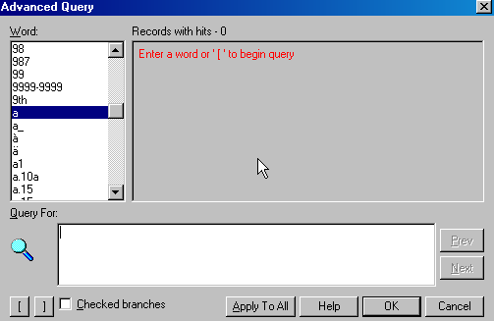
(CD-ROM: Advanced Query)
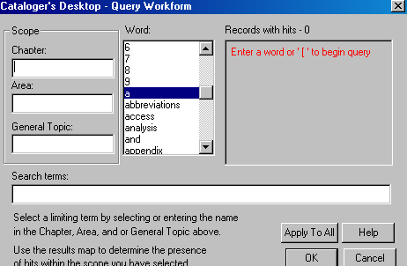
(CD-ROM: Query Workform)

the Web version integrates these templates into one continuous Advanced Search screen.

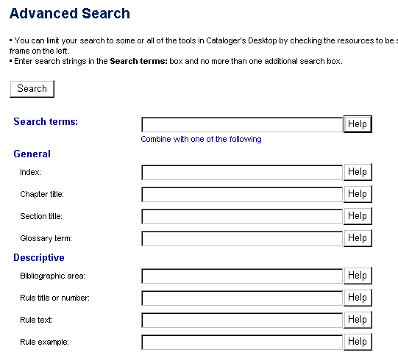
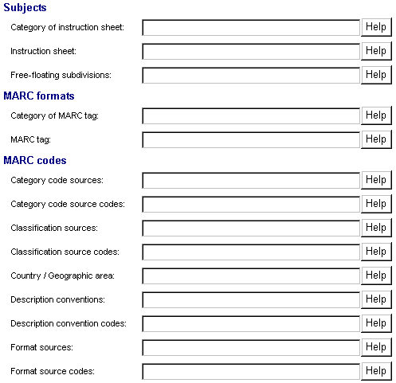
(WEB: Advanced Search Screen)
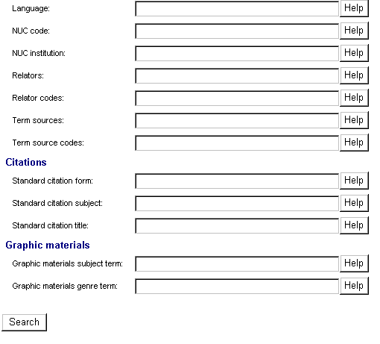

Where the CD-ROM version requires the user to consciously select which resource to search:

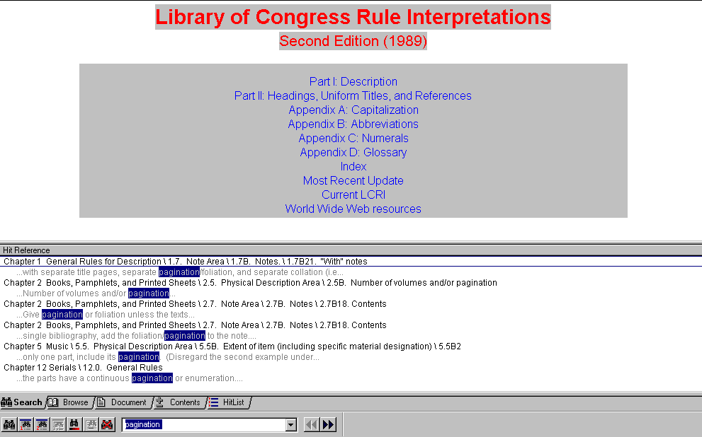
(CD-ROM: Search results for the word “pagination” in the LCRI.)

the Web version defaults to searching multiple resources simultaneously.
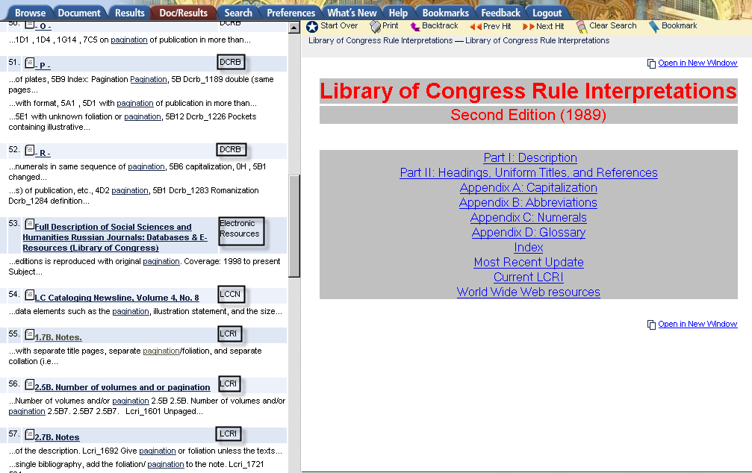

(WEB: Search results for the word “pagination” within various resources)

Also, depending on which search box is used, a different set of resources will be searched:

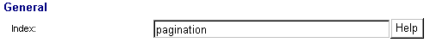
(WEB: Click the “Help” button to view the list of resources.)

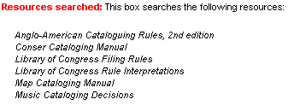

Where the CD-ROM version offers the Go To feature for quick searching within one resource,
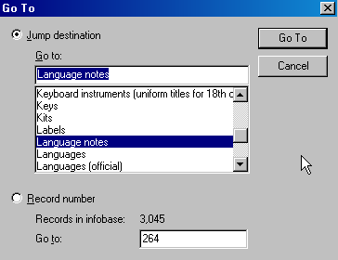

(CD-ROM: Control + G)
the Web version offers a Quick Search box for searching within several resources.

(WEB)
(This box, located at the top right corner of the screen, should be the preferred way to search.)

4. Customization
Each version allows users to limit access to the resources they use most frequently:

Just as the CD-ROM version offers a customizable infobase list from the Welcome Screen,

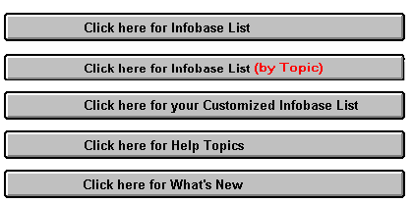
(CD-ROM)
(Users make changes to the list by highlighting and deleting the infobases they do not plan to use.)

the Web version also allows users to select Preferences from the list of available resources.

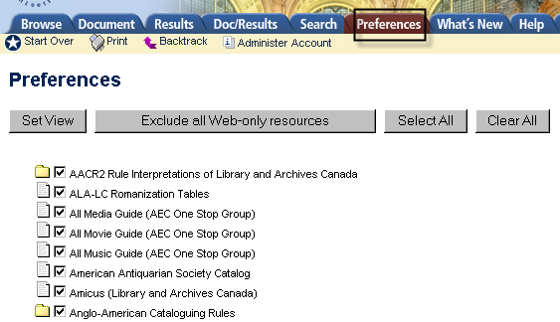
(WEB)
(Users are advised to “Clear All” the checked boxes before selecting the resources they plan to use.)

Just as the CD-ROM version allows users to access infobases according to specific topics,

(CD-ROM)

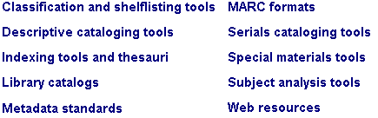
(CD-ROM)

the Web version offers pre-defined Categories of resources that reflect the functions or types of materials that are most relevant to a cataloger’s workflow.

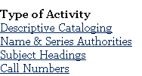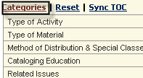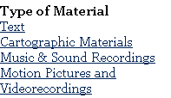
(WEB)

While the CD-ROM version requires that a shadow file be created before setting bookmarks,

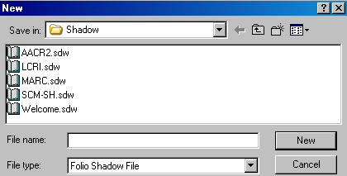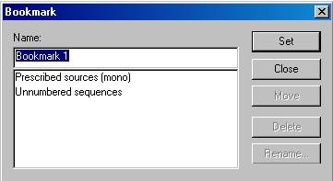
(CD-ROM: Shadow File Window) (CD-ROM: Bookmark Feature)

the Web version simply requires that the Document view be opened before adding a bookmark using the icon. The list of saved bookmarks is then accessed using the tab.

NOTE: The level of bookmarking specificity varies between the CD-ROM and Web versions:

While the CD-ROM version offers bookmarking at any level within the full-text document,
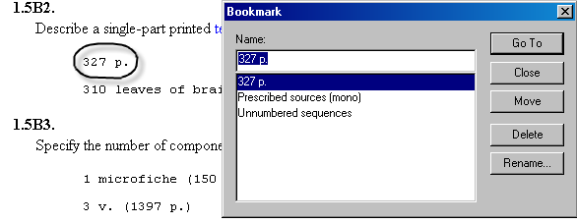
(CD-ROM: Bookmarking an individual word)

The Web version only offers bookmarking at the section title level.
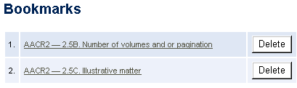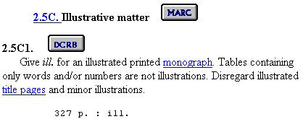
(WEB: Bookmarking a section title)
5. Miscellaneous Web Issues

Certain functions are available only with the Web version of Cataloger’s Desktop because it is a Web application:

1. All customization features (i.e., Preferences, Bookmarks) are stored as cookies on the cataloger’s personal workstation. For this reason, they cannot be shared and they will disappear if cookies are deleted.

2. Many remote databases have been added (e.g., media, movie, theater and music guides, historical society catalogs, government agency websites, Autocat archives, and OCLC documentation) bringing the Web version of Cataloger’s Desktop closer to becoming a comprehensive gateway for cataloging resources.

3. A view tab has been added to the navigation bar for customers to send Feedback and comments to CDS (alternatively accessed via http://desktop.loc.gov/feedback.asp).

4. Search sessions time out after 30 minutes of inactivity.

