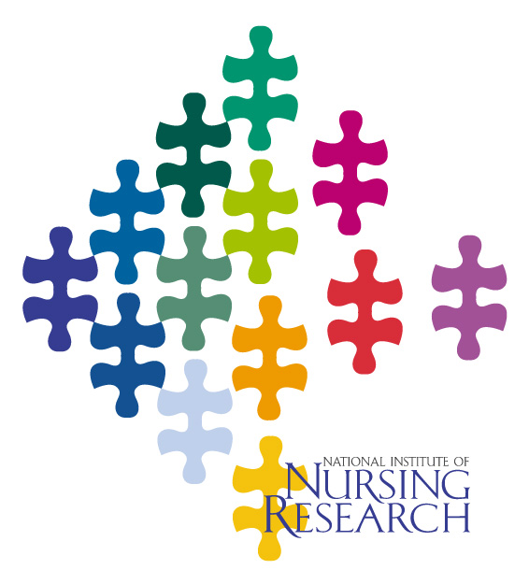
NINR Focus:
Hispanic Health
one in a series of focus papers on research directions and NINR-funded research advances

Comparing the health profile of Hispanic people to that of the general U.S. population reveals numerous disparities. Disproportionate numbers of adult Hispanics suffer from high blood pressure, diabetes, arthritis, and obesity. Children of Mexican descent are at special risk for growth deficiency and related problems. Investigators funded by the NINR are finding new ways of safeguarding the health of Hispanic men and women of all ages, in urban and rural settings across the U.S.

Addressing Hispanic Health Disparities

Examples of NINR-funded Research Findings

- Self-Management of chronic conditions for older Hispanics. Community health care workers led the Tomando Control de su Salud (Taking Control of Your Health) program for older Hispanics with a variety of chronic conditions. The weekly class sessions focused on healthy eating, exercise, relaxation, and family communication. Participants reported lower pain, fatigue, and distress, an increase in exercise, and a lower rate of physician and ER visits. Lorig, Stanford University, 2003.

- Depression in Mexican American women. A survey of Mexican American women revealed that over half had depressive symptoms, and 28% were at high risk for depression, due mostly to alcohol use, marital status, and poverty. Those who had spent their childhoods in Mexico had lower levels of depression than those who came to the US during their childhood. A sense of mastery, life satisfaction, and resilience contributed to lower depression scores. Lee, University of California at San Francisco, 2002.

- HIV prevention for Adolescent Mothers. Project CHARM, an HIV prevention program for minority adolescent mothers, consisted of class sessions using videos, role playing, and skill-building exercises that addressed HIV knowledge and safe sex practices. Young women in the intervention group showed significant gains in AIDS knowledge and in their intention to use condoms, and they reported fewer sex partners at a six-month follow-up. Including couples in the intervention may help sustain the health benefits. Koniak-Griffin, UCLA, 2003.
- Delays in reporting Breast Cancer Symptoms. Factors that contribute to a delay in reporting self-discovered breast cancer symptoms among both Latino and black women included low income and lack of health insurance, lower education, and poor breast cancer knowledge. Decreasing the delay in reporting symptoms could help reduce breast cancer mortality in minority populations. Facione & Dodd, University of California at San Francisco, 2002.

- Cultural Support for Mexican American Mothers. A nurse researcher who followed 20 Mexican American mothers during their pregnancy, and for two years after giving birth, found that strong family and cultural support exists for pregnant women regardless of the circumstances of the pregnancy. After birth, families tended to band together to allow for consistent childcare. Family and community support of pregnant women may help explain the higher rate of positive birth outcomes noted in this population. Domain, University of Kansas, 2001.

- Antibiotics use in a Hispanic community. Interviews of over 600 heads of households in a Hispanic community found that one third of the family members had been recently ill, and many took an antibiotic. However, most of the reported symptoms were viral in nature, for which antibiotics are ineffective. Antibiotics were available over-the-counter in local bodegas, and prescription medications were often saved and shared among family and friends. Teaching the proper use of medications will need to take into account language barriers and cultural practices. Larson, Columbia University, 2004.

- Pain in children with leukemia. All of a group of Latino children with acute leukemia reported having pain, with the most common locations being the legs, abdomen, head or neck, and the back. The children described the pain as “uncomfortable” or “annoying”. Pain management strategies of medication, massage, use of hot or cold compress, and sleep, helped to lower pain scores, while functional status remained high. Van Cleve, Loma Linda University, 2004.

- Lay health advisers and HIV prevention. Nurses trained lay health advisers (LHAs) in HIV prevention for a Latino community. Many of the LHAs talked about HIV with their family and friends, helping to clear up misconceptions such as the fear of getting HIV through casual contact, and the belief that persons with HIV/AIDS are easy to identify. They encouraged the use of condoms, and urged testing for those with concerns about HIV exposure. The LHAs also helped others make clinic appointments and negotiate the public health care system. McQuiston, University of North Carolina at Chapel Hill, 2003.

- Menopause beliefs of Latina women. Interviews with older Latina women about menopause beliefs revealed three common themes: 1) menopause can reorder the harmony and balance in life needed to maintain optimal health, 2) the “change of life” is a normal adult phase for women, and 3) this period is a time for women to reorient their lives to focus more on personal needs and desires. However, many lacked basic knowledge about the course of menopause and possible ways to manage symptoms. Villarruel, University of Michigan, 2002.

- Hearing protection for Mexican American workers. Among Mexican American manufacturing workers, when hearing protective devices (HPDs) were required on the job, three-quarters reported regular use, but when HPDs were optional, only 27% used them. Interpersonal influences, education, and perceived health status contributed to the use of HPDs. Particularly among vulnerable minority populations, nurses need to promote occupational safety measures. Kerr, University of Minnesota, 2002.

- Sexual Behaviors Among Latino Youths. A survey of Latino youths showed that, while 27% reported no forms of intimate contact at all, over 60% had kissed or held hands, around 30% had engaged in heavy petting, and 24% reported having had sexual intercourse. Second and third generation youths reported more intimate behaviors and sexual activity than those who were first generation immigrants. This exploratory study can help with interventions to delay initiation of intercourse and promote safe sex practices. Villarruel, University of Michigan, 2002.

- Nurse Home Visits for Adolescent Latina Mothers. A group of mostly Latina adolescent mothers was followed from early in their pregnancy. Half received normal public health care, while the other half received an early intervention program (EIP) consisting of multiple home visits from a public health nurse to enhance maternal caretaking skills and socialization, and improve birth outcomes. Infants in the EIP required fewer total days of hospitalization. For the mothers, more continued their education, and fewer had repeat pregnancies. Koniak-Griffin, UCLA, 2001.

- Translating an Advance Directive Questionnaire. The Life Support Preferences Questionnaire (LSPQ), a series of end-of-life vignettes to help stimulate discussion on life-support preferences, was translated into Spanish. Tests of the resulting LSPQ-S with both bilingual and Spanish-only subjects showed that few were aware of advance directives or had one in place. The Spanish-speaking respondents scored significantly higher for preferring life-sustaining treatment than an English–speaking sample. Froman, University of Texas, Galveston, 2003.

- Prenatal stress affects pregnancy outcomes. A study of high-risk pregnant women, including low-income Hispanics, found that those with a pessimistic attitude experienced more stress during their pregnancy and delivered infants of lower birth weight. Optimistic women reported engaging in health behaviors linked to more positive birth outcomes. Maternal disposition may affect birth outcomes and fetal health as much as ethnicity or medical risk. Lobel, State University of New York at Stony Brook, 2002.

Revised 6/2004
The National Institute of Nursing Research (NINR) supports clinical and basic research to establish a scientific basis for the care of individuals across the life span. NINR-supported research seeks to improve the management of patients during illness and recovery, reduce the risks for disease and disability, promote healthy lifestyles, and improve the clinical settings in which care is provided, including problems encountered by families and caregivers. To accomplish its mission, NINR provides grants to universities and other research organizations and conducts intramural research and research training on the campus of the National Institutes of Health. These efforts foster multidisciplinary collaborations to ensure a comprehensive approach to research on illness and disabling conditions. NINR emphasizes the special needs of at-risk and underserved populations, and implementing knowledge to reduce health disparities is an ongoing goal.

National Institute of Nursing Research
Office of Science Policy and Public Liaison
31 Center Drive – MSC 2178
Building 31, Room 5B10
Bethesda, MD 20892-2178

Phone: 301-496-0207
FAX: 301-480-8845
http://ninr.nih.gov/ninr/

