What Form Should PIs Use for Population Tracking? (New versus Old)
All new clinical research studies should collect and report information on participants with respect to two categories of ethnicity and five categories of race. The new form (5/01 Version), based on recent changes by the Office of Management and Budget (OMB) regarding standards for data on race and ethnicity, includes two categories of ethnicity and five categories of race. The old form for tracking participants (4/98 Version) in NIH-supported clinical research includes five race/ethnicity categories. Guidelines for choosing the new form versus the old form are as follows:

New Form (5/01 Version)
- Studies begun after January 10, 2002, must use the new form and must be designed to ask participants’ two questions, one about their ethnicity and one about their race.
- Principal Investigators (PIs) who started a study prior to January 10, 2002, using the old form can switch to the new form if they want, but they also must change their data collection methods to ask two questions (one about ethnicity and another about race) rather than one question (that combined race and ethnicity) for all participants enrolled to the study from that point on.
- For studies that began prior to January 10, 2002: When the study comes in for competing continuation (Type 2) and plans to collect new/additional data, the PI is required to change to the new standards for collecting data and use the new (5/01 Version) format for reporting data to NIH. In some cases, this will mean that PIs will need to re-ask study participants about their race and ethnicity using the new two-question format. Note: PIs should not re-ask about race and ethnicity if the subjects are no longer participating in the study.

Old Form (4/98 Version)
- Studies begun prior to January 10, 2002 (and now in their non-competing Type 5 period) that were structured with one question about race and ethnicity can continue to report accrual based on the old form, i.e., using five categories of race/ethnicity. However, when they come in for competitive renewal (Type 2), they will need to change to the new standards/new form (5/01 version) for any additional data collection.
- Principal Investigators should not switch to the new form if only one question about race and ethnicity is used in data collection.
PIs may be confused by the choices, and the NIH Program Staff should be prepared to provide advice on which form should be used. Note:
- If enrollment data is submitted using the wrong form, the PI should be contacted to request a revision using the appropriate form.
- Entry of population data into the Population Tracking System should not be attempted until the target data and/or enrollment data have been submitted by the PI in the appropriate format.
Samples of the old and new forms are on the following pages.

Sample of New Target Form (5/01 Version)

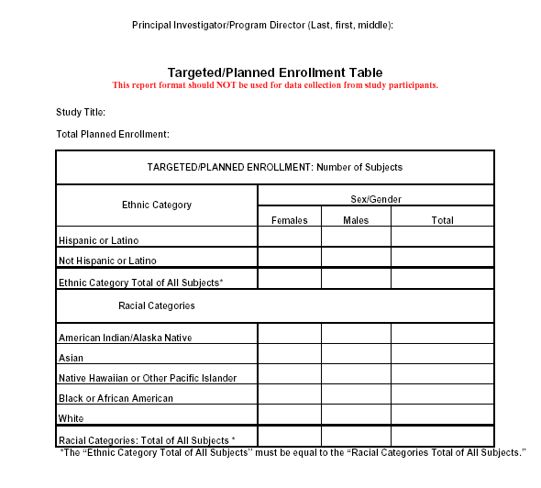
(Ref: http://grants.nih.gov/grants/funding/phs398/enrollment.pdf )

Sample of New Enrollment Form (5/01 Version)
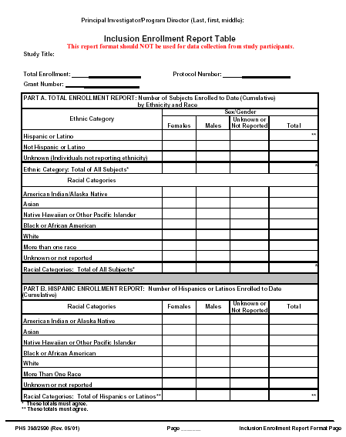

(Ref: http://grants.nih.gov/grants/funding/phs398/enrollmentreport.pdf )

Sample of Old Inclusion Form (4/98 Version)

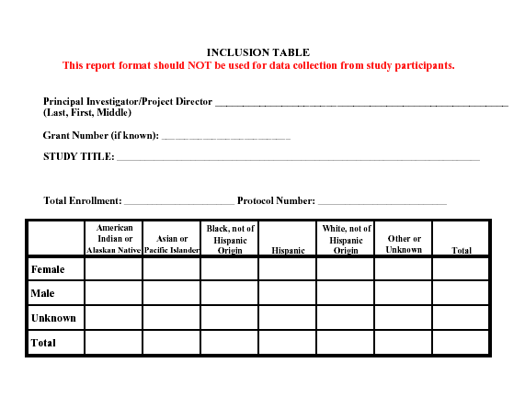
(Ref: http://grants.nih.gov/grants/funding/women_min/InclusionOld_Form.pdf )

